AI USAGE DISCLOSURE FORM
Samsung PRISM GenAI Hackathon 2026 · Theme 05 · THREAD
1. Team Details
Team Name | ReflexAi
Project / Product Name | THREAD
Organization / Institution | SRM Institute of Science and Technology, Kattankulathur
Submission Date | 30 September 2026
2. AI Usage Declaration
Did the team use Artificial Intelligence (AI) in developing this project? YES
Disclosure principle: AI was used as an engineering assistant for implementation, review, experimentation, analysis and communication. Architecture ownership, product decisions, acceptance criteria, source integration, final claims and submission approval remained with the team. AI outputs were treated as proposals and were reviewed, modified and tested before adoption.
3. Purpose of AI Usage (Brief Details)
Activity | How AI was used
Idea generation / brainstorming | Used for architecture alternatives, failure-mode analysis, experiment design and edge-case exploration.
Code generation or assistance | Used for targeted implementation patches, refactoring suggestions, adapter code and regression-test scaffolding.
UI / UX design | Used for interface critique, interaction-flow iteration, visual direction and copy refinement; final product choices were team-directed.
Content creation | Used to draft and edit technical documentation, presentation copy and video narration; factual claims were reconciled against repository evidence.
Data analysis | Used to inspect benchmark logs, group failure modes, compare runs and identify reproducibility or provenance gaps.
Testing / debugging | Used to reproduce defects, propose counterexamples, author regressions, inspect traces and validate fixes against existing tests.
Other | Repository audit, experiment planning, source/provenance checking and submission-evidence review.
4. Feature Origin Classification
Classification uses “Both” where the feature was human-directed and materially implemented/reviewed with AI assistance. Prompt descriptions below are representative summaries rather than copied chat transcripts.
Feature | Origin | Disclosure: tools, prompt summary, output, modification
Interruptible voice controller | Both — human-designed system, AI-assisted implementation and review | Tools/platforms: OpenAI Codex, OpenAI ChatGPT, Anthropic Claude Code.  Representative prompt summary: review the controller for stale-intent races, correction handling, authorization boundaries, idempotency and cancellation; propose minimal fixes and independent regressions.  Output summary: candidate Python changes, counterexamples, tests and trace-level diagnostics.  Team modification/verification: diffs were reviewed, unsafe or over-broad changes were rejected, defects were reproduced before repair, and accepted fixes were validated against regression suites. Failed attempts were retained rather than hidden.
FDB-v3 benchmark, reproducibility and evidence pipeline | Both — team-defined evaluation policy, AI-assisted tooling and analysis | Tools/platforms: OpenAI Codex, OpenAI ChatGPT, Anthropic Claude Code; local Qwen diagnostic model and faster-whisper are runtime/evaluation components.  Representative prompt summary: integrate the released FDB-v3/LiveKit contract, pin model and dependency identities, preserve failures, and produce reproducible run artifacts without conflating local diagnostics with Samsung’s official rerun.  Output summary: runner/reproduction scripts, evidence manifests, failure analysis and documentation.  Team modification/verification: source/config identities and hashes were checked; local judging is explicitly separated from organizer scoring; historical measurements are not transferred to changed source revisions.
Kitchen browser + Android extension | Both — team product concept and acceptance criteria, AI-assisted implementation/testing | Tools/platforms: OpenAI Codex, OpenAI ChatGPT, Anthropic Claude Code.  Representative prompt summary: apply the same correction/authorization model to a persistent checklist, with explicit client-owned storage, receipts, idempotency and stale-input protection across browser and Android clients.  Output summary: host/client adapters, persistence boundary, Android/browser test scaffolds and failure diagnostics.  Team modification/verification: real checklist writes and read-back were exercised; receipt semantics, duplicate protection, playback accounting, APK/source identity and client persistence were independently checked.
UI/UX, documentation and submission media | Both — human creative direction and editorial approval, AI-assisted production | Tools/platforms: OpenAI ChatGPT, OpenAI Codex, Anthropic Claude Code; AI-assisted motion/generated assets and synthetic/re-voiced speech were used in the launch film and explicitly disclosed.  Representative prompt summary: explain THREAD’s architecture and evidence clearly, remove unsupported claims, improve interface/media presentation, and keep historical demonstrations visibly distinct from current-release qualification.  Output summary: UI critiques, documentation drafts, presentation/video copy, motion concepts and generated visual assets.  Team modification/verification: final narrative, visual choices and claims were reviewed by the team; unsupported score predictions were removed; synthetic/re-voiced media is labelled, while the separate recorded demo retains original received audio.
5. Ethical & Compliance Confirmation
AI usage complies with guidelines and policies: YES
No proprietary or copyrighted data misused: I AGREE. Public/open-source dependencies and third-party assets are attributed in the repository; no proprietary benchmark answers or private credentials are included in the submission.
6. Declaration & Sign-Off
I confirm that the disclosure above has been reviewed by the team and accurately describes the use of AI assistance in developing and presenting THREAD.
Name of Team Representative | Nargis Sultana
Role | Team Representative
Signature | 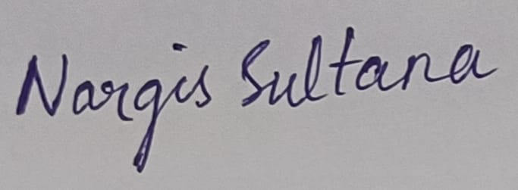
Date | 30.09.2026

