RetainIQ
Customer Churn Early-Warning Engine using Logistic Regression
CSE305 – Machine Learning Fundamentals
Mini Project 2 – Continuous Assessment 3 (Option 2)
Dataset: Telco Customer Churn (IBM / Kaggle)
Notebook: RetainIQ_Churn_Prediction.ipynb (executed on ByteXL Nimbus)

Table of Contents

1. Project Title
RetainIQ: Customer Churn Early-Warning Engine – a Logistic Regression classifier that predicts whether a telecom customer is likely to churn (leave the service) or likely to remain.

2. Problem Statement
Subscription businesses lose recurring revenue whenever a customer cancels, and winning a new customer usually costs much more than keeping an existing one. If the company can identify customers who are likely to leave before they actually leave, the retention team can contact them with targeted offers such as discounts, contract upgrades or better support.
The task is a binary classification problem: given a customer's demographic, account, service and billing information, predict Churn = 1 (likely to churn) or Churn = 0 (likely to remain). Missing a real churner (False Negative) costs the company that customer's future revenue, while a false alarm (False Positive) costs only a call or a small offer. Therefore recall on the churn class is more important than raw accuracy.

3. Project Objective
- Clean and explore the Telco churn data and document every data-quality decision.
- Build a leakage-free preprocessing pipeline (one-hot encoding and standard scaling fitted on training data only).
- Train a Logistic Regression model, interpret its coefficients and show how it produces probabilities with the sigmoid function.
- Visualise a decision boundary and study how the classification threshold changes false positives, false negatives, precision and recall.
- Select a business-appropriate threshold, evaluate the final model on the test set, and give recommendations to a customer-retention team.

4. Dataset Description
The project uses the Telco Customer Churn dataset (IBM sample data, available on Kaggle as WA_Fn-UseC_-Telco-Customer-Churn.csv). It contains 7,043 customers and 21 columns; each row is one customer of a fictional telecom company. The notebook loads it with a relative path so that it runs on ByteXL Nimbus without changes.
Property | Value
Rows × columns | 7,043 × 21
Target | Churn (Yes = 1,869 / 26.54%, No = 5,174 / 73.46%)
Input features | 19 (after dropping customerID)
Numerical features | tenure, MonthlyCharges, TotalCharges
Categorical features | 16 (gender, SeniorCitizen, Partner, Dependents, services, Contract, PaperlessBilling, PaymentMethod)
Class balance | Imbalanced (≈ 2.8 : 1)

5. Feature Description
Feature | Type | Description
customerID | ID | Unique customer code (dropped – no predictive meaning)
gender | Categorical | Male / Female
SeniorCitizen | Categorical | Whether the customer is 65+ (stored as 0/1, converted to No/Yes)
Partner, Dependents | Categorical | Whether the customer has a partner / dependents
tenure | Numerical | Number of months the customer has stayed (0–72)
PhoneService, MultipleLines | Categorical | Phone service and multiple lines
InternetService | Categorical | DSL, Fiber optic or No internet
OnlineSecurity, OnlineBackup, DeviceProtection, TechSupport | Categorical | Add-on services (Yes / No / No internet service)
StreamingTV, StreamingMovies | Categorical | Streaming add-ons
Contract | Categorical | Month-to-month, One year, Two year
PaperlessBilling | Categorical | Electronic bill (Yes/No)
PaymentMethod | Categorical | Electronic check, Mailed check, Bank transfer (auto), Credit card (auto)
MonthlyCharges | Numerical | Current monthly bill in $ (18.25–118.75)
TotalCharges | Numerical | Total amount billed so far (stored as text in raw file)
Churn | Target | Yes = customer left in the last month; No = stayed

6. Data-Cleaning Process

6.1 Data-quality findings
- isnull() reported no missing values, but TotalCharges contained 11 blank strings (hidden missing values) and was stored as text (wrong data type).
- All 11 blank rows had tenure = 0 – brand-new customers who had not been billed yet.
- 0 duplicate rows and all customerIDs unique. Ignoring customerID, 22 rows share identical profiles; these are different real customers and were kept.
- No negative or impossible values: tenure 0–72 months, MonthlyCharges $18.25–$118.75. Category labels are consistent; "No internet service" is a valid category, not an error.
- Target distribution: 73.46% No, 26.54% Yes → moderately imbalanced.

6.2 Cleaning decisions
Decision | Justification
Convert TotalCharges to numeric | It is a money amount stored as text.
Fill 11 blank TotalCharges with 0 | All have tenure = 0, so nothing has been billed – 0 is the true value. Better than the mean (would invent ~$2,280) or dropping rows (data loss).
Drop customerID | Random unique label; carries no behavioural information.
SeniorCitizen 0/1 → No/Yes | Treat consistently with other binary categories.
Encode Churn Yes/No → 1/0 | Model needs a numeric target; 1 = positive class (churn).
Keep 22 profile duplicates | They are different customers with the same simple profile.
Rows before cleaning: 7,043. Rows after cleaning: 7,043 – no customer was removed.

7. Exploratory Data Analysis
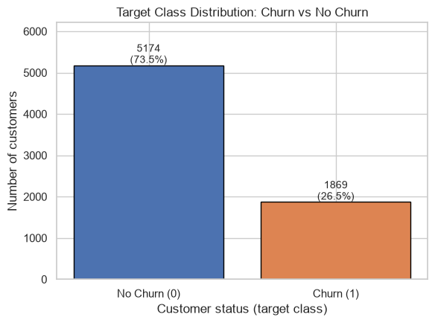
Figure 1: Target class distribution
About three in four customers stay and one in four churns. A model that always predicts "No churn" would already be 73.5% accurate, so accuracy alone is a weak metric here.
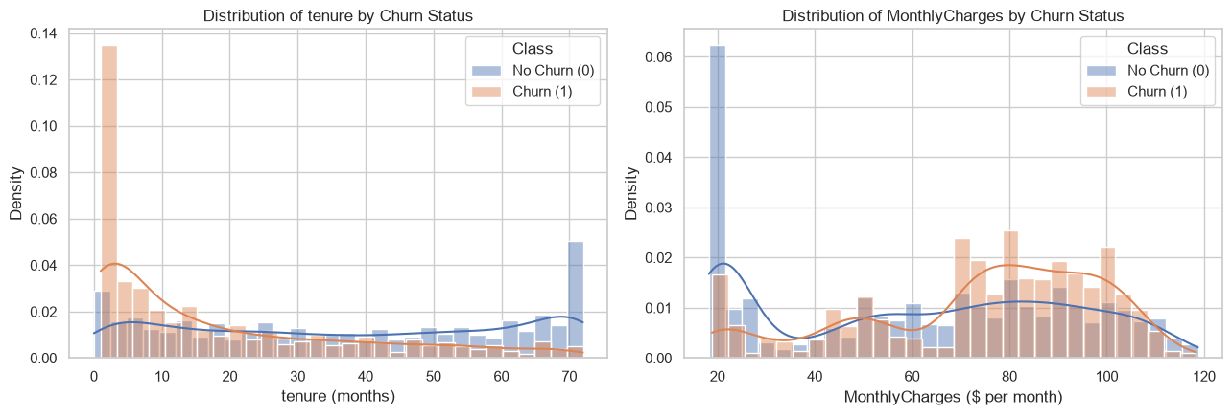
Figure 2: tenure and MonthlyCharges grouped by churn status
Churners are concentrated at low tenure (median 10 months vs 38 months for customers who stay) and pay higher monthly bills (median $79.65 vs $64.43). The two classes still overlap considerably.
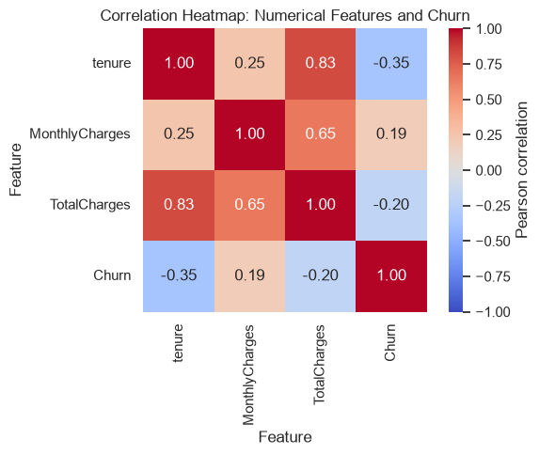
Figure 3: Correlation heatmap of numerical features and churn
tenure has the strongest correlation with churn (−0.35), MonthlyCharges is positive (+0.19) and TotalCharges negative (−0.20). tenure and TotalCharges are strongly correlated (0.83), indicating multicollinearity.
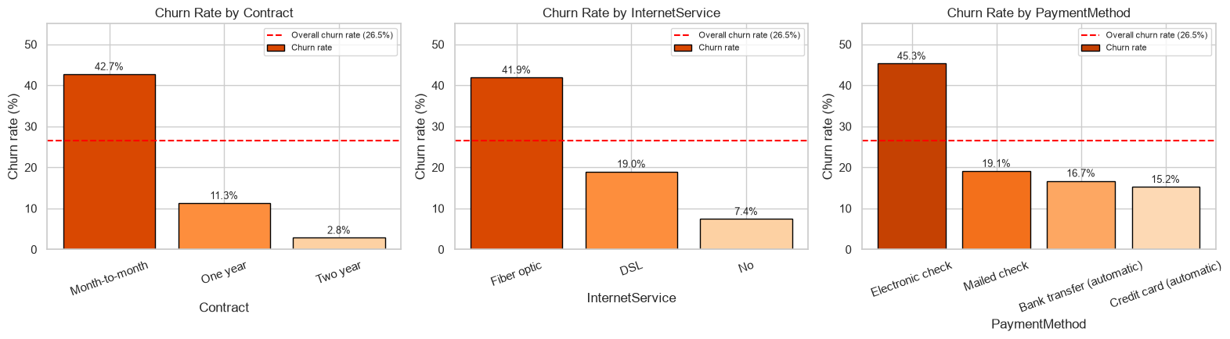
Figure 4: Churn rate by contract type, internet service and payment method
Month-to-month customers churn at 42.7% compared with 11.3% (one year) and 2.8% (two year). Fiber-optic users churn at 41.9% and electronic-check payers at 45.3%.

Key EDA observations
- Only 26.5% of customers churn – the dataset is imbalanced.
- New customers are most at risk (median tenure 10 vs 38 months).
- Contract type is the clearest signal: month-to-month churn is about 15× the two-year rate.
- Higher monthly bills and fiber-optic internet are associated with more churn.
- Electronic-check customers churn about 3× more than automatic-payment customers.
These are associations, not causes. For example, switching a customer to automatic payment would not necessarily stop them from leaving.

8. Preprocessing Methodology
- Features X (19 columns) and target y were separated.
- 80:20 stratified train-test split with random_state = 42: 5,634 training and 1,409 test customers; churn rate 26.5% in both.
- A ColumnTransformer applied StandardScaler to the 3 numerical features and OneHotEncoder(drop="first") to the 16 categorical features, giving 30 model features. The first category of each feature is the reference category.
- The transformer was fitted on X_train only and then used to transform X_test, which prevents data leakage. Scaled training means are 0 and stds are 1; the test means (−0.023, −0.028, −0.043) are close to 0 but not exactly 0, which confirms that training statistics were used.
Why scaling helps: TotalCharges reaches ~8,700 while dummy variables are 0/1. Scaling makes the lbfgs solver converge reliably and lets the L2 penalty treat all features fairly. With standardised features, a coefficient is the change in log-odds for a one-standard-deviation increase, so coefficient sizes can be compared. Scaling also keeps the decision-boundary plot from being stretched by one feature's range.

9. Logistic Regression Methodology
The model is LogisticRegression(max_iter=1000, random_state=42) with default L2 regularisation (C = 1.0). No automated hyperparameter tuning was used. It was trained only on the processed training set (training accuracy 0.806, converged in 40 iterations).
predict() returns a hard label (0/1) using P(Churn) ≥ 0.5, while predict_proba() returns the probability of each class. For example, the second test customer has P(Churn) = 0.684 and is labelled 1; the fourth has P(Churn) = 0.399 and is labelled 0. Probabilities carry more information and are used to rank customers and to test thresholds.
Intercept: −1.584. The most important coefficients are listed below (positive = higher churn odds; odds ratio = e^coef):
Feature | Coefficient | Odds ratio | Effect
InternetService_Fiber optic | +1.181 | 3.257 | Higher churn vs DSL
TotalCharges | +0.528 | 1.695 | Higher churn (given tenure)
PaymentMethod_Electronic check | +0.393 | 1.481 | Higher churn vs bank transfer
StreamingTV_Yes | +0.375 | 1.455 | Higher churn
PaperlessBilling_Yes | +0.374 | 1.454 | Higher churn
MonthlyCharges | −0.467 | 0.627 | Lower (multicollinearity)
PhoneService_Yes | −0.521 | 0.594 | Lower churn
Contract_One year | −0.684 | 0.505 | Lower churn vs month-to-month
tenure | −1.257 | 0.284 | Lower churn per 1 std (~24.6 months)
Contract_Two year | −1.314 | 0.269 | Much lower churn vs month-to-month
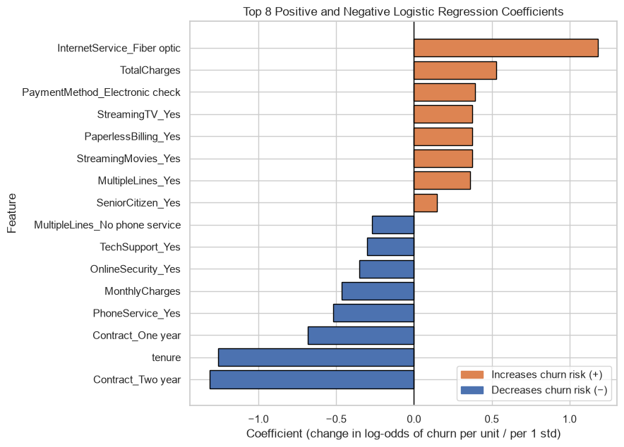
Figure 5: Top positive and negative coefficients
The coefficients agree with the EDA: fiber optic, electronic check and month-to-month contracts raise churn risk; long contracts and longer tenure lower it. MonthlyCharges has a negative coefficient even though churners pay more – this happens because its effect is already captured by fiber optic, streaming services and TotalCharges (multicollinearity). Coefficients describe association with other features held constant, not causation.

10. Sigmoid-Function Explanation
σ(z) = 1 / (1 + e^(−z)), z = b₀ + b₁x₁ + b₂x₂ + … + bₙxₙ
z is the model's raw churn score (the log-odds). Because e^(−z) is always positive, the denominator is always greater than 1, so σ(z) always lies strictly between 0 and 1 (σ(−10) = 0.000045, σ(10) = 0.999955). Logistic Regression uses the sigmoid because a linear score can be any real number, while a probability must be between 0 and 1; the sigmoid is also smooth for gradient-based training. σ(0) = 0.5, so the default threshold of 0.5 corresponds to z = 0, the point where evidence for both classes is equal.
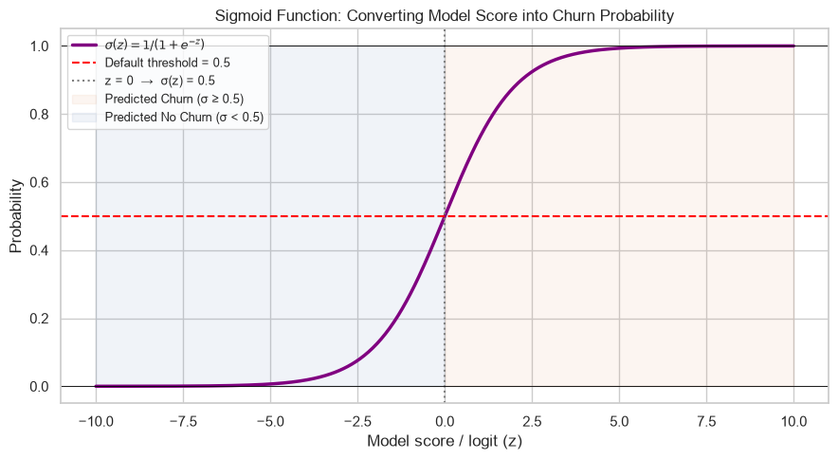
Figure 6: Sigmoid curve with default threshold 0.5
Connection to the trained model: z = model.decision_function(X_test) was computed and passed through the NumPy sigmoid. The result matched predict_proba[:, 1] for all 1,409 test customers (maximum difference 0.0). For example, z = −3.023 → 0.0464 and z = 0.773 → 0.6842. Test-set scores range from −6.36 to 1.78.
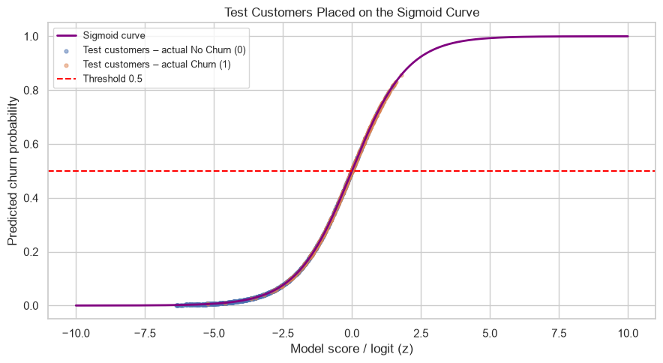
Figure 7: Test customers placed on the sigmoid curve

11. Decision-Boundary Analysis
The decision boundary is where the model is exactly undecided. The model computes a score z, converts it to probability p = σ(z), and predicts churn if p ≥ threshold. With threshold 0.5 the boundary is z = 0. Because z is linear in the features, the boundary is a straight line in 2D (a hyperplane in more dimensions); changing the threshold t moves it parallel to z = ln(t / (1 − t)).
A separate two-feature Logistic Regression was trained on scaled tenure and MonthlyCharges (training data only): z = −1.436 − 1.330·tenure + 1.007·MonthlyCharges.
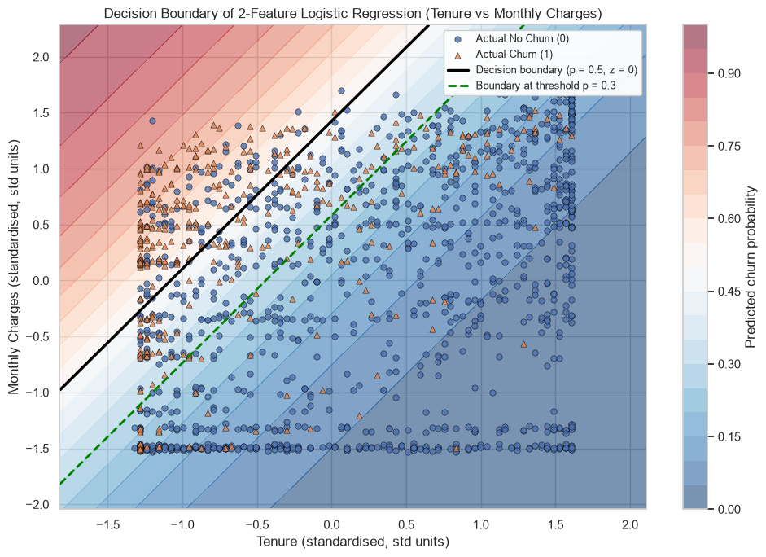
Figure 8: Decision boundary of the 2-feature model (training data)
The upper-left region (low tenure, high monthly charges) is predicted as churn; the lower-right region (long tenure, low charges) as no churn. Lowering the threshold to 0.3 shifts the boundary (green dashed line) so more customers are flagged. The classes overlap heavily: the 2-feature model reaches only 77.3% test accuracy (baseline 73.5%) with 42.3% recall, compared with 80.6% accuracy for the full 30-feature model. Tenure and MonthlyCharges carry useful signal but do not separate the classes well on their own. The plot is a simplified view; the full model's boundary is a 29-dimensional hyperplane that cannot be drawn.

12. Threshold Experiment
Using the test-set probabilities from predict_proba, seven thresholds were applied (churn if P(Churn) ≥ threshold):
Threshold | TN | FP | FN | TP | Accuracy | Precision | Recall | F1
0.2 | 670 | 365 | 54 | 320 | 0.7026 | 0.4672 | 0.8556 | 0.6043
0.3 (chosen) | 774 | 261 | 91 | 283 | 0.7502 | 0.5202 | 0.7567 | 0.6166
0.4 | 847 | 188 | 125 | 249 | 0.7779 | 0.5698 | 0.6658 | 0.6141
0.5 (default) | 927 | 108 | 165 | 209 | 0.8062 | 0.6593 | 0.5588 | 0.6049
0.6 | 976 | 59 | 224 | 150 | 0.7991 | 0.7177 | 0.4011 | 0.5146
0.7 | 1011 | 24 | 304 | 70 | 0.7672 | 0.7447 | 0.1872 | 0.2991
0.8 | 1032 | 3 | 364 | 10 | 0.7395 | 0.7692 | 0.0267 | 0.0517

- Lower threshold → more customers flagged: false positives rise (108 → 365 from 0.5 to 0.2), false negatives fall (165 → 54), recall rises, precision falls.
- Higher threshold → fewer, more confident alerts: precision rises to 0.769 at 0.8, but recall collapses to 2.7%.
- Accuracy is highest at 0.5 (0.806), which is also where many churners are missed.
Chosen threshold: 0.30. It gives the highest F1 of the tested thresholds (0.6166), increases recall from 55.9% to 75.7% (283 instead of 209 churners caught, +74), and keeps precision above 50% (0.520). The cost is 153 extra false alarms, which is acceptable because a retention offer is much cheaper than losing a customer. Threshold 0.2 reaches 85.6% recall but precision drops to 46.7% with 365 false alarms.

13. Confusion-Matrix Analysis
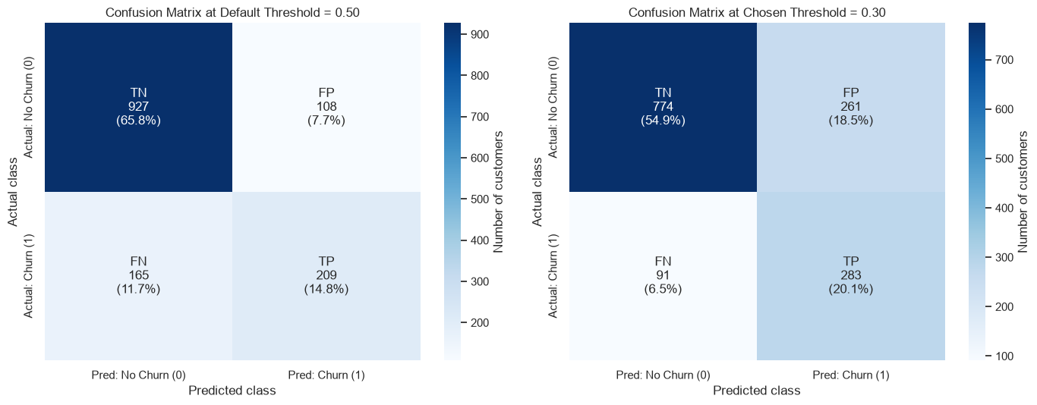
Figure 9: Confusion matrices at threshold 0.50 and 0.30
Component | Meaning for RetainIQ | @0.5 | @0.3
True Positive (TP) | Churner correctly flagged – can be retained | 209 | 283
True Negative (TN) | Loyal customer correctly left alone | 927 | 774
False Positive (FP) | Loyal customer flagged – wasted offer (small cost) | 108 | 261
False Negative (FN) | Churner missed – customer lost (largest cost) | 165 | 91

Moving from 0.5 to 0.3 moves 74 customers from FN to TP and 153 customers from TN to FP, which shrinks the costliest error.

14. Accuracy, Precision, Recall and F1-score
Accuracy = (TP + TN) / (TP + TN + FP + FN)
Precision = TP / (TP + FP) Recall = TP / (TP + FN)
F1 = 2 × Precision × Recall / (Precision + Recall)
At the chosen threshold 0.3 on the test set:
- Accuracy = (283 + 774) / 1409 = 0.7502 – 75% of all test customers are classified correctly.
- Precision = 283 / (283 + 261) = 0.5202 – about half of the flagged customers really churn.
- Recall = 283 / (283 + 91) = 0.7567 – the model catches about 76% of all churners.
- F1 = 0.6166 – the best balance between precision and recall among the tested thresholds.
Why accuracy alone is misleading: predicting "No churn" for every customer gives 73.5% accuracy but 0% recall. The default threshold has higher accuracy (80.6%) than 0.3 (75.0%) yet misses 74 more churners. Recall is the most important metric for this application, with F1 used as a guardrail so that precision does not collapse.
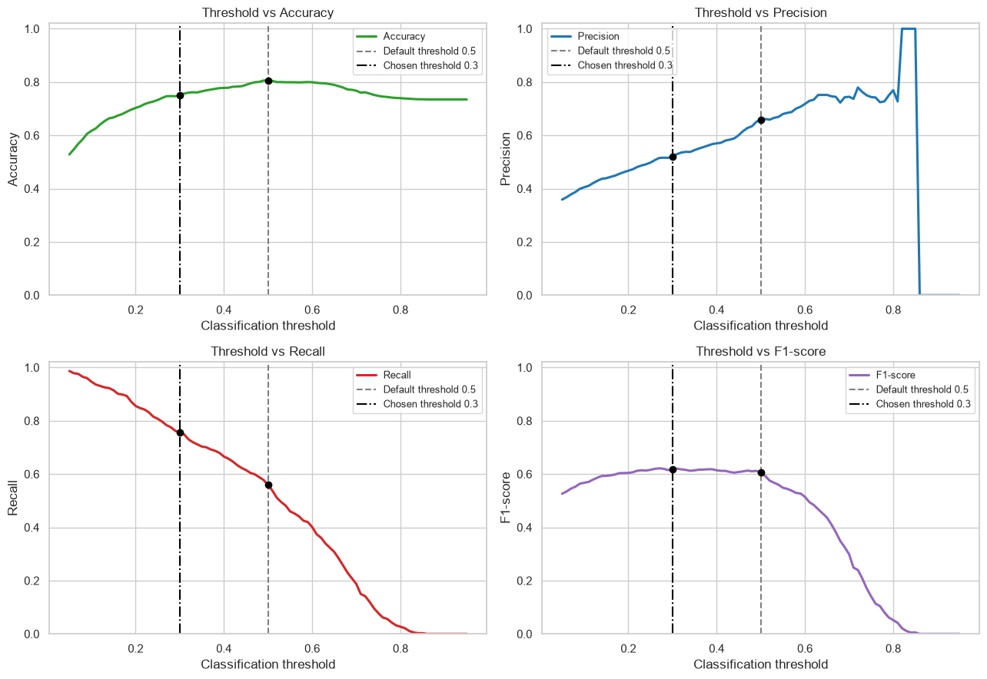
Figure 10: Threshold vs Accuracy, Precision, Recall and F1 (0.05–0.95)
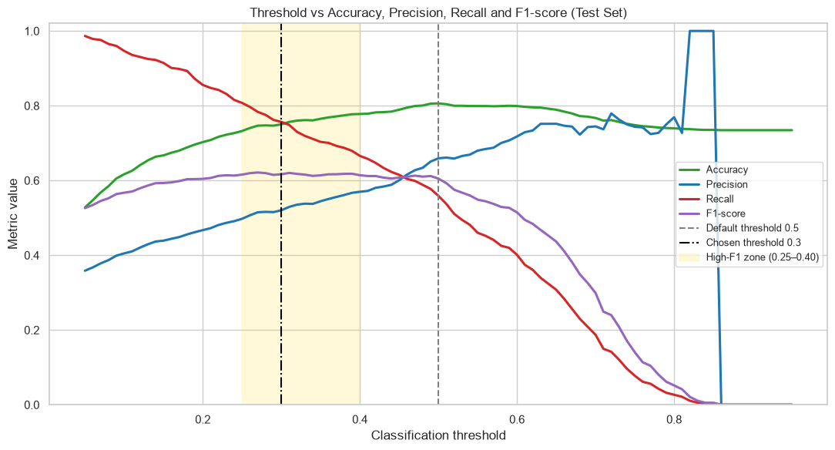
Figure 11: Combined threshold plot with default and chosen thresholds
Recall falls steadily as the threshold rises while precision generally increases – the precision–recall trade-off. F1 peaks in the 0.25–0.40 zone (fine-grid best 0.27, F1 = 0.621), so 0.30 is close to optimal. Above ~0.8 precision becomes unstable because only a handful of customers are flagged; the maximum test probability is 0.856, so above that no one is flagged. Accuracy peaks at 0.50.

15. Results and Observations
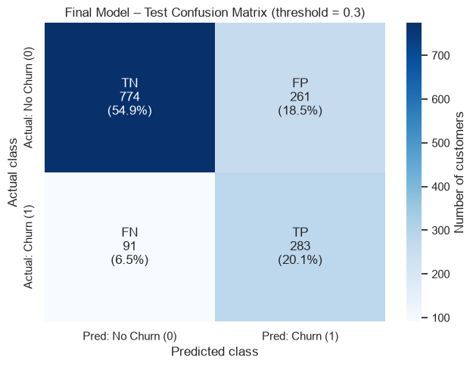
Figure 12: Final test confusion matrix at threshold 0.30
Metric (test set) | Default 0.5 | Chosen 0.3
Accuracy | 0.8062 | 0.7502
Precision | 0.6593 | 0.5202
Recall | 0.5588 | 0.7567
F1-score | 0.6049 | 0.6166
TP / FN | 209 / 165 | 283 / 91
FP / TN | 108 / 927 | 261 / 774

- Strongest churn drivers: fiber-optic internet, TotalCharges (given tenure), electronic-check payment, paperless billing and streaming services.
- Strongest protective factors: two-year and one-year contracts, longer tenure, phone service, online security and tech support.
- Sources of wrong predictions: missed churners (FN) look like loyal customers – median tenure 24 vs 6 months for TPs, average bill $59.95 vs $76.89, and only 58% month-to-month vs 98% – so their average churn probability is just 0.18. False positives look like churners (94% month-to-month, average bill $76.94) but stayed. The reasons for these cases are probably not in the data.

Recommendation for the customer-retention team
- Use an alert threshold of 0.30: it catches about 3 in 4 churners, and about 1 in 2 alerts is a real churner.
- Prioritise month-to-month customers in their first year, especially fiber-optic users paying by electronic check.
- Offer discounted one- or two-year contract upgrades, bundle Online Security / Tech Support, and encourage automatic payment.
- Use cheap actions for borderline scores (0.30–0.50) and stronger offers for high scores (> 0.70). Agents should review the list before acting.

Real-world use
Each month, new customer data passes through the same fitted preprocessor and model. A retention dashboard ranks customers by churn probability, marks those with P(Churn) ≥ 0.30 as "At Risk", shows their main risk factors, and lets managers adjust the threshold to their budget. The model supports human decisions rather than replacing them.

16. Limitations
- Missing behavioural data: no complaint history, support calls, network quality, usage trends or competitor pricing – the most likely real reasons for churn.
- Linear model: Logistic Regression draws straight boundaries and cannot capture feature interactions unless they are engineered.
- Multicollinearity: tenure, MonthlyCharges and TotalCharges are strongly related, which makes individual coefficients unstable (e.g. MonthlyCharges is negative).
- Single snapshot: one month of data from one fictional company; patterns may not transfer to other companies, regions or time periods.
- Moderate precision: about 48% of alerts at the chosen threshold are false alarms.

17. Future Improvements
- Add behavioural and time-based features (support tickets, usage drop, late payments, complaint sentiment).
- Engineer interaction features (e.g. Contract × InternetService, tenure groups) and reduce redundant features.
- Compare class_weight="balanced" with the threshold approach and use cross-validation for more stable estimates.
- Choose the threshold with a cost matrix (value of a saved customer vs cost of an offer).
- Retrain regularly, monitor for data drift, and compare with other models in future work.

18. Conclusion
RetainIQ shows that an interpretable Logistic Regression model can act as a useful churn early-warning system on the Telco dataset. On the 1,409 held-out test customers, lowering the threshold from 0.5 to 0.30 increased recall from 55.9% to 75.7%, catching 74 more churners (283 vs 209) at the cost of 153 extra false alarms, and gave the best F1 (0.617) among the tested thresholds. Accuracy fell from 80.6% to 75.0%, confirming that accuracy is not the right goal for an imbalanced churn problem.
The coefficients agree with the exploratory analysis: month-to-month contracts, short tenure, fiber-optic internet and electronic-check payments are associated with higher churn, while long contracts and support add-ons are associated with loyalty. Because the classes overlap and important behavioural data is missing, the model should be used as a ranking and prioritisation tool that supports the retention team, not as a fully automatic decision-maker.

