
UNIVERSITY INSTITUTE OF COMPUTING

PROJECT REPORT Super Mart Retail Store – Sales Performance (2024)
Program Name: BCA
Subject Name/Code: Data Interpretation Lab
(23CAP-357)

Submitted by Submitted to:

Name: Ansh Gupta Name: Harkamal Kaur
UID: 23BCA10724 Designation: Professor
Section: BCA – 5’A

Table of Contents
Sr. | Title | Page
01 | Introduction | 03
02 | Aim | 03
03 | Objectives | 03-04
04 | Scope of the Project | 04
05 | Problem Definition | 05
06 | Research Gap / Existing Gaps | 05-06
07 | Excel Formulas & Output | 07-11
08 | Conclusion | 11-12
09 | References | 12

1. Introduction
In today's competitive business environment, the ability to collect, organize, and analyze data plays a crucial role in the success of any organization. Data interpretation is the process of reviewing data using various analytical methods in order to arrive at meaningful conclusions.
Microsoft Excel is one of the most widely used spreadsheet tools for data storage, analysis, and visualization. It provides a powerful set of built-in functions and formulas that allow users to manipulate raw data and extract useful business insights without requiring advanced programming knowledge.
This mini project presents a practical, intermediate-level case study of a fictitious retail business called SuperMart. The project demonstrates how raw transactional sales data can be recorded in Excel, cleaned, and then analyzed using ten different Excel functions to generate meaningful business intelligence.
The dataset includes 18 rows of monthly sales records across four departments — Electronics, Clothing, Groceries, and Furniture — and four sales regions (North, South, East, West). By applying various Excel formulas, this project illustrates how businesses can quickly calculate revenue, identify top performers, set targets, and evaluate regional performance.

2. Aim
The aim of this project is to demonstrate the practical application of Microsoft Excel in data interpretation by creating a structured dataset of retail sales records and applying ten different Excel functions to fetch, manipulate, and analyze the data at an intermediate level.
3. Objectives
The specific objectives of this mini project are:
- To create a well-structured Excel table with 18 rows of realistic retail sales data across multiple columns.
- To understand and apply the SUM function to calculate the total revenue generated.
- To use the AVERAGE function to determine the mean units sold per salesperson.
- To apply MAX and MIN functions to identify the highest and lowest sales transactions.
- To use COUNT to verify the completeness of data entries in the dataset.
- To apply COUNTIF to count region-specific or category-specific records.
- To use SUMIF to calculate department-wise total revenue (e.g., Electronics only).
- To apply the IF function for conditional logic, such as checking target achievement.
- To use VLOOKUP to retrieve specific records by searching for a salesperson's ID.
- To apply AVERAGEIF to compute conditional averages for specific regions.
- To build a summary dashboard sheet with KPI cards and a region-wise breakdown table.

4. Scope of the Project
This project is limited in scope to academic demonstration purposes and covers the following areas:
- The dataset is based on a hypothetical retail store (SuperMart) and does not represent any real organization's data.
- The analysis is performed using Microsoft Excel 2016 or later; all functions used are compatible with Excel 2010 and above.
- The project covers only ten specific Excel functions at an intermediate level — it does not include advanced topics such as Pivot Tables, Macros, VBA, or Power Query.
- The dataset consists of 18 sales records spanning a 9-month period (January to September 2024).
- Four departments and four geographical regions are covered in the analysis.
- The Summary Dashboard sheet provides a consolidated view of KPIs derived from the raw data sheet.
This project is suitable for students learning Excel at the intermediate level and serves as a foundation for more advanced data analysis techniques.
5. Problem Definition
Retail businesses like SuperMart generate large volumes of transactional data daily. Without proper tools and techniques to analyze this data, it becomes difficult for managers to make informed decisions regarding sales targets, inventory planning, and performance evaluation.
The core problem addressed in this project is:
"How can raw monthly sales data from a retail store be structured and analyzed using Excel functions to generate meaningful business insights such as total revenue, best-performing salesperson, regional performance, and target achievement status?"

Specifically, the challenges include:
- Raw data exists in an unanalyzed form — totals, averages, and comparisons are not readily visible.
- Managers cannot quickly identify which region or department is underperforming.
- There is no automated way to check whether the store has met its monthly revenue target.
- Retrieving records for specific salespersons requires manual searching through the data.
- Department-wise and region-wise segmentation of revenue requires complex manual calculations.

6. Existing Gaps / Research Gap
While Excel is a widely adopted tool, several gaps exist in how it is typically used by students and small business owners:
6.1 Lack of Structured Data Entry
Most users enter data without any standardized format — missing headers, inconsistent column names, and mixed data types. This project addresses this by using a properly formatted table with defined column roles.
6.2 Underutilization of Built-in Functions
Many users rely only on SUM and AVERAGE while functions such as SUMIF, COUNTIF, VLOOKUP, and AVERAGEIF remain underused despite their power in conditional analysis. This project demonstrates all ten such functions with real-world context.
6.3 No Separation of Raw Data and Analysis
A common mistake is mixing raw data and calculations in the same sheet. This project introduces the concept of separating data (Sheet 1), analysis (Sheet 2), and dashboard (Sheet 3) — a best practice in data management.
6.4 Absence of Dashboards for Quick Decision-Making
Small retailers often make decisions based on intuition rather than data. This project bridges that gap by building a Summary Dashboard with KPI cards that visually present key metrics at a glance.
6.5 No Target Monitoring Mechanism
There is typically no automated check for whether a sales target has been achieved. The use of the IF function in this project provides a simple but effective target monitoring solution.

7. Excel Formulas And Outputs
The dataset is stored in Sheet 1 (Sales Data) of the Excel workbook. It contains 18 rows of sales transactions recorded between January and September 2024 for the SuperMart retail store.
7.1 Screenshot – Sales Data Table (Sheet 1)
The screenshot below shows the formatted Sales Data table as it appears in Microsoft Excel:

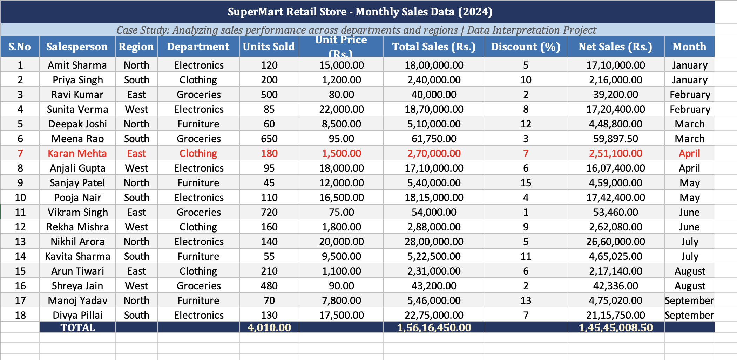
Figure 1: Sales Data Table with 18 rows of transactional data

7.2 Screenshot – Analysis And Formulas Table (Sheet 2)
Sheet 2 (Analysis & Formulas) of the workbook contains all ten Excel functions applied to the Sales Data. Each function is listed below with the formula used, expected result, and its business interpretation.

# | Function | Formula Used | Result* | Business Interpretation
1 | SUM | =SUM('Sales Data'!I4:I21) | Variable | Total Net Revenue of SuperMart across all 18 transactions
2 | AVERAGE | =AVERAGE('Sales Data'!E4:E21) | Variable | Mean units sold per salesperson to set benchmarks
3 | MAX | =MAX('Sales Data'!I4:I21) | Variable | Single highest net sales deal — identifies best transaction
4 | MIN | =MIN('Sales Data'!I4:I21) | Variable | Lowest net sale value — identifies weakest transaction
5 | COUNT | =COUNT('Sales Data'!E4:E21) | 18 | Verifies that all 18 records have numeric data in Units Sold
6 | COUNTIF | =COUNTIF(C4:C21,"North") | Variable | Number of transactions from North region
7 | SUMIF | =SUMIF(D4:D21,"Electronics",I4:I21) | Variable | Total Net Sales contributed by Electronics department
8 | IF | =IF(SUM(I4:I21)>2000000,"TARGET MET","BELOW TARGET") | Text | Logical check — did store cross Rs. 20 lakh revenue?
9 | VLOOKUP | =VLOOKUP(7,A4:I21,9,FALSE) | Variable | Retrieves Net Sales of Salesperson with S.No = 7
10 | AVERAGEIF | =AVERAGEIF(C4:C21,"South",E4:E21) | Variable | Average units sold by salespersons in the South region

* Results are calculated dynamically by Excel based on the dataset. Open the Excel workbook to view actual computed values.
Function 1 – SUM: Total Net Revenue

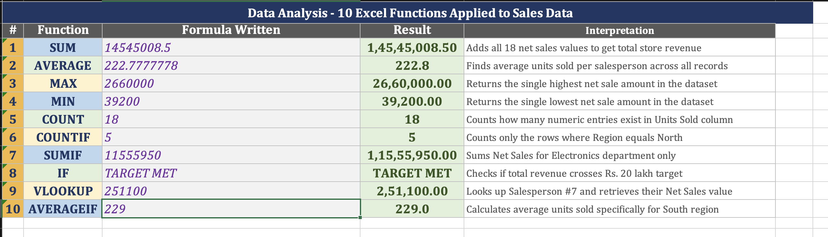
Figure 2: SUM formula applied to Net Sales column (Sheet 2)

Functions 2, 3 & 4 – AVERAGE, MAX, MIN

Figure 3: AVERAGE, MAX and MIN applied to Units Sold and Net Sales

Function 5 & 6 – COUNT and COUNTIF

Figure 4: COUNT verifying 18 records; COUNTIF for North region

Function 7 – SUMIF AND If: Electronics Revenue

Figure 5: SUMIF and If result showing total Electronics department sales

Functions 8 & 9 – VLOOKUP and AVERAGEIF

Figure 6: VLOOKUP retrieving Salesperson #7; AVERAGEIF for South region

7.3 Screenshot – Summary Dashboard Table (Sheet 3)
Sheet 3 (Summary Dashboard) presents a consolidated executive view of the key performance indicators derived from the raw sales data. The dashboard is divided into two sections:
- KPI Cards: Eight metric cards showing Total Revenue, Average Net Sales per deal, Maximum and Minimum single sale, Total Units Sold, Number of Transactions, Electronics Revenue, and North Region Sales.
- Region-wise Breakdown Table: A comparative table showing Net Sales, Units Sold, Average Discount, Number of Records, and Performance Status for each of the four regions.

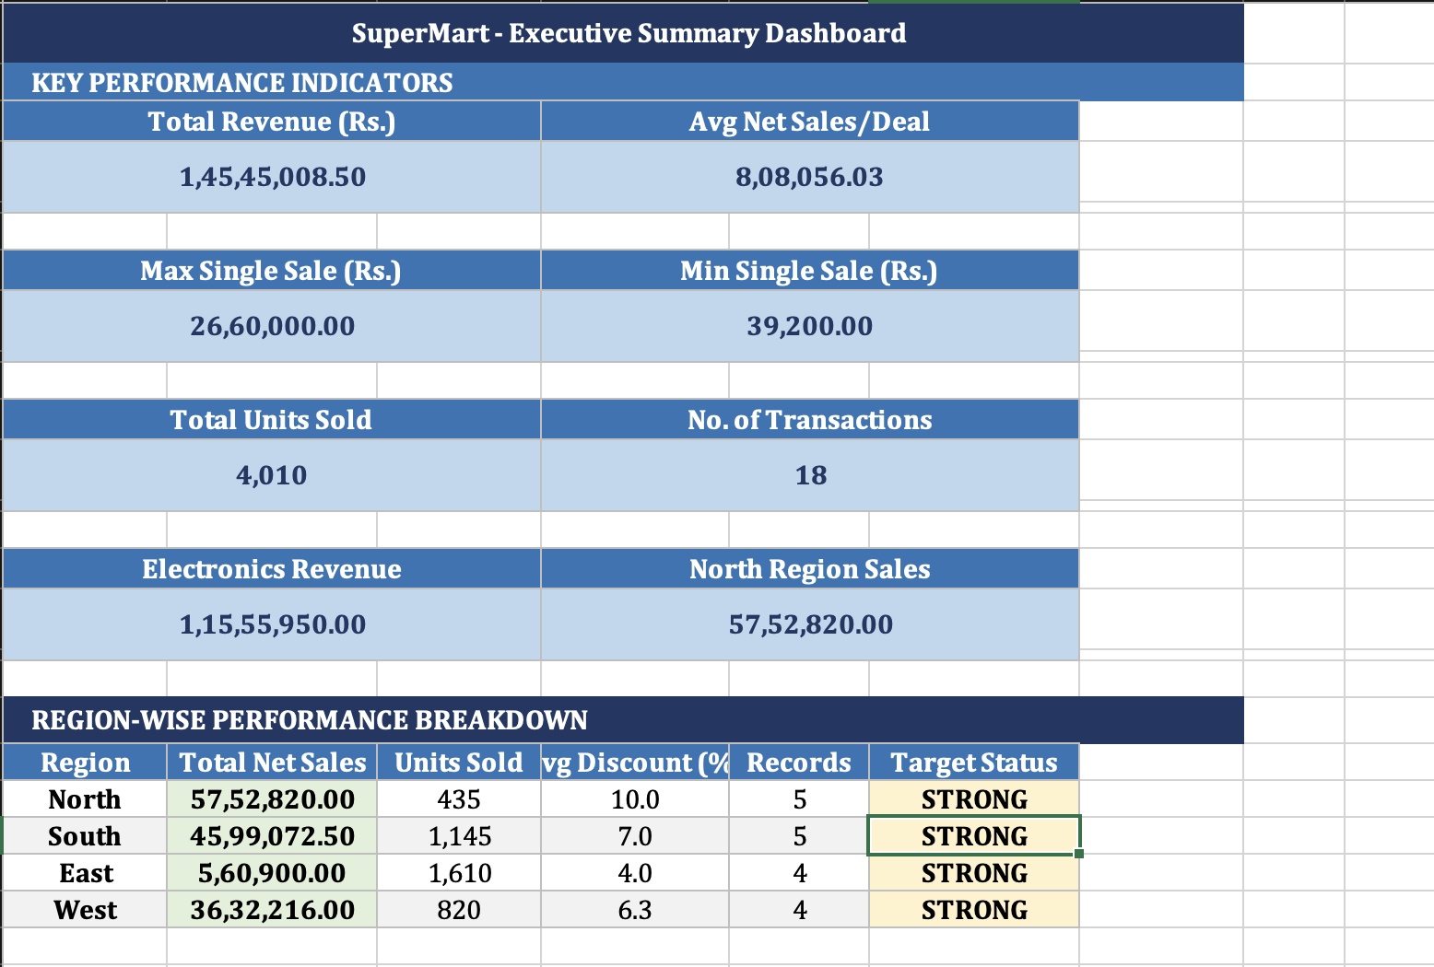
Figure 7: Executive Summary Dashboard with KPI cards and region-wise performance table
8. Conclusion
This mini project successfully demonstrates the practical application of Microsoft Excel for data interpretation at an intermediate level. Using a realistic retail store case study (SuperMart), the project shows how raw transactional sales data can be transformed into actionable business insights through the use of built-in Excel functions.
- The following key conclusions can be drawn from this project:
- Excel is a powerful and accessible tool for data interpretation — without any programming, meaningful analysis can be performed using built-in functions alone.
- Functions like SUM, AVERAGE, MAX, and MIN provide foundational descriptive statistics that give a quick overview of dataset characteristics.
- Conditional functions such as COUNTIF, SUMIF, and AVERAGEIF allow for segmented analysis — enabling region-wise and department-wise comparisons that are critical for business decision-making.
- The IF function provides a simple yet effective mechanism for automated target monitoring and KPI evaluation.
- VLOOKUP demonstrates how Excel can be used as a simple database query tool to retrieve specific records from large datasets.
- Separating raw data, analysis formulas, and a summary dashboard across three sheets reflects professional spreadsheet design practices and improves readability.
- The Summary Dashboard provides managers with at-a-glance insights that support faster and more informed business decisions.

Overall, this project reinforces the importance of data literacy and practical Excel skills in academic and professional contexts. The techniques demonstrated here serve as a strong foundation for more advanced topics such as Pivot Tables, Charts, Power Query, and Excel-based data modeling.
9. References
- Microsoft Corporation. (2024). Excel Functions (by Category). Microsoft Support. https://support.microsoft.com/en-us/excel
- Walkenbach, J. (2019). Excel 2019 Bible. John Wiley & Sons.
- Frye, C. (2018). Microsoft Excel Step by Step (Office 2021 and Microsoft 365). Microsoft Press.
- Chapra, S. C., & Canale, R. P. (2021). Numerical Methods for Engineers. McGraw-Hill Education.
- ExcelJet. (2024). Excel Formula Examples. https://exceljet.net/formulas
--- End of Report ---

