SOFTWARE DESIGN DOCUMENT
TASKFLOW
Version 1.0

Project | TASKFLOW
Document | Software Design Document
Prepared by | Ansh Patel
Institution | Indian Institute of Information Technology, Pune
Based on the approved TASKFLOW Software Requirements Specification, Version 1.0.

Table of Contents
1. Introduction
2. Design Overview
3. System Architecture
4. Module Design
5. Database Design
6. Data Flow Design
7. User Interface Design
8. Interface and API Design
9. Security Design
10. Error Handling and Validation
11. Non-Functional Design
12. Deployment Design
13. Future Extensibility
14. Conclusion
Appendix A: Data Dictionary

1. Introduction

1.1 Purpose
This Software Design Document (SDD) describes the technical design of TASKFLOW. It translates the functional and non-functional requirements defined in the approved SRS into a structured design covering architecture, modules, database organization, user interface, interfaces, security, validation, deployment, and maintainability.

1.2 Scope
The design covers the core TASKFLOW scope: user account and profile management, personal task management, daily routine tracking, reminders and notifications, and basic slump/focus support. Advanced analytics, social/community features, complex gamification, and third-party integrations are outside the initial version.

1.3 Design Goals
- Keep the application simple and focused on essential productivity functions.
- Keep user task and routine data persistent across sessions.
- Separate major functions into maintainable modules.
- Protect personal data through authentication, authorization, secure transmission, and protected credential storage.
- Allow future expansion without changing the core task model.

2. Design Overview
TASKFLOW is designed as a standalone productivity application with a client-facing user interface, application/business logic, and persistent storage. The design uses logical separation between authentication, task management, routines, reminders/notifications, and focus support so that each area can be changed independently where practical.

2.1 Design Assumptions
- Users access TASKFLOW through a supported browser or application runtime.
- Persistent database services are available.
- The target platform provides the notification mechanism when reminders are used.
- Internet connectivity may be required for client-server communication and notification services.

2.2 High-Level Components
Component | Responsibility
Presentation Layer | Displays screens and captures user actions.
Authentication/User Service | Handles account creation, login, logout, and user identity.
Task Management Service | Creates, edits, deletes, completes, validates, and retrieves tasks.
Routine Service | Stores recurring activities and routine completion states.
Reminder/Notification Service | Stores reminder configuration and triggers due notifications.
Focus Support Service | Provides a small actionable prompt or next step when the user reports difficulty starting/continuing work.
Persistence Layer | Stores users, tasks, routines, completion states, and reminder information.

3. System Architecture
The logical architecture follows a layered approach. User actions originate in the presentation layer, are processed by the relevant application service, and are persisted through the database layer. Reminder events additionally interact with the notification mechanism provided by the target platform.
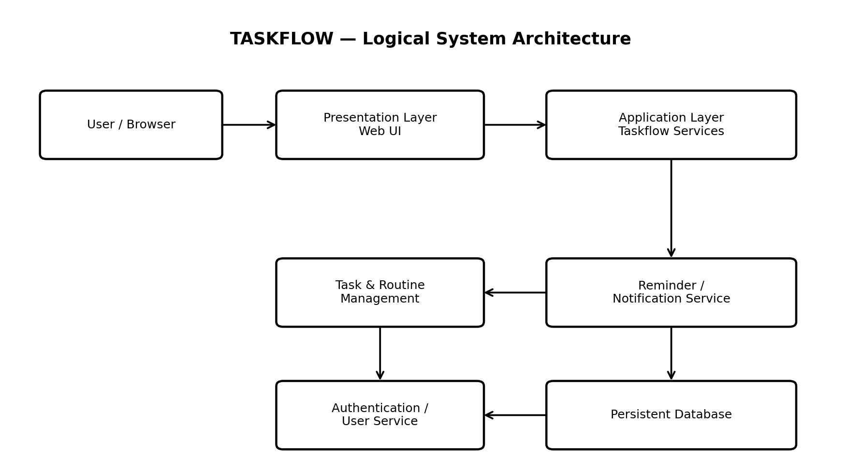
Figure 1. Logical system architecture.

3.1 Architectural Flow
- User → UI: user enters credentials, creates tasks, updates routines, configures reminders, or requests focus support.
- UI → Application Services: validated requests are sent to the appropriate service.
- Application Services → Database: user-specific data is created, read, updated, or deleted.
- Reminder Service → Notification Mechanism: a due reminder generates a platform notification, subject to platform availability.
- Application Services → UI: operation results, current task/routine states, or validation errors are returned.

4. Module Design

4.1 User Account and Profile
Provides account creation, authentication, logout, and association of personal data with the correct user.
Related requirements: FR-01 to FR-04

4.2 Task Management
Manages creation, viewing, editing, deletion, completion, status, priority, deadlines, descriptions, and reminders for tasks.
Related requirements: FR-05 to FR-11

4.3 Daily Routine Tracking
Allows recurring daily activities to be defined, completed, displayed, and retained for future use.
Related requirements: FR-12 to FR-15

4.4 Notifications and Reminders
Creates and manages reminders and triggers notifications when configured times are reached without duplicating the same reminder notification.
Related requirements: FR-16 to FR-19

4.5 Slump and Focus Support
Provides a simple actionable suggestion or next step when a user reports difficulty starting or continuing work, without modifying task data automatically.
Related requirements: FR-20 to FR-23

4.6 Module Interaction
From | To | Purpose
Authentication | User/Profile | Establish authenticated user context.
Dashboard | Task Management | Retrieve and update current task information.
Dashboard | Routine Service | Retrieve current routines and completion status.
Task/Routine Service | Reminder Service | Create, modify, or remove reminder configurations.
Reminder Service | Notification Mechanism | Deliver due notification.
Task View | Focus Support | Open support flow for the selected task.
Focus Support | Task View | Return the user to the relevant task or task list.

5. Database Design
The database is designed around persistent user, task, routine, completion, and reminder information. The exact database technology can be selected during implementation; the logical model below is independent of a specific vendor.
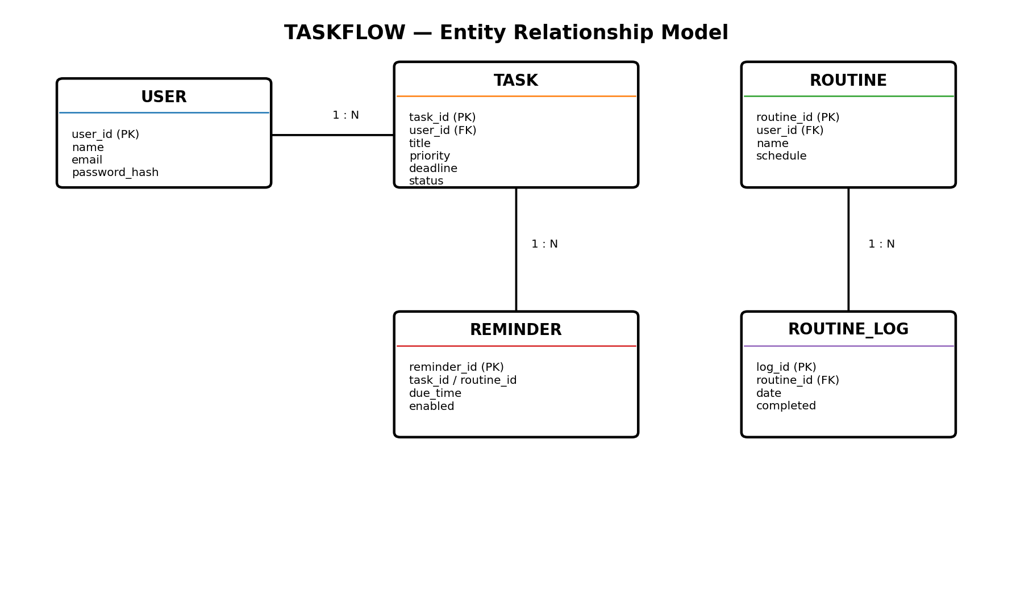
Figure 2. Logical entity relationship model.

5.1 Main Entities
Entity | Purpose | Key Relationships
User | Stores account identity and authentication-related information. | One user has many tasks and routines.
Task | Stores personal work items and their current state. | Belongs to one user; may have reminder information.
Routine | Stores recurring activities defined by a user. | Belongs to one user; has completion logs.
Routine_Log | Stores completion state for routine occurrences. | Belongs to one routine.
Reminder | Stores scheduled reminder configuration. | Associated with a task or routine activity.

5.2 Logical Schema
Table | Important Fields
USER | user_id PK, name, email, password_hash
TASK | task_id PK, user_id FK, title, description, priority, deadline, status, created_at
ROUTINE | routine_id PK, user_id FK, name, schedule, active
ROUTINE_LOG | log_id PK, routine_id FK, date, completed
REMINDER | reminder_id PK, task_id/routine_id reference, due_time, enabled, notification_sent

5.3 Integrity Rules
- Every task and routine must be associated with a valid user.
- A user can access only records belonging to that user.
- A task must contain a valid title before it can be saved.
- Routine completion records must reference an existing routine.
- A reminder must contain a valid due time and enabled/disabled state.
- Deleting a task should also remove or deactivate its associated reminder configuration.

6. Data Flow Design
The main data flow begins with a user action and ends with either a persisted state change or a returned result/error. A typical task-creation flow is:
1. User enters task information.
2. UI validates required fields and basic input format.
3. Task Management Service validates ownership and business rules.
4. Persistence Layer stores the task against the authenticated user.
5. System returns success and refreshes the relevant task view.

6.1 Reminder Flow
1. User configures a reminder for a task or routine.
2. Reminder Service stores the schedule.
3. At the due time, the service checks that the reminder is enabled and has not already been delivered.
4. Notification is requested through the platform notification mechanism.
5. The reminder state is updated to prevent duplicate delivery.

7. User Interface Design
The UI follows the SRS requirement for a simple and consistent productivity interface. Common actions such as save, edit, delete, complete, cancel, and logout should be clearly identifiable. Validation errors should be shown near the relevant action.

7.1 Main Screens
Screen | Main Elements | Primary Actions
Login / Register | Email, password, account controls | Register, login
Dashboard | Current tasks, completed work, routines, reminders | Open, complete, create
Task View | Task title, description, priority, deadline, status | Create, edit, delete, complete
Routine View | Recurring activities and completion status | Create, complete, modify
Reminder Controls | Reminder time, enabled state | Set, modify, remove
Focus Support | Short actionable suggestion / next step | Start support, return to task

7.2 Navigation Flow
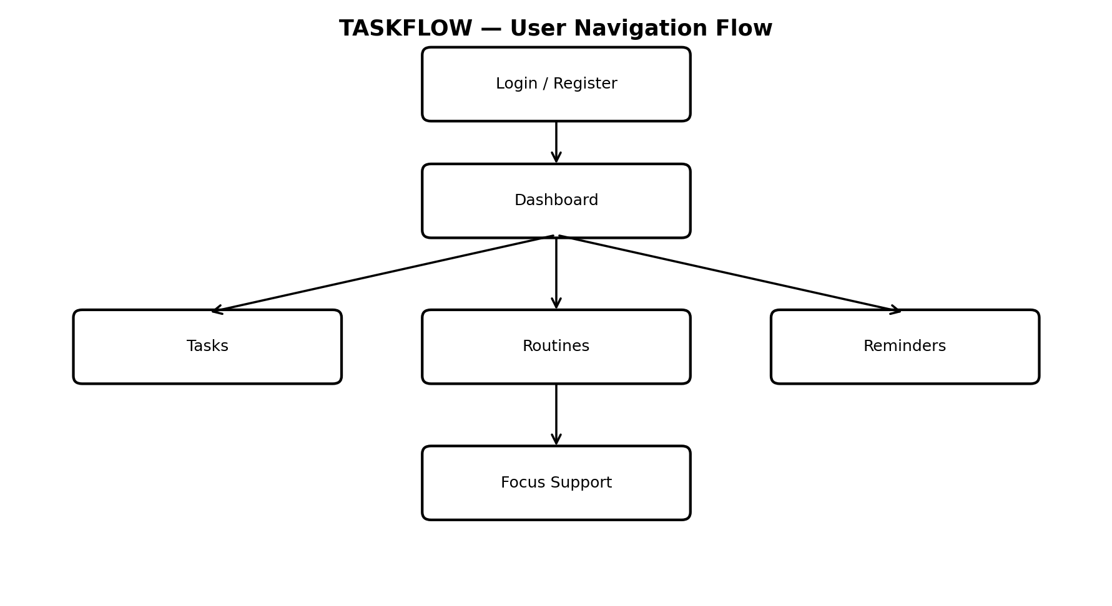
Figure 3. Suggested user navigation flow.

7.3 UI Principles
- Minimal navigation for frequent actions.
- Clear distinction between pending and completed work.
- Consistent placement and wording of controls.
- Readable feedback for successful and failed operations.
- Responsive layout suitable for common desktop and mobile screen sizes.

8. Interface and API Design
If TASKFLOW is implemented using a client-server model, the client communicates with application services through standard secure web requests. Endpoint names below are logical examples and can be adjusted during implementation.
Operation | Logical Endpoint | Purpose
Register | POST /api/auth/register | Create a new user account.
Login | POST /api/auth/login | Authenticate a registered user.
Logout | POST /api/auth/logout | End the authenticated session.
List Tasks | GET /api/tasks | Retrieve tasks belonging to the current user.
Create Task | POST /api/tasks | Create a task after validation.
Update Task | PUT /api/tasks/{id} | Modify an existing task owned by the user.
Delete Task | DELETE /api/tasks/{id} | Delete an existing task owned by the user.
Complete Task | PATCH /api/tasks/{id}/complete | Mark a task completed.
List Routines | GET /api/routines | Retrieve current routines.
Create Reminder | POST /api/reminders | Create a reminder configuration.

8.1 Interface Rules
- Requests involving personal data must execute in an authenticated user context.
- Object identifiers must be validated before database access.
- Responses should use clear success and error status information.
- Sensitive authentication information must never be returned in normal API responses.
- Network communication should use secure web protocols.

9. Security Design

9.1 Authentication
Registered users must be authenticated before accessing personal task and routine information. Passwords must not be stored as plain text; a secure password-hashing mechanism should be used.

9.2 Authorization
Every task, routine, reminder, and completion record must be accessed in the context of its owning user. Authorization checks should occur in the application layer before data is returned or modified.

9.3 Data Protection
- Use secure communication for network transfers.
- Hash passwords using a suitable password-hashing algorithm.
- Validate and sanitize user-controlled input.
- Avoid exposing internal database details through error messages.
- Use session/token mechanisms appropriate to the selected implementation platform.

10. Error Handling and Validation
Situation | Expected System Response
Missing task title | Reject save and explain that a title is required.
Invalid deadline/reminder | Reject invalid value and request correction.
Unauthorized task access | Reject operation without revealing protected data.
Unknown task ID | Return a clear not-found response.
Database/service failure | Show a user-friendly error and avoid application crash.
Duplicate reminder event | Do not create a second notification.
Invalid login | Reject authentication and display a generic login error.

11. Non-Functional Design
Requirement Area | Design Response
Performance | Use direct CRUD operations for normal task/routine actions and avoid unnecessary processing.
Security | Authentication, ownership checks, password hashing, and secure transmission.
Usability | Simple screens, clear controls, limited navigation, understandable errors.
Reliability | Persistent storage and validation to prevent invalid state.
Maintainability | Separate services/modules for tasks, routines, reminders, authentication, and focus support.
Portability | Responsive UI and dependence on standard browser/application capabilities.

12. Deployment Design
A practical deployment can use three logical parts: the client application, an application server/API, and a persistent database. The notification mechanism may be provided by the target platform or an external notification service if selected during implementation.
Layer | Deployment Responsibility
Client | Runs the TASKFLOW interface in a supported browser or application runtime.
Application Server | Runs authentication, task, routine, reminder, and focus-support logic.
Database Server | Persists user, task, routine, completion, and reminder data.
Notification Platform | Delivers due notifications subject to platform availability.

13. Future Extensibility
The initial design deliberately remains limited to the core requirements. The modular architecture and stable task model provide room for future additions such as analytics, integrations, richer productivity assistance, or other services without requiring a redesign of the core task structure.

13.1 Current Exclusions
- Advanced analytics
- Social/community features
- Complex gamification
- Third-party integrations

14. Conclusion
This design document converts the TASKFLOW SRS into a practical technical blueprint. It defines the logical architecture, major modules, persistent data model, interface structure, security approach, validation rules, and deployment arrangement required for the initial system. The design keeps the implementation focused on the approved scope while maintaining separation of concerns for future maintenance and extension.

Appendix A: Data Dictionary
Field | Meaning
user_id | Unique identifier for a user account.
task_id | Unique identifier for a task.
routine_id | Unique identifier for a recurring routine.
reminder_id | Unique identifier for a reminder configuration.
status | Current task state, such as pending or completed.
priority | User-selected importance level of a task.
deadline | Target date/time associated with a task.
schedule | Definition of when a routine occurs.
completed | Boolean completion state for a routine occurrence.
due_time | Configured time at which a reminder becomes due.

