Minor Project 1: SQL Case Study for E-Commerce Analysis

**Instructions:**

**Step 1: Paste the sample datasets in post gre sql and write your query for each question of both Problem Statements.**

**Step 2: After writing all the queries for both Problem Statements, you can upload the .doc file on MyCaptain WebApp.**

**Problem Statement 1**

**These are the sample dataset for e-commerce platform**

CREATE TABLE IF NOT EXISTS Customers (

    CustomerID INT PRIMARY KEY,

    CustomerName VARCHAR(100),

    Country VARCHAR(50)

);

INSERT INTO Customers (CustomerID, CustomerName, Country) VALUES

(1, 'John Doe', 'USA'),

(2, 'Jane Smith', 'Canada'),

(3, 'Emily Jones', 'UK'),

(4, 'Chris Brown', 'USA'); ‘’

SELECT * FROM Customers

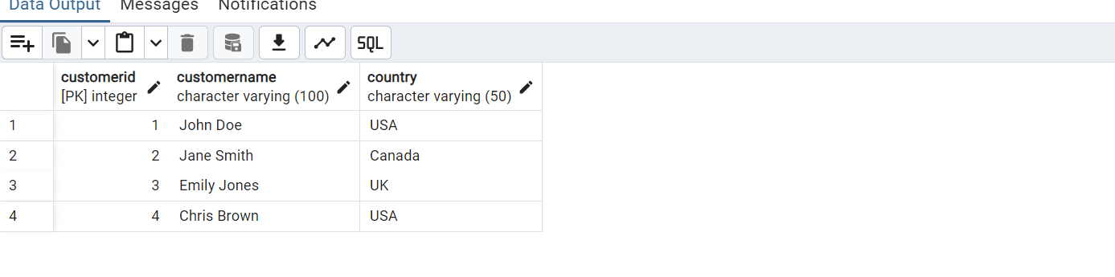

CREATE TABLE IF NOT EXISTS Products (

    ProductID INT PRIMARY KEY,

    ProductName VARCHAR(100),

    Price DECIMAL(10, 2),

    Category VARCHAR(50)

);

INSERT INTO Products (ProductID, ProductName, Price, Category) VALUES

(1, 'Laptop', 1200.00, 'Electronics'),

(2, 'Smartphone', 700.00, 'Electronics'),

(3, 'Book', 15.00, 'Books'),

(4, 'Table', 150.00, 'Furniture');

SELECT * FROM Products

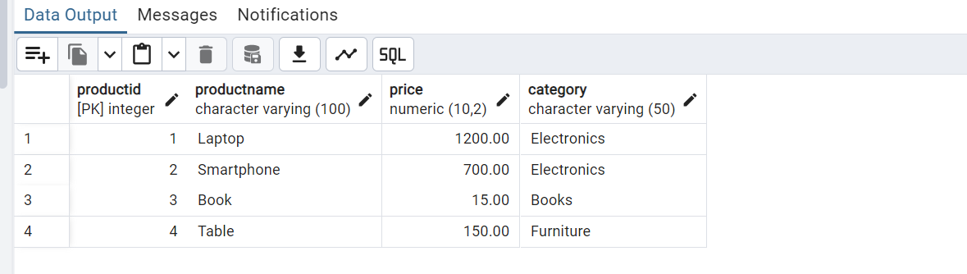

CREATE TABLE IF NOT EXISTS Transactions (

    TransactionID INT PRIMARY KEY,

    CustomerID INT,

    ProductID INT,

    Quantity INT,

    TransactionDate DATE

);

INSERT INTO Transactions (TransactionID, CustomerID, ProductID, Quantity, TransactionDate) VALUES

(1, 1, 1, 1, '2023-03-15'),

(2, 2, 2, 1, '2023-03-15'),

(3, 3, 3, 2, '2023-03-16'),

(4, 4, 4, 3, '2023-03-17'),

(5, 1, 3, 1, '2023-03-18');

SELECT * FROM Transactions

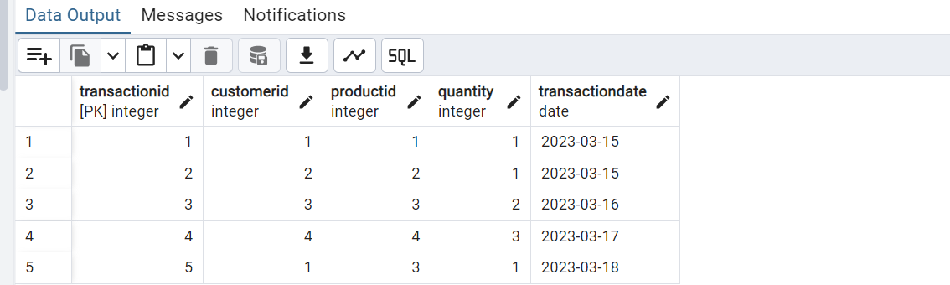

1.What is the total revenue generated from each product category?

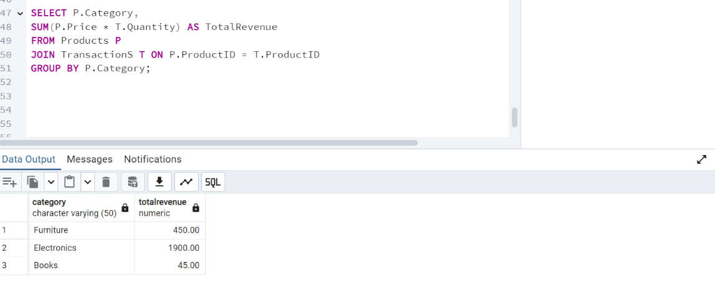

2.Which customer made the highest number of transaction

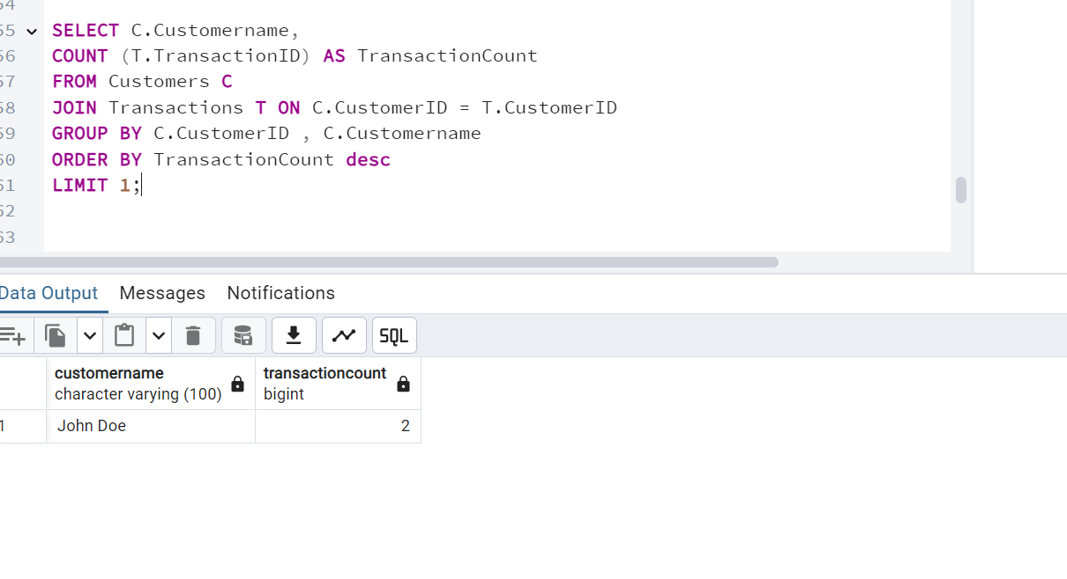

3.List products that have never been sold.

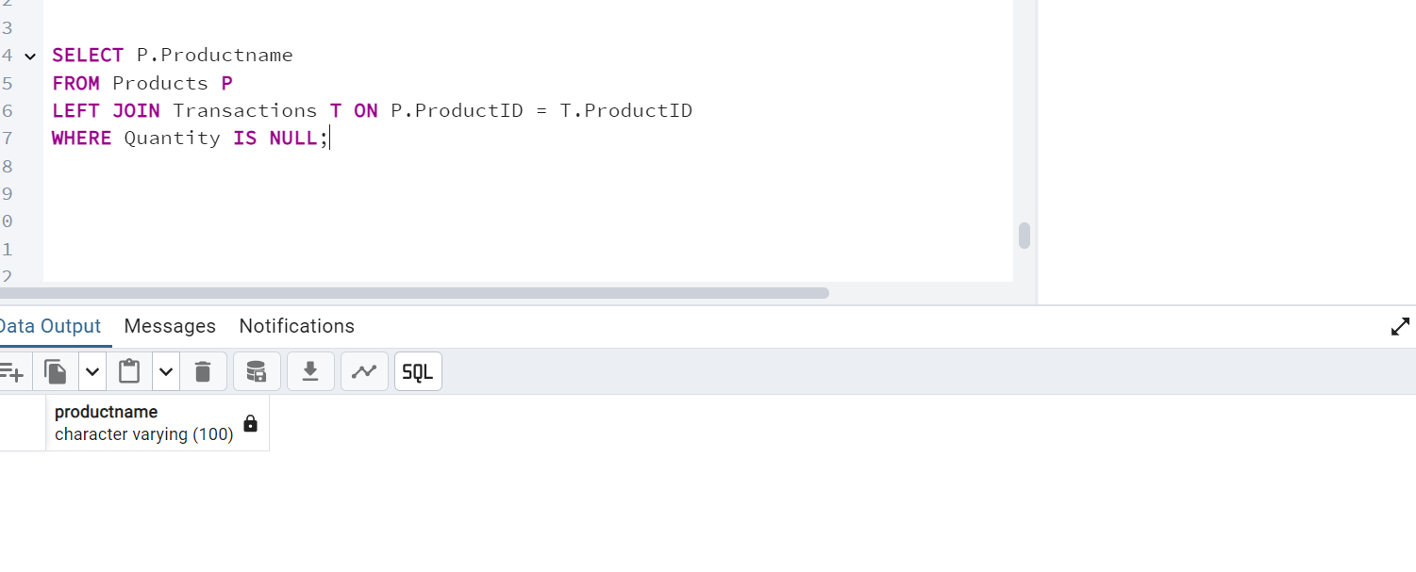

4. What is the average transaction value for each country?

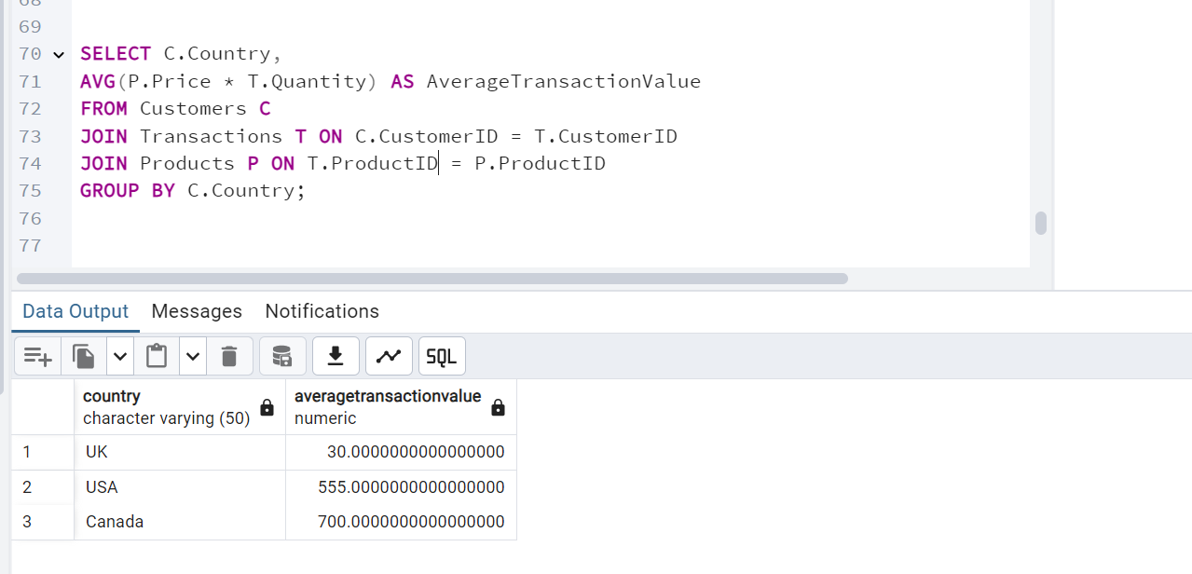

5. Which product category is most popular in terms of quantity sold?

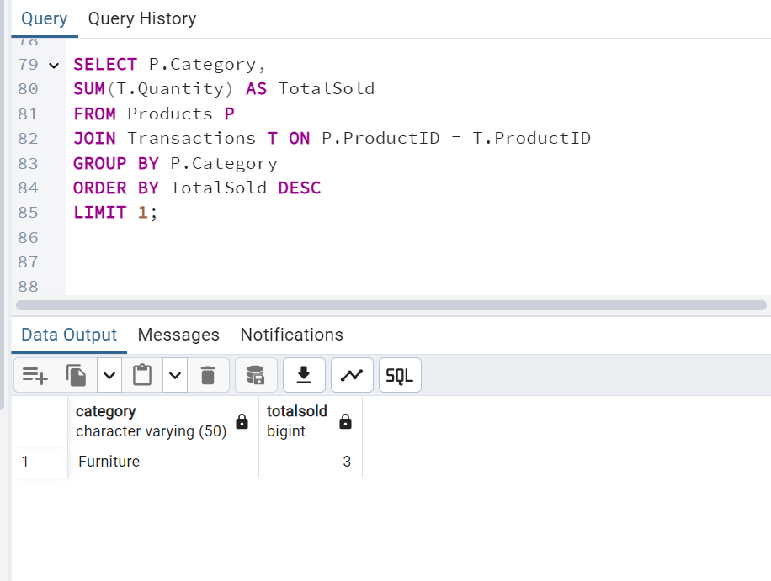

6. Identify customers who have spent more than $1000 in total.

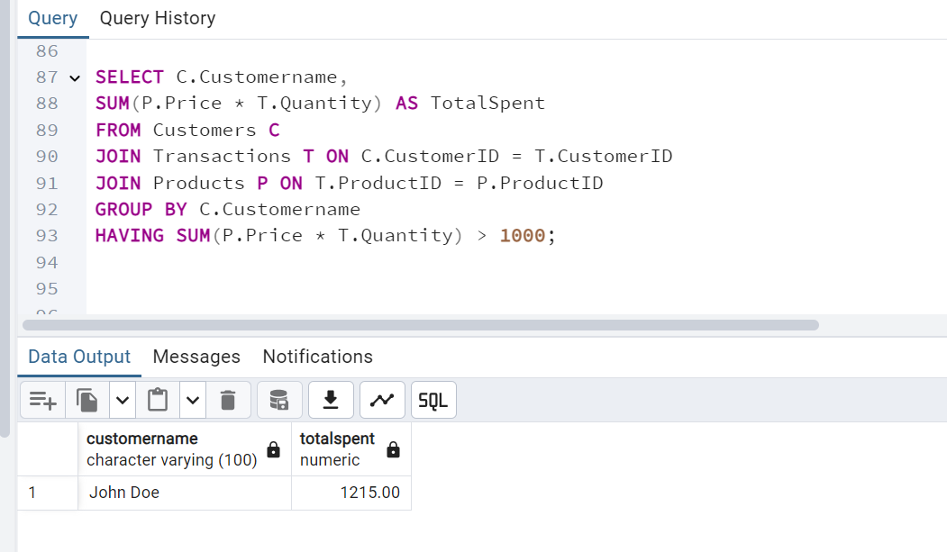

7. How many transactions involved purchasing more than one item?

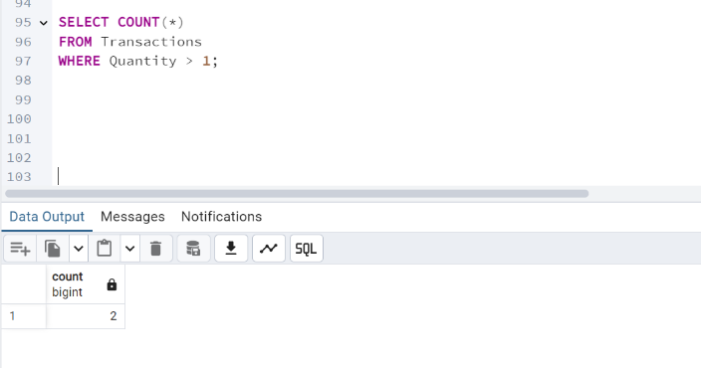

8. What is the difference in total sales between 'Electronics' and 'Furniture' categories?

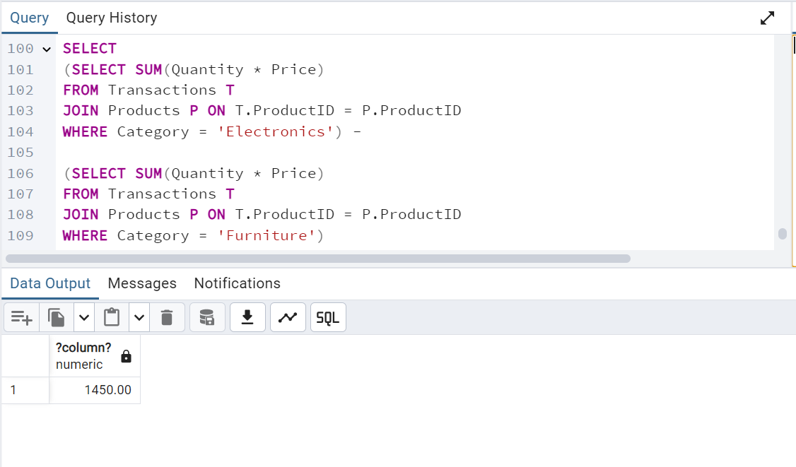

9. Which country has the highest average spending per transaction?

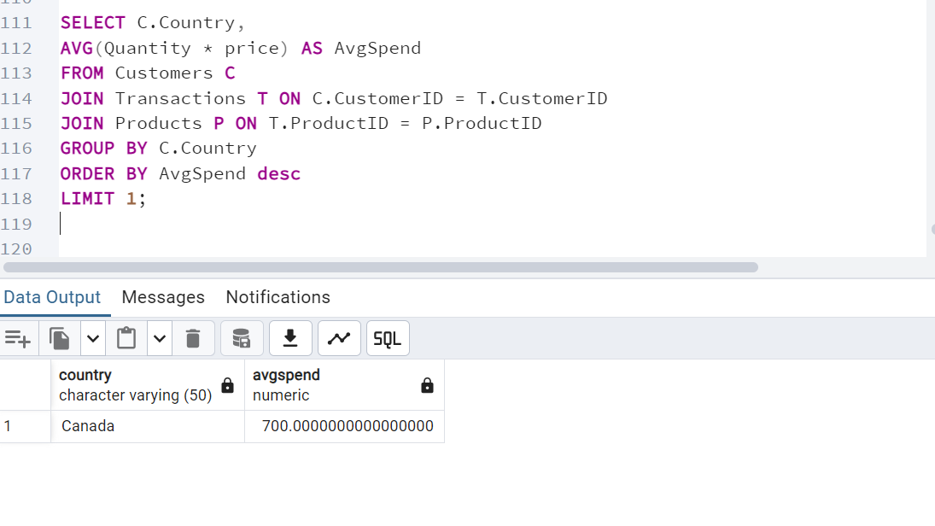

10. For each product, calculate the total revenue and categorize its sales volume as 'High' (more than $500), 'Medium' ($100-$500), or 'Low' (less than $100)

