Author: Anshu Ukey  
Affiliation: Data Analytics Portfolio Project  
Email: anshu.ukey@gmail.com | Location: Bhopal, India  
Date: 12August 2025|Version: v1.0

**Google FY2024 Greenhouse Gas Emissions.**

Operational vs Scope 3 Analysis and Dashboard

Abstract:  
This report analyses Google’s FY2024 greenhouse gas emissions, focusing on Operational totals (Scope 1 + Scope 2, market‑based) and Scope 3 value‑chain categories. A Power BI dashboard summarizes trends from 2019–2024, highlights latest‑year KPIs, and ranks top contributors using SQL‑based analysis. Results show Scope 3 as the dominant driver, while operations demonstrate decoupling via efficiency and cleaner electricity. Recommendations prioritize supplier clean‑electricity programs and low‑carbon construction materials.

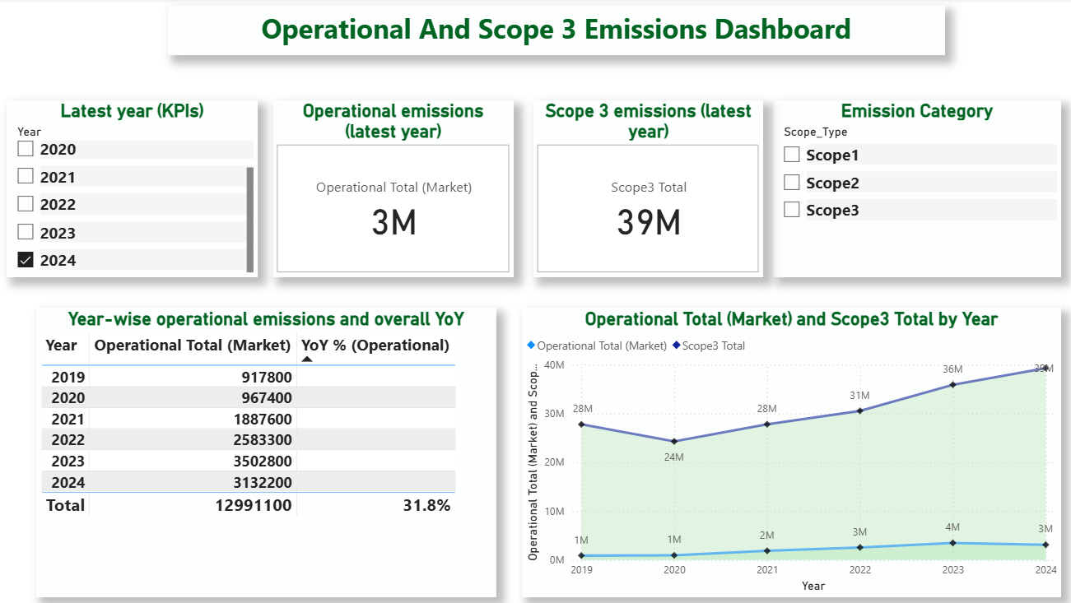

Contents

Introduction 3

Dataset 3

Executive summary 3

Background 3

Scope and Ambition 3

Methods 4

Dashboard Overview 4

Results 6

Insights 6

Recommendations 6

Conclusion 6

Limitations 6

Reproducibility 7

Appendices 7

Appendix B: SQL 7

B1. Top3_contributors.sql — Combine scopes and categories; compute 2024 percent‑of‑total and ranks 7

B2. YoY_growth_scope3.sql — Year-over-year growth rate and rank for Scope 3 categories (2024 vs 2023) 9

B3. Top5_contributors_emission_scope3.sql — Top 5 Scope 3 categories with totals. 9

B4. Scope1_vs_Scope2.sql — Operational composition and ranks 10

# Introduction

This report presents an analysis of Google's operational and Scope 3 emissions. The objective of this project is to evaluate year-over-year changes, highlight key trends, and provide insights into operational and Scope 3 emissions data for better sustainability tracking.

# Dataset

The dataset includes year-wise operational and Scope 3 emission figures from 2019 to 2024. The key categories of emissions considered are Scope 1, Scope 2 (location-based and market-based), and Scope 3 emissions. The data was analyzed and visualized using Excel and Power BI.

# Executive summary

* FY2024 operational emissions ≈ 3.13 MtCO2e (Scope 1 + Scope 2, market‑based), down year over year.
* FY2024 Scope 3 ≈ 39 MtCO2e, with increases from capital goods and construction activity.
* 2019–2024 trend: Scope 3 ~28M→~39M; Operational peaks ~4M (2023) and ~3M (2024).
* Priorities: supplier clean electricity, low‑carbon materials, and continued efficiency.

Background

* Objective: Present FY2024 emissions with 2019–2024 context for portfolio documentation and insights.
* Definitions: Operational = Scope 1 + Scope 2 (market‑based); Scope 3 = sum of relevant value‑chain categories per inventory boundary.
* Data notes: Metrics mirror published disclosures; values are structured and visualized without recalculation.

# Scope and Ambition

* Scope: This analysis covers Operational emissions (Scope 1 + Scope 2, market‑based) and relevant Scope 3 categories as disclosed in the latest inventory; Scope 2 is tracked using the market‑based method for comparability.
* Ambition: Near‑term ambition is consistent with science‑based target thresholds (e.g., ≥42% reduction for Scopes 1+2 by 2030 from a recent base year, and measurable Scope 3 reduction pathways where Scope 3 exceeds 40% of total).
* Focus areas: Prioritize Scope 3 hotspots (capital goods, construction) and maintain operational decarbonization via clean electricity and efficiency to align with 1.5°C pathways.

Methods

* Data preparation: Tables emissions_yearly and emissions_scope3 analyzed with SQL for ranking, %‑of‑total, and YoY.
* Visualization: Power BI produced KPI cards and a 2019–2024-line chart; images exported as PNG.
* Assumptions: Latest‑year values follow published inventory and category boundaries.

Dashboard Overview

The dashboard provides an interactive view of emissions data. It includes KPIs for the latest year, year-over-year percentage changes, and a time-series visualization of both operational and Scope 3 emissions.



Figure1. Dashboard overview: “FY2024 KPIs; Operational ≈ 3M, Scope 3 ≈ 39M.”

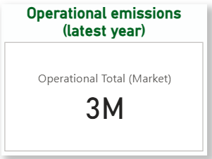

 Figure2. Operational (Scope 1 + Scope 2, market‑based) ≈ 3.13 MtCO2e; YoY down versus 2023.

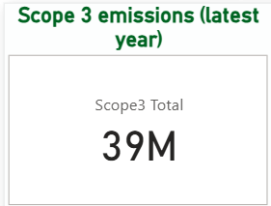

Figure3. Scope 3 total ≈ 39M tCO2e (FY2024); higher year over year, driven by capital goods and construction‑related activity

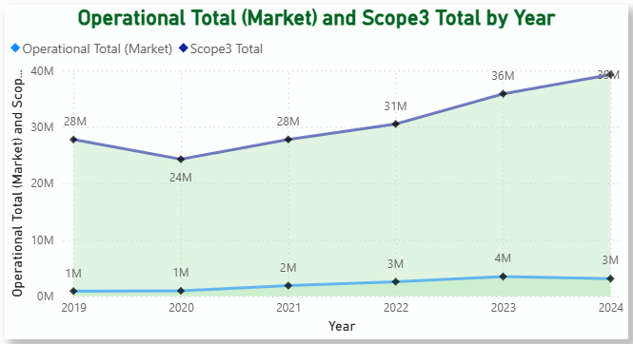

Figure4. Operational vs Scope 3 emissions trend (2019–2024): Scope 3 rises from ~28M to ~39M, while Operational increases to ~4M in 2023 and eases to ~3M in 2024*.*

Results

* FY2024 totals: Operational ≈ 3.13 MtCO2e; Scope 3 ≈ 12.05 MtCO2e; operational down YoY, Scope 3 up YoY.
* Multi‑year: Scope 3 accelerates post‑2021; operational stays an order of magnitude lower with improvement in 2024.
* Contribution: 2024 emissions concentrate in a small set of Scope 3 categories, guiding prioritization.

Insights

* Decoupling operations: Lower operational emissions despite higher electricity demand.
* Scope 3 concentration: Capital goods and construction drive increases; target supplier programs.
* Regional signal: Vary procurement by location based on carbon‑free energy and hourly matching.

Recommendations

* Supplier clean electricity: Standardize clean‑energy commitments with high‑impact suppliers.
* Low‑carbon materials: Specify low‑carbon concrete and steel in new builds.
* Operations: Maintain low PUE and carbon‑intelligent computing to sustain declines.

# Conclusion

This dashboard provides a consolidated view of Google's operational and Scope 3 emissions. It highlights the growing impact of Scope 3 emissions and the need for stronger sustainability measures. The insights gained can guide data-driven strategies for emission reduction.

Limitations

* Source dependency: Values mirror published inventory and boundaries; some categories aggregated.
* No primary recalculation: Analysis structures and visualizes reported data; no independent accounting.

# Reproducibility

* Artifacts: PBIX, PNG images, SQL scripts, and this document.
* Workflow: Run SQL → export CSV → refresh visuals → export images → assemble Word → Save as PDF.
* Repo layout: /docs, /images, /sql, /pbix, /data.

Appendices  
Appendix A: Images  
A1: Year-over-year Operational table

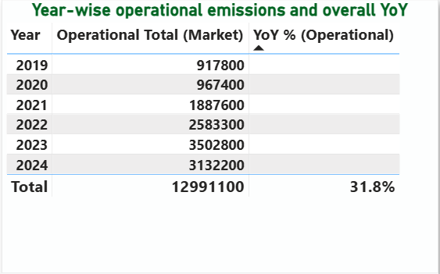  
A1. Year-over-year Operational emissions: 2019–2024 values with annual % change.

**The prior rise into 2023 reflects load growth; the 2024 decline narrows operational impact even as Scope 3 remains the dominant driver.**

## Appendix B: SQL

## B1. Top3_contributors.sql — Combine scopes and categories; compute 2024 percent‑of‑total and ranks

WITH combined_emissions AS (

-- Scope 1 and Scope 2 (market-based)

SELECT

`Greenhouse gas emissions inventory` AS Category,

`2019`, `2020`, `2021`, `2022`, `2023`, `2024`

FROM google_env_ghg.emissions_yearly

WHERE `Greenhouse gas emissions inventory` IN ('Scope 1', 'Scope 2 (market-based)')

UNION ALL

-- Scope 3 categories (exclude totals)

SELECT

`Scope 3 Emissions` AS Category,

`2019`, `2020`, `2021`, `2022`, `2023`, `2024`

FROM google_env_ghg.emissions_scope3

WHERE `Scope 3 Emissions` NOT LIKE '%total%'

),

total_2024 AS (

-- Calculate combined total for % contribution

SELECT SUM(`2024`) AS total_2024

FROM combined_emissions

)

SELECT

c.Category,

c.`2019`, c.`2020`, c.`2021`, c.`2022`, c.`2023`, c.`2024`,

ROUND(c.`2024` / t.total_2024 * 100, 2) AS Percent_of_total_2024,

ROW_NUMBER() OVER (ORDER BY c.`2024` DESC) AS Ranks

FROM combined_emissions c

CROSS JOIN total_2024 t

ORDER BY c.`2024` DESC;

OutputB1. Ranked table with 2024 percent‑of‑total for all scopes and categories.

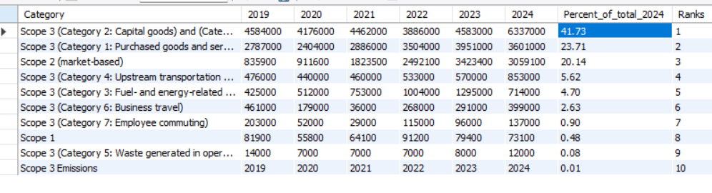

## B2. YoY_growth_scope3.sql — Year-over-year growth rate and rank for Scope 3 categories (2024 vs 2023)

WITH yoy_analysis AS (

SELECT

`Scope 3 Emissions` AS Category,

`2023`,

`2024`,

RANK() OVER (ORDER BY `2024` DESC) AS Emissions_Rank,

ROUND(((`2024` - `2023`) / `2023`) * 100, 2) AS YoY_Growth_Rate

FROM google_env_ghg.emissions_scope3

WHERE `Scope 3 Emissions` LIKE 'Scope 3 (Category%'

)

SELECT

Category,

`2024` AS Current_Emissions_2024,

Emissions_Rank,

YoY_Growth_Rate,

CASE

WHEN YoY_Growth_Rate < -10 THEN 'Significant Improvement'

WHEN YoY_Growth_Rate < 0 THEN 'Improving'

WHEN YoY_Growth_Rate < 10 THEN 'Stable'

ELSE 'Needs Attention'

END AS Performance_Status

FROM yoy_analysis

ORDER BY Current_Emissions_2024 DESC;

OutputB2. Table of Scope 3 categories with 2024 rank and YoY_Growth_Rate

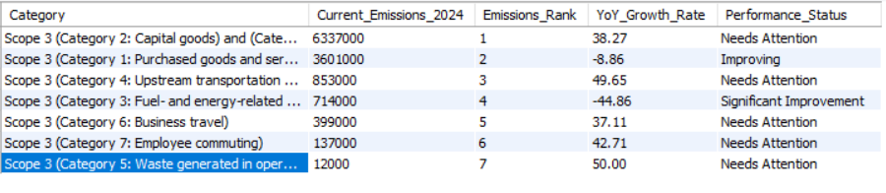

## B3. Top5_contributors_emission_scope3.sql — Top 5 Scope 3 categories with totals.

(

SELECT

`Scope 3 Emissions` AS Category,

`2019`, `2020`, `2021`, `2022`, `2023`, `2024`,

ROW_NUMBER() OVER (ORDER BY `2024` DESC) AS Ranks

FROM google_env_ghg.emissions_scope3

WHERE `Scope 3 Emissions` LIKE 'Scope 3 (Category%'

ORDER BY `2024` DESC

LIMIT 5

)

UNION ALL

(

SELECT

`Scope 3 Emissions` AS Category,

`2019`, `2020`, `2021`, `2022`, `2023`, `2024`,

'' AS Ranks -- Empty for totals

FROM google_env_ghg.emissions_scope3

WHERE `Scope 3 Emissions` LIKE 'Scope 3 (total)%'

OR `Scope 3 Emissions` LIKE 'Total emissions%'

);

OutputB3. Table of Top5_contributors_emission_scope3.sql — Top 5 Scope 3 categories by 2024 emissions with total row.

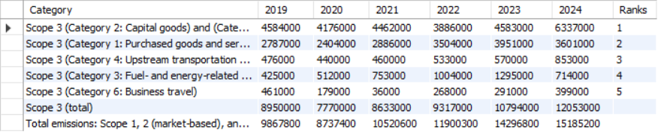

## B4. Scope1_vs_Scope2.sql — Operational composition and ranks

SELECT

`Greenhouse gas emissions inventory` AS Category,

`2019`, `2020`, `2021`, `2022`, `2023`, `2024`,

ROW_NUMBER() OVER (ORDER BY `2024` DESC) AS Ranks

FROM google_env_ghg.emissions_yearly

WHERE `Greenhouse gas emissions inventory` IN ('Scope 1', 'Scope 2 (market-based)')

ORDER BY `2024` DESC;

OutputB4. Table of Scope 1 vs Scope 2 by year with ranks