Week – 2

**Exercise 1: Control Structures**

**Scenario 1:** The bank wants to apply a discount to loan interest rates for customers above 60 years old.

* + **Question:** Write a PL/SQL block that loops through all customers, checks their age, and if they are above 60, apply a 1% discount to their current loan interest rates.

BEGIN

FOR rec IN (

SELECT c.CustomerID, l.LoanID, l.InterestRate

FROM Customers c

JOIN Loans l ON c.CustomerID = l.CustomerID

WHERE MONTHS_BETWEEN(SYSDATE, c.DOB) / 12 > 60

) LOOP

UPDATE Loans

SET InterestRate = InterestRate - 1

WHERE LoanID = rec.LoanID;

END LOOP;

COMMIT;

END;

/

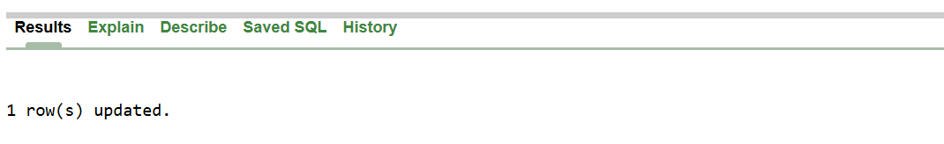

**Scenario 2:** A customer can be promoted to VIP status based on their balance.

* + **Question:** Write a PL/SQL block that iterates through all customers and sets a flag IsVIP to TRUE for those with a balance over $10,000.

ALTER TABLE Customers ADD IsVIP CHAR(1);

BEGIN

FOR rec IN (

SELECT CustomerID, Balance

FROM Customers

WHERE Balance > 10000

) LOOP

UPDATE Customers

SET IsVIP = 'Y'

WHERE CustomerID = rec.CustomerID;

END LOOP;

COMMIT;

END;

/



**Scenario 3:** The bank wants to send reminders to customers whose loans are due within the next 30 days.

* + **Question:** Write a PL/SQL block that fetches all loans due in the next 30 days and prints a reminder message for each customer.

BEGIN

FOR rec IN (

SELECT l.LoanID, l.EndDate, c.Name, c.CustomerID

FROM Loans l

JOIN Customers c ON l.CustomerID = c.CustomerID

WHERE l.EndDate BETWEEN SYSDATE AND SYSDATE + 30

) LOOP

DBMS_OUTPUT.PUT_LINE('Reminder: Loan ID ' || rec.LoanID ||

' for Customer ' || rec.Name ||

' (ID: ' || rec.CustomerID ||

') is due on ' || TO_CHAR(rec.EndDate, 'DD-MON-YYYY'));

END LOOP;

END;

/



**Exercise 3: Stored Procedures**

**Scenario 1:** The bank needs to process monthly interest for all savings accounts.

* + **Question:** Write a stored procedure **ProcessMonthlyInterest** that calculates and updates the balance of all savings accounts by applying an interest rate of 1% to the current balance.

CREATE OR REPLACE PROCEDURE ProcessMonthlyInterest AS

BEGIN

UPDATE Accounts

SET Balance = Balance * 1.01

WHERE AccountType = 'Savings';

COMMIT;

END;

/

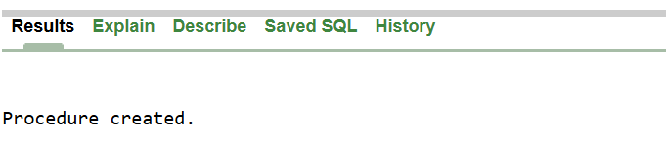

**Scenario 2:** The bank wants to implement a bonus scheme for employees based on their performance.

* + **Question:** Write a stored procedure **UpdateEmployeeBonus** that updates the salary of employees in a given department by adding a bonus percentage passed as a parameter.

CREATE OR REPLACE PROCEDURE UpdateEmployeeBonus (

p_department IN VARCHAR2,

p_bonus_pct IN NUMBER -- e.g., pass 10 for 10%

) AS

BEGIN

UPDATE Employees

SET Salary = Salary + (Salary * p_bonus_pct / 100)

WHERE Department = p_department;

COMMIT;

END;

/



Scenario 3: Customers should be able to transfer funds between their accounts. o Question: Write a stored procedure TransferFunds that transfers a specified amount from one account to another, checking that the source account has sufficient balance before making the transfer.

CREATE OR REPLACE PROCEDURE TransferFunds (

p_from_account IN NUMBER,

p_to_account IN NUMBER,

p_amount IN NUMBER

) AS

v_balance NUMBER;

BEGIN

-- Get balance of source account

SELECT Balance INTO v_balance

FROM Accounts

WHERE AccountID = p_from_account

FOR UPDATE;

IF v_balance < p_amount THEN

RAISE_APPLICATION_ERROR(-20001, 'Insufficient funds in source account.');

END IF;

-- Deduct from source

UPDATE Accounts

SET Balance = Balance - p_amount,

LastModified = SYSDATE

WHERE AccountID = p_from_account;

-- Add to destination

UPDATE Accounts

SET Balance = Balance + p_amount,

LastModified = SYSDATE

WHERE AccountID = p_to_account;

COMMIT;

END;

/

