Week – 6 – RaectJS-HOL

1 - In this hands-on lab, you will learn how to:

* Set up a react environment
* Use create-react-app

function App(){

  return (

    <h1>first react app</h1>

  );

}

export default App;

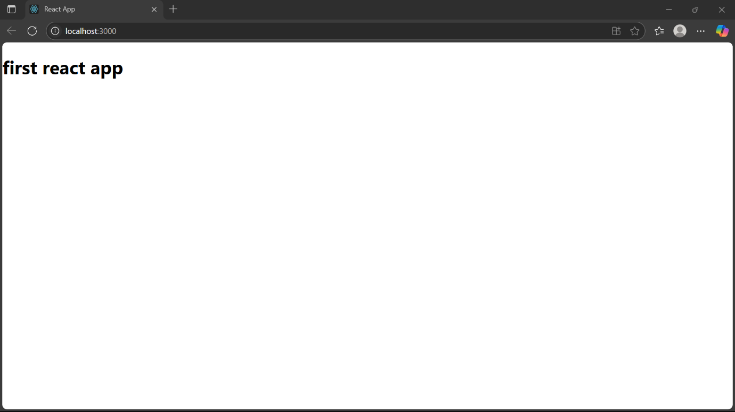

2 - In this hands-on lab, you will learn how to:

* Create a class component
* Create multiple components
* Render a component

import './App.css';

import Home from './Components/Home';

import About from './Components/About';

App.js -

import Contact from './Components/Contact';

function App() {

return (

<div className="container">

<Home />

<About />

<Contact />

</div>

);

}

export default App; 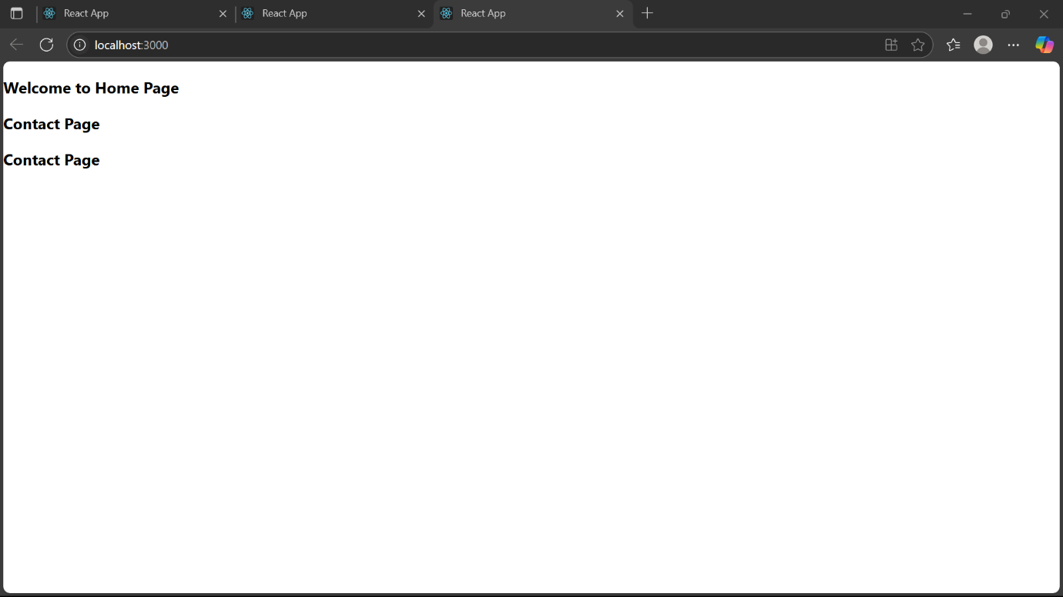

3 - In this hands-on lab, you will learn how to:

* Create a function component
* Apply style to components
* Render a component

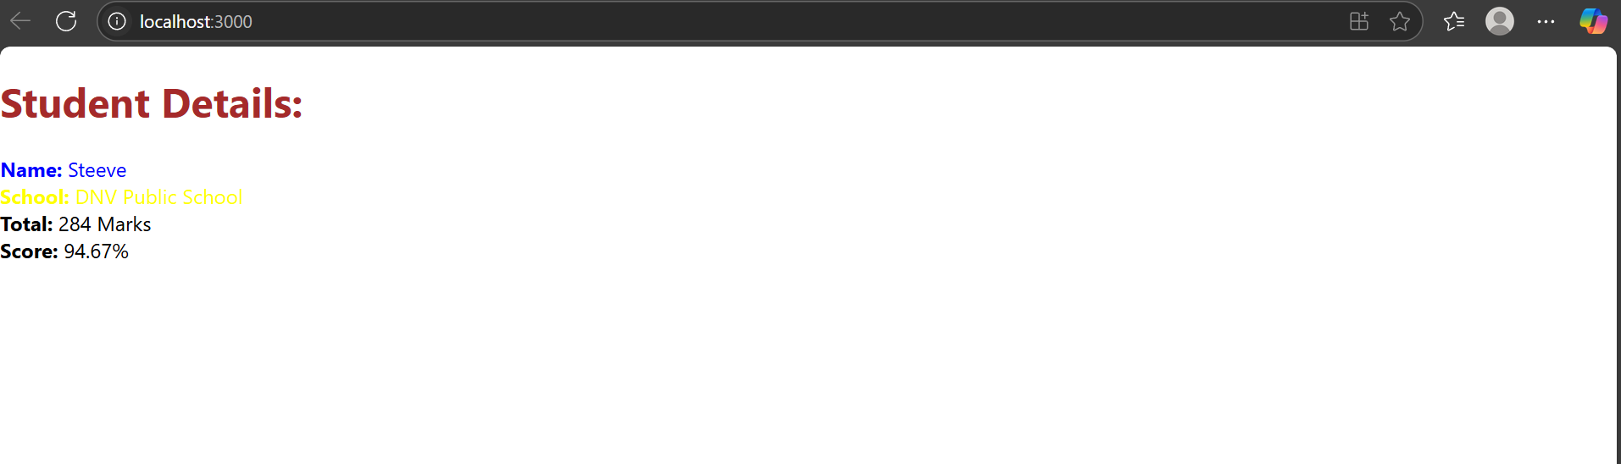

App.js –

import  CalculateScore  from './Components/Calculatescore'; // ✅ correct import path

function App() {

  return (

    <div>

      <CalculateScore

        Name="Steeve"

        School="DNV Public School"

        total={284}

        goal={300}

      />

    </div>

  );

}

export default App;

4-

In this hands-on lab, you will learn how to:

* Implement componentDidMount() hook
* Implementing componentDidCatch() life cycle hook.

Post.js –

class Posts extends React.Component {

constructor (props) {

}

loadPosts() {

}

componentDidMount() {

}

render() {

componentDidCatch(error, info) {

} }

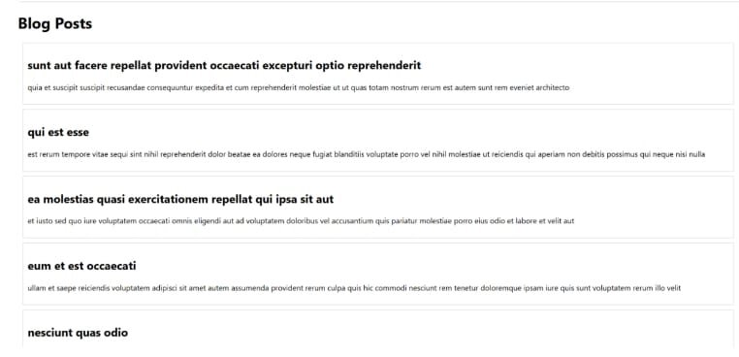

5 –

In this hands-on lab, you will learn how to:

* Style a react component
* Define styles using the CSS Module
* Apply styles to components using className and style properties

