Week - 7

ReactJs HandsOnLearning

Create a React Application named “officespacerentalapp” which uses React JSX to create elements, attributes and renders DOM to display the page.

Create an element to display the heading of the page.

Attribute to display the image of the office space

Create an object of office to display the details like Name, Rent and Address.

Create a list of Object and loop through the office space item to display more data.

To apply Css, Display the color of the Rent in Red if it’s below 60000 and in Green if it’s above 60000.

import React from "react";

App.js

function App() {

const singleOffice = {

name: "Premium Office Space",

rent: 55000,

address: "123, Business Park, Mumbai"

};

const officeList = [

{ name: "Eco Workspace", rent: 45000, address: "Delhi" },

{ name: "Startup Hub", rent: 75000, address: "Bangalore" },

{ name: "Luxury Suite", rent: 90000, address: "Hyderabad" },

{ name: "Budget Office", rent: 30000, address: "Chennai" }

];

const getRentStyle = (rent) => {

return {

color: rent < 60000 ? "red" : "green",

fontWeight: "bold"

};

};

return (

<div style={{ padding: "20px", fontFamily: "Arial" }}>

<h1> Office Space Rental Portal</h1>

<img

src="https://images.unsplash.com/photo-1581091012184-7e0cdfbb6795"

alt="Office Space"

style={{ width: "400px", height: "250px", borderRadius: "10px" }}

/>

<h2>Featured Office</h2>

<p><strong>Name:</strong> {singleOffice.name}</p>

<p><strong>Rent:</strong> <span style={getRentStyle(singleOffice.rent)}>{singleOffice.rent}</span></p>

<p><strong>Address:</strong> {singleOffice.address}</p>

<h2>Available Offices</h2>

<ul>

{officeList.map((office, index) => (

<li key={index} style={{ marginBottom: "10px" }}>

<p><strong>Name:</strong> {office.name}</p>

<p>

<strong>Rent:</strong>{" "}

<span style={getRentStyle(office.rent)}>{office.rent}</span>

</p>

<p><strong>Address:</strong> {office.address}</p>

</li>

))}

</ul>

</div>

);

}

export default App;

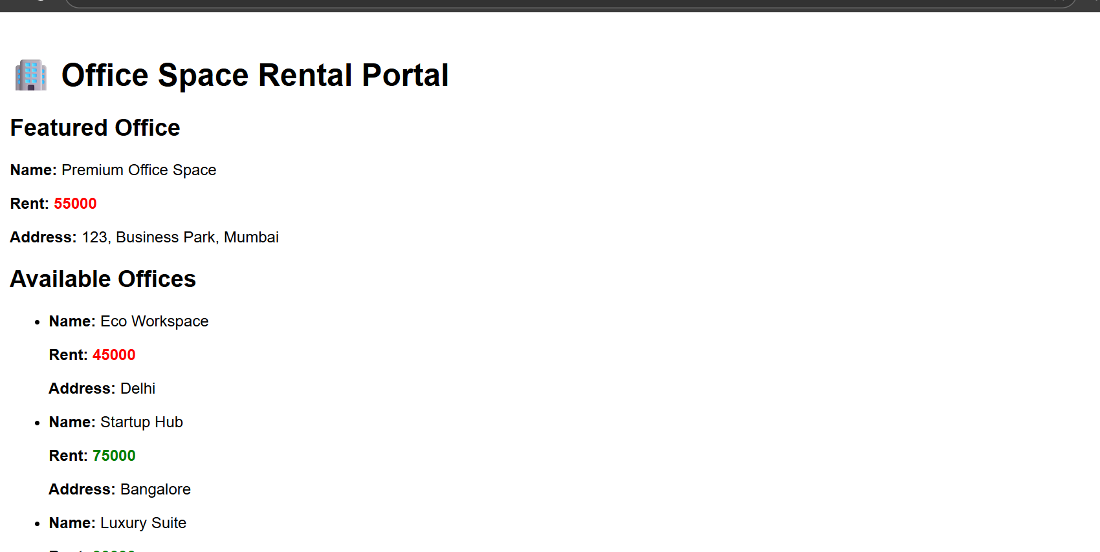

2-Create a React Application “eventexamplesapp” to handle various events of the form elements in HTML.

App.js

import React, { useState } from "react";

import CurrencyConverter from "./CurrencyConverter";

function App() {

const [count, setCount] = useState(0);

// a. Increment function

const increment = () => {

setCount(count + 1);

};

const sayHello = () => {

console.log("Hello! You clicked the Increment button.");

};

const handleIncrementClick = () => {

increment();

sayHello();

};

const decrement = () => {

setCount(count - 1);

};

const sayWelcome = (msg) => {

alert(`Message: ${msg}`);

};

const handleClick = (e) => {

console.log("Synthetic Event: I was clicked");

alert("I was clicked");

};

return (

<div style={{ padding: "20px" }}>

<h1>🎯 Event Handling Examples</h1>

<h2>Counter: {count}</h2>

<button onClick={handleIncrementClick}>Increment</button>

<button onClick={decrement}>Decrement</button>

<div style={{ marginTop: "20px" }}>

<button onClick={() => sayWelcome("Welcome to React Event Handling!")}>

Say Welcome

</button>

</div>

{/\* Synthetic Event \*/}

<div style={{ marginTop: "20px" }}>

<button onClick={handleClick}>Synthetic Event: OnPress</button>

</div>

{/\* Currency Converter \*/}

<div style={{ marginTop: "30px" }}>

<CurrencyConverter />

</div>

</div>

);

}

export default App;

Currencyconverter.js

import React, { useState } from "react";

function CurrencyConverter() {

const [rupees, setRupees] = useState("");

const [euros, setEuros] = useState("");

const handleSubmit = (e) => {

e.preventDefault();

const euroValue = parseFloat(rupees) / 90;

setEuros(euroValue.toFixed(2));

};

return (

<div>

<h2> Currency Converter</h2>

<form onSubmit={handleSubmit}>

<label>

Indian Rupees:

<input

type="number"

value={rupees}

onChange={(e) => setRupees(e.target.value)}

required

/>

</label>

<button type="submit" style={{ marginLeft: "10px" }}>

Convert

</button>

</form>

{euros && (

<p style={{ marginTop: "10px" }}>

<strong>Converted Euros:</strong> €{euros}

</p>

)}

</div>

);

}

export default CurrencyConverter;

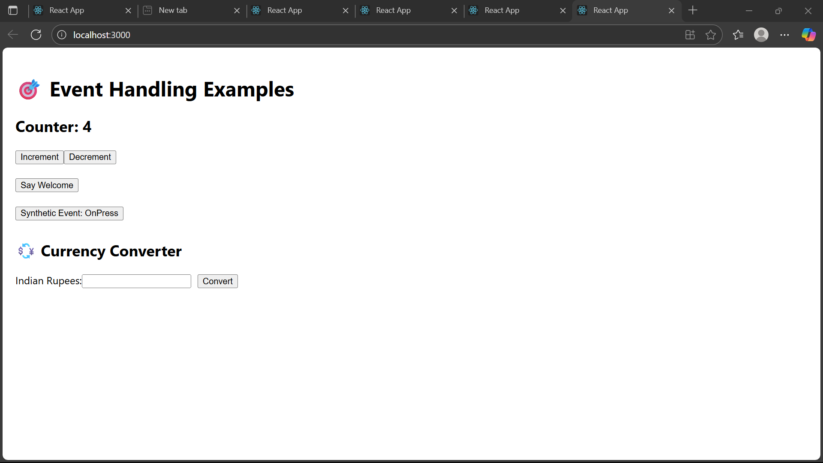

3 -

Create a React Application named “ticketbookingapp” where the guest user can browse the page where the flight details are displayed whereas the logged in user only can book tickets.

The Login and Logout buttons should accordingly display different pages. Once the user is logged in the User page should be displayed. When the user clicks on Logout, the Guest page should be displayed.

App.js

import React, { useState } from "react";

import GuestPage from "./components/GuestPage";

import UserPage from "./components/UserPage";

function App() {

const [isLoggedIn, setIsLoggedIn] = useState(false);

const handleLogin = () => {

setIsLoggedIn(true);

};

const handleLogout = () => {

setIsLoggedIn(false);

};

return (

<div style={{ padding: "20px", fontFamily: "Arial" }}>

<h1>✈️ Ticket Booking App</h1>

<div style={{ marginBottom: "20px" }}>

{isLoggedIn ? (

<button onClick={handleLogout}>Logout</button>

) : (

<button onClick={handleLogin}>Login</button>

)}

</div>

{isLoggedIn ? <UserPage /> : <GuestPage />}

</div>

);

}

export default App;

User.js

import React from "react";

const UserPage = () => {

const flightData = [

{ flightNo: "AI101", destination: "New York", time: "10:30 AM" },

{ flightNo: "AI202", destination: "London", time: "2:45 PM" },

{ flightNo: "AI303", destination: "Dubai", time: "6:00 PM" }

];

const handleBook = (flightNo) => {

alert(`Ticket booked successfully for flight ${flightNo}`);

};

return (

<div>

<h2>Welcome Back, User! 👋</h2>

<h3>Book Your Flight</h3>

<ul>

{flightData.map((flight, index) => (

<li key={index}>

Flight: {flight.flightNo} | Destination: {flight.destination} | Time: {flight.time}{" "}

<button onClick={() => handleBook(flight.flightNo)}>Book Ticket</button>

</li>

))}

</ul>

</div>

);

};

export default UserPage;

4 –

Create a React App named “bloggerapp” in with 3 components.

1. Book Details
2. Blog Details
3. Course Details

Implement this with as many ways possible of Conditional Rendering.

import React, { useState } from "react";

import BookDetails from "./components/BookDetails";

import BlogDetails from "./components/BlogDetails";

import CourseDetails from "./components/CourseDetails";

function App() {

const [view, setView] = useState("book");

const renderComponent = () => {

if (view === "book") {

return <BookDetails />;

} else if (view === "blog") {

return <BlogDetails />;

} else if (view === "course") {

return <CourseDetails />;

} else {

return <p>Please select a view.</p>;

}

};

return (

<div style={{ padding: "20px" }}>

<h1>BloggerApp</h1>

<div style={{ marginBottom: "20px" }}>

<button onClick={() => setView("book")}>Book Details</button>

<button onClick={() => setView("blog")}>Blog Details</button>

<button onClick={() => setView("course")}>Course Details</button>

<button onClick={() => setView("none")}>Clear</button>

</div>

{renderComponent()}

<div style={{ marginTop: "30px" }}>

<h2> Ternary Rendering Example</h2>

{view === "blog" ? (

<p>You are viewing the <strong>Blog</strong>.</p>

) : (

<p>You are not viewing the blog.</p>

)}

</div>

{/\* 3. Logical AND Rendering \*/}

<div style={{ marginTop: "20px" }}>

<h2>✅ Logical AND Rendering Example</h2>

{view === "course" && <p>This is a premium course for professionals.</p>}

</div>

</div>

);

}

export default App;

Bookdetails.js

import React from "react";

const BookDetails = () => {

const books = [

{ title: "Master React", price: 670 },

{ title: "Deep Dive into Angular 11", price: 800 },

{ title: "Mongo Essentials", price: 450 },

];

return (

<div className="section">

<h2>Book Details</h2>

{books.map((book, i) => (

<div key={i}>

<strong>{book.title}</strong>

<p>{book.price}</p>

</div>

))}

</div>

);

};

export default BookDetails;

CourseDetails.js

import React from "react";

const CourseDetails = () => {

const courses = [

{ name: "Angular", date: "4/5/2021" },

{ name: "React", date: "6/3/20201" },

];

return (

<div className="section">

<h2>Course Details</h2>

{courses.map((course, i) => (

<div key={i}>

<strong>{course.name}</strong>

<p>{course.date}</p>

</div>

))}

</div>

);

};

export default CourseDetails;

Blog.js

import React from "react";

const BlogDetails = () => {

const blogs = [

{

title: "React Learning",

author: "Stephen Biz",

content: "Welcome to learning React!",

},

{

title: "Installation",

author: "Schewzdenier",

content: "You can install React from npm.",

},

];

return (

<div className="section">

<h2>Blog Details</h2>

{blogs.map((blog, i) => (

<div key={i}>

<strong>{blog.title}</strong>

<p><em>{blog.author}</em></p>

<p>{blog.content}</p>

</div>

))}

</div>

);

};

export default BlogDetails;