LAB-11
Dushyant Singh Raghav
500120590
Devops B-3
Prerequisites: Terraform Installed: Make sure you have Terraform installed on your machine. Follow the official installation guide if needed.
Exercise Steps:
Step 1: Create a New Directory:
Create a new directory for your Terraform configuration:
“Terraform-Demo”
Step 2: Create Terraform Configuration File (main.tf):
Create a file named main.tf with the following content:
Step 2: Create Terraform Configuration File (main.tf):
Create a file named main.tf with the following content:

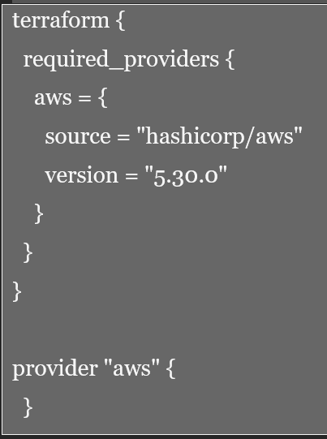
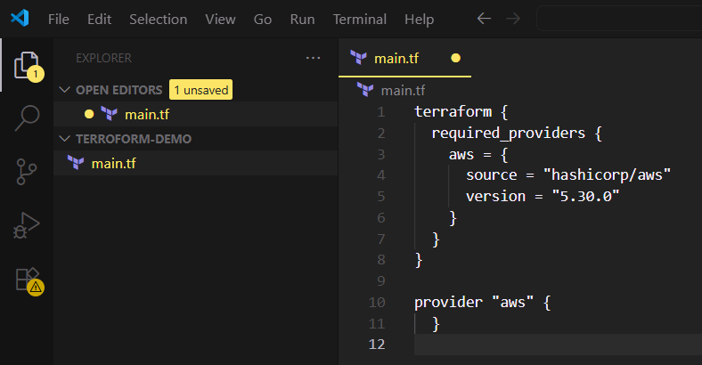
Step 3: Initialize Terraform:
Run the following command to initialize your Terraform working directory:
