LAB-14
Dushyant Singh Raghav
500120590
Devops - B3
Exercise Steps:
Step 1: Create a New Directory:
Create a new directory to store your Terraform configuration:
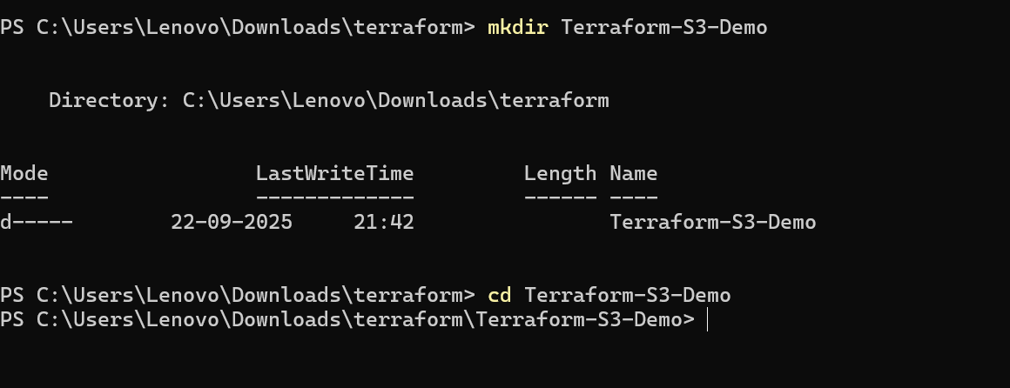
Step 2: Create the Terraform Configuration File (main.tf):
Create a file named main.tf with the following content:
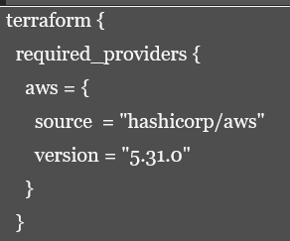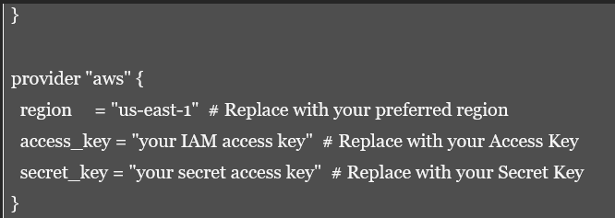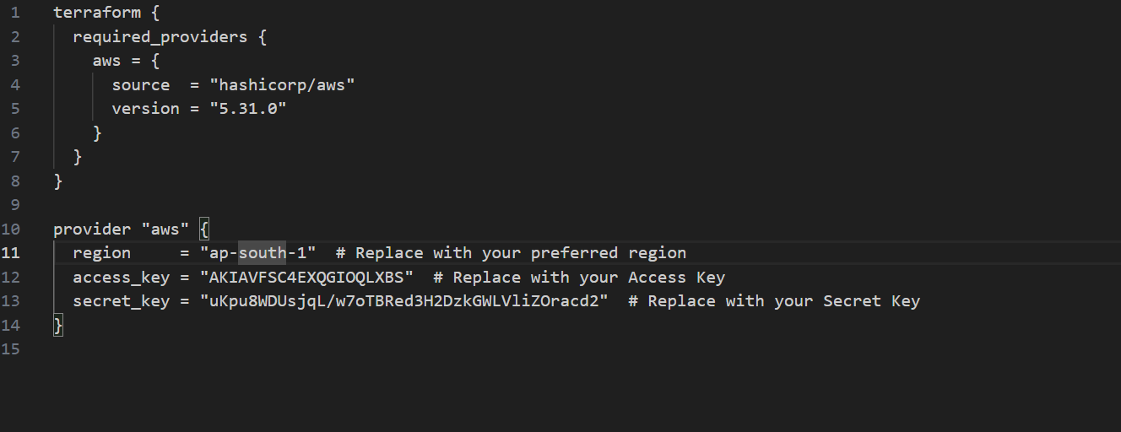
This file sets up the Terraform AWS provider.

Step 3: Create a Terraform Configuration File for the S3 Bucket (s3.tf):
Create another file named s3.tf with the following content:
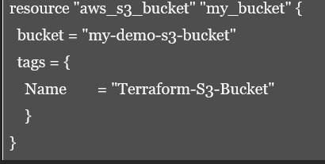
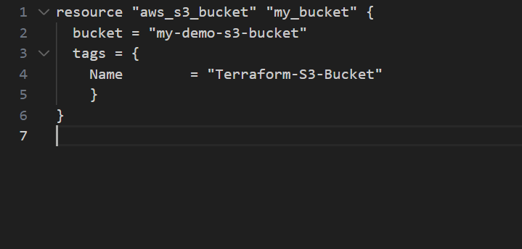
This file provisions an S3 bucket with a unique name using a random string suffix.

Step 4: Initialize Terraform:
Run the following command to initialize your Terraform working directory:
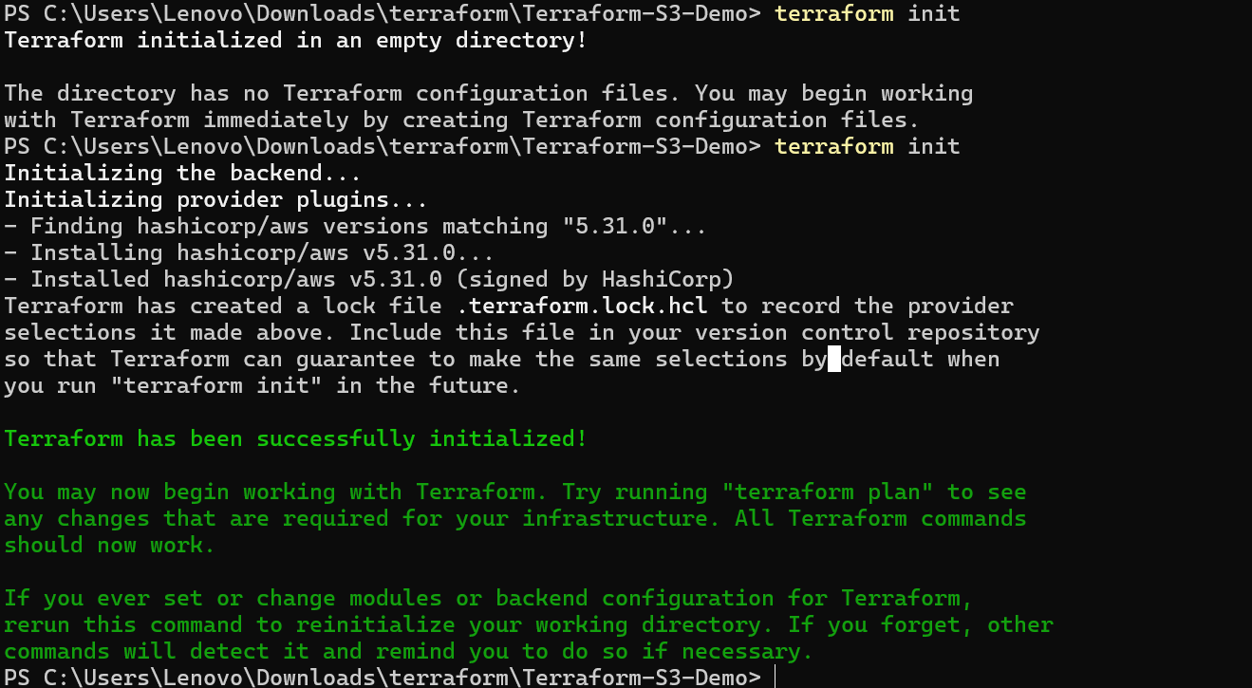
Step 5: Review the Plan:
Preview the changes Terraform will make:
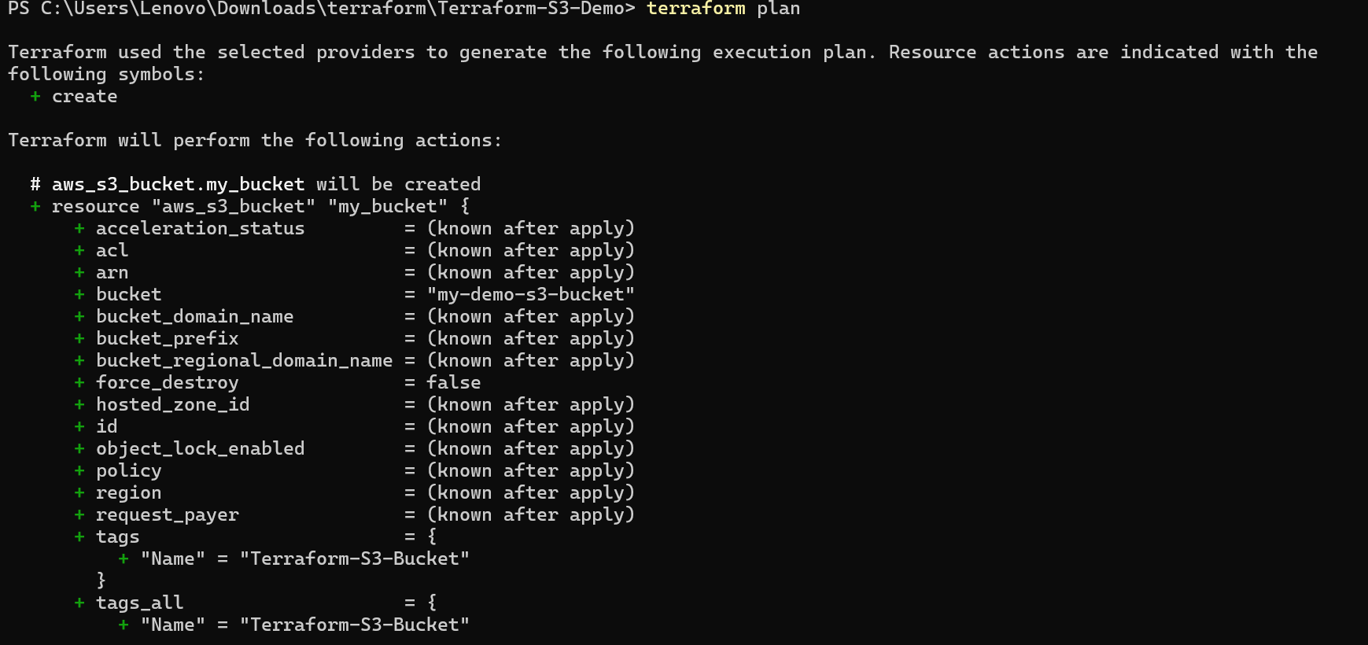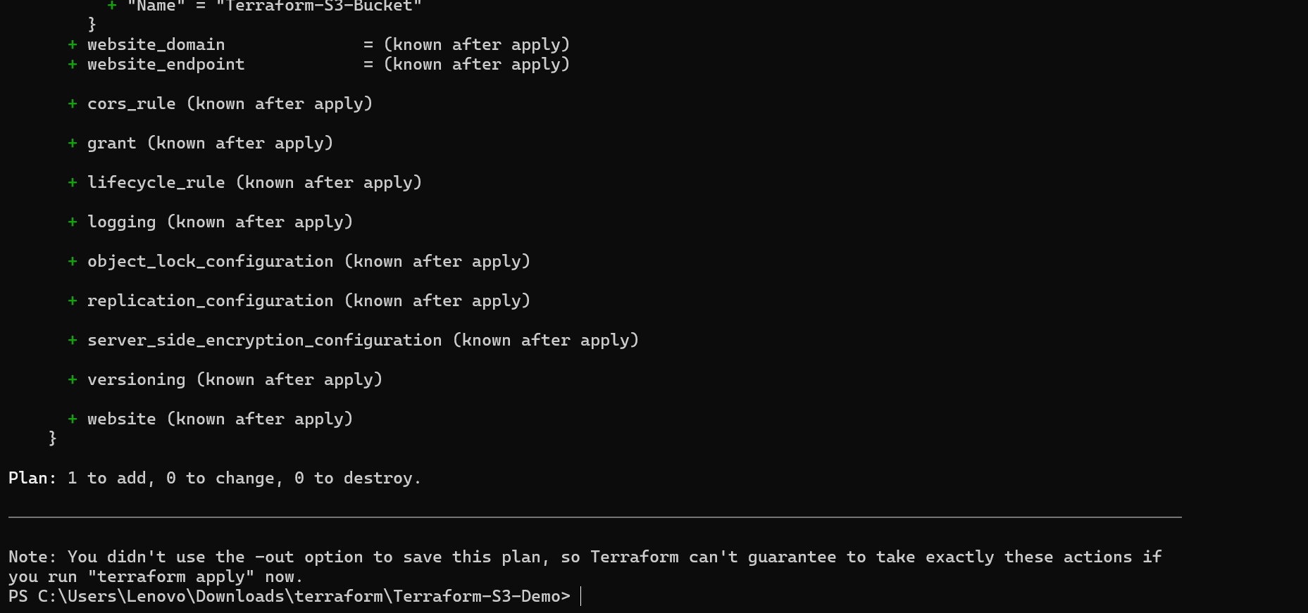
Review the output to ensure it meets your expectations.

Step 6: Apply the Changes:
Create the resources:
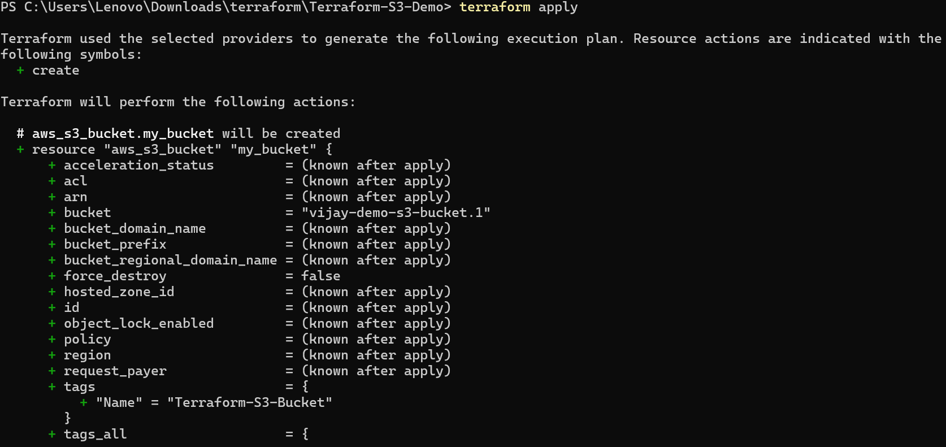
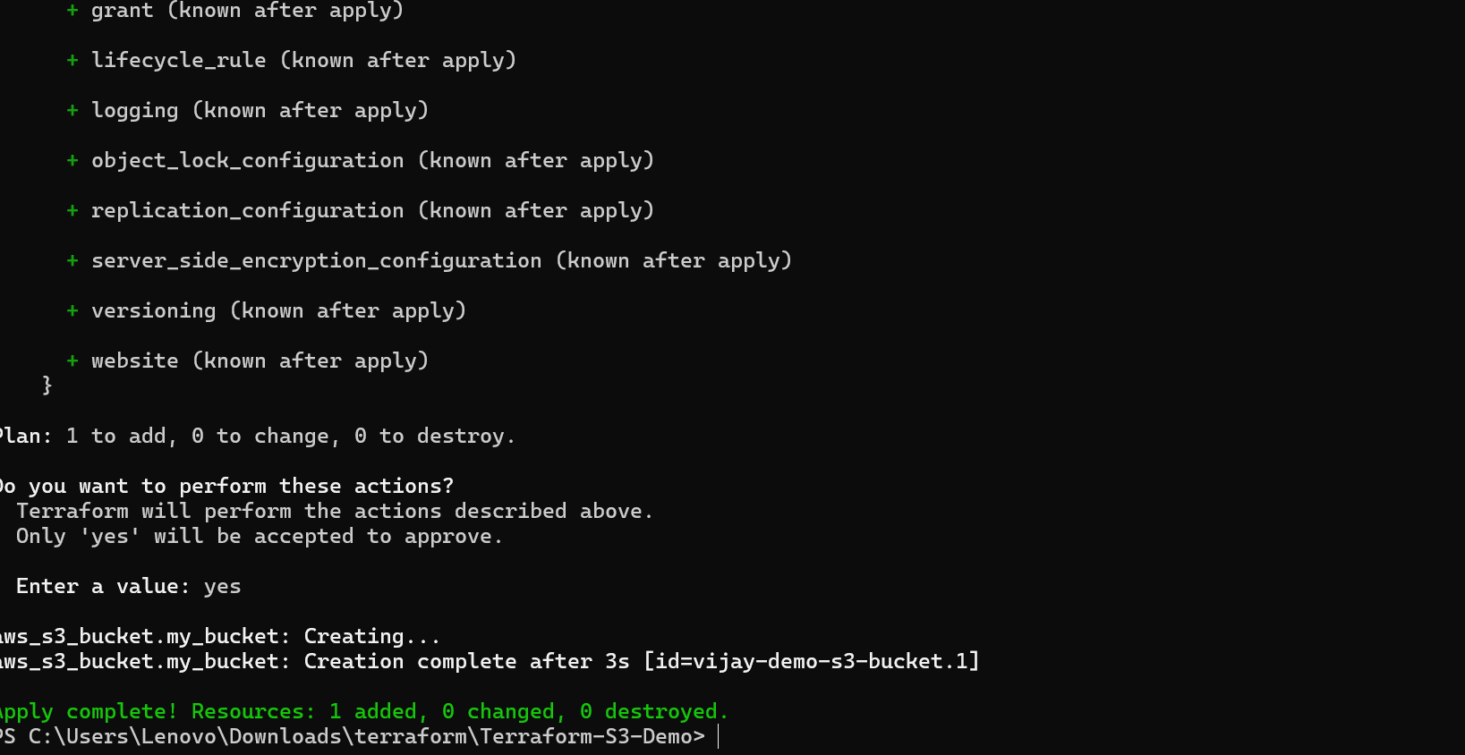
When prompted, type yes to confirm.

Step 7: Verify Resources:
- Log in to your AWS Management Console.
- Navigate to the S3 dashboard.
- Verify that the S3 bucket has been created with the specified configuration.

Step 8: Cleanup Resources:
To remove the resources created, run the following command:
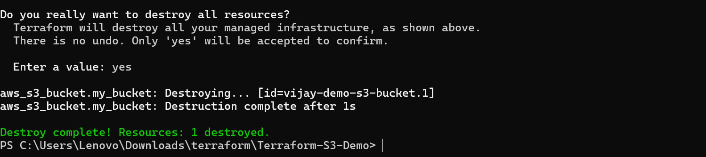
When prompted, type yes to confirm.

