LAB-18
Dushyant Singh Raghav
500120590
Devops B3
Objective
- Learn how to scan Infrastructure as Code (IaC) templates for security vulnerabilities.
- Use open-source IaC security tools to detect misconfigurations.
- Understand common risks such as public access, unencrypted resources, and insecure network rules.

Prerequisites
- A Linux/Windows/Mac machine with:
  - Terraform installed (for sample IaC)
  - Checkov (pip install checkov) or tfsec (brew install tfsec or binary download)
- Git installed (optional, for version control of IaC templates)

Step 1: Create an Insecure IaC Template
Create a file named main.tf with the following Terraform code:
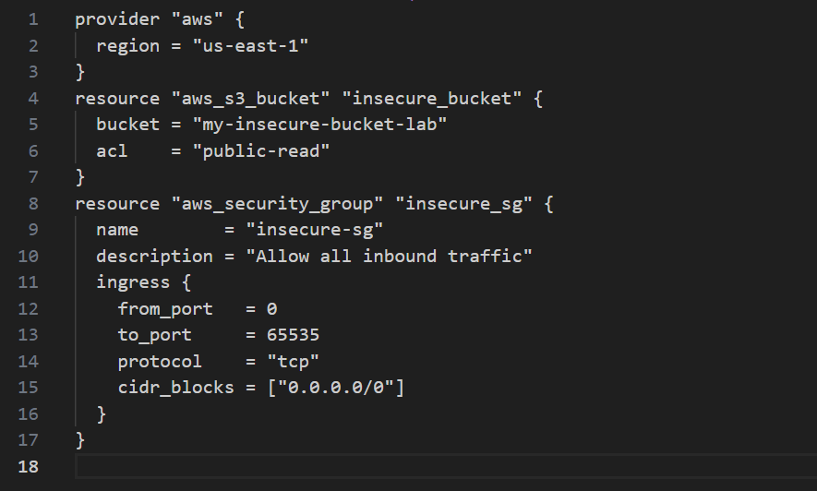
Step 2: Scan the Template with Checkov
Run Checkov on the current directory:
- Public S3 bucket access (public-read)
- Security group open to all inbound traffic

Expected Findings:
- Warns about S3 bucket without encryption
- Flags open Security Group rules

Step 4: Review the Report
Example output (Checkov):
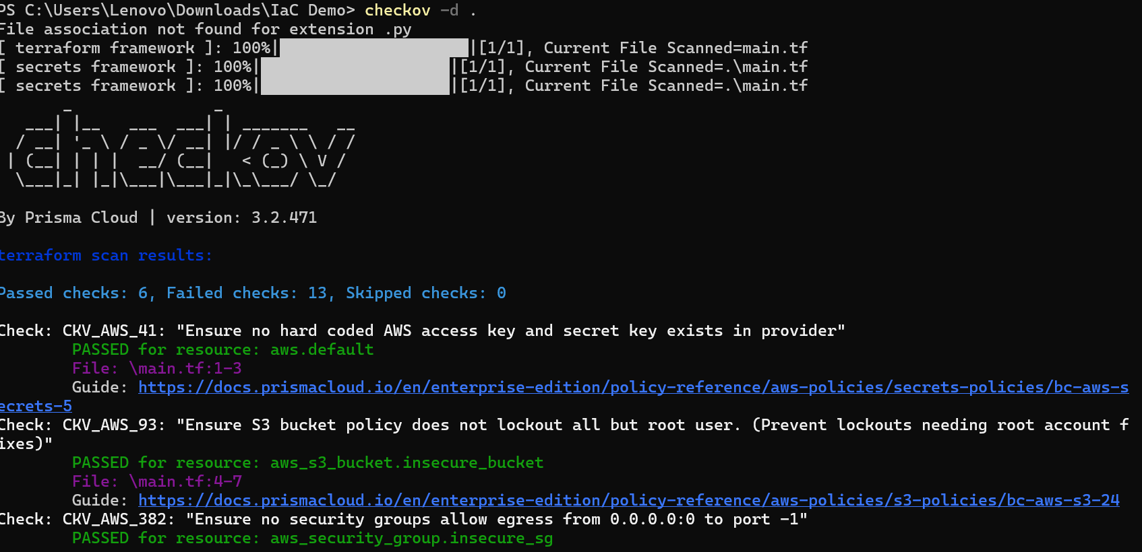
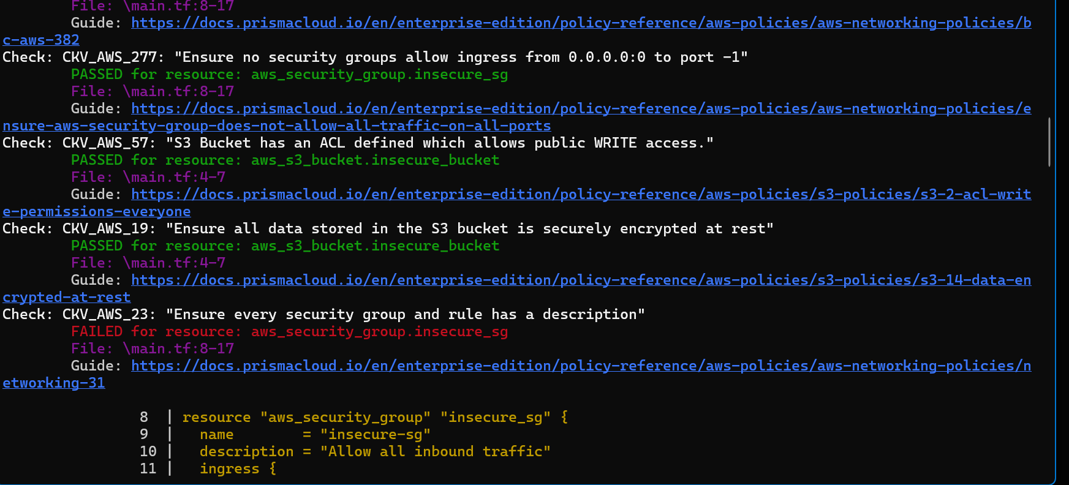
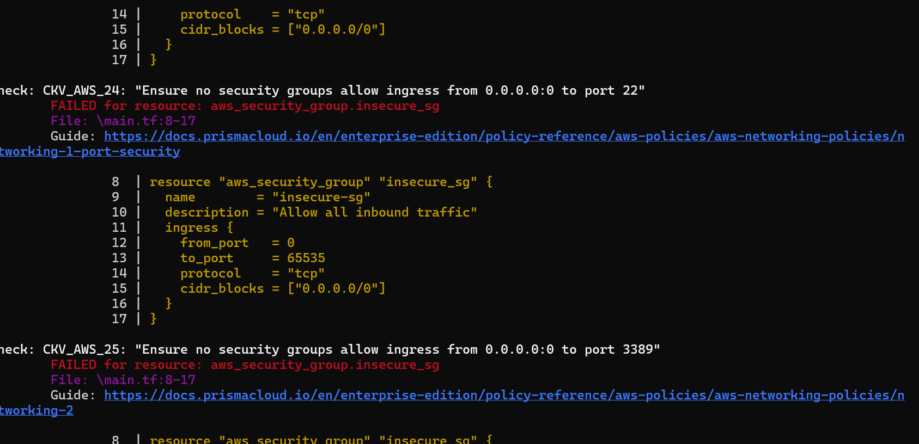
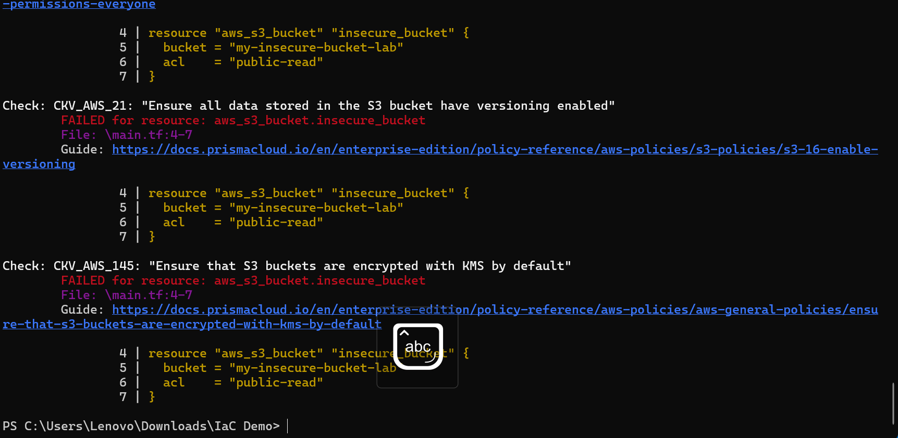
Step 5: Apply Fixes (Optional)
Modify the IaC template to:
- Set S3 bucket ACL to private
- Enable encryption (AES256)
- Restrict Security Group to specific IP ranges

Step 6: Rescan the Template
Run the scan again:
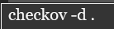
Now the findings should be resolved or reduced.

Step 7: Document Findings
Create a simple findings log:

