LAB-20
Dushyant Singh Raghav
500120590
Devops B3
Creating a Pipeline Script
Steps to be followed:
- Log in to the Jenkins CI tool and create a pipeline script

Step 1: Log in to the Jenkins Cl tool and create a pipeline script

- Open the browser, go to the Jenkins Dashboard by typing localhost:8080 in your browser, provide the credentials, and click the Sign in button


Click on the New Item option as shown in the screenshot below:
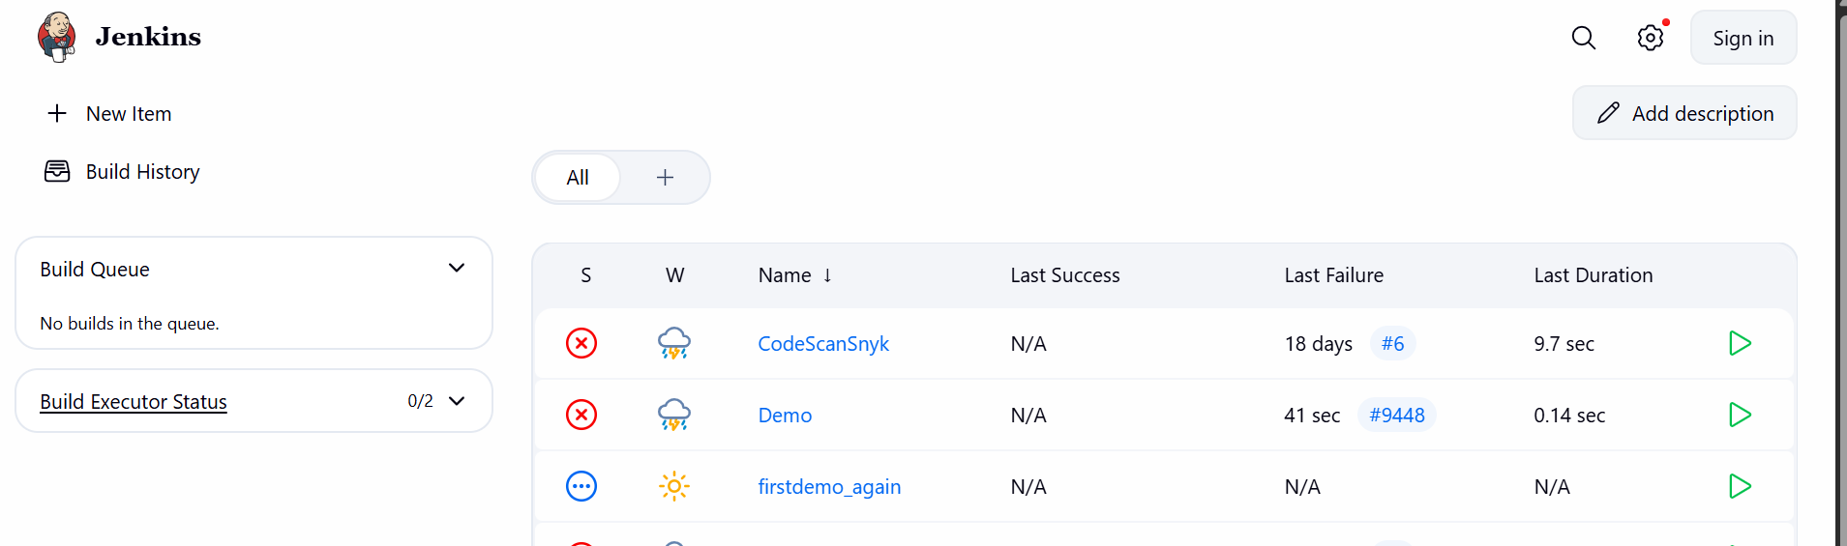
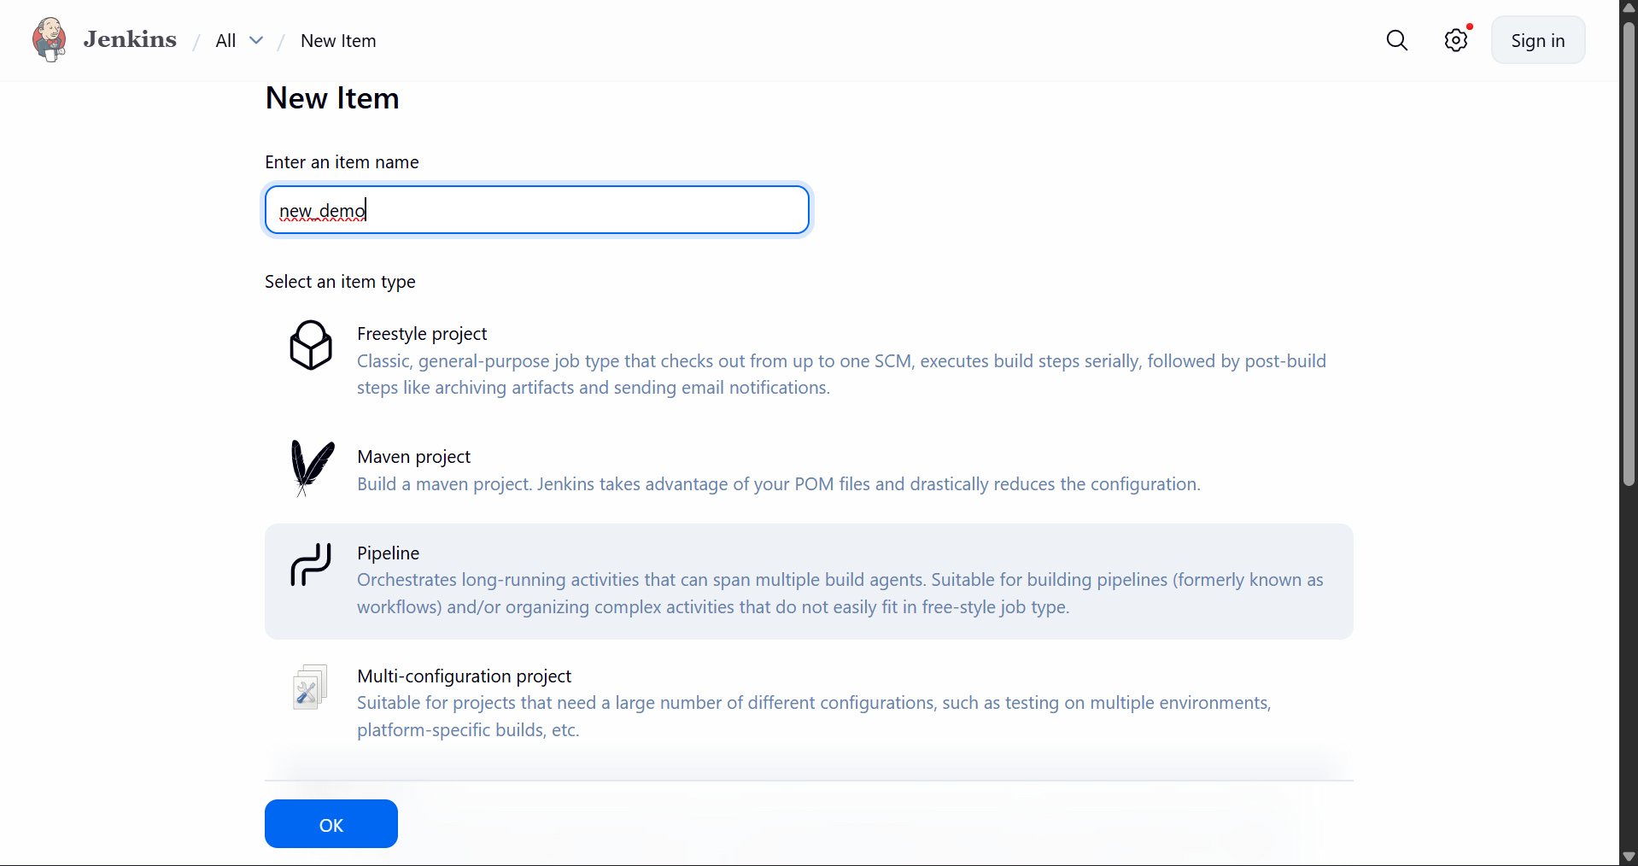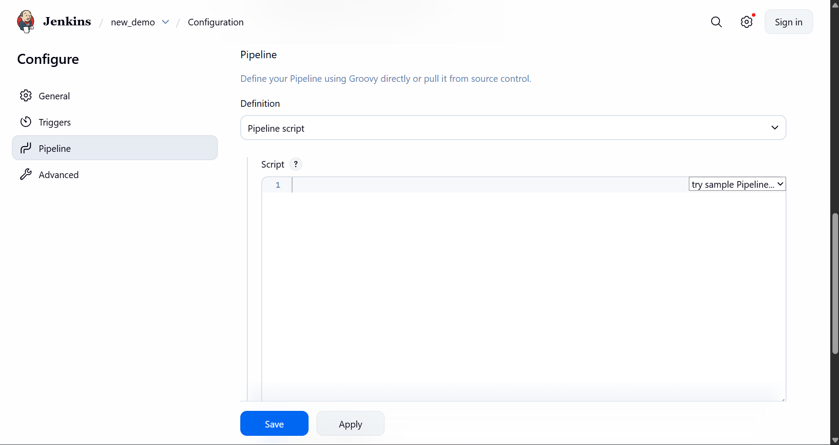
Enter the following pipeline script in the script editor and click on Save as shown in the screenshot below
