AMBALA COLLEGE OF ENGINEERING & APPLIED RESEARCH
(Affiliated to Kurukshetra University, Kurukshetra)
ORQESTRA AI
DESIGN AND DEVELOPMENT OF A DURABLE
MULTI-AGENT WORKFLOW ORCHESTRATOR
A fault-tolerant orchestration framework with workspace controls,
reviewable tools, and reproducible verification
PROJECT REPORT
Submitted in partial fulfillment of the requirements for the award of the degree of
Bachelor of Technology (B.Tech.)
Computer Science and Engineering
(Artificial Intelligence & Machine Learning)

Under the Supervision of
Er. Abhishek Saini
Submitted By
Anshita (2323810)
Department
Computer Science & Engineering (AIML)
Academic Session
2026–2027 | Seventh Semester
Submission Date
November 2026

CERTIFICATE
This is to certify that Anshita (Roll No. 2323810), student of the Department of Computer Science and Engineering (Artificial Intelligence & Machine Learning), Ambala College of Engineering & Applied Research, has completed the project entitled “ORQESTRA AI: Design and Development of a Durable Multi-Agent Workflow Orchestrator” during the seventh semester of the B.Tech. programme, under the supervision of Er. Abhishek Saini.
The report is submitted in partial fulfillment of the requirements for the award of the degree of Bachelor of Technology. The project work and report are presented for academic evaluation. Institutional verification and signatures are to be completed by the designated authorities.

Project Supervisor | Department Coordinator
Er. Abhishek Saini  Signature: ____________________  Date: ________________________ | Er. Gagandeep Kaur  Signature: ____________________  Date: ________________________

DECLARATION OF STUDENT
I hereby declare that this project report entitled “ORQESTRA AI: Design and Development of a Durable Multi-Agent Workflow Orchestrator” presents work undertaken by me as part of the seventh-semester B.Tech. project in Computer Science and Engineering (Artificial Intelligence & Machine Learning) at Ambala College of Engineering & Applied Research, under the supervision of Er. Abhishek Saini.
I have distinguished implemented system behavior from the separate research experiment described in the accompanying draft paper. I have stated the evaluation conditions and limitations alongside the results. This report has not been submitted in its present form for an award at another institution. Where prior work, software, tools, or research are used, they are acknowledged in the references.
I understand that the final declaration, originality review, dates, and signatures must be completed in accordance with the college and university requirements.
Date: ______________________
Place: _____________________
Anshita (2323810)
Signature: __________________________

PREFACE
This report documents the design, implementation, evaluation, and deployment boundaries of ORQESTRA AI, a seventh-semester B.Tech. project. ORQESTRA is a browser-based prototype for submitting typed task graphs, executing them through a separately scheduled worker service, and retaining workflow state and outputs in PostgreSQL. Its central engineering concern is reliable and reviewable execution: the system records task attempts, requeues work after lease expiry, fences stale publications, scopes data to workspaces, and makes sensitive writes wait for human approval.
The report follows the academic structure of the supplied project-report reference. It begins with the problem and requirements, explains the architecture and modules, and then presents implementation evidence, evaluation, security controls, deployment assumptions, limitations, and future work. A separate research study examines worker leases and attempt fencing through a controlled ablation. That study is not generalized into claims about LLM quality or production reliability.
• Chapter 1 introduces ORQESTRA, its motivation, objectives, scope, and project contributions.
• Chapter 2 reviews workflow orchestration, durable execution, leases, fencing, verification, and relevant related work.
• Chapter 3 records functional and non-functional requirements, actors, and system use cases.
• Chapter 4 explains architecture, workflow state, database and API design, trust boundaries, and deployment layout.
• Chapter 5 describes the implemented modules and their interactions.
• Chapter 6 presents verification strategy, project validation evidence, and the separate lease/fencing experiment.
• Chapter 7 covers security, privacy, operations, and the hosted demonstration boundary.
• Chapter 8 discusses results, limitations, and engineering trade-offs.
• Chapter 9 concludes and sets out future work. Appendices provide interface screenshots, configuration examples, and a glossary.

ACKNOWLEDGEMENT
I express my sincere gratitude to Er. Abhishek Saini, Assistant Professor in the CSE (AIML) Department, for supervising this project and providing direction during its development. I thank Er. Gagandeep Kaur and the faculty of Ambala College of Engineering & Applied Research for their academic support and encouragement.
I also thank my family and friends for their patience and support. The project benefited from open-source software, technical documentation, and research communities whose work is cited in this report.
Anshita
(2323810)

ABSTRACT
ORQESTRA AI is a full-stack academic prototype for building, executing, monitoring, and verifying durable task workflows. It addresses a practical problem in agent applications: a plan may be valid at submission but still fail operationally if task dependencies are ambiguous, a worker stops while holding work, a late result overwrites a retry, workspace data is exposed, or an output is presented without evidence of verification. ORQESTRA responds with typed task contracts, directed acyclic graph validation, PostgreSQL persistence, leased worker claims, attempt-scoped result fencing, workspace-scoped access, approval-gated sensitive writes, and a dashboard that exposes workflow progress and artifacts.
The system uses a React and TypeScript frontend, a FastAPI backend, PostgreSQL, and a separate Python polling worker. Three built-in deterministic agents inspect CSV data, summarize numeric fields, and verify results. Optional capabilities include bounded research retrieval, spreadsheet analysis, workspace document memory, reviewed code patch proposals, optional OpenAI-assisted planning, multi-format deliverable synthesis, and a five-tier verification rubric. Optional provider planning and isolated code execution are explicitly disabled or unconfigured in the selected hosted demonstration scope.
Project validation records include 282 backend tests passing with four PostgreSQL-only cases skipped in the SQLite run, 124 selected PostgreSQL CI checks passing, and successful lint, formatting, type checking, and frontend production build as recorded on 2 November 2026. A separate controlled experiment ran 540 trials across three design variants, three failure conditions, two lease lengths, and 30 seeds per condition. With a killed worker, the full design recovered all 30 workflows at each lease length; without expiry-based requeue, none recovered. During a stalled-worker experiment, fencing rejected late publications in all 30 full-design trials, while the no-fencing variant accepted stale results in all 30. These results concern constructed failures and deterministic millisecond agents on one machine. They do not establish live-model quality, real-world failure rates, or production readiness.
The project demonstrates how typed contracts, durable state, human oversight, and explicit verification can be combined in an agent workflow product. Its contribution is an integrated engineering prototype and a bounded measurement of lease and fencing behavior, with limitations visible to users and reviewers.

Keywords
Agent orchestration; durable workflows; task scheduling; PostgreSQL; worker leases; attempt fencing; human-in-the-loop; workspace isolation; verification; fault injection.

TABLE OF CONTENTS
• Certificate
• Declaration of Student
• Preface
• Acknowledgement
• Abstract
• List of Figures and Tables
• Abbreviations
• Chapter 1 Introduction
• Chapter 2 Background and Literature Review
• Chapter 3 Requirement Analysis
• Chapter 4 System Architecture and Design
• Chapter 5 Implementation
• Chapter 6 Verification and Evaluation
• Chapter 7 Security, Privacy and Deployment
• Chapter 8 Results and Discussion
• Chapter 9 Conclusion and Future Scope
• References
• Appendix A Interface Evidence
• Appendix B Configuration and Workflow Examples
• Appendix C Glossary
Page numbers are generated in the footer. The chapter and section headings in this document are also available through Word’s navigation pane.

List of Figures and Tables
• Figure 4.1 ORQESTRA system architecture
• Figure 4.2 Durable task lifecycle
• Figure A.1 Workflow execution dashboard
• Figure A.2 Agent registry
• Figure A.3 Planning and validated task graph
• Table 3.1 Functional requirements
• Table 3.2 Non-functional requirements
• Table 4.1 Principal data entities
• Table 5.1 Implemented modules and boundaries
• Table 6.1 Project validation summary
• Table 6.2 Worker fault-injection outcomes
• Table 6.3 Stall-case completion time

Abbreviations
Term | Meaning
API | Application Programming Interface
CSRF | Cross-Site Request Forgery
DAG | Directed Acyclic Graph
HTTP / HTTPS | Hypertext Transfer Protocol / Secure HTTP
LLM | Large Language Model
RBAC | Role-Based Access Control
SSE | Server-Sent Events
TLS | Transport Layer Security
UI | User Interface
VPS | Virtual Private Server

CHAPTER 1
INTRODUCTION
Reliable orchestration is the engineering layer between an AI request and a useful result. It must validate the plan, preserve the task state, control access to data and tools, and make output quality inspectable even when a process fails.

1.1 Background
AI agent applications are commonly described in terms of models, prompts, and tools. A working product also needs a workflow runtime. A user request can expand into multiple dependent tasks; tasks may run in separate processes; a process can disappear after a claim; two attempts can overlap after a long pause; and outputs may need review before an external write. Without durable state and explicit authority checks, an apparently intelligent application can lose work or publish inconsistent results.
ORQESTRA focuses on this orchestration layer. It treats an execution plan as a typed directed graph rather than free-form instructions. The API validates the graph before execution. PostgreSQL stores workflows, tasks, attempts, events, and artifacts. Worker processes claim ready work through short database transactions and execute outside the transaction. A time-limited lease permits recovery after worker loss; attempt ownership checks prevent a superseded worker from publishing its late result after recovery has created a newer attempt.

1.2 Problem Statement
A prototype agent platform must coordinate independent tasks and tools without assuming that workers are always available, plans are always valid, outputs are always correct, or users belong to a single trust domain. Common failure modes include invalid dependencies, duplicate execution after retry, stale-result publication, unscoped artifacts, unsafe handling of retrieved content, and unreviewed sensitive actions. ORQESTRA studies how a small, reproducible web system can address these conditions with durable orchestration and visible controls.

1.3 Objectives
• Represent workflow requests with typed, versioned task contracts and reject invalid graphs before dispatch.
• Persist workflow state, task attempts, leases, events, approvals, documents, and artifacts in PostgreSQL.
• Recover unfinished pure tasks after a worker process exits or its lease expires.
• Fence result publication to the current task attempt and lease owner.
• Provide authenticated workspace access with role checks, CSRF protection, and scoped artifacts.
• Make sensitive write actions reviewable and bind approval to a canonical argument fingerprint.
• Offer deterministic data-processing agents and explicit optional AI integration rather than requiring a live model for the core demonstration.
• Present outputs, workflow events, verification findings, and known limitations through a browser dashboard.
• Measure selected reliability mechanisms under controlled fault injection and report limitations.

1.4 Scope
The completed prototype includes workflow submission and monitoring; a PostgreSQL-backed task runtime; deterministic CSV inspection, summarization, and verification; optional planning; workspace-level authentication and role controls; bounded data and research tools; document retrieval; reviewed code patch proposals; approval gating; deliverable synthesis; and verification. The project includes local Compose configuration and a single-VPS staging profile. The selected hosted demonstration keeps live LLM planning and sandbox execution outside the active release scope.
The system is an academic prototype, not an autonomous coding service or a production financial, legal, or operational decision system. It does not provide unrestricted shell access, a general web browser, or an open-ended search tool to agents. Its current built-in workflow catalog is intentionally small and deterministic.

1.5 Contribution
The engineering contribution is an integrated demonstration of typed planning, durable scheduling, attempt ownership, workspace boundaries, human review, and output verification in one service. The research contribution is a mechanism-level ablation of lease expiry and attempt fencing in the running worker loop. The research draft measures recovery and publication behavior under injected crash and stall conditions; it does not propose a new distributed systems mechanism.

1.6 Organization of the Report
Chapters 2 and 3 establish the technical background and requirements. Chapters 4 and 5 explain the architecture and implementation. Chapter 6 describes validation and the research experiment. Chapter 7 presents security and deployment. Chapters 8 and 9 interpret the results, limitations, and future development.

CHAPTER 2
BACKGROUND AND LITERATURE REVIEW

2.1 Workflow Orchestration
A workflow engine coordinates a collection of tasks, their dependencies, and their state transitions. A directed acyclic graph (DAG) is a useful representation when tasks can depend on earlier results but cannot depend cyclically on future work. Explicit dependency edges enable the runtime to determine which tasks are ready, which must wait, and which should be skipped after an upstream failure. Typed request and result contracts make this structure machine-checkable and improve the ability to reject malformed plans before execution.
Durable workflow systems typically persist progress so that a service restart does not erase completed work. Some systems use event histories and deterministic replay, while other designs use database-backed queues and task attempts. ORQESTRA uses a custom Python DAG runtime backed by PostgreSQL task, attempt, and event records. This is an explicit architecture choice; the implementation does not use LangGraph or its PostgreSQL checkpointer.

2.2 Leases and Fencing
A lease gives a worker temporary ownership of a task. If a worker stops and the lease expires, another worker can reclaim the task. A lease bounds the time before recovery, but a pause can be temporary: the original worker may resume after its lease has expired. If that worker can still write, its late output can conflict with the retry. Fencing ties publication authority to the current attempt or ownership token so that an older attempt cannot update the accepted task result after a newer attempt exists [1, 2].
Lease expiry and fencing solve related but distinct problems. Expiry enables re-assignment; fencing rejects publication by a superseded attempt. Neither necessarily prevents the original computation from continuing. If a task performs an external side effect, such as sending a message, database fencing cannot undo the side effect; the external service needs idempotency or its own deduplication policy. ORQESTRA’s attempt key includes the attempt number and distinguishes attempts, but it is not a stable task-level key for suppressing cross-attempt side effects.

2.3 Human-in-the-Loop Systems
When a tool changes external or durable state, execution authority should be explicit. ORQESTRA pauses sensitive actions for review, records the action and a canonical fingerprint of its arguments, and checks the fingerprint again at execution. This prevents an approved action from being silently changed after review. Role checks distinguish workspace owners and members from viewers. Approval is therefore a runtime state transition with authorization and integrity properties, rather than a simple confirmation message in the interface.

2.4 Retrieval and Untrusted Data
A retrieval system can return useful context, but retrieved text remains data supplied by a source. It must not acquire authority to change tool permissions or override the workflow policy. ORQESTRA labels retrieved page text and document chunks as untrusted content, scopes them to the owning workspace, and stores research provenance. Research access is bounded by operator-configured host allowlists, HTTPS-only fetching, DNS checks, redirect blocking, response limits, and timeouts.

2.5 Verification and Reproducibility
An agent’s own assertion that its answer is correct is not independent evidence. ORQESTRA separates task outputs from a verification rubric that records defects, limitations, and a calibrated outcome. Generated artifacts receive SHA-256 content fingerprints. The deterministic CSV benchmark stores raw fixture hashes and compares results with fixed expected summaries. These controls support repeatability for defined inputs; they do not establish general model quality or user-level effectiveness.

2.6 Related Work
Gray and Cheriton introduced leases for distributed file-cache consistency [1]. Kleppmann describes the stale-client problem in distributed locking and motivates fencing tokens [2]. Durable workflow research such as Beldi and Durable Functions uses logs, replay, and formalized execution semantics [3, 4]. Research on failures in LLM-based multi-agent systems has catalogued behavioral failures and proposed fault injection methods [5, 6]. Stream-processing reliability evaluations provide a systems precedent for controlled failure comparisons [7].
The accompanying research draft describes its gap cautiously: the authors did not locate an identical internal ablation in the sources reviewed, but the search did not cover ACM Digital Library or IEEE Xplore. This is a provisional observation, not a claim that no related study exists. The ORQESTRA study is narrow by design: it measures lease expiry and attempt fencing under constructed failures in a deterministic prototype.

2.7 Summary
The background motivates four design principles used in ORQESTRA: validate workflow structure before running it; persist state at task boundaries; separate task reassignment from result publication authority; and make data provenance, approvals, and verification visible. These principles guide the requirements and architecture in the next chapters.

CHAPTER 3
REQUIREMENT ANALYSIS

3.1 Stakeholders and Actors
Actor | Role in the system | Authority boundary
Workspace owner | Creates and manages a workspace, configures membership, submits work, and reviews sensitive actions. | Can manage membership and make owner-authorized approval decisions.
Workspace member | Uses workflows and tools within an assigned workspace. | Cannot access another workspace; sensitive actions remain gated.
Viewer | Reads permitted workflow and artifact information. | Read-only role; cannot approve or reject writes.
API service | Authenticates, validates requests, applies access checks, and persists state. | Does not execute agent handlers in the request transaction.
Worker process | Claims eligible tasks, runs registered agents, and publishes owned results. | May publish only while its attempt and lease ownership remain current.
External provider | Optional LLM planning or approved research source. | Optional and bounded; provider output is untrusted until validated.

3.2 Functional Requirements
ID | Requirement | Acceptance behavior
FR-01 | Account and session management | Register/login/logout with hashed passwords and server-side session checks.
FR-02 | Workspace membership | Enforce owner/member/viewer permissions and isolate workflow data by workspace.
FR-03 | Typed workflow submission | Validate schemas, agent capability, input bindings, duplicate IDs, missing dependencies, and cycles.
FR-04 | Durable task execution | Persist workflow/task state and attempt records before handler execution.
FR-05 | Lease recovery | Requeue eligible unfinished work after a lease expires or a worker restarts.
FR-06 | Publication fencing | Accept a result only from the current running attempt and recorded owner.
FR-07 | Monitoring and event history | Expose progress, events, task state, metrics, and output through scoped API and dashboard.
FR-08 | Safe data analysis | Bound CSV/XLSX inputs, profile and summarize deterministically, and export formula-safe CSV.
FR-09 | Document memory and research | Store workspace-scoped chunks/provenance and treat retrieved text as untrusted evidence.
FR-10 | Sensitive write review | Pause configured writes; bind decision to a SHA-256 argument fingerprint and enforce role checks.
FR-11 | Deliverable synthesis | Create Markdown, printable HTML, and JSON deliverables with durable content hashes.
FR-12 | Output verification | Assign one of five calibrated verification statuses and disclose limitations.

3.3 Non-Functional Requirements
Category | Requirement | Design response
Reliability | Recover pure tasks at attempt boundaries after worker interruption. | Database-backed task state, expiring leases, startup recovery and result ownership checks.
Security | Prevent cross-workspace access and unauthorized sensitive writes. | Membership checks on reads/writes, session/CSRF/origin controls, approval states.
Integrity | Reject malformed plans and stale results. | Versioned contracts, DAG validation, attempt ownership fencing, artifact hashes.
Reproducibility | Make fixture evaluation repeatable. | Frozen cases, input hashes, seeded trials, structured result records.
Bounded resource use | Constrain file parsing, network retrieval and sandbox execution. | Input caps, timeouts, allowlists, resource-limited isolated sandbox configuration.
Maintainability | Separate API, worker, agents, contracts and UI. | Modular backend packages, versioned schemas, typed frontend and automated checks.
Observability | Expose enough state to explain workflow progress and failures. | Task events, attempt records, status metrics, verification details and dashboard views.

3.4 Use Cases
Use case | Primary flow | Important control
Execute deterministic workflow | User signs in, chooses workspace, submits input, watches three tasks, and inspects verified result. | Schema validation; workspace scope; durable attempt and event state.
Recover interrupted work | Worker claims a task, process stops, lease expires, a later worker reclaims the task and completes. | Current attempt owns publication; completed upstream tasks remain preserved.
Review a sensitive write | Tool proposal pauses; authorized owner reviews fingerprinted arguments; approved action proceeds if unchanged. | Viewer cannot approve; changed arguments fail fingerprint check.
Search document memory | User imports a supported document and retrieves relevant chunks in the same workspace. | Chunk offsets preserved; workspace isolation; retrieved text marked untrusted.
Synthesize a deliverable | User selects workflow outputs, requests a format, and reviews generated artifact and verification report. | Artifact hash, attachment authorization, five-tier rubric.

3.5 Constraints and Assumptions
• The implementation favors deterministic and offline behavior for the core path; live LLM planning requires explicit configuration and opt-in.
• The primary relational database is PostgreSQL; SQLite is used for many local automated tests but cannot replace PostgreSQL-only concurrency acceptance.
• Worker recovery is at-least-once: a task may execute again after lease expiry, so pure agents should be idempotent and side effects require stronger protections.
• The managed host is a demonstration environment. Fresh-host TLS, restore, and operational acceptance remain separate deployment checks.
• The project report reflects repository evidence through 2 November 2026 and a live-site observation on 11 November 2026.

CHAPTER 4
SYSTEM ARCHITECTURE AND DESIGN

4.1 Architectural Overview
ORQESTRA is organized as a browser client, an HTTPS edge, an API service, one or more polling workers, and a shared PostgreSQL database. The React dashboard sends session-authenticated requests to FastAPI. The API validates plans, authorizes workspace access, and persists workflow state. Workers claim eligible tasks through database transactions, then execute handlers outside locks. This separation keeps long-running computation out of request processing and allows the worker fleet to scale independently from the API.
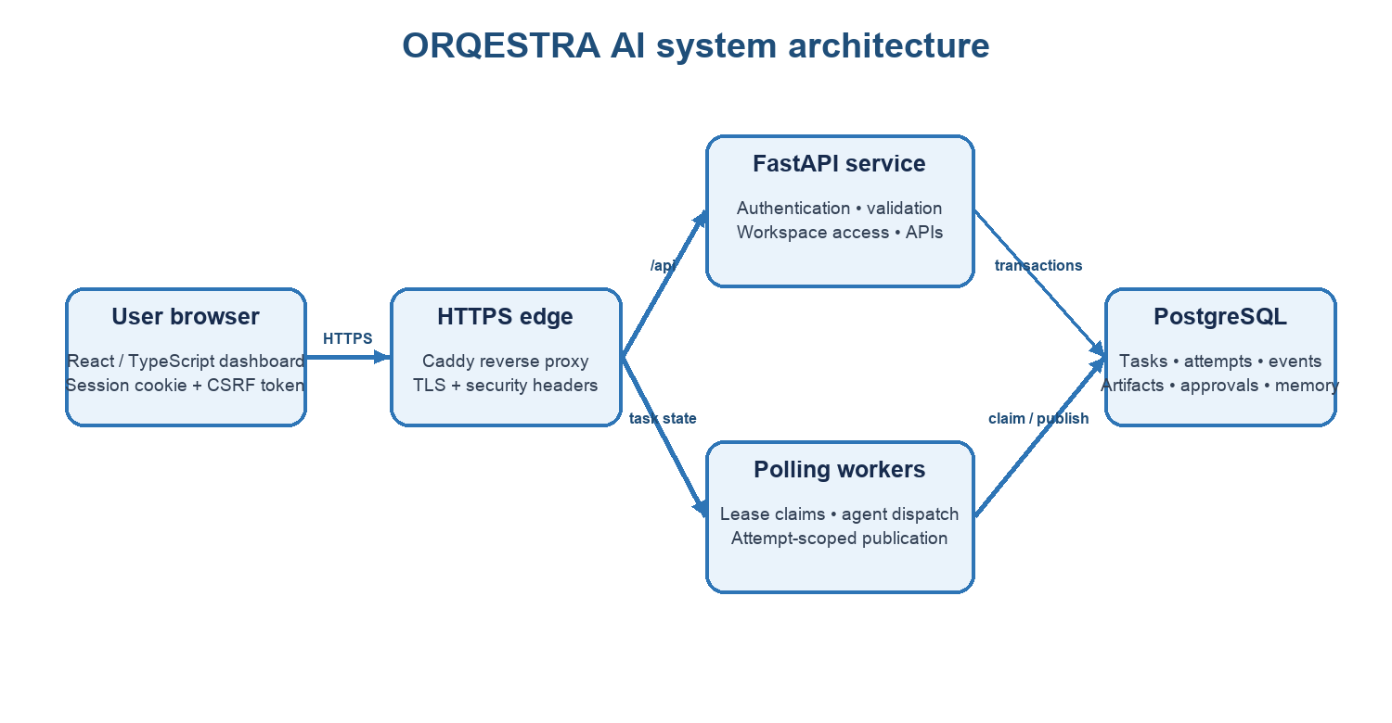
Figure 4.1. Browser, edge, API, worker, and durable database boundaries.

4.2 Workflow Graph and Contracts
A workflow consists of tasks with unique identifiers, declared capabilities, typed inputs and outputs, and dependency edges. Before persistence, the planner/runtime checks that identifiers are unique, all dependencies exist, the graph is acyclic, each input binding is valid, and the registered agent supports the requested capability. Contracts are versioned and exported as JSON Schemas. Task outputs are validated before downstream tasks consume them. Invalid results stop further progression and pending dependent work is skipped rather than receiving malformed data.

4.3 Task State and Attempt Lifecycle
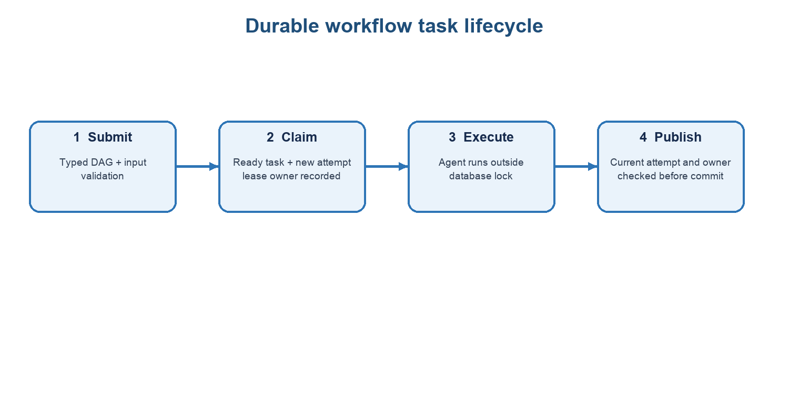
Figure 4.2. Task submission, lease claim, execution, and fenced publication.
Recovery path: when an attempt lease expires, the worker marks the old attempt expired and returns the unfinished task to pending. A later claim creates a new attempt; the old worker no longer owns the task result.
The worker briefly locks and claims a ready task using PostgreSQL row locking with SKIP LOCKED. It persists a new attempt, worker ownership, and lease expiry before leaving the transaction. The handler runs without holding a database lock. Result publication occurs in a second transaction and checks the current task attempt, attempt state, and lease owner. If recovery has superseded the attempt, the result is discarded. When a lease has expired, recovery marks the old attempt expired and makes the task pending so a new worker can claim it.
The current production default lease is 360 seconds and is not renewed. A legitimate task that outlives its lease can be reassigned; this is a known false-expiry risk. Publication fencing depends on recovery changing the current attempt. The ownership check does not itself compare the current clock with the deadline, so a worker that finishes after the deadline but before a recovery pass may still publish. This window is documented in the research draft and remains an improvement area.

4.4 Principal Data Entities
Entity | Purpose | Key relationship or control
Workspace | Tenant boundary for users and artifacts. | Membership and role determine access to related records.
Workflow | Top-level request, status, routing and timestamps. | Belongs to one workspace; owns tasks and events.
Task | A node in a workflow DAG. | Stores dependency state, input/output references, status and current attempt.
TaskAttempt | One execution claim and result lifecycle. | Records attempt number, worker, lease, timing and outcome.
WorkflowEvent | Auditable state transition or progress record. | Ordered within workflow and exposed through authenticated reads/streaming.
Approval | Decision for a sensitive tool action. | Contains action fingerprint, reviewer, decision, expiry and execution state.
DocumentChunk / ResearchSource | Workspace-scoped retrieval evidence. | Stores source identity, offsets, content hash and untrusted status.
Artifact | Generated report, dataset or chart output. | Workspace-scoped; content fingerprint supports integrity checks.

4.5 API Design
The API is resource-oriented. Authenticated routes manage sessions, workspaces, workflow submission and reads, cancellation, events, artifacts, approvals, data analysis, document memory, and optional research or code-proposal tools. Mutating requests require an authenticated session plus CSRF and trusted-origin checks. Workflow and artifact reads re-check workspace authorization. An optional Server-Sent Events endpoint provides event cursors and periodically rechecks access; the dashboard also polls REST endpoints approximately every 1.8 seconds.

4.6 Routing and Planning
The planning layer can operate offline or use an explicitly configured OpenAI provider. Offline planning is the default and does not make provider calls. Optional planning is constrained by an operator-held credential, token/cost/deadline checks, a maximum of two provider calls, schema validation, and persisted planning attempts. The routing subsystem supports fixed and adaptive policy evaluation with capability eligibility and persisted decision factors. Only one built-in agent currently exists for each capability, so the current policies do not produce a meaningful performance comparison.

4.7 Deployment Architecture
The production Compose overlay models a single VPS. Caddy is the only service published on ports 80 and 443; it terminates HTTPS and forwards API/health paths internally. The frontend and API are not host-published, and PostgreSQL has no host port mapping. Database credentials are mounted from secret files. Encrypted backup and isolated restore scripts are supplied. The optional code sandbox requires a dedicated TLS-protected Docker Engine and is disabled by default; the production host Docker socket must not be mounted into the API.

4.8 Design Rationale
Choice | Rationale | Trade-off
Custom Python DAG runtime | Small, inspectable execution model aligned with the implemented feature set. | Does not inherit LangGraph checkpointer behavior; fewer ecosystem features.
PostgreSQL task queue | Transactions and row-level locking coordinate multiple workers with durable state. | Database is a central dependency and must be operated, migrated and backed up.
Lease plus attempt fence | Expiry enables recovery while current-attempt checks reject superseded publications. | At-least-once execution remains; no lease renewal or external side-effect rollback.
Deterministic core agents | Offline workflows are reproducible and need no provider account or paid inference. | Does not measure model quality or demonstrate broad autonomous reasoning.
Human approval for selected writes | Keeps sensitive state changes under explicit workspace review. | Adds a waiting state and requires clear expiry/retry behavior.

CHAPTER 5
IMPLEMENTATION

5.1 Technology Stack
Layer | Technology | Responsibility
Frontend | React, TypeScript, Vite, Nginx | Dashboard, workflow graph, task/event views, workspace and artifact interactions.
API | Python, FastAPI, Pydantic | Authentication, request validation, authorization, workflow and tool routes.
Persistence | PostgreSQL 16, SQLAlchemy, Alembic | Durable workflow state, attempts, events, users, workspaces, approvals and artifacts.
Worker | Python polling process | Task claims, leases, handler dispatch, recovery and fenced result publication.
Contracts | JSON Schema and versioned protocol types | Validation and interchange for task inputs, results, planner proposals and tool payloads.
Operations | Docker Compose, Caddy, GitHub Actions | Local and staging deployment, HTTPS edge, CI checks and operational scripts.

5.2 Authentication and Workspace Access
User passwords are stored as salted scrypt hashes. Authenticated requests use HttpOnly, SameSite=Lax session cookies. HTTPS deployments enable secure cookies. Mutating API calls require a session-bound CSRF token and a trusted origin. Login attempts are throttled through the primary database. Workspace membership roles control access to workflow records and artifacts; a viewer role cannot approve sensitive actions. Public registration is disabled in the staging profile, where an operator bootstraps the first account.

5.3 Planner, Contracts and Agent Registry
A planner proposal is not executed as received. The runtime validates its task graph, input bindings, schema versions, declared capabilities, and output contracts. The registry maps capability names to known agent implementations and validates worker compatibility. Deterministic built-in agents inspect a bounded CSV input, compute numeric summaries, and independently verify result structure and expected constraints. Invalid contract results produce sanitized failure states and prevent dependent tasks from running.

5.4 Scheduler and Recovery
Workers poll for eligible workflows and claim tasks using short database transactions. PostgreSQL SKIP LOCKED allows independent workers to claim separate work without waiting on the same queue rows. Each attempt persists its lease and ownership before dispatch. Cancellation fencing prevents a late worker from reviving a cancelled workflow. Expired leases are recovered at worker startup and during polling. A pure task may be executed again after lease expiry, so the system provides at-least-once recovery rather than exactly-once execution.

5.5 Data Analysis
CSV/XLSX analysis imports are workspace-scoped and bounded. Inputs are limited to 5 MiB, 5,000 rows, 100 columns, and 16,384 characters per cell, with additional parsing and archive safeguards. The module profiles columns, computes deterministic numeric statistics, produces SVG charts, records content hashes, and generates safe CSV exports. Formula-like strings are escaped in exported CSV; formulas are read as text and macro-enabled formats are rejected. Source uploads are not retained as raw files.

5.6 Restricted Research
The research tool is disabled by default and requires an operator-managed exact host allowlist. When enabled, it accepts a small bounded number of caller-provided URLs, uses HTTPS, resolves and pins public addresses, blocks redirects, caps response size and request time, and extracts a bounded text representation. It does not crawl links or expose a general-purpose search engine. Retrieved content is retained with workspace-scoped provenance and labeled as untrusted evidence.

5.7 Workspace Document Memory
Document memory accepts supported text-bearing material under file-size and character limits, rejects traversal patterns and unsupported formats, splits content into bounded chunks, and records exact source offsets. Deterministic 128-dimensional embeddings support keyword and hybrid ranking. Retrieved passages are restricted to their owning workspace, and deleting a source cascades to its immediate index records. Retrieval contributes context but cannot change the agent’s tool permissions.

5.8 Code Proposal Sandbox
The coding surface produces workspace-scoped patch proposals and reviewable unified diffs. If enabled, a separate isolated Docker Engine runs fixed checks in a pinned container image with no network, no host mounts, read-only root, bounded temporary storage, non-root UID, dropped capabilities, memory/CPU/PID caps, and a wall-clock limit. Only fixed test/compile commands are accepted. This sandbox is disabled by default and is not active in the selected hosted demo. A coding walkthrough must not be represented as an executed sandbox run when it was only simulated or proposed.

5.9 Human Approval and Write Gate
Sensitive tools such as CSV export, patch application, and workspace configuration writes may transition a task to waiting_approval. The approval record captures a canonical JSON fingerprint of the requested arguments. At execution, ORQESTRA recomputes and compares the fingerprint; modified parameters invalidate the approval. Decisions expire after 24 hours, sensitive values are masked in review surfaces, and role checks prevent viewers from approving or rejecting. This control protects the approval boundary but does not make all agent outputs inherently safe.

5.10 Deliverable Synthesis and Verification
The reporting module can synthesize Markdown, styled printable HTML, and structured JSON. Artifacts are durable and have SHA-256 fingerprints. Verification assigns PASS, PASS_WITH_WARNINGS, REVISION_REQUIRED, FAIL, or INDETERMINATE, attributes defects, and requires limitations disclosures. Upstream task failures or missing mandatory limitations disclosure prevent a PASS. External verification is kept distinct from an agent’s self-assessment so the final status is interpretable.

5.11 Frontend and Observability
The React dashboard provides workspace selection, workflow submission, graph and task status views, planning ledger, event history, metrics, outputs, artifact inspection, and recovery controls. REST polling refreshes the interface approximately every 1.8 seconds; authenticated SSE is available for event streaming and rechecks access while connected. Workflow search uses bounded pagination and status filters across workspace history. The interface shows agent registry and decision details so execution is not a hidden black box.

5.12 Repository Organization
backend/app/ FastAPI API, persistence, planner, agents and worker
backend/contracts/ Versioned JSON Schema exports
backend/tests/ Runtime, security, recovery and feature checks
frontend/src/ React dashboard and workflow surfaces
docs/ Architecture, security, operations and feature guides
compose.yaml Local development services
compose.production.yaml Staging deployment overlay

CHAPTER 6
VERIFICATION AND EVALUATION

6.1 Verification Strategy
The project uses layered verification. Unit-level checks exercise contract validation, agents, numeric bounds, routing, retrieval, approvals, authentication, and report verification. Database-focused checks exercise migrations, lease claims, concurrent workers, cancellation, and recovery. Frontend checks include a production build and selected manual browser acceptance. CI runs backend and frontend checks and dependency/security automation. These levels provide implementation evidence, but they are not a third-party penetration test or complete browser end-to-end suite.

6.2 Project Validation Record
Evidence area | Recorded outcome | Boundary
Backend local suite | 282 passed; four PostgreSQL-only tests skipped in the SQLite run (2 Nov 2026 completion record). | SQLite run does not cover database row-locking/concurrency cases.
PostgreSQL CI selection | 124 passed, including process termination/restart, cancellation and full-history search. | Selected acceptance group, not the entire product on a fresh host.
Static and frontend checks | Ruff, formatting, Mypy and frontend TypeScript/Vite production build passed. | Build and static checks do not establish runtime user acceptance.
Manual browser acceptance | Synthetic workflow completion, event status, history navigation, keyboard activation, and automatic reconnect after API restart were checked locally. | Manual checks; full keyboard/SSE-reconnect browser E2E remains open.
Hosted release | As of 2 Nov the latest hosted release health still needed verification. On 11 Nov the URL initially displayed the provider wake-up screen. | Current live application readiness and release health remain unconfirmed.
Deployment operations | Compose profile, health checks, encrypted backup and isolated restore scripts are present. | Fresh VPS/TLS and remote restore acceptance remain outstanding.

6.3 Frozen CSV Benchmark
The Checkpoint 15 frozen v2 benchmark contains 78 cases: 71 expected-success and 7 expected-failure. It spans numeric CSV variations, missing values, quoted Unicode, formula-like strings, prompt-like content, and invalid input. Raw fixture bytes are SHA-256 hashed. Each dispatch mode runs three to five replicates, defaulting to three. Valid outputs are recursively compared with expected summaries; invalid inputs pass when correctly rejected. The benchmark compares fixture agreement and local sequential execution. It does not measure live-model quality, provider cost, parallel speedup, or routing superiority. Because the suite’s multiple replicates reuse the same frozen cases, intervals across case-replicates are descriptive rather than independent-user estimates.

6.4 Lease and Attempt-Fencing Experiment
The separate research draft focuses on worker process failure while a task is held. It compares the full design with two ablations: no_lease disables expiry-based requeue while retaining ownership checks; no_fencing removes the result publication ownership check. The production worker loop runs in two processes against PostgreSQL. Three sequential deterministic tasks inspect, summarize, and verify a small CSV. The agents are deliberately millisecond-scale; an injected delay creates a measurable gap between handler completion and publication.
Factor | Values
Design | full; no_fencing; no_lease
Injected scenario | F1 killed worker; F2 worker stalls past lease then resumes; F3 no failure control
Lease length | 2 seconds; 5 seconds
Replicates | 30 seeded trials per design × scenario × lease cell
Main sample | 3 × 3 × 2 × 30 = 540 trials
Workers / workload | Two real worker processes; one workflow and isolated PostgreSQL schema per trial
Timing controls | 20 ms polling; failure set after first execution event; 0.4 lease-length artificial delay before publication
Environment | One laptop-class machine; eight isolated trials concurrently (up to ten during overlapping validation)

6.5 Experimental Results
For every row below, counts are out of 30 trials at each lease length; outcomes were identical at 2 seconds and 5 seconds.
Design | Failure | Completed | Expected output | Stale accepted | Stuck
full | F1 crash | 30/30 | 30/30 | 0/30 | 0/30
no_fencing | F1 crash | 30/30 | 30/30 | 0/30 | 0/30
no_lease | F1 crash | 0/30 | 0/30 | 0/30 | 30/30
full | F2 stall | 30/30 | 30/30 | 0/30 | 0/30
no_fencing | F2 stall | 30/30 | 30/30 | 30/30 | 0/30
no_lease | F2 stall | 30/30 | 30/30 | 0/30 | 0/30
all designs | F3 control | 30/30 each | 30/30 each | 0/30 | 0/30

After a killed worker, the full design completed all 30 trials at both lease lengths; without expiry-based requeue, all 30 trials remained stuck until timeout. The median time from failure to next attempt was 1.81 s (IQR 1.78–1.84) with a 2 s lease and 4.52 s (IQR 4.48–4.64) with a 5 s lease. These values are about 0.9 lease lengths because the lease starts at claim, and most of it remained when the failure was injected.
During a stall, no_fencing accepted both the resumed worker’s result and the retry result in 30/30 trials, while the full design published only the retry in 30/30 inspected 2 s trials. This demonstrates that lease expiry by itself does not stop a paused worker from publishing; the ownership check rejects it once recovery has created a newer attempt. In all completed trials, outputs matched the checked-in expected output because the agents were deterministic. Output equality therefore could not reveal the duplicate publication; ownership events were required.

6.6 Completion-Time Comparison
Lease | Full design median | No-fencing median | Difference
2 s | 4.241 s | 3.925 s | 0.316 s (about 0.32 s)
5 s | 10.538 s | 9.782 s | 0.756 s (about 0.76 s)

The extra end-to-end completion time is consistent with the full design rejecting the late result and waiting for retry under the injected stall timings. It is not an isolated estimate of fencing overhead. No_fencing is a deliberately weakened comparison, and the measured difference must not be generalized to different task durations, workloads, failure timings, or lease configurations.

6.7 Threats to Validity
• The failure occurs after the handler returns, not during computation, and a fixed artificial publication delay creates the race window.
• The ownership check does not compare the wall clock with the lease deadline; the study does not test publication after expiry but before recovery runs.
• The two lease lengths are short test values, while the production default is 360 seconds. Renewal and false expiry of a healthy long-running agent were not studied.
• The agents are deterministic and have no external side effects. The results do not quantify LLM behavior, semantic correctness, or side-effect duplication.
• All processes and the database shared one laptop-class machine; concurrent isolated trials may affect absolute timings. The experiment used PostgreSQL 18 rather than project PostgreSQL 16.
• There is no independent replication. Statistical tests are exploratory and unadjusted; the strongest evidence is the observed counts and ownership events.
• Network partitions, clock skew, multi-workflow contention inside one orchestrator, error retry/backoff, and lease renewal were not studied.

6.8 Interpretation
The experiment supports a narrow implementation claim: under the tested failure protocol, lease expiry enabled recovery from a killed worker, and attempt fencing prevented a resumed superseded attempt from publishing after recovery. It does not show that the system is fault tolerant under every failure mode, nor that the architecture is better than a workflow engine with replay, renewal, or transactional external tools. It also demonstrates that duplicate execution remains possible even when duplicate publication is prevented.

CHAPTER 7
SECURITY, PRIVACY AND DEPLOYMENT

7.1 Threat Model
The project considers unauthorized users, cross-workspace access, malicious or prompt-like retrieved content, server-side request forgery, sandbox escape, accidental formula execution in exports, stale worker results, and unauthorized external writes. It also considers operational risks from lost database credentials, unverified backup recovery, and exposed service ports. The review is an OWASP-informed source and test review, not independent penetration testing or certification.

7.2 Security Controls
Risk | Control | Residual limitation
Session theft / cross-site writes | HttpOnly SameSite cookies; CSRF token; trusted-origin validation; scrypt password hashing. | Email verification, password reset and external alerting remain open.
Cross-tenant disclosure | Workspace membership checks on workflow, artifact, document and event access. | Retention and broad independent authorization review remain future work.
Prompt-like retrieved text | Retrieved content is labeled untrusted and cannot grant tool permissions. | Models could still misinterpret context; live-model quality and adversarial evaluation are incomplete.
SSRF and redirect abuse | Exact operator allowlist, HTTPS, public DNS pinning, redirect blocking and bounded fetch. | Research feature is disabled unless operator domains are configured.
CSV formula execution | Formula-like exported values are escaped; formulas read as text; macros rejected. | Safe export does not replace independent consumer-side validation.
Sandbox escape / resource abuse | Separate TLS Docker Engine, no network/mounts, read-only root, non-root, capabilities and resource limits. | Sandbox disabled by default; isolated engine and runtime acceptance are required.
Sensitive unauthorized writes | Approval state machine, argument fingerprint, expiry and workspace role enforcement. | External side effects still require service-side idempotency/deduplication.
Stale result publication | Current task/attempt/owner fence and lease recovery. | Deadline-only window remains; fencing does not prevent duplicate computation.

7.3 Data Handling
The database stores workflow inputs and outputs, task attempts, event history, approvals, selected normalized analysis data, document chunks, provenance, and generated artifacts within workspaces. Uploaded source dataset files are not retained as raw files after analysis, while derived profiles, charts, exports, and hashes are stored. LLM planning may transmit task instructions, CSV column names, and row count to the configured provider; CSV row values stay local according to project configuration. Provider calls are optional and disabled without operator configuration.

7.4 Deployment Profile
Local development uses Docker Compose for PostgreSQL, API, worker, and frontend. The staging overlay adds Caddy HTTPS termination, secret-file database credentials, health checks, disabled public registration, and host-only bootstrap. Only Caddy is externally published. Backups require GPG encryption; restore validates checksums and targets a new isolated database. These assets provide a deployment path, but the completion record explicitly says a fresh-host TLS deployment and remote restore acceptance have not yet been completed.

7.5 Hosted Demonstration Status
The requested demonstration address is https://orqestra.anshita-dawar.prod.page. When first opened on 11 November 2026, it displayed the Blitz hosting provider’s wake-up page after inactivity. The application then finished starting and served the ORQESTRA sign-in page, confirming that the public frontend was reachable. Authenticated workflow and API health were not checked. Accordingly, the report records the hosted frontend as reachable while leaving signed-in application readiness unverified.

7.6 Operations Checklist
• Restrict staging ingress to an operator allowlist or VPN; expose only HTTPS and required HTTP redirect traffic.
• Use mounted secrets and do not commit credentials or API keys to the repository.
• Verify database migration readiness and service health before accepting demo workflows.
• Run encrypted backup and restore drills to a separate database; verify the restored data and preserve the passphrase independently.
• Keep the code sandbox and live LLM planning disabled unless their dedicated configuration and operational controls are accepted.
• Review dependency alerts and update pinned dependencies before a new deployment.
• Document release timestamp, commit, health result, and demo scenario so the hosted page matches the inspected build.

CHAPTER 8
RESULTS AND DISCUSSION

8.1 Implemented Outcome
ORQESTRA delivers a working end-to-end prototype in which a user can authenticate, select a workspace, submit a typed workflow, inspect task execution, and review a persisted result. The runtime is not a direct model wrapper: it includes plan validation, capability-aware dispatch, state persistence, attempts, leases, event history, cancellation controls, and output verification. The dashboard makes execution state visible and supports operational review.

8.2 Reliability Outcome
The project demonstrates recovery at task boundaries and protection against stale publication after a newer attempt is recorded. PostgreSQL subprocess acceptance and the separate fault-injection study provide evidence for these mechanisms under particular conditions. The system still permits at-least-once computation, does not renew leases, and leaves a short interval in which a worker may publish after deadline but before recovery. For external effects, approval and attempt fencing are not substitutes for idempotency at the destination service.

8.3 Security and Governance Outcome
The implementation brings security and governance into the workflow path rather than treating them as a deployment-only concern. Workspace checks, typed tools, bounded data access, untrusted retrieval labels, human approval, and artifact fingerprints all contribute to a reviewable execution record. Their value is limited by the scope of automated and manual evidence: the project has not undergone independent penetration testing, full browser E2E coverage is incomplete, and production recovery flows such as email verification and password reset remain open.

8.4 Research Outcome
The research study contributes a measured account of how the implemented lease and attempt-fencing mechanisms behave under a controlled crash and stall protocol. Its most important practical observation is that lease expiry and fencing do different work: expiry restores eligibility; fencing blocks publication by an older attempt after recovery has changed ownership. The no_fencing result also shows why deterministic output comparison alone is insufficient for detecting stale writes. Event-level evidence is necessary. The accompanying manuscript remains a research draft and should receive independent academic review before submission or publication.

8.5 Learning Outcomes
• Designing versioned request/result contracts and validating DAG structure before execution.
• Using relational transactions and row-level locking to coordinate independent worker processes.
• Understanding the difference between retry, at-least-once execution, stale-result fencing, idempotency, and exactly-once claims.
• Building tenant isolation and approval authorization into data and state transitions.

CHAPTER 9
CONCLUSION AND FUTURE SCOPE

9.1 Conclusion
ORQESTRA AI demonstrates a durable orchestration architecture for typed, workspace-scoped workflows. It combines a React dashboard, FastAPI service, PostgreSQL persistence, a separate polling worker, deterministic task agents, optional bounded tools, sensitive-action approvals, deliverable synthesis, and verification. Its core engineering contribution is an auditable lifecycle from plan validation through attempt claim, task execution, fenced publication, and artifact inspection.
The project’s evidence is strongest where behavior is deterministic and conditions are explicit. Recorded tests verify broad implementation behavior, PostgreSQL acceptance covers selected worker recovery cases, and the controlled experiment shows lease expiry and attempt fencing operating as designed under its injected failures. The project does not establish live LLM quality, production readiness, real-world failure probabilities, or superiority over established workflow engines.

9.2 Future Scope

Close the publication deadline window
Check lease validity inside the publication transaction and test a worker finishing after expiry but before recovery.

Add lease renewal and false-expiry evaluation
Measure healthy long-running tasks across lease sweeps and compare renewal, backoff, and recovery policies.

Expand worker fault injection
Terminate handlers mid-execution and test network partitions, clock skew, and multiple workflows in one orchestrator.

Test non-deterministic and side-effecting agents
Introduce controlled nondeterministic outputs and a test counter/service to measure duplicate external effects and deduplication.

Broaden evaluation
Build held-out multi-domain datasets and evaluate planning, research, coding proposals, verification quality, cost, latency, and human review effort.

Complete browser acceptance
Add automated keyboard, SSE reconnect, upload, approval, artifact-download, and workspace isolation E2E coverage.

Complete staging operations
Rehearse a clean VPS deployment, TLS issuance, monitoring/alert delivery, backup restoration and disaster recovery.

Independent security review
Commission a focused penetration test and address lifecycle flows, rate limits, retention, and authorization findings.

Increase agent diversity
Add independently implemented capabilities so fixed and adaptive routing can be evaluated with meaningful candidates.

Improve user-facing provenance
Provide clearer lineage from source input through task outputs, retrieved evidence, verification defects, and final artifact.

9.3 Final Statement
The project shows that the reliability, security, and verification layers around agent execution can be implemented and inspected as first-class system components. Its next stage should preserve that emphasis while broadening the evaluation and completing deployment and independent review gates.

REFERENCES
[1] C. G. Gray and D. R. Cheriton, “Leases: An efficient fault-tolerant mechanism for distributed file cache consistency,” Proceedings of the 12th ACM Symposium on Operating Systems Principles, 1989, pp. 202–210. doi: 10.1145/74850.74870.
[2] M. Kleppmann, “How to do distributed locking,” 8 Feb. 2016. [Online]. Available: http://martin.kleppmann.com/2016/02/08/how-to-do-distributed-locking.html.
[3] H. Zhang, A. Cardoza, P. B. Chen, S. Angel, and V. Liu, “Fault-tolerant and transactional stateful serverless workflows,” Proceedings of the 14th USENIX Symposium on Operating Systems Design and Implementation, 2020, pp. 1187–1204.
[4] S. Burckhardt et al., “Durable Functions: Semantics for stateful serverless,” Proceedings of the ACM on Programming Languages, vol. 5, 2021, Art. 133.
[5] M. Cemri et al., “Why do multi-agent LLM systems fail?” Advances in Neural Information Processing Systems, 2025; arXiv:2503.13657.
[6] J. Jia, Z. Deng, Z. Chen, Y. Wang, and Z. Zheng, “MAS-FIRE: Fault injection and reliability evaluation for LLM-based multi-agent systems,” arXiv:2602.19843, 2026. Preprint.
[7] G. van Dongen and D. Van den Poel, “A performance analysis of fault recovery in stream processing frameworks,” IEEE Access, vol. 9, pp. 93745–93763, 2021. doi: 10.1109/ACCESS.2021.3093208.
[8] A. K. Iannillo, “ChaosLLM: A dependability testing approach for tool-calling agents,” Proceedings of IEEE ISSRE Workshops, 2025. doi: 10.1109/ISSREW67781.2025.00085.
[9] ORQESTRA AI project repository, source code, contracts, tests, and project documentation. https://github.com/anshiiii-hub/ORQESTRA. Repository state reviewed at local commit 0dddb35dd369ae025045fba1b3140739e14167fd; accessed 11 Nov. 2026.
[10] ORQESTRA AI, “ORQESTRA AI deployment architecture,” project documentation, docs/architecture.md, accessed 11 Nov. 2026.
[11] ORQESTRA AI, “Completion record,” project documentation, docs/project-completion.md, 2 Nov. 2026.
[12] ORQESTRA AI, “Checkpoint 15: evaluation and security review,” project documentation, docs/checkpoint15-security-review.md.
[13] ORQESTRA AI, “Recovery controls and benchmark smoke suite,” project documentation, docs/benchmarks-recovery.md.
[14] ORQESTRA AI, “Accounts, sessions and workspace roles,” project documentation, docs/authentication.md.
[15] ORQESTRA AI, “Approvals, human-in-the-loop, and write gating,” project documentation, docs/approvals.md.
[16] ORQESTRA AI, “Restricted research tools,” project documentation, docs/research.md.
[17] ORQESTRA AI, “Data analysis agent,” project documentation, docs/data-analysis.md.
[18] ORQESTRA AI, “Document memory and knowledge retrieval,” project documentation, docs/document-memory.md.
[19] ORQESTRA AI, “Code proposal sandbox,” project documentation, docs/sandbox.md.
[20] ORQESTRA AI, “Synthesis, reporting, and verifiable summary artifacts,” project documentation, docs/reporting-verification.md.
[21] PostgreSQL Global Development Group, “SELECT: The locking clause,” PostgreSQL Documentation, https://www.postgresql.org/docs/18/sql-select.html.
[22] Temporal Technologies, “Activity definition,” Temporal documentation, https://docs.temporal.io/activity-definition. Accessed 2 Nov. 2026.
[23] React, “React documentation,” https://react.dev/; FastAPI, “FastAPI documentation,” https://fastapi.tiangolo.com/; PostgreSQL Global Development Group, “PostgreSQL documentation,” https://www.postgresql.org/docs/.
[24] ORQESTRA AI, “Design and Development of an Adaptive, Fault-Tolerant Multi-Agent LLM Orchestration Framework,” research paper draft, ORQESTRA_paper_v7.docx, accessed 11 Nov. 2026.

APPENDIX A INTERFACE EVIDENCE
The following interface captures are included as project evidence. They illustrate the implemented local dashboard and registry surfaces; they are not screenshots of the hosted page inspected on 11 November 2026.
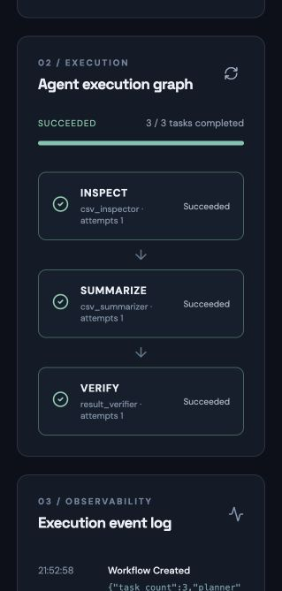
Figure A.1. Workflow execution and task graph surface.
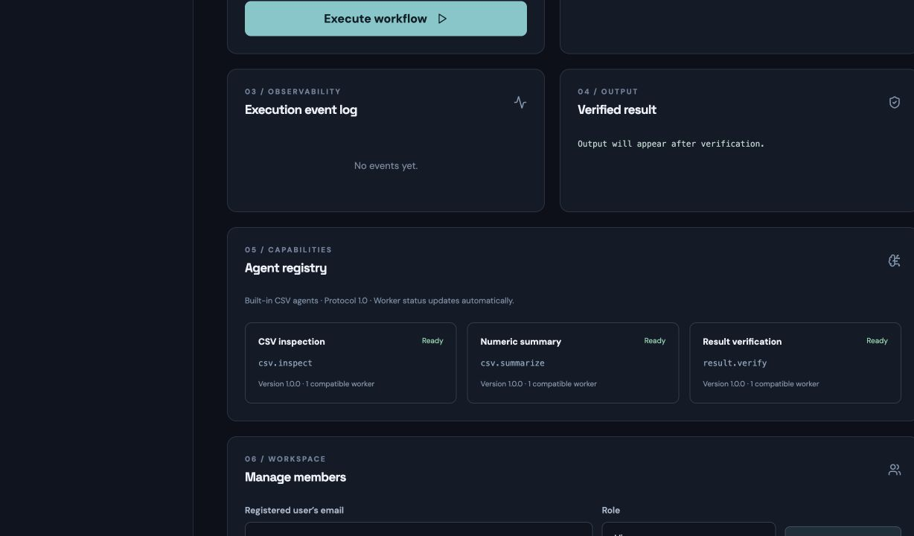
Figure A.2. Registered agent and capability surface.
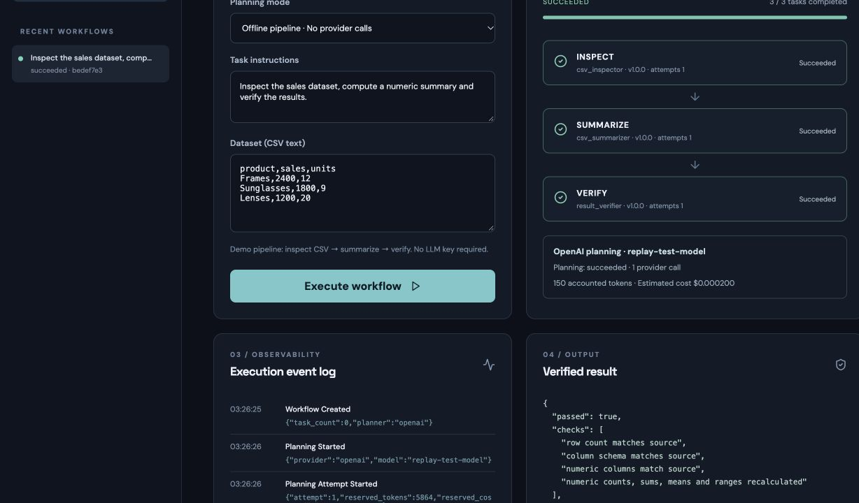
Figure A.3. Planning and validated workflow surface.

APPENDIX B CONFIGURATION AND WORKFLOW EXAMPLES

B.1 Local Service Layout
PostgreSQL → FastAPI API ← React dashboard
↑ ↓
└──── Polling worker

Workflow state, task attempts, leases, events and artifacts
are persisted in the shared PostgreSQL database.

B.2 Example Three-Task Workflow
Task | Input | Output | Dependency
inspect_csv | Workspace dataset reference | Column profile and row summary | None
summarize_numeric | Validated inspection output | Numeric aggregates | inspect_csv
verify_summary | Summary plus expected constraints | Verification status and findings | summarize_numeric

B.3 Operator Configuration Notes
• Keep offline planning selected for the standard demonstration.
• Set the exact frontend origin and secure cookies for HTTPS.
• Configure research only with an explicit operator-managed allowlist.
• Keep sandbox execution disabled unless a dedicated TLS Docker Engine and resource controls are available.
• Use host-mounted secret files for database credentials in staging; never publish PostgreSQL directly.
• Treat provider cost estimates as estimates rather than invoices or hard billing caps.

APPENDIX C GLOSSARY
Term | Definition
Attempt | A single claim and execution instance of a task. Re-execution after recovery creates a new attempt.
At-least-once execution | A recovery guarantee under which a task may execute more than once, though only an eligible result should be published.
Capability | A declared class of work that a registered agent can perform and a worker can support.
DAG | A directed graph with no cycles, used to express task dependencies.
Fencing | A check that prevents a superseded task attempt from publishing a result after a newer attempt owns the task.
Lease | A time-limited task claim that permits re-assignment after expiry.
Idempotency | A property by which repeated operations have the same effect as one operation; attempt IDs alone do not provide cross-attempt idempotency.
Workspace | An access-controlled tenant boundary for users, workflows, documents, approvals, and artifacts.
Verification rubric | A five-level report that classifies deliverable evidence and defects without equating model confidence with correctness.

