Software Requirements Specification

Smart E-Challan System

Prepared By-

Ankit Juneja 20103060

Saniya Singla 20103061
Rajat Bector 20103078
Anshika Goyal 20103115
Table of Contents
Table of Contents ii
Revision History ii
1. Introduction 1
1.1 Purpose 1
1.2 Intended Audience and Reading Suggestions 1
1.3 Project Scope 1
2. Overall Description 2
2.1 Product Perspective 2
2.2 Product Features 2
2.3 User Classes and Characteristics 2
2.4 Design and Implementation Constraints 2
2.5 User Documentation 2
3. System Features 3
3.1 System Feature 1 3
3.2 System Feature 2 4
4. External Interface Requirements 4
4.1 User Interfaces 4
4.2 Hardware Interfaces 4
4.3 Software Interfaces 4
4.4 Communications Interfaces 4
5. Other Nonfunctional Requirements 5
5.1 Performance Requirements 5
5.2 Safety Requirements 5
5.3 Security Requirements 5
5.4 Software Quality Attributes 5
6. Other Requirements 5
Appendix A: Analysis Models 6

Introduction
This document is prepared in order to determine a software requirement specification for Smart E-Challan System. Smart E-Challan System is an application to improve the efficiency of the process of generating challan ticket. In this application the traffic officer can upload photos of the vehicle and its number plate. In order to gain an overview about the report, firstly the purpose and scope of this document will be given, then an overall description of Smart E-Challan System is followed. In addition to these, system features such as Security login, uploading photos, extracting information through number plate and generating challan and SMS to offender have been described properly.

Purpose

The SRS is needed to evolve as the development of the software product processes. The purpose of this document is to give a complete description about how Smart Attendance System can be developed. This document is to provide information about what the software product is to do to students and teachers. In addition to these, it provides a basis for validation and verification.

Intended Audience
This document is intended for the developers working on this project and the college instructors to evaluate the project.

Project Scope
The name of the software is Smart E-Challan System. Smart E-Challan System is an application that helps in generating challan with such a convenience. The aim of this system is to simplify the tedious and manual task of ticketing and make it efficient and fast. The user is a traffic officer, who can login through the security credentials and would click the photo of the vehicle and further send it to admin to generate the challan.

Overall Description
In this section, background information about what type of requirements the system should have will be provided briefly.

Product Perspective
Smart E-Challan System is an independent application which traffic officer can use to ticket challan through an app by simply clicking a photo. It is not a part of a larger system, it is an independent system.

Product Features
After opening the app, the first thing the traffic officer needs to do is login through his/her ID. Then the officer clicks and upload photo of the vehicle. Image is processed to filter out the vehicle number and gather offender’s details via it. The officer initiates the ticket by clicking generate challan and then sms/email is sent to the offender.

User Classes and Characteristics
Smart E-challan System doesn’t require any specific computer knowledge to use it except the developers and the administrators of it. Standard users are thought to be from any age, any gender, any nationality who can just use a mobile application.
On the other hand, administrators and potential developers need a high level of expertise to understand technologies.

Design and Implementation Constraints
There might be occurrence of problem if officer don’t even know how to use a simple mobile application. Sometimes it may happen that the photo of vehicle is not properly captured and is missing or number plate is foggy/blurred and it can lead to termination of challan or wrong recognition of the number plate which may lead to issue of challan to wrong person. App does require connection to scan and upload pictures.

3. System Features
This section describes the key features and services provided by the product.

3.1 System Feature 1
Security Login.
3.1.1 Description
The user is given a unique id, password through which he can identify himself as the . police officer generating the challan.
3.1.2 Stimulus/Response Sequences
The user opens the app and clicks the login button .
3.1.3 Functional Requirements
Flutter, Dart, Django, Mysql, python

3.2 System Feature 2
Search for a specific student’s attendance record.
3.1.1 Description
The user can search a particular name in the attendance record and the corresponding attendance will be shown there.
3.1.2 Stimulus/Response Sequences
The user opens the website and clicks the check attendance button. Then the user needs to click on the search bar present on the top of the page and enter the student’s name there.
3.1.3 Functional Requirements
Flutter, Dart, Django, MySql, python

3.3 System Feature 3
Upload photo for marking attendance.
3.1.1 Description
The police officer can upload the photo of the license plate of the vehicle to mark to generate its challan.
3.1.2 Stimulus/Response Sequences
The user needs to be logged in as the officer. Then click on the upload photo button to generate challan for a particular vehicle.
3.1.3 Functional Requirements
Flutter,Dart,Django,Mysql,python

4. External Interface Requirements

4.1 User Interfaces
Various interfaces for Smart Attendance System could be:
- Home Page
- Police Officer Login Page
- Generate Challan Page
- Confirmation Page

4.2 Hardware Interfaces
The System must run over the internet, all the hardware is required to be connected to the internet. As for e.g. Modem, WAN-LAN, Ethernet Cross-Cable.
4.3 Software Interfaces
The last user needs an application to interact with the system.

4.4 Communications Interfaces
A system with a web browser and stable internet connection is required for the communication purposes.
Communication standards and network communication protocol:
TCP
UDP
FTP

5. Other Nonfunctional Requirements

5.1 Availability
The system should be available at all times, meaning the user can access it using a application, only restricted by the down time of the server on which the system runs. In case of a hardware failure or database corruption, a replacement page will be shown. Also in case of a hardware failure or database corruption, backups of the database should be retrieved from the server and saved by the administrator. Then the service will be restarted. It means 24 X 7 availability.

5.2 Accurate
The system should be accurate in identifying numbers and texts in the photograph and recording their meaning such that no false challan is generated. License Plate Number is a very crucial data and it needs to be recorded accurately as it can affect the entire challan.

5.3 Reliability
The system provides storage of all databases on redundant computers with automatic switch over. The reliability of the overall program depends on the reliability of the separate components. The main pillar of reliability of the system is the backup of the database which is continuously maintained and updated to reflect the most recent changes. Thus the overall stability of the system depends on the stability of the container and its underlying operating system.

5.4 User Friendly and Fast
The system should be easy to use as the police officers may not be that technically advanced and hence the system should have easy to use big buttons whose meanings are clear and understandable on their own. The system should be fast as the police officer has the entire area to patrol and can not spend plenty time at a single vehicle.
Appendix A: Analysis Models

A.1 Level Zero Data Flow Diagram
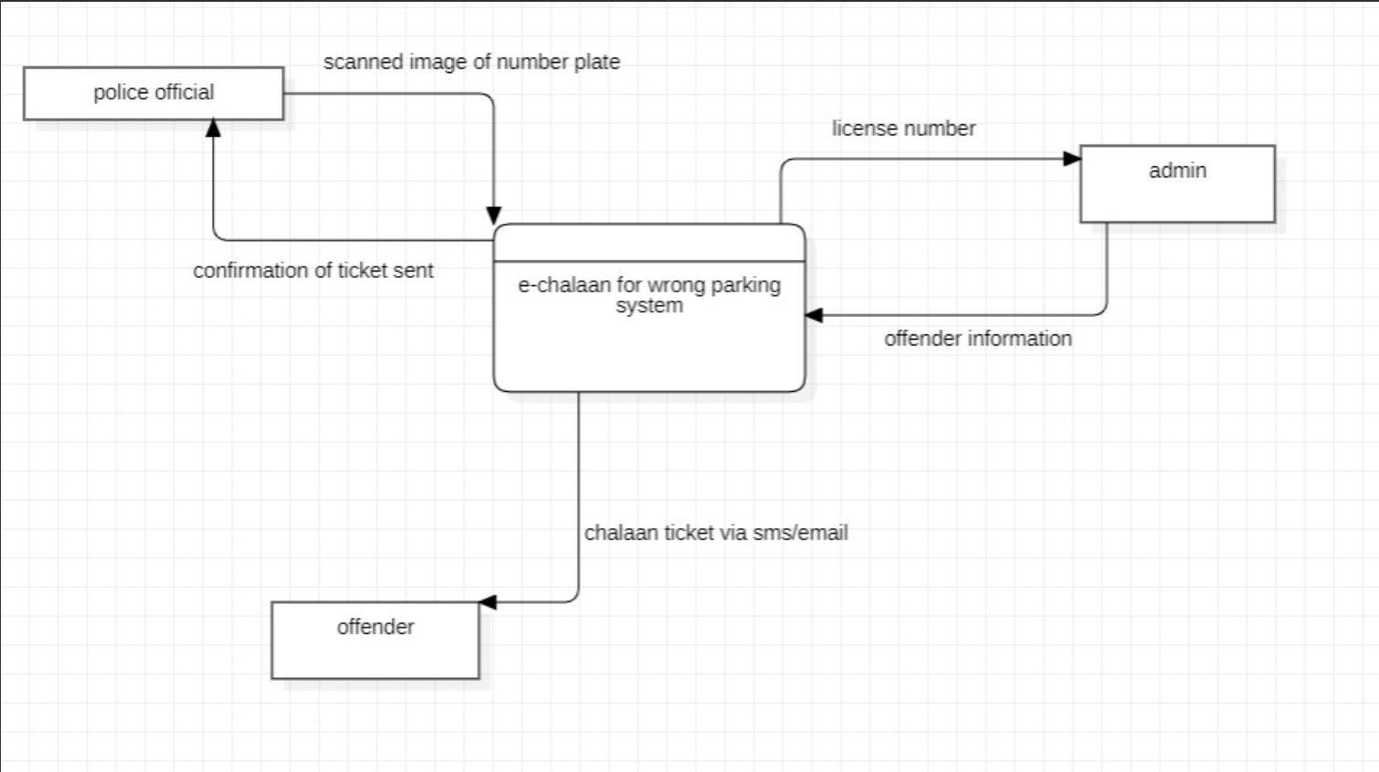

A.2 Level One Data Flow Diagram
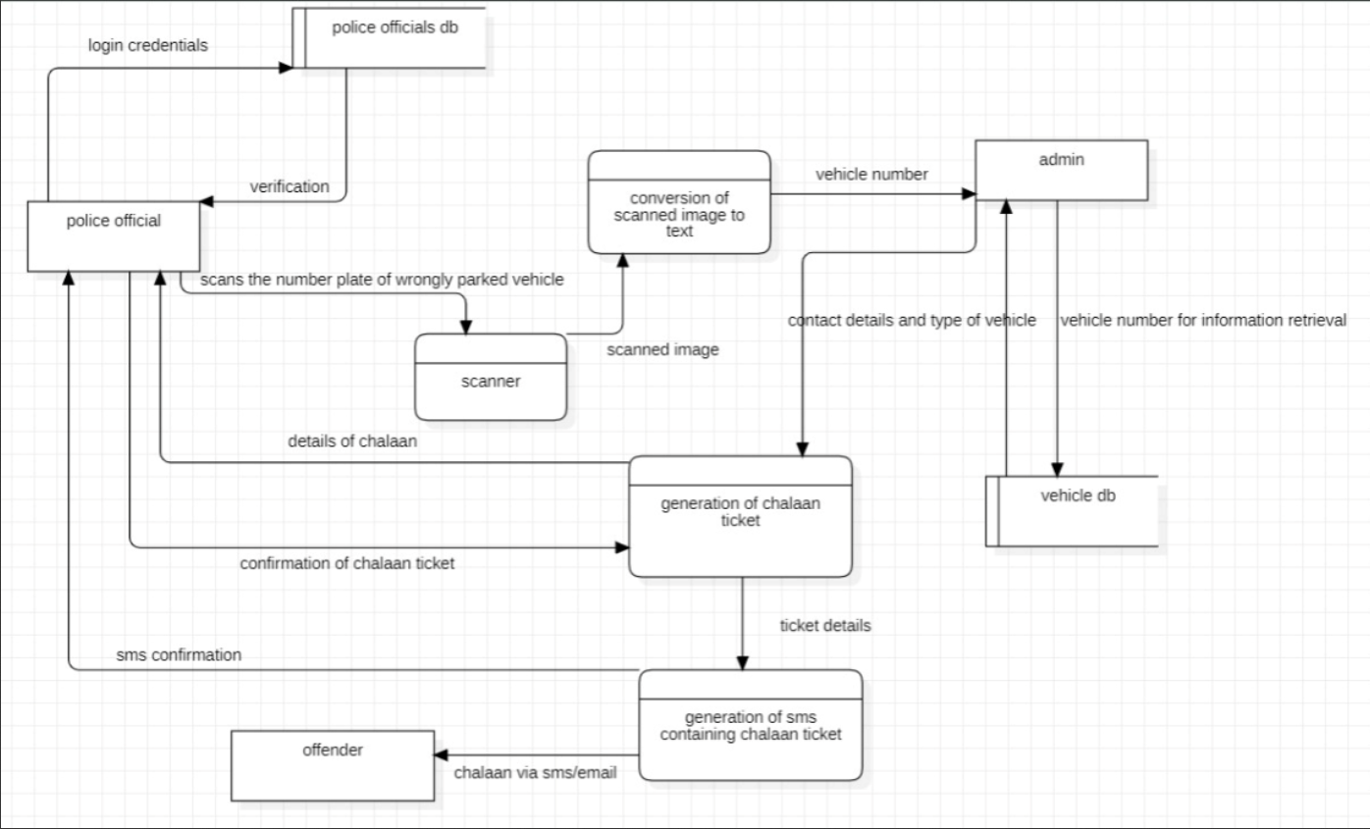

A.3 Activity Diagram
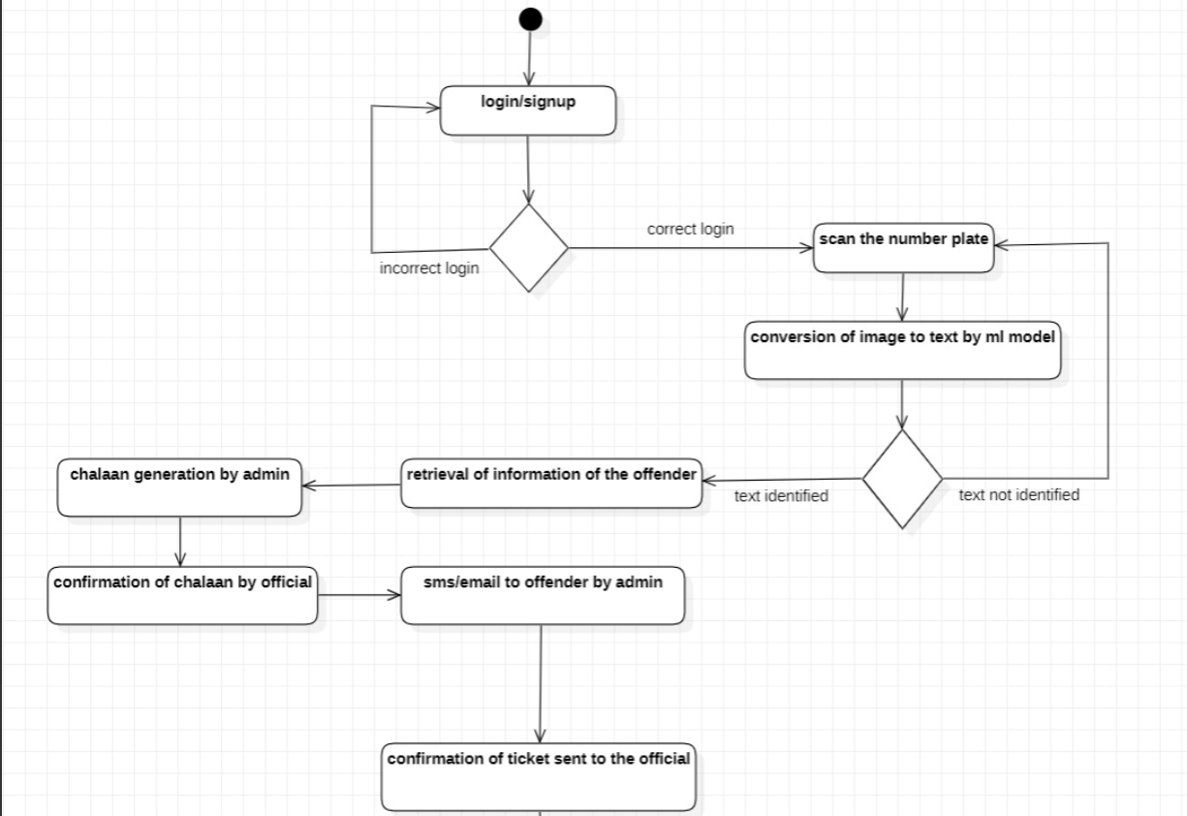

A.4 Use Case Diagram
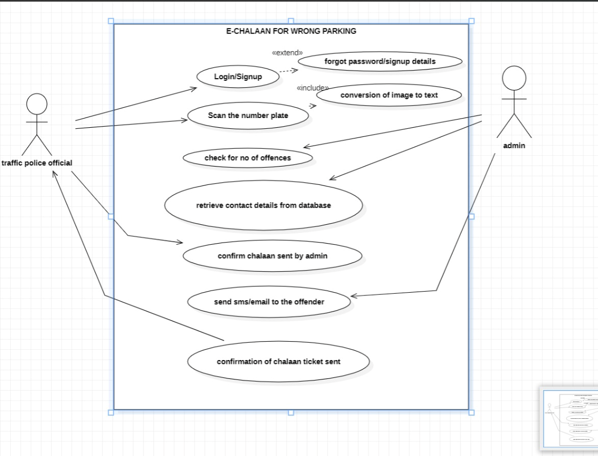

A.5 Class Diagram

