INTRODUCTION TO DATA ANALYTICS
Agricultural Crop
Production Analysis
Project Report
Project Title | Agricultural Crop Production Analysis
Subject | Introduction to Data Analytics
Program | BTech, Semester III
Group ID | BT_DA_05
Project ID | DA-023
Team Leader | Anshika Srivastav (BCS2025191)
Mentor | Arsh Singh
Section | A
Date | 30 October 2026
Team Members
No. | Student ID | Name | Roll Number
1 | BCS2025092 | ANIKET | 2510303097
2 | BCS2025094 | AMAL SINGH TOMAR | 2510303070
3 | BCS2025095 | ANSH PRATAP GANGWAR | 2510303111
4 | BCS2025096 | SUMIT PAL | 2510303521
5 | BCS2025097 | PRATEEK PANDEY | 2510303382
6 | BCS2025098 | MOHIT KUMAR | 2510303330
7 | BCS2025120 | ADITYA KUMAR | 2510303037
8 | BCS2025172 | KUMKUM | 2510303274
9 | BCS2025191 | ANSHIKA SRIVASTAV (Team Leader) | 2510303114
10 | BCS2025229 | PRASHANT SINGH | 2510303381
11 | BCS2025248 | MOHD SUBHAN | 2510303326
12 | BCS2025393 | AFTAB ALAM | 2510303049
13 | BCS2025441 | PRADEEP KUMAR | 2510303370
14 | BCS2025442 | MANISH MAURYA | 2510303291

1. Introduction
Agriculture is one of the most important sectors of the Indian economy. Knowing which crops are produced the most, which crops are growing, and how production is linked with the area under cultivation and the yield helps in planning and decision making. The objective of this project is to analyze the crop production data of India to understand production, area and yield of different crops from 2006-07 to 2010-11. The analysis was done using Python (pandas and matplotlib) in a Jupyter notebook.

2. Dataset Description
Source: Kaggle, “Agriculture Crops Production in India”
- Number of rows: 55 (44 individual crops and 11 group total rows)
- Number of columns: 16 in the original file, 18 after cleaning
- Period covered: five years, 2006-07 to 2010-11
- The values are index numbers, not tonnes. In the data, Yield is close to Production ÷ Area × 100, so the numbers show relative levels and changes, not actual quantities.
Main columns and their meaning
Column | Meaning
Crop | Name of the crop or crop group (for example Rice, Wheat, Total Oilseeds).
Production (year) | Production index of the crop in that year. There is one column for each of the five years.
Area (year) | Index of the area under cultivation for the crop in that year.
Yield (year) | Index of output per unit of area for the crop in that year.
Category (added) | Crop group assigned during cleaning: Cereals, Pulses, Oilseeds, Fibres, Plantation, Spices, Fruits & Vegetables or Other Cash Crops.
Type (added) | Shows whether the row is an Individual Crop or a Group Total.

3. Data Cleaning
The following checks and steps were carried out before the analysis:
- Checked missing values: none found in any of the 16 columns.
- Removed duplicates: none found. All 55 crop names are also unique.
- Cleaned the crop names (extra spaces and the missing space in “Rapeseed & Mustard”).
- Validated the data by checking Yield against Production ÷ Area × 100. Most values match closely. Three values do not match: Tobacco in 2007-08 and 2009-10 (difference 11.3 points) and Sannhamp in 2009-10 (difference 26.1 points). These were kept as given in the source file.
- The file mixes single crops with 11 group rows such as Total Foodgrains and Cereals. These rows were marked as Group Total so that they are not counted twice. All charts use the 44 individual crops.
- Added two columns, Category and Type, and saved the cleaned dataset as cleaned_agriculture_crops.csv.

4. Analysis and Charts
This section presents six charts based on the cleaned data. Each chart is followed by a short explanation of what it shows.

Chart 1: Crops by Category
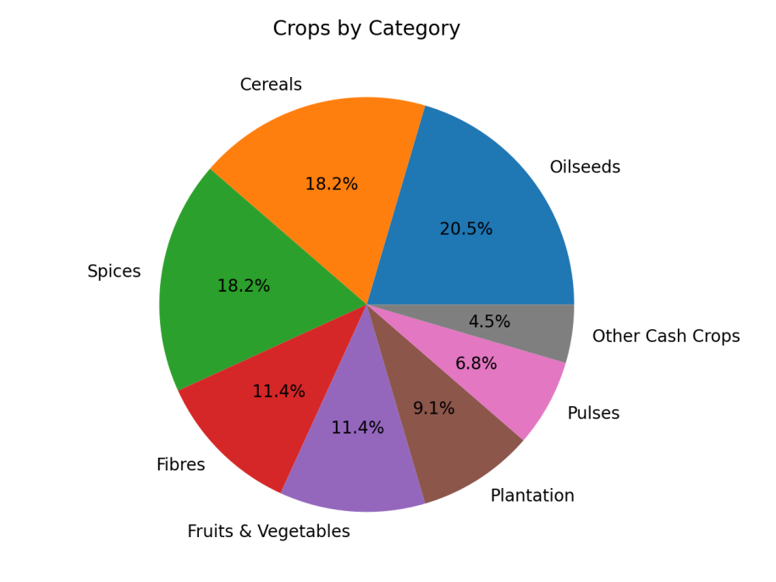
Figure 1: Crops by Category
Oilseeds is the largest category with 9 of the 44 crops (20.5%), followed by Cereals and Spices with 8 crops each (18.2%). Other Cash Crops is the smallest with only 2 crops (4.5%).

Chart 2: Top 10 Crops by Production (2010-11)
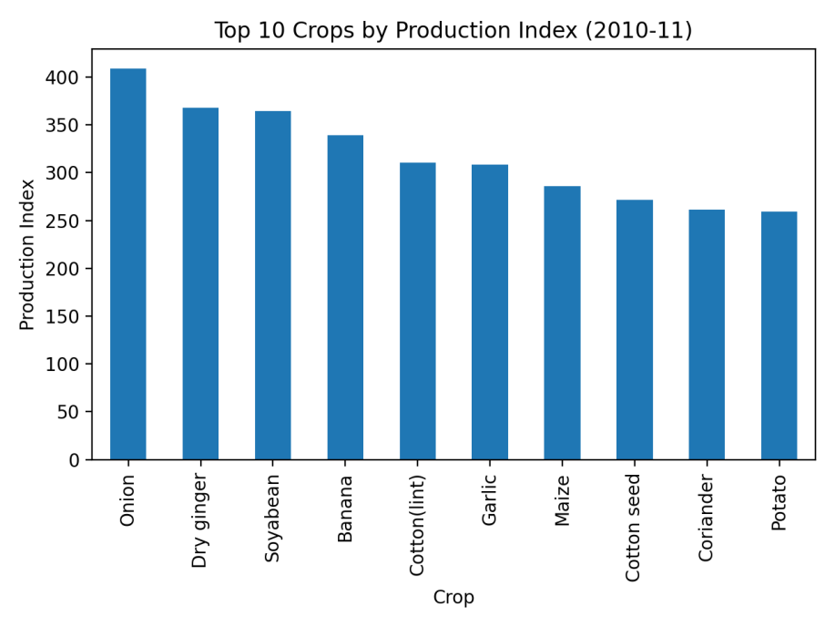
Figure 2: Top 10 Crops by Production Index (2010-11)
Onion has the highest production index at 409.1, followed by Dry ginger (368.1) and Soyabean (364.4). Spices, vegetables and fibre crops dominate the list. Maize (286.0) is the only cereal in the top 10.

Chart 3: Average Production, Area and Yield by Year
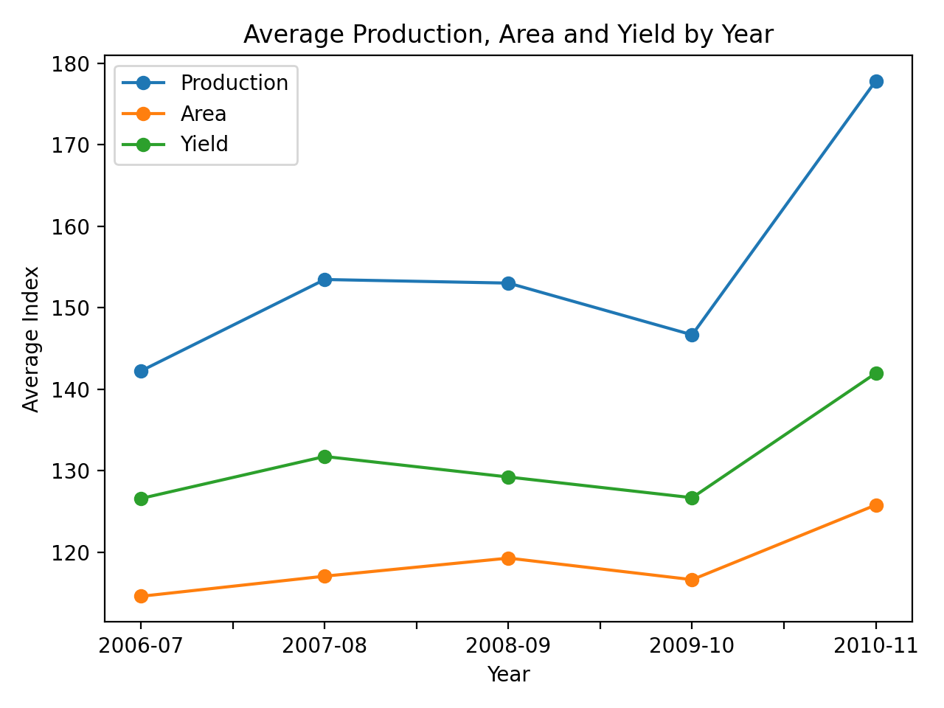
Figure 3: Average Production, Area and Yield by Year
The average production index rose from 142.2 in 2006-07 to 177.8 in 2010-11, an increase of 25.0%. It fell slightly in 2009-10 (146.7) and then jumped by 21.2% in 2010-11. Average area and yield moved in the same pattern, rising by 9.8% and 12.1% over the five years, which shows the growth came from both more area and better yield.

Chart 4: Average Production by Category (2010-11)
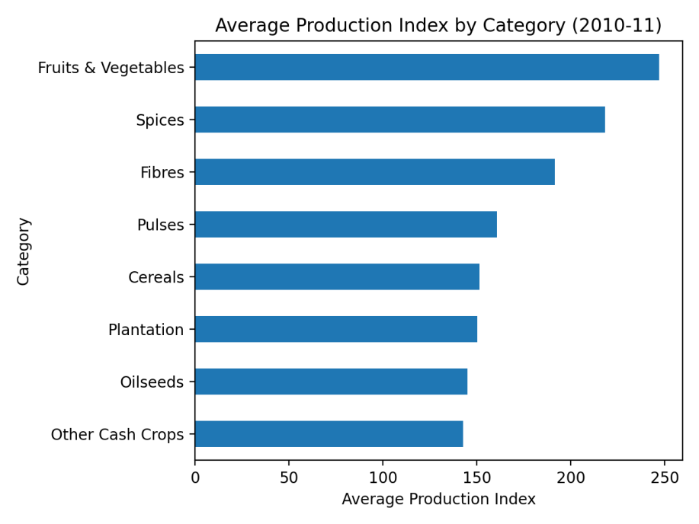
Figure 4: Average Production Index by Category (2010-11)
Fruits & Vegetables has the highest average production index at 247.2, followed by Spices (218.3) and Fibres (191.6). Other Cash Crops (142.6) and Oilseeds (145.1) have the lowest averages.

Chart 5: Top 10 Crops by Production Growth
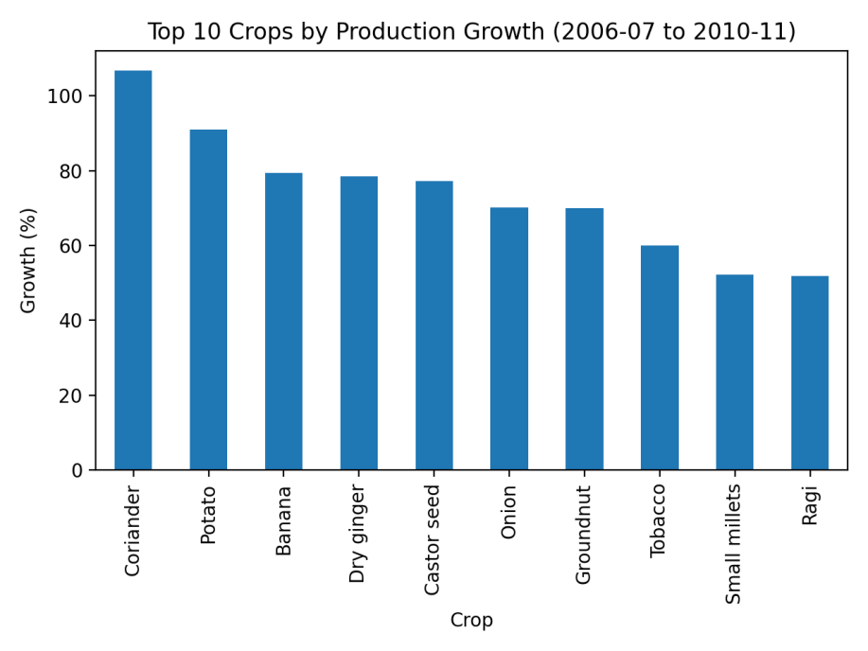
Figure 5: Top 10 Crops by Production Growth (2006-07 to 2010-11)
Coriander grew the most, with production up 106.7%, followed by Potato (90.9%), Banana (79.3%) and Dry ginger (78.4%). Overall, 30 of the 44 crops grew and 14 declined. The biggest falls were in Sunflower (-46.9%), Safflower (-37.4%) and Mesta (-36.1%).

Chart 6: Area vs Production (2010-11)
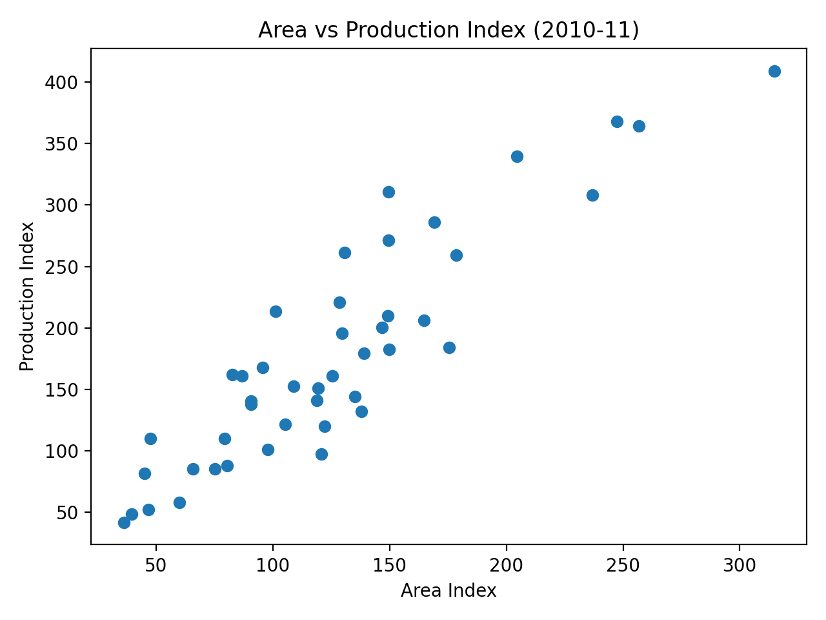
Figure 6: Area vs Production Index (2010-11)
Crops with a larger area index also tend to have a higher production index. The correlation between the two is 0.90, which is a strong positive relationship. Onion stands out with both the largest area index (314.7) and the highest production index (409.1).

5. Key Findings
- The cleaned dataset has 55 rows: 44 individual crops and 11 group totals. There are no missing values or duplicates.
- Oilseeds has the most crops (9 crops, 20.5%), followed by Cereals and Spices (8 crops each).
- Onion has the highest production index in 2010-11 (409.1), followed by Dry ginger (368.1) and Soyabean (364.4).
- Between 2006-07 and 2010-11, the average production index rose by 25.0%, the average area index by 9.8% and the average yield index by 12.1%.
- Fruits & Vegetables has the highest average production index (247.2) and Other Cash Crops the lowest (142.6).
- 30 of the 44 crops increased production. Coriander grew the most (+106.7%) and Sunflower fell the most (-46.9%).
- Staple cereals grew slowly compared with other crops: Rice +2.8%, Wheat +14.6%, while Maize grew +43.9%. Total Foodgrains grew 12.7%.
- Area and production are strongly related (correlation 0.90).

6. Recommendations
- Support the fast-growing and high-production crops such as Onion, Potato, Banana and spices with better storage, transport and market access, so that higher production is not wasted.
- Study why Sunflower, Safflower, Mesta, Coconut and Black pepper declined (for example price, rainfall or farmers shifting to other crops) and give targeted support to these crops.
- Improve the yield of Rice and Wheat through better seeds and irrigation, because their production grew only 2.8% and 14.6%.
- Since area and production are strongly linked, increasing cultivated area works, but crops with low yield should also be given priority for yield improvement.

7. Conclusion
The analysis of 44 crops from 2006-07 to 2010-11 shows that crop production grew strongly over the period, with the average production index up 25.0%, helped by both a larger area and a higher yield. Fruits & Vegetables and Spices lead in production, while Cereals and Oilseeds are lower on average. Growth was uneven: most crops grew, but some, such as Sunflower and Coconut, declined sharply. The data are index numbers for five years only, so the findings show relative trends for this period and not actual tonnes. Based on these results, the following actions are suggested:
- Back the growing crops. Invest in storage, transport and markets for Onion, Potato, Banana and spices.
- Investigate the declining crops. Find the reasons for the fall in Sunflower, Safflower, Mesta, Coconut and Black pepper and support them.
- Raise yield of staple cereals. Rice and Wheat grew slowly, so better seeds and irrigation can improve their output.

