QuickAI
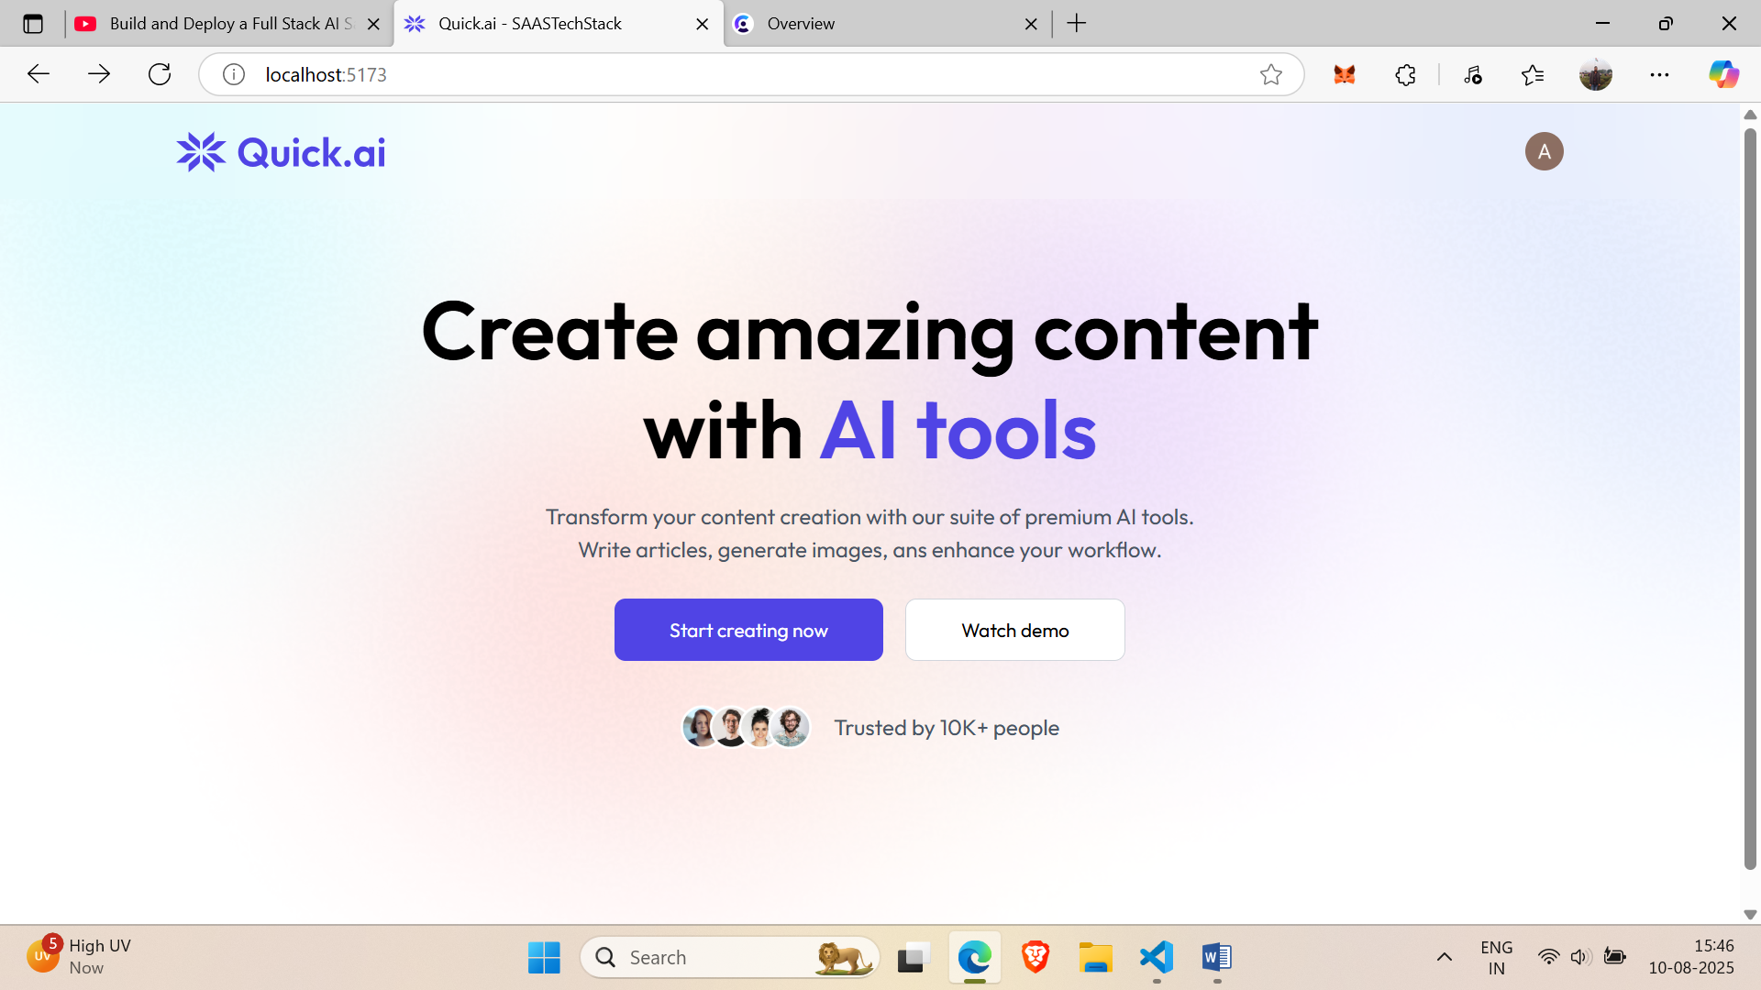
Hero.jsx
Sign-in using clerk by get started button
Navbar.jsx=logo+get started button
Add hero page on home(mount)

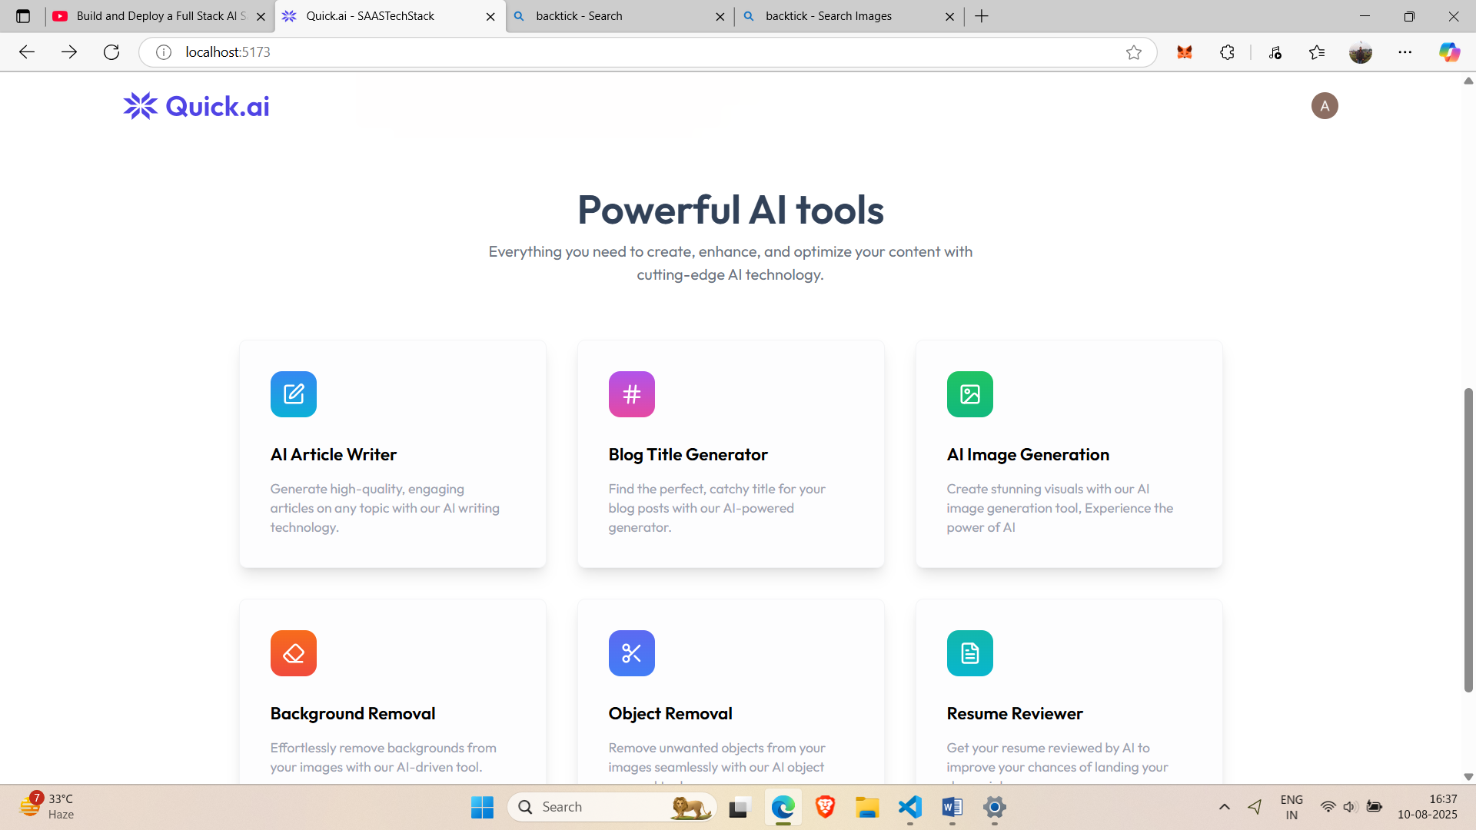
for above we added aitools in home
Ai tools uses aitoolsdata in assessts,jsx that tells about theses six cells

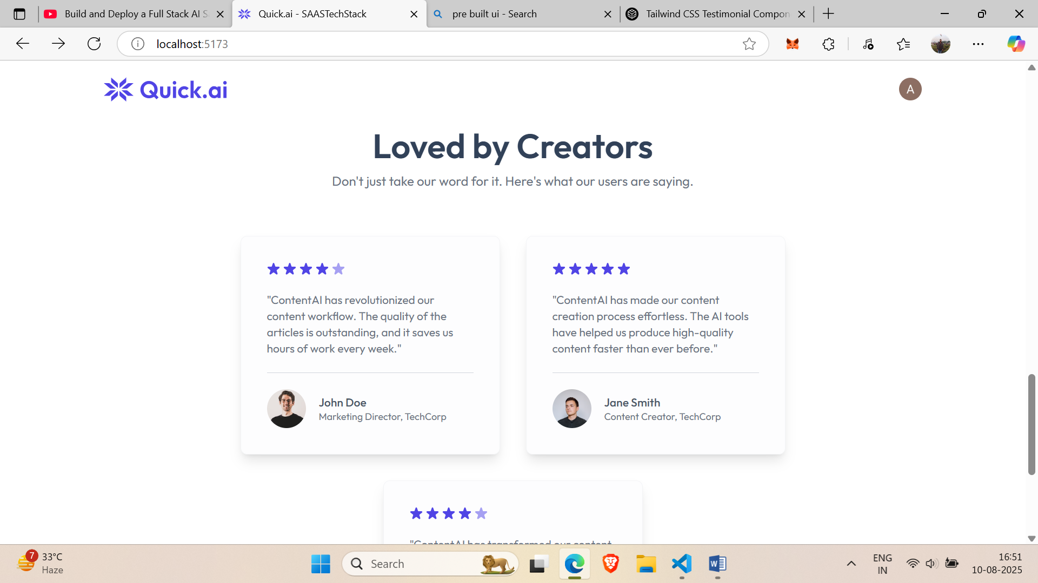
used code from prebuilt ai .com under components just changed svg tags to rating mech between div at 36 line in testimonial.jsx
Mounted testimonial on home page
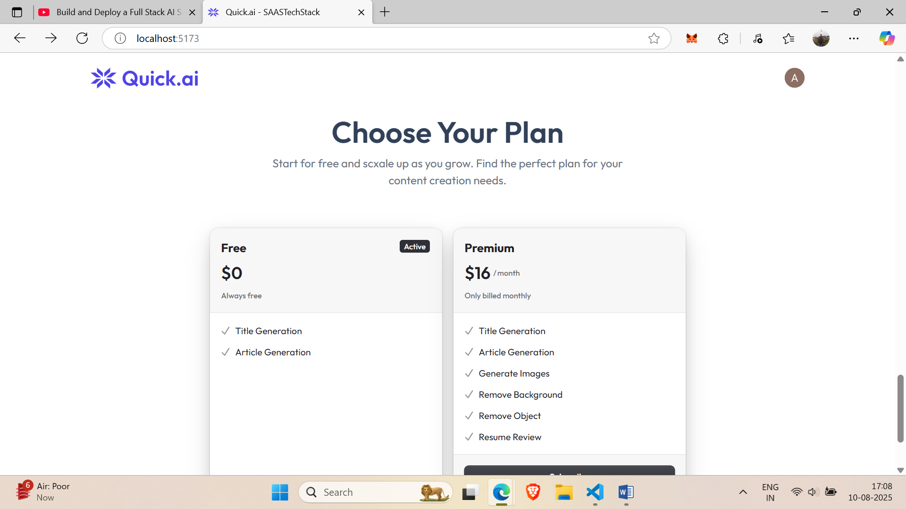
above plan is created using clerk on plan.jsx and then mounted on home

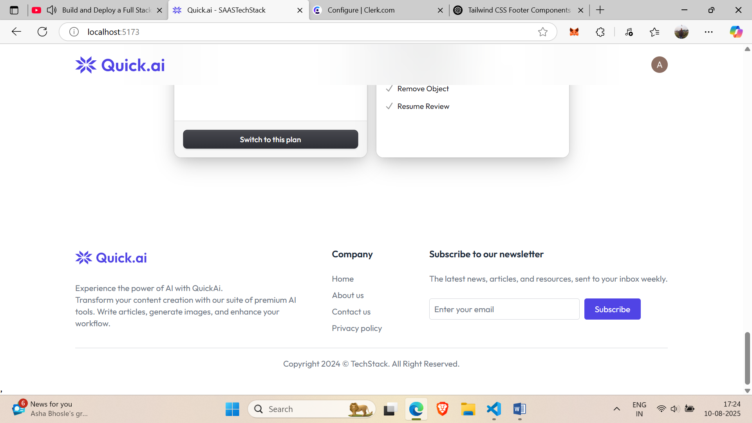
Added footer from prebuil.ai code and mounted on home

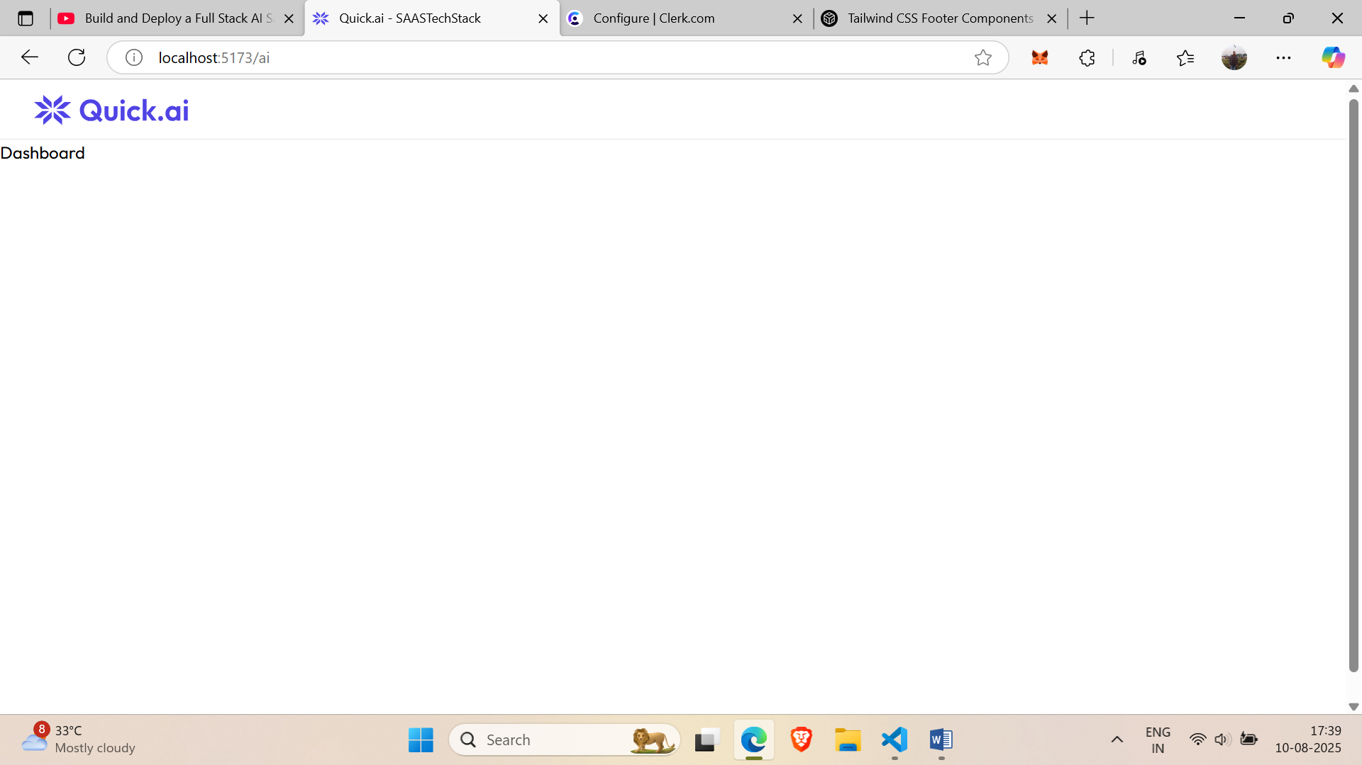
Then updated layout for side bar and navbar linebelow the logo and side bar icon that is hidden o full screen and visible on right on small screen
After this create sidebar.jsx in components
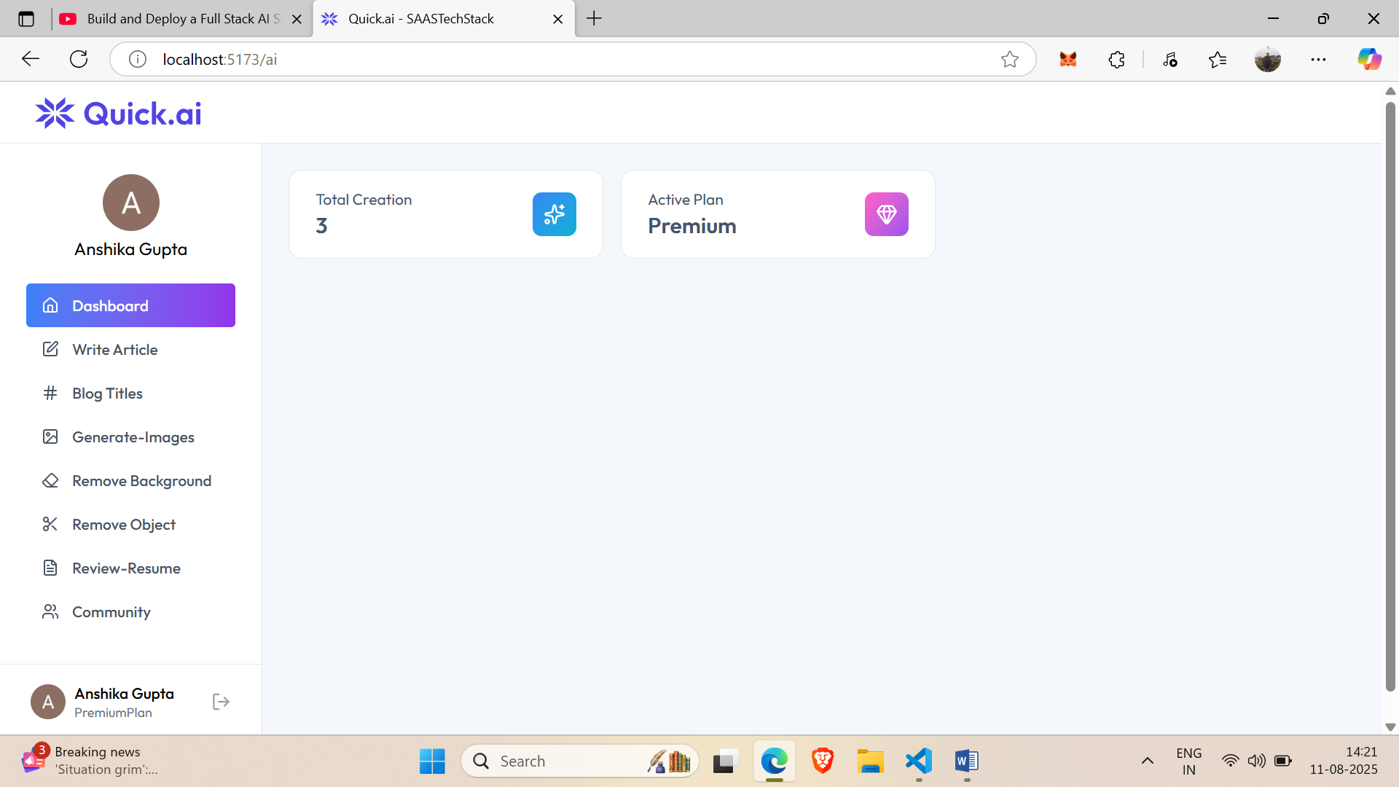
After sidebar.jsx that includes few pre-built cdes
Now change dashboard.jsx
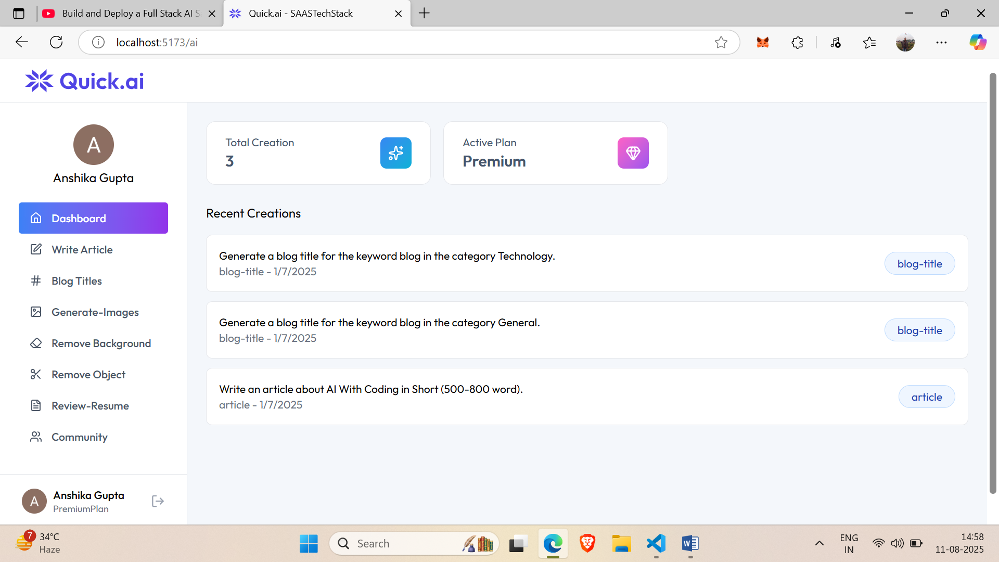
after this we created creationItems.jsx containing the recscent creation their expanded and non expanded views

Similarly create all the pages according to ui
Once the frontend(-client folder) is completed let’s create backend-server folder
Create server.js
And then rightclick to open integrated terminal simultaneous to running frontend and then run few npm cmd for installing pakage required in backend
npm install express dotenv cors axios cloudinary multer
{
Express-for backend server,
Dotenv-to create the .env file and store the environment variables
Cors- to connect the backend with any frontend
Axios-to make api calls
Cloudinary-to store images on cloud storage
Multer-upload the images
}
Then install nodemon for restarting the projrct after making any changes and is installed in dev
“npm install --save-dev nodemon”

After this make few changes in pakage.json(test:””)to(server:””)
And then implement server.js
And then use NEON for storage and connecting database using given string in neon app and integrating it in our project. Create a new project in neo and azure and then click connect button and copy the string.
And then in neon applications in the project under production and sql editor we need to create our table that we need for storing te data
Then connect backend to clerk for been able to fetch the data for that see clerk docs for express and follow instructions
Db.js has links to db
Auth.js verifies weather user is premium for free with user id and if free then initiates the free_usage credits=0
aiController.js has a function generateArticle that check if user is on free trial and has used 10 or (available credits) credits already then it won’t generate more articles

4:17

