(Project name)



For the award of the degree of

Master of Computer Applications
In
Computer Applications

By

SHIFALI PRASHAR



GOVT. COLLEGE DHARAMSHALA

HIMACHAL PRADESH JULY 2023-2025

University Roll No.—23013728028 Class Roll No.--23232

CERTIFICATE

This is to certify that the work presented in this Project entitled “Grocery Management System” is a bonafide record of the work done during the period from Jan – June 2023 at “FUTURE FINDERS” by <your name>

The project work is an authentic record of my own work and is carried out under the supervision and guidance of Guide <GUIDE NAME>, <X> Department. The matter presented in the report has not been submitted elsewhere, wholly or in part, for the award of any other degree or diploma.

Your name(19xxxxx)

This is to certify that the above statement made by the candidate is correct to the best of my knowledge.

<Guide name>
Guide Name

Department of <X>

<HOD NAME>
HOD <X>

<X> Department Chandigarh Engineering College, Landran, Mohali, PUNJAB

DECLARATION

I hereby declare that the Project Report entitled “HEART DISEASE PREDICTION USING MACHINE LEARNING” is an authentic record of our own work as requirement of project during the period from 19 March,2022 to 31 May,2022 for the award of degree of B.Tech.(CSE) ,IK Gujral Punjab Technical University Campus,Hoshairpur , under the guidance of Dr Brijesh Bakariya.

Date <Name><Roll no>

Certified that the above statement made by the student is correct to the best of our knowledge And belief.

Signatures
Examined by:

1. 2. 3. 4.

Head of Department
(Signature and Seal)

Acknowledgment
I express my sincere gratitude to the I.K. Gujral Punjab Technical University, Kapurthala for giving me the opportunity to work on the Major Project during my final year of B.Tech (CSE) is an important aspect in the field of engineering.

I would like to thank Deputy Director Dr. Reetipal Singh, Principal and Dr. Brijesh Bakariya, Head of Department,CSE at I.K G PTU Campus Hoshiarpur for their kind support.

I also owe my sincerest gratitude towards Dr. Brijesh Bakariya for his valuable advice and healthy criticism throughout my project which helped me immensely to complete my work successfully.I would also like to thank everyone who has knowingly and unknowingly helped me throughout my work. Last but not least, a word of thanks for the authors of all those books and papers which I have consulted during my project work as well as for the preparing report.

<Name>
<Roll no>
<Branch>

INDEX
- Introduction
1.1 What is SDLC?
1.2 Importance of SDLC
- Phases of SDLC
2.1 Requirement Analysis
2.2 System Design
2.3 Implementation (Coding)
2.4 Testing
2.5 Deployment
2.6 Maintenance
- Overview of the E-Commerce Delivery Dashboard
3.1 Project Objective
3.2 Dataset Description
3.3 Tools and Technologies Used
- Mapping SDLC Phases to the Project
4.1 Requirement Analysis in this Project
4.2 System Design in this Project
4.3 Implementation in this Project (Code Walkthrough)
4.4 Testing in this Project (Model Evaluation)
4.5 Deployment in this Project (Streamlit Hosting)
4.6 Maintenance in this Project (Future Scope)
- Machine Learning Lifecycle vs. SDLC
5.1 ML Lifecycle Phases
5.2 How They Connect in This Project
- Conclusion
- References

Introduction
Introduction
The Advanced General Health Checkup Dashboard is an interactive, web-based application designed to assist healthcare professionals, researchers, and data analysts in exploring and analyzing individual health checkup data efficiently. Built using the Python Streamlit framework, this dashboard offers user-friendly tools for filtering health records by demographics and medical conditions, visualizing critical health indicators, and identifying potential health risks.
In an era where large volumes of health-related data are generated routinely, having accessible and dynamic tools that facilitate insightful analysis is essential. This project aims to bridge the gap between complex health data and actionable understanding by providing an intuitive platform that supports personalized exploration, visual analytics, and data-driven decision-making.
Through this dashboard, users can examine the distribution of key metrics such as BMI, chronic disease prevalence, and lifestyle factors, uncover correlations, and export customized datasets for further offline analysis. The project embraces modern data visualization techniques and interactive UI components, making health data exploration engaging and effective across various user groups.
If you'd like, I can also help you draft introductions tailored for presentations, proposals, or academic papers. Just let me know!

1.1.2. COMPANY PROFILE

ABOUT COMPANY:
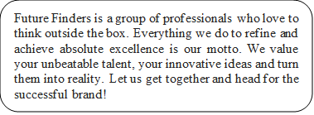

PHILOSOPHY

- To impart hardcore practical quality training among students/developers about latest technologies trending today.
- To share knowledge of information security and create awareness in the market. The solution to clients' as per the International standard practices and governance.

- To support good business practices through continual employee training and education
- To equip a local team with a strong knowledge of international best practices and international expert support so as to provide practical advisories in the best interests of our clients



COMPANY’S VISION & MISSION
FUTURE FINDERS only vision is to provide with cutting edge practical skills so that students can easily cope with and quickly adapt to the ever- changing technologies in the corporate environment. Our mission at FUTURE FINDERS is to create the highest standards in education through improvisation of quality and practical skills.

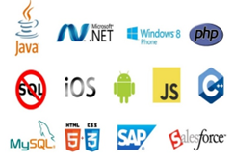 SERVICES

- Software Testing

- Mobile Application Testing
- Web Development
- Web Designing
- Mobile App Development
- Digital Marketing Services
Embedded System Services
Why Choose Us?
- Hundreds of Clients & Nearly a Decade of Experience
- Goal Oriented, ROI-Driven Focus
- A Streamlined / Quality-Driven Process
- Talented Designers & Expert Developers
- Our Websites & E-marketing Platforms are Easy to Manage
- We Are Dedicated to Our Clients’ Success

- We focus on imparting practical skills to the trainees & not just theoretical knowledge. The courses are designed in this way at FUTURE FINDERS correspond to the standards of the corporate divisions and industries. Only through the acquisition of practical skills; you can handle the everlasting technologies that venture out in real-time situations.
- At FUTURE FINDERS, we have competence to expand and adjust as per client specific requirements.
- Skilled Workforce: At FUTURE FINDERS, you deal with the highly professional and proficient employees.
- Cost Efficiency: We help you to reduce the unnecessary investment and ask for the reasonable amount of money.
- Quality Of the Product: Our software service sector has been maintaining the highest international standards of quality.
- Infrastructure: Well organized team and tools to handle the projects with responsible approach Hardware, Software, Networking, Voice, Conferencing, disaster recovery all infra all you need for international projects.
- Ongoing Involvement: FUTURE FINDERS, products are “built for change” as we are well responsive that the necessity to improve a Web solution generally arises even before the solution is out of the door.

- Partnership: FUTURE FINDERS, considers every client a partner. From the initial stages, you are closely involved into the procedure of technical classification, development, and testing.

KEY PROFESSIONALS

In addition to a panel of eminent consultants and advisors, we have a dedicated pool of trained Developers and Trainer, investigators, working under the guidance of professional managers. “A Ship is as good as the crew who sail her.” Our Technical team of professionals handing, designing & delivering of projects has a strong presence in the North India & the US. Our engineers are already working on the latest technologies like I-Phone & Android Applications, Robotics, VLSI-VHDL, Embedded System, Networking and Cloud computing. Our key professionals and advisors are listed below:

MR. BONISH SINGLA: (DIRECTOR)
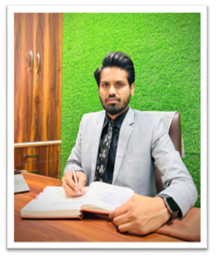

He is the backbone of FUTURE FINDERS, and a man with more than 9 years rich practical experience who believes in taking up new ventures and projects. He has been awarded many times for his exemplary work in process improvement for IT Service Delivery Domains. MASTERS in Computer applications and Certified from CU Certification. Holds total of 9 Years of rich experience including 5 Years in Information Security Implementation, Maintenance and Auditing and initial over 4 years of experience in Project Management, Client Relationship Management and Server, Desktop and IT Service Delivery/

MISS.HARJIT KAUR: (BRANCH MANAGER)

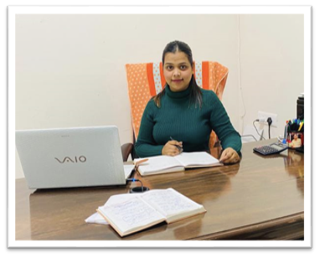

She has more than 5 years solid industrial experience in software companies & is very innovative in her technical approach. MCA, Diploma in Information Technology, expertise in search engine optimization and web designing.

MISS. ISHA BALA: (HUMAN RESOURCES)
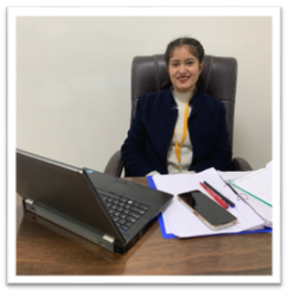
A very committed team leader and multi-talented person, who has been professionally attached with company.

MISS. DIVYA: (HEAD COUNCILOR)
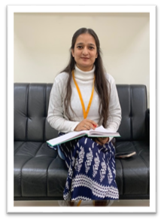
She is determinate and a team player. She is good at problem solving skills and a fast learner. She can do multitasking.

MR. SUKHBIR SINGH: (TECHNICAL HEAD)
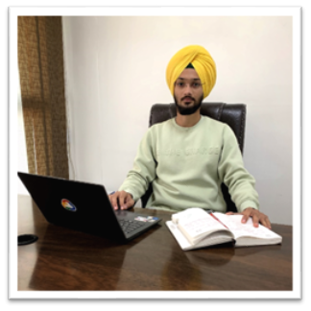
He has more than 3 years of experience in PLC and Scada.). He has been awarded many times for his brilliant services.

MR. JASPAL SINGH: (CIVIL &MECHANICAL HEAD)
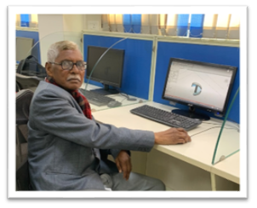
He has more than 38years of experience in industrial field. He is providing services as a technical trainer for more than 8 years. He did his B.Tech in Mechanical Engineering from PEC (Punjab Engineering College). He has been awarded many times for his brilliant services.

MR. CHETAN KALRA: (DIGITAL MARKETING HEAD)
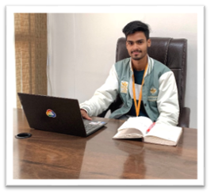
B.tech (CSE) – IKG-PTU, Expertise in Python Programming, Full Stack Development, Presenting ideas for web development software, including Application software, Working closely with analysts, Senior Developers, Programmers, designers and staff, Producing detailed specifications and writing the program codes, Testing the product in controlled, real situations before going live, Preparation of training manuals for users and Maintaining the systems once they are up and running.

1.3 ABOUT THE COURSE

What is Python?
Python is an interpreted, object-oriented, high-level programming language with dynamic semantics. Its high-level built in data structures, combined with dynamic typing and dynamic binding, make it very attractive for Rapid Application Development, as well as for use as a scripting or glue language to connect existing components together. Python's simple, easy to learn syntax emphasizes readability and therefore reduces the cost of program maintenance. Python supports modules and packages, which encourages program modularity and code reuse. The Python interpreter and the extensive standard library are available in source or binary form without charge for all major platforms, and can be freely distributed.

Why Python?
Programmers fall in love with Python because of the increased productivity it provides. Since there is no compilation step, the edit-test-debug cycle is incredibly fast. Debugging Python programs is easy: a bug or bad input will never cause a segmentation fault. Instead, when the interpreter discovers an error, it raises an exception. When the program doesn't catch the exception, the interpreter prints a stack trace. A source level debugger allows inspection of local and global variables, evaluation of arbitrary expressions, setting breakpoints, stepping through the code a line at a time, and so on. The debugger is written in Python itself, testifying to Python's introspective power. On the other hand, often the quickest way to debug a program is to add a few print statements to the source: the fast edit-test-debug cycle makes this simple approach very effective.

Course Outline

Module 1: Basics of Python
- Fundamental concepts
- Control Statements
- Data Types
- Methods and Function
- Recursion and Backtracking
Module 2: OOPs Concepts
- Objects and Classes
- Inheritance
- Polymorphism
- Encapsulation
- Abstraction and Interface
Module 3: Modules
- Numpy Library
- Pandas Library
- MatPlotLib Library
- Scipy Library
Module 4: Error and File Handling
- Try and Except
- Else and Finally
- Read Files
- Write/Create Files
- Delete Files
Module 5: Machine Learning
- Introduction
- Supervised Learning
- Unsupervised Learning
- Training set and testing set
- Model training

1. Executive Summary
This report presents the Advanced General Health Checkup Dashboard, an interactive web-based application developed using the Streamlit framework to facilitate interactive exploration and visualization of individual health checkup data. The application supports filtering by demographics and health conditions, visualizes key health metrics and relationships, flags potential health risks, and allows exporting customized datasets for offline analysis.
The dashboard aims to empower healthcare professionals, data analysts, and researchers to efficiently analyze health profiles, identify risk factors, and glean insights to support decision-making and personalized care strategies.
2. Project Background and Motivation
With increasing volumes of health data generated from regular checkups, there is a growing need for accessible tools that enable non-technical stakeholders to analyze and interpret complex health information. Traditional static reports or spreadsheets can be overwhelming and do not allow dynamic filtering or interactive visualization.
Streamlit, a modern Python app framework, provides an ideal environment to rapidly develop such interactive dashboards. This project harnesses Streamlit’s capabilities to develop a user-friendly health analytics dashboard using real-world health data features such as general health ratings, medical conditions, demographics, anthropometric data, and lifestyle habits.
3. Data Description
3.1 Source and Format
The dataset contains anonymized records of individual health checkups, structured as a CSV file named data.csv. Each row corresponds to one individual’s recent checkup data and includes a mixture of categorical, binary, and numerical variables.
3.2 Data Fields
Field Name | Data Type | Description
General_HealthCheck | Categorical | Overall health assessment label (e.g., Excellent, Very Good, Good, Fair, Poor)
Exercise | Categorical | Last known exercise activity (within past year, past 2 years, 5+ years ago)
Heart_Disease, Skin_Cancer, Other_Cancer, Depression, Diabetes, Arthritis | Binary (Yes/No) | Presence or absence of specific chronic conditions
Sex | Categorical | Biological sex (Male or Female)
Age_Category | Categorical | Age group bracket (e.g., 18-24, 65-69, 80+)
Height_(cm) | Numeric | Measured height in centimeters
Weight_(kg) | Numeric | Measured weight in kilograms
BMI | Numeric | Body Mass Index calculated from height and weight
Smoking_History | Binary | Indicates smoking history (Yes/No)
Alcohol_Consumption | Numeric | Frequency or quantity of alcohol intake
Fruit_Consumption | Numeric | Frequency or quantity of fruit consumption
Green_Vegetables_Consumption | Numeric | Frequency or quantity of green vegetable consumption
FriedPotato_Consumption | Numeric | Frequency or quantity of fried potato consumption
3.3 Data Cleaning and Preparation
Initial data integrity checks revealed formatting inconsistencies such as merged header names, which were corrected by ensuring proper delimiter usage (comma-separated). Missing values were handled by excluding them from visualizations or replacing with reasonable defaults where necessary. Data types were explicitly set to enable efficient filtering and calculation.
4. Technologies Employed
Technology | Purpose
Python 3.x | Core language for data processing and app logic
Streamlit | Framework for building the interactive web app
Pandas | Data manipulation and aggregation
Matplotlib & Seaborn | Plotting and data visualization
NumPy | Numerical computations
5. System Architecture and Workflow
The project follows a simple yet effective architecture:
- Data Loading: CSV data is loaded into a pandas DataFrame. The use of Streamlit caching (@st.cache_data) optimizes performance by avoiding repeated loading.
- User Inputs and Filtering: Through the sidebar, users select filters for age, sex, general health status, and specific chronic conditions. These filter selections dynamically subset the main dataset.
- Data Display and Summary: The app displays the first 25 records from the filtered data alongside descriptive statistics such as means, medians, and counts.
- Health Risk Alerts: Automated flags highlight individuals who meet criteria indicating elevated health risks such as high BMI (>30) or diabetes presence.
- Visual Analytics: Multiple tabbed views present histograms of BMI, bar charts summarizing health condition prevalences, consumption trends for fruits and vegetables, and more.
- Correlation Exploration: Heatmaps and grouped aggregations expose relationships between variables, helping identify behavioral or physiological patterns.
- Data Export: Users can download the currently filtered data subset as a CSV file for offline use or further analysis.
6. Detailed Feature Set
6.1 Sidebar Filters
- Age Category: Multi-select filter with all age groups.
- Sex: Multi-select for Male/Female.
- General Health Status: Multi-select (e.g., Excellent, Good).
- Chronic Conditions: Each illness is a multi-select of Yes/No to tailor analysis to specific patient subsets.
6.2 Tabs and Content
Tab 1: Summary
- Displays filtered data preview.
- Provides descriptive numeric statistics for quick appraisal.
- Shows health alerts identifying individuals with BMI > 30 or diabetes, to focus attention on at-risk groups.
Tab 2: Visualizations
- Histogram of BMI values for population distribution understanding.
- Bar charts of general health categories and diabetes prevalence.
- Grouped bar charts comparing fruit and vegetable intake by health status.
Tab 3: Correlations
- Heatmap of Pearson correlations between height, weight, BMI, and diet factors.
- Table of mean BMI values stratified by age and sex, enabling demographic comparison.
Tab 4: Export Data
- Downloadable CSV of filtered dataset supporting offline review or integration with other tools.
6.3 Additional UX Enhancements
- Use of Streamlit tabs improves navigation.
- Responsive plotting using Seaborn and Matplotlib for clarity.
- Health alerts provide actionable insights instantly.
7. Analytical Insights Enabled by the Dashboard
- BMI Distribution: Identify prevalence of underweight, normal, overweight, and obese classifications within filtered populations.
- Health Status Trends: Visualize how chronic conditions and lifestyle habits distribute among different age and sex demographics.
- Diet Versus Health: Examine correlations suggesting links between fruit / vegetable consumption and overall health status.
- High-Risk Individuals: Instantly identify subpopulations requiring further clinical attention based on BMI/diabetes criteria.
8. Challenges and Solutions
- Data Format Issues: Initially, column headers were merged, causing key errors in column referencing. This was resolved by correct CSV formatting.
- Filtering Logic Complexity: Enabling multi-filter criteria across categorical and binary columns required careful Boolean indexing to maintain accuracy.
- Performance Considerations: Leveraged Streamlit’s caching decorator to avoid repeated costly data loading.
- Visual Clarity: Selected color palettes and plot types optimized for legibility and quick comprehension.
9. Usage Guide
- Place data.csv in the project root directory.
- Install required Python packages:
text
pip install streamlit pandas matplotlib seaborn numpy
- Run the app with:
text
streamlit run app.py
- Use the sidebar filters to select the demographics and health conditions of interest.
- Navigate through tabs to explore summary statistics, visualizations, and correlation heatmaps.
- Download filtered data from the Export tab for offline use.
- Monitor health alerts at the summary tab for subjects with potential health concerns.
10. Future Work and Enhancements
- Time-Series Analysis: Incorporate longitudinal data to track health trends over time.
- Predictive Modeling: Integrate machine learning algorithms to assess personalized risk scores.
- User Accounts: Implement authentication to save user filter configurations.
- Interactive Visualizations: Utilize tools like Plotly for more interactive charting features.
- Integration with Medical Records: Link with Electronic Medical Record (EMR) systems for real-world pipeline deployment.
- Automated Reports: Generate downloadable PDF or HTML summaries per filter set.
11. Conclusion
The Advanced General Health Checkup Dashboard serves as a versatile and intuitive platform for interactive health data analysis. It combines powerful filtering mechanisms, visual analytics, health risk identification, and data export capabilities into a single accessible web application. This project lays the groundwork for sophisticated health informatics tools that foster data-driven interventions and personalized care.

