Name: Anshika Jain

Email ID: [Pgp20anshikajain@imt.ac.in](mailto:Pgp20anshikajain@imt.ac.in)

Roll number: 200103034

DSA Individual Assignment

Submitted to:

Prof. (Dr.) Sridhar Vaithianathan

Associate Professor, analytics, IMT – Hyderabad

18th December, 2020

__________________________________________________________________________________________

R Markdown

#basic functions (mathematic operations)  
a=5 #assigning value to variable a  
b=7 #assigning value to variable b  
a+b

## [1] 12

a-b

## [1] -2

a*b

## [1] 35

a/b

## [1] 0.7142857

a%%b #Modulus function: Remainder of a/b

## [1] 5

#print function   
  
print("I am anshika jain")

## [1] "I am anshika jain"

sprintf("sum of the two numbers=%d", 4+7) #%d used for whole number output

## [1] "sum of the two numbers=11"

sprintf("modulus of 80/3=%f", 80/3) #%f used for fraction

## [1] "modulus of 80/3=26.666667"

sprintf("modulus of 80/3=%0.2f", 80/3) #%0.2f inidcates output till 2 decimal spaces

## [1] "modulus of 80/3=26.67"

a=80  
b=3   
round(a/b) #Round off to the nearest whole number

## [1] 27

##vectors concept  
  
A= c(1,2,3,4,5) #A is a variable, c is the combined function   
length(A) #Finding the length of the combined function A

## [1] 5

A[c(1,3)] #Finding the number on the 1st and 3rd position

## [1] 1 3

A[5]= 10 #Replacing the number on the 5th position with 10  
A

## [1] 1 2 3 4 10

sort(A) #Arranging in ascending order

## [1] 1 2 3 4 10

#Sequence concept  
  
#creating a sequence from 6 to 21 with a difference of 3  
AddThree = seq(from=6, to=21, by=3)  
AddThree

## [1] 6 9 12 15 18 21

#creating a series of 10 even numbers   
Even= seq(from=2, by=2, length=10)  
Even

## [1] 2 4 6 8 10 12 14 16 18 20

#Value of TRUE = 1 and False= 0   
  
sprintf("is four present in even?=%s", 4%in%Even) #%s is to get output in terms of true or false

## [1] "is four present in even?=TRUE"

sprintf("is four present in even?=%d", 4%in%Even) #%d is to get output in terms of 1(true) or 0(false)

## [1] "is four present in even?=1"

#If-Else function   
  
#Identifying the eligibility for voting or driving or both from age data   
  
age=19   
  
if(age>=18){  
 print("Drive and vote")  
} else if(age>=16){  
 print("Drive")  
} else  
 print("Not eligible")

## [1] "Drive and vote"

#Switch concept  
  
grade = "B"  
  
switch (grade ,  
 "A" = print("Great"),  
 "B" = print("Good"),  
 "c" = print("Average"),  
 "D" = print("Bad"),  
 print("no such grade"))

## [1] "Good"

#String concept  
  
str1= "this is a string module"  
nchar(str1) #counting the number of characters in a string

## [1] 23

str2= paste("owl", "bear", sep = ",") #sep refers to separator (how words in string are to be separated)  
str2

## [1] "owl,bear"

substr(str2, 5, 8) #printing a sub-part of a string (4 and 8 are starting character and ending character)

## [1] "bear"

sub("owl", "hawk", str2) #replacing a word in a string

## [1] "hawk,bear"

#Factors vector concept   
  
Direction = c("up", "down", "right", "left", "down", "left")  
  
factor(Direction) #Finding unique values from a function

## [1] up down right left down left   
## Levels: down left right up

#Data Frames concept   
  
#Data frames concept enables you to document data in tabular form and present data more logically and clearly   
  
customerdata = data.frame(name = c("Tom", "sally", "Sue"), age= c(43,28,42), stringsAsFactors = T)  
  
customerdata

## name age  
## 1 Tom 43  
## 2 sally 28  
## 3 Sue 42

NewRecord = data.frame(name="mark", age=22)  
finalCustomerData = rbind(NewRecord, customerdata) #Binding two frames by rows  
finalCustomerData

## name age  
## 1 mark 22  
## 2 Tom 43  
## 3 sally 28  
## 4 Sue 42

customerdata[1,1:2] #fetching details from row 1, two columns

## name age  
## 1 Tom 43

CustomerId = c(101,102,103,104)   
CustData= cbind(finalCustomerData,CustomerId) #binding two frames by column  
CustData

## name age CustomerId  
## 1 mark 22 101  
## 2 Tom 43 102  
## 3 sally 28 103  
## 4 Sue 42 104

#Matrix Concept   
  
Mat= matrix(data = c(1,2,3,4,5), nrow = 5, ncol =5)  
Mat

## [,1] [,2] [,3] [,4] [,5]  
## [1,] 1 1 1 1 1  
## [2,] 2 2 2 2 2  
## [3,] 3 3 3 3 3  
## [4,] 4 4 4 4 4  
## [5,] 5 5 5 5 5

plot(Mat)

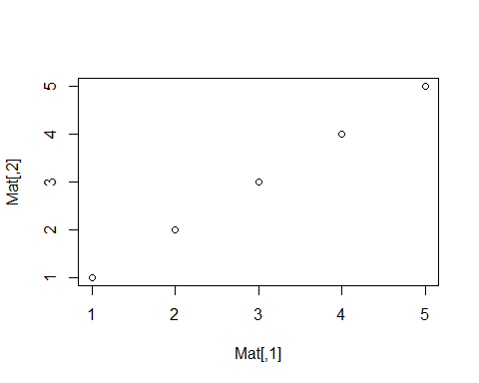

#Plotting a line  
X2= c(1,2,3,4,5)  
y2= c(5,4,3,2,1)  
  
plot(X2, y2, type = "l")

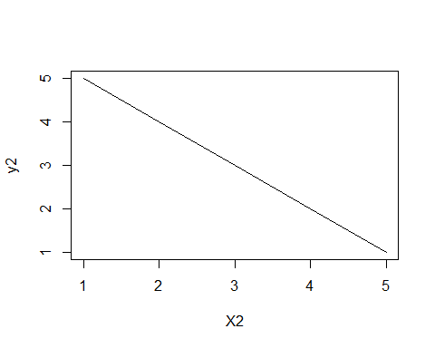

#Array Concept   
  
theArray = array(1:12, dim=c(2,3,2))# Total Elements = R x C x OD  
theArray

## , , 1  
##   
## [,1] [,2] [,3]  
## [1,] 1 3 5  
## [2,] 2 4 6  
##   
## , , 2  
##   
## [,1] [,2] [,3]  
## [1,] 7 9 11  
## [2,] 8 10 12

theArray [1, ,]# Accessing all elements from Row 1, all columns, all outer dimensions & build C x OD (R x C)

## [,1] [,2]  
## [1,] 1 7  
## [2,] 3 9  
## [3,] 5 11

theArray[1, ,1]# Accessing all elements from Row 1, all columns, first outer dimension

## [1] 1 3 5

theArray[, ,1]# Accessing all rows, all columns, first outer dimension

## [,1] [,2] [,3]  
## [1,] 1 3 5  
## [2,] 2 4 6

# Array with Four Outer Dimensions (OD)  
theArray_4D = array(1:32, dim=c(2,4,4))  
theArray_4D

## , , 1  
##   
## [,1] [,2] [,3] [,4]  
## [1,] 1 3 5 7  
## [2,] 2 4 6 8  
##   
## , , 2  
##   
## [,1] [,2] [,3] [,4]  
## [1,] 9 11 13 15  
## [2,] 10 12 14 16  
##   
## , , 3  
##   
## [,1] [,2] [,3] [,4]  
## [1,] 17 19 21 23  
## [2,] 18 20 22 24  
##   
## , , 4  
##   
## [,1] [,2] [,3] [,4]  
## [1,] 25 27 29 31  
## [2,] 26 28 30 32

theArray_4D [1, ,]

## [,1] [,2] [,3] [,4]  
## [1,] 1 9 17 25  
## [2,] 3 11 19 27  
## [3,] 5 13 21 29  
## [4,] 7 15 23 31

theArray_4D[1, ,1]

## [1] 1 3 5 7

theArray[, ,1]

## [,1] [,2] [,3]  
## [1,] 1 3 5  
## [2,] 2 4 6

Learnings from the assignment

* R is a simple programming language containing ‘easy to use’ functions
* R programming allows instant execution of mathematical operations, conditions, and parameters
* R programming has simple functions that can be used in treatment of huge data sets in a short span of time
* R programming is also an efficient tool for statistical operations, graphical representation and more
* R programming enables simple and ‘easy to understand’ ways of documentation, calculations as well as analysis