Assignment 3 - Java (Scanner Class)
Name: Anshika Tyagi

Question 1: Sum of Two Numbers
Java program to accept two integers, calculate and display their sum.
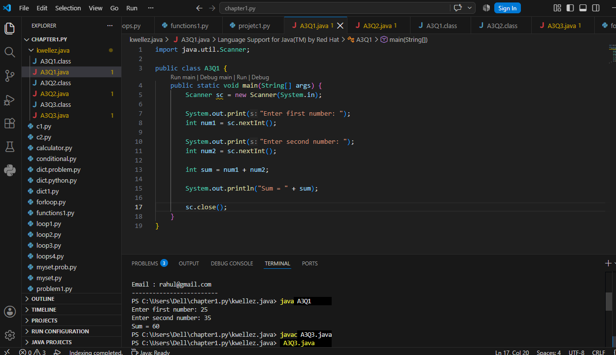

Question 2: Email Address Input
Java program to accept the user's full name and email address, and display both in a formatted manner.
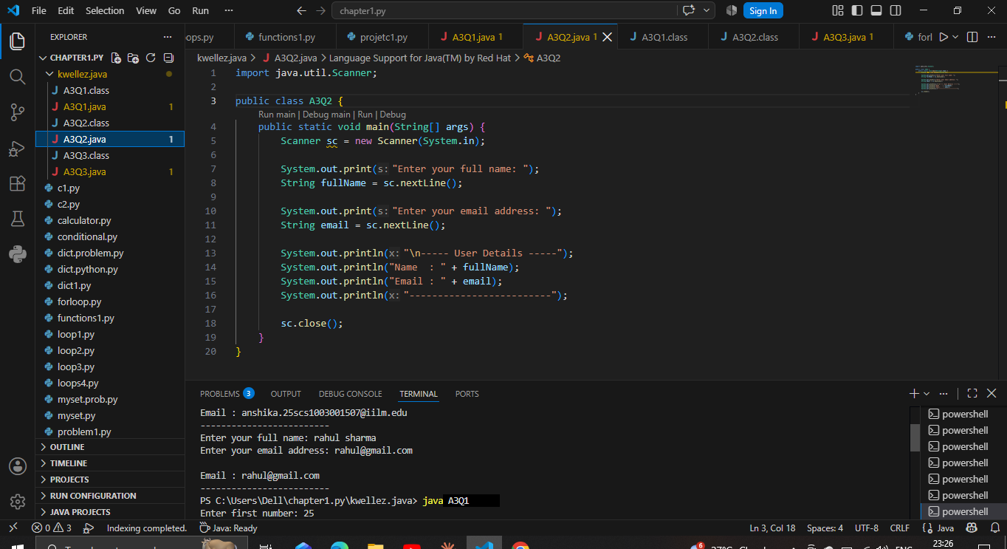

Question 3: Simple Interest Calculator
Java program to calculate Simple Interest using the formula SI = (P x R x T) / 100.
