BIG DATA
PROJECT REPORT

PREDICTION OF FUTURE SPREAD OF CORONA-VIRUS IN INDIA

Submitted by:
Anshika Bajpai
9917103009



PROBLEM STATEMENT :
Its 17th May and India have reported its 85710 total confirmed cases due to COVID-19. We need a strong model that predicts how the virus could spread across India. The goal of this task is to build a model that predicts the spread of the virus in the next 7 days.

CONTROL FLOW AND WORK DONE:
- Data Preprocessing and cleaning the data by summing up all values of a particular day. Normalization is done on the dataset.
- Visualizing the pattern of COVID-19 cases in India using the Plotly library.
- Implementing a simple recurrent neural network algorithm to predict the target variable(Confirmed Cases).
- Used Keras ModelCheckpoint to save the model.
- Evaluating the model(mean square error of training and testing dataset) and checking its accuracy(mean absolute percentage error).
- Post-processing of the dataset.
- Plotting and Visualization of predicted and actual values.
- Hyperparameter optimization using the TPE algorithm is used to find the best parameters and best model.
- The saved model is used for future predictions of 7 days.
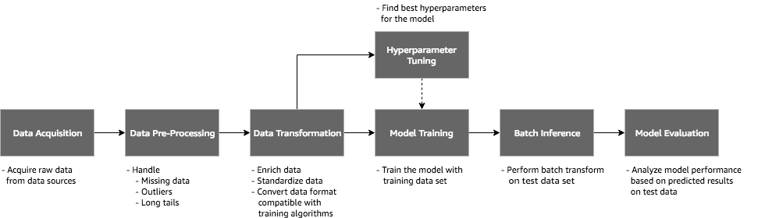

ALGORITHMS USED:
- A Recurrent Neural network will be used for predicting future values.
- Bayesian Optimization technique using HyperOpt Library is used for Hyperparameter tuning of models.

DATASET:
Time series dataset is used
Kaggle dataset is used which is updated by Kaggle on a daily basis.
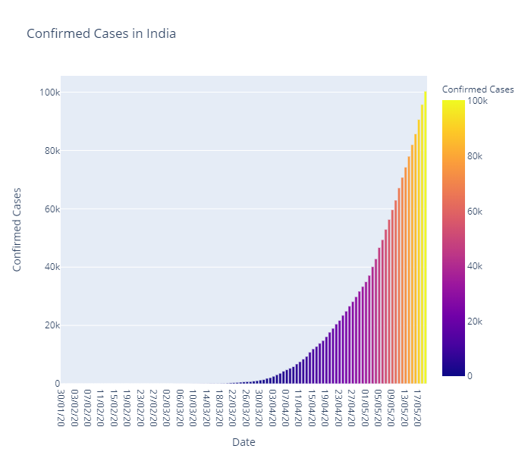
Dataset reference: https://www.kaggle.com/sudalairajkumar/covid19-in-india?select=covid_19_india.csv

RESULTS:
- Error-values and accuracy when lookback = 25
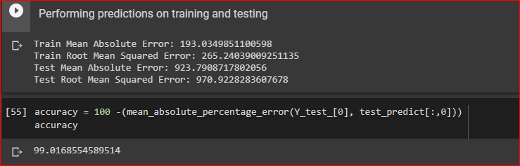

- Visualization for Training Data:
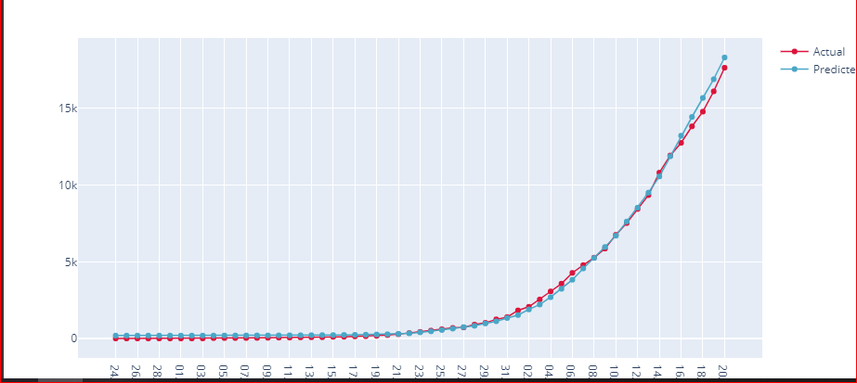

- Future Predictions:
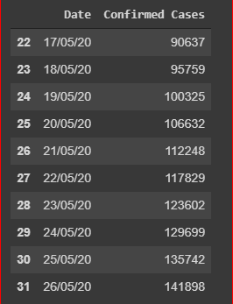
ANALYSIS OF DATASET:
Due to the unavailability of large datasets, It was not possible to test the model on many values. So, there is still scope for improvement in the model and its error values.

CODE PYTHON:
https://colab.research.google.com/drive/1ZG9K1GYFSGyfBAL6ygUoevj4IDMX_D8d#scrollTo=nB4dNP6KP02a
This code will work on google colab.
- You need to have a kaggle.json file loaded in your drive in order to access the dataset.
- If you want to train and test the model. (DO NOT RUN the Hyperparameter section)
- If you want to run the saved model and inference on that use load model function instead of the RNN model section.
- For hyperparameter tuning, you need to preprocess the data, run all code lines after hyperparameter tuning.
- For future forecasting, load saved model and run the last block of the code.

WORK DISTRIBUTION
ANSHIKA BAJPAI - 9917103009 (complete project)

