Cross-Modality Transfer Learning for Knee Meniscus Segmentation
via Registration-Constrained Unpaired Image Translation
Anshika Bajpaiᵃ, Chia-Ying James Linᵃ, Madilyn Feikᶜ, Abhay Sistaᶜ, Mounica Chiduralaᶜ, Ashley Ellenbergerᶜ, Bryan Saltzmanᶜ, and Rakesh Shiradkarᵇ
ᵃIndiana University Bloomington, Bloomington, Indiana; ᵇDepartment of Biomedical Engineering and Informatics, Indiana University Indianapolis, Indianapolis, Indiana; ᶜIU Health, Indianapolis, Indiana
ABSTRACT
Automated meniscus segmentation in proton density (PD)-weighted knee MRI is hindered by the scarcity of labeled training data. Dual-echo steady-state (DESS) MRI offers rich publicly available annotations, but the fundamental contrast difference between DESS and PD (fluid appears dark in DESS and bright in PD), preventing direct model transfer. We propose a cross-modality domain adaptation pipeline that uses a registration-constrained generative adversarial network (RegGAN) to translate DESS volumes to synthetic PD images while explicitly penalizing anatomical deformation. The translation preserves meniscus anatomy (mean displacement 0.055 pixels, 0% topology violations), enabling DESS segmentation masks to supervise a 2.5D U-Net in the PD domain. A pre-trained DESS segmentation model applied directly to real PD achieves near-zero meniscus Dice (0.00). Fine-tuning on synthetic PD images raises Dice to 0.69 on a held-out cohort of 17 expert-annotated real PD patients. Further fine-tuning with 15 manually annotated real PD cases achieves a mean Dice of 0.78, demonstrating that anatomy-preserving synthetic data substantially reduces annotation burden for cross-modality segmentation.
Keywords: Knee MRI, Meniscus segmentation, Domain adaptation, Generative adversarial networks, Unpaired image translation, Transfer learning, Cross-modality
1. DESCRIPTION OF PURPOSE
The meniscus is a critical fibrocartilaginous structure responsible for load distribution, shock absorption, and joint stability in the knee. Accurate automated meniscus segmentation in MRI supports quantitative grading of cartilage injury, longitudinal monitoring of osteoarthritis progression, and pre-surgical planning. Proton density (PD)-weighted MRI is the dominant clinical protocol for knee evaluation, offering high soft-tissue contrast and short acquisition times. However, constructing supervised segmentation models for PD MRI requires expert voxel-level annotation, which is expensive and time-intensive at scale.
Dual-echo steady-state (DESS) MRI provides complementary T2 relaxometry and has been distributed alongside dense expert segmentation labels in publicly available datasets such as SKM-TEA [1]. The tissue contrast between the two sequences differs substantially: fluid and cartilage appear dark on DESS but bright on PD, with reversed contrast at tissue boundaries, making direct transfer of a DESS-trained model to PD images unsuccessful. Prior unpaired image-to-image translation methods such as CycleGAN [2] have achieved modality-level appearance transfer but produce uncontrolled spatial deformations, distorting meniscus anatomy and rendering associated segmentation masks unreliable for downstream training.
This work addresses this limitation by introducing a registration-constrained generative pipeline (RegGAN) that enforces minimum geometric deformation during DESS-to-PD translation. We evaluate whether synthetic PD images generated under anatomy-preserving constraints are sufficient to transfer meniscus segmentation knowledge from the DESS domain to real PD MRI, and whether augmenting synthetic training data with a small cohort of manually annotated real PD cases further improves segmentation on unseen clinical data.
2. METHODS
Domain adaptation. RegGAN extends the CycleGAN framework [2] with a lightweight differentiable registration network R, implemented as a 2D convolutional U-Net inspired by VoxelMorph [3]. The generator GAB translates DESS slices to synthetic PD; R then takes the concatenation of the synthetic PD and a real PD image as input and predicts a dense 2D displacement field. Three auxiliary loss terms constrain the predicted field: a registration similarity loss (λ = 5.0) enforcing pixel-level alignment between the warped synthetic PD and real PD, a smoothness penalty (λ = 10.0) on spatial gradients of the displacement field, and a magnitude penalty (λ = 5.0) directly penalizing displacement amplitude. Generators and discriminators follow a ResNet-based [4] architecture with 9 residual blocks (nᵍgf = 48) and PatchGAN [5] discriminators trained using the least-squares GAN objective [6]. Training used 69 DESS volumes from SKM-TEA [1] and 69 PD-weighted volumes from an institutional cohort (IU dataset), extracting approximately 11,000 DESS and 2,200 PD sagittal slices as unpaired training data on an NVIDIA A100 40 GB GPU.
Segmentation and fine-tuning. A publicly available 2.5D U-Net with ResNet34 encoder pre-trained on DESS for multi-class knee segmentation [7] serves as the source-domain baseline. The original 5-class head is replaced by a 3-class head (background, lateral meniscus, medial meniscus) for cross-modality transfer. In the first fine-tuning configuration (synthetic PD), only synthetic PD slices paired with DESS meniscus labels are used. In the second configuration (synthetic + real PD), 15 manually annotated real PD patients are added to training using a merged binary loss that combines lateral and medial softmax probabilities against binary ground truth. Both configurations use weighted cross-entropy (background weight 0.1, meniscus weight 1.5) combined with soft Dice loss, cosine learning rate scheduling (1×10⁻⁵ to 1×10⁻⁷), and augmentation including horizontal/vertical flipping, brightness jitter (±20%), and Gaussian noise (σ = 0.02), trained for 50 epochs with early stopping (patience 10).
Evaluation. All segmentation models were evaluated on a held-out cohort of 17 real PD patients with expert manual meniscus annotations, distinct from the fine-tuning cohort. Performance was quantified using the binary Dice coefficient (lateral and medial meniscus combined). Domain adaptation quality was assessed with Fréchet Inception Distance (FID) [8], structural similarity index (SSIM), and Jacobian determinant analysis of the deformation field to confirm topology preservation.
3. RESULTS AND EVALUATION
RegGAN achieved an FID of 164.4 between synthetic PD and real PD images, compared to 260.4 for raw DESS images evaluated against the same real PD distribution, a 37% reduction in distributional distance. The SSIM between DESS and synthetic PD was 0.357, reflecting the expected contrast shift rather than structural failure. Deformation analysis confirmed anatomy preservation throughout: the mean Jacobian determinant of the registration field was 1.000056; the rate of Jacobian folding (det(J) < 0, indicating topology violations) was 0.0% across all test volumes; and the mean displacement at the meniscus region was 0.055 pixels.
Segmentation performance on the 17-patient held-out cohort is summarized in Table 1. The pre-trained DESS model applied without fine-tuning to real PD achieves a mean binary meniscus Dice of 0.00, confirming complete failure of zero-shot cross-modality transfer. Fine-tuning on synthetic PD images alone improves mean Dice to 0.69, demonstrating that RegGAN-generated images provide sufficient domain alignment for meaningful label transfer. The combined fine-tuning approach using synthetic PD and 15 annotated real PD patients achieves the highest performance with a mean Dice of 0.78, a relative gain of 13% over the synthetic-only baseline.
Per-patient Dice scores for the best model ranged from 0.69 to 0.84 across all 17 cases, with consistent improvement over both the DESS baseline and the synthetic-only model. These results indicate that anatomy-preserving synthetic data from RegGAN effectively bridges the cross-modality gap, and that a small real-PD annotation effort provides an additional, complementary performance gain.
4. SUPPORTING IMAGES, TABLES, FIGURES
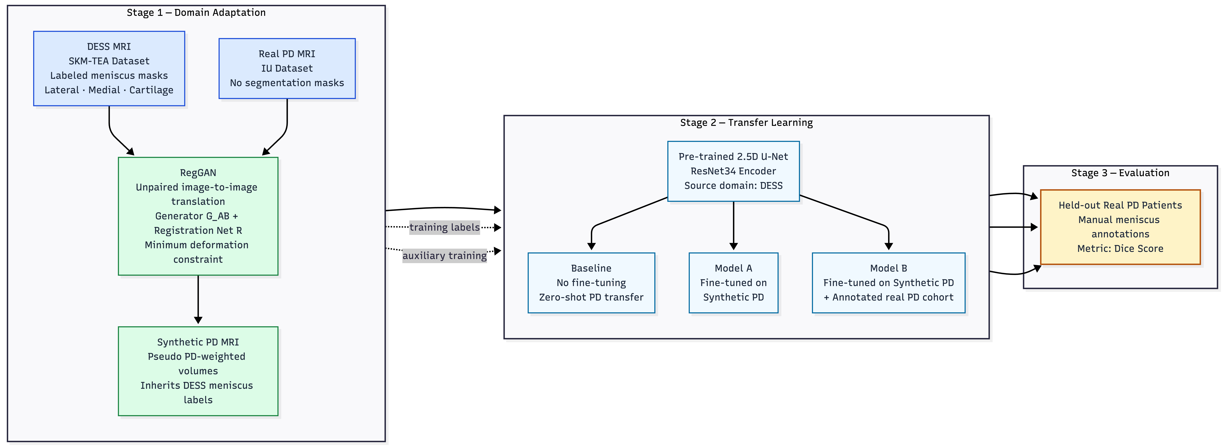
Figure 1. Overview of the proposed cross-modality domain adaptation pipeline. RegGAN translates DESS MRI (SKM-TEA, with lateral meniscus, medial meniscus, and cartilage labels) to synthetic PD MRI under minimum-deformation constraints. A pre-trained 2.5D U-Net is progressively fine-tuned on synthetic PD and evaluated on a held-out real PD cohort.
Table 1. Binary meniscus Dice score on 17 held-out real PD patients.
Model | Training Data | Mean Dice
Pre-trained DESS baseline | DESS only (no PD) | 0.00
Synthetic PD fine-tuning | Fake PD (RegGAN output) | 0.69
Synthetic + Real PD fine-tuning | Fake PD + annotated real PD | 0.78

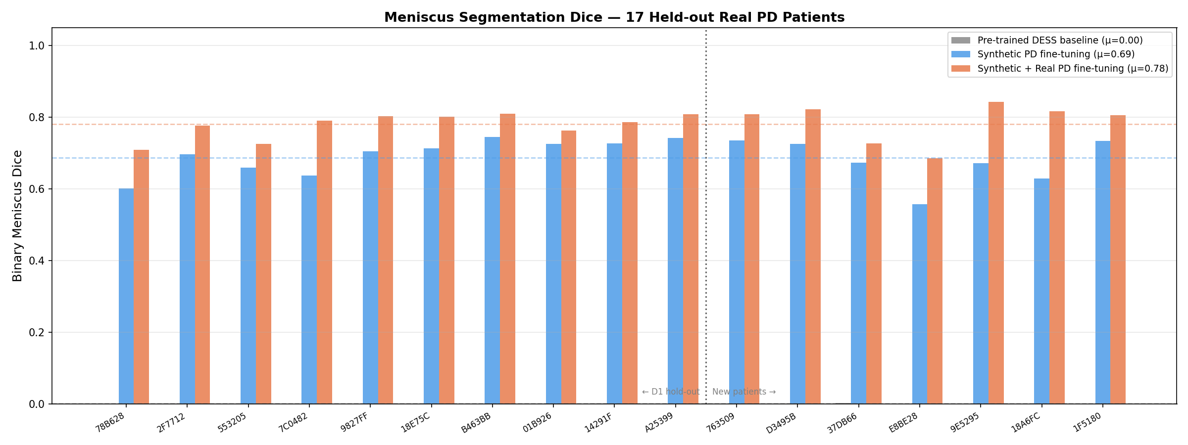
Figure 2. Per-patient binary meniscus Dice scores on all 17 held-out real PD patients (10 original + 7 extended hold-out). Dashed lines: group means. Grey: DESS baseline (no fine-tuning). Blue: synthetic PD fine-tuning. Orange: synthetic + annotated real PD fine-tuning.
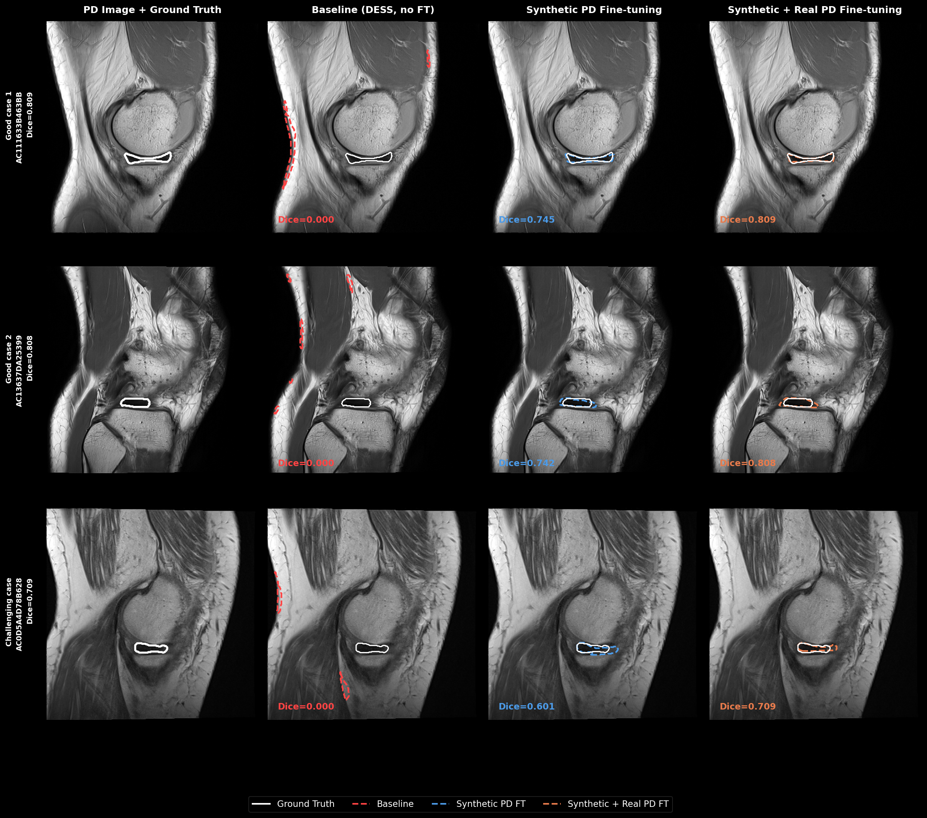
Figure 3. Qualitative meniscus segmentation on three representative real PD patients (rows). Columns: PD image with ground truth (white), Baseline (DESS, no fine-tuning), Synthetic PD fine-tuning (pseudo PD), and Synthetic + Real PD fine-tuning (mixed). Top two rows show successful segmentation; bottom row shows a challenging case where fine-tuning partially recovers the meniscus boundary.
5. CONCLUSIONS
This study demonstrates that registration-constrained generative domain adaptation enables effective cross-modality transfer of meniscus segmentation from DESS to PD-weighted knee MRI. The proposed RegGAN pipeline achieves near-rigid anatomical preservation during translation (mean displacement 0.055 px, 0% topology violations), allowing DESS segmentation labels to be directly reused for PD model training without paired acquisitions. On a held-out cohort of 17 expert-annotated real PD patients, fine-tuning on synthetic PD alone improves meniscus Dice from 0.00 to 0.69; augmenting with 15 annotated real PD patients further improves Dice to 0.78. These results establish anatomy-preserving GAN-based domain adaptation as a practical, label-efficient pathway for cross-modality MRI segmentation.
6. BREAKTHROUGH WORK
This work presents a novel anatomy-preserving cross-modality adaptation framework combining a deformation-penalized registration network within an unpaired GAN training loop with a progressive transfer learning strategy for knee meniscus segmentation. By demonstrating that synthetic images generated under minimum-deformation constraints preserve the geometric fidelity needed to transfer dense segmentation labels across MRI contrasts, this study provides a reproducible and label-efficient approach applicable to other organ systems and acquisition protocol pairs where labeled source-domain data exist but target-domain annotations are scarce. This work has not been presented or submitted for publication or presentation elsewhere.
ACKNOWLEDGMENTS
The authors gratefully acknowledge computational resources provided by Indiana University's BigRed200 high-performance computing cluster. This work was supported in part by Indiana University research funds.
REFERENCES
[1] Desai, A. D., Bhave, S., Hancu, I., Watkins, R. D., Gold, G. E., Hargreaves, B. A., and Sandino, C. M., "SKM-TEA: A dataset for accelerated MRI reconstruction with dense image labels for quantitative clinical evaluation," in Advances in Neural Information Processing Systems, vol. 35, 2022.
[2] Zhu, J.-Y., Park, T., Isola, P., and Efros, A. A., "Unpaired image-to-image translation using cycle-consistent adversarial networks," in Proc. IEEE Int. Conf. Computer Vision, 2223–2232, 2017.
[3] Balakrishnan, G., Zhao, A., Sabuncu, M. R., Guttag, J., and Dalca, A. V., "VoxelMorph: A learning framework for deformable medical image registration," IEEE Trans. Medical Imaging 38(8), 1788–1800 (2019).
[4] He, K., Zhang, X., Ren, S., and Sun, J., "Deep residual learning for image recognition," in Proc. IEEE Conf. Computer Vision and Pattern Recognition, 770–778, 2016.
[5] Isola, P., Zhu, J.-Y., Zhou, T., and Efros, A. A., "Image-to-image translation with conditional adversarial networks," in Proc. IEEE Conf. Computer Vision and Pattern Recognition, 1125–1134, 2017.
[6] Mao, X., Li, Q., Xie, H., Lau, R. Y. K., Wang, Z., and Smolley, S. P., "Least squares generative adversarial networks," in Proc. IEEE Int. Conf. Computer Vision, 2794–2802, 2017.
[7] Desai, A. D., Schmidt, A. M., Rubin, E. B., Sandino, C. M., Black, M. S., Mazzoli, V., Stevens, K. J., Boutin, R., Re, T. J., Gold, G. E., Hargreaves, B. A., and Chaudhari, A. S., "The International Workshop on Osteoarthritis Imaging Kaggle AKOA knee MRI plane challenge results," Radiology: Artificial Intelligence 3(6), e200165 (2021).
[8] Heusel, M., Ramsauer, H., Unterthiner, T., Nessler, B., and Hochreiter, S., "GANs trained by a two time-scale update rule converge to a local Nash equilibrium," in Advances in Neural Information Processing Systems, vol. 30, 2017.

