**LAB Assignment #3**

The third.cc comprises of the network setup as shown below:

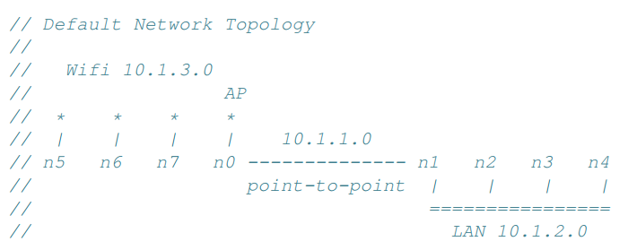

Nodes **n0** and **n1** are connected via a single point to point link (Network 1). On the other hand, nodes **n1, n2, n3** and **n4** are connected via a CSMA link (Network 2), and the nodes **n5, n6, n7** and **n0** are on Wifi network. Since **n0** and **n1** are part of two networks, they’ll have multiple IP addresses. The source code (third.cc) and documentation (**BuildingWirelessNetworkTopology.pdf**) detailing this network setup were provided to you as part of the assignment preparation in the earlier google classroom post. You are required to go through **them** to understand the underlying implementation of this network setup.

As part of this week’s lab assignment you are required to perform following modifications in the third.cc program:

1. *Change the data rate of the CSMA channel to 500 Mbps.*
2. *Send 4 packets each of size 2048 bytes at an interval time of 5.0 seconds, i.e., every 5.0 seconds send one packet.*
3. *Make modifications to the start and stop time of the* ***UDP server*** *and* ***UDP client*** *accordingly.*
4. *Examine the logged pcap file to determine the number of UDP packets exchanged between the* ***UDP client*** *and* ***UDP server.***
5. *Identify the IP address of the client (n5) and the server (n4).*
6. *In addition to n4, also install the* ***UdpEchoServer*** *application on n3, and make it listen on port 15. Similarly, in addition to n5, also install the* ***UdpEchoClient*** *application on n6. Now you’ll have 2 servers (n4 & n3) and two clients (n5 and n6).*
7. *Make modifications to the code such that n5 sends data to n4, and n6 sends data to n3 simultaneously. Do you observe any error when you try to have such multiple transmissions at the same time?*
8. Display the ‘x’ and ‘y’ coordinates of the wireless nodes with the ***UdpEchoClient*** *application installed on them (n5 and n6) as they* change their positions during the simulation.