**Week2 Socket Programming Assignment (22nd Jan 2024)**

**File transfer using Sockets:**

**Task#1::** Building on the concepts of Socket programming that you learnt in the last week’s lab, the 1st task of this week’s lab assignment requires you to write a client-server socket program to upload the file (**client.txt**) from client machine to the server machine. Thereafter, the client will request the file (**server.txt**) from the server. The server responds back to client with the requested file. Both the **client.txt** and **server.txt** are provided to you as part of assignment. You are required to execute both the upload and download operations locally (running client & server on same machine) as well as remotely (client & server on different machine).

**ROUND TRIP TIME(RTT) calculation using Sockets:**

Round-trip time (RTT) [Fig 2] is the duration in milliseconds (ms) it takes for a network request to go from a starting point to a destination and back again to the starting point. RTT is an important metric in determining the health of a connection on a local network or the larger Internet, and is commonly utilized by network administrators to diagnose the speed and reliability of network connections.

The ping utility, available on virtually all computers, is a method of estimating round-trip time. Fig. 1 shows an example of several pings from client machine to server machine with the round-trip time calculated as shown in Fig. Notice that one of the ping times - 17.604ms - is higher than the rest.

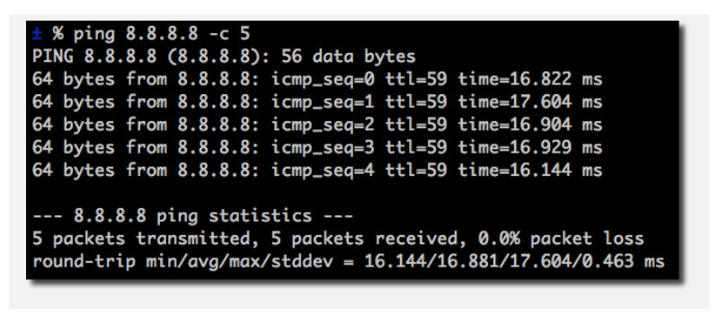

**Fig. 1 Ping to server machine**

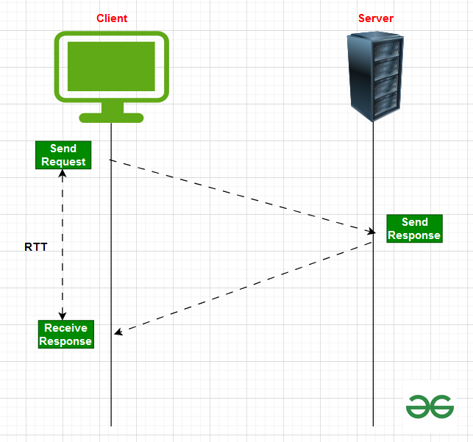

**Fig. 2 RTT description**

**Task#2::** As 2nd task for this week’s assignment, you should write a socket program to calculate RTT between client and server machines. You can start initially by having both the client and the server run locally on the same machine. Thereafter, make one of your friend’s machine as server and your own machine as client, and compute the RTT. Do you observe any differences in the RTT values when you make these changes?