PRACTICAL-1

How to Install VS Code on Windows

Step 1: Download VS Code
- Go to the official Visual Studio Code website:
  - 👉 https://code.visualstudio.com
- C

Step 2: Run the Installer
- Locate the downloaded .exe file (usually in your Downloads folder).
- Double-click the installer: VSCodeUserSetup-x64-*.exe

🔹 Step 3: Setup Wizard
- Click Next to begin.
- Accept the license agreement and click Next.
- Choose the destination folder (default is usually fine):
C:\Users\<YourName>\AppData\Local\Programs\Microsoft VS Code
- Click Next until you get to the Select Additional Tasks screen.
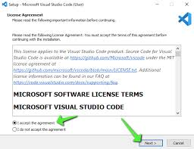
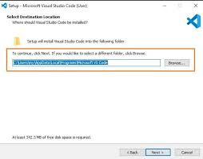
🔹 Step 4: Recommended Settings
On the “Select Additional Tasks” screen, check the following boxes:
✅ Add “Open with Code” action to Windows Explorer
✅ Add to PATH (important to run code from terminal)
✅ Register Code as an editor for supported file types
Then click Next, then Install.
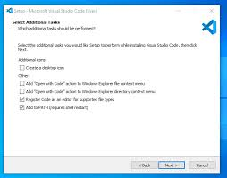
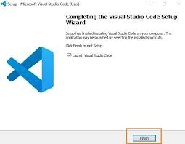

🔹 Step 5: Launch VS Code
- Once installation is complete, check “Launch Visual Studio Code” and click Finish.
- VS Code will open.
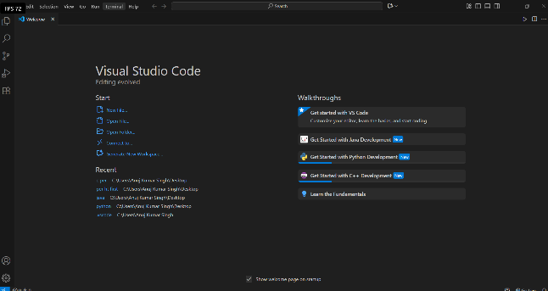

Optional: Install Extensions (Recommended)
Once VS Code opens, you can install useful extensions like:
- C/C++ by Microsoft (for C and C++ development)
- Code Runner (to run code snippets)
- Python (if you're coding in Python)
- Live Server (for web development)
To install:
- Click the Extensions icon (or press Ctrl+Shift+X)
- Search for the extension name.
- Click Install.
- 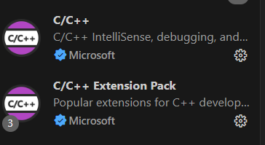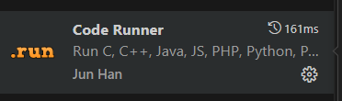

FIRST PROGRAM
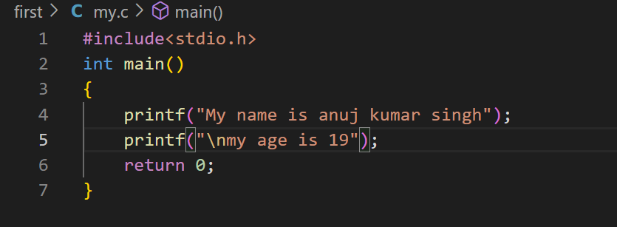

OUTPUT:
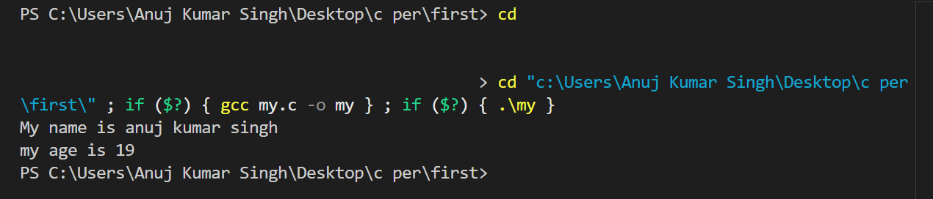

PRACTICAL-2
Flow chart and algorithms sum of two numbers and greater among two numbers.

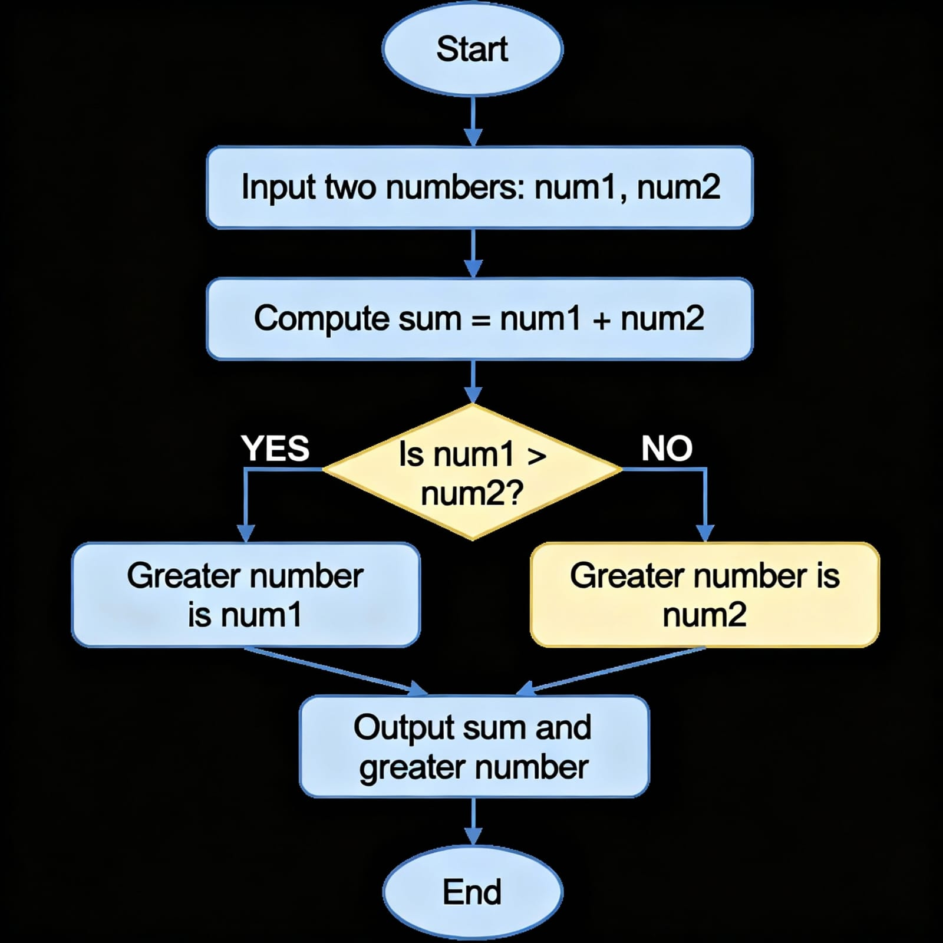

ALOGRITHMS
STEP 1: Start
STEP 2: Take input of two numbers a and b from user.
STEP 3: Now, take sum variable and calculate sum= a+b.
STEP 4: if (a >b):
Print “a is greater number” .
Else Print “b is greater number”.
STEP 5:First print sum of number then print condition statement.

Shortcut of VS CODE
