ASSESSMENT -1

FUNDAMENTALS OF DATA SCIENCE





Submitted by
Anshika Malla
Student ID: 11446
UWE ID: 24071173
Artificial Intelligence
Kathmandu, Nepal

PART 1 [50 marks]
Translate the following statements into Python expressions in IDLE:
Note down the response to each. Do they differ from what you would expect?
[Each question carries 5 marks]

- The perimeter of a rectangle with length 9 & width 6

Input:

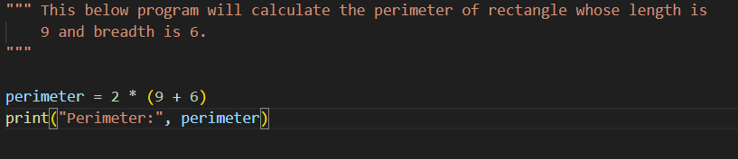
Output:
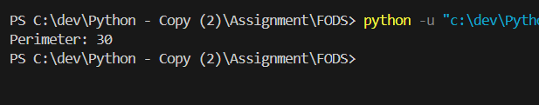

- Python is great, it’s wild!

Input:
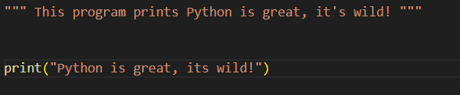

Output:

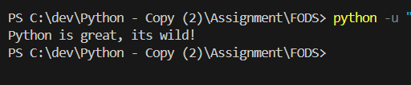
- 2 to the 10thpower

Input:

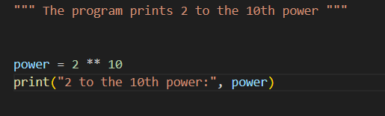

Output:

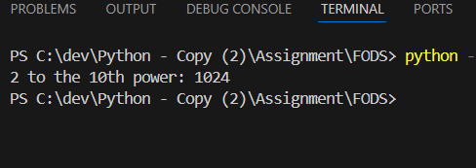

- 7 factorials minus 5 factorials

Input:

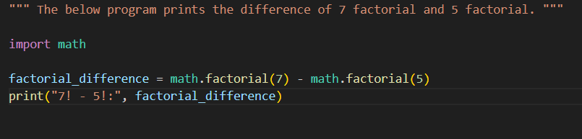

Output:

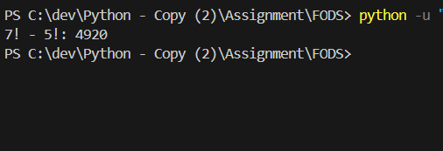

- Your forename multiplied by 5

Input:

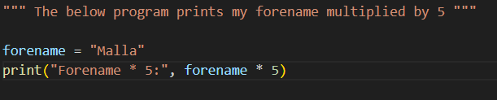

Output:

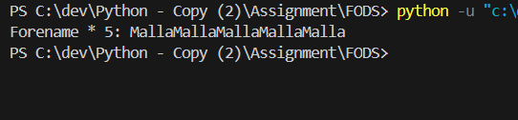

- Your name left justified 15 spaces

Input:

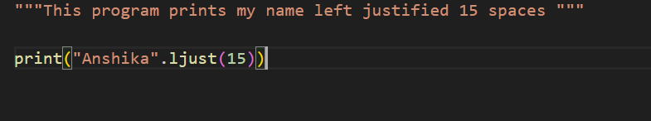

Output:

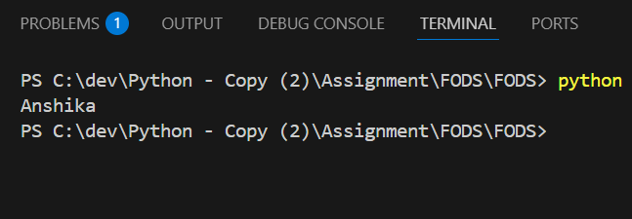

- PI to 5 decimal places

Input:

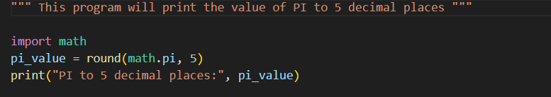

Output:

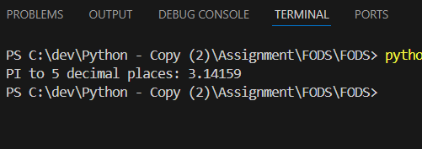

- 200 modulus 12

Input:

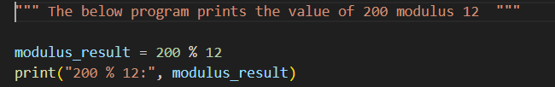

Output:

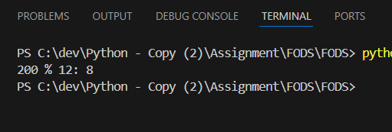

- 7.2 as an integer value

Input:

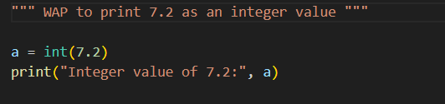

Output:

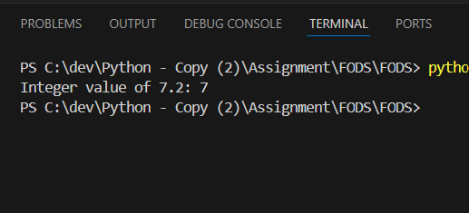

- The Unicode encoding for your name

Input:

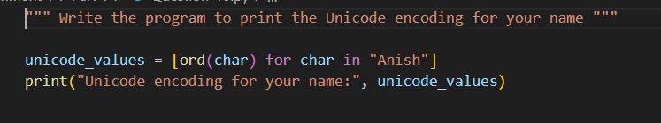

Output:

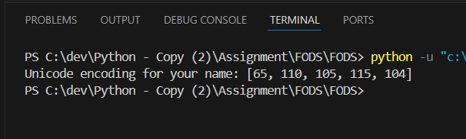

PART 2 [50 marks]

- Write a program to take a number input from the user and display whether the number is even or odd. [5]

Input:
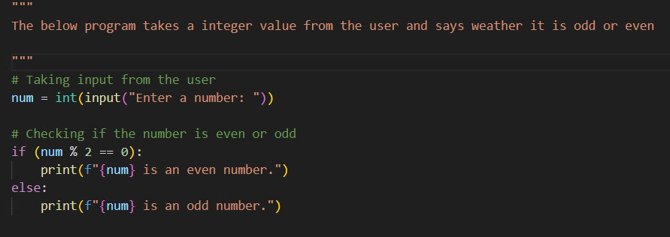

Output:

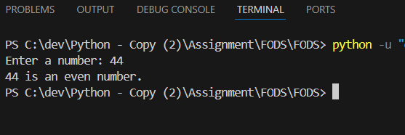

- Write a program that prompts the user for two integer values and displays the results of the first number divided by the second, with exactly two decimal places displayed. [5]

Input:

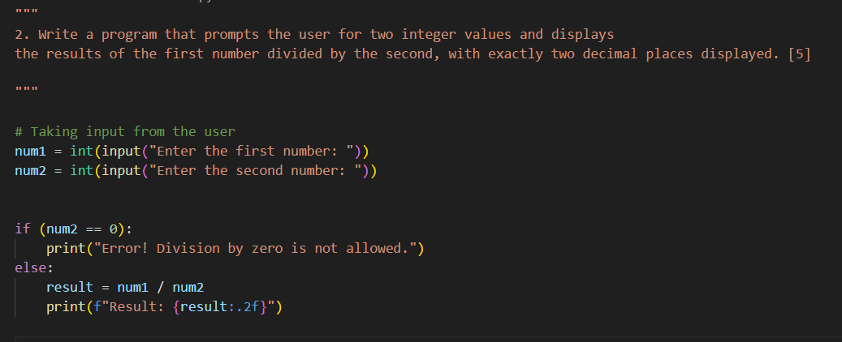

Output:

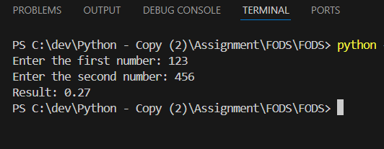

- Write a program that will convert Celsius value to Fahrenheit.[5]

Input:

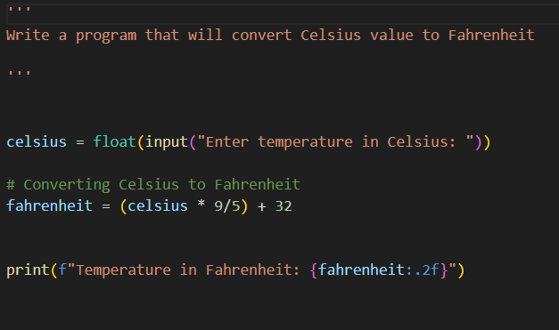

Output:

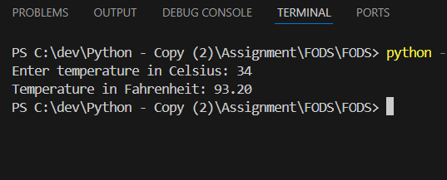

- Write a program to find the Euclidean distance between two coordinates. Take both the coordinates from the user as input.[5]

Input:

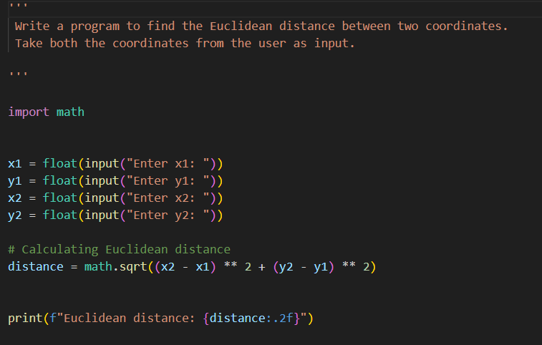

Output:

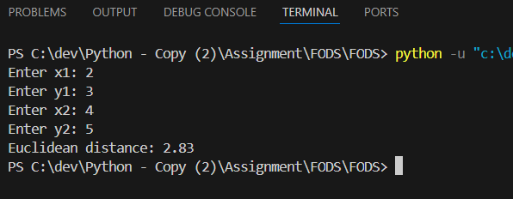

- Write a program to find the simple interest when the value of principle, rate of interest and time period is provided by the user.[5]

Input:

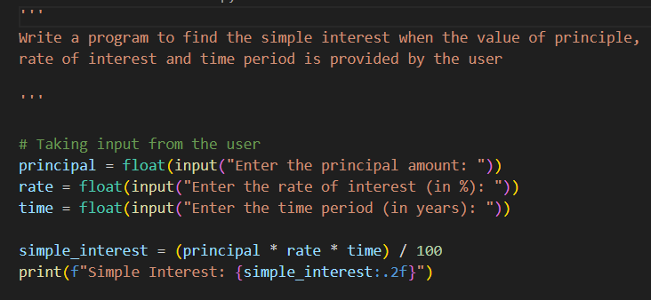

Output:

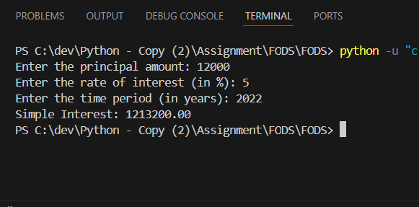

- Write a Python program to find those numbers which are divisible by 7 and multiple of 5, between 1500 and 2000 (both included). [5]

Input:

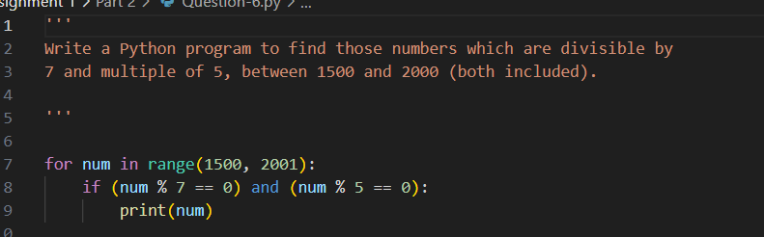

Output:

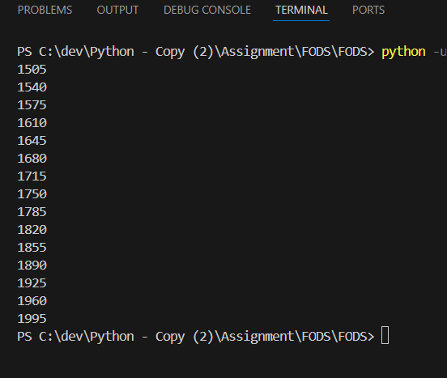

- Write a Python program that accepts a string and calculates the number of digits and letters.[5]

Input:

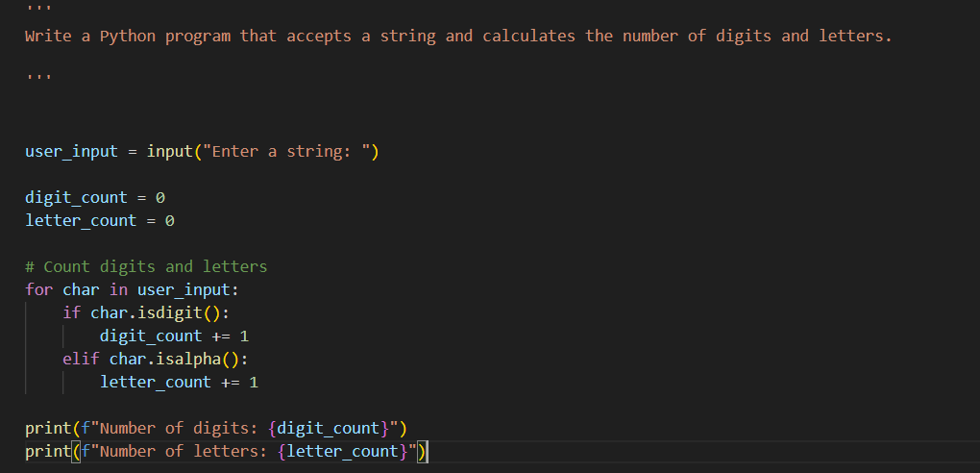

Output:

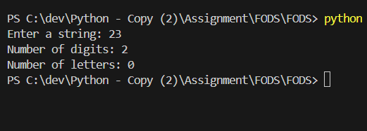

- Write a program to create a number guessing game for the user. The program should ask the user to input a number. The program specifications are as mentioned below.
- The program should generate a random number for the answer. [2.5]
- The program should prompt the user for a number input. [2.5]
- The program should provide the feedback to the user after each guess (e.g. “Too high”, “Too low” or “Correct number”). [2.5]
- The program should check the user input for 5 times and allow the users to guess for at most 5 times if their input doesn’t match the answer number. [2.5]
- If the user is not able to guess the answer within 5 times, the program should display “Game Over” message and exit. [5]

Input:

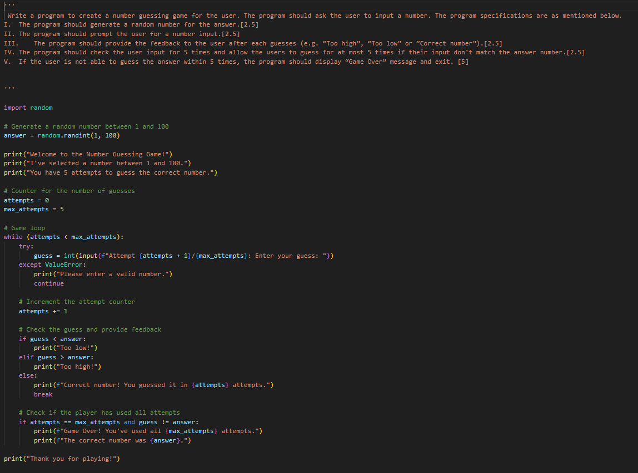
Output:

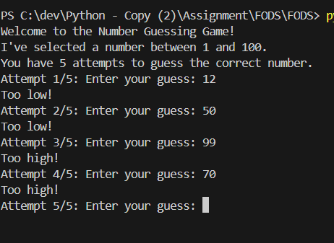

END OF ASSIGNMENT 1

