ASSESSMENT -4

FUNDAMENTALS OF DATA SCIENCE





Submitted by
Anshika Malla
Student ID: 11446
UWE ID: 24071173
Artificial Intelligence
Kathmandu, Nepal

1.Create a null vector of size 10 but the fifth value which is 1.[10 marks]

Input:

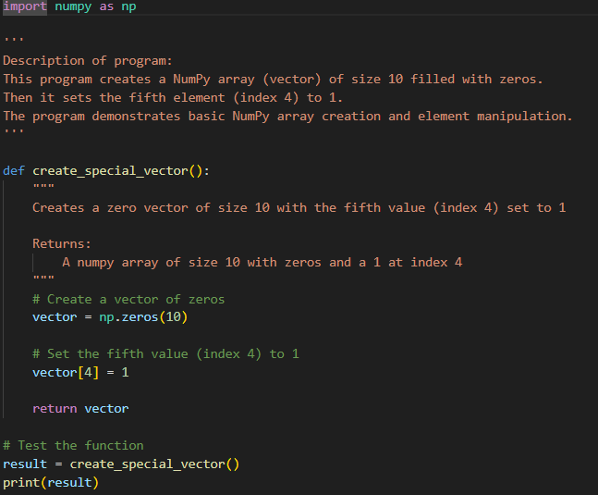

Output:

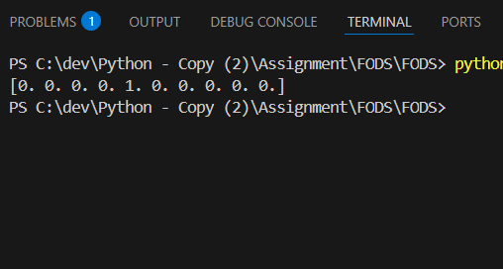
2. Ask user to input two numbers a, b. Write a program to generate a random array of shape (a, b) and print the array and avg of the array.[10 marks]

Input:

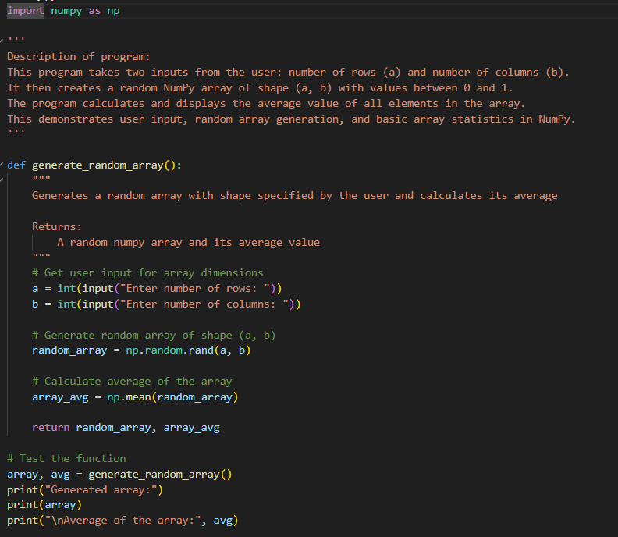

Output:
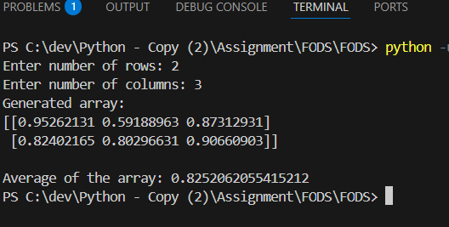
3. Create a vector of size 10 with values ranging from 0 to 1, both excluded.[10 marks]

Input:
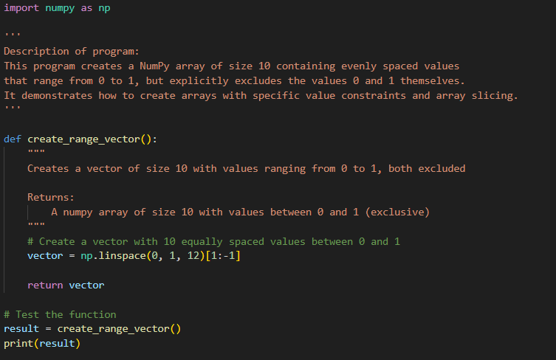

Output:

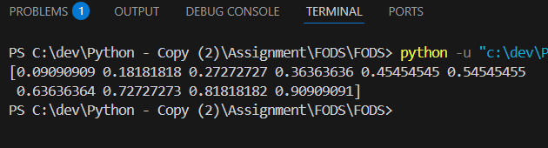4

4. Can you create a identity matrix of shape (3,4). If yes write code for it.[10 marks]

Input:

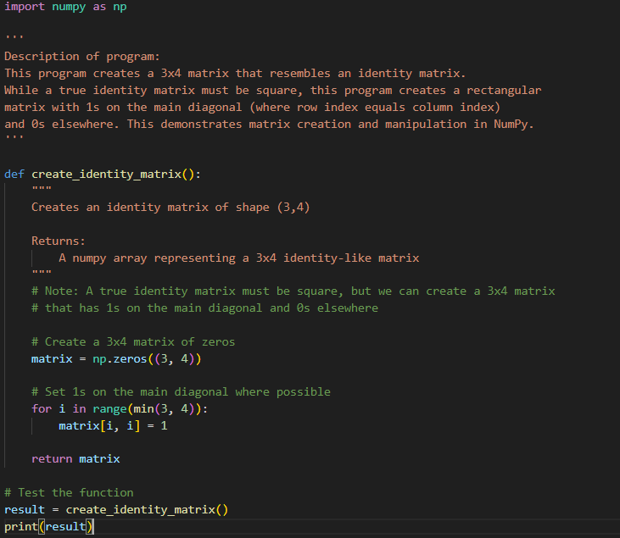

Output:

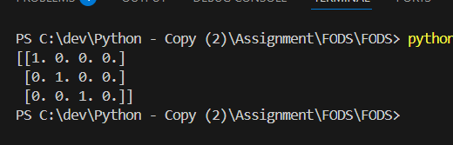
5. Create a 5x5 matrix with row values ranging from 0 to 4.[10 marks]

Input:

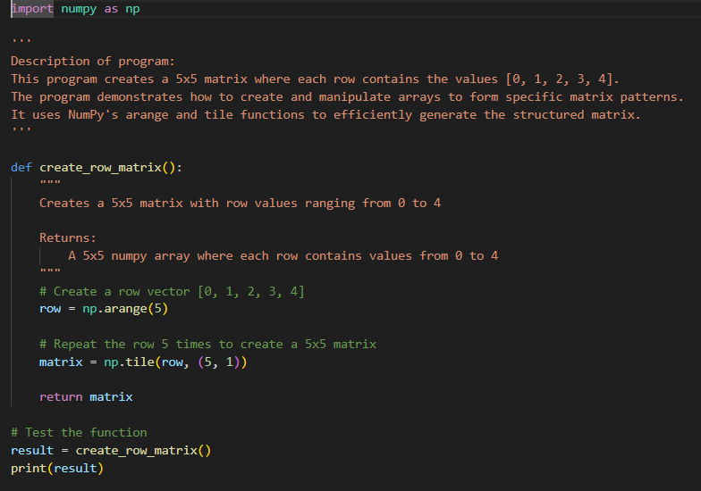

Output:

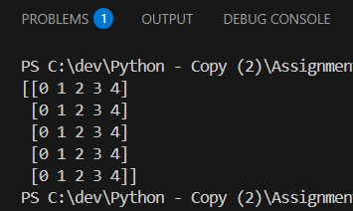

6.Write a program to input an array of numbers from the user (at least 10 elements in list), sort them and perform slicing operations to get elements between indexes such as 2-5, 5-8, 2-9. [15 marks]

Input:

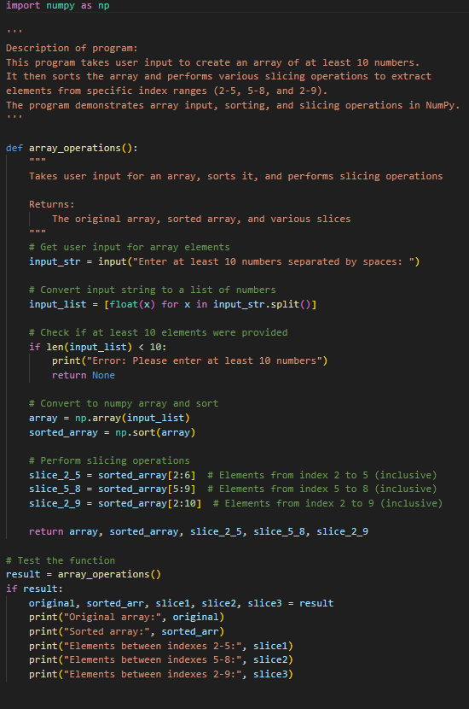

Output:

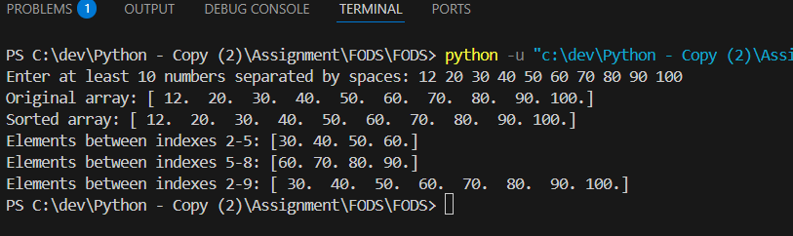

7. Create an array of random integer numbers as a numpy array, sort them and perform operations such as reshaping of the array into matrix of feasible dimensions. (e.g., if we have an array of 1 * 10, then we can reshape it into 2 * 5 or 5 * 2 matrix.) [Hint: Use the array of reshape (row * column)] [15 marks]

Input:

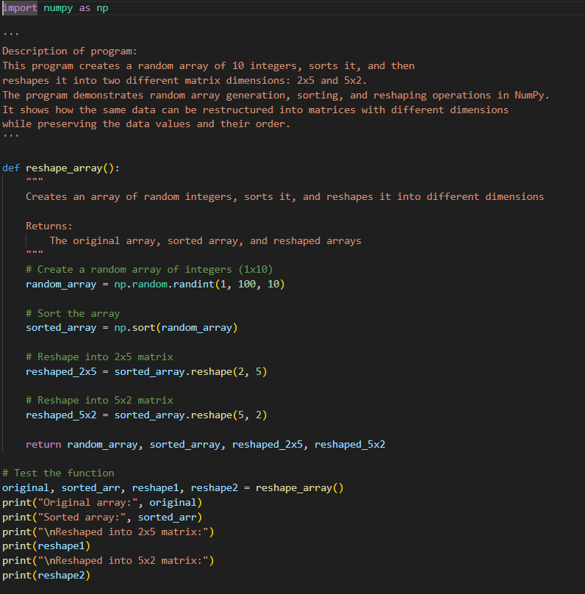

Output:

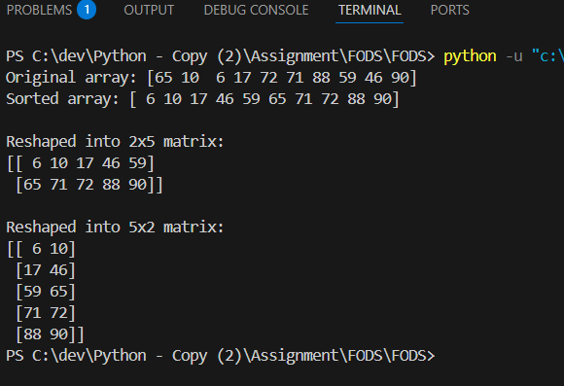

8. Write a Pandas program to add, subtract, multiple and divide two Pandas Series.[10 marks]

Input:

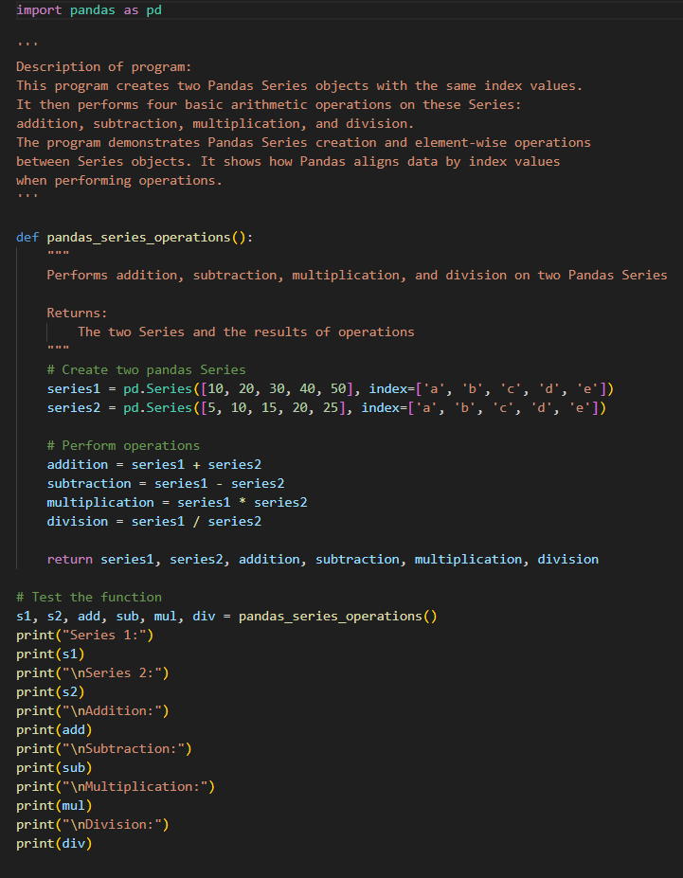

Output:

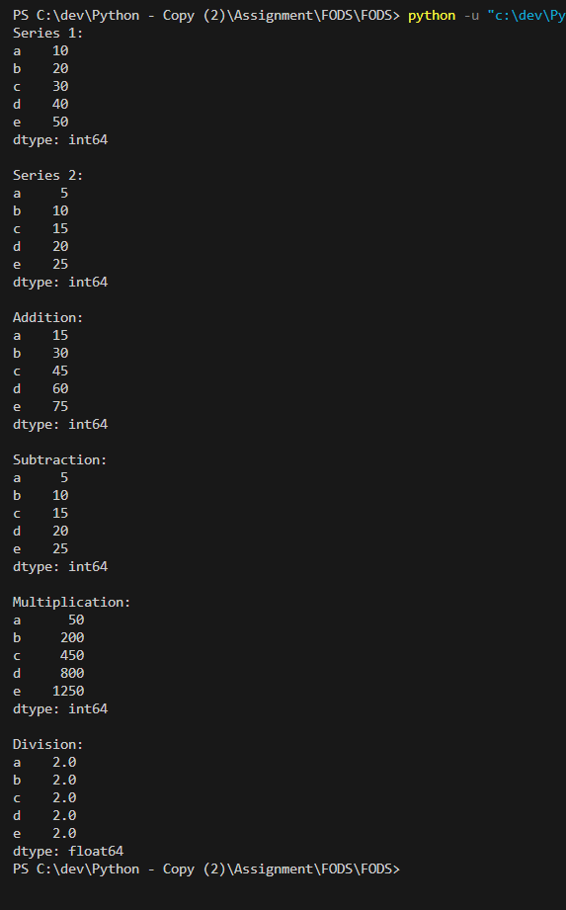

9. Given the table below, [10 marks / 1 each]

- Write a query to select only the Name and Salary columns.
- How would you filter out all employees in the "IT" department?
- Write code to select employees who are older than 30 and find the average salary of employees in each department.
- Write code to count the number of employees in each department.
- Add a new column Bonus which is 10% of each employee's salary.
- Replace all occurrences of "HR" in the Department column with "Human Resources."
- Find the employee(s) with the longest tenure (based on JoinDate).
- Create a new column SalaryCategory where salaries above 75,000 are categorized as "High" and the rest as "Low."
- Write a program to check if there are any duplicate EmployeeIDs and remove them if found.
- Use Pandas to calculate the median Age of all employees.

Input:

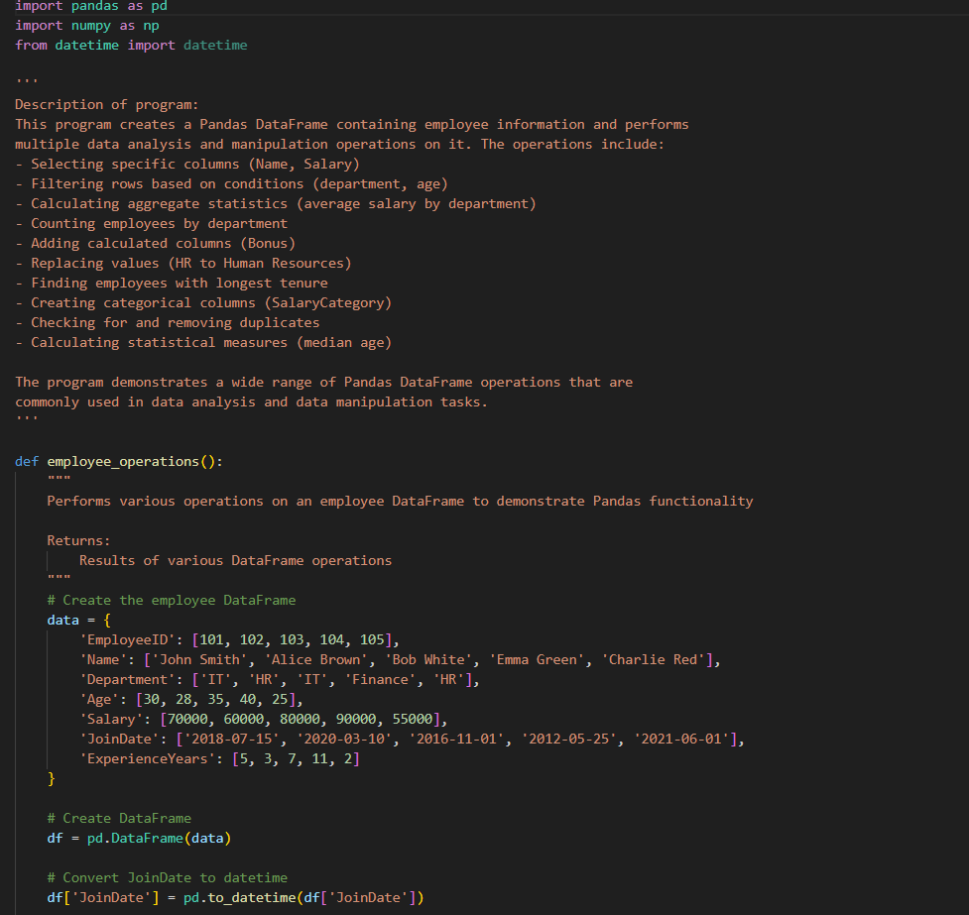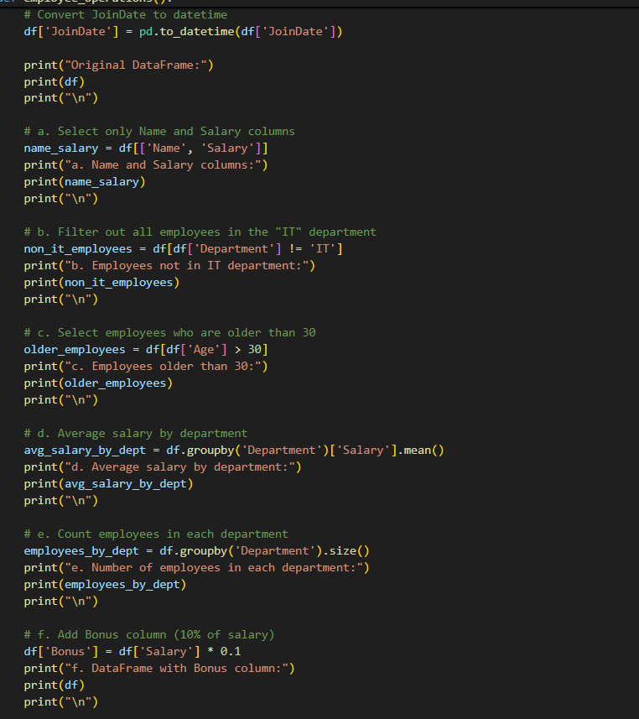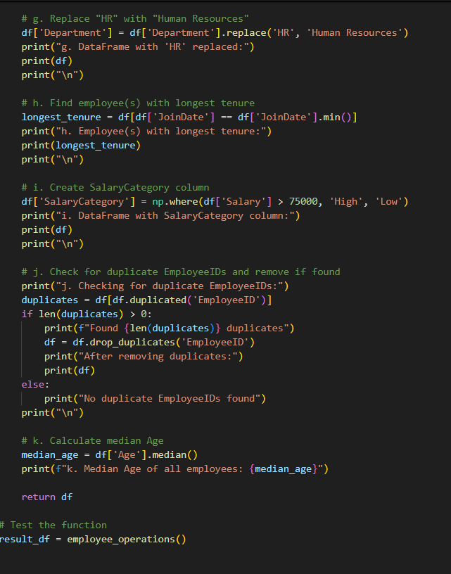

Output:
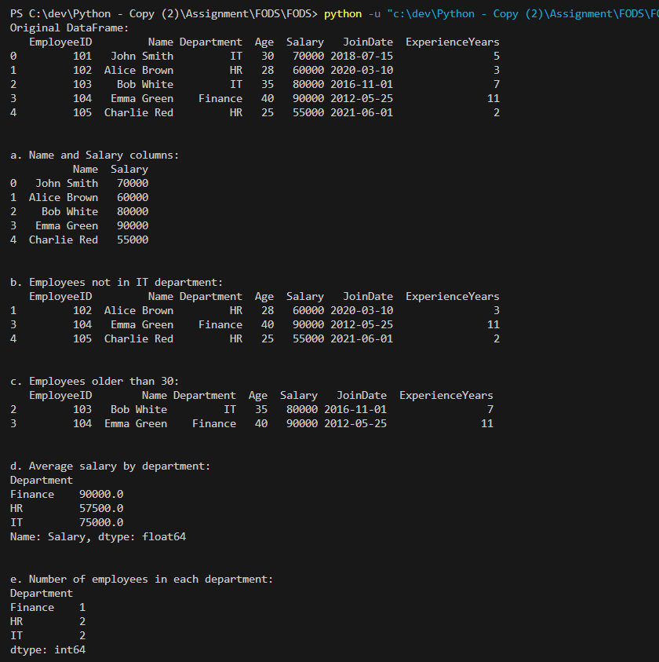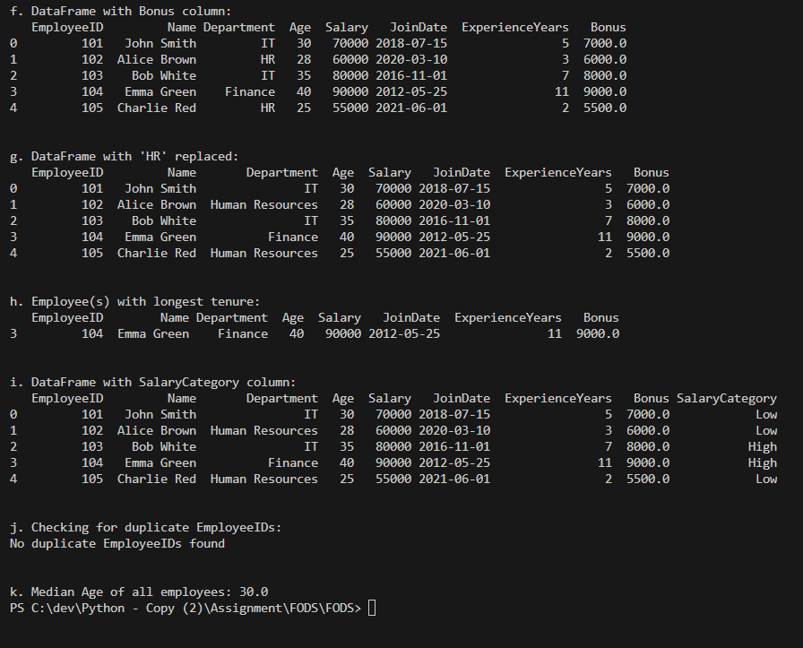

END OF ASSIGNMENT 4

