Evaluating Biomedical Language Models for Evidence-Based Answer Classification on PubMedQA
MAAI902 - NLP and LLMs
University of Wollongong in Dubai
Instructor: Dr. Pallavi Ranjan
Student name: Anshika Reddy Annapureddy
Student ID: 1651353
October 2026

TABLE OF CONTENTS
ABSTRACT 3
1. INTRODUCTION 3
2. LITERATURE REVIEW 4
3. PROBLEM DEFINITION AND JUSTIFICATION FOR NLP 5
3.1 Task 5
3.2 Why NLP is appropriate 5
4. DESCRIPTION OF INPUT DATA 6
5. PRE-PROCESSING AND EMBEDDING TECHNIQUES 7
6. PROPOSED MODELS, PIPELINES, AND TOOL STACK 7
7. TRAINING AND EVALUATION DESIGN 8
8. RESULTS 9
8.1 Label distribution 9
8.2 Test metrics 9
9. DISCUSSION, EXPECTED OUTPUTS, AND VALUE PROPOSITION 12
Alignment with UAE healthcare AI priorities 13
10. ETHICAL CONSIDERATIONS AND MITIGATION 14
11. CONCLUSION 14
REFERENCES 15
APPENDIX 16

ABSTRACT

Biomedical abstracts are being produced at a faster rate than researchers are reading them, but systematic reviews still depend on expert judgement to determine if a paper can have a positive, negative or ambiguous answer to a research question. This report contains implementation and performance evaluation of 3 different text classifiers trained on the expert-labelled PubMedQA [3] subset: (1) TF-IDF [9] + logistic regression as a baseline, (2) fine-tuned BERT-base [7], (3) fine-tuned PubMedBERT [8]. The inputs were research questions and abstract text together and outputs were 3-class evidence labels. Training was on Google Colab(T4 GPU), with an official test split of 500 examples (held out) and logged accuracy, macro-F1 [6], per-class metrics, confusion matrix and timing. PubMedBERT had the best performance, showing an accuracy of 60.4% and macro-F1 being 0.391 and it was clear that no transformers could predict the minority "maybe" class on the test set, while sparse baseline could predict a small fraction. A Streamlit demonstration was created for non-clinical purposes. This work is aimed at supporting literature triage rather than clinical decision making, it is based only on expert labels and does not draw on the synthetic PubMedQA split for headline metrics.

INTRODUCTION

Evidence-based biomedical research requires a careful review of the literature to decide whether an abstract gives a definite or a negative answer or leaves the issue unresolved. Jin et al. (2019) design a supervised NLP task using PubMedQA [3]. Recent surveys indicate that well fined-tuned models from the BERT family still hold up well on biomedical natural language processing tasks. On the other hand, general large language models may be useful for reasoning-style question answering, but they hallucinate and miss nuances (Chen et al., 2025). Benchmark scores on PubMedQA only weakly correlate with clinical judgements (Kim & Yoon, 2025) and medial hallucination research emphasizes the need for an explicit "uncertain" class (Pandit et al., 2025).

PROBLEM STATEMENT: Can fine-tuned biomedical text encoders (BERT-base [7], PubMedBERT [8]) improve three-way evidence (yes / no / maybe) classification over a TF–IDF [9] and logistic regression baseline on PubMedQA [3] expert question–abstract pairs?

LITERATURE REVIEW

“PubMedQA: A dataset for biomedical research question answering” [3] provides 1,000 expert annotations plus larger weakly labelled sets. “WhyMedQA: Enhanced biomedical why question answering using transfer learning approach” [1] shows transfer learning on expert PubMedQA in a generative “why” QA setting; my work stays discriminative so I can compare a linear model with encoders on the same labels.
“Benchmarking large language models for biomedical natural language processing applications and recommendations” [2] compares GPT-style models with fine-tuned BERT across BioNLP tasks and recommends task-specific fine-tuning rather than prompt-only LLMs for many classification setups that shows consistent with my choice of Hugging Face Transformers [10] fine-tuning instead of calling a closed API.
“Reasoning or knowledge: Stratified evaluation of biomedical LLMs” [6] indicates that headline question-answering scores might conceal weaker subsets of reasoning. These findings motivate to report per-class metrics and qualitative maybe errors and not just accuracy.
"MedHallu: A general benchmark for identifying medical hallucinations of large language models" [5] partially from expert PubMedQA and benefits from able-to-abstain, which is consistent with maybe as safety-relevant.
“Questioning our questions: How well do medical QA benchmarks evaluate clinical capabilities of language models?” [4] meta-analysis of clinical assessments of large language models finds a correlation of ρ ≈ 0.59 between medical question-answering benchmarks and clinical performance. This project is more likely to be used to support research reading workflows than bedside utilization.

Paper | Focus | Link to this work
PubMedQA: A dataset for biomedical research question answering [3] | Question + abstract → yes / no / maybe (expert labels) | Task, dataset, expert-only test policy
Benchmarking large language models for biomedical natural language processing applications and recommendations [2] | Fine-tuned encoders vs zero / few-shot LLMs on BioNLP tasks | Justifies BERT [7] / PubMedBERT [8] fine-tuning over prompts
Reasoning or knowledge: Stratified evaluation of biomedical LLMs [6] | Separates knowledge-recall vs multi-step reasoning items | Motivates macro-F1 and per-class text metrics
MedHallu: A comprehensive benchmark for detecting medical hallucinations in large language models [5] | Hallucination benchmark incl. expert PubMedQA subset | Treats maybe / uncertainty as safety-relevant
Questioning our questions: How well do medical QA benchmarks evaluate clinical capabilities of language models? [4] | Meta-analysis of benchmark vs clinical LLM performance | Literature triage only — not bedside diagnosis

Research gap: Prior studies have mainly been about benchmarking large language models or similar question-answering setups. There has been very little study done in comparing sparse TF-IDF [9], general domain BERT [7], and PubMedBERT [8], on the same expert PubMedQA [3] split. This project aims to fill this research gap.

PROBLEM DEFINITION AND JUSTIFICATION FOR NLP

3.1 Task
For the biomedical research questions, the system would have a single-label 3-class classification (yes, no, maybe). In the abstract context, ' yes ' means the abstract supports a positive answer, ' no ' means the abstract supports a negative answer and ' maybe ' is where the evidence is either insufficient or mixed.

3.2 Why is NLP appropriate
Manual screening is not scalable to Pub Med [3] and rules of keywords often don't work because of negation, hedging and paraphrasing ("no significant difference" vs. "significant reduction"). Published research supports the hypothesis that learnt representations (e.g. Sparse TF-IDF [9] or contextual BERT embeddings) can capture the language used by humans to skim through abstracts. NLP is relevant here because humans are still involved: the algorithm is selecting which publications to look through, but the decision of what to do about them is still left to the analyst.
Unlike customer reviews or support tickets, these are structured scientific publications provided with a binary or ternary decision about the evidence. The model assists systematic reading rather than sentiment analysis or ticket prioritization.

DESCRIPTION OF INPUT DATA

Each instance of the PubMedQA expert [3] dataset includes a PubMed ID, a research question, context sentences (the abstract) and a final decision yes/no/maybe. Data are loaded with Hugging Face [10] Datasets (qiaojin/PubMedQA, config pqa_labeled). The official test set contains 500 Pub Med IDs from the ground-truth JSON file in PubMedQA repo. There is a set of 500 IDs from which a 15% validation set is created using a stratified split with a seed of 42 for early stopping, leaving 425 instances to fit the model.

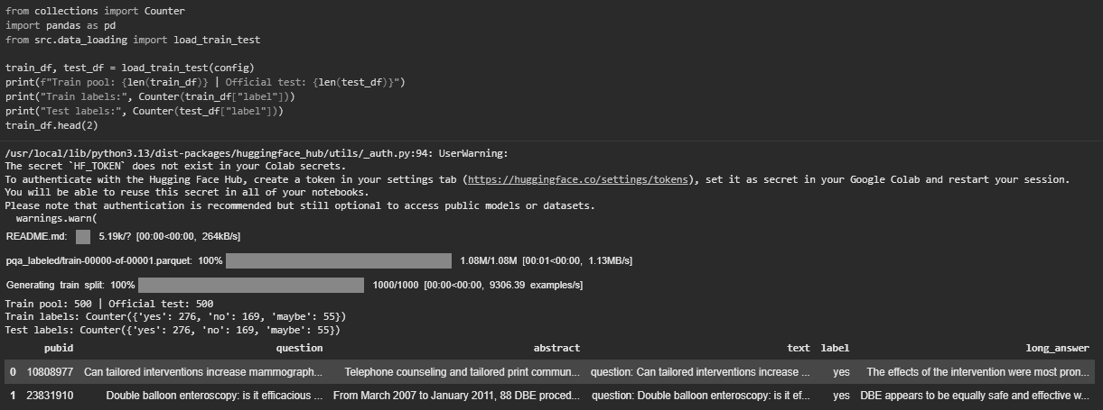
Figure 1. Colab output: train pool and official test sizes with yes/no/maybe counts (expert subset only).

Most rows have a yes/no/maybe question and one or more abstract sentence(s). For example, train pool has questions about screening interventions, surgery, and biomarkers prognostics-all topics in which research often reports "mixed results" or state "further research is needed." These are exactly the types of topics for which you should expect "maybe" labels. Long_answer field were not used as training data; though it does contain some value in our quality assessment, it is likely to be confusing to the classification task by adding generation.

PRE-PROCESSING AND EMBEDDING TECHNIQUES

Every model concatenates the question and abstract in the format question: {q} abstract: {a}. For TF-IDF [9] the lowercasing, unigrams, and bigrams, max_features of 50,000 (reduced to 5000 in smoke mode), sublinear TF and minimum document frequency are used. The logistic regression models use multinomial loss, balanced class weights and LBFGS optimization.
The data is tokenized with the Hugging Face tokenizer [10] for BERT-base-uncased [7] and PubMedBERT [8] with length=512 (also for padding/truncation). PubMedBERT (microsoft/BiomedNLP-PubMedBERT-base-uncased-abstract-fulltext) have domain-specific contextual embeddings, while the baseline was a sparse bag-of-n-grams. It shows the value of pre-training/fine-tuning over a relatively strong linear model.
Most long abstracts are certainly longer than 512 subwords tokens. The paper is truncated from the head with Hugging face default strategy instead of implementing my own scheme for segment fusion, this will be the best so far strategies that can be computed using Colab and complete a three-model run in one go. The baseline model probably also accessed to the same string that has been fused, and only on character level truncation would be used if necessary to meet with the space limit. Besides, whitespace is normalized and dataset loading is checked for the removal of corrupted rows, synthetic oversampling is not used in the homework grading.

PROPOSED MODELS, PIPELINES, AND TOOL STACK

The pipeline stages for this project are: (1) load and validate the expert data; (2) constructing fused text and splits; (3) training 3 classifiers; (4) evaluating with official test set; (5) export metrics, plots, and demo.
Models: TF-IDF [9] + logistic regression, BERT-base [7] sequence classification head and PubMedBERT [8] model; using the above head with identical hyperparameters, such as learning rate 2×10⁵, batch size 8, epochs 3, and early stopping patience 2 on validation macro-F1 [6].
Tools: Python 3.10+, Google Colab (T4 GPU), PyTorch, Hugging Face Transformers [10] and Datasets, scikit-learn [9], pandas, NumPy, matplotlib for confusion matrices, GitHub for the project repository and Streamlit for the prototype UI.

TRAINING AND EVALUATION DESIGN

The random seed was locked at 42 for Python, NumPy, and PyTorch. The notebook was run with smoke_test set to False, so all 425/75/500 samples with three epochs of transformer training. Checkpoints were saved in checkpoints/ on Colab then downloaded locally for Streamlit. Metrics on the official test were accuracy, macro-F1 [6], precision/recall/F1 per class, confusion matrices, wall-clock time to train, and average inference time per example (run in a 20-sample latency probe with a batch size of 1 in transformers).

The training consisted of cloning/uploading the repo, installing the requirements file, enabling GPU, running the cells from top to bottom and then downloading checkpoints if the results were stable. The smoke-test flag was only added when debugging the pipeline wiring, so all the results below come from the setting where smoke_test = false (ie the same as in Figure 1). Hyperparameters weren't optimized beyond the defaults in src/config.py so that the three models can be compared at least. Early stopping was selected based on validation macro-F1 [6] with patience 2.

Evaluation metrics: accuracy is the measure of completeness and macro-F1 [6] serves as the primary aggregate metric for an imbalanced data set. Precision and recall are diagnostic for each class. Confusion matrices are used to understand error structure and timing for cost. Statistical significance tests across folds were not done as only a single official test split was used, this is more important than trying to represent the 500-point test set as a large-sample clinical trial.

RESULTS

This section reports the official 500-example test split only. Validation scores guided early stopping but are not headline results. All metrics below come from the notebook exports.

8.1 Label distribution
Label | Train (fit) | Validation | Test (official)
yes | 239 | 37 | 276
no | 143 | 26 | 169
maybe | 43 | 12 | 55

8.2 Test metrics
Model | Accuracy | Macro-F1 | F1 yes | F1 no | F1 maybe | Train (s) | Infer (ms)*
TF–IDF + LogReg | 0.532 | 0.363 | 0.650 | 0.370 | 0.067 | 1.31 | 2.7
BERT-base | 0.552 | 0.237 | 0.711 | 0.000 | 0.000 | 93.9 | 27.9
PubMedBERT | 0.604 | 0.391 | 0.719 | 0.455 | 0.000 | 67.2 | 25.5

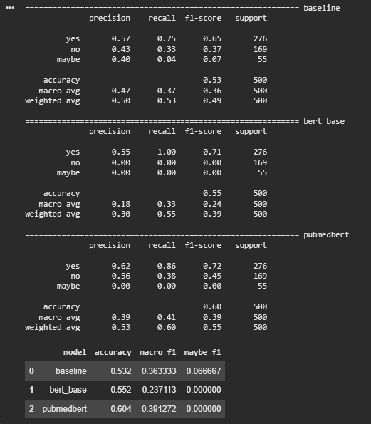
Figure 2. Notebook classification reports and summary table for all three models (official 500-example test set).

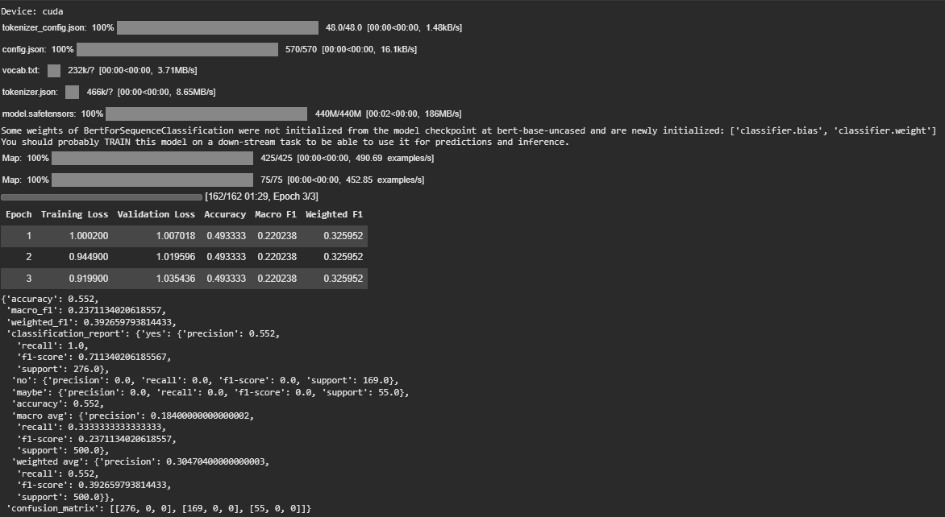
Figure 3. BERT-base [7] fine-tuning log and test evaluation (note collapse to predicting yes for every instance).

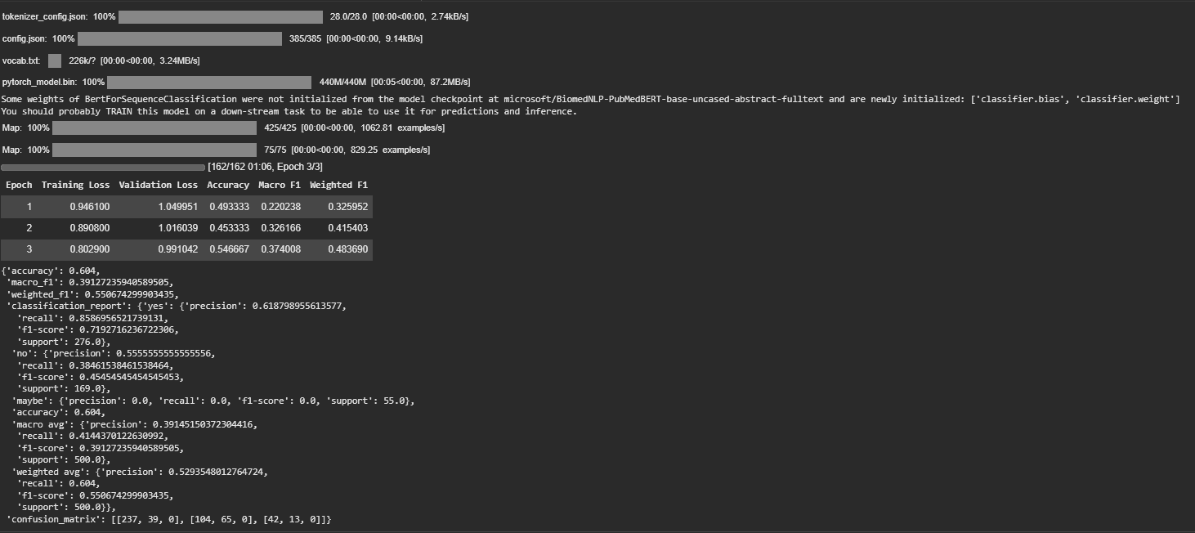
Figure 4. PubMedBERT [8] fine-tuning log and test evaluation (best macro-F1 [6] among transformers).

PubMedBERT [8] outperformed BERT-base [7] on yes/no separation, but they both gave zero test predictions for maybe. The baseline was overall weaker but was only non-zero maybe F1 (0.067). BERT-base's 55.2% accuracy is misleading: it always predicts yes on the 500 test instances (see Fig. 3), so no and maybe have zero recall.

The confusion matrix for PubMedBERT [8] is provided in Figure 4. It shows that out of 302 true instances, 237 were correctly identified as yes and 65 were correctly identified as no. All the 55 true instances identified as maybe are divided between predicted yes (42) and predicted no (13). Pattern indicates that model has probably learnt a binary decision boundary where "maybe" appears as noise. This behavior of model is like one warned by MedHallu [5] when systems sound confident without evidence (Pandit et al., 2025). The baseline model while having much lower accuracy does manage to predict maybe with a low recall.

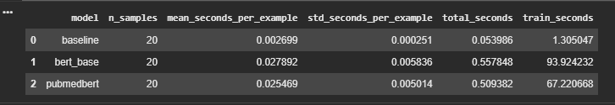
Figure 5. Training and inference timing comparison from the notebook.

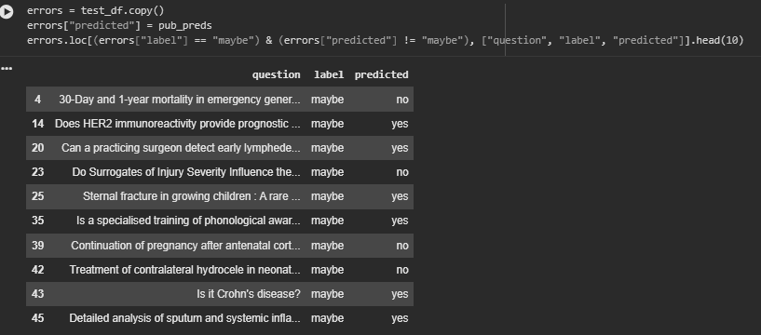
Figure 6. Examples where gold label is maybe but PubMedBERT [8] predicted yes or no.

DISCUSSION, EXPECTED OUTPUTS, AND VALUE PROPOSITION

BERT-base [7] performs 55.2% accuracy in predicting the unbalanced evidence labeling-better than random prediction but fails to predict two class labels. Macro-F1 will be more effective in unbalanced evidence labeling. The improvement in PubMedBERT [8] over BERT-base indicates that domain-specific pre-training can lead to even better results on the small training data, given the small budget of three epochs.

RQ1: PubMedBERT [8] outperformed the baseline for macro-F1 [6] (+0.028) but not maybe recall (only the classical model had any maybe detection). RQ2: Transformers are one to two orders of magnitude slower to inference (Figure 5), and vastly more expensive to train-acceptable only if the benefit (perhaps an FP rate reduction) balances the use of expensive GPUs. RQ3: Errors concentrate on hedged questions (Figure 6), which matches with MedHallu [5]'s focus on overconfidence when evidence is weak (Pandit et al., 2025).

Deliverables: Github repository with src/ and Colab notebook, results/ exports, checkpoints to run local inference, and a Streamlit demo on port 8510.

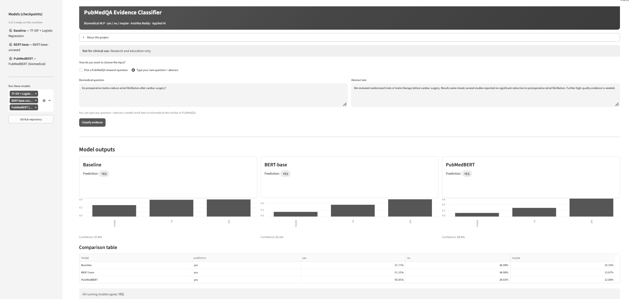
Figure 7. Streamlit prototype (non-clinical disclaimer; research demonstration only).

Value Proposition: PubMedBERT [8] could be used instead of the linear model to gain a faster initial triage of the systematic review screenings on Pub Med [3]; alternatively, PubMedBERT may be used in a scenario where the GPU latency is tolerable for superior discrimination of affirmative/negative results. When the probability is close to maybe, human review will be necessary. In our application to UAE health informatics, the approach could hasten research while falling under the national AI framework and not another clinical workflow.

Alignment with UAE healthcare AI priorities

Overall, this is a project supports the UAE general interest in AI research and innovation across priority sectors, including healthcare. It proposes an aspirational research-supporting tool for organization and categorization of evidence from biomedical literature. This could be useful if universities like SEHA, DHA, or MoHAP-affiliated teams screen PubMed for reviews or policy-oriented summaries. This system is not being developed to help with patient diagnosis, treatment decisions, or to replace interpretation by experts. Its general expertise is most likely to be limited to categorizing evidence in research; any errors made by the model (e.g. Blind collapsing of uncertain terms to binary answers) would be a limitation of AIML systems for biomedical NLP research rather than a failing that should be hidden during deployment debate.
The UAE National Strategy for Artificial Intelligence 2031 and the digitalization of the health sector reinforce the importance of safe and transparent AI, data sovereignty and human accountable services. Organizations such as SEHA, DHA and MoHAP's research centers are more frequently consulting external literature rather than local electronic health record data when putting together evidence profiles and training health informaticians. The PubMed-based evidence classifier would more likely be a research acceleration and education tool, where it would help analysts select abstracts to take into a systematic review or policy brief, but not replace clinicians in a point of care setting.
For further deployment within the UAE, the use of Arabic-English bilingual abstracts may be relevant. The future goal is to make sure that the transparent TF-IDF [9] baseline is easier to audit, whether for procurement or ethics approval. PubMedBERT [8] could then be deployed subsequently, if it includes uncertainty thresholds and mandatory expert review for cases that need it, which was expected of responsible AI in the Emirates.

ETHICAL CONSIDERATIONS AND MITIGATION

There is always the risk that an approval generated by a positive logistic regression figure will be used as the de facto clinical validation. This is partly addressed by written disclaimers in this report that should help prevent that.
Hallucination and overconfidence are tied to this task because maybe is an honest reflection of weak evidence. When transformers never predict maybe, they effectively hallucinate certainty. Reporting that failure transparently is part of ethical reporting, not an embarrassment to hide. Bias matters too: PubMed is English-heavy and reflects published literature biases; I cannot claim UAE hospital readiness without local data and governance review, including Emirati and expatriate populations underrepresented in English PubMed.
In a UAE context, misusing the tool would be taking the model outputs and putting them into apps used by patients without the supervision of DHA/MOHAP authorities. The best way to minimize this misuse is to use it solely for research and education purposes, document all limitations clearly and perform local validation studies prior to any operational health informatics pilot.

CONCLUSION

This project is a NLP problem on real biomedical text, with documented preprocessing steps and embeddings, three consistant pipelines and a clear tool stack focussed on scikit-learn [9] and Hugging face, ethical boundaries and a prototype showing expected outputs. The review of the relevant literature and methods relates to my choices of implementation to published results rather than treat the model as a "black box".
Three NLP pipelines were implemented and compared on expert PubMedQA [3] classification dataset. Although PubMedBERT [8] outperformed on combined test scores, it struggled with the "maybe" class as transformers tend to turn 'maybe' predictions into either yes/no. The TF-IDF [9] baseline performed well and was efficient at detecting the "maybe" class. Plans for future implementation include incorporation of class-weighted loss, longer training, and model calibration before deployment. For the UAE, these results point towards a more educated selection of NLP techniques for literature-based health research and informatics programs, consequently assisting national AI visions without overclaiming clinical readiness.

REFERENCES

[1]Bhuiyan, F. I., & Uddin, A. (2025). WhyMedQA: Enhanced biomedical why question answering using transfer learning approach. Computers in Biology and Medicine, 111382. https://doi.org/10.1016/j.compbiomed.2025.111382

[2]Chen, Q., Hu, Y., Peng, X., Xie, Q., Jin, Q., Gilson, A., Singer, M. B., Ai, X., Lai, P.-T., Wang, Z., Keloth, V. K., Raja, K., Huang, J., He, H., Lin, F., Du, J., Zhang, R., Zheng, W. J., Adelman, R. A., Lu, Z., & Xu, H. (2025). Benchmarking large language models for biomedical natural language processing applications and recommendations. Nature Communications, 16(1), 3280. https://doi.org/10.1038/s41467-025-56989-2

[3]Jin, Q., Dhingra, B., Liu, Z., Cohen, W., & Lu, X. (2019). PubMedQA: A dataset for biomedical research question answering. In Proceedings of the 2019 Conference on Empirical Methods in Natural Language Processing and the 9th International Joint Conference on Natural Language Processing (EMNLP-IJCNLP) (pp. 2567–2577). Association for Computational Linguistics. https://doi.org/10.18653/v1/D19-1259

[4]Kim, S., & Yoon, H.-J. (2025). Questioning our questions: How well do medical QA benchmarks evaluate clinical capabilities of language models? In Proceedings of the 24th Workshop on Biomedical Language Processing (pp. 274–296). Association for Computational Linguistics. https://doi.org/10.18653/v1/2025.bionlp-1.24

[5]Pandit, S., Xu, J., Hong, J., Wang, Z., Chen, T., Xu, K., & Ding, Y. (2025). MedHallu: A comprehensive benchmark for detecting medical hallucinations in large language models. In Proceedings of the 2025 Conference on Empirical Methods in Natural Language Processing (pp. 27991–28012). Association for Computational Linguistics. https://aclanthology.org/2025.emnlp-main.143/

[6]Thapa, R., Wu, Q., Wu, K., Zhang, H. G., Zhang, A., Wu, E., Ye, H., & Zou, J. (2026). Reasoning or knowledge: Stratified evaluation of biomedical LLMs. In Proceedings of the 19th Conference of the European Chapter of the Association for Computational Linguistics (pp. 2450–2483). Association for Computational Linguistics. https://doi.org/10.18653/v1/2026.eacl-long.111

[7]Devlin, J., Chang, M.-W., Lee, K., & Toutanova, K. (2019). BERT: Pre-training of deep bidirectional transformers for language understanding. In Proceedings of NAACL-HLT 2019 (pp. 4171–4186). https://doi.org/10.18653/v1/N19-1423

[8]Gu, Y., Tinn, R., Cheng, H., Lucas, M., Usuyama, N., Liu, X., Naumann, T., Gao, J., & Poon, H. (2021). Domain-specific language model pretraining for biomedical natural language processing. ACM Transactions on Computing for Healthcare, 3(1), 1–23. https://doi.org/10.1145/3458754

[9]Pedregosa, F., Varoquaux, G., Gramfort, A., Michel, V., Thirion, B., Grisel, O., Blondel, M., Prettenhofer, P., Weiss, R., Dubourg, V., Vanderplas, J., Passos, A., Cournapeau, D., Brucher, M., Perrot, M., & Duchesnay, E. (2011). Scikit-learn: Machine learning in Python. Journal of Machine Learning Research, 12, 2825–2830.

[10]Wolf, T., Debut, L., Sanh, V., Chaumond, J., Delangue, C., Moi, A., Cistac, P., Rault, T., Louf, R., Funtowicz, M., Davison, J., Shleifer, S., von Platen, P., Ma, C., Jernite, Y., Plu, J., Xu, C., Le Scao, T., Gugger, S., ... Rush, A. M. (2020). Transformers: State-of-the-art natural language processing. In Proceedings of EMNLP 2020: System Demonstrations (pp. 38–45). https://doi.org/10.18653/v1/2020.emnlp-demos.6

APPENDIX

GitHub: https://github.com/anshikareddy403/pubmedqa-evidence-classification

Colab: notebooks/pubmedqa_evidence_classification.ipynb in the repository.

Streamlit (local): streamlit run pubmedqa_evidence_demo.py --server.port 8510 with checkpoints/ beside the app.

The demo loads checkpoints from a local checkpoints/ directory, shows readiness for each model in the sidebar, and lets users pick official PubMedQA questions from a dropdown or paste custom text. I kept expert labels hidden by default so a live demo can show predictions first and only then reveal the gold label for comparison.

