Project Report

1. Selected Problem Statement and Reason for Selection
Problem: Users struggle to create strong and unpredictable passwords manually.
This project focuses on generating secure random passwords automatically.
This issue is important because weak passwords increase the risk of hacking and data breaches.

2. Problem Statement Explanation
What is the problem?
Users often create simple and repetitive passwords.
Where does this problem exist?
Across all online platforms requiring login credentials.
Who is affected?
All internet users.
Why is it serious?
Weak passwords can be easily guessed or cracked.
What could happen if not solved?
Accounts may be compromised, leading to data theft and security risks.

3. Proposed Solution
This project is a Random Password Generator.
It generates strong, unique, and secure passwords automatically.
How the system works:
- User selects password length
- Chooses character types (uppercase, lowercase, numbers, symbols)
- System generates a secure random password
Who will use it:
Students, developers, and general users.

4. Project Features
- Random Password Generation: Creates secure passwords instantly.
- Custom Length Option: User can choose password length.
- Character Selection: Include/exclude symbols, numbers, etc.
- Easy Interface: Simple and user-friendly design.

5. Technology Stack
HTML: Structure
CSS: Styling
JavaScript: Password generation logic

6. Project Screenshots (Proof of Work)
Include screenshots of:
- Interface
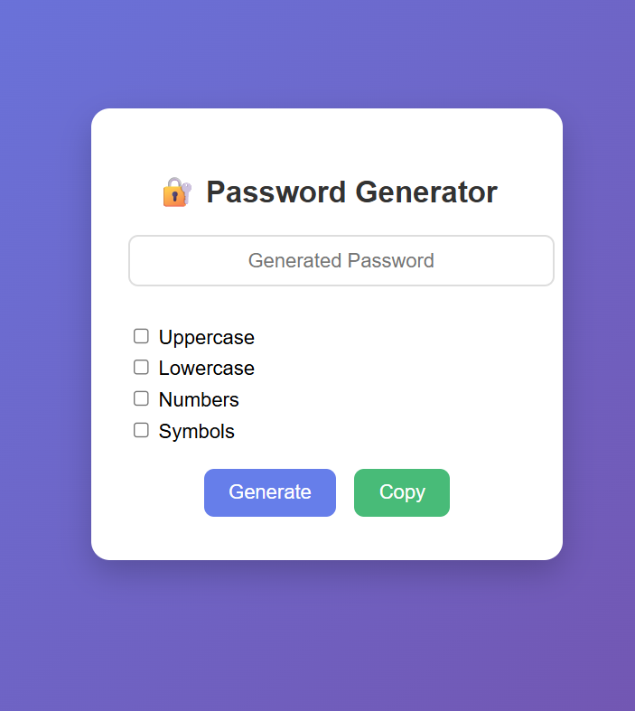

- Generated password output
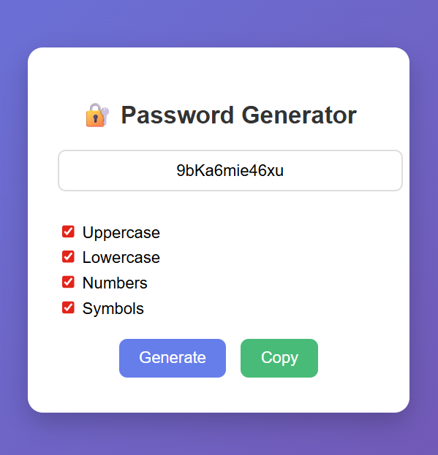

7. Open Source Repository
Upload your project to GitHub and include the repository link.

8. Future Scope
- Add password strength meter
- Save generated passwords securely
- Integrate with password managers
- Develop mobile app version

