+91 8423914548



1 77777 66666

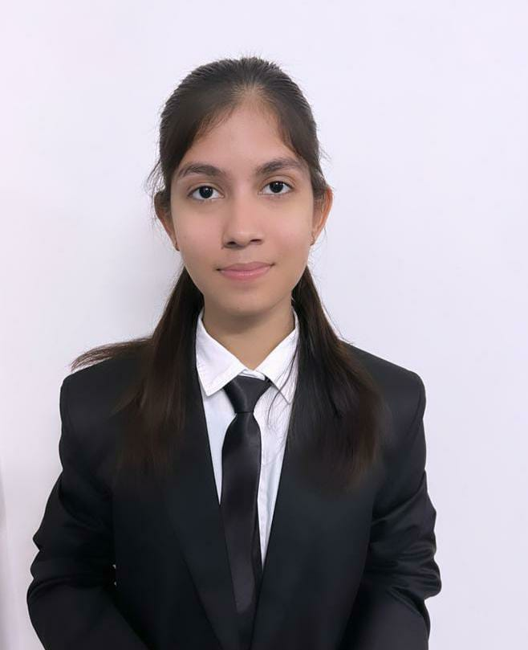

ANSHIKA

[www.linkedin.com/in/anshika](http://www.linkedin.com/in/anshika)

anshika853@gmail.com



COMPUTER SCIENCE ENGINEER

Kanpur, UP



Anshika



SUMMARY

A Punctual, Self - motivated and an Oragnised Person who loves to work in a busy environment and produce high standards of work. Passionate about technolgical skills and in pirsuit of gaining more opportunities to become an efficient coder.

TECHNICAL SKILLS

Programming languages: Python, C

Web Technologies:

HTML5, CSS

Platforms:

Windows10, Windows11, Linux

CERTIFICATIONS

Responsive Web Design | Free Code Camp | Nov'23

* Database management system | swayam nptel | register on Nov’2023

POWER SKILLS

* Proficient in managing tasks
* Dedicated towards achieveing goals in life
* .Ability to adapt and thrive in dynamic work environment.
* Maintaining composure in high stress situation.

EXTRA CURRICULAR ACTIVITIES

* Cyber Sleuth- Attended a workshop in ethical hacking Sep’23
* Spardha- participated in a claasical dance competition Oct’21

PROJECTS

Language Learning System Nov’23

Domain: Web Application|Programming Languages: HTML, Javascript, CSS

* Constructed a website for learning different language through online platform.
* Collaborated with a cross- functional team to build an interactve language learning web aapplication using HTML, CSS , Java Script..
* Conducted virtual language assessments and provided personalized feedback to learners, enhancing their language proficiency

Optical Fibre: Losses associated with optical fibre and future scope

* Domain: Fibre Optics Communication | Optical Fibre Security
* Build a report on Optical Fibre which in cludes its complete working , future scope , losses associated with it and its application.
* Demonstrated various improvement in optical fibre to minimise its losses and enhance its working.
* It enables to know about the high speed data transmission involved with Optical Fibre.

ACHIEVEMENTS

The Incredibles – G.K. Competition Jan '21

Secured 3rd position in GK competition highlighting a well rounded knowledge of current affairs

4 Star Rating in Python on HackerRank Nov '23

EDUCATION

B.Tech. in Computer Science Apr '23 - Present Lovely Professional University | Kanpur,UP

Higher Secondary Jun '21 - Mar '22

Mother Teresa Mission Higher Secondary School | Kanpur, UP

Jun’19 - Apr-20

90%

Secondary Mother Teresa Mission Higher Secondary School | Kanpur, UP

91%