**Front-End UI/UX Mini Project**

**TITLE PAGE**

* **Project Title:** Interior Design Studio Website
* **Submitted By:**
  + **Team Members:** Anshika Sharon Sonwani, Freida B. Rodrigues, Evan Devanand P A
  + **Roll Numbers: 2460334, 2460367, 2460365**
  + **College Email ID:**
  + **[anshika.sharon@btech.christuniversity.in](mailto:anshika.sharon@btech.christuniversity.in  )**

[**freida.b@btech.christuniversity.in**](mailto:freida.b@btech.christuniversity.in)

[**evan.devanand@btech.christuniversity.in**](mailto:evan.devanand@btech.christuniversity.in)

* **Course:** *UI/UX Design Fundamentals*
* **Instructor Name:** Mr. Narendra
* **Institution:** *Christ University*
* **Date of Submission:** 11/08/2025

**Abstract**

This project involves designing and developing a responsive multi-page website for an interior design studio, showcasing its services, portfolio, and client testimonials. The key goal is to create a clean, modern aesthetic while effectively presenting the studio’s philosophy, expertise, and past work. Built entirely with HTML and CSS, the site emphasizes advanced CSS techniques such as CSS Grid for masonry-style layouts and the checkbox hack for portfolio filtering, without relying on JavaScript. The design follows a neutral color palette with a bold accent, complemented by high-quality project images. Pages include Home, Services, Portfolio, and Testimonials, each crafted for visual appeal and usability. The final outcome is a functional, aesthetically pleasing front-end interface that adapts seamlessly across devices, demonstrating proficiency in CSS-based layouts and enhancing the studio’s online presence.

**Objectives**

* Understand the structure and flow of a service-based business website.
* Design a clean, modern, and visually appealing interface tailored to an interior design brand.
* Apply **CSS Grid** to create responsive and masonry-style portfolio layouts.
* Implement CSS-only interactive features such as portfolio filters (checkbox hack).
* Maintain consistent branding with a neutral palette and one bold accent color.
* Ensure full responsiveness and accessibility across desktop, tablet, and mobile devices.
* Optimize image presentation for high-quality project showcases.

**4. Scope of the Project**

* Front-end design only, using pure HTML and CSS.
* Pages include Home, Services, Portfolio, and Testimonials.
* Portfolio uses CSS Grid for masonry layout and CSS-only filters.
* Fully responsive for desktop, tablet, and mobile.
* No JavaScript, backend, or external libraries used.

|  |  |
| --- | --- |
| **Tools & Technologies Used**   * **HTML5** – Content structure and semantic layout * **CSS3** – Styling, Grid layout, responsiveness * **VS Code** – Code editing * **Chrome DevTools** – Testing and debugging |  |

**HTML Structure Overview**

* Used semantic tags: <header>, <nav>, <main>, <section>, <footer>
* Structured into reusable sections: Home (Philosophy), Services, Portfolio, Testimonials
* Navigation menu with <ul> and anchor links for easy page access
* Portfolio section uses <div> containers with category classes for CSS filtering
* Testimonials implemented with radio inputs and labels for CSS-only carousel
* Footer present on all pages with copyright and policy links

**CSS Styling Strategy**

* **CSS Grid** for portfolio masonry layout.
* **Flexbox** for navigation and content alignment.
* **Checkbox & radio hacks** for CSS-only filtering and carousel.
* **Responsive design** using media queries for mobile, tablet, and desktop.
* Neutral base palette with one bold accent color for brand consistency.
* High-quality images styled with hover effects for interactivity.

**Key Features**

| • **Multi-page structure**: Home, Services, Portfolio, Testimonials. |  |
| --- | --- |
| • **Responsive design** for desktop, tablet, and mobile. |  |
| • **CSS Grid-based masonry layout** for portfolio projects. |
| **• CSS-only filtering system** using the checkbox hack. |  |
| • **Testimonials carousel** powered by pure CSS animations. |  |
| **• Neutral color palette** with one bold accent for brand identity. |  |
| **• High-quality images with hover effects** for better engagement**.**  **• Semantic HTML** for improved accessibility and SEO. |  |

**Challenges Faced & Solutions**

| * **Challenge:** Creating a masonry-style portfolio without JavaScript. **Solution:** Used **CSS Grid** with grid-auto-flow and grid-row tricks to achieve the layout. |  |
| --- | --- |
| * **Challenge:** Implementing project filtering without any scripting. **Solution:** Applied the **checkbox hack** in CSS to show/hide items based on selected filters. |  |
| * **Challenge:** Building an interactive testimonials carousel using only HTML & CSS. **Solution:** Used **CSS keyframe animations** and radio buttons to create an automatic slider effect. |
| * **Challenge:** Ensuring responsiveness across devices. **Solution:** Utilized **media queries** and flexible units (%, rem, fr) for adaptive layouts. |  |

**Outcome**

The project resulted in a fully functional, multi-page interior design studio website built entirely with HTML and CSS. It features a clean, modern layout with a responsive design that works seamlessly on desktops, tablets, and mobile devices. The portfolio showcases projects in a visually appealing masonry grid with CSS-only filtering, and client testimonials are displayed in a smooth CSS-based carousel. This website serves as an effective digital portfolio for the studio, enhancing its online presence, attracting potential clients, and demonstrating the designer’s ability to create interactive, professional websites without JavaScript or backend support.

**Future Enhancements**

* Add JavaScript for advanced interactivity (dynamic filters, animations).
* Include a contact form with backend support for client inquiries.
* Add before/after image sliders for project showcases.
* Implement multilingual support for a wider audience.
* Optimize images and add lazy loading for faster performance.

**Sample Code**

1. Masonry-Style Portfolio (CSS Grid)

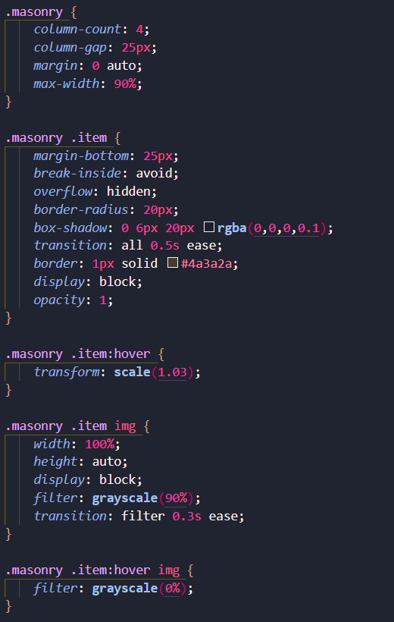

1. CSS checkbox hack for Filtering

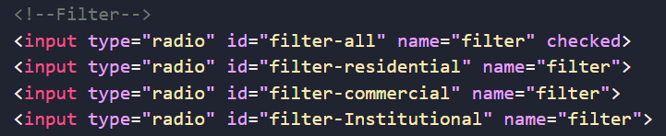

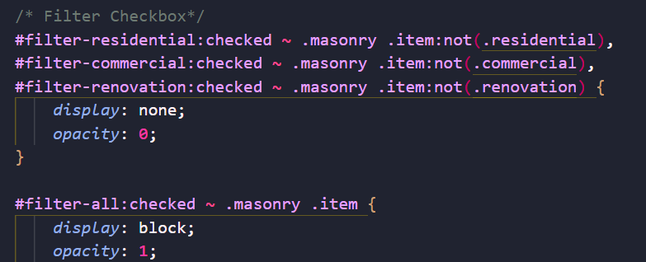

1. CSS Testimonials Carousel

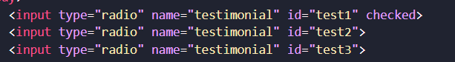

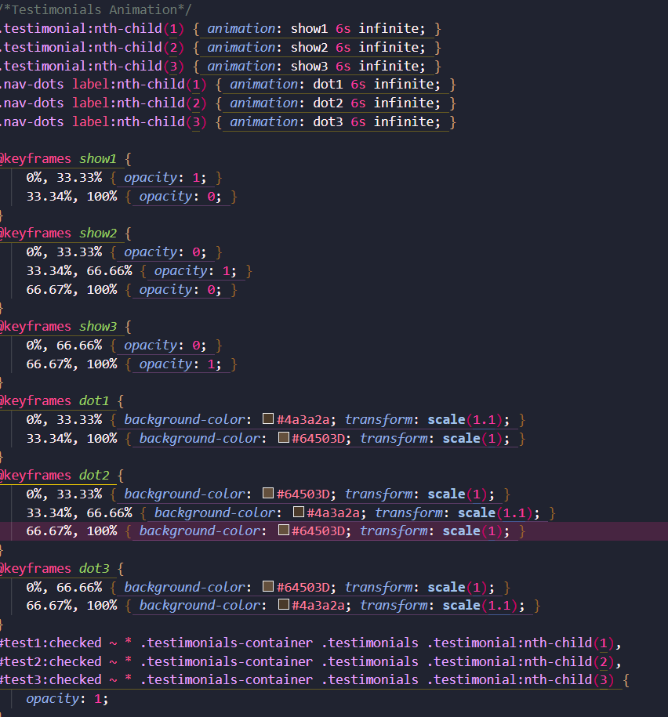

1. Responsive Layout

