Website Traffic Analysis Report

Objective
Analyze website traffic logs to understand user journeys, top landing pages, bounce rates and traffic sources, and recommend improvements for Alfido Tech.

Dataset
Dataset: Website Traffic Analysis (Kaggle). The dataset contains pageview, preview and click events with date, country, city and link information.

Methodology
- Cleaned the dataset by removing duplicates, handling missing values and formatting dates.
- Estimated sessions and users using proxy identifiers.
- Calculated bounce rate and estimated average session duration.
- Analyzed entry and exit links and traffic by country.
- Generated business recommendations.

Figure 1: User Journey Funnel
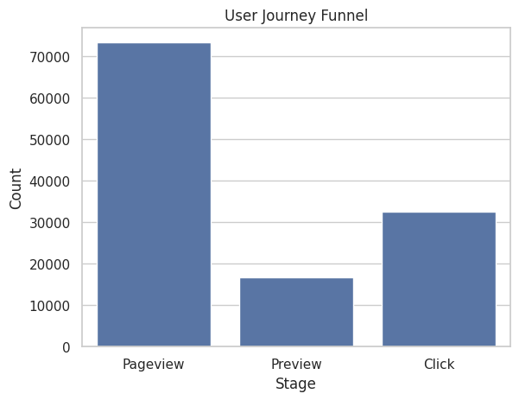

Figure 2: Top Entry Links
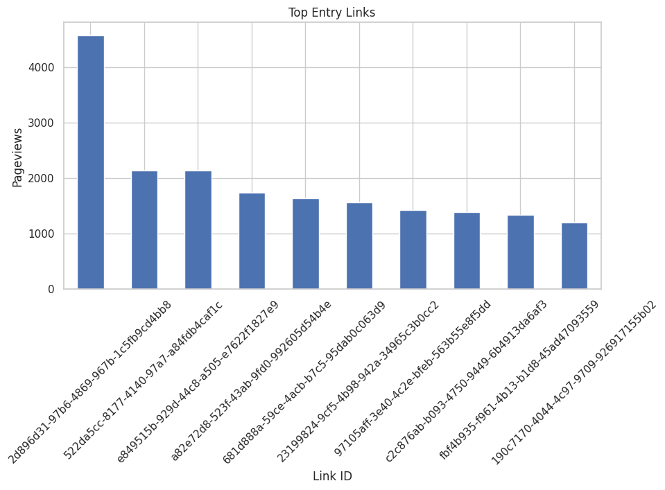

Figure 3: Top Estimated Exit Links
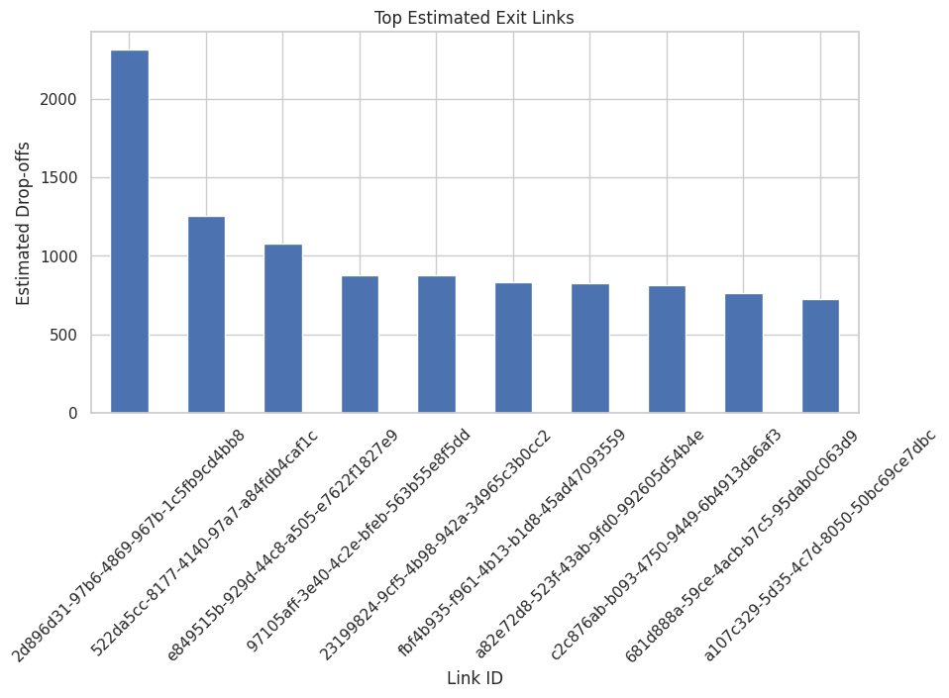

Figure 4: Top Traffic Sources by Country
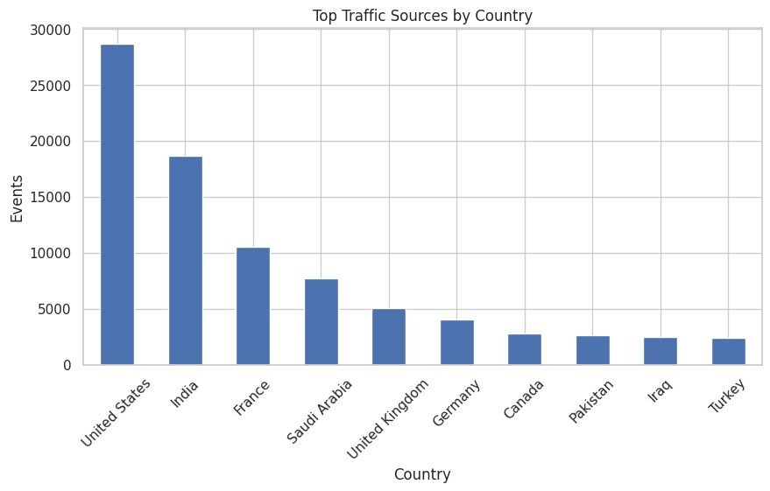

Key Insights
• Most visitors follow the Pageview → Preview → Click journey.
• Some entry links attract high traffic but produce relatively fewer clicks.
• Certain links show high estimated drop-offs, indicating opportunities for optimization.
• Traffic is concentrated in a few countries, allowing targeted marketing efforts.

Recommendations for Alfido Tech
- Improve high-traffic landing links with stronger call-to-action buttons.
- Reduce drop-offs by simplifying landing pages and improving page speed.
- Optimize the preview experience to encourage more clicks.
- Focus campaigns on countries generating the highest traffic.
- Implement detailed session IDs, timestamps and referral tracking for richer analytics.

Conclusion
The analysis provides insights into visitor behaviour, entry and exit patterns and engagement. Although the dataset lacks real session IDs and referral information, proxy metrics enabled meaningful analysis and practical business recommendations.

