**WEEK - 2**

**JUnit Testing Exercises**

**Exercise 1: Setting Up Junit**

**Output:**

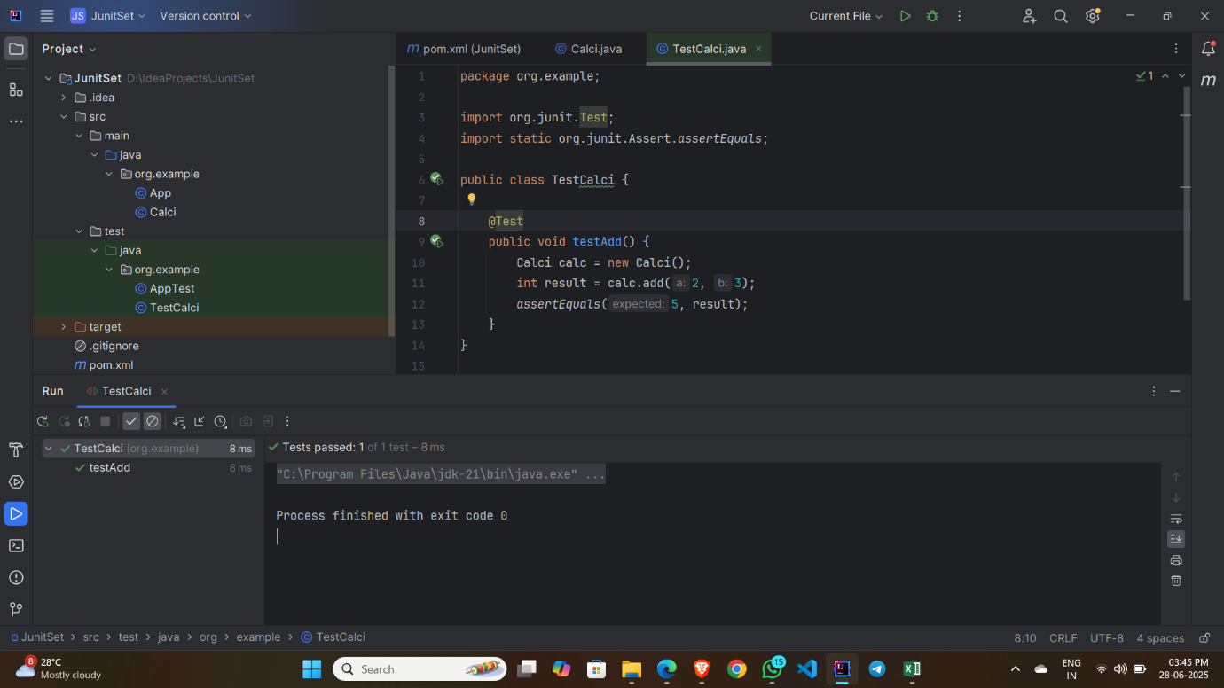

**Exercise 3: Assertions in Junit**

**Output:**

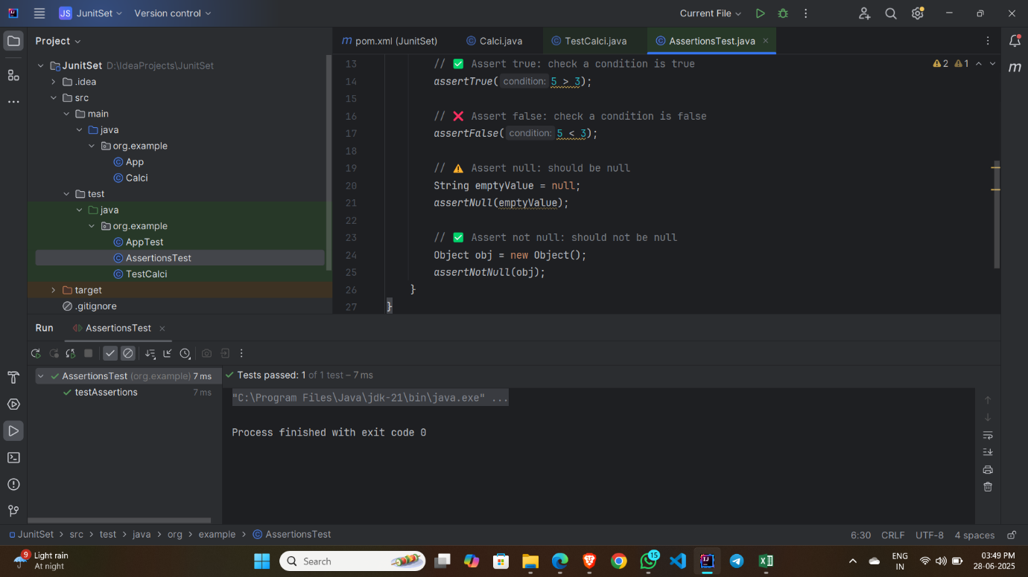

**Exercise 4: Arrange-Act-Assert (AAA) Pattern, Test Fixtures, Setup and Teardown Methods in Junit**

**Input:**

**BasicCalculator.java :**

package org.example;  
  
public class BasicCalculator {  
 public int add(int a, int b) {  
 return a + b;  
 }  
 public int subtract(int a, int b) {  
 return a - b;  
 }  
}

**Basic CalculatorTest.java :**

package org.example;  
  
import org.junit.After;  
import org.junit.Before;  
import org.junit.Test;  
import static org.junit.Assert.*;  
  
public class BasicCalculatorTest {  
  
 private BasicCalculator calculator;  
  
 @Before  
 public void setUp() {  
 calculator = new BasicCalculator();  
 System.*out*.println("Setup complete.");  
 }  
  
 @After  
 public void tearDown() {  
 calculator = null;  
 System.*out*.println("Teardown complete.");  
 }  
  
 @Test  
 public void testAddition() {  
 int result = calculator.add(10, 5);  
 *assertEquals*(15, result);  
 }  
  
 @Test  
 public void testSubtraction() {  
 int result = calculator.subtract(20, 8);  
 *assertEquals*(12, result);  
 }  
}

**Output:**

