**WEEK - 2**

**Mockito Hands-On Exercises**

**Exercise 1: Mocking and Stubbing**

**Code :**

**External.api :**

package org.example;  
  
// This is the external API we want to mock in tests  
public interface ExternalApi {  
 String getData();  
}

**MyService.java :**

package org.example;  
  
public class MyService {  
  
 private final ExternalApi api;  
  
 public MyService(ExternalApi api) {  
 this.api = api;  
 }  
  
 public String fetchData() {  
 return api.getData(); // Call to external dependency  
 }  
}

**Output :**

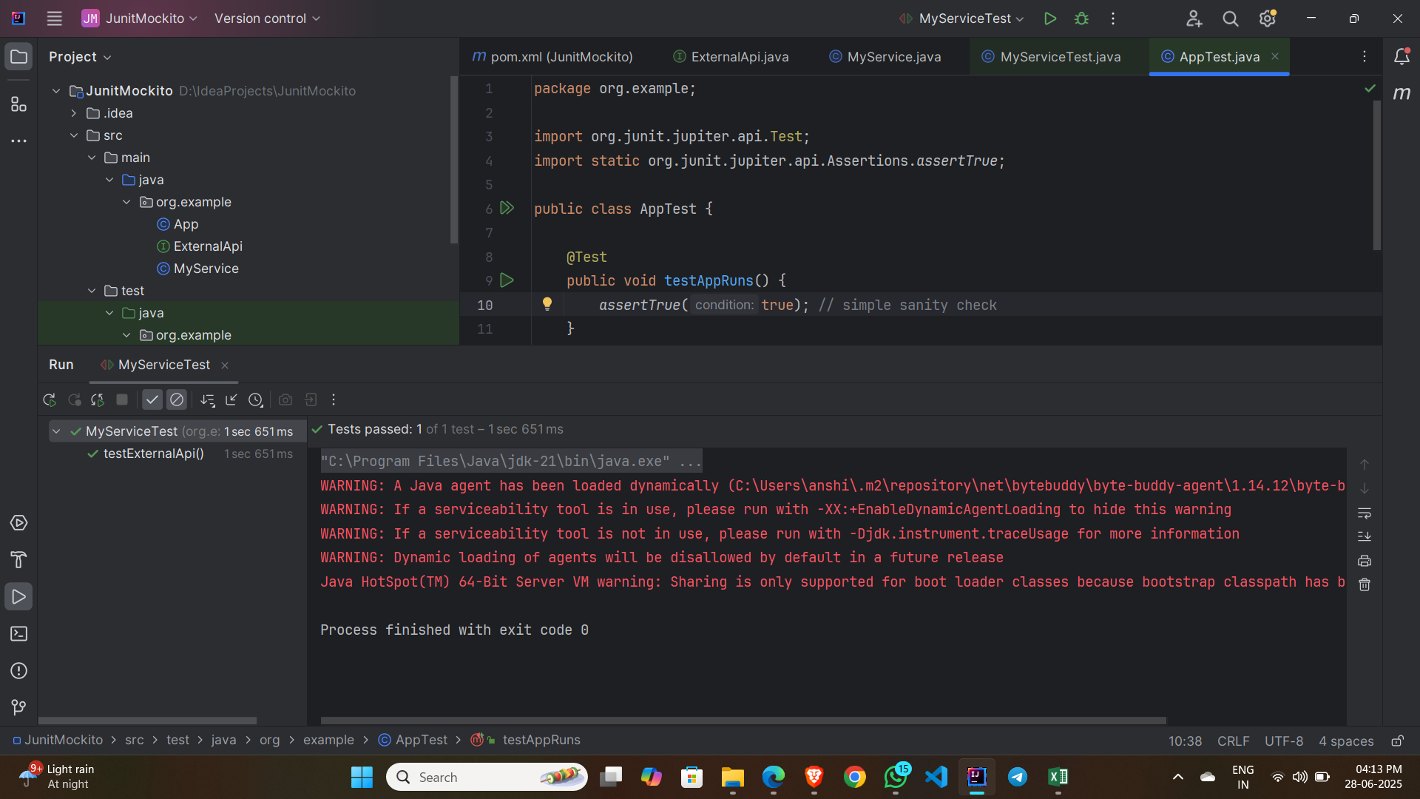

**Exercise 2: Verifying Interactions**

**Output :**

