WEEK – 3

Spring Core and Maven

Exercise 1: Configuring a Basic Spring Application

Code:

pom.xml:

<project xmlns="http://maven.apache.org/POM/4.0.0" xmlns:xsi="http://www.w3.org/2001/XMLSchema-instance"  
 xsi:schemaLocation="http://maven.apache.org/POM/4.0.0 http://maven.apache.org/xsd/maven-4.0.0.xsd">  
 <modelVersion>4.0.0</modelVersion>  
  
 <groupId>org.example</groupId>  
 <artifactId>LibraryManagement</artifactId>  
 <version>1.0-SNAPSHOT</version>  
 <packaging>jar</packaging>  
  
 <name>LibraryManagement</name>  
 <url>http://maven.apache.org</url>  
  
 <properties>  
 <project.build.sourceEncoding>UTF-8</project.build.sourceEncoding>  
 </properties>  
  
 <dependencies>  
  
 <!-- Spring Core -->  
 <dependency>  
 <groupId>org.springframework</groupId>  
 <artifactId>spring-context</artifactId>  
 <version>5.3.31</version>  
 </dependency>  
  
  
 <dependency>  
 <groupId>org.springframework</groupId>  
 <artifactId>spring-core</artifactId>  
 <version>6.2.8</version>  
 </dependency>  
 </dependencies>  
</project>

BookRepository.java:

package org.example.repository;  
  
public class BookRepository {  
 public void saveBook(String bookName) {  
 System.*out*.println("Saving book: " + bookName);  
 }  
}

BookService.java:

package org.example.service;  
  
import org.example.repository.BookRepository;  
  
public class BookService {  
  
 private BookRepository bookRepository;  
  
 // Setter for dependency injection  
 public void setBookRepository(BookRepository bookRepository) {  
 this.bookRepository = bookRepository;  
 }  
  
 public void addBook(String bookName) {  
 System.*out*.println("Adding book: " + bookName);  
 bookRepository.saveBook(bookName);  
 }  
}

App.java:

package org.example;  
  
import org.example.service.BookService;  
import org.springframework.context.ApplicationContext;  
import org.springframework.context.support.ClassPathXmlApplicationContext;  
  
  
public class App {  
 public static void main(String[] args) {  
 ApplicationContext context = new ClassPathXmlApplicationContext("applicationContext.xml");  
  
 BookService bookService = context.getBean("bookService", BookService.class);  
 bookService.addBook("The Spring Journey");  
 }  
}

Output:

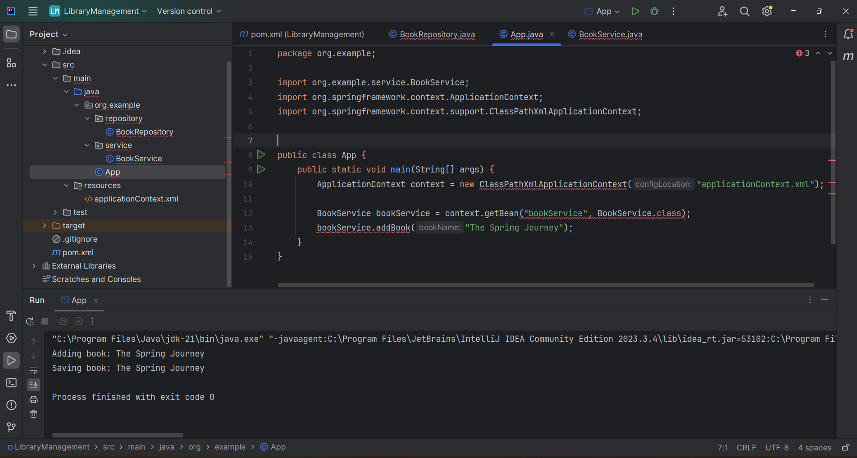

Exercise 2: Implementing Dependency Injection

Code:

BookService.java:

package org.example.service;  
  
import org.example.repository.BookRepository;  
  
public class BookService {  
  
 private BookRepository bookRepository;  
  
 // Setter for dependency injection  
 public void setBookRepository(BookRepository bookRepository) {  
 this.bookRepository = bookRepository;  
 }  
  
 public void addBook(String bookName) {  
 System.*out*.println("Adding book: " + bookName);  
 bookRepository.saveBook(bookName);  
 }  
}

App.java:

package org.example;  
  
import org.example.service.BookService;  
import org.springframework.context.ApplicationContext;  
import org.springframework.context.support.ClassPathXmlApplicationContext;  
  
  
public class App {  
 public static void main(String[] args) {  
 ApplicationContext context = new ClassPathXmlApplicationContext("applicationContext.xml");  
  
 BookService bookService = context.getBean("bookService", BookService.class);  
 bookService.addBook("Effective Spring DI");  
 }  
}

Output:

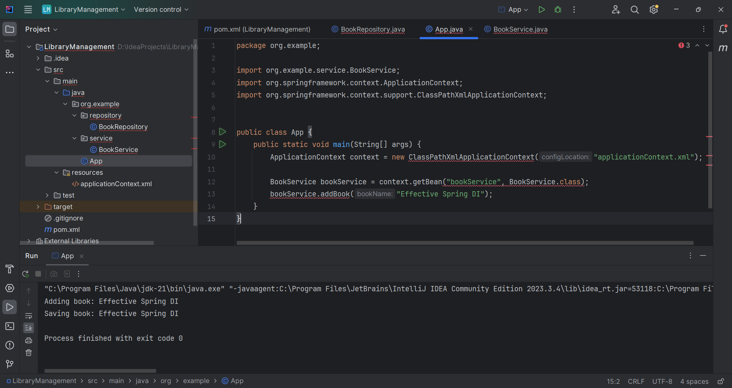

Exercise 4: Creating and Configuring a Maven Project

Code:

pom.xml:

<project xmlns="http://maven.apache.org/POM/4.0.0" xmlns:xsi="http://www.w3.org/2001/XMLSchema-instance"  
 xsi:schemaLocation="http://maven.apache.org/POM/4.0.0 http://maven.apache.org/xsd/maven-4.0.0.xsd">  
 <modelVersion>4.0.0</modelVersion>  
  
 <groupId>org.example</groupId>  
 <artifactId>LibraryManagement2</artifactId>  
 <version>1.0-SNAPSHOT</version>  
 <packaging>jar</packaging>  
  
 <name>LibraryManagement2</name>  
 <url>http://maven.apache.org</url>  
  
 <properties>  
 <project.build.sourceEncoding>UTF-8</project.build.sourceEncoding>  
 </properties>  
  
 <dependencies>  
 <!-- Spring Context -->  
 <dependency>  
 <groupId>org.springframework</groupId>  
 <artifactId>spring-context</artifactId>  
 <version>5.3.34</version>  
 </dependency>  
  
 <!-- Spring AOP -->  
 <dependency>  
 <groupId>org.springframework</groupId>  
 <artifactId>spring-aop</artifactId>  
 <version>5.3.34</version>  
 </dependency>  
  
 <!-- Spring WebMVC -->  
 <dependency>  
 <groupId>org.springframework</groupId>  
 <artifactId>spring-webmvc</artifactId>  
 <version>5.3.34</version>  
 </dependency>  
 </dependencies>  
  
 <build>  
 <plugins>  
 <!-- Maven Compiler Plugin -->  
 <plugin>  
 <groupId>org.apache.maven.plugins</groupId>  
 <artifactId>maven-compiler-plugin</artifactId>  
 <version>3.10.1</version>  
 <configuration>  
 <source>1.8</source>  
 <target>1.8</target>  
 </configuration>  
 </plugin>  
 </plugins>  
 </build>  
  
  
</project>

Output:

