**WEEK - 4**

**Spring REST using Spring Boot 3**

**HandsOn – 1:**

**Create a Spring Web Project using Maven**

**SpringLearnApplication.java –**

package com.cognizant.springlearn;

import org.springframework.boot.SpringApplication;

import org.springframework.boot.autoconfigure.SpringBootApplication;

@SpringBootApplication

public class SpringLearnApplication {

public static void main(String[] args) {

System.out.println("Starting Spring Boot Application");

SpringApplication.run(SpringLearnApplication.class, args);

System.out.println("Application Started Successfully");

}

}

**Output:**

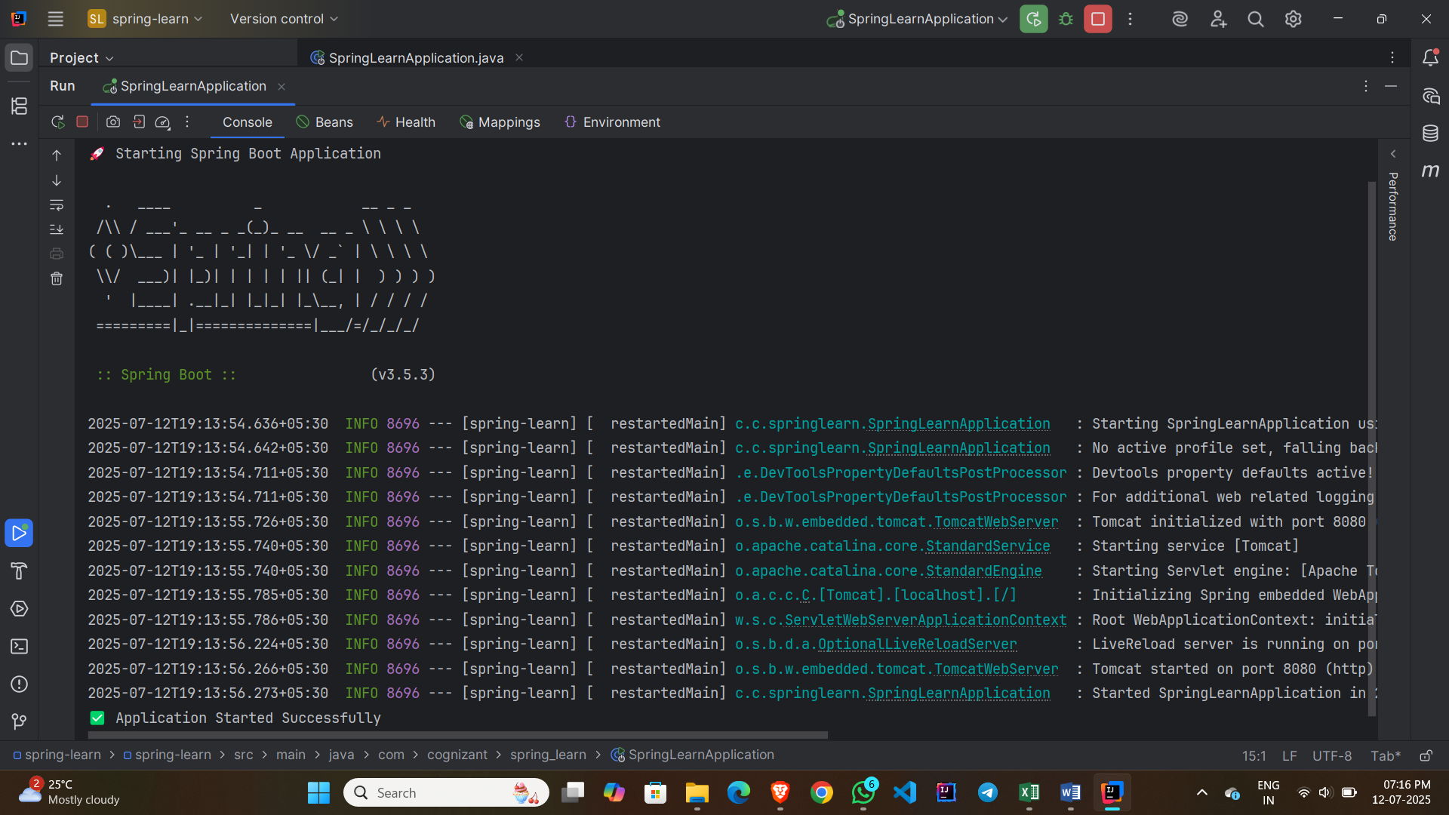

**HandsOn – 2:**

**Spring Core – Load Country from Spring Configuration XML**

**Country.java –**

package com.cognizant.springlearn;

import org.slf4j.Logger;

import org.slf4j.LoggerFactory;

public class Country {

private String code;

private String name;

private static final Logger LOGGER = LoggerFactory.getLogger(Country.class);

public Country() {

LOGGER.debug("Inside Country Constructor.");

}

public String getCode() {

LOGGER.debug("Inside getCode()");

return code;

}

public void setCode(String code) {

LOGGER.debug("Inside setCode()");

this.code = code;

}

public String getName() {

LOGGER.debug("Inside getName()");

return name;

}

public void setName(String name) {

LOGGER.debug("Inside setName()");

this.name = name;

}

@Override

public String toString() {

return "Country [code=" + code + ", name=" + name + "]";

}

}

**country.xml –**

<?xml version="1.0" encoding="UTF-8"?>

<beans xmlns="http://www.springframework.org/schema/beans"

xmlns:xsi="http://www.w3.org/2001/XMLSchema-instance"

xsi:schemaLocation="http://www.springframework.org/schema/beans

http://www.springframework.org/schema/beans/spring-beans.xsd">

<bean id="country" class="com.cognizant.spring_learn.Country">

<property name="code" value="IN" />

<property name="name" value="India" />

</bean>

</beans>

**SpringLearnApplication.java –**

package com.cognizant.spring_learn;

import org.springframework.boot.CommandLineRunner;

import org.springframework.boot.SpringApplication;

import org.springframework.boot.autoconfigure.SpringBootApplication;

import org.springframework.context.annotation.Bean;

@SpringBootApplication

public class SpringLearnApplication {

public static void main(String[] args) {

SpringApplication.run(SpringLearnApplication.class, args);

System.out.println(">>> Application has started <<<");

}

@Bean

public CommandLineRunner run() {

return args -> {

System.out.println(">>> Hello from Spring Boot <<<");

};

}

}

**Output:**

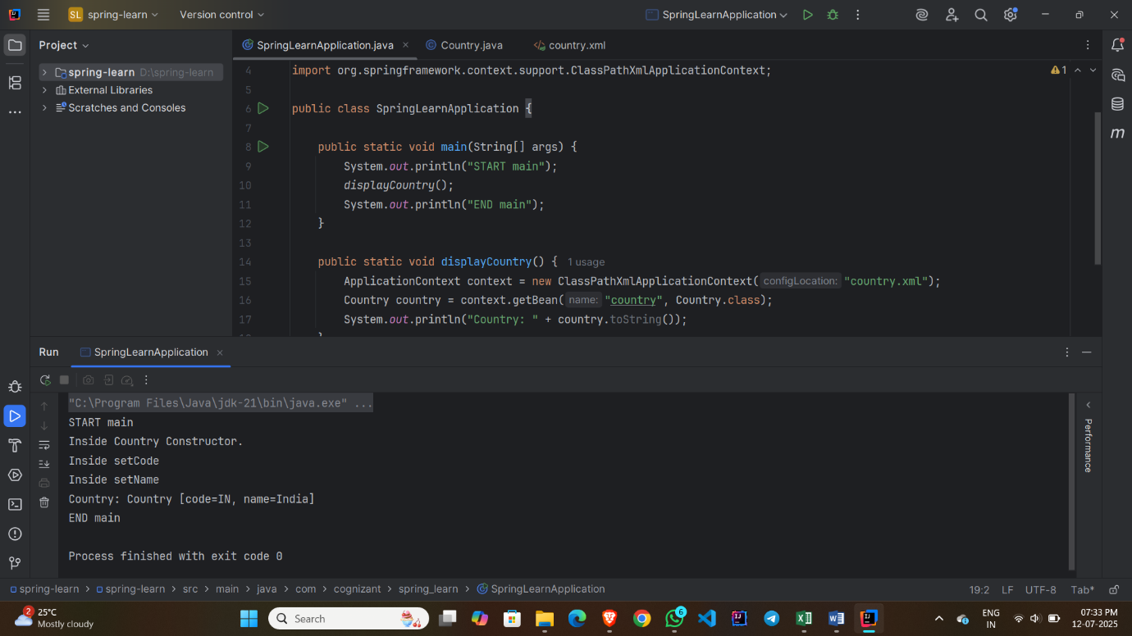

**HandsOn – 3:**

**Hello World RESTful Web Service**

**HelloController.java –**

package com.cognizant.spring_learn.controller;

import org.slf4j.Logger;

import org.slf4j.LoggerFactory;

import org.springframework.web.bind.annotation.GetMapping;

import org.springframework.web.bind.annotation.RestController;

@RestController

public class HelloController {

private static final Logger LOGGER = LoggerFactory.getLogger(HelloController.class);

@GetMapping("/hello")

public String sayHello() {

LOGGER.info("START - sayHello()");

String message = "Hello World!!";

LOGGER.info("END - sayHello()");

return message;

}

}

**SpringLearnApplication.java –**

package com.cognizant.spring_learn;

import org.springframework.boot.SpringApplication;

import org.springframework.boot.autoconfigure.SpringBootApplication;

@SpringBootApplication

public class SpringLearnApplication {

public static void main(String[] args) {

SpringApplication.run(SpringLearnApplication.class, args);

}

}

**Output:**

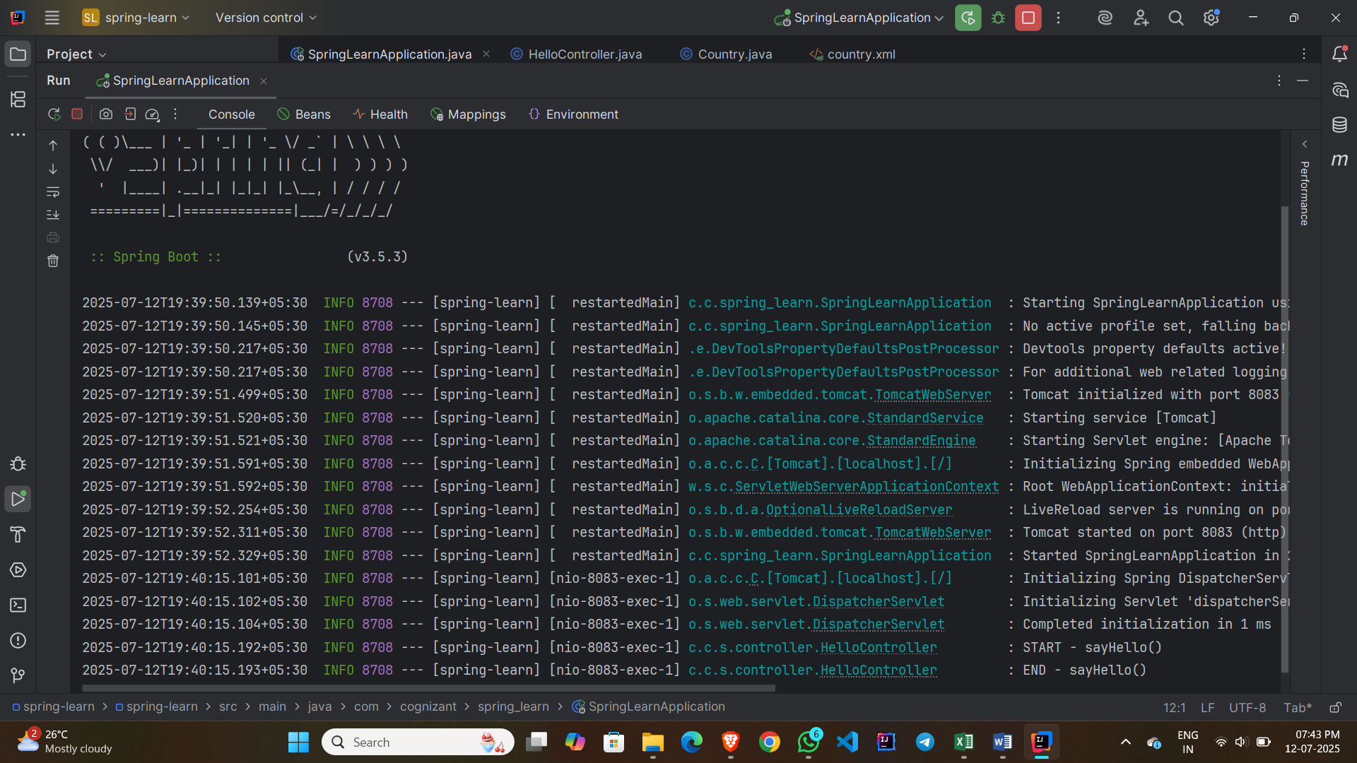

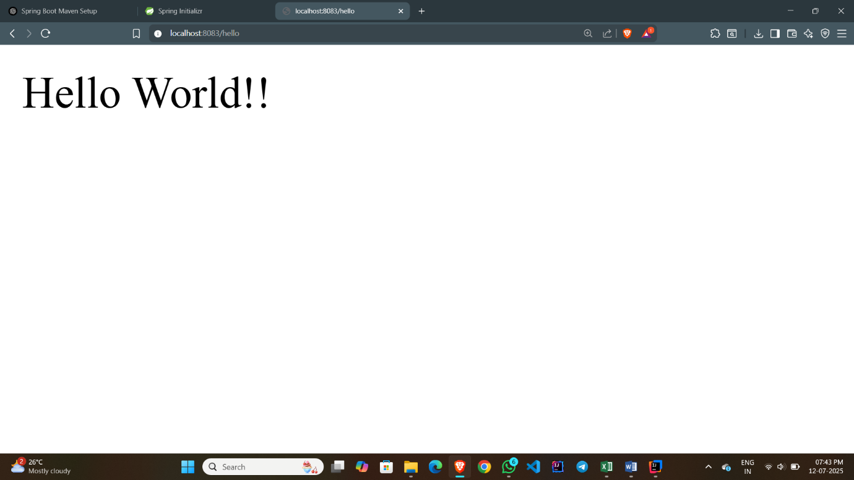

**HandsOn – 4:**

**REST - Country Web Service**

**Country.java –**

package com.cognizant.spring_learn.model;

public class Country {

private String code;

private String name;

// Getters and Setters

public String getCode() {

return code;

}

public void setCode(String code) {

this.code = code;

}

public String getName() {

return name;

}

public void setName(String name) {

this.name = name;

}

}

**country.xml –**

<?xml version="1.0" encoding="UTF-8"?>

<beans xmlns="http://www.springframework.org/schema/beans"

xmlns:xsi="http://www.w3.org/2001/XMLSchema-instance"

xsi:schemaLocation="http://www.springframework.org/schema/beans

https://www.springframework.org/schema/beans/spring-beans.xsd">

<bean id="in" class="com.cognizant.spring_learn.model.Country">

<property name="code" value="IN"/>

<property name="name" value="India"/>

</bean>

</beans>

**SpringLearnApplication.java –**

package com.cognizant.spring_learn;

import org.springframework.boot.SpringApplication;

import org.springframework.boot.autoconfigure.SpringBootApplication;

import org.springframework.context.annotation.ImportResource;

@SpringBootApplication

@ImportResource("classpath:country.xml")

public class SpringLearnApplication {

public static void main(String[] args) {

SpringApplication.run(SpringLearnApplication.class, args);

}

}

**CountryController.java –**

package com.cognizant.spring_learn.controller;

import com.cognizant.spring_learn.model.Country;

import org.slf4j.Logger;

import org.slf4j.LoggerFactory;

import org.springframework.beans.factory.annotation.Autowired;

import org.springframework.context.ApplicationContext;

import org.springframework.web.bind.annotation.RequestMapping;

import org.springframework.web.bind.annotation.RestController;

@RestController

public class CountryController {

private static final Logger LOGGER = LoggerFactory.getLogger(CountryController.class);

@Autowired

private ApplicationContext context;

@RequestMapping("/country")

public Country getCountryIndia() {

LOGGER.info("START - getCountryIndia()");

Country in = (Country) context.getBean("in");

LOGGER.info("END - getCountryIndia()");

return in;

}

}

**Output:**

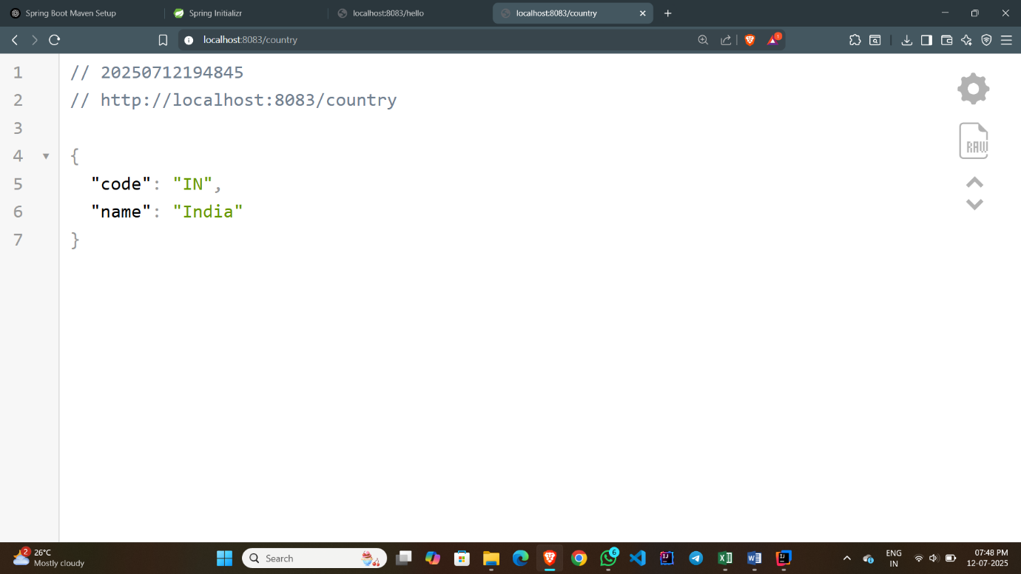

**HandsOn – 5:**

**REST - Get country based on country code**

**CountryService.java –**

package com.cognizant.spring_learn.service;

import com.cognizant.spring_learn.model.Country;

import org.springframework.context.ApplicationContext;

import org.springframework.context.support.ClassPathXmlApplicationContext;

import org.springframework.stereotype.Service;

import java.util.List;

@Service

public class CountryService {

public Country getCountry(String code) {

ApplicationContext context = new ClassPathXmlApplicationContext("country.xml");

List<Country> countryList = context.getBean("countryList", List.class);

return countryList.stream()

.filter(country -> country.getCode().equalsIgnoreCase(code))

.findFirst()

.orElse(null);

}

}

**CountryController.java –**

package com.cognizant.spring_learn.controller;

import com.cognizant.spring_learn.model.Country;

import com.cognizant.spring_learn.service.CountryService;

import org.slf4j.Logger;

import org.slf4j.LoggerFactory;

import org.springframework.beans.factory.annotation.Autowired;

import org.springframework.web.bind.annotation.*;

@RestController

public class CountryController {

private static final Logger LOGGER = LoggerFactory.getLogger(CountryController.class);

@Autowired

private CountryService countryService;

@GetMapping("/countries/{code}")

public Country getCountry(@PathVariable String code) {

LOGGER.info("START getCountry()");

Country country = countryService.getCountry(code);

LOGGER.info("END getCountry()");

return country;

}

}

**SpringLearnApplication.java –**

package com.cognizant.spring_learn;

import org.springframework.boot.SpringApplication;

import org.springframework.boot.autoconfigure.SpringBootApplication;

@SpringBootApplication

public class SpringLearnApplication {

public static void main(String[] args) {

SpringApplication.run(SpringLearnApplication.class, args);

}

}

**Output:**

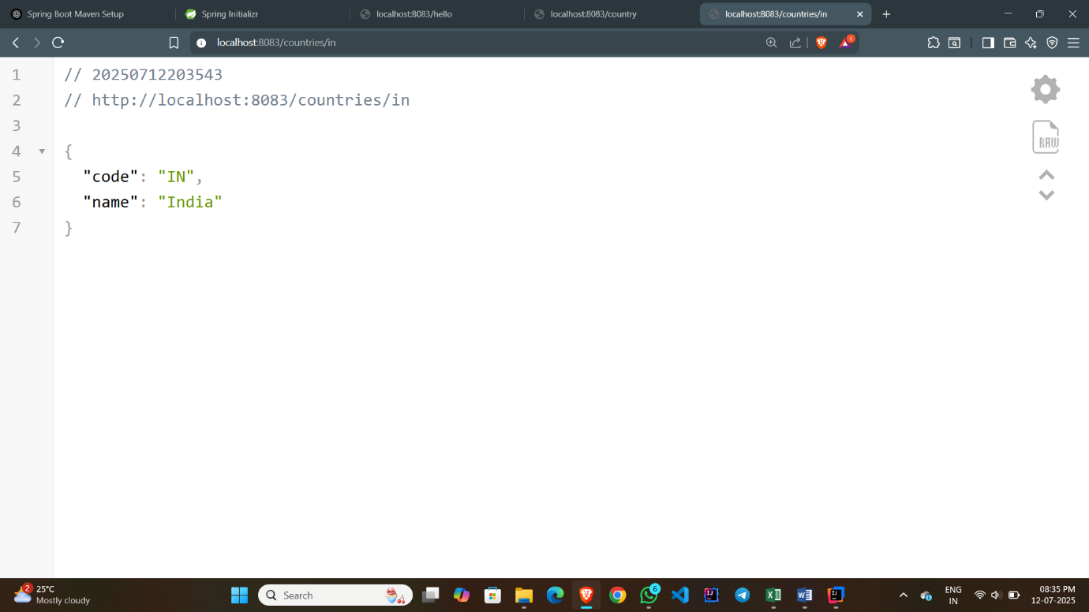

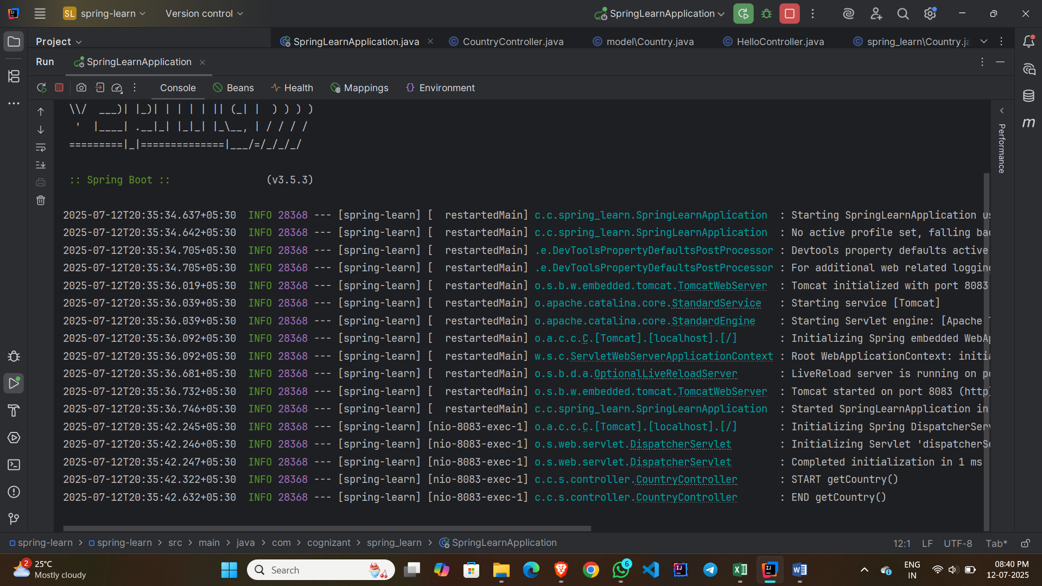

**HandsOn – 6:**

**Create authentication service that returns JWT**

**pom.xml –**

<?xml version="1.0" encoding="UTF-8"?>  
<project xmlns="http://maven.apache.org/POM/4.0.0" xmlns:xsi="http://www.w3.org/2001/XMLSchema-instance"  
 xsi:schemaLocation="http://maven.apache.org/POM/4.0.0 https://maven.apache.org/xsd/maven-4.0.0.xsd">  
 <modelVersion>4.0.0</modelVersion>  
 <parent>  
 <groupId>org.springframework.boot</groupId>  
 <artifactId>spring-boot-starter-parent</artifactId>  
 <version>3.5.3</version>  
 <relativePath/> <!-- lookup parent from repository -->  
 </parent>  
 <groupId>com.cognizant</groupId>  
 <artifactId>spring-learn</artifactId>  
 <version>0.0.1-SNAPSHOT</version>  
 <name>spring-learn</name>  
 <description>Demo project for Spring Boot</description>  
 <url/>  
 <licenses>  
 <license/>  
 </licenses>  
 <developers>  
 <developer/>  
 </developers>  
 <scm>  
 <connection/>  
 <developerConnection/>  
 <tag/>  
 <url/>  
 </scm>  
 <properties>  
 <java.version>17</java.version>  
 </properties>  
 <dependencies>  
 <!-- Spring Boot Starter Web -->  
 <dependency>  
 <groupId>org.springframework.boot</groupId>  
 <artifactId>spring-boot-starter-web</artifactId>  
 </dependency>  
  
 <!-- Spring Security -->  
 <dependency>  
 <groupId>org.springframework.boot</groupId>  
 <artifactId>spring-boot-starter-security</artifactId>  
 </dependency>  
  
 <!-- JWT -->  
 <dependency>  
 <groupId>io.jsonwebtoken</groupId>  
 <artifactId>jjwt-api</artifactId>  
 <version>0.11.5</version>  
 </dependency>  
 <dependency>  
 <groupId>io.jsonwebtoken</groupId>  
 <artifactId>jjwt-impl</artifactId>  
 <version>0.11.5</version>  
 <scope>runtime</scope>  
 </dependency>  
 <dependency>  
 <groupId>io.jsonwebtoken</groupId>  
 <artifactId>jjwt-jackson</artifactId>  
 <version>0.11.5</version>  
 <scope>runtime</scope>  
 </dependency>  
  
 <dependency>  
 <groupId>org.junit.jupiter</groupId>  
 <artifactId>junit-jupiter</artifactId>  
 <version>5.10.2</version>  
 <scope>test</scope>  
 </dependency>  
  
 <!-- Spring Boot Starter Test -->  
 <dependency>  
 <groupId>org.springframework.boot</groupId>  
 <artifactId>spring-boot-starter-test</artifactId>  
 <scope>test</scope>  
 </dependency>  
  
 </dependencies>  
  
  
 <build>  
 <plugins>  
 <plugin>  
 <groupId>org.springframework.boot</groupId>  
 <artifactId>spring-boot-maven-plugin</artifactId>  
 </plugin>  
 </plugins>  
 </build>  
  
</project>

**SecurityConfig.java –**

package com.cognizant.spring_learn.config;  
  
import org.springframework.context.annotation.Bean;  
import org.springframework.context.annotation.Configuration;  
import org.springframework.security.config.annotation.web.builders.HttpSecurity;  
import org.springframework.security.core.userdetails.*;  
import org.springframework.security.provisioning.InMemoryUserDetailsManager;  
import org.springframework.security.web.SecurityFilterChain;  
  
@Configuration  
public class SecurityConfig {  
  
 @Bean  
 public InMemoryUserDetailsManager userDetailsService() {  
 UserDetails user = User.*withUsername*("user")  
 .password("{noop}pwd") // {noop} means plain text password  
 .roles("USER")  
 .build();  
 return new InMemoryUserDetailsManager(user);  
 }  
  
 @Bean  
 public SecurityFilterChain filterChain(HttpSecurity http) throws Exception {  
 http.csrf().disable()  
 .authorizeHttpRequests()  
 .requestMatchers("/authenticate").authenticated()  
 .anyRequest().permitAll()  
 .and()  
 .httpBasic(); // Enables Basic Auth  
  
 return http.build();  
 }  
}

**JwtUtil.java -**

package com.cognizant.spring_learn.util;  
  
import io.jsonwebtoken.Jwts;  
import io.jsonwebtoken.SignatureAlgorithm;  
import io.jsonwebtoken.security.Keys;  
import org.springframework.stereotype.Component;  
  
import java.security.Key;  
import java.util.Date;  
  
@Component  
public class JwtUtil {  
 private final Key key = Keys.*secretKeyFor*(SignatureAlgorithm.*HS256*); // Generates a random secret key  
  
 public String generateToken(String username) {  
 long expirationTime = 1000 * 60 * 60; // 1 hour  
 return Jwts.*builder*()  
 .setSubject(username)  
 .setIssuedAt(new Date())  
 .setExpiration(new Date(System.*currentTimeMillis*() + expirationTime))  
 .signWith(key)  
 .compact();  
 }  
}

**AuthenticationController.java –**

package com.cognizant.spring_learn.controller;  
  
import com.cognizant.spring_learn.util.JwtUtil;  
import org.springframework.security.core.annotation.AuthenticationPrincipal;  
import org.springframework.security.core.userdetails.User;  
import org.springframework.web.bind.annotation.*;  
  
import java.util.Map;  
  
@RestController  
public class AuthenticationController {  
  
 private final JwtUtil jwtUtil;  
  
 public AuthenticationController(JwtUtil jwtUtil) {  
 this.jwtUtil = jwtUtil;  
 }  
  
 @GetMapping("/authenticate")  
 public Map<String, String> authenticate(@AuthenticationPrincipal User user) {  
 // Generate token from authenticated user  
 String token = jwtUtil.generateToken(user.getUsername());  
 return Map.*of*("token", token);  
 }  
}

**SpringLearnApplication.java –**

package com.cognizant.spring_learn;  
  
import org.springframework.boot.SpringApplication;  
import org.springframework.boot.autoconfigure.SpringBootApplication;  
  
@SpringBootApplication  
public class SpringLearnApplication {  
 public static void main(String[] args) {  
 SpringApplication.*run*(SpringLearnApplication.class, args);  
 }  
}

**Output :**

