1**WEEK – 5**

**Microservices with Spring Boot 3 and Spring Cloud**

**Handson 1 : Creating Microservices for account and loan**

**Account Microservice :**

**FileName: AccountController.java**

package com.cognizant.account;  
  
import org.springframework.web.bind.annotation.*;  
  
@RestController  
public class AccountController {  
  
 @GetMapping("/accounts/{number}")  
 public Account getAccount(@PathVariable String number) {  
 return new Account(number, "savings", 234343);  
 }  
  
 record Account(String number, String type, double balance) {}  
}

**Output:**

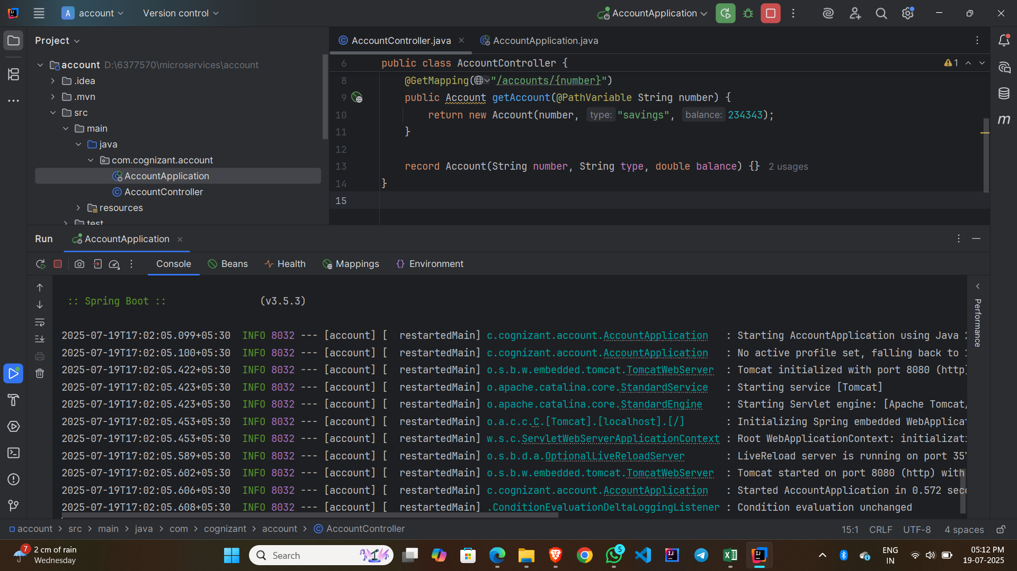

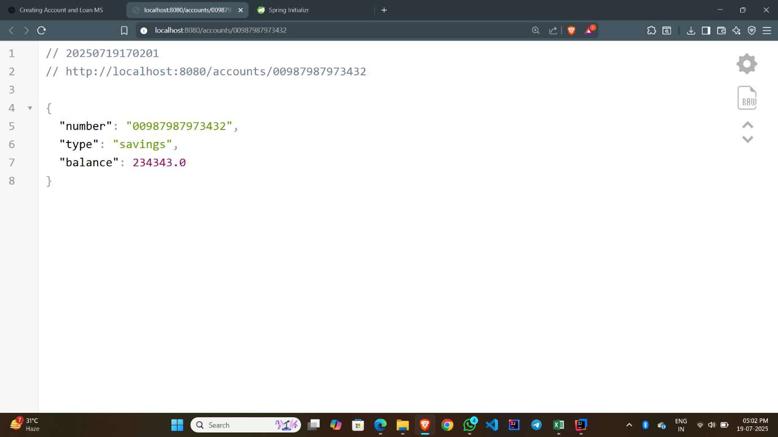

**Loan Microservice :**

**FileName: LoanController.java**

package com.cognizant.loan;  
  
import org.springframework.web.bind.annotation.*;  
  
@RestController  
public class LoanController {  
  
 @GetMapping("/loans/{number}")  
 public Loan getLoan(@PathVariable String number) {  
 return new Loan(number, "car", 400000, 3258, 18);  
 }  
  
 record Loan(String number, String type, int loan, int emi, int tenure) {}  
}

**Output:**

