**WEEK - 6**

**React**

**Hands-on 1:**

**App.js:**

function App() {

  return (

    <h1 style={{textAlign: "center"}}>Welcome to the first session of React</h1>

  )

}

export default App;

**Output:**

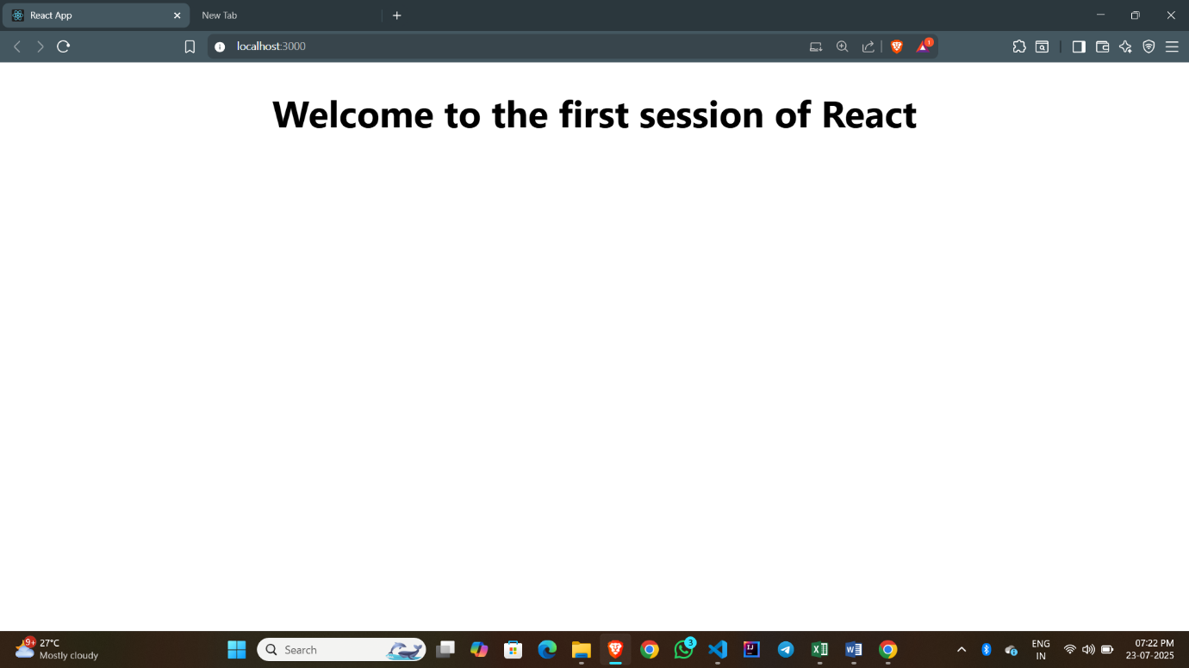

**Hands-on 2:**

**App.js:**

import React from 'react'

import Home from './Components/Home'

import About from './Components/About'

import Contact from './Components/Contact'

import './App.css'

const App = () => {

  return (

    <div>

      <Home />

      <About />

      <Contact />

    </div>

  )

}

export default App

**Home.js:**

import React from 'react'

const Home = () => {

  return (

    <div style={{textAlign: "center"}}>Welcome to Home page of Student Management Portal</div>

  )

}

export default Home

**About.js:**

import React from 'react'

const About = () => {

  return (

    <div style={{textAlign: "center"}}>Welcome to About page of Student Management Portal</div>

  )

}

export default About

**Contact.js:**

import React from 'react'

const Contact = () => {

  return (

    <div style={{textAlign: "center"}}>Welcome to Contact page of Student Management Portal</div>

  )

}

export default Contact

**Output:**

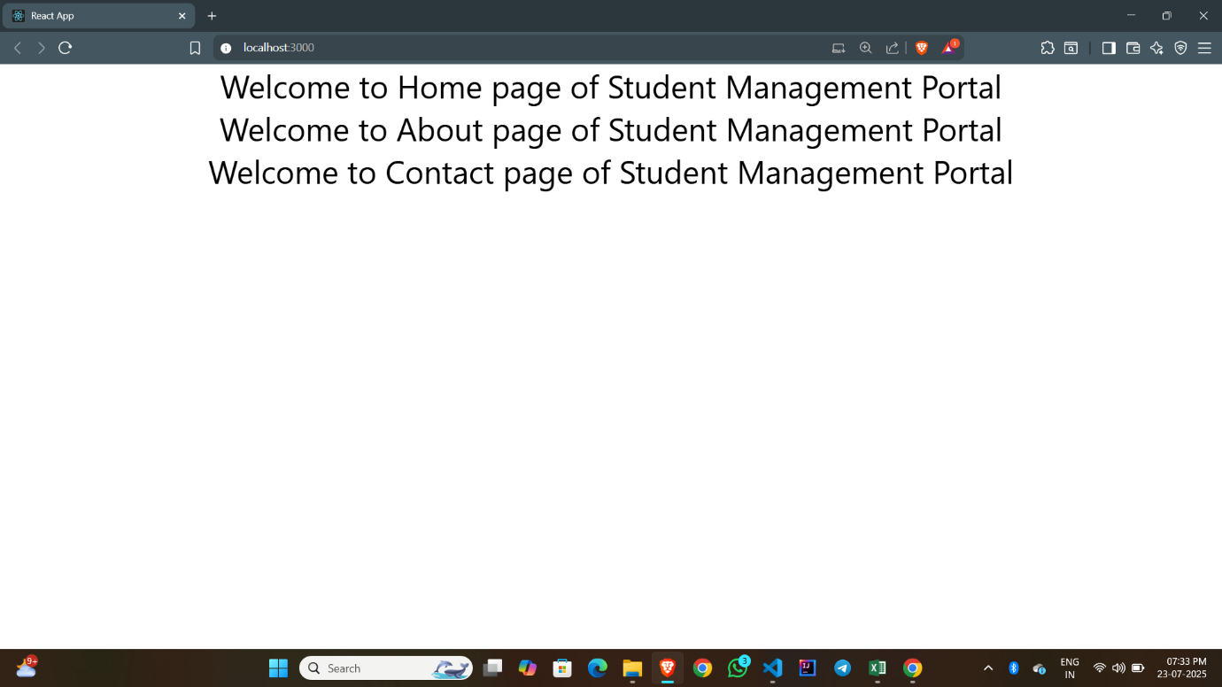

**Hands-on 3:**

**App.js:**

import React from 'react'

import { CalculateScore } from './Components/CalculateScore'

const App = () => {

  return (

    <div>

      <CalculateScore Name={"Steeve"}

      School={"DNV Public School"}

      total={284}

      goal={3}

      />

    </div>

  )

}

export default App

**CalculateScore.js:**

import '../Stylesheets/mystyle.css';

const percentToDecimal = (decimal) => {

  return (decimal * 100).toFixed(2) + '%';

};

const calcScore = (total, goal) => {

  return percentToDecimal(total / goal);

};

export const CalculateScore = ({ Name, School, total, goal }) => (

  <div className="formatstyle">

    <h1 style={{ color: 'brown' }}>Student Details:</h1>

    <div className="Name">

      <b><span>Name: </span></b>

      <span>{Name}</span>

    </div>

    <div className="School">

      <b><span>School: </span></b>

      <span>{School}</span>

    </div>

    <div className="Total">

      <b><span>Total:</span></b>

      <span>{total}</span>

      <span> Marks</span>

    </div>

    <div className="Score">

      <b>Score:</b>

      <span>{calcScore(total, goal)}</span>

    </div>

  </div>

);

**mystyle.js:**

.Name {

  font-weight: 300;

  color: *blue*;

}

.School {

  color: *crimson*;

}

.Total {

  color: *darkmagenta*;

}

.formatstyle {

  text-align: *center*;

  font-size: *large*;

}

.Score {

  color: *forestgreen*;

}

**Output:**

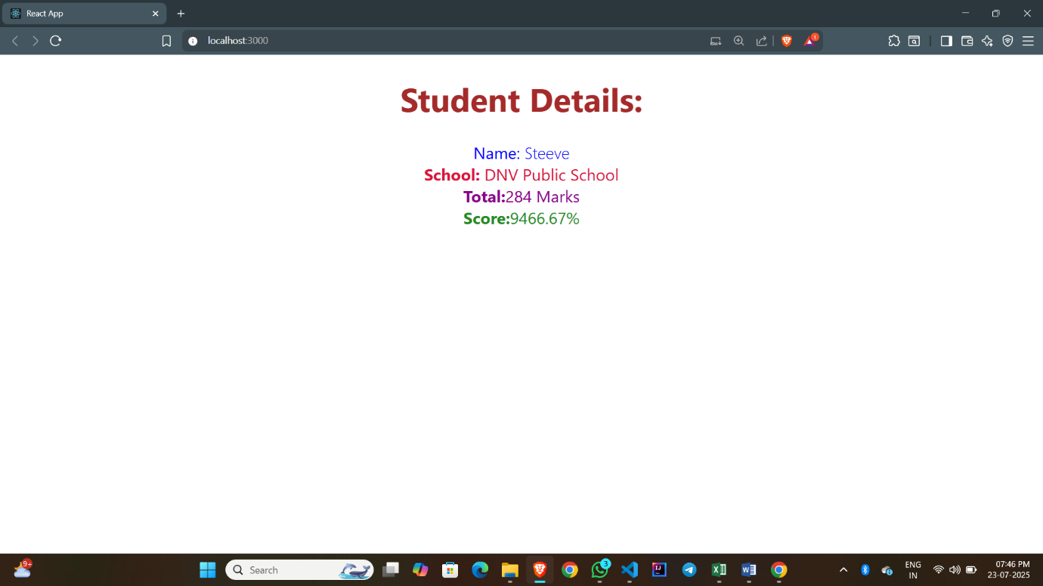

**Hands-on 4:**

**App.js:**

*// App.js*

import React from 'react';

import Posts from './Posts';

function App() {

  return (

    <div className="App">

      <Posts />

    </div>

  );

}

export default App;

**Posts.js:**

*// Posts.js*

import React from 'react';

import Post from './Post'; *// The model class*

class Posts extends React.Component {

    constructor(props) {

*super*(props);

*this*.state = {

            posts: [],

            hasError: false

        };

    }

    async loadPosts() {

        try {

            const response = await fetch("https://jsonplaceholder.typicode.com/posts");

            const data = await response.json();

*// Use your Post model to create instances*

            const postObjects = data.map(item => new Post(item.id, item.title, item.body));

*this*.setState({ posts: postObjects });

        } catch (error) {

            console.error("Fetch error:", error);

*this*.setState({ hasError: true });

        }

    }

    componentDidMount() {

*this*.loadPosts();

    }

    componentDidCatch(error, info) {

        alert("An error occurred while rendering the component.");

        console.error("Error caught:", error, info);

    }

    render() {

        if (*this*.state.hasError) {

            return <h1>Something went wrong!</h1>;

        }

        return (

            <div>

                <h1>Blog Posts</h1>

                {*this*.state.posts.map(post => (

                    <div key={post.id} style={{ marginBottom: '20px' }}>

                        <h2>{post.title}</h2>

                        <p>{post.content}</p>

                    </div>

                ))}

            </div>

        );

    }

}

export default Posts;

**Post.js:**

class Post{

    constructor(id, title, content) {

*this*.id = id;

*this*.title = title;

*this*.content = content;

    }

}

export default Post;

**Output:**

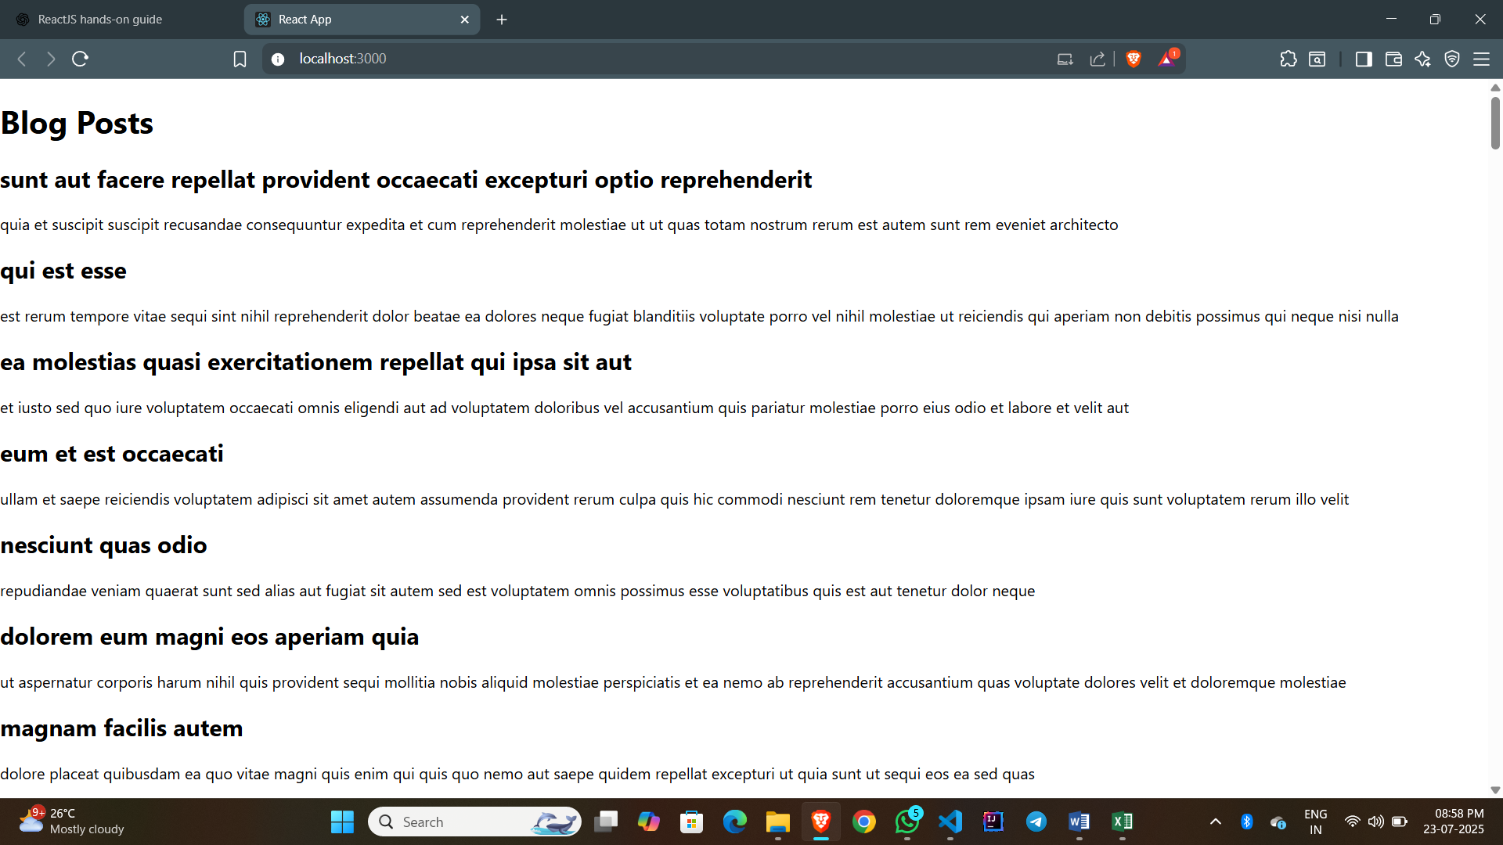

**Hands-on 5:**

**App.js:**

import logo from './logo.svg';

import './App.css';

import { CohortsData} from './Cohort'

import CohortDetails from './CohortDetails';

function App() {

  return (

  <div>

    <h1>Cohorts Details</h1>

    {CohortsData.map(cohort => <CohortDetails cohort={cohort}/>)}

  </div>

  );

}

export default App;

**CohortDetails.js:**

import styles from './CohortDetails.module.css';

function CohortDetails(props) {

    return (

        <div className={styles.box}>

            <h3 style={{ color: props.cohort.currentStatus === 'Ongoing' ? 'green' : 'blue' }}>

                {props.cohort.cohortCode} -

                <span>{props.cohort.technology}</span>

            </h3>

            <dl>

                <dt>Started On</dt>

                <dd>{props.cohort.startDate}</dd>

                <dt>Current Status</dt>

                <dd>{props.cohort.currentStatus}</dd>

                <dt>Coach</dt>

                <dd>{props.cohort.coachName}</dd>

                <dt>Trainer</dt>

                <dd>{props.cohort.trainerName}</dd>

            </dl>

        </div>

    );

}

export default CohortDetails;

**CohortDetails.module.css:**

.box {

  width: 300px;

  display: *inline-block*;

  margin: 10px;

  padding: 10px 20px;

  border: 1px *solid* *black*;

  border-radius: 10px;

}

dt {

  font-weight: 500;

}

**Output:**

