**WEEK – 7**

**React**

**Hands-on 1: Cricketapp**

**App.js:**

import React from 'react';

import ListofPlayers from './ListofPlayers';

import IndianPlayers from './IndianPlayers';

function App() {

  const flag = true; *// Toggle between true or false to test*

  return (

    <div className="App">

      <h1>Cricket App</h1>

      {flag ? <ListofPlayers /> : <IndianPlayers />}

    </div>

  );

}

export default App;

**ListofPlayers.js:**

import React from 'react';

const ListofPlayers = () => {

  const players = [

    { name: "Virat", score: 85 },

    { name: "Rohit", score: 45 },

    { name: "Dhoni", score: 90 },

    { name: "Hardik", score: 60 },

    { name: "Jadeja", score: 95 },

    { name: "Bumrah", score: 75 },

    { name: "Shami", score: 65 },

    { name: "Rahul", score: 55 },

    { name: "Gill", score: 80 },

    { name: "Surya", score: 68 },

    { name: "Pant", score: 92 },

  ];

*// Using arrow function to filter*

  const highScorers = players.filter(p => p.score >= 70);

  return (

    <div>

      <h2>All Players</h2>

      <ul>

        {players.map((player, index) => (

          <li key={index}>{player.name} - {player.score}</li>

        ))}

      </ul>

      <h2>Players with Score ≥ 70</h2>

      <ul>

        {highScorers.map((player, index) => (

          <li key={index}>{player.name} - {player.score}</li>

        ))}

      </ul>

    </div>

  );

};

export default ListofPlayers;

**IndianPlayers.js:**

import React from 'react';

const IndianPlayers = () => {

    const T20players = ["Virat", "Rohit", "Bumrah", "Hardik"];

    const RanjiPlayers = ["Pujara", "Iyer", "Vihari", "Jadeja"];

*// Merging arrays using ES6 spread operator*

    const allPlayers = [...T20players, ...RanjiPlayers];

*// Destructuring to get Odd and Even index players*

    const oddTeam = allPlayers.filter((_, i) => i % 2 !== 0);

    const evenTeam = allPlayers.filter((_, i) => i % 2 === 0);

    return (

        <div>

            <h2>Odd Team Players</h2>

            <ul>

                {oddTeam.map((player, i) => <li key={i}>{player}</li>)}

            </ul>

            <h2>Even Team Players</h2>

            <ul>

                {evenTeam.map((player, i) => <li key={i}>{player}</li>)}

            </ul>

            <h1>List of Indian Players Merged: </h1>

            <ul>

                {allPlayers.map((player, i) => <li key={i}>{player}</li>)}

            </ul>

        </div>

    );

};

export default IndianPlayers;

**Output:  
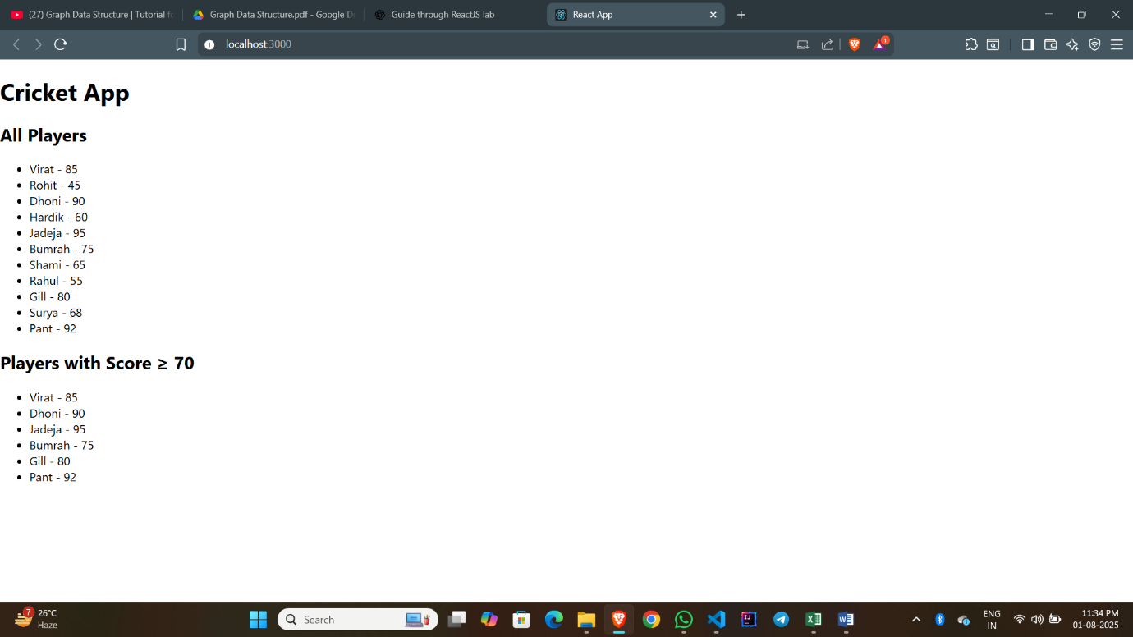**

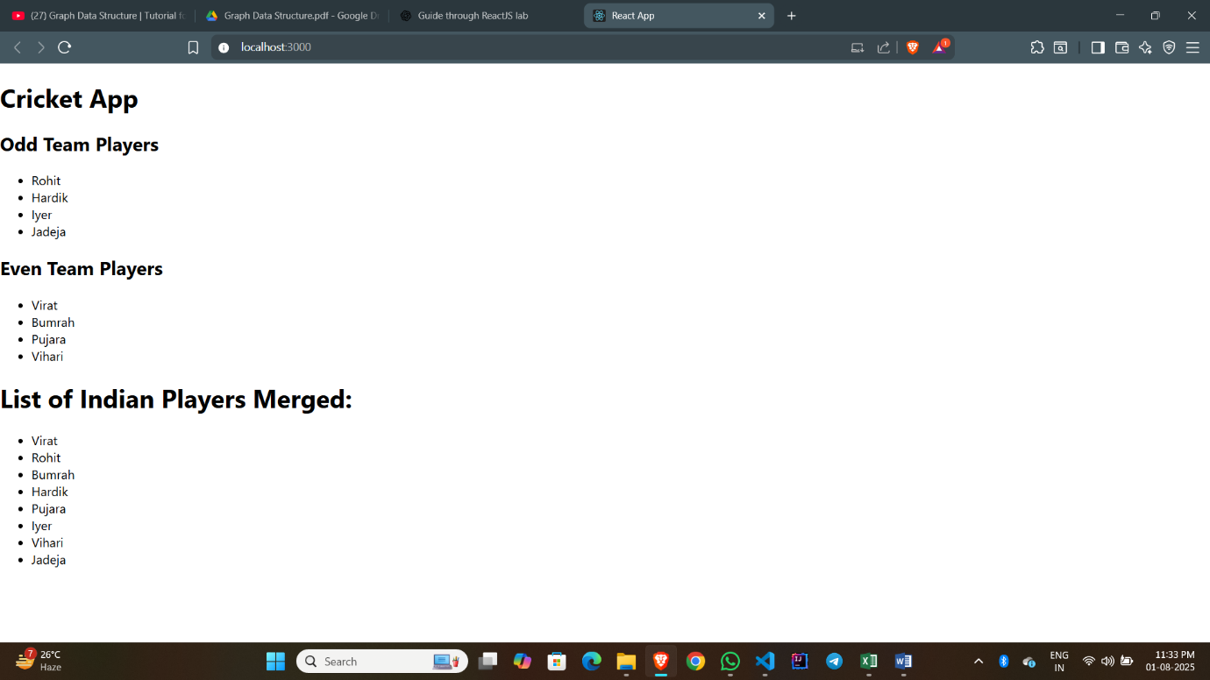

**Hands-on 2 : OfficeSpaceRentalApp**

**App.js:**

import React from 'react';

function App() {

*// Create a single office object*

  const office = {

    name: "Andey's Office",

    rent: 58000,

    address: "Sector C, Ratlam",

    image: "/office.png" *// Assuming the image is in the public folder*

  };

*// Create a list of office objects*

  const officeList = [

    { name: "Bhandar Tower", rent: 75000, address: "Bandra, Mumbai" },

    { name: "Ocean Godrej", rent: 58000, address: "Kondapur, Hyderabad" },

    { name: "Village Nest", rent: 90000, address: "HSR Layout, Bangalore" },

    { name: "SpaceY", rent: 45000, address: "Wakad, Pune" }

  ];

*// JSX rendering logic*

  return (

    <div style={{ textAlign: 'center', fontFamily: 'Arial' }}>

      <h1>Office Space Rental</h1>

      <img src={office.image} alt="Office" style={{ width: '300px', height: '200px' }} />

      <h2>{office.name}</h2>

      <p><strong>Address:</strong> {office.address}</p>

      <p style={{ color: office.rent < 60000 ? 'red' : 'green' }}>

        <strong>Rent:</strong> ₹{office.rent}

      </p>

      <h2>Available Office Spaces</h2>

      {officeList.map((item, index) => (

        <div key={index} style={{

          border: '1px solid gray',

          margin: '10px',

          padding: '10px',

          width: '300px',

          marginLeft: 'auto',

          marginRight: 'auto'

        }}>

          <h3>{item.name}</h3>

          <p><strong>Address:</strong> {item.address}</p>

          <p style={{ color: item.rent < 60000 ? 'red' : 'green' }}>

            <strong>Rent:</strong> ₹{item.rent}

          </p>

        </div>

      ))}

    </div>

  );

}

export default App;

**Output:**

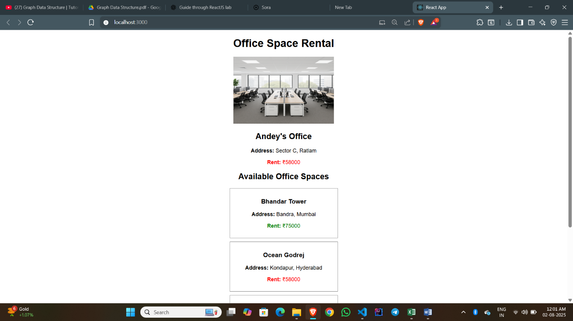

**Hands-on 3: EventExamplesApp**

Counter.js:

import React, { Component } from 'react';

class Counter extends Component {

    constructor() {

*super*();

*this*.state = {

            count: 0

        };

*// Bind methods*

*this*.increment = *this*.increment.bind(*this*);

*this*.decrement = *this*.decrement.bind(*this*);

*this*.sayHello = *this*.sayHello.bind(*this*);

*this*.handleMultiple = *this*.handleMultiple.bind(*this*);

    }

    increment() {

*this*.setState({ count: *this*.state.count + 1 });

    }

    decrement = () => {

*this*.setState({ count: *this*.state.count - 1 });

    };

    sayHello() {

        alert("Hello! This is a static message.");

    }

    handleMultiple() {

*this*.increment();

*this*.sayHello();

    }

    render() {

        return (

            <div className="component-box">

                <h2>Counter: {*this*.state.count}</h2>

                <button onClick={*this*.handleMultiple}>Increase</button>

                <button onClick={*this*.decrement}>Decrease</button>

            </div>

        );

    }

}

export default Counter;

Welcome.js:

import React from 'react';

const Welcome = () => {

    const sayWelcome = (msg) => {

        alert(msg);

    };

    return (

        <div className="component-box">

            <button onClick={() => sayWelcome("Welcome to React Event Handling!")}>

                Say Welcome

            </button>

        </div>

    );

};

export default Welcome;

SyntheticEventDemo.js:

import React from 'react';

const SyntheticEventDemo = () => {

  const handleClick = (e) => {

    e.preventDefault();

    alert("I was clicked!");

  };

  return (

  <div className="component-box">

    <button onClick={handleClick}>Click Me</button>

  </div>

);

};

export default SyntheticEventDemo;

CurrencyCounter.js:

import React, { useState } from 'react';

const CurrencyConvertor = () => {

    const [rupees, setRupees] = useState('');

    const [euros, setEuros] = useState('');

    const handleSubmit = () => {

        const euroRate = 0.011; *// Example rate*

        const converted = parseFloat(rupees) * euroRate;

        setEuros(converted.toFixed(2));

    };

    return (

        <div className="component-box">

            <h3 style={{color: "green"}}>Currency Converter!!!</h3>

            <input

                type="number"

                placeholder="Enter amount in INR"

                value={rupees}

                onChange={(e) => setRupees(e.target.value)}

            />

            <br />

            <button onClick={handleSubmit}>Convert</button>

            {euros && <p>Converted Amount: €{euros}</p>}

        </div>

    );

};

export default CurrencyConvertor;

App.js:

import React from 'react';

import Counter from './Counter';

import Welcome from './Welcome';

import SyntheticEventDemo from './SyntheticEventDemo';

import CurrencyConvertor from './CurrencyConvertor';

function App() {

  return (

    <div className="App">

      <h1 style={{ textAlign: 'center' }}>React Event Handling Lab</h1>

      <Counter />

      <Welcome />

      <SyntheticEventDemo />

      <CurrencyConvertor />

    </div>

  );

}

export default App;

**Output:**

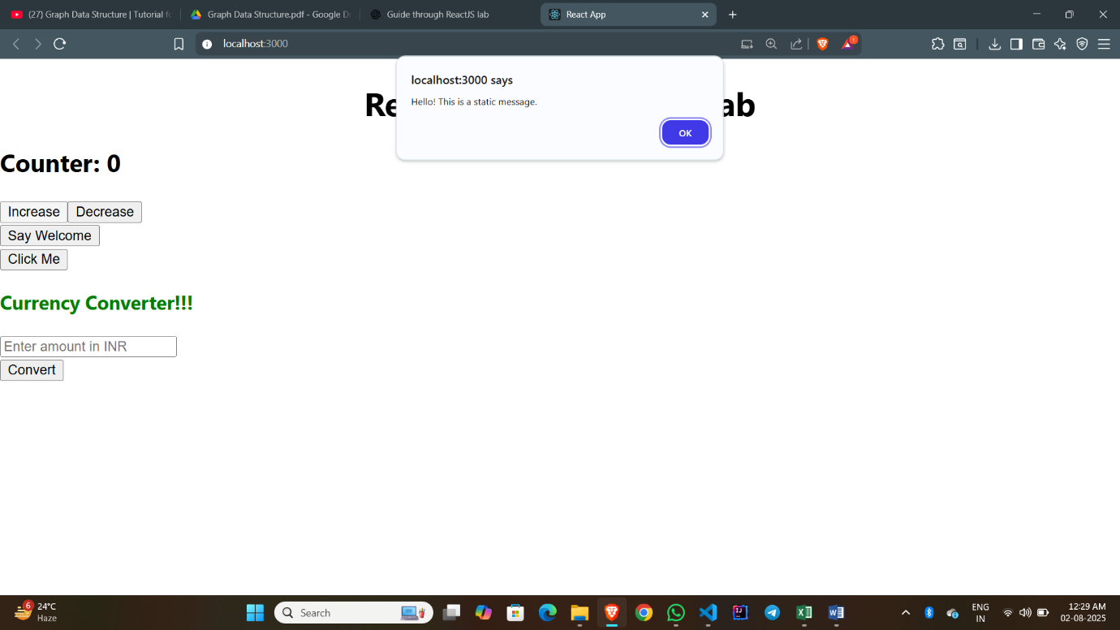

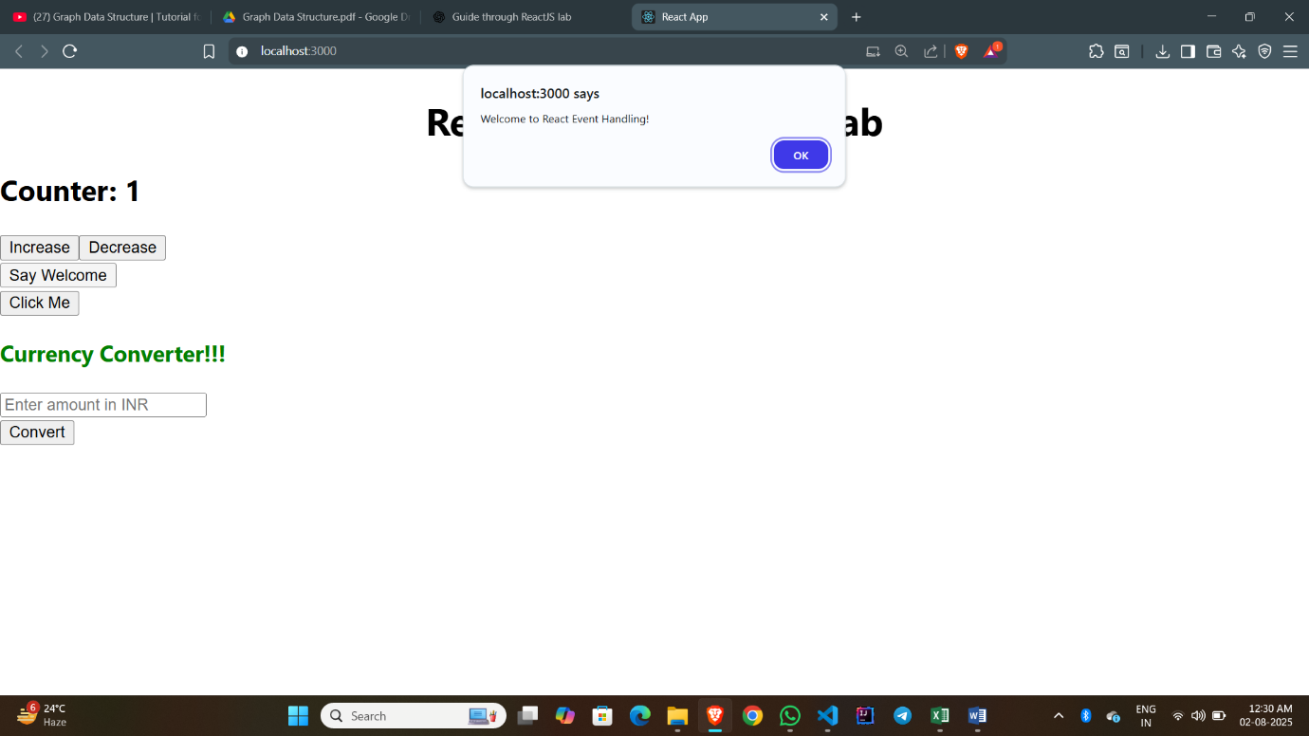

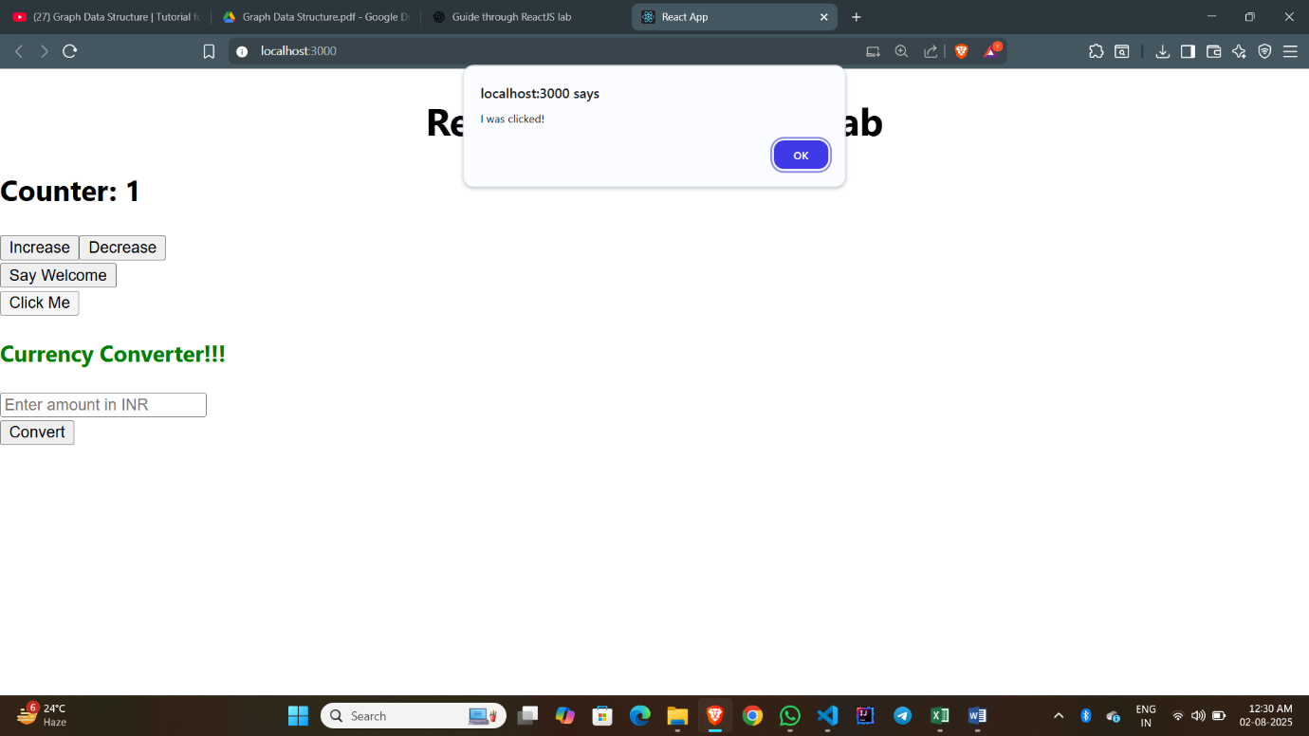

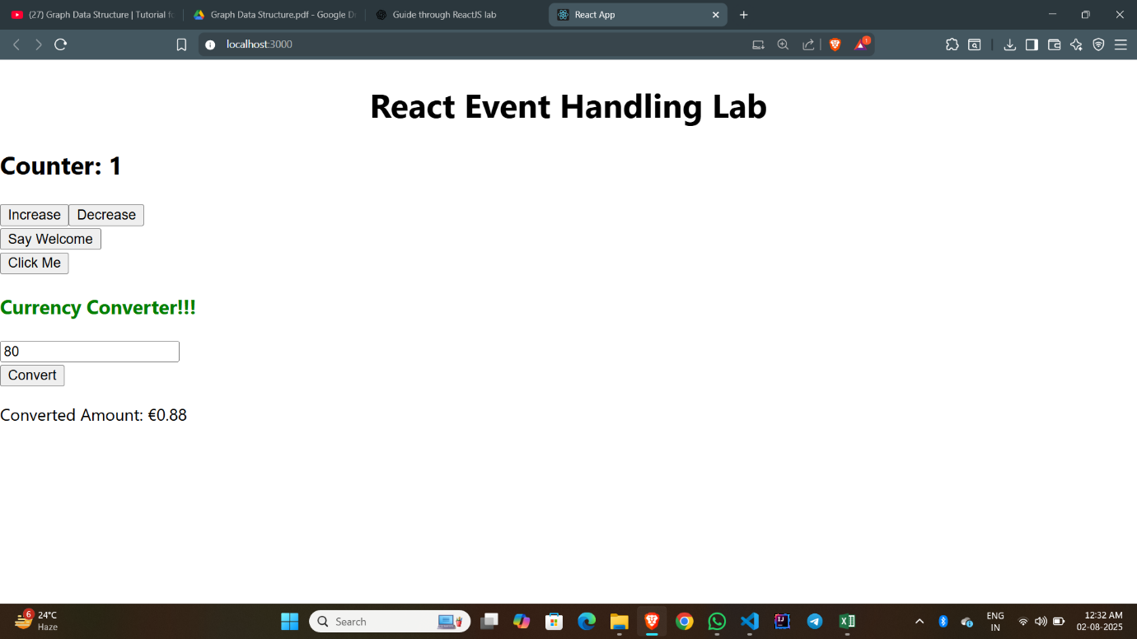

**Hands-on 4: TicketBookingApp**

**GuestPage.js:**

import React from 'react';

const GuestPage = () => {

  return (

    <div className="component-box">

      <h2>Welcome, Guest!</h2>

      <p>You can browse flight details here.</p>

    </div>

  );

};

export default GuestPage;

**UserPage.js:**

import React from 'react';

const UserPage = () => {

  return (

    <div className="component-box">

      <h2>Welcome, User!</h2>

      <p>You can now book tickets and view all flight details.</p>

    </div>

  );

};

export default UserPage;

**App.js:**

import React, { useState } from 'react';

import GuestPage from './GuestPage';

import UserPage from './UserPage';

import './App.css';

function App() {

  const [isLoggedIn, setIsLoggedIn] = useState(false);

*// Optional: Use element variable (for learning purpose)*

  let content;

  if (isLoggedIn) {

    content = <UserPage />;

  } else {

    content = <GuestPage />;

  }

  return (

    <div className="App">

      <h1>Flight Ticket Booking App</h1>

      {*/* Conditional button rendering */*}

      {isLoggedIn ? (

        <button  onClick={() => setIsLoggedIn(false)}>Logout</button>

      ) : (

        <button onClick={() => setIsLoggedIn(true)}>Login</button>

      )}

      {*/* Conditional content */*}

      {content}

    </div>

  );

}

export default App;

**Output:**

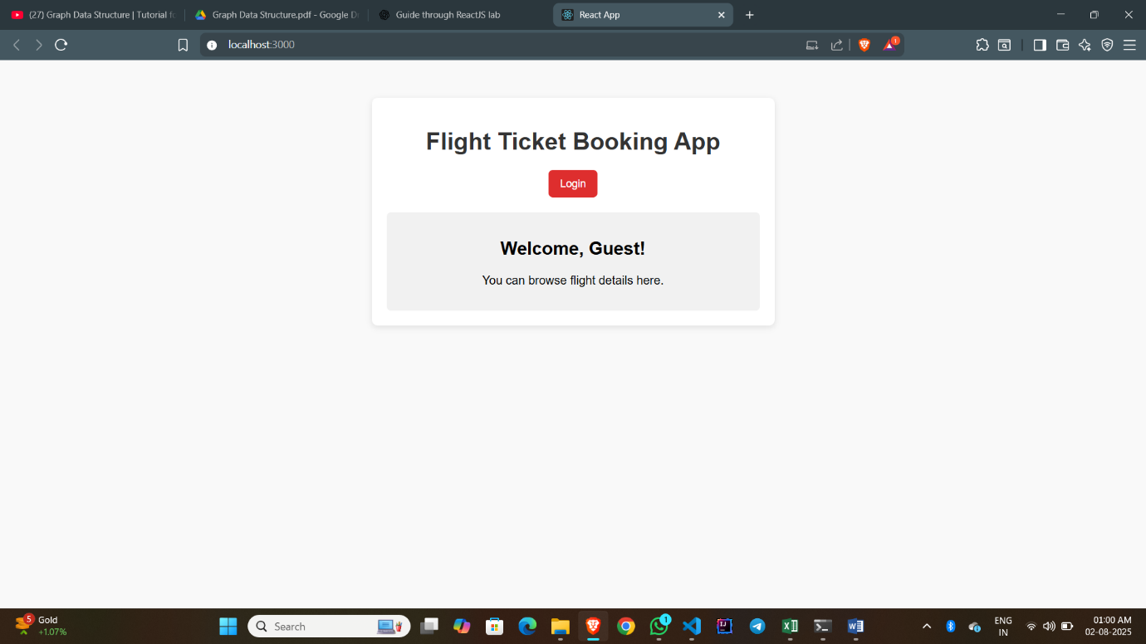

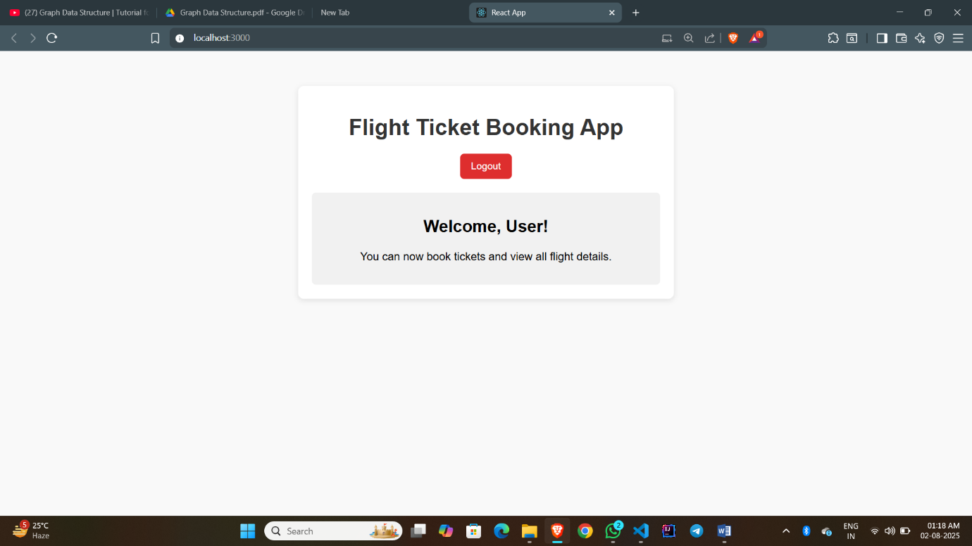

**Hands-on 5: BloggerApp**

**BookDetails.js:**

const BookDetails = () => {

  return (

    <div>

      <h2>Book Details</h2>

      <p>Title: React for Beginners</p>

      <p>Author: Jane Doe</p>

    </div>

  );

};

export default BookDetails;

**BlogDetails.js:**

const BlogDetails = () => {

  return (

    <div>

      <h2>Blog Details</h2>

      <p>Title: Why React is Awesome</p>

      <p>Author: John Smith</p>

    </div>

  );

};

export default BlogDetails;

**CourseDetails.js:**

const CourseDetails = () => {

  return (

    <div>

      <h2>Course Details</h2>

      <p>Course: Fullstack with React</p>

      <p>Instructor: Mary Poppins</p>

    </div>

  );

};

export default CourseDetails;

**App.js:**

import React from 'react';

import './App.css';

function App() {

  const courses = [

    { name: "Angular", date: "4/5/2021" },

    { name: "React", date: "6/3/20201" }

  ];

  const books = [

    { title: "Master React", price: 670 },

    { title: "Deep Dive into Angular 11", price: 800 },

    { title: "Mongo Essentials", price: 450 }

  ];

  const blogs = [

    { title: "React Learning", author: "Stephen Biz", content: "Welcome to learning React!" },

    { title: "Installation", author: "Schewzdenier", content: "You can install React from npm." }

  ];

  return (

    <div className="container">

      <div className="column">

        <h2>Course Details</h2>

        {courses.map((c, i) => (

          <div key={i}>

            <strong>{c.name}</strong>

            <p>{c.date}</p>

          </div>

        ))}

      </div>

      <div className="column border-left">

        <h2>Book Details</h2>

        {books.map((b, i) => (

          <div key={i}>

            <strong>{b.title}</strong>

            <p>{b.price}</p>

          </div>

        ))}

      </div>

      <div className="column border-left">

        <h2>Blog Details</h2>

        {blogs.map((b, i) => (

          <div key={i}>

            <strong>{b.title}</strong>

            <p><b>{b.author}</b></p>

            <p>{b.content}</p>

          </div>

        ))}

      </div>

    </div>

  );

}

export default App;

**Output:**

