Celebal Technologies Internship - Week 5 Assignment

Apache Spark (PySpark)
Name: Anshita Garg
Internship: Celebal Technologies Data Engineering Internship
Week: 5

Q1. What are the key limitations of traditional MapReduce that make Spark a preferred choice for modern big data processing?
Key limitations of Traditional MapReduce:
- Stores intermediate data on disk after every stage, making it slower.
- High latency for iterative algorithms like Machine Learning.
- Complex programming model requiring separate Map and Reduce functions.
- Poor support for interactive analytics.
- Inefficient for real-time processing.
Advantages of Spark:
- In-memory computation makes processing much faster.
- Supports batch, streaming, SQL, machine learning, and graph processing.
- Easier APIs in Python, Scala, Java, and R.
- Optimized execution using DAG (Directed Acyclic Graph).

Q2. Explain how Spark uses In-Memory Computing.
Spark stores intermediate data in RAM instead of repeatedly reading and writing to disk. This significantly speeds up iterative algorithms such as machine learning because the same dataset can be reused across iterations.

Q3. Remove duplicate rows based on user_id and transaction_date.
from pyspark.sql import SparkSession
spark = SparkSession.builder.appName("Week5").getOrCreate()

from pyspark.sql.types import StructType, StructField, StringType, IntegerType, DateType
from datetime import date

schema = StructType([
StructField("user_id", StringType(), True),
StructField("transaction_date", DateType(), True),
StructField("amount", IntegerType(), True)
])

data = [
("user1", date(2023, 1, 1), 100),
("user2", date(2023, 1, 1), 150),
("user1", date(2023, 1, 2), 200),
("user2", date(2023, 1, 1), 150)
]

df = spark.createDataFrame(data, schema)
df_unique = df.dropDuplicates(["user_id", "transaction_date"])
df_unique.show()
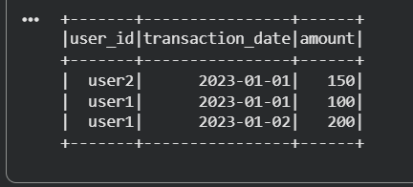

Q4. Filter West region and compute average sales.
from pyspark.sql.functions import avg
from pyspark.sql.types import StructType, StructField, StringType, IntegerType

sales_schema = StructType([
StructField("region", StringType(), True),
StructField("product_category", StringType(), True),
StructField("sale_amount", IntegerType(), True)
])

sales_data = [
("West", "Electronics", 200),
("West", "Electronics", 300),
("East", "Clothes", 150),
("West", "Books", 50),
("East", "Electronics", 400)
]

df_sales = spark.createDataFrame(sales_data, sales_schema)

result = (df_sales.filter(df_sales.region == "West")
.groupBy("product_category")
.agg(avg("sale_amount").alias("Average_Sale")))
result.show()
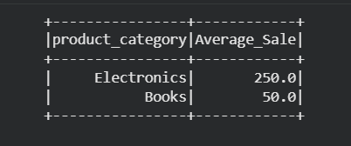

Q5. Difference between .na.drop() and .na.fill()
- .na.drop() removes rows containing null values.
- .na.fill() replaces null values with a specified value.
df = df.na.fill({"status": "Unknown"})

Q6. Count records for each city where count > 100.
from pyspark.sql.functions import count
result = (df.groupBy("city")
.agg(count("*").alias("Total"))
.filter("Total > 100"))
result.show()
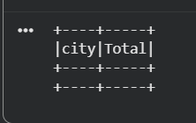

Q7. Immutability of Spark DataFrames
Spark DataFrames are immutable. Every transformation creates a new DataFrame rather than modifying the existing one.

Q8. Filter users aged 18–30 with Premium subscription.
result = df.filter((df.age >= 18) &
(df.age <= 30) &
(df.subscription == "Premium"))
result.show()
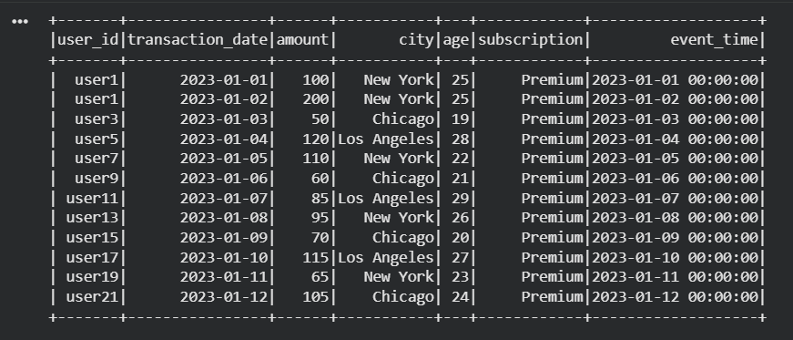

Q9. Why handle null values before aggregations?
Handling nulls before aggregations improves accuracy and prevents incorrect analytical results.

Q10. Cast raw_timestamp and rename to event_time.
from pyspark.sql.functions import col
from pyspark.sql.types import TimestampType
df = (df.withColumn("event_time",
col("raw_timestamp").cast(TimestampType()))
.drop("raw_timestamp"))
df.show()
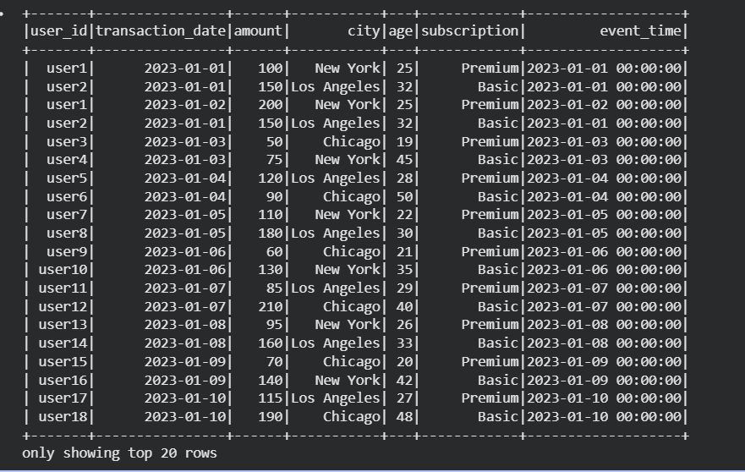

Q11. Explain Shuffle
Shuffle redistributes data across partitions during operations such as groupBy and join. It is a wide transformation because data moves between partitions and executors.

Q12. Remove rows with null email or empty username.
from pyspark.sql.functions import col
clean_df = df.filter(col("email").isNotNull() &
(col("username") != ""))
clean_df.show()
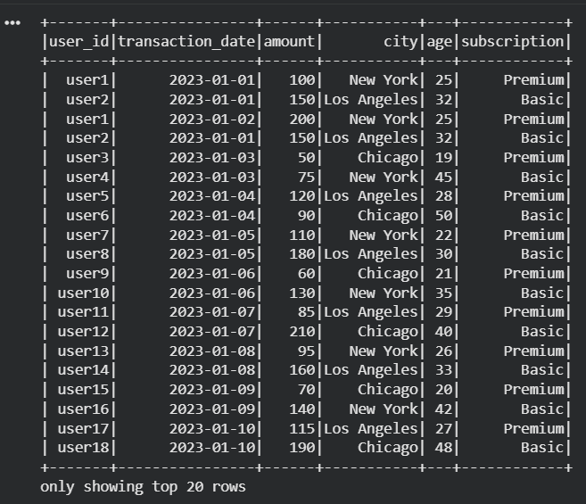

Q13. Calculate min, max and average price.
from pyspark.sql.functions import min, max, avg
result = df.agg(min("price").alias("Minimum"),
max("price").alias("Maximum"),
avg("price").alias("Average"))
result.show()
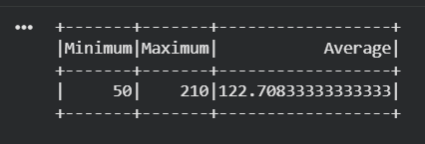

Q14. Risk of inferSchema=True with inconsistent dates
Spark may infer incorrect data types, convert invalid values to null, or treat dates as strings, leading to unreliable analysis.

Q15. Final Processing Pipeline
from pyspark.sql.functions import sum
result = (df.dropDuplicates()
.na.fill({"price": 0})
.groupBy("store_id")
.agg(sum("price").alias("Total_Revenue")))
result.show()
