EXPERIMENT NO. 1

THEORY:
Generations of Computers:

First Generation (1940-1956) Vacuum Tubes
The first computers used vacuum tubes for circuitry and magnetic drums for memory, and were often enormous, taking up entire rooms. They were very expensive to operate and in addition to using a great deal of electricity, generated a lot of heat, which was often the cause of malfunctions. The UNIVAC and ENIAC computers are examples of first-generation computing devices.
Second Generation (1956-1963) Transistors
Transistors replaced vacuum tubes in the second generation of computers. The transistor was invented in 1947 but did not see widespread use in computers until the late 1950s. The transistor was far superior to the vacuum tube, allowing computers to become smaller, faster, cheaper, more energy-efficient and more reliable than their first-generation predecessors.
Third Generation (1964-1971) Integrated Circuits
The development of the integrated circuit was the hallmark of the third generation of computers. Transistors were miniaturized and placed on silicon chips, called semiconductors, which drastically increased the speed and efficiency of computers. Instead of punched cards and printouts, users interacted with third generation computers through keyboards and monitors and interfaced with an operating system, which allowed the device to run many different applications at one time with a central program that monitored the memory.
Fourth Generation (1971-Present) Microprocessors
The microprocessor brought the fourth generation of computers, as thousands of integrated circuits were built onto a single silicon chip. What in the first generation filled an entire room could now fit in the palm of the hand. In 1981 IBM introduced its first computer for the home user, and in 1984 Apple introduced the Macintosh.
Fifth Generation (Present and Beyond) Artificial Intelligence
Fifth generation computing devices, based on artificial intelligence, are still in development, though there are some applications, such as voice recognition, that are being used today. The goal of fifth-generation computing is to develop devices that respond to natural language input and are capable of learning and self-organization.

Computer Types:
Many types of computers exist that differ widely in Size, Cost, Computational Power and intended Use.
- Personal Computer/ Desktop computers: which is found in homes, Schools and business offices
- Portable Notebook Computers: A compact version of PC with all of these components packaged into a single unit the size of a thin briefcase.
- Work Stations: with high-resolution graphics I/O capability. Used in the engineering applications, Interactive design works.
- Enterprise System Servers: used for business data processing in medium to large corporations that require much more computing power and storage capacity than workstations.
- Super Computers: Contain sizable database storage units and are capable of handling large volumes of requests to access the data.
- Hand-held computers: A portable computer that is small enough to be held in one’s hand. Although extremely convenient to carry, handheld computers have not replaced notebook computers because of their small keyboards and screens. Hand-held computers are also called PDAs, palmtops and pocket computers
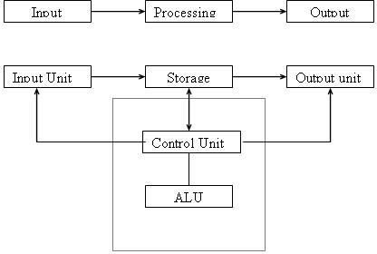
Block Diagram of Computer:

A computer can process data, pictures, sound and graphics. They can solve highly complicated problems quickly and accurately.
Input Unit:
Computers need to receive data and instruction in order to solve any problem. The input unit consists of one or more input devices. Keyboard is the one of the most commonly used input device.
Storage Unit:
The storage unit of the computer holds data and instructions that are entered through the input unit, before they are processed
- Primary Storage: Stores and provides very fast.
- Secondary Storage: Secondary storage is used like an archive.
Memory Size:
All digital computers use the binary system, i.e. 0’s and 1’s. The size of the primary storage is specified in KB (Kilobytes) or MB (Megabyte). One KB is equal to 1024 bytes and one MB is equal to 1000KB. The size of the primary storage in a typical PC usually starts at 16MB. PCs having 32 MB, 48MB, 128 MB, 256MB memory are quite common.
Output Unit:
The output unit of a computer provides the information and results of a computation to outside world. Printers, Visual Display Unit (VDU) are the commonly used output devices.
Arithmetic Logical Unit:
All calculations are performed in the Arithmetic Logic Unit (ALU) of the computer.. The ALU can perform basic operations such as addition, subtraction, multiplication, division, etc and does logic operations viz, >, <, =, ‘etc.
Control Unit:
It controls all other units in the computer. The control unit instructs the input unit, where to store the data after receiving it from the user.
Central Processing Unit:
The control unit and ALU of the computer are together known as the Central Processing Unit (CPU). The CPU is like brain performs the following functions:
- It performs all calculations.
- It takes all decisions.
- It controls all units of the computer.
Introduction to Computer Hardware:
Hardware is the physical appearance of the devices or tools. It is what which we can touch and feel.
Computer Hardware consists of the Monitor, CPU, Keyboard, Mouse and all other devices connected to the computer either externally or internally.
  - CPU The central processing unit contains the heart of any computer, the processor. The processor is fitted on to a Mother Board. The Mother Board contains various components, which support the functioning of a PC.
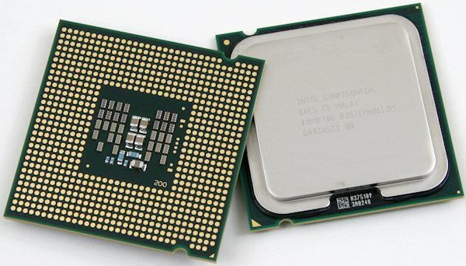

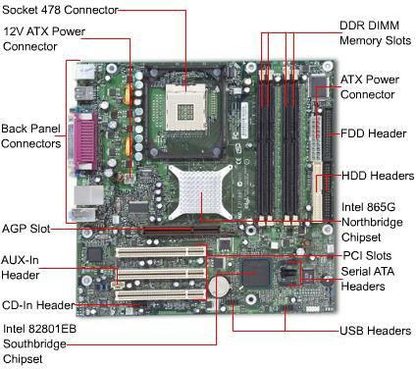
System board/Motherboard which holds the Processor, Random Access Memory and other parts, and has slots for expansion cards.

2 RAM (Random Access Memory)- For program execution and short term data- storage, so the computer doesn't have to take the time to access the hard drive to find something. More RAM can contribute to a faster PC.
3. ROM (Read Only Memory)-Instructions which are critical to the operation of a computer are stored permanently on Read only Memory. (ROM) chip installed by the manufacturer inside the computer. This ROM chip is also called firm ware, retains instructions in a permanently accessible nonvolatile form.

EXPERIMENT NO. 2
THEORY:
Safety Precautions:

  - Beware of electrostatic discharge (ESO)

  - Build computer on a hard surface, away from concepts.

  - Wear shoes and the short sleeved cotton wear.

  - Use Phillips, head screw driver.

  - Keep the components away from moisture.

  - Avoid using pressure while installing.

Steps for Assembling:

  - Fix the SMPS on the cabinet of PC using the screws provided.

  - Fix the motherboard on the cabinet of PC using the screws provided.

  - Connect the power cables from SMPS to motherboard.

  - Insert the preprocessor into the slot provided such that the corner with no pin coincides with corner without pinhole on motherboard.

  - Apply the appropriate adhesive on the processor for fixing the processor fan.

  - Fix the processor fan on the processor and use clips on it to keep it firm.

  - Connect the power cable to the processor fan

  - Insert the RAM card into the slots provided on the motherboard.

  - Set the jumpers setting on the hard disc drive.

  - Fix the hard disc drive in the space provided in the PC cabinet using screws provided.

  - Fix the FDD in the space provided in the PC cabinet using screws provided.

  - Fix the CD-ROM in the space provided in the PC cabinet using screws provided.

  - Connect the FDD, HDD, CD-ROM drive to motherboard using flat ribbon.

  - Connect power supply to the HDD, FDD, CD-ROM drive using the cables from the SMPS.

  - Connect wires of speakers and lights of cabinet to the motherboard.
  - Connect the network interface and other cards to motherboard by inserting in right slots and fix them in cabinet using the screws provided.

  - Place the cabinet in right position.

  - Fix the doors of the cabinet.

  - Connect the data cable of monitor to the CPU.

  - Connect the keyboard cable to the CPU.

  - Connect the mouse cable to the CPU.

  - Connect other devices to CPU.

  - Connect the LAN cable to NIC in CPU.

  - Connect the power supply to CPU.

  - Connect the power supply to Monitor.

  - Switch on the computer after giving the power supply.

Steps for Disassembling:

  - Switch of the power supply

  - Disconnect the power supply cable from monitor.

  - Disconnect the power supply cable from CPU.

  - Disconnect the LAN cable to NIC in CPU.

  - Disconnect the other devices in CPU such as printers.

  - Disconnect the mouse cable from CPU.

  - Disconnect the keyboard cable from CPU.

  - Disconnect data cable of monitor from CPU.

  - Remove the doors of cabinet.

  - Place the cabinet such that motherboard faces the ceiling.

  - Disconnect the NIC and other cards from mother board by removing from slots and unscrewing from cabinet.

  - Disconnect the wires of speakers from mother board.

  - Remove power supply cables from HDD, FDD, CD-ROM drive etc.

  - Disconnect the HDD, FDD, CD-ROM drive from mother board by removing flat ribbon cable.

  - Remove CR-ROM from cabinet.

  - Remove the FDD from cabinet by unscrewing it.

  - Remove the HDD from cabinet by unscrewing it.

  - Removing RAM cards from slots on mother board.

  - Disconnect the power cables from processor fan.

  - Remove the processor fan by unlocking clips on it.

  - Disconnect the power cables from SMPS on power cabinet.

  - Remove mother board from cabinet by unscrewing it.

  - Remove the SMPS from cabinet of PC by unscrewing it.

EXPERIMENT NO. 3
- Backup your files. The installation process will delete all data on your hard drive. It is recommended that you back up all files you want to keep before installing a new operating system. You can backup your files to another hard drive, an external hard drive, a flash drive, or a cloud-based service like Google Drive, or Drop box.

- Restart your computer. Press the power button on your computer and then click Restart in the power options menu.

- Immediately press Del, Esc, F2, F10, or F9 when it restarts. Depending on the make and model of your computer, pressing one of these buttons immediately after you power on your computer will enter the system BIOS.
- Some computers tell you which button to press to enter the BIOS as the computer starts up.
- Find your BIOS's boot options menu. The boot options menu of your BIOS may vary in location or name from the illustration, but you may eventually find it if you search around.
- If you can't find the boot options menu, search the name of your BIOS (most likely located in the BIOS menu) online for help.
- Select the optical disk drive as the first boot device of your computer. Although this method may vary among computers, the boot options menu is typically a menu of movable device names where you should set your CD, DVD or Blu-ray drive as the first boot device. It can also be a list of devices that you can set the order of their boot on. Consult a manual or the internet for help if you're stuck.

- Place the Windows 7 Installation disc in the disc drive. Press the button on your CD, DVD, or Blu-ray drive. Then place the Windows 7 installation disc in the disk tray and push it back in the drive.

- Save the changes in the settings. Press the button indicated on the screen or select the save option from the BIOS menu to save your configuration.

- Shut off your computer. Either turn off the computer by choosing the shut-down option in your current operating system, or hold the power button until the computer powers off.

- Start your computer from the disc. When the computer starts, press a key if you are asked if you would like to boot from the disc by pressing any key. After you choose to start from the disc. Windows Setup will begin loading.
- If you are not asked to boot from the disc, you may have done something wrong. Retry the previous steps and make sure you have selected the correct drive in the BIOS boot menu.
- Choose your Windows Setup options. Once Windows Setup loads, you'll be presented with a window. Use the drop-down menus to select your preferred language, keyboard type, and time/currency format, and then click next in the lower-right corner.

- Click the Install Now button. It's the blue button in the center of the screen.

- Accept the License Terms. Read over the Microsoft Software License Terms. Then click the checkbox next to I accept the license terms, and click Next in the lower-right corner.

- Select the Custom installation. This option allows you to do a clean install of Windows 7. This will erase all your files on the installation drive.
- If you do not want to erase all your files, select Upgrade instead. This option requires an existing Windows installation. You can only upgrade from one Windows edition to another. For example, if you have Windows Vista Home Edition, you can only upgrade to Windows 7 Home Edition. You would not be able to upgrade to Windows 7 Premium.
- Select a hard drive and partition you want to install Windows on. A hard drive is a physical part of your computer that stores data, and partitions "divide" hard drives into separate sections. Click the hard drive or partition you want to install Windows 7 on.
- If the hard drive has data on it, you’ll need to use the following steps to Delete or Format the drive. Be aware that this will permanently erase all data from the disk.
- Select the hard drive from the list of hard drives.
- Click Drive options (advanced).
- Click Delete or Format from Drive options.
- If your computer doesn't have any partitions yet, create one to install Windows on it.
- Select the hard drive from the list of hard drives.
- Click Drive options (advanced).
- Select New from Drive options.
- Select the size, and click OK.

- Install Windows on your preferred hard drive and partition. Once you've decided on where to install Windows, select it and click Next. Windows will begin installing. Your computer may start and restart several times during the installation process.

EXPERIMENT NO. 4
THEORY:
Installing Ubuntu 14.04
1. Download the ISO images using above download links or from Ubuntu website, burn it to a CD or a USB stick with the help of USB Linux Installer.
2. After system boot choose your CD/DVD or USB drive displayed on your system BIOS options.
3. The CD/DVD or USB content is loaded into your RAM memory until it reaches the first stage of Installation process.
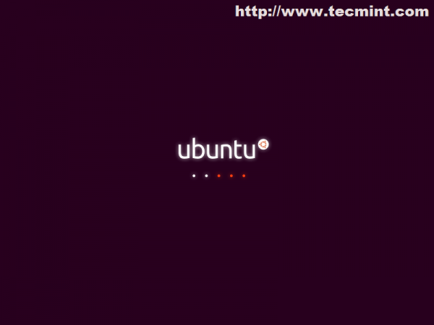
Booting Ubuntu
4. The next step asks you Install it or just give it a try …choose Install Ubuntu. The Try Ubuntu option will load the system into a Linux Live Mode ( Live CD ) for running in a test mode without any changes applied on your machine.
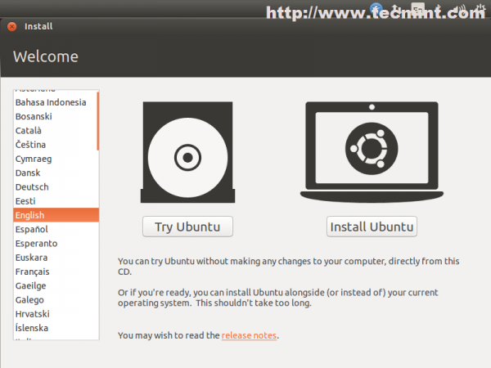
Ubuntu Install Screen
5. The preparation step verifies HDD space and network connection. Leave it as default ( third-party software and updates will be installed later) and choose Continue.
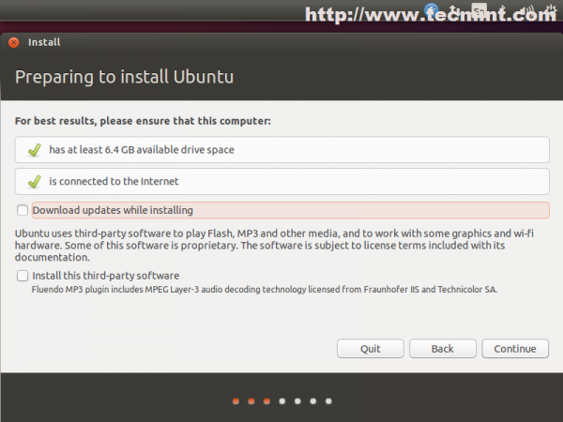
Preparing to Install Ubuntu
6. The next step is one of the most important steps and has four options.
- Erase disk and install Ubuntu is a customized version of disk partition table made by Ubuntu developers and requires no previous knowledge of file systems and partitions what so ever. Also be advised that choosing this options on machines with previous Operating Systems already installed will erase all your data completely – so a previous important data backup is necessary.
- Encrypt the new Ubuntu installation for security is a option that ensures that all your physical data are encrypted – Laptop users have a benefit in case of a stolen device.
- Use LVM with Ubuntu is a option for advanced users and requires some knowledge of Linux Logical Volume Management and how space is distributed along many hard-disks or physical partitions – choose this if you really know what you’re doing.
- Something else option allows a full user control over partition table – so choose this.

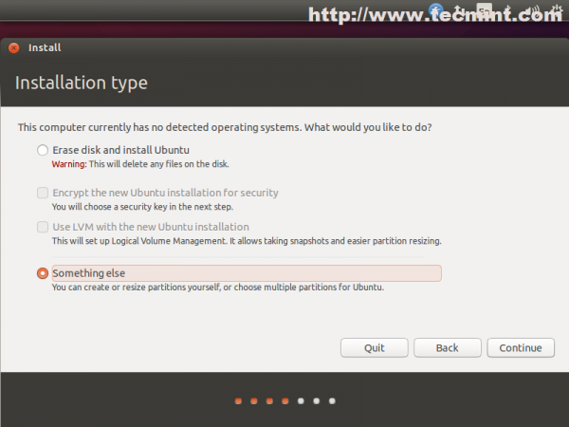
Installation Type

7. For a basic partition table create the following scheme.
- Root partition “/”, ext4 formated with a least 20G disk space.
- Swap partition with 2xRAM size.
- Home partition “/home“, ext4 formated with the rest of free space designed for Users.
To create partitions choose New Partition Table –> Continue and choose your free space from first hard-disk (/dev/sda) like in the screenshoots below.
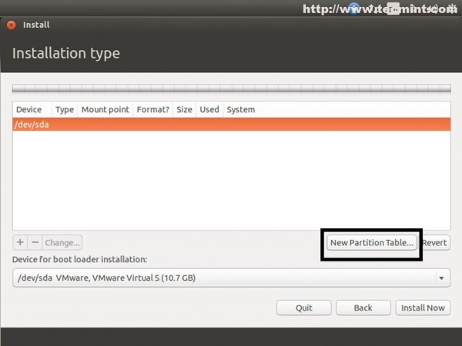
New Partition Table
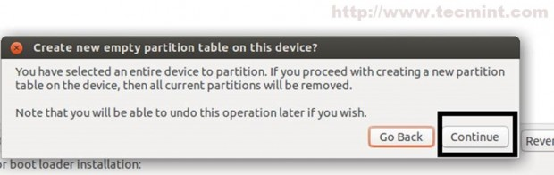
Create New Partition

Hit the “+” button and on next window prompt choose the following settings for fist partition.
- Partition size in MB – min 20GB
- Partition Type as Primary
- Location at the beginning
- Ext4 journaling file system
- Root as Mount Point “/“

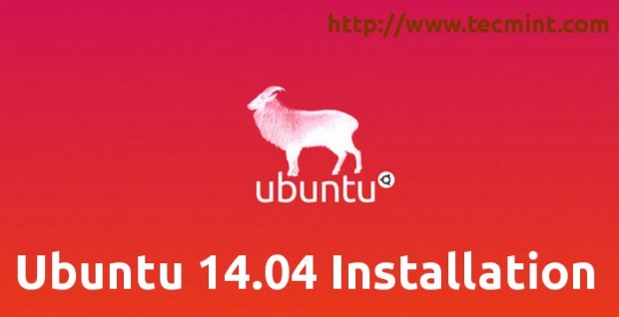
Ubuntu 14.04 Installation Guide

The second partition create it as a Logical Swap Area Space with a value of twice of your RAM.

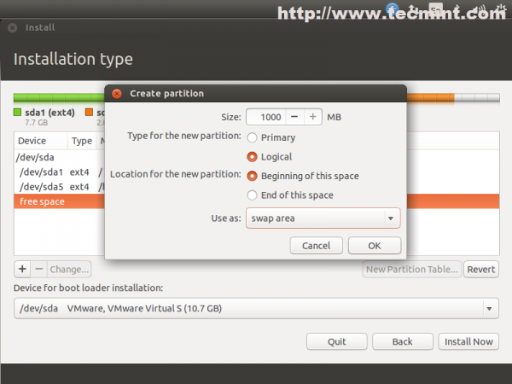
Create Partition
On the Third Partition allocate the hole left free space for Users homes also as Logical. The reason for choosing Logical types is that old HDD’s can hold only three partitions as Primary on MBR, the fourth demanding for an Extended Partition.
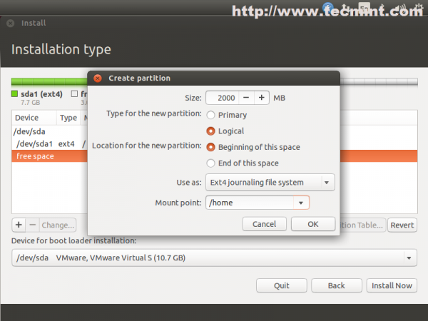
Create Swap Partition
The final Partition Table should look something like in the screenshoot below but with different values for Size.
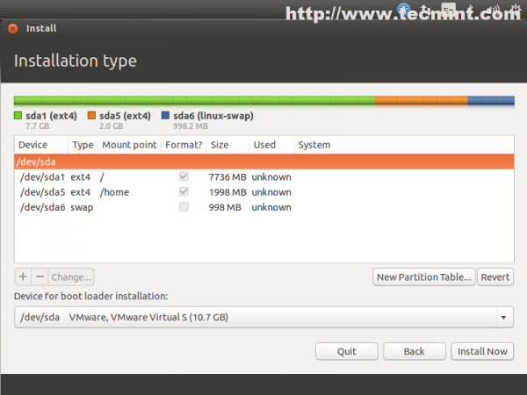
Create Home Partition

8. After your disk has been sliced hit on Install Now button. On the next stage choose your Location from map – Location will have an impact on your system time also so be advised to choose your true location.
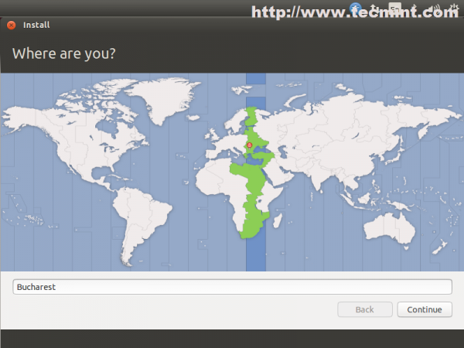
Select Location
9. Select your Keyboard – On this step you also have the option for Detecting your keyboard by pressing some of the keyboard buttons.
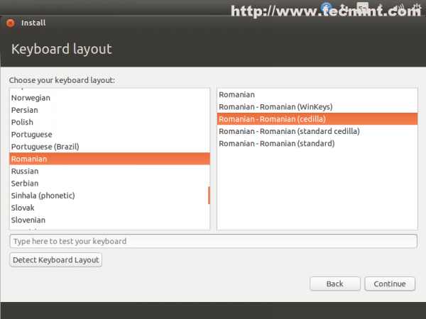
Select Keyboard

10. The last interactive step of Installation process requires to enter your system administrative name ( user with sudo rights), your System hostname ( you can choose FQDN also ) and your password ( choose a strong one with at least 6 characters ).
For automatically logon without password choose Log in automatically and also you can choose to Encrypt hole home folder for a better security and privacy but this will have an impact on your system speed.

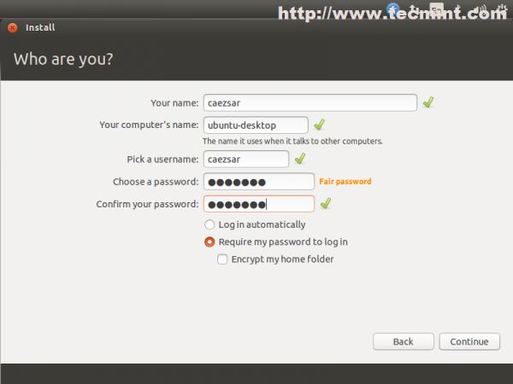
Create New Super User

11. That is all for setting your Ubuntu OS. The installer now starts copying system files to your hard drive while it presents you with some information about your brand new Ubuntu LTS for 5 years support system.
Also if you have another Operating System installed and you did not mess with it’s partition during Ubuntu setups, the installer will automatically detect it and present it by Grub Menu on next reboot.
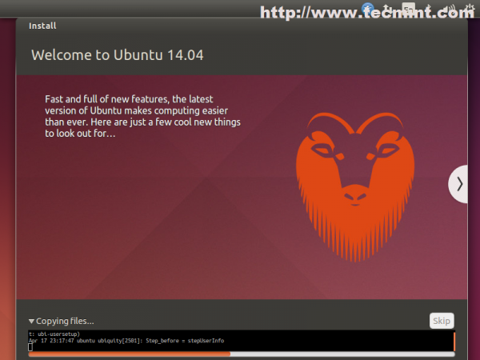
Copying System Files
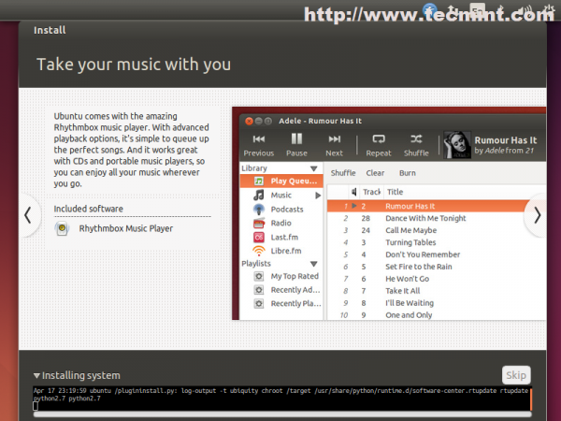
Installing System
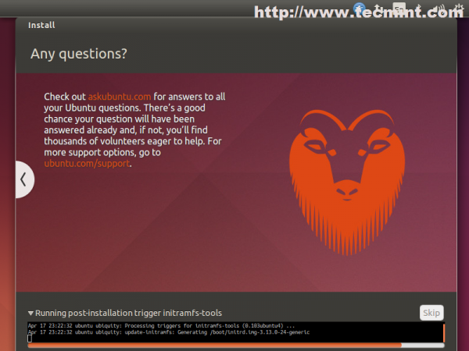
Running Post Installation

12. After installer finishes his job click on Restart Now prompt and press Enter after a few seconds for your system to reboot.
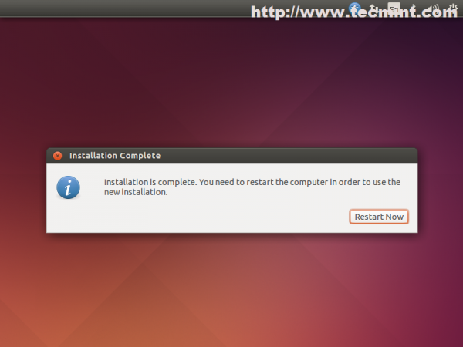

EXPERIMENT NO. 5
THEORY:
1)mv: Short for move, this command can be used to move your files from one folder to another.
2)rm: Short for remove, this command is used to remove any files or folders.
3)cp: Short for copy, this command can be used to copy files or folders in a directory.
4)chown: This command is used to change ownership of a file.
5)chmod: This command is used to change permissions on a file.
6)ls: Short for list, this command can be used to view all of the files and folders in your current working directory.

7)pwd: Short for print working directory, this command can be used to display the directory in which you are currently working.
8)sudo: Also referred to as superuser do, a sudo command allows you to run other commands with administrative privileges. This command is especially useful for modifying files in a directory that a user wouldn't necessarily have access to.
9)cd: Short for change directory, this command can be used to change the directory in which you are currently working. There are a variety of cd commands that can be used to take you to specific files or folders.
10)cd / : An alternate to a basic cd command, the cd / command can be used to take you to the root directory.
11)cd .. : This command can be used to take you up one directory level.
12)cd - : This command can be used to navigate to a previous directory.

