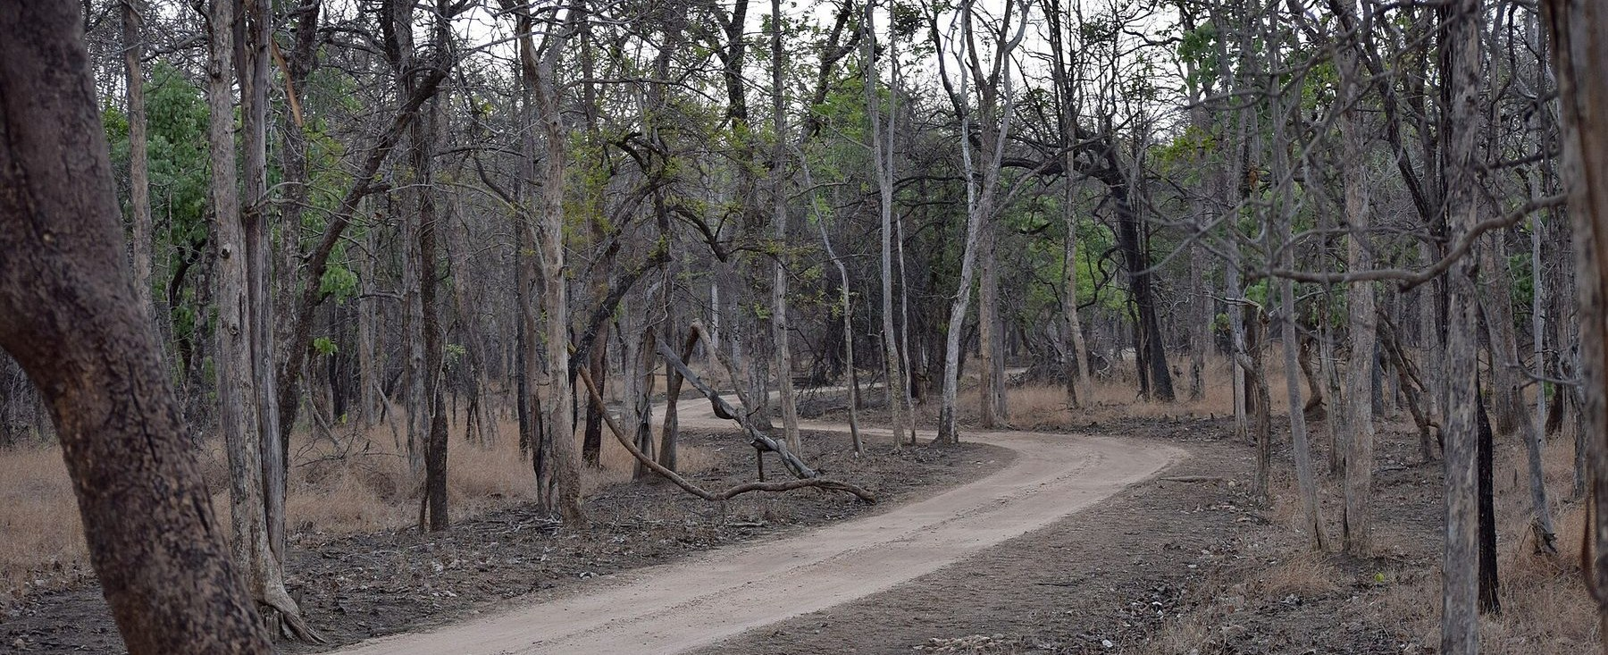
FOREST GUARD AI · TECHNICAL REPORT
Protecting Forests.
Preventing Conflict.
Saving Lives.
AI-assisted wildlife monitoring, explainable GIS risk,
guard response and a privacy-safe community portal.

Hackathon build · 11 November 2026
Single-node · CPU inference · synthetic demo dataset
Real local inference. Seeded observations are synthetic and labelled.
REAL INFERENCE · NO LIVE FEEDS · NO GPS CLAIMS

01 · OVERVIEW

Executive summary
Forest Guard AI is a working, local-first platform for human–wildlife conflict prevention. A detection is analysed on the machine, attached to a real camera station, scored against village boundaries with an explainable model, converted into an assigned guard task, and republished to the public as a coarse advisory that never reveals the animal's location. It was built for a solo-student hackathon, and every screen is wired to a live API.
The honest boundary matters. Villages, cameras, guards, detections, incidents and alerts in the shipped dataset are synthetic and labelled. Uploaded images and short videos are genuinely analysed by YOLO-World v2 and CLIP on CPU. No live feeds, GPS collars, government systems or cloud inference are involved, and no field accuracy is claimed.
Area | What was delivered | Evidence
Platform | FastAPI + SQLAlchemy/SQLite API; React 18 + Vite SPA with eight pages | 28 API/domain tests; production build
AI | Two-stage local detection (YOLO-World v2 + CLIP ViT-B/32), image and 5-frame video | Genuine upload captured in screenshot 02
GIS | Leaflet map with 8 layers, clustering, filters, detail panel and risk cells | Screenshot 03; map payload tests
Risk | Configurable weighted score with five evidence components and species multipliers | Risk diagram; boundary tests
Response | Alert lifecycle, guard assignment, RBAC and append-only audit events | Lifecycle test; screenshot 05
Community | Public advisories, reports with optional image, reference-code status check | Sanitisation tests; screenshot 07–08
Demo data | 5 villages, 12 cameras, 6 guards, 230 detections, 18 tracks, 13 alerts, 6 incidents | Deterministic seed on first boot

STATUS AT A GLANCE
Built and verified: all six modules, eight pages, 28 backend tests, production bundle, 10 live screenshots and 3 architecture diagrams. Not built or not claimed: live camera integration, GPS tracking, real SMS/email dispatch, field accuracy, scale-out infrastructure.

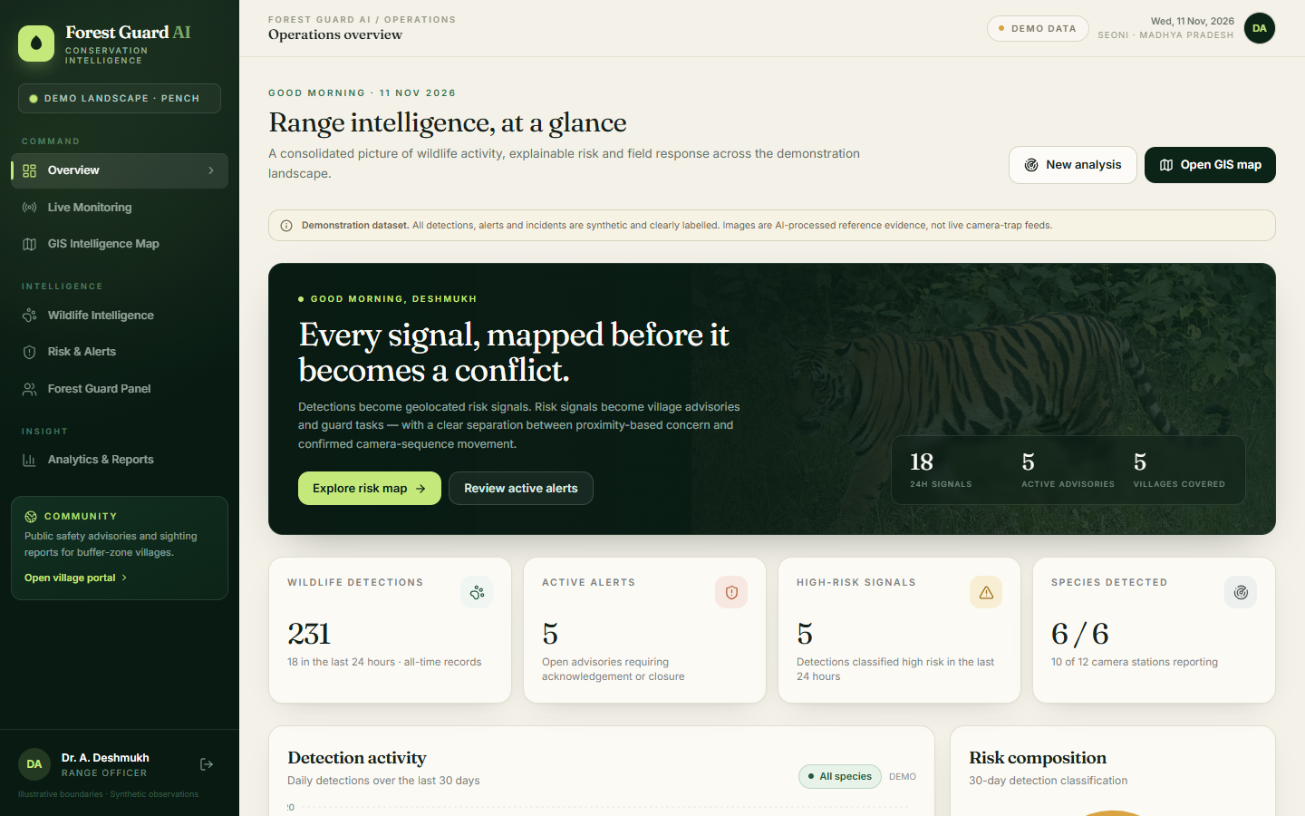
The operations console at a glance. Figures on every page come from the same seeded dataset, and the demo-data badge is visible throughout.

02 · CONTEXT

The problem and the design response
Forest teams already collect camera images, patrol notes, incident logs and village calls. The binding constraint is not a lack of data — it is the time and judgement needed to turn fragmented records into one defensible action.
Four operational gaps shaped the product: sightings arrive late; maps and records live in different tools; warnings are broadcast to everyone or no one; and community reports disappear without a trace. Each maps to a module rather than a dashboard widget.

Design principles
Principle | How it is enforced
Honesty | Synthetic records carry demo badges and API flags. Uploads return a real result or a 503 — never a fabricated one.
Explainability | Every alert stores its score components, species weight, distance basis and a written reason.
Privacy by architecture | Public payloads are sanitised server-side; coordinates and camera codes never reach the browser.
Local-first | No cloud inference or external data calls. OpenStreetMap is used only for basemap tiles.
Reproducibility | A fixed random seed generates the same landscape and history on every reset.
Honest movement | Tracks require ≥3 detections across ≥2 cameras within 24 h and 7 km; GPS is never implied.

Explicit non-goals
• No live camera feeds, CCTV integration or government surveillance access.
• No GPS telemetry, animal collars or individual re-identification.
• No real dispatch channel: guard notification is simulated in-app and labelled.
• No claim of field accuracy, deployment, adoption or measured impact.
• No public exposure of sensitive wildlife locations.
THE CORE IDEA
A nearby sighting and a confirmed approach are different evidence. The product shows proximity, recency, frequency, incidents and movement separately, so a high score means “verify this soon” — not “a conflict will occur”.

The evidence chain
Stage | Question answered | Stored artefact
Frame | What was seen, and how sure is the model? | Annotated media, species, confidence, bounding box
Place | Which station and how far from a village? | Camera coordinates, boundary distance
Risk | Why is it urgent? | Components, weights, score, level, written basis
Alert | Who should act, and where? | Affected villages, assigned guard, timestamp
Response | What happened? | Acknowledge/respond/resolve events with actor and note

03 · ENGINEERING

System architecture
A React single-page client talks to a FastAPI JSON API. The API owns authentication, domain services, media serving and CSV export. The AI engine is loaded lazily on the first upload and stays resident. SQLite is the database of record; the study area, village boundaries and risk configuration are files in the repository.
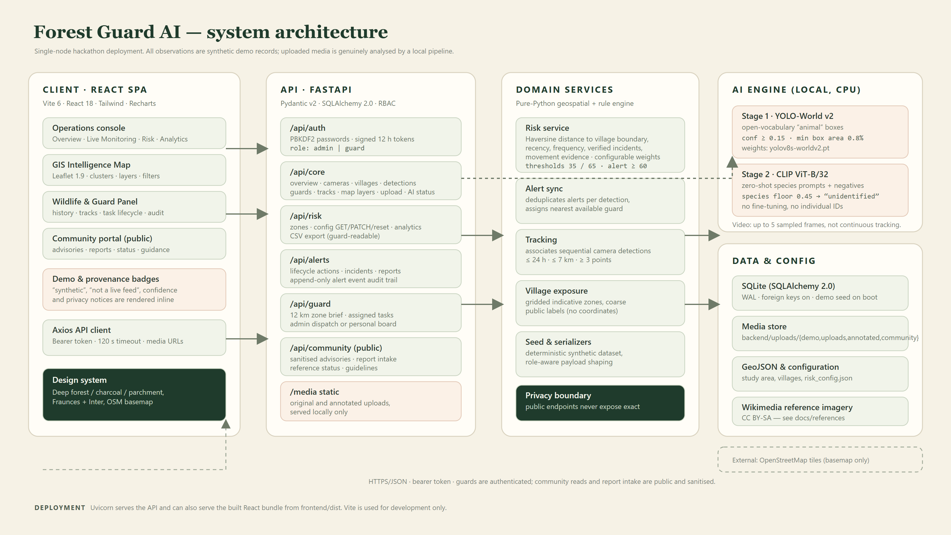
Figure 1 — Single-node architecture. The public portal and the console read the same data through different serializers.
Layer | Technology | Responsibility
Client | React 18 · Vite 6 · Tailwind · Leaflet 1.9 · Recharts | Eight pages, map layers, forms, filters, charts
API | FastAPI · Pydantic v2 · SQLAlchemy 2.0 | Auth, RBAC, validation, domain endpoints, CSV export
Domain | Pure-Python services | Risk scoring, alert sync, tracking, seeding, serializers
AI | PyTorch · YOLO-World v2 · CLIP ViT-B/32 | Localisation, species scoring, annotation
Data | SQLite (WAL) · GeoJSON · media store | Records, boundaries, risk config, uploads

Routers stay thin and services own the logic. The privacy boundary is implemented in serializers, not in the client: public endpoints physically omit coordinates, camera identifiers and detection media. Tests assert the absence of those keys, so a future UI change cannot accidentally leak them.

04 · MODULE 1

AI detection: local, conservative, bounded
The engine uses two off-the-shelf models on CPU, with no fine-tuning. YOLO-World v2 is configured with the single open-vocabulary class animal; each proposed crop is then scored by CLIP against three prompts per species for six regional species, plus negative prompts for empty forest, vehicles and people. If the negative-prompt mass dominates, the crop is vetoed to unidentified — a wrong dangerous-species label is worse than an honest “verify this frame”.
Decision rule | Default | Effect
Detector confidence | 0.15 | Boxes below the floor are dropped
Minimum box area | 0.8 % of frame | Rejects tiny spurious boxes
Species floor | 0.45 | Weak crops become “unidentified”, not a forced species
Combined floor | 0.50 | 0.55 × species + 0.45 × detector
Full-frame path | 0.62 | Separate floor when a crop fills the frame
Box cap | 6 per frame | After IoU de-duplication at 0.55
Video sampling | up to 5 frames | Independent frames — no temporal tracking

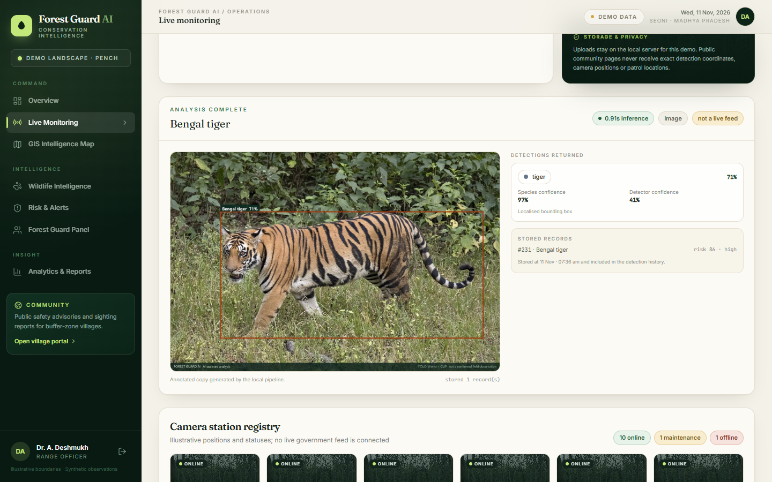
Figure 2 — A genuine tiger upload in the running app: annotated result, 71 % species confidence, stored recognition #231, risk 86 (high).

What the evaluation does and does not show
Reference image | Expected | Predicted | Detector | Species | Overall
tiger.jpg | tiger | tiger | 0.41 | 0.97 | 0.71
leopard.jpg | leopard | leopard | 0.45 | 1.00 | 0.75
elephant.jpg | elephant | elephant | 0.66 | 1.00 | 0.85
bear.jpg | sloth bear | sloth bear | 0.80 | 0.99 | 0.90
boar.jpg | wild boar | wild boar | 0.59 | 1.00 | 0.81
deer.jpg | deer | deer | 0.62 | 1.00 | 0.83

6 / 6 TOP-1 IS A SMOKE CHECK, NOT AN ACCURACY CLAIM
One licenced photograph per class, no train/test split, no night or IR strata. It proves the plumbing works end to end. A defensible evaluation requires a licenced camera-trap dataset with location-based splits; see the limitations section.

05 · MODULES 2 & 3

GIS intelligence and the explainable risk score
The map is the operational core. Forest and village polygons, camera stations, guard posts, clustered detections, gridded risk cells, alert coverage and inferred tracks are independent layers with filters, a legend and a click-through detail panel. Distance is measured to the nearest village boundary, not its centroid, so an edge-of-forest sighting is treated as genuinely close.
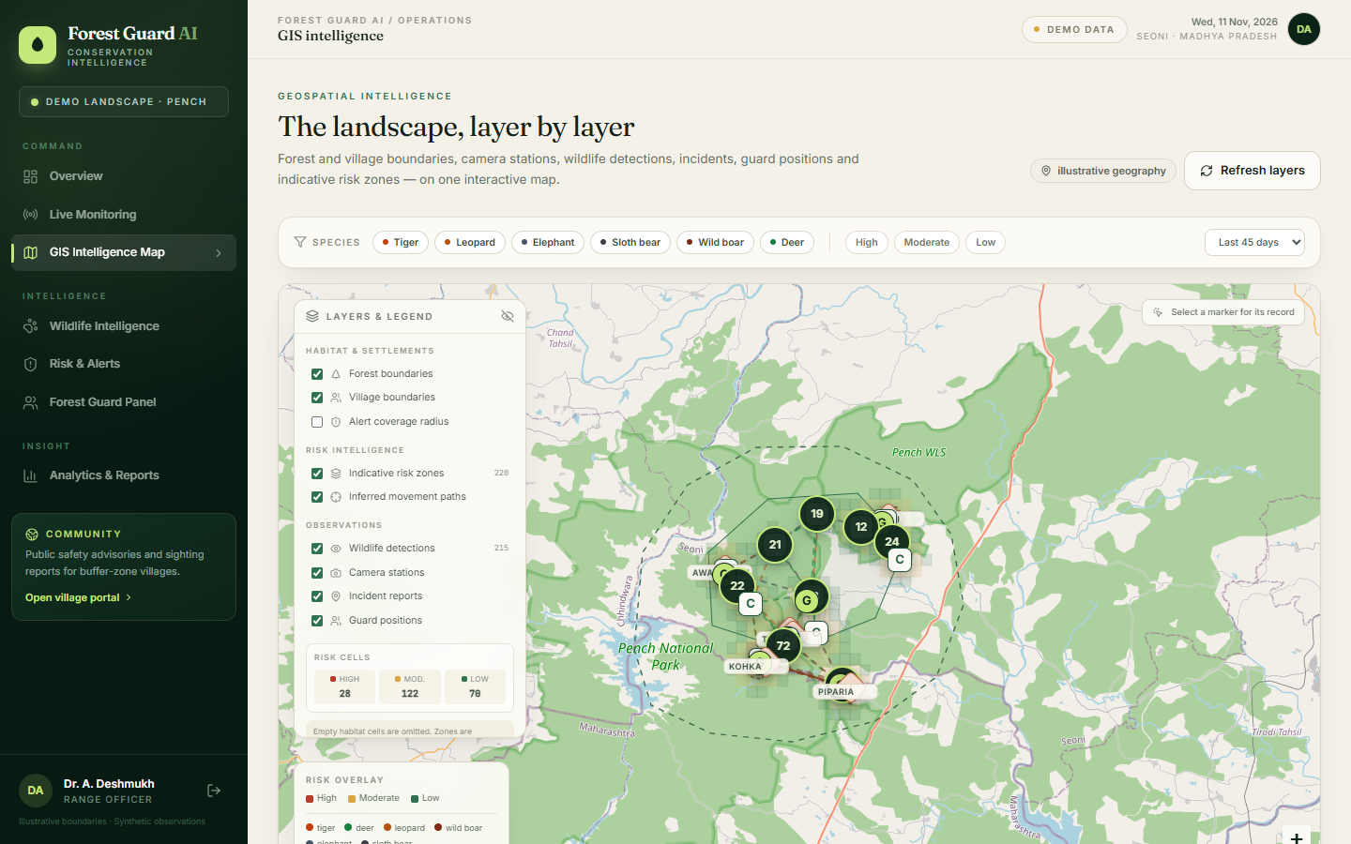
Figure 3 — The live GIS page: layer controls, species/risk/time filters, 222 detections in the 21-day window, and risk cells with inline scores.
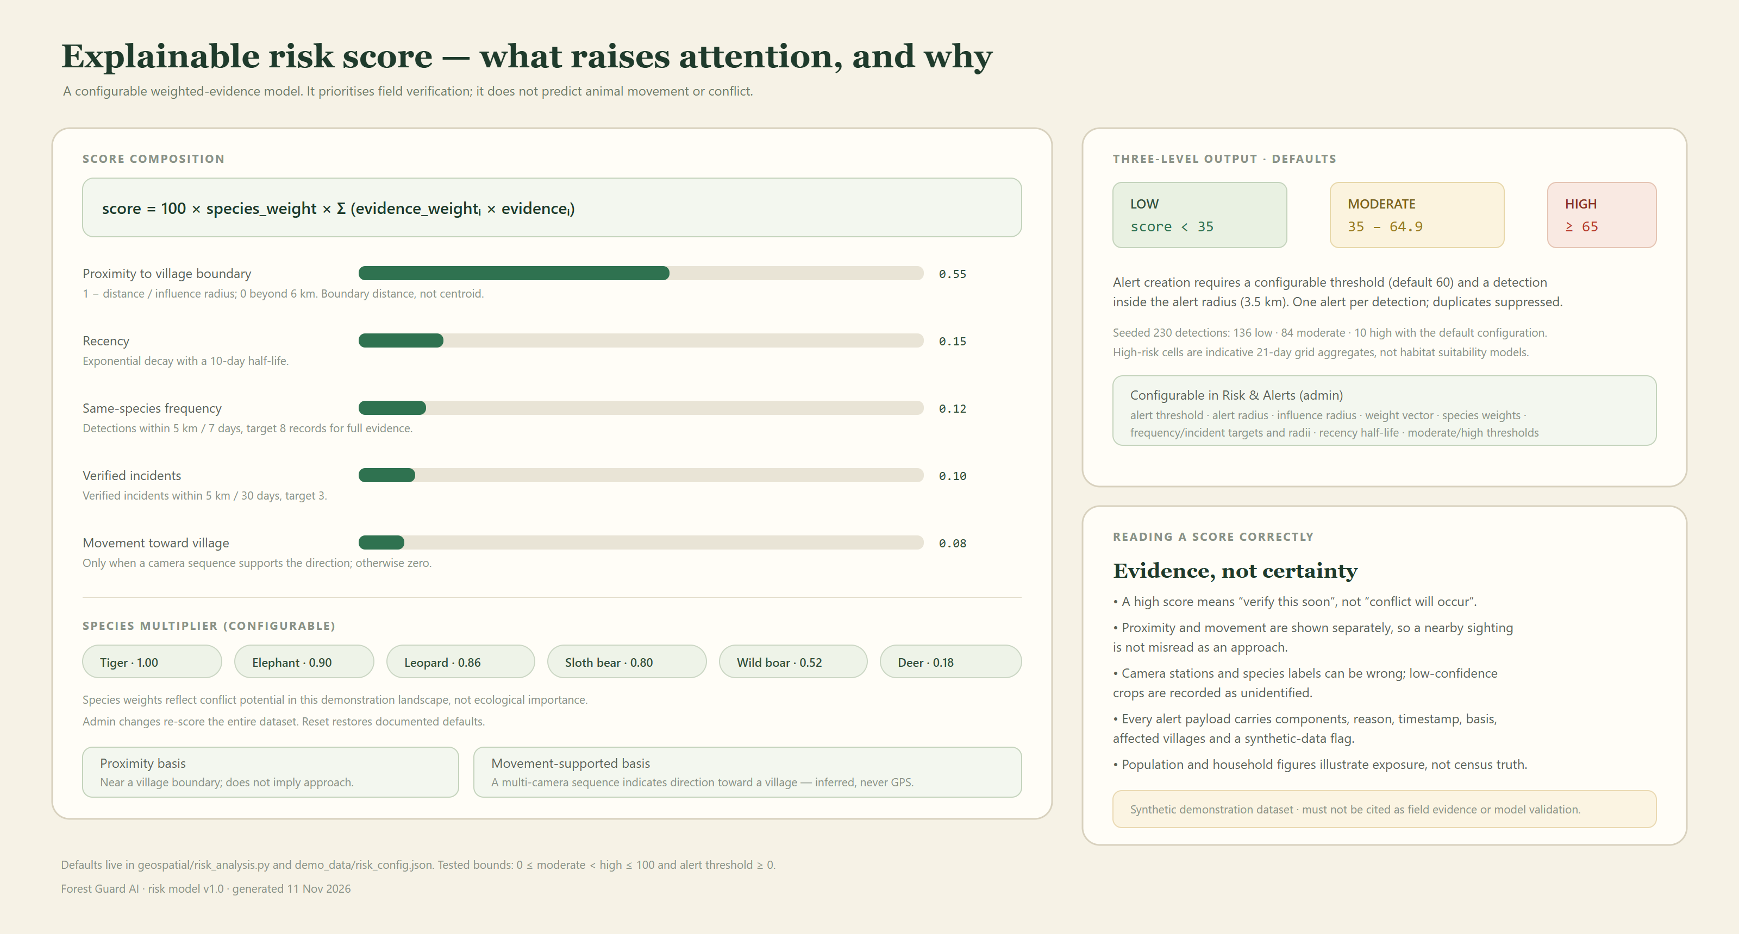
Figure 4 — Risk model: five weighted evidence components, species multipliers, three output levels and configurable alert rules.
Movement is a separate component worth 0.08, non-zero only when a camera sequence (≤24 h, ≤7 km, ≥3 points, ≥2 cameras) supports a direction toward a village. Tracks are labelled as inferred camera sequences, never GPS.

06 · MODULES 4 & 5

From alert to field response
An alert is a task, not a notification. A detection at or above the configurable threshold (default 60) inside the alert radius (3.5 km) creates exactly one alert, lists every village inside that radius, records the score basis and assigns the nearest available guard. Duplicate alerts per detection are suppressed.
Step | Actor | What is recorded
Detection | System | Species, confidence, camera, timestamp, risk score and components
Alert | System | Threshold, radius, affected villages, reason, synthetic-data flag
Assign | Admin / guard | Guard id, actor, timestamp
Acknowledge | Guard | Ownership, optional note, append-only audit event
Respond | Guard | Response status, note, timestamp
Resolve | Guard | Closure note and final state

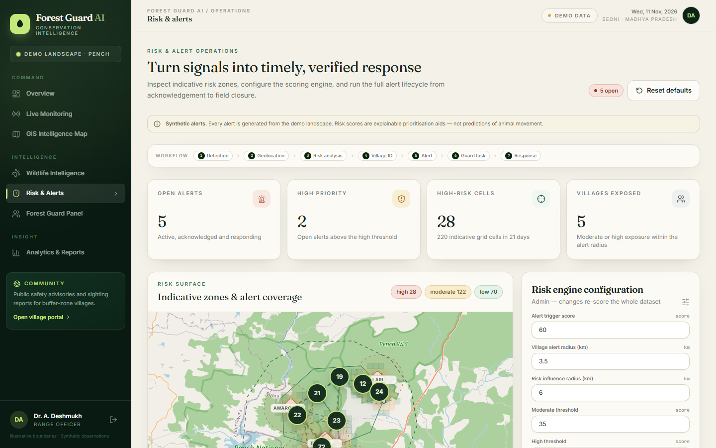  Figure 5 — Alert queue, risk surfacing, engine configuration and the full lifecycle controls. | 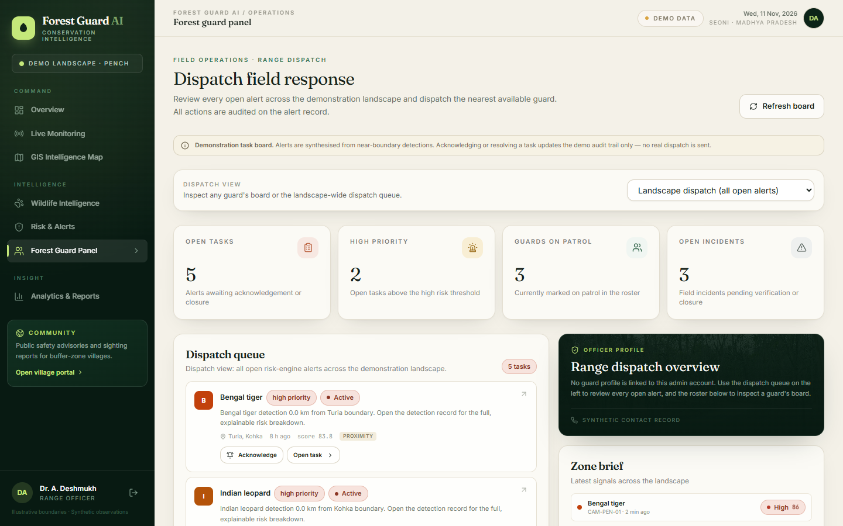  Figure 6 — Guard board: scoped tasks, statuses and high-risk areas.
RBAC is enforced in the API: a guard sees only their own board and cannot edit risk configuration; admins dispatch and inspect any guard. Notifications are simulated in-app — the interface says so, and no SMS or email is sent.

Who can do what
Role | Scope | Permitted actions
Admin | Entire range: all alerts, every guard board, risk configuration | Dispatch, assign, acknowledge, respond, resolve, change or reset risk config, export analytics
Guard | Own assigned tasks, incidents, community inbox | Acknowledge, respond and resolve own alerts; review reports and incidents
Public | Sanitised advisories and coarse village risk | Read guidance, submit a report, check status by reference code

07 · MODULE 6

Community portal and the privacy boundary
The public portal is a different view of the same data, not a separate dataset. It publishes coarse advisories by village, safety guidance, a sighting/conflict report form with an optional image, and a reference-code status lookup. All of it works without a login.
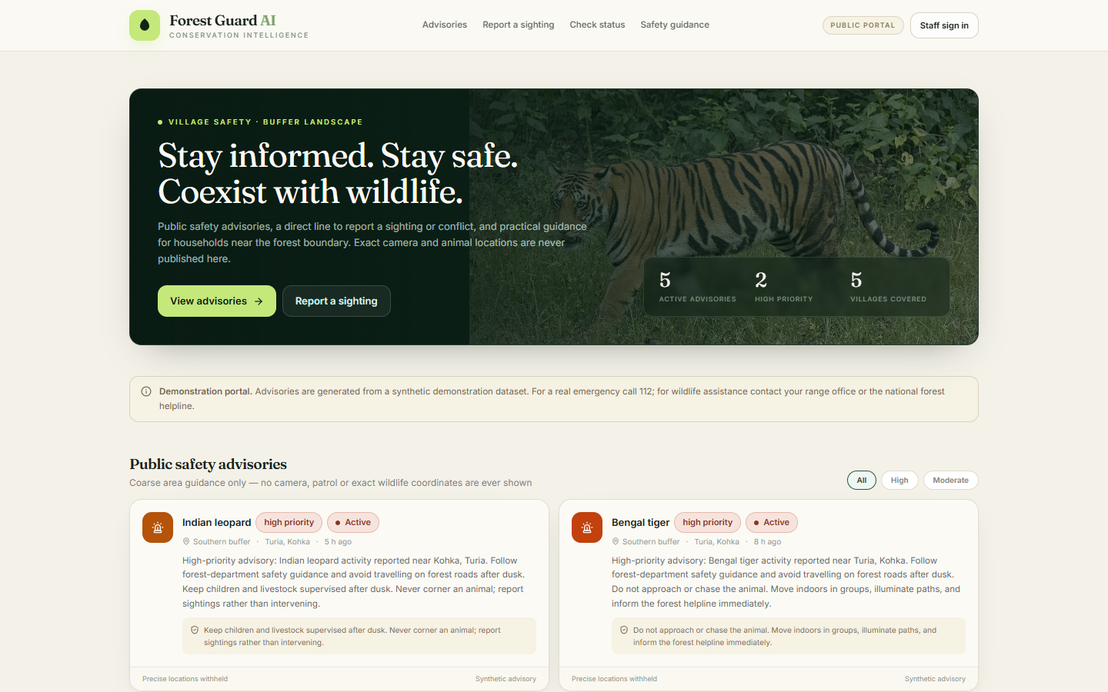  Figure 7 — Public portal: advisories, guidance and the reporting entry point. | 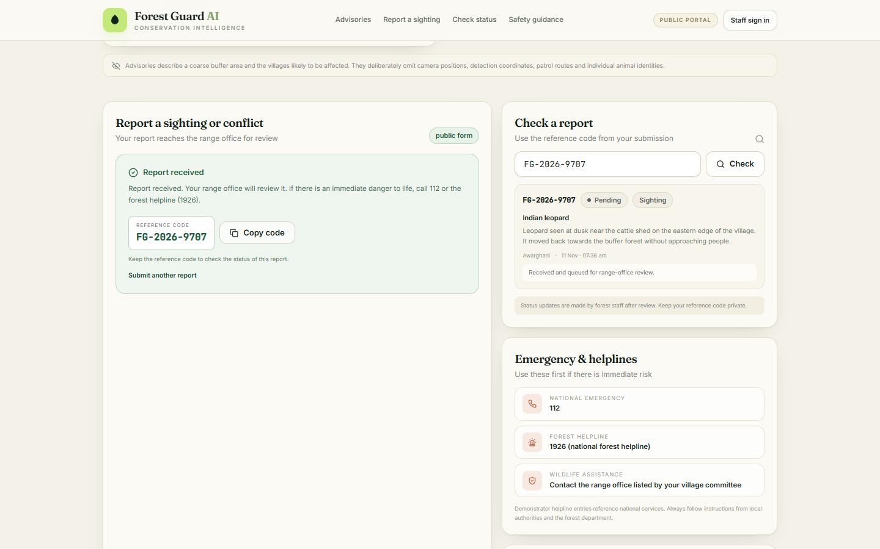  Figure 8 — Report submission result and status check by reference code.

Server-side sanitisation
Public payload | Console payload
Village names and coarse risk level | Exact coordinates and camera station codes
Advisory text and safety guidance | Species confidence, bounding boxes and media
Report reference code and status | Reporter details and moderation fields
Aggregated counts and trends | Guard assignment, notes and audit events

The community API never returns latitude, longitude or camera identifiers; automated tests assert their absence. Submission validation covers category, supported species, description length, coordinate pairing and image type/size. Reference codes use the form FG-YYYY-NNNN and are checked for collisions.

Public report lifecycle
• Submit — category (sighting or conflict), species, village, description, optional contact and photograph.
• Validate — supported species, description of at least 12 characters, paired coordinates, accepted image types and size.
• Issue reference — a collision-checked code such as FG-2026-9707 is returned immediately.
• Triage — the report appears in the guard-only inbox and can be marked pending, verified or closed with a note.
• Status lookup — the reporter checks progress with the code, without an account and without seeing sensitive locations.

08 · QUALITY

Verification and testing
The backend suite runs against a temporary SQLite database created per session, with the AI engine in demo mode. Tests never touch the demo database, download weights or need a GPU. The upload test asserts demo mode returns HTTP 503 and leaves record counts unchanged.
Suite | Tests | What is verified
test_api_core.py | 9 | Health/meta, login and 401s, seed counts, detection filters, map layers, non-GPS tracks, demo upload 503, CSV export
test_api_risk_alerts.py | 5 | Analytics totals, risk zones/exposure, config RBAC + temp-file writes, full alert lifecycle audit, filters/404
test_api_guard_community.py | 9 | Admin dispatch vs scoped guard board, sanitised public payloads, report round trip and validation, guard-only incidents
test_geospatial.py | 5 | Haversine, point-in-polygon, ring closure, threshold boundaries, explainable score bounds and weight sum
Total | 28 | All passed on 11 November 2026 in 1.27 s (2 unrelated deprecation warnings)

Other checks actually performed
• Production build: npm run build succeeds with Vite 6.
• Browser flows: Playwright + Edge captured all ten screenshots from the live app, including a real tiger upload and a public report submission. No browser errors were reported.
• Data consistency: the upload precedes the dashboard captures, so the same 231 detections and 14 alerts appear on the overview, guard panel and analytics pages.
• AI smoke evaluation: the production engine was run over the six reference photos; raw JSON is stored in docs/references/.
• Configuration safety: risk-config tests write to a temporary path; the repository's risk_config.json was verified unchanged.
Not covered: UI component unit tests, load/soak testing, accessibility audit, security penetration testing and evaluation on a labelled camera-trap dataset. These are explicit gaps, not implied passes.

Deliverable verification
Artefact | Location | Status
Backend suite | tests/ | 28 passed in 1.27 s; isolated temp database
Production bundle | frontend/dist/ | Vite 6 build completed
Screenshots | docs/screenshots/ | 10 PNG files captured from the running app
Diagrams | docs/diagrams/ | 3 hand-authored SVGs rendered to PNG at 2×
AI smoke output | docs/references/ai_smoke_evaluation.json | Recorded 11 Nov 2026 with caveats
Report sources | deliverables/build_deck.py · build_report.py · build_docx.py | Reproducible from repository assets

09 · CLOSE

Limitations, roadmap and how to run it
Area | Current limit | Consequence
Classifier | Zero-shot CLIP, six labels, no fine-tuning | Will confuse similar species and struggle with night/IR frames
Evaluation | Six reference photos, one per class | No accuracy or field-performance claim is possible
Storage | SQLite, no spatial index | Single-node only; polygons parsed in Python
Tracking | Camera-sequence association, no individual IDs | Movement is a coarse, inferred direction
Dispatch | Simulated in-app notification | No real responder SLA or SMS delivery
Landscape | Illustrative Seoni-area geometry and synthetic population | Exposure figures illustrate the method, not census truth

Next steps, in priority order
• 1 · Measurement. Licence a regional camera-trap dataset, split by camera location, and report per-species precision/recall at a fixed threshold, stratified by day/night and occlusion.
• 2 · Spatial infrastructure. Move to PostgreSQL + PostGIS with spatial indexes, then add a task queue so inference scales beyond one process.
• 3 · Real response. Integrate an SMS/radio gateway with delivery receipts and acknowledgement SLAs; add an offline-first guard client.
• 4 · Governance. Add audit export, data-retention rules and role-scoped media access before any pilot deployment.

Reproduce the build
python -m venv .venv && source .venv/bin/activate
pip install -r requirements.txt
python -m uvicorn backend.main:app --port 8000
cd frontend && npm install && npm run dev
python -m pytest -q

Open http://127.0.0.1:5173 and sign in as admin@forestguard.ai / forest123 (admin) or guard@forestguard.ai / guard123 (guard). The community portal is public at /community. Setup, API, testing, demo script, AI limits and image credits live in docs/.
Imagery is CC BY-SA / CC BY-SA-compatible from Wikimedia Commons and individually attributed in docs/image-credits.md; basemap © OpenStreetMap contributors. Model weights are excluded from the repository and must be obtained separately. This report describes a demonstration system, not a validated or deployed service.

