WEEK 2 REPORT
Data Collection, Cleaning, and Preprocessing for Logistics Analysis
A documented Python pipeline that turns messy shipment records into an analysis-ready dataset
Prepared by: Ansh Maheshwari
Date: October 2026
Tools: Python 3, pandas, NumPy, scikit-learn, matplotlib

1. Introduction
Week 1 defined a logistics scenario: a regional distributor that needs better demand forecasts, inventory policies and delivery routes. Every one of those analyses depends on the quality of the underlying shipment, inventory and delivery records. This report covers the step that comes before modelling: collecting the data, finding what is wrong with it, fixing it in a documented and repeatable way, and preparing it for analysis.
The objectives are to (1) describe a public reference dataset and simulate collecting it, (2) identify the common quality problems in logistics data, (3) apply and justify techniques for duplicates, inconsistent formats, missing values, outliers and scaling, (4) show each step in Python, and (5) reflect on how data quality shapes decisions.

2. Data Collection Simulation

2.1 Reference dataset
The reference is the DataCo Smart Supply Chain dataset, published on Kaggle. It records order lines for a supply-chain company, with order and shipping dates, scheduled and actual shipping days, shipping mode, delivery status, customer region, sales amounts and product details. It holds well over 180,000 rows and about 50 columns, so it is large enough to show realistic data-quality problems. The file is usually read with latin-1 encoding because of special characters in some text fields.
A real extract of this kind normally arrives from several sources: an order management system, a warehouse system and carrier tracking files. Each source has its own formats and conventions, which is why merged logistics data is rarely clean.

2.2 Simulated dataset
Because the raw file cannot always be downloaded, the accompanying script simulates a table of 6,160 shipment records with 11 fields modelled on the reference dataset. The simulation deliberately injects the problems described in Section 3, so every cleaning step has something to do and its effect can be measured. The same pipeline can be pointed at the real file by changing the loading function and a column-rename map.
Field | Type | Meaning
order_id | integer | Unique order identifier
order_date / ship_date / delivery_date | date | Order placed, handed to carrier, delivered to customer
ship_mode | category | Standard, Second, First Class or Same Day
region | category | Destination region (North, South, East, West, Central)
distance_km | float | Route distance from warehouse to customer
weight_kg | float | Shipment weight
order_value_inr | float | Order value in Indian rupees
planned_days | integer | Promised transit days for the chosen ship mode
stock_on_hand | float | Units of the item in stock at dispatch

3. Data Quality Assessment
Quality problems fall into a few recurring families: duplicates, inconsistent formats, missing values, impossible values and outliers. The table lists those injected into the simulated data and the real-world cause each represents.
Data-quality issue | How it was injected in the simulation | Typical real-world cause
Duplicate records | 160 copied rows | Repeated ERP exports, retried API calls
Mixed date formats | About 15 % of dates written as DD/MM/YYYY text | Merged files from different systems
Inconsistent labels | 13 spellings of 4 ship modes; 10 spellings of 5 regions | Free-text entry, no drop-down lists
Numbers stored as text | Weights such as “12.5 kg” and “N/A” | Units typed into the field
Missing values | 2–5 % in six columns; weight missing more often for Same Day | Skipped fields, failed sensor or scan
Impossible values | Negative distance, zero weight, delivery before shipment | Data-entry and integration errors
Extreme outliers | Weights of 2,000–9,000 kg; order values of ₹5–20 million | Wrong unit or extra digits

Detection starts with an audit of data types, missing counts and distinct values, followed by targeted checks for each issue family. In pandas this is quick to do, and the table below shows the checks used and what they found.
Issue | pandas check used to find it | Count found in this run
Exact duplicates | df.duplicated().sum() | 160 rows
Hidden missing values | df.isna().sum() plus value_counts() on text columns | “N/A” strings hid inside weight_kg
Label variants | df.ship_mode.nunique() | 13 levels, expected 4
Negative distance | (df.distance_km <= 0).sum() | 15 rows
Zero weight | (df.weight_kg <= 0).sum() | 10 rows
Delivery before shipment | (df.delivery_date < df.ship_date).sum() | 40 rows
Extreme weights | IQR rule on log1p(weight) | 79 flagged

def audit(df, label):
return pd.DataFrame({"dtype": df.dtypes.astype(str),
"missing": df.isna().sum(),
"missing_%": (100 * df.isna().mean()).round(2),
"unique": df.nunique()})

One result from the audit deserves attention. The raw weight column shows only about 1 % missing, yet it also contains “N/A” text and values such as “12.5 kg”. isna() cannot see these, so the true amount of missing data is higher and the column is stored as text rather than numbers. Checking data types and distinct values is therefore as important as counting nulls.

4. Methodology: Cleaning and Preprocessing
The pipeline runs in a fixed order. Order matters: duplicates are removed first so they do not distort later statistics, formats are fixed before rules are applied, and scaling comes last so it uses fully cleaned values.

4.1 Removing duplicates
Duplicated rows double-count orders, which inflates demand, revenue and volume. The pipeline removes exact duplicates and then checks order_id for repeats. In this run 160 exact duplicates were removed, leaving 6,000 unique orders. No further repeated IDs remained, which confirms the first step caught them all.
df = df.drop_duplicates() # identical rows
df = df.drop_duplicates(subset="order_id", keep="first") # repeated IDs

4.2 Fixing data types and hidden missing values
Weights stored as text cannot be averaged or compared. The unit is stripped, placeholder strings such as “N/A” are converted to proper missing values, and the column is converted to numbers. Using errors="coerce" turns anything unreadable into NaN instead of stopping the script, so those values flow into the missing-value step where they are handled openly.
w = df["weight_kg"].astype(str).str.replace("kg", "", regex=False).str.strip()
w = w.replace({"N/A": np.nan, "nan": np.nan})
df["weight_kg"] = pd.to_numeric(w, errors="coerce")

4.3 Parsing dates
About 15 % of dates were written as DD/MM/YYYY while the rest used YYYY-MM-DD. Letting pandas guess is risky, because a date such as 03/04/2025 could be read as March or April. The pipeline parses with an explicit ISO format first and then with the day-first format for whatever failed. After this step no order or ship dates were left unparsed.
iso = pd.to_datetime(df[c], format="%Y-%m-%d", errors="coerce")
dmy = pd.to_datetime(df[c], format="%d/%m/%Y", errors="coerce")
df[c] = iso.fillna(dmy) # try ISO first, fall back to DD/MM/YYYY

4.4 Standardising categories
Labels such as “standard class”, “Standard Class ” and “STD CLASS” would be counted as three separate groups in a group-by or a one-hot encoding. The pipeline strips whitespace, lower-cases the text and maps every variant to one canonical label. Ship-mode levels fell from 13 to 4, and region levels from 10 to 5.
df["ship_mode"] = df["ship_mode"].str.strip().str.lower().map(mode_map)
df["region"] = df["region"].str.strip().str.title()

4.5 Applying validity rules
Some values are impossible, not merely unusual: a negative distance, a zero weight, or delivery before shipment. They are replaced with missing values so they can be handled with the other missing data, instead of being kept as if they were real. Found: 15 negative distances, 10 zero weights and 40 deliveries dated before shipment.
The effect on results is large. Before this step, the 40 reversed dates produced transit times of hundreds of negative days. They pulled the mean transit time down to 2.98 days, when the cleaned figure is 4.37 days. A planner using the uncleaned number would believe deliveries are about a day and a half faster than they really are.
df.loc[df.distance_km <= 0, "distance_km"] = np.nan
df.loc[df.weight_kg <= 0, "weight_kg"] = np.nan
bad_seq = df.delivery_date < df.ship_date
df.loc[bad_seq, "delivery_date"] = pd.NaT

4.6 Handling missing values
The right treatment depends on why data is missing. Values can be missing completely at random (MCAR), missing in a way that depends on other recorded fields (MAR), or missing because of the value itself (MNAR). In the simulation, weight is missing more often for Same Day shipments, which is a MAR pattern. Deleting those rows would remove a particular kind of shipment from the data and bias the analysis, so the pipeline imputes instead.
Medians are used for numeric columns because logistics data is right-skewed, and the mean would be pulled up by a few very heavy or very long shipments. Where a related field explains the pattern, the median is taken within groups. The delivery date is deliberately not imputed: it defines the outcome being studied, and invented values would make delivery performance look better or worse than it is.
Column | Method | Reason
region | Mode (most frequent) | Categorical; there is no meaningful average
weight_kg | Median within ship_mode | Skewed data; missingness depends on ship mode, so the group median respects that pattern
distance_km | Median within region | Distance varies by destination; the median is robust to the long tail
order_value_inr | Weight × median value-per-kg | Value is closely tied to weight, so this keeps the relationship
stock_on_hand | Median within region | Simple, and no time ordering is available to carry values forward
delivery_date | Not imputed | It defines the outcome (transit time); inventing it would bias delivery analysis

The pipeline also adds a 0/1 flag for each imputed numeric column. This keeps a record of which values were estimated, so later models can learn from it and analysts can run the analysis with and without imputed rows.
for c in ["weight_kg", "distance_km", "order_value_inr"]:
df[f"{c}_was_missing"] = df[c].isna().astype(int) # keep a trace
df["region"] = df["region"].fillna(df["region"].mode()[0])
df["weight_kg"] = df["weight_kg"].fillna(
df.groupby("ship_mode")["weight_kg"].transform("median"))
df["distance_km"] = df["distance_km"].fillna(
df.groupby("region")["distance_km"].transform("median"))

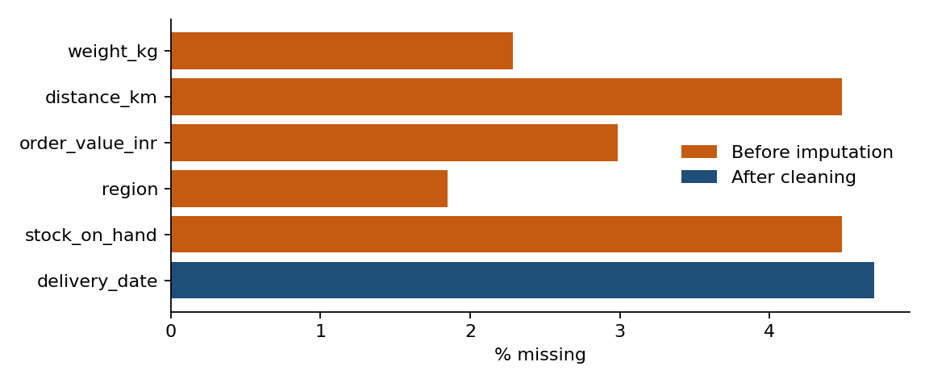
Figure 1. Share of missing values in each column before imputation and after cleaning

4.7 Detecting and treating outliers
Outliers need different handling depending on their cause. A 5,000 kg parcel in a food-distribution table is almost certainly a typing error, whereas a 1,700 km route may be a real long-haul delivery. Detection therefore combines a statistical rule with judgement.
Two rules were compared. The z-score rule flags points more than three standard deviations from the mean, but the mean and standard deviation are themselves distorted by the outliers, and the rule assumes a bell-shaped distribution. The IQR rule flags points beyond 1.5 times the interquartile range outside the quartiles and is less affected by extreme values. Because weight, distance and value are right-skewed, the IQR rule is applied on the log scale, which stops legitimate large values from being flagged simply because the distribution has a long tail.
Flagged values are capped (winsorised) at the fences instead of being deleted. This keeps every order in the dataset while limiting the influence of extreme entries, and a 0/1 outlier flag records which rows were changed.
Column | IQR flagged | |z| > 3 flagged | Max before | Max after capping
weight_kg | 79 | 25 | 8,661.3 | 66.9
distance_km | 74 | 8 | 1,800 | 1,762.2
order_value_inr | 184 | 106 | 19,269,231.3 | 27,386.1

lg = np.log1p(df[c]) # detect on the log scale
q1, q3 = lg.quantile([0.25, 0.75])
lo, hi = q1 - 1.5 * (q3 - q1), q3 + 1.5 * (q3 - q1)
df[f"{c}_outlier"] = ((lg < lo) | (lg > hi)).astype(int)
df[c] = np.expm1(lg.clip(lo, hi)) # cap at the fences

The effect on weight is clear. The maximum fell from 8,661.3 kg to 66.9 kg, and the mean fell from 38.71 kg to 13.41 kg, much closer to the median of 11.36 kg. Freight cost, load planning and vehicle capacity calculations all use weight, so an uncorrected mean of 38.71 kg would overstate the typical load by almost three times.
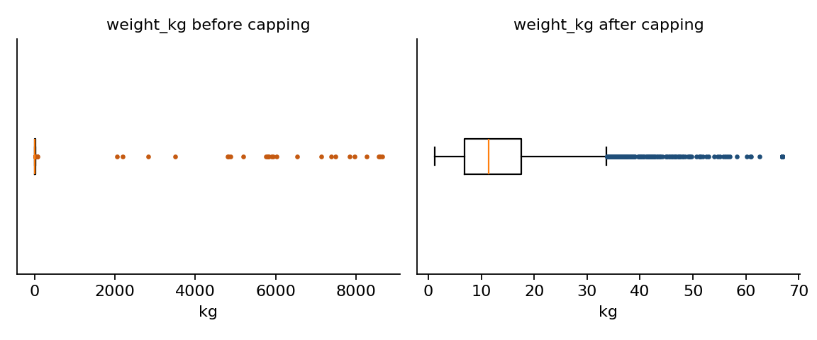
Figure 2. Box plots of shipment weight before and after capping
Distance shows a different pattern. It had few true errors, so capping barely changed its maximum, which shows that the long-distance orders are genuine and are kept. Treating all flagged values the same way would have been a mistake.

4.8 Feature engineering
Cleaned fields are turned into variables that logistics analysis uses directly: processing days (order to ship), transit days (ship to delivery), delay against the planned days, a late-delivery flag, calendar features and value per kg. Rows without a valid delivery date keep a missing transit value instead of an invented one.
df["transit_days"] = (df.delivery_date - df.ship_date).dt.days
df["delay_days"] = df.transit_days - df.planned_days
df["is_late"] = (df.delay_days > 0).astype(float).where(df.transit_days.notna())
df["value_per_kg"] = df.order_value_inr / df.weight_kg

4.9 Encoding categorical variables
Models need numbers. Ship mode has a natural order from fastest to slowest, so it is encoded as an ordinal value (Same Day = 0 up to Standard Class = 3), which keeps that order. Region has no order, so it is one-hot encoded, which avoids implying that one region is larger than another.
df["ship_mode_ord"] = df.ship_mode.map({"Same Day": 0, "First Class": 1,
"Second Class": 2, "Standard Class": 3})
df = pd.concat([df, pd.get_dummies(df.region, prefix="region", dtype=int)], axis=1)

4.10 Normalisation and scaling
Variables measured in different units, such as kilograms, kilometres and rupees, sit on very different numeric scales. Distance-based methods such as K-Means and gradient-based models are dominated by the largest-scale variable unless the features are brought to a comparable range. Four common techniques are compared below.
Technique | Formula | Best used when
Min-max | (x − min) / (max − min) | Bounded range needed (neural networks, distance-based methods); sensitive to outliers
Standardisation (z-score) | (x − mean) / std | Roughly symmetric data; linear models, K-Means, PCA
Robust scaling | (x − median) / IQR | Outliers remain in the data
Log transform | log(1 + x) | Strongly right-skewed positive data such as weight, distance and value

For this dataset the chosen approach is a log transform followed by standardisation. The log step reduces the right skew, and standardisation then gives each feature a mean of 0 and a standard deviation of 1. Min-max scaling was rejected as the main method because it is sensitive to the remaining extreme values.
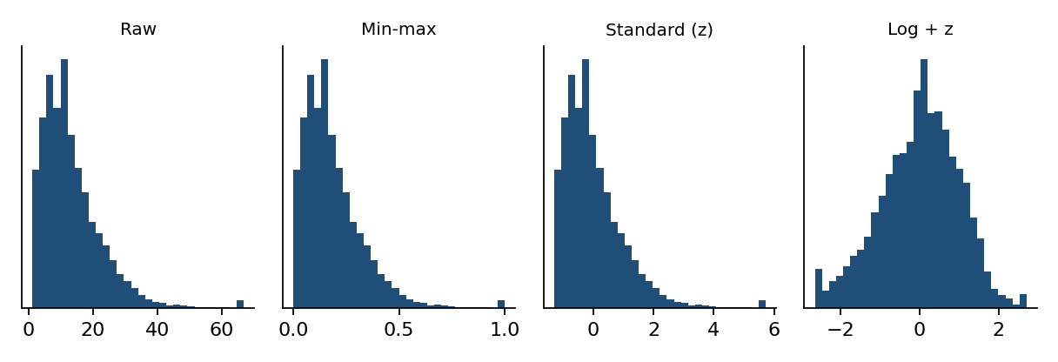
Figure 3. Shipment weight under raw, min-max, standardised and log-then-standardised scaling
A key point is avoiding data leakage. The scaler learns its mean and standard deviation only from the training portion, and the same values are then applied to the test portion. If the scaler were fitted on all data, information from future orders would leak into training and make model results look better than they would be in practice. The split is by date: the earliest 80 % of orders are used for training.
for c in ["weight_kg", "distance_km", "order_value_inr"]:
df[f"log_{c}"] = np.log1p(df[c])
cutoff = df.order_date.quantile(0.8) # time-based split
train, test = df[df.order_date <= cutoff], df[df.order_date > cutoff]
scaler = StandardScaler().fit(train[num_cols]) # fit on TRAIN only
train[z_cols] = scaler.transform(train[num_cols])
test[z_cols] = scaler.transform(test[num_cols]) # reuse train statistics

Checking the result: on the training rows the scaled features have a mean of essentially zero and an average standard deviation of 1.000, as expected (4,807 training and 1,193 test rows).

5. Results and Validation
After the full pipeline, the dataset passes every automated validation rule. These checks are written as assertions in the script, so any future data load that breaks a rule stops the run instead of passing bad data downstream.
Measure | Raw data | Cleaned data
Rows | 6,160 | 6,000
Ship-mode spellings | 13 | 4
Region spellings | 10 | 5
Mean weight (kg) | 38.71 (max 8,661.3) | 13.41 (max 66.9)
Mean transit time (days) | 2.98 (40 negative values) | 4.37
Missing values in core columns | Yes (six columns) | 0
Columns | 11 | 38 (with flags and features)

Validation rule | Result
no duplicate order_id | PASS
no missing in core columns | PASS
distance > 0 | PASS
weight > 0 | PASS
ship_date >= order_date | PASS
delivery_date >= ship_date (where present) | PASS
ship_mode has 4 valid levels | PASS

checks = {
"no duplicate order_id": df.order_id.is_unique,
"distance > 0": (df.distance_km > 0).all(),
"ship_date >= order_date": (df.ship_date >= df.order_date).all(),
"ship_mode has 4 valid levels": df.ship_mode.nunique() == 4,
}
assert all(checks.values())

The simulated data contains 282 rows without a valid delivery date (missing originally, or removed by the date rule). These remain in the full dataset but are excluded when transit time or lateness is modelled, so the delivery analysis uses only observed outcomes.

6. Reflection: Why Data Quality Matters in Logistics
The results show that cleaning changes the conclusions, not just the appearance of the table. Three examples from this run make the point:
- Delivery performance: reversed dates made average transit time look like 2.98 days instead of 4.37. A manager comparing carriers on that figure would draw the wrong conclusion about service levels.
- Load and cost planning: unchecked weight entries inflated the mean shipment weight to 38.71 kg against a cleaned 13.41 kg. Vehicle sizing, freight budgets and route capacities built on the first number would be badly off.
- Demand and inventory: 160 duplicated rows counted some orders twice. Applied across a full year of SKU-level data, double-counting inflates forecasts and leads to overstock and tied-up working capital.
Poor data also damages trust. When planners see forecasts or KPIs that contradict what they know from the warehouse floor, they stop using the system. Clean, documented data is therefore a precondition for adoption, as well as for accuracy.
Three practices follow from this work. First, make cleaning reproducible: a script that runs the same steps every time is auditable, and a manual spreadsheet edit is not. Second, never fix silently: flag imputed and capped values so the analysis can be checked. Third, prevent errors at the source with drop-down lists, input validation and unit standards, since cleaning later is always more expensive than entering data correctly.

6.1 Limitations
- Simulated data: the problem types are realistic, but real data has messier and less predictable errors. Results such as the transit-time shift will differ on the real file.
- Simple imputation: group medians are transparent but ignore relationships between variables. KNN or model-based imputation could be compared in a later phase.
- Capping decisions: the 1.5 × IQR threshold is a convention. In practice, flagged values should be reviewed with the people who know the operation.

6.2 Next steps
The cleaned dataset is ready for exploratory analysis and modelling in Week 3. The immediate next steps are to run the pipeline on the real DataCo file, build baseline KPIs such as OTIF from the cleaned fields, and begin the forecasting and segmentation work planned in Week 1.

References
- Constante, F. et al. DataCo Smart Supply Chain for Big Data Analysis. Kaggle / Mendeley Data (dataset).
- McKinney, W. Python for Data Analysis. O’Reilly Media.
- Little, R. J. A. & Rubin, D. B. Statistical Analysis with Missing Data. Wiley.
- Tukey, J. W. (1977). Exploratory Data Analysis. Addison-Wesley.
- Pedregosa, F. et al. (2011). Scikit-learn: Machine Learning in Python. Journal of Machine Learning Research, 12.
- pandas documentation: pandas.pydata.org/docs
- Hyndman, R. J. & Athanasopoulos, G. Forecasting: Principles and Practice (online textbook, OTexts).

