WEEK 3 REPORT
Advanced Data Analysis and Visualization in Logistics
Exploring cost drivers, delivery performance and bottlenecks in a simulated year of shipments
Prepared by: Ansh Maheshwari
Date: October 2026
Tools: Python 3, pandas, NumPy, SciPy, scikit-learn, matplotlib, seaborn

1. Introduction
Weeks 1 and 2 defined a logistics scenario and prepared clean data. This report moves to the analysis stage: exploring a full year of shipment records, visualising them, and turning the patterns into operational insights. The aim is to answer three practical questions for a regional distributor. What drives transport cost? Where does delivery performance break down? Which changes would improve efficiency most?
The report is organised as follows: the simulated dataset (Section 2), the method (Section 3), the numerical exploratory analysis (Section 4), nine visualisations with the reasoning for each chart type (Section 5), the combined insights (Section 6), recommendations (Section 7) and limitations (Section 8).

2. Data Simulation

2.1 Scenario and structure
The dataset represents 8,000 outbound shipments from one Delhi NCR warehouse to five destination zones between 2025-01-01 and 2025-12-31. Each row is one shipment with 20 variables covering timing, route, vehicle, carrier, load, cost and delivery outcome.
Variable | Type | Description
shipment_id, order_date | ID, date | Unique ID and order date (1 Jan–31 Dec 2025); month and weekday are derived
dispatch_hour | integer | Hour the shipment left the warehouse (8–21)
dest_zone | category | North, Central, West, East or South of the Delhi NCR warehouse
carrier | category | Carrier A, B or C
vehicle_type | category | Mini Van (1 t), Truck 4T, Truck 10T
ship_mode | category | Standard or Express
distance_km, weight_kg | float | Route distance and shipment weight
load_factor | float (0–1) | Weight divided by vehicle capacity
cost_inr, cost_per_kg | float | Transport cost in rupees and cost per kilogram
dwell_hours | float | Hours between order readiness and leaving the warehouse
planned_days, actual_days, delay_days, is_late | integer | Promised and actual transit days; delay = actual − planned; late if delay > 0

2.2 How the data was generated
The data is simulated, and the relationships inside it were chosen to resemble real logistics operations: cost grows with distance and vehicle size, evening dispatch batches create warehouse queues, monsoon months slow deliveries, volume peaks in the festive season, and one carrier is weaker on one lane. Random noise is added to every relationship so that patterns are visible but not perfect.
This design has an important consequence. The analysis can recover the relationships that were built in, which shows that the methods work. The numbers are not findings about a real company, and the report treats them as an illustration of how such an analysis would be done and interpreted.

3. Methodology
The analysis follows a fixed sequence, and each step is reproducible in the accompanying script (week3_eda_visualization.py).
- Descriptive statistics: mean, median, standard deviation, skewness and 95th percentile for every key variable, to understand typical values and spread.
- Distribution checks: histograms (with log scales where data is skewed) to see shape, clusters and extremes.
- Correlation analysis: Spearman rank correlation instead of Pearson, because distance, weight and cost are skewed and relationships are monotonic rather than strictly linear.
- Group comparisons: late rates and costs compared across carriers, zones, vehicles, hours and months to locate where problems concentrate.
- Cost-driver model: a linear regression on log cost to separate the effect of each driver while holding the others constant.
- Significance check: a Mann–Whitney U test for the warehouse dwell-time difference, which does not assume normally distributed data.
Choices of chart type follow the question being asked: bars for comparisons across categories, lines for trends over time, histograms for distributions, scatter plots for relationships between two numbers, and heatmaps for two categorical dimensions at once.

4. Exploratory Data Analysis

4.1 Central tendency and spread
Variable | Mean | Median | Std dev | Skew | 95th pct.
distance_km | 891.78 | 915.4 | 586.51 | 0.15 | 1,829.84
weight_kg | 1,087.78 | 727.9 | 1,129.45 | 3.04 | 3,118.49
load_factor | 0.39 | 0.35 | 0.25 | 0.60 | 0.87
cost_inr | 25,396.39 | 21,851.5 | 19,134.13 | 1.12 | 60,383.7
cost_per_kg | 44.61 | 25.16 | 70.93 | 8.18 | 148.17
dwell_hours | 9.42 | 7.2 | 7.75 | 2.06 | 24.7
planned_days | 3.02 | 3 | 1.38 | 0.38 | 5
actual_days | 3.18 | 3 | 1.71 | 0.47 | 6
delay_days | 0.16 | 0 | 0.79 | 0.29 | 1

Comparing the mean with the median shows where the data is skewed. Weight has a mean of 1,087.78 kg against a median of 727.9 kg (skewness 3.04), so a small number of heavy shipments pull the average up. Cost per kilogram is even more skewed: a mean of ₹44.61 against a median of ₹25.16, because very light loads in large vehicles produce extreme values. For these variables the median describes a typical shipment better than the mean.
Distance is roughly symmetric (mean 891.78 km, median 915.4 km) but its spread is wide because the warehouse serves both nearby and distant zones. Delivery performance is tight in central terms: the planned time averages 3.02 days and the actual time 3.18 days, an average delay of 0.16 days. Overall, 70 % of shipments arrive on time or early, and late shipments are on average 1.16 days late.

4.2 Correlations
Pair (Spearman) | ρ | Reading
Distance and cost | 0.86 | Very strong: distance is the main driver of total cost
Weight and cost | 0.30 | Weak: heavier loads cost somewhat more, but weight alone explains little
Load factor and cost per kg | -0.62 | Strong negative: fuller vehicles cost less per kilogram
Weight and cost per kg | -0.54 | Negative: heavy loads spread fixed cost across more kilograms
Dwell time and delay | 0.25 | Moderate positive: longer waiting leads to later delivery
Distance and delay | 0.27 | Moderate positive: long routes are more likely to run late

Two further observations come from the full matrix (Figure 4). Distance and weight are almost uncorrelated, so each contributes separate information about cost. Dwell time has no correlation with cost but a clear link to delay, which shows that warehouse queues hurt service rather than the transport bill. Correlation does not prove cause, so the group comparisons and the regression in later sections are used to check these relationships.

4.3 Vehicle profile
Vehicle | Share of shipments | Median load factor | Median cost per kg (INR) | Median cost (INR)
Mini Van | 41.1 % | 48 % | 23.8 | 11,966
Truck 10T | 7.1 % | 25 % | 15.5 | 49,859
Truck 4T | 51.9 % | 28 % | 27.8 | 31,686

The two truck types carry loads well below their capacity at the median, which sets up the utilisation analysis in Section 5.6.

5. Visualisations and Interpretation
Each subsection states why the chart type was chosen, shows the key code, and interprets the result.

5.1 Trend: monthly volume and cost
A combined bar and line chart suits monthly data: bars show volume (a count) and the line shows average cost (a rate) against a second axis, so seasonality in demand can be compared with cost movement.
g = df.groupby("month").agg(n=("shipment_id", "count"), cost=("cost_inr", "mean"))
fig, ax = plt.subplots(figsize=(7.2, 3.1))
ax.bar(g.index, g.n, color=NAVY) # volume
ax2 = ax.twinx()
ax2.plot(g.index, g.cost, color=ORANGE, marker="o") # average cost

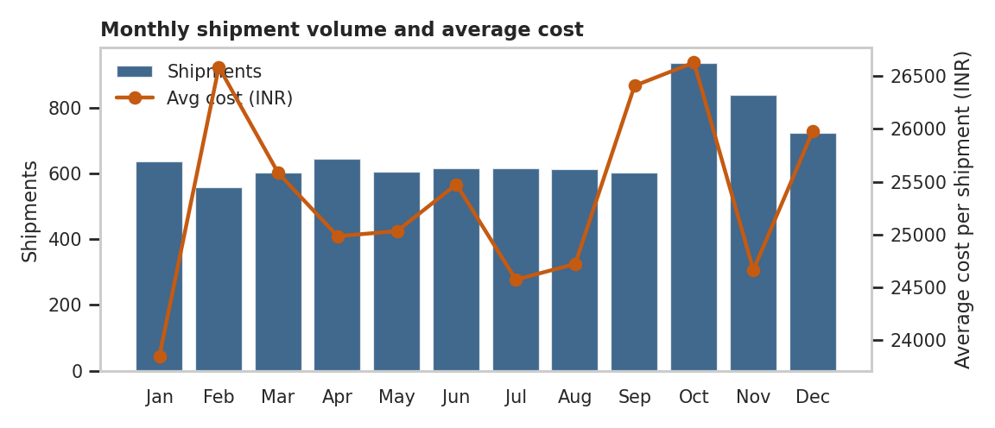
Figure 1. Monthly shipments (bars) and average cost per shipment (line)
Volume peaks in Oct with 936 shipments, against 559 in the quietest month, a difference of 67 %. October and November together account for 22.2 % of annual volume, compared with 16.7 % if volume were spread evenly across two months. Average cost per shipment rises from ₹23,848 in January to ₹25,978 in December (about 9 %). Note that the cost axis does not start at zero, so the line exaggerates the visual change. The practical message is that capacity must be planned for the autumn peak and cost budgets should allow for a rising trend.

5.2 Distributions of distance, weight and cost
Histograms show the full shape of a variable, not just its average. Log scales are used for weight and cost because both are right-skewed, which would otherwise compress most of the data into a narrow band.
fig, axes = plt.subplots(1, 3, figsize=(7.4, 2.7))
sns.histplot(df.distance_km, bins=40, ax=axes[0])
sns.histplot(df.weight_kg, bins=40, log_scale=True, ax=axes[1])
sns.histplot(df.cost_inr, bins=40, log_scale=True, ax=axes[2])

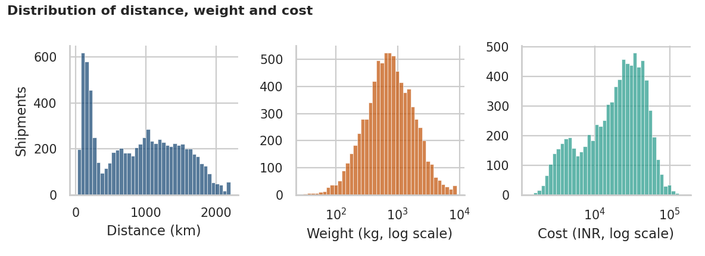
Figure 2. Distribution of distance, weight and cost
Distance has two clusters: a short-haul group under about 300 km (mostly the North zone) and a long-haul group between roughly 600 and 2,000 km. A single average distance would describe neither well, which argues for managing short-haul and long-haul operations separately. Weight is roughly bell-shaped on the log scale, with a long upper tail of heavy consignments. Cost shows a small left shoulder from low-cost van trips and a main body of truck shipments.

5.3 Delivery delay by destination zone
A bar chart of delay values shows how much service falls short of the plan, and box plots compare the spread of delay across zones. Box plots are chosen over averages alone because they show the median, the range and extreme cases together.
vc = df.delay_days.value_counts(normalize=True).sort_index() * 100
axes[0].bar(vc.index, vc.values) # delay distribution
order = df.groupby("dest_zone").delay_days.mean().sort_values().index
sns.boxplot(data=df, x="dest_zone", y="delay_days", order=order, ax=axes[1])

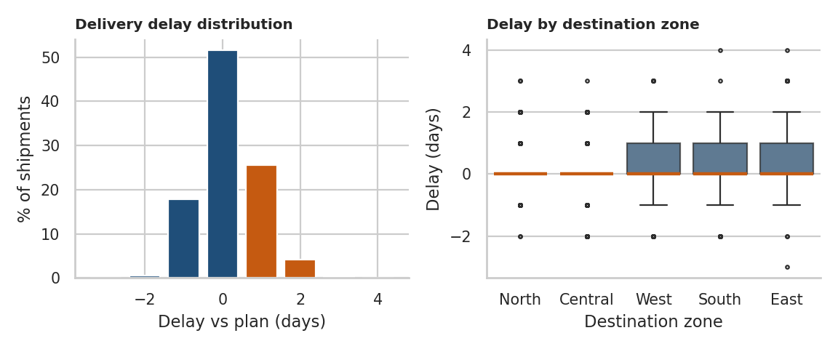
Figure 3. Distribution of delay against plan (left) and delay by destination zone (right)
Most shipments arrive exactly on plan, and when they are late it is usually by one day. The zones differ clearly: average delay is 0.45 days in the East and 0.4 days in the South, against -0.07 days in the North. Long-haul zones carry more delay, which is consistent with the positive distance–delay correlation.

5.4 Correlation heatmap
A heatmap is the standard way to scan many pairwise relationships at once. A diverging colour scale centred on zero makes strong positive and negative values stand out, and annotating the cells keeps the exact values readable.
corr = df[cols].corr(method="spearman")
sns.heatmap(corr, annot=True, fmt=".2f", cmap="RdBu_r", center=0, vmin=-1, vmax=1)

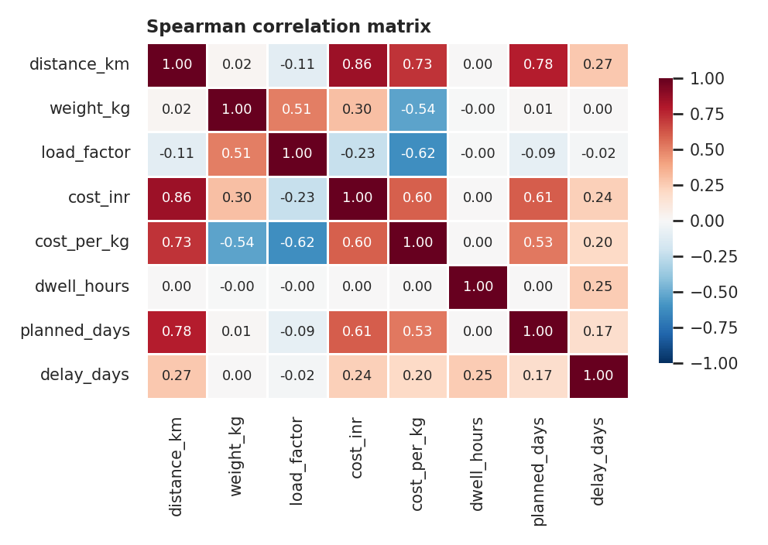
Figure 4. Spearman correlation matrix of the main numeric variables
The strongest signals are distance with cost (0.86), and load factor with cost per kilogram (-0.62). Dwell time relates to delay (0.25) but not to cost. Planned days follow distance closely, which is expected, because the delivery promise is built from distance.

5.5 Relationship: distance, cost and vehicle type
A scatter plot is the natural choice for the relationship between two numeric variables. Log-log axes are used because both variables are skewed, which turns a curved relationship into a near-straight band, and colour shows whether vehicle type changes the pattern.
sns.scatterplot(data=df.sample(3000), x="distance_km", y="cost_inr",
hue="vehicle_type", alpha=0.45, s=14)
ax.set_xscale("log"); ax.set_yscale("log")

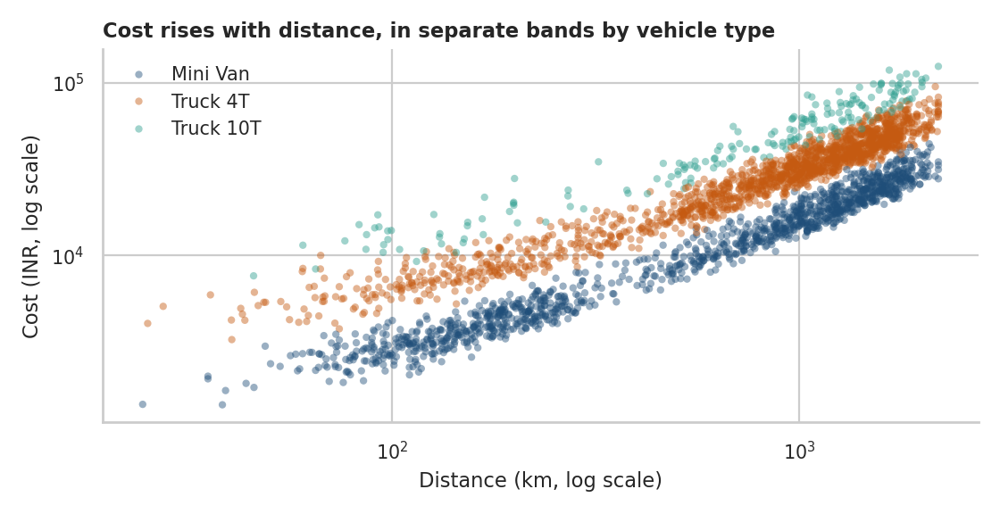
Figure 5. Cost against distance for a 3,000-shipment sample, coloured by vehicle type
Cost rises steadily with distance, but the data splits into parallel bands by vehicle type. At the same distance, a Truck 4T costs clearly more than a Mini Van, and a Truck 10T more again. The size of the vehicle therefore shifts the whole cost level, and this is tested formally in Section 6.1.

5.6 Vehicle utilisation and cost per kilogram
Load factor is continuous, so it is grouped into bands and shown as a bar chart of median cost per kilogram. Medians are used instead of means because cost per kilogram is highly skewed. Sample sizes are printed on each bar so that no band is read without knowing how much data supports it.
bins = [0, 0.2, 0.4, 0.6, 0.8, 1.01]
df["lf_bin"] = pd.cut(df.load_factor, bins, labels=labels, right=False)
g = df.groupby("lf_bin", observed=True).agg(med=("cost_per_kg", "median"))
ax.bar(g.index.astype(str), g.med)

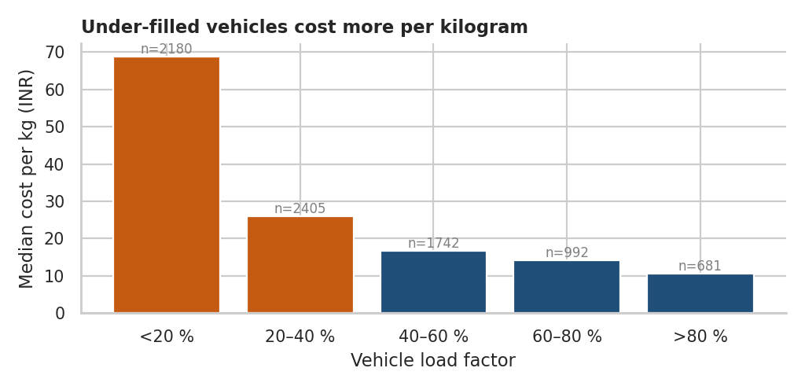
Figure 6. Median cost per kilogram by vehicle load factor
Load-factor band | Median cost per kg (INR) | Shipments
<20 % | 68.9 | 2,180
20–40 % | 25.9 | 2,405
40–60 % | 16.8 | 1,742
60–80 % | 14.2 | 992
>80 % | 10.7 | 681

Cost per kilogram falls from ₹68.9 for vehicles under 20 % full to ₹10.7 for those above 80 % full, a 6.4-fold difference. 57.3 % of all shipments travel below 40 % load. This is the single largest efficiency gap in the dataset, since the money is spent moving empty space.

5.7 Bottleneck analysis: dispatch hour
Two panels show the same story from cause to effect. A bar chart of mean dwell time by hour identifies where the queue forms, and a line chart of late rate by hour, split into peak season and other months, shows whether that queue turns into late deliveries.
g = df.groupby("dispatch_hour").agg(dwell=("dwell_hours", "mean"), late=("is_late", "mean"))
axes[0].bar(g.index, g.dwell, color=[ORANGE if 15 <= h <= 19 else NAVY for h in g.index])
fest = df.month.isin([10, 11])
for lab, mask in [("Oct–Nov", fest), ("Other months", ~fest)]:
axes[1].plot(*late_by_hour(df[mask]), label=lab)

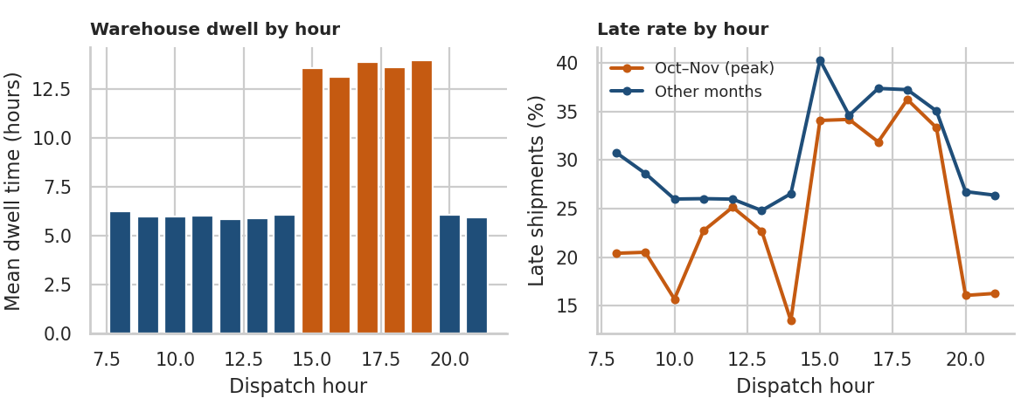
Figure 7. Mean dwell time (left) and late rate (right) by dispatch hour
Dispatch hours | Mean dwell (hours) | Late shipments (%) | Shipments
08–11 | 6 | 25.4 | 1,708
12–15 | 8.1 | 28.5 | 3,066
16–19 | 13.6 | 35.6 | 2,755
20–21 | 6 | 24.4 | 471

Dwell time jumps to 13.6 hours for shipments dispatched between 15:00 and 19:59, compared with 6 hours at other times. The difference is statistically significant (Mann–Whitney U, p < 0.001). Because 45.1 % of shipments leave in this window, it is both the busiest and the slowest period, which is the signature of a loading or dispatch bottleneck. During the October–November peak, shipments in this window are late 33.9 % of the time against 19.5 % at other hours.

5.8 Carrier and zone performance
A heatmap works well for two categorical dimensions at once. Colour intensity shows the late rate, so a weak combination stands out immediately, which would be hard to see in a long table.
pv = df.pivot_table(index="carrier", columns="dest_zone", values="is_late", aggfunc="mean") * 100
sns.heatmap(pv[["North", "Central", "West", "East", "South"]],
annot=True, fmt=".0f", cmap="Oranges")

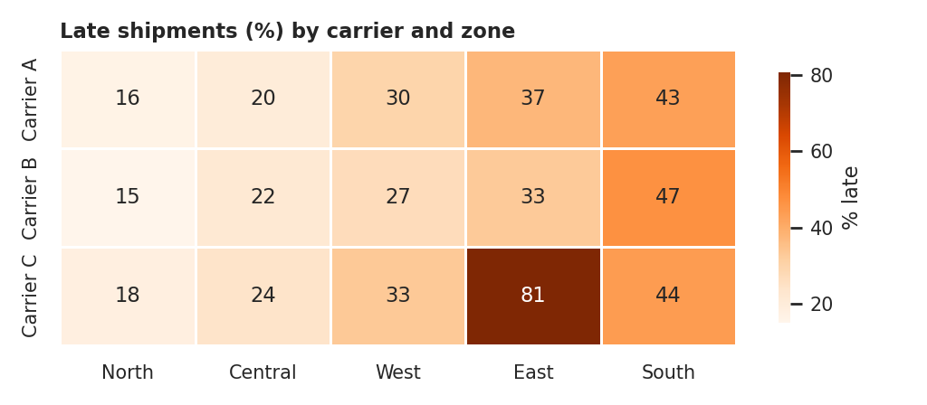
Figure 8. Late shipments (%) by carrier and destination zone
Carrier C delivers late 80.8 % of the time on the East lane (255 shipments), against 35.3 % for the other carriers in the same zone. Across all zones, Carrier C's late rate is 37 % compared with 28.6 % and 27.8 % for Carriers A and B, but almost all of that gap comes from the East lane. Carrier C performs in line with the others elsewhere, which shows that a carrier-level average would hide the real problem. The South zone is weaker for every carrier, which points to route length rather than carrier quality.

5.9 Seasonality in delivery performance
A line chart is the right tool for a trend over time. A shaded band marks the monsoon months so the reader can link the movement to a known cause without extra annotation.
g = df.groupby("month").is_late.mean() * 100
ax.axvspan(6.5, 9.5, alpha=0.12, label="Monsoon (Jul–Sep)")
ax.plot(g.index, g.values, marker="o")

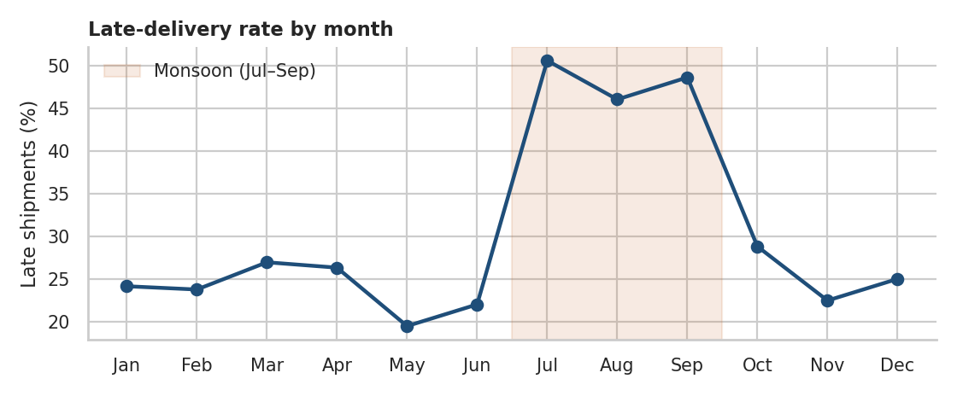
Figure 9. Share of late deliveries by month, with the monsoon period shaded
The late rate roughly doubles during the monsoon, at 48.5 % against 24.6 % in the other months. October and November, despite the highest volume, show a late rate of 25.8 %, close to the baseline. In this dataset, weather is a stronger driver of lateness than volume, while volume mainly drives cost and capacity needs.

6. Analytical Insights

6.1 What drives cost?
The visual evidence points to distance and vehicle size. To separate their effects, a regression was fitted on the logarithm of cost. Working in logs means coefficients can be read as percentage effects, and it reduces the influence of skew.
X = pd.DataFrame({"log_distance": np.log(df.distance_km), "log_weight": np.log(df.weight_kg),
"express": (df.ship_mode == "Express").astype(int),
"truck_4T": (df.vehicle_type == "Truck 4T").astype(int),
"truck_10T": (df.vehicle_type == "Truck 10T").astype(int),
"carrier_B": (df.carrier == "Carrier B").astype(int),
"carrier_C": (df.carrier == "Carrier C").astype(int)})
model = LinearRegression().fit(X, np.log(df.cost_inr))

Driver | Coefficient | Effect on cost
Distance (elasticity) | 0.760 | 10 % increase ≈ 7.6 % change in cost
Weight (elasticity) | 0.053 | 10 % increase ≈ 0.5 % change in cost
Express vs Standard | 0.227 | +25.5 %
Truck 4T vs Mini Van | 0.653 | +92.1 %
Truck 10T vs Mini Van | 1.155 | +217.3 %
Carrier B vs A | -0.063 | -6.1 %
Carrier C vs A | 0.056 | +5.7 %

The model explains 98.2 % of the variation in log cost. At the same distance and weight, a Truck 4T costs about 92.1 % more than a Mini Van and a Truck 10T about 217.3 % more. Express service adds about 25.5 %. Carrier differences are small, at roughly 6 % either way. The distance elasticity of 0.76 means that a 10 % longer route raises cost by about 7.6 %, which is less than proportional because each trip has a fixed charge. The weight coefficient is close to zero once vehicle type is included, because the vehicle already captures the size of the load. Cost is therefore driven mainly by which vehicle is used and how far it travels, and much less by how much it carries. This is why under-filled vehicles are so expensive per kilogram.
Vehicle type and weight are related, so these coefficients describe association, not a guaranteed saving from switching vehicles. The next section tests this with a conservative scenario.

6.2 Where are the bottlenecks?
Three separate causes of late delivery appear. The first is internal: the late-afternoon dispatch queue. The second is a specific lane: Carrier C to the East. The third is external: monsoon weather. These have different owners and different fixes, which is why each was isolated before drawing conclusions.

6.3 Summary of insights
Theme | Finding | Evidence | Suggested action
Cost driver | Vehicle choice and distance dominate cost | Truck 4T +92.1 % vs van at equal distance and weight; R² = 0.982 | Right-size vehicles
Efficiency | Most vehicles run under-filled | 57.3 % of shipments below 40 % load; cost per kg 6.4× higher below 20 % | Consolidate loads
Bottleneck | Evening dispatch queue | Dwell 13.6 h vs 6 h for the 15:00–19:59 window | Stagger dispatch
Carrier risk | Carrier C on the East lane | 80.8 % late vs 35.3 % for other carriers in the East | Reallocate or penalise
Seasonality | Monsoon delays | 48.5 % late in Jul–Sep vs 24.6 % otherwise | Add delivery buffers
Demand peak | Oct–Nov volume surge | October has 67 % more shipments than the quietest month | Book capacity early

7. Recommendations
- 1. Right-size vehicles. 1,825 shipments (22.8 % of the total) weighed 1,000 kg or less yet travelled in a truck. If the regression effect is taken at face value, moving them to mini vans would cut about 14.3 % of total transport spend. This is an illustrative estimate that ignores route and van-availability limits, and it should be validated with a pilot on a few lanes.
- 2. Consolidate loads. With 57.3 % of shipments below 40 % load, set a minimum load target for non-urgent orders and combine orders going to the same zone before dispatch.
- 3. Stagger the dispatch window. Spread the 15:00–19:59 batch across the day, add loading capacity or a second shift in that window, and track dwell time against a target below 8 hours.
- 4. Act on the Carrier C–East lane. Review service with the carrier, reallocate East volume to Carriers A or B, or add a lane-level penalty clause, because the problem is concentrated and measurable.
- 5. Add monsoon buffers. Extend the promised delivery time by a day on long-haul routes from July to September, or position stock closer to customers before the rains.
- 6. Prepare for the October peak. Secure carrier capacity and temporary warehouse labour before October, when volume runs well above the quietest months.
Progress should be tracked with the KPIs from Week 1: OTIF, cost per shipment, cost per kilogram, load factor and dwell time, reviewed monthly by lane and carrier.

8. Limitations
- Simulated data: relationships were built in, so the analysis shows the method, not the behaviour of a real network. On real data, effects would be noisier and some would not appear.
- Association, not causation: correlations and regression coefficients describe patterns. Interventions such as changing vehicles should be tested in pilots.
- Single warehouse and one year: the data covers one origin and one year, so multi-year trends, multi-warehouse effects and unusual events are not represented.
- Missing costs: the cost of late delivery (penalties, lost customers) and carbon emissions are not modelled, so the estimated benefits are partial.

9. Conclusion
The exploration shows that a handful of clear, measurable factors account for most of the cost and service problems in the simulated network. Cost is driven by vehicle choice and distance, and wasted by under-filled vehicles. Delivery performance is damaged by an evening dispatch queue, one weak carrier lane and the monsoon. Each finding was supported by both a visual and a number, and each leads to a specific action. The same workflow of describing, visualising, comparing and modelling can be applied to real shipment data to prioritise where operational effort will have the greatest effect.

References
- Hunter, J. D. (2007). Matplotlib: A 2D graphics environment. Computing in Science & Engineering, 9(3).
- Waskom, M. L. (2021). seaborn: statistical data visualization. Journal of Open Source Software, 6(60).
- McKinney, W. Python for Data Analysis. O’Reilly Media.
- Tukey, J. W. (1977). Exploratory Data Analysis. Addison-Wesley.
- Tufte, E. R. The Visual Display of Quantitative Information. Graphics Press.
- Pedregosa, F. et al. (2011). Scikit-learn: Machine Learning in Python. Journal of Machine Learning Research, 12.
- Chopra, S. & Meindl, P. Supply Chain Management: Strategy, Planning, and Operation. Pearson.

