WEEK 4 REPORT
Predictive Modeling and Optimization in Logistics Systems
Forecasting delivery delay and using the predictions to optimise carriers, dispatch and routes
Prepared by: Ansh Maheshwari
Date: October 2026
Tools: Python 3, pandas, scikit-learn, SciPy, Google OR-Tools, matplotlib, seaborn

1. Introduction
The earlier weeks planned the project, cleaned the data and explored it. Week 3 showed that deliveries run late for identifiable reasons: warehouse queues, one weak carrier lane and the monsoon. This report moves from describing the past to predicting the future and acting on it. A model is built to forecast how late each shipment is likely to be, and its output is then used to drive three optimisation methods.
The report follows the project flow: problem definition and data (Section 2), model selection (Section 3), evaluation and validation (Section 4), optimisation strategies (Section 5), recommendations (Section 6) and limitations (Section 7).

2. Problem Definition and Data

2.1 The prediction problem
The question is: at the moment a shipment leaves the warehouse, how many days late is it likely to be? The target variable is delay_days, defined as actual transit days minus planned days. A value of 0 means on time, +1 means one day late, and a negative value means early.
This problem matters because the answer changes decisions. If a shipment is likely to be late, the company can warn the customer, upgrade the service, assign a different carrier or prioritise it in the dispatch queue. Averages over a month cannot support those shipment-level decisions.

2.2 Dataset
The dataset is the simulated shipment table from Week 3: 8,000 shipments from a Delhi NCR warehouse during 2025. It is simulated, so the results demonstrate the method and are not findings about a real company. The mean delay is 0.197 days with a standard deviation of 0.809 days in the training period.
Feature | Type | Why it is included
distance_km | numeric | Longer routes have more opportunities for delay
weight_kg, load_factor | numeric | Shipment size and how full the vehicle is
dwell_hours | numeric | Time spent waiting in the warehouse before leaving; known at the moment of dispatch
dispatch_hour | numeric | Time of day the shipment leaves
planned_days | numeric | The promise made to the customer, which already reflects distance and ship mode
monsoon | binary | 1 for July–September; a known seasonal weather risk
dest_zone, carrier | categorical | Lane and carrier effects (one-hot encoded)
vehicle_type, ship_mode | categorical | Vehicle size and Standard or Express service

Only information available at dispatch time is used. The outcome itself (actual_days) and anything calculated from it are excluded, because using them would leak the answer into the model and give unrealistically good results. The raw month number is also excluded: the model is trained on January to September and tested on October to December, so a month value above 9 would be unseen and would be treated as September, which sits inside the monsoon period. The monsoon flag carries the useful seasonal information safely.

2.3 Training and test split
Data is split by time, not at random. The first nine months (5,501 shipments) train the model, and the last three months (2,499 shipments) test it. This mirrors real use, where a model trained on the past must predict an unseen future, and a random split would let the model learn from shipments that happened after the ones it is tested on.
df = pd.read_csv("logistics_shipments_simulated.csv", parse_dates=["order_date"]).sort_values("order_date")
df["monsoon"] = df.month.isin([7, 8, 9]).astype(int)

train = df[df.order_date < "2025-10-01"] # Jan–Sep
test = df[df.order_date >= "2025-10-01"] # Oct–Dec, never used for fitting or tuning

NUM = ["distance_km", "weight_kg", "load_factor", "dwell_hours", "dispatch_hour", "planned_days", "monsoon"]
CAT = ["dest_zone", "carrier", "vehicle_type", "ship_mode"]
pre = ColumnTransformer([("num", "passthrough", NUM),
("cat", OneHotEncoder(handle_unknown="ignore"), CAT)])

3. Model Selection and Implementation
Five approaches were compared, from the simplest to the most flexible. Starting with a baseline and a simple model is good practice: a complex model is only worth using if it clearly beats a simple one.
Model | Role | Rationale
Mean baseline | Reference point | Predicts the average delay for everything; any useful model must beat it
Linear regression | Simple, interpretable | Fast and transparent, but assumes each factor acts independently and in a straight line
Decision tree | Non-linear, readable rules | Captures interactions such as a carrier being weak on one lane; unstable on its own
Random forest | Ensemble of trees | Averages many trees to reduce variance; handles mixed feature types
Gradient boosting | Ensemble, sequential | Builds trees that correct earlier errors; usually the strongest on tabular data

Tree-based models suit this problem because delay depends on interactions that a straight-line model cannot express. For example, Carrier C is slow only on the East lane, and the effect of distance depends on the ship mode. Preprocessing is wrapped in a scikit-learn pipeline together with each model, so the same transformations are applied to training and test data and no information leaks between them.
models = {
"Mean baseline": Pipeline([("pre", pre), ("m", DummyRegressor())]),
"Linear regression": Pipeline([("pre", pre_scaled), ("m", LinearRegression())]),
"Decision tree": Pipeline([("pre", pre), ("m", DecisionTreeRegressor(max_depth=6, min_samples_leaf=30))]),
"Random forest": Pipeline([("pre", pre), ("m", RandomForestRegressor(n_estimators=200, min_samples_leaf=10))]),
"Gradient boosting": Pipeline([("pre", pre), ("m", GradientBoostingRegressor(random_state=42))]),
}
for name, pipe in models.items():
pipe.fit(train[NUM + CAT], train.delay_days)
pred = pipe.predict(test[NUM + CAT])

4. Evaluation and Validation

4.1 Metrics
- MAE (mean absolute error): the average size of the prediction error in days. It is easy to explain and not dominated by a few large misses.
- RMSE (root mean squared error): like MAE but it penalises large errors more heavily, so it shows whether the model makes occasional big mistakes.
- R²: the share of the variation in delay that the model explains. A value of 0 means no better than predicting the average.
- ROC-AUC, precision, recall and lift: used for the late-risk classifier in Section 4.5, where the decision is binary (late or not).

4.2 Cross-validation and tuning
Ordinary k-fold cross-validation shuffles the data, which lets the model train on later shipments and be scored on earlier ones. Time-series cross-validation avoids this: each fold trains on an earlier period and validates on the period that follows. Five such folds were used on the training months.
Hyper-parameters of the gradient boosting model were tuned by randomised search, which tries a set of random combinations from a defined grid and keeps the best by cross-validated MAE. Thirty combinations were tried.
tscv = TimeSeriesSplit(n_splits=5) # folds validate on later periods
grid = {"m__n_estimators": [100, 200, 300], "m__max_depth": [2, 3, 4],
"m__learning_rate": [0.03, 0.05, 0.1], "m__subsample": [0.7, 0.85, 1.0],
"m__min_samples_leaf": [1, 10, 30, 60]}
search = RandomizedSearchCV(gb_pipe, grid, n_iter=30, cv=tscv,
scoring="neg_mean_absolute_error", random_state=42)
search.fit(train[NUM + CAT], train.delay_days)

Hyper-parameter | Values searched | Selected by search
n_estimators | 100, 200, 300 | 300
max_depth | 2, 3, 4 | 4
learning_rate | 0.03, 0.05, 0.1 | 0.03
subsample | 0.7, 0.85, 1.0 | 0.7
min_samples_leaf | 1, 10, 30, 60 | 1

4.3 Results
Model | CV MAE (± sd) | Test MAE | Test RMSE | Test R²
Mean baseline | 0.580 ± 0.075 | 0.596 | 0.765 | -0.028
Linear regression | 0.546 ± 0.026 | 0.536 | 0.682 | 0.185
Decision tree | 0.575 ± 0.069 | 0.531 | 0.684 | 0.180
Random forest | 0.563 ± 0.070 | 0.528 | 0.678 | 0.194
Gradient boosting | 0.544 ± 0.034 | 0.522 | 0.668 | 0.217
Gradient boosting (tuned) | 0.547 ± 0.038 | 0.526 | 0.673 | 0.206

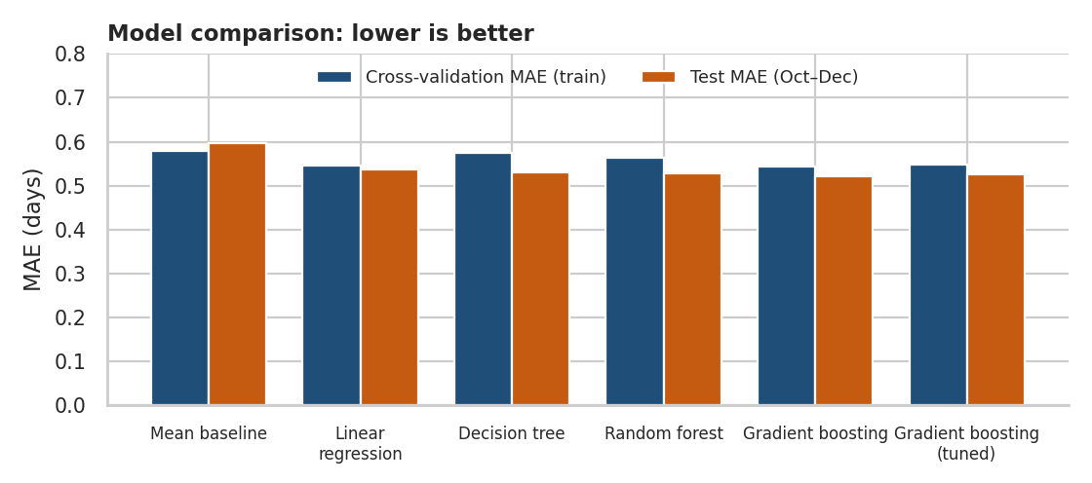
Figure 1. Cross-validation MAE (training months) and test MAE (October–December) for each model
Every model beats the baseline, but the gains are moderate. The selected gradient boosting model reduces test MAE from 0.596 to 0.522 days (12 % lower) and RMSE from 0.765 to 0.668 (13 % lower), and explains 21.7 % of the variation in delay (R² = 0.217). Linear regression is close behind (R² = 0.185), which shows that most of the predictable signal is simple. The ensemble models add value by capturing lane-specific effects.
The tuning result is worth stating plainly. The tuned model (CV MAE 0.547) did not improve on the default settings (CV MAE 0.544), and the difference is well inside the fold-to-fold variation of about ±0.04 days. The final model was therefore chosen by cross-validation error, and the default gradient boosting configuration was kept. The test set was used once, for the final report, and played no part in the choice.
A model that explains about 22 % of the variation may look weak. Individual delays contain random elements that no dispatch-time feature can capture, such as traffic on the day and handling errors. The remaining error (a residual spread of 0.668 days) most likely reflects this random variation. The value of the model is in ranking shipments by risk and in quantifying drivers, which the next sections show.

4.4 Diagnostics and feature importance
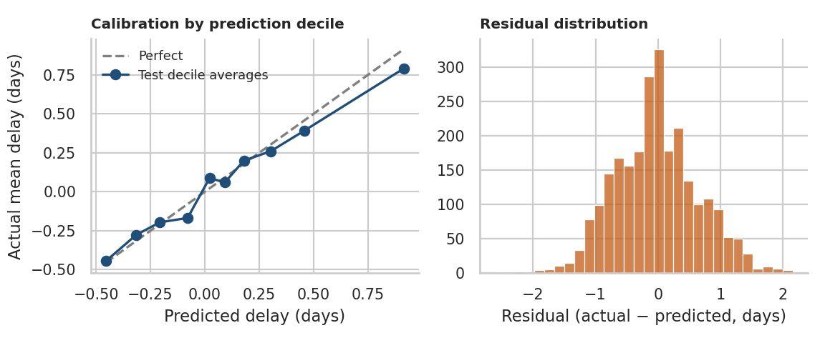
Figure 2. Predicted versus actual delay by prediction decile (left) and residual distribution (right)
Calibration is good. When test shipments are grouped into ten bands by predicted delay, the actual average delay follows the diagonal closely, from -0.44 days in the lowest band to 0.79 days in the highest. Residuals are centred near zero (mean -0.021 days) and roughly symmetric, so the model is not systematically over- or under-predicting.
Permutation importance measures how much the test error rises when one feature is randomly shuffled. A large rise means the model relies on that feature.
pi = permutation_importance(best_model, test[NUM + CAT], test.delay_days, n_repeats=10,
scoring="neg_mean_absolute_error", random_state=42)
imp = pd.Series(pi.importances_mean, index=NUM + CAT).sort_values()

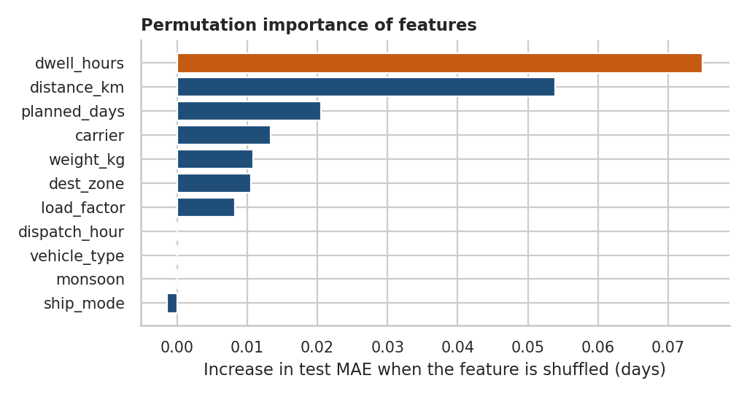
Figure 3. Permutation importance of each feature on the test period
Feature | Importance (MAE increase, days) | Reading
dwell_hours | 0.075 | Largest driver of delay
distance_km | 0.054 | Second driver: longer routes
planned_days | 0.021 | Proxy for distance and mode
carrier | 0.013 | Smaller, lane-specific effect
weight_kg | 0.011 | Smaller, lane-specific effect
dest_zone | 0.011 | Smaller, lane-specific effect

Warehouse dwell time is the strongest predictor of delay, ahead of distance. This agrees with the Week 3 bottleneck analysis and confirms that waiting before dispatch is a controllable cause of lateness. Carrier and zone matter less overall because the weak lane covers only a small share of shipments, but they matter a great deal within that lane. Several features (dispatch hour, vehicle type, monsoon) show no importance on their own, because their effects are already carried by dwell time and distance. Importance shows how much the model uses a feature, and it does not prove cause.

4.5 Late-risk classifier
Operations usually act on a yes/no question: will this shipment be late? A second model predicts the probability that delay is greater than zero. Gradient boosting was compared with logistic regression.
gbc = GradientBoostingClassifier(n_estimators=200, max_depth=3,
learning_rate=0.05, subsample=0.85)
clf = Pipeline([("pre", pre), ("m", gbc)])
clf.fit(train[NUM + CAT], train.is_late)
p = clf.predict_proba(test[NUM + CAT])[:, 1]
auc = roc_auc_score(test.is_late, p)
flag = p >= np.quantile(p, 0.80) # the riskiest 20 % of shipments

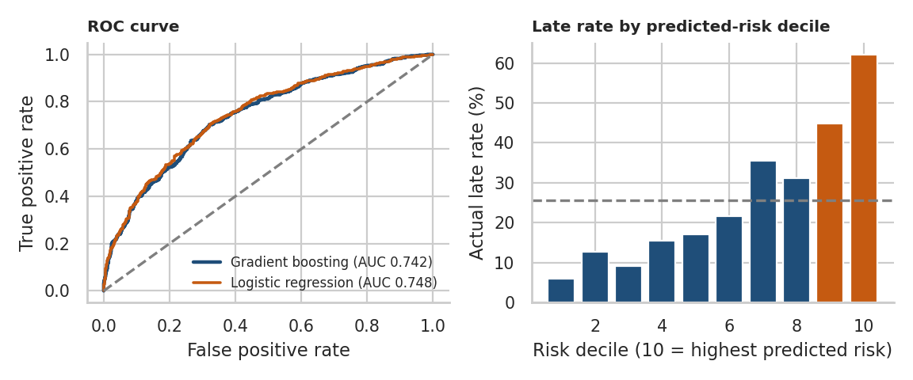
Figure 4. ROC curve (left) and actual late rate by predicted-risk decile (right)
Measure | Gradient boosting | Logistic regression
ROC-AUC on the test period | 0.742 | 0.748
Actual late rate in test period | 25.6 % | –
Late rate among the riskiest 20 % (flagged) | 53.4 % | –
Share of all late shipments caught by the flag | 41.7 % | –
Lift over the average late rate | 2.09× | –

Both models reach an AUC of about 0.75, meaning the model ranks a late shipment above an on-time one roughly three times out of four. Ranking is clearly useful: the actual late rate rises from 6 % in the lowest-risk decile to 62 % in the highest, against an overall rate of 25.6 %. If the riskiest 20 % of shipments are flagged, 53.4 % of them are late, which is 2.09 times the average, and the flag captures 41.7 % of all late shipments. Logistic regression scores marginally higher on AUC, but it cannot represent the carrier-by-lane interaction, so gradient boosting is used in the optimisation work where carrier choice is tested.

5. Optimization Strategies
The predictions are not the end goal. They are inputs to decisions. Three optimisation methods use model output, and each is explained with its assumptions. All savings estimates are illustrative because they rest on simulated data and stated assumptions.

5.1 Carrier allocation (linear programming)
Problem: how should each zone's shipments be divided among the three carriers to minimise cost plus the cost of lateness? For each carrier and zone, the expected cost comes from a log-cost regression and the expected late probability comes from the classifier, which is asked what would happen if the same shipments went with a different carrier.
Formulation: minimise the sum over zones z and carriers c of x(z,c) × [cost(z,c) + P × late_probability(z,c)], where x is the number of shipments assigned and P is the penalty for a late delivery, assumed here to be ₹2,000. Each zone's demand must be met exactly. To avoid dependence on a single carrier, every carrier must keep at least 15 % of total volume and none may exceed 55.00000000000001 %.
unit = cost + penalty * p_late # expected cost per shipment
A_eq = zone_demand_constraints # every shipment is assigned
A_ub = carrier_share_constraints # 15 % <= share <= 55 %
res = linprog(unit.ravel(), A_ub=A_ub, b_ub=b_ub, A_eq=A_eq, b_eq=demand,
bounds=(0, None), method="highs")
allocation = res.x.reshape(5, 3)

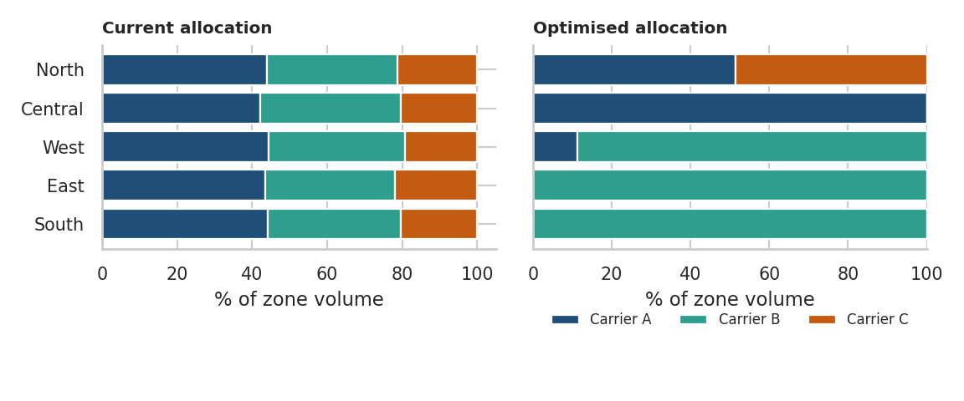
Figure 5. Share of each zone's volume by carrier, current versus optimised
Measure (8,000 shipments) | Current mix | Optimised | Change
Expected transport cost (₹ million) | 206.12 | 198.47 | -3.7 %
Expected late shipments | 2,127 | 1,999 | -6 %
Expected late rate | 26.6 % | 25 % | -1.6 pts
Cost + late-penalty objective | – | – | −3.8 %
Carrier A / B / C share of volume | 43.8 / 35.5 / 20.7 % | 30 / 55 / 15 % | –

Zone | Carrier A | Carrier B | Carrier C
North | 44 → 51 % | 35 → 0 % | 21 → 49 %
Central | 42 → 100 % | 37 → 0 % | 20 → 0 %
West | 44 → 11 % | 36 → 89 % | 19 → 0 %
East | 43 → 0 % | 35 → 100 % | 22 → 0 %
South | 44 → 0 % | 35 → 100 % | 20 → 0 %

The optimiser reduces expected transport cost by 3.7 % and expected late shipments by 6 %. The main reason is visible in the allocation: on the East lane the model predicts a late risk of 70.2 % for Carrier C against 31.3 % and 31.9 % for Carriers A and B, so East volume moves away from Carrier C. Carrier B is both cheaper and as reliable as Carrier A in this data, so it is given the maximum permitted share. The share limits deliberately stop the solution from putting everything with one carrier, which would create a supply risk that the model cannot measure.
These unit costs and late probabilities come from the October–December test period and are scaled to 8,000 shipments, so the figures describe conditions outside the monsoon. The penalty of ₹2,000 is an assumption; a higher penalty would push more volume toward the most reliable carriers.

5.2 Dispatch scheduling (model-based what-if)
The model learned that long warehouse dwell increases lateness, and dwell is highest for shipments leaving between 15:00 and 19:59. A what-if analysis asks the trained model what would happen if that window ran as smoothly as the rest of the day, for example by staggering dispatch times or adding loading capacity. In the test data, dwell times in that window are multiplied by the ratio of the off-peak to peak average (0.44), and the late-risk classifier scores the shipments again.
ratio = df[~evening].dwell_hours.mean() / df[evening].dwell_hours.mean()
scenario = test.copy()
scenario.loc[evening_test, "dwell_hours"] *= ratio
p_before = clf.predict_proba(test[NUM + CAT])[:, 1]
p_after = clf.predict_proba(scenario[NUM + CAT])[:, 1]

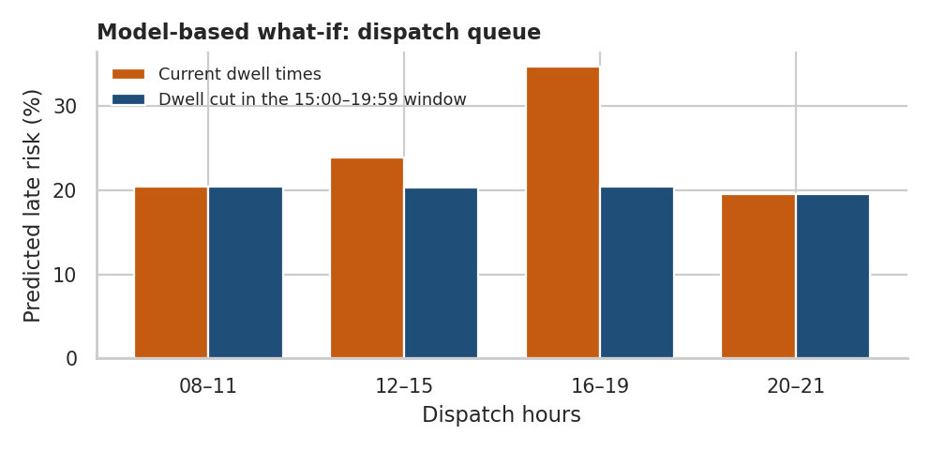
Figure 6. Predicted late risk by dispatch window under current and reduced dwell times
The window affects 44 % of shipments. Within it, predicted late risk falls from 34.6 % to 20.6 %, and across all shipments from 26.5 % to 20.4 %, which is about 62 fewer late shipments per 1,000. This is a best-case estimate: it assumes dwell can be brought all the way down to off-peak levels and that the relationship learned by the model is causal. A realistic target would capture part of this gain.

5.3 Load consolidation and route planning (capacitated VRP)
Week 3 showed that most vehicles run well below capacity. A capacitated vehicle routing problem (CVRP) was solved with Google OR-Tools for 24 North-zone deliveries in October, using real shipment weights (16,776 kg in total) and 4-tonne trucks. Each delivery's distance from the warehouse comes from the data, and the direction is simulated, because the dataset has no map coordinates. The solver minimises total distance plus a fixed charge per truck, subject to the capacity limit.
mgr = pywrapcp.RoutingIndexManager(n + 1, n_vehicles, 0) # 0 = depot
routing = pywrapcp.RoutingModel(mgr)
routing.SetArcCostEvaluatorOfAllVehicles(transit_cb)
routing.SetFixedCostOfAllVehicles(fixed_cost_in_distance_units)
routing.AddDimensionWithVehicleCapacity(demand_cb, 0, [4000] * n_vehicles, True, "Load")
params.local_search_metaheuristic = LocalSearchMetaheuristic.GUIDED_LOCAL_SEARCH
solution = routing.SolveWithParameters(params)

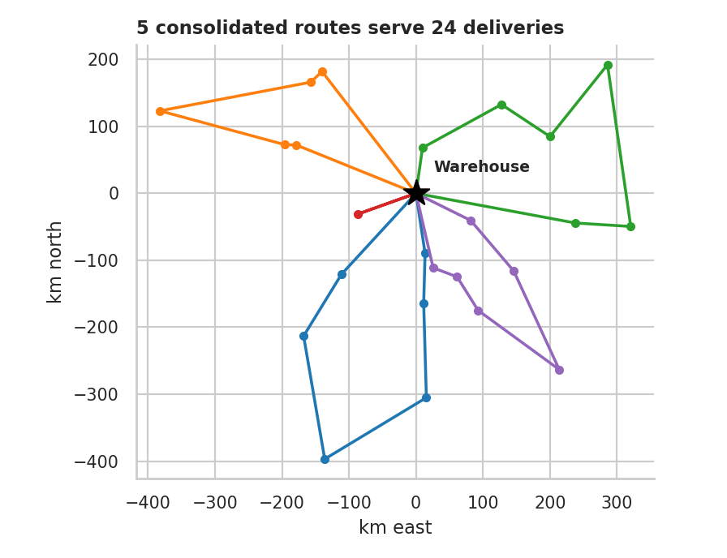
Figure 7. Consolidated delivery routes from the warehouse (simulated directions)
Measure (24 deliveries) | One truck each | Consolidated | Change
Trucks used | 24 | 5 | −19
Distance travelled (km) | 10,436 | 3,721 | −64.3 %
Average vehicle load | 17 % | 84 % | +67 pts
Estimated cost (₹) | 339,222 | 122,850 | −63.8 %

The 24 deliveries are served by 5 trucks instead of 24. Distance falls by 64.3 %, average load rises from 17 % to 84 %, and estimated cost falls by 63.8 %. This is an upper bound, since the comparison is against sending a separate truck to every customer. It also ignores delivery time windows and customer preferences, and consolidation may lengthen individual delivery times, which the late-risk model should be used to check. Even so, it shows how much capacity is currently wasted.

5.4 How the strategies fit together
Strategy | Model input | Method | Illustrative effect
Carrier allocation | Predicted late risk and expected cost by carrier and zone | Linear programme with share limits | Cost -3.7 %, late shipments -6 %
Dispatch scheduling | Dwell time effect learned by the model | Counterfactual what-if | 62 fewer late shipments per 1,000
Load consolidation | Shipment weights and distances | Capacitated vehicle routing | Distance −64.3 %, load 17 % → 84 %
Proactive alerts | Late-risk score per shipment | Threshold on top 20 % risk | 2.09× late rate in flagged group

The strategies address different parts of the system and reinforce each other. Consolidation raises load factor and cuts cost; the dispatch change reduces waiting; carrier allocation matches each lane to the most reliable partner; and the risk score tells staff which individual shipments need attention.

6. Recommendations
The steps below are ordered by expected benefit and ease of starting. Each is tied to a measurable indicator so progress can be checked.
Step | Action | Basis in this report | KPI to monitor
1 | Reduce evening dispatch dwell time | Largest driver of predicted delay; what-if scenario | Mean dwell by hour; late rate
2 | Shift East lane volume away from Carrier C | Predicted late risk on that lane about twice other carriers | Lane late rate; cost per shipment
3 | Introduce late-risk alerts for the top 20 % of shipments | Model lift and recall | Share of late shipments intercepted
4 | Pilot load consolidation on one zone | Routing results | Load factor; cost per kg
5 | Retrain and monitor the model monthly | Seasonal shifts and drift | MAE, AUC, calibration

- Start with dispatch dwell time. It is the model's strongest predictor and is under the company's own control, with no contract changes needed.
- Use the risk score as an early warning. Flagging the top 20 % of shipments catches about two in five late deliveries with twice the average hit rate, which is enough to justify proactive customer messages or expediting.
- Treat the carrier result as a lead for investigation. The model points to the East lane, and the next step is to confirm the cause with Carrier C before moving volume.
- Maintain the model. Retrain monthly, track MAE and AUC on new data, and watch for drift when conditions such as monsoon or festive peaks change the pattern of delays.

7. Limitations
- Simulated data: relationships were built into the data, so the model recovers known effects. Real data would be noisier, and some effects would not appear.
- Modest explanatory power: R² of about 0.2 means individual delays remain uncertain. The model is best used for ranking and for quantifying drivers.
- Association versus cause: the what-if and allocation analyses treat the model's learned effects as causal. They should be tested in controlled pilots.
- Assumed costs: the late penalty, the share limits and the routing cost parameters are assumptions, and the results move with them.
- Limited validation period: the test period (October–December) contains no monsoon months, so seasonal performance is untested.

8. Conclusion
A gradient boosting model trained on dispatch-time information predicts delivery delay with 12 % lower error than a naive baseline, and a companion classifier ranks shipments by lateness risk well enough to flag a high-risk group at about twice the average late rate. The model identifies warehouse dwell time and distance as the main drivers, and its output supports three optimisation strategies: reallocating carriers with a linear programme, cutting dispatch dwell time, and consolidating loads with a routing solver. Each strategy produced an improvement in the simulation, and each rests on assumptions stated in the report. The workflow of predicting, validating honestly and then optimising can be applied to real shipment data to direct operational effort where it will have the greatest effect.

References
- Hastie, T., Tibshirani, R. & Friedman, J. The Elements of Statistical Learning. Springer.
- Friedman, J. H. (2001). Greedy function approximation: a gradient boosting machine. Annals of Statistics, 29(5).
- Breiman, L. (2001). Random forests. Machine Learning, 45(1).
- Bergstra, J. & Bengio, Y. (2012). Random search for hyper-parameter optimization. Journal of Machine Learning Research, 13.
- Hyndman, R. J. & Athanasopoulos, G. Forecasting: Principles and Practice (online textbook, OTexts).
- Pedregosa, F. et al. (2011). Scikit-learn: Machine Learning in Python. Journal of Machine Learning Research, 12.
- Dantzig, G. B. & Ramser, J. H. (1959). The truck dispatching problem. Management Science, 6(1).
- Google OR-Tools: Vehicle Routing documentation (developers.google.com/optimization/routing).
- Virtanen, P. et al. (2020). SciPy 1.0: fundamental algorithms for scientific computing in Python. Nature Methods, 17.

