Assignment 1 (Web Devlopment Basics)
(Ishendra Rai 32)

Ques . Explain the difference between frontend, backend, and full-stack development with
suitable real-world examples.
Ans :
Type | Description | Example
Frontend Development | It deals with the visual part of a website — everything users see and interact with directly in their browser. Built using HTML, CSS, and JavaScript. | When you visit Amazon, the product layout, buttons, and animations are all frontend.
Backend Development | It handles the server-side logic, databases, and APIs. It ensures data is stored, processed, and delivered to the frontend. Built using Node.js, Python (Django/Flask), PHP, Java, etc. | When you log in, your credentials are checked by the backend before granting access.
Full-Stack Development | A combination of both frontend and backend. Full-stack developers work on the entire web application — from UI design to database management. | A full-stack developer can create the entire website like Netflix — handling UI, data, and API integrations.

Ques 2. Create a simple diagram showing how the client-server model works in web architecture. 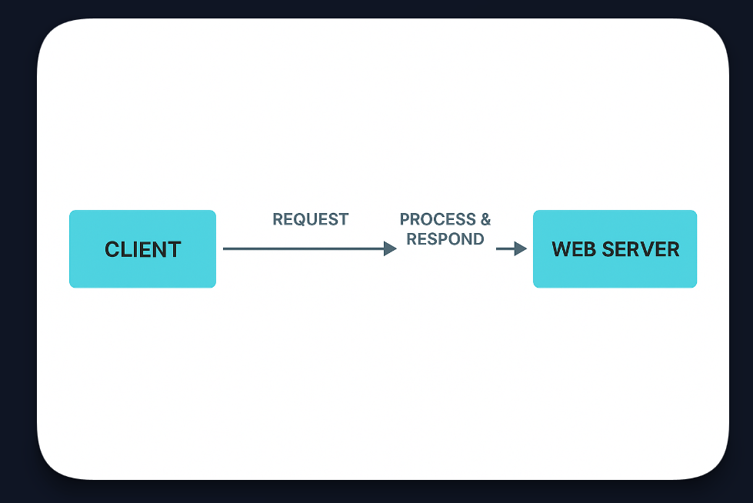
Ques 3. Describe how a browser requests and displays a web page from a web server.
Ans -
- User enters a URL (e.g., www.google.com) in the browser.
- The browser sends a request to the DNS server to get the IP address of the website.
- The browser sends an HTTP/HTTPS request to the web server using that IP.
- The web server processes the request and sends back the required HTML, CSS, JS files.
- The browser renders these files — displaying the text, images, styles, and scripts.
- Any additional API calls (like fetching user data) are made dynamically after the page loads.
Ques. 4 Identify and list the tools required to set up a web development environment. Explain the
purpose of each.
Ans -
Tool | Purpose
Visual Studio Code (VS Code) | Code editor for HTML, CSS, JS, and frameworks.
Web Browsers (Chrome, Edge, Firefox) | To preview and test web applications.
Node.js & npm | For running JavaScript on the server and managing packages.
Git & GitHub | For version control and collaboration.
Live Server (VS Code Extension) | To auto-refresh browser while editing code.
Postman | To test backend APIs.

Ques 5. Explain what a web server is and give examples of commonly used servers.
Ans - A web server is software or hardware that stores, processes, and delivers web pages to users upon request. It uses HTTP/HTTPS protocols.
Examples:
- Apache HTTP Server
- Nginx
- Microsoft IIS
- LiteSpeed
- Node.js Express server

Ques 6. Define the roles of a frontend developer, backend developer, and database administrator
in a project.
Ans -
Role | Responsibilities
Frontend Developer | Designs the user interface, ensures responsiveness, and handles user interactions using HTML, CSS, and JS.
Backend Developer | Builds server logic, APIs, handles database communication, and ensures security.
Database Administrator (DBA) | Manages database structure, performance, backup, and access control.

Ques 7. Install VS Code and configure it for HTML, CSS, and JavaScript development. Take a
screenshot of the setup.
Ans - Steps:
- Install VS Code from https://code.visualstudio.com
- Install extensions:
  - Live Server
  - Prettier – Code Formatter
  - HTML CSS Support
  - JavaScript (ES6) Code Snippets
- Create files:
  - index.html
  - style.css
  - script.js
📸 Take a Screenshot showing:
- VS Code with your files open (index.html, style.css, script.js)
- Extensions sidebar visible.
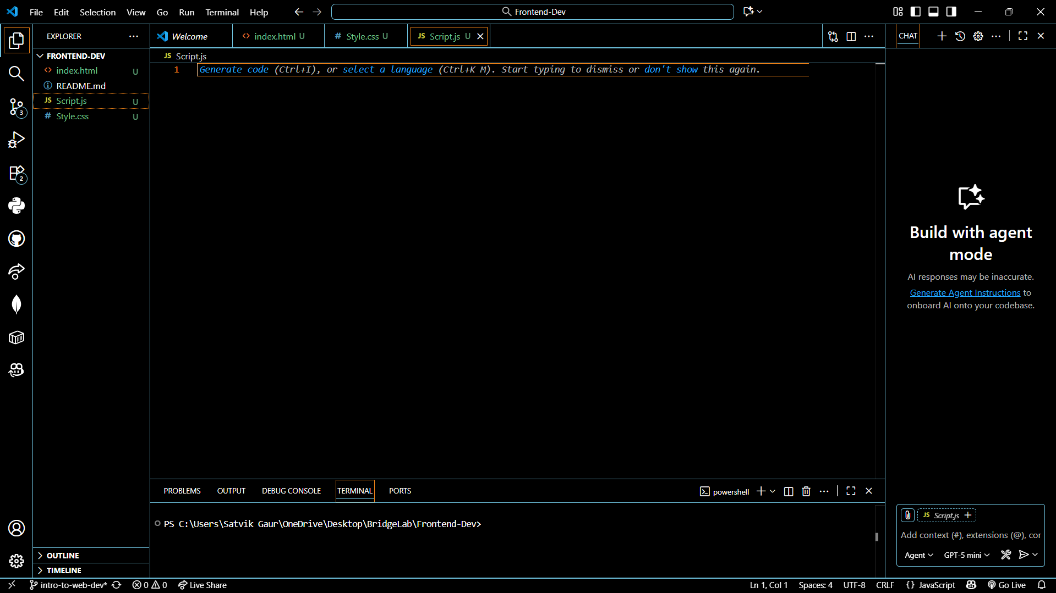

Ques 8. Explain the difference between static and dynamic websites. Provide an example of
each.
Ans -
Type | Description | Example
Static Website | Contains fixed content — same for all users. Built using HTML, CSS, and JS only. | Portfolio website or a school info site.
Dynamic Website | Content changes based on user interaction or data. Uses server-side scripts and databases. | Facebook, Amazon, YouTube.
Ques 9 . Research and list five web browsers. Explain how rendering engines differ between
them.
Ans -
Browser | Rendering Engine | Description
Google Chrome | Blink | Fast and supports modern web standards.
Mozilla Firefox | Gecko | Open-source engine optimized for performance.
Microsoft Edge | Blink | Same as Chrome; replaced old EdgeHTML engine.
Safari | WebKit | Used on Apple devices; optimized for iOS/macOS.
Opera | Blink | Chromium-based with built-in VPN and ad blocker.

Ques 10. Draw a labeled diagram showing the basic web architecture flow — client, server,
database, and APIs.

