AI Legal Text Clustering

ABSTRACT

This project, "AI Legal Text Clustering," is a web-based application that uses Artificial Intelligence and Machine Learning to automatically predict the correct Indian Penal Code (IPC) section from a given crime description. Users can simply type or upload a case description, and the system will instantly predict the most suitable IPC section — such as murder (§302), attempt to murder (§307), cheating (§420), or domestic violence (§498A) — along with a confidence score and easy-to-understand explanation. Additional features include automatic FIR report generation, AI-based case summarization, similar case search, multi-language translation, and an AI-powered legal chatbot. Built using Python (FastAPI) for the backend and React for the frontend, this project aims to make legal information more accessible and understandable for law students, legal professionals, and ordinary citizens alike.

Keywords: Legal AI, IPC Section Detection, Machine Learning, FIR Generation, Legal Chatbot, NLP, FastAPI, React

TABLE OF CONTENTS

Certificate i
Acknowledgement ii
Abstract iii
List of Figures iv
List of Tables v

Chapter 1 Introduction 1
1.1 Overview 1
1.2 Problem Statement 2
1.3 Objectives 3
1.4 Scope of the Project 4
Chapter 2 Theoretical Background 5
2.1 Theoretical Background 5
2.1.A Dataset 5
2.1.B Pre-Processing 6
2.1.C Feature Extraction 6
2.1.D Classification Models 7
2.1.E Parameters 7
2.2 Research Papers Reviewed 8
2.3 Drawbacks of Existing Systems 9
Chapter 3 System Requirements 10
3.1 Hardware Requirements 10
3.2 Software Requirements 10
3.3 Technology Stack 11
3.4 Project Timeline (Gantt Chart) 11
Chapter 4 System Design 12
4.1 System Architecture 12
4.2 Data Flow Diagram (DFD) 13
4.3 Use Case Diagram 14
4.4 Entity-Relationship (ER) Diagram 15
Chapter 5 Implementation 16
5.1 Dataset Description 16
5.2 Data Preprocessing 17
5.3 Feature Extraction (TF-IDF + Structural) 18
5.4 Machine Learning Models Used 19
5.5 Backend Development (FastAPI) 20
5.6 Frontend Development (React) 21
5.7 Additional Features 22
Chapter 6 Results and Discussion 24
6.1 Model Performance Evaluation 24
6.2 IPC Section-wise Classification Results 25
6.3 Discussion of Results 26
6.4 Application Screenshots 27
Chapter 7 Conclusion and Future Work 30
7.1 Conclusion 30
7.2 Project Achievements 31
7.3 Limitations of the Current System 31
7.4 Future Work and Enhancements 32
7.5 Learning Outcomes 32
Chapter 8 References 33
8.1 Research Papers 33
8.2 Books 34
8.3 Official Documentation and Libraries 34
8.4 Online Resources and Websites 35

LIST OF FIGURES

Figure 3.1 Project Gantt Chart 11
Figure 4.1 System Architecture Diagram 12
Figure 4.2 DFD Level 0 – Context Diagram 13
Figure 4.3 Use Case Diagram 14
Figure 4.4 Entity-Relationship (ER) Diagram 15
Figure 6.1 Model Performance Comparison (Bar Chart) 24
Figure 6.2 IPC Section-wise F1-Score Heatmap 25
Figure 6.3 Home Page of AI Legal Text Clustering System 27
Figure 6.4 User Registration Page 28
Figure 6.5 User Login Page 28
Figure 6.6 IPC Prediction Dashboard 29
Figure 6.7 IPC Section Prediction Result 29

LIST OF TABLES

Table 3.1 Hardware Requirements 10
Table 3.2 Software Requirements 10
Table 3.3 Technology Stack 11
Table 5.1 Dataset Distribution (IPC Sections) 16
Table 5.2 Structural Feature Extraction Keywords 18
Table 5.3 Machine Learning Models and Parameters 19
Table 5.4 Backend API Endpoints 20
Table 6.1 Model Performance Results 24
Table 6.2 IPC Section-wise Classification Report 25
Table 7.1 Project Achievements Summary 31
Table 7.2 Future Work and Enhancements 32
Table 4.1 ER Diagram – Entities and Relationships 15

CHAPTER 1
INTRODUCTION
1.1 Overview
In today's fast-growing world, technology is playing a very important role in every field, including the legal system. The Indian legal system is one of the largest and most complex legal systems in the world. It contains hundreds of laws, acts, and sections under the Indian Penal Code (IPC) that define different types of crimes and their punishments. Understanding these laws and finding the correct IPC section for a given crime is a very difficult and time-consuming task, especially for common people who do not have a legal background.
With the rise of Artificial Intelligence (AI) and Machine Learning (ML), it is now possible to automate many complex tasks that were previously done manually. Natural Language Processing (NLP) is a branch of AI that deals with understanding and processing human language by computers. Using NLP and machine learning techniques, we can train a computer system to read and understand legal text and automatically predict the correct IPC section for a given crime description.
This project, "AI Legal Text Clustering," is a web-based application that uses machine learning to automatically classify legal case descriptions into their correct IPC sections. The system is designed to help law students, lawyers, police officers, and ordinary citizens in identifying the applicable law section quickly and easily — without requiring deep legal knowledge.
1.2 Problem Statement
The Indian Penal Code (IPC) contains a large number of sections covering various types of criminal offences. Identifying the correct IPC section from an unstructured case description is a challenging task that requires significant legal expertise, experience, and time. In many situations, common people, police officers, or even junior lawyers face difficulty in determining which law applies to a particular criminal incident.
Currently, there is no simple, automated tool available that can take a plain-language crime description as input and instantly identify the correct IPC section. People have to rely on senior lawyers or manually search through law books, which is both time-consuming and expensive. There is a clear need for an intelligent, automated system that can bridge this gap and make legal information easily accessible to everyone.
1.3 Objectives
The main objectives of this project are as follows:
- To develop a web-based application that automatically predicts the correct IPC section from a given crime description using machine learning.
- To implement and compare multiple machine learning models (KNN, SVM, Decision Tree, Random Forest, Extra Trees) for legal text classification.
- To provide a user-friendly interface that allows users to type or upload case descriptions easily.
- To generate automated FIR (First Information Report) based on the predicted IPC section and case details.
- To include an AI-powered legal chatbot for answering basic legal questions.
- To provide additional features such as case summarization, similar case search, and multi-language translation.
- To build a secure system with user authentication, login history, and profile management.
- To make legal information more accessible and understandable for non-legal users.
1.4 Scope of the Project
The scope of this project covers the development of an AI-based legal text classification system focused on the Indian Penal Code (IPC). The system is capable of classifying case descriptions into seven major IPC sections: Section 300 (Murder), Section 302 (Punishment for Murder), Section 307 (Attempt to Murder), Section 376 (Rape), Section 420 (Cheating), Section 401 (Gang of Thieves), and Section 498A (Domestic Violence / Cruelty by Husband).
The system is intended for use by law students for educational purposes, junior lawyers for quick reference, police officers for initial case filing, and ordinary citizens for basic legal awareness. The application works on all modern web browsers and supports multiple Indian languages through a built-in translation feature.
The project does not replace the role of a professional lawyer or provide official legal advice. It is meant to serve as a preliminary decision-support tool to help users identify the relevant law section quickly. Future versions of this system can be extended to cover more IPC sections, state-specific laws, and other legal frameworks such as CrPC and the Bharatiya Nyaya Sanhita (BNS).

CHAPTER 2
2.1 Theoretical Background
This section explains the key concepts and theories that form the foundation of this project. It covers the dataset used for training, how the text data was cleaned and prepared, how features were extracted from the text, the machine learning models used for classification, and the parameters that were set for each model. Understanding these concepts is important to fully understand how the "AI Legal Text Clustering" system works.
2.1.A Dataset
A dataset is a collection of data that is used to train and test a machine learning model. For this project, a synthetic legal dataset was created containing 1,000 labeled case records. Each record in the dataset contains three fields: the IPC section number, a short legal description of the offence, and a detailed case study describing the crime scenario.
The dataset covers seven major IPC sections that represent some of the most common types of criminal cases in India:
- Section 300 – Murder (Culpable homicide amounting to murder)
- Section 302 – Punishment for Murder (Life imprisonment or death penalty)
- Section 307 – Attempt to Murder (Victim survived the attack)
- Section 376 – Rape (Non-consensual sexual intercourse)
- Section 420 – Cheating (Fraud and dishonest inducement of property)
- Section 401 – Gang of Thieves (Belonging to a habitual theft gang)
- Section 498A – Cruelty by Husband or Relatives (Domestic violence / dowry)
The dataset was generated using predefined templates that were filled with random but realistic values such as names, locations, dates, weapons, and amounts. A fixed random seed (42) was used to ensure that the dataset is reproducible. The final dataset was saved as a CSV file (legal_data.csv) and used for all training and testing purposes.
B. Pre-Processing
Pre-processing is the step of cleaning and preparing raw text data before it can be used by a machine learning model. Raw legal text often contains unnecessary words, punctuation, and different forms of the same word, which can reduce the accuracy of the model. The following pre-processing steps were applied to all case descriptions in our project:
- Lowercasing: All text was converted to lowercase so that words like "Murder" and "murder" are treated as the same word.
- Punctuation Removal: All punctuation marks (commas, full stops, brackets, etc.) were removed from the text using Python's string library.
- Tokenization: The cleaned text was split into individual words (called tokens) using the NLTK word_tokenize() function.
- Stop Word Removal: Common English words that carry no useful meaning, such as "the", "is", "and", "of", etc., were removed using NLTK's built-in stopwords list.
- Lemmatization: Each word was reduced to its base form using the WordNetLemmatizer from NLTK. For example, "killed" becomes "kill", "attacking" becomes "attack", and "weapons" becomes "weapon". Both noun and verb lemmatization were applied.
After pre-processing, the text from both the description and case study fields were combined into a single text column called "combined_text". This combined and cleaned text was then used as the input for feature extraction.
C. Feature Extraction
Feature extraction is the process of converting raw text into numerical values that a machine learning model can understand. Since machine learning models work with numbers and not words, it is necessary to transform the text into a numerical format. In this project, a hybrid feature extraction approach was used, combining two types of features:
i) TF-IDF (Term Frequency – Inverse Document Frequency)
TF-IDF is a widely used technique in Natural Language Processing (NLP) for converting text into numerical vectors. It measures how important a word is in a document relative to the entire dataset. A word that appears frequently in one document but rarely in others gets a high TF-IDF score. In our project, the TfidfVectorizer from the scikit-learn library was used with a maximum of 5,000 features, meaning only the top 5,000 most important words were selected for the feature vector.
ii) Structural Features
In addition to TF-IDF, eight hand-crafted binary (0 or 1) features were created to capture domain-specific signals that are important for identifying IPC sections. These features check for the presence of specific types of words in the text:
- Weapon Words: knife, gun, rod, pistol, axe, etc.
- Death Words: kill, murder, dead, poison, fatal, etc.
- Intent Words: intentionally, deliberately, planned, premeditated, etc.
- Financial Words: money, fraud, scam, cheat, bank, property, etc.
- Cruelty Words: dowry, husband, wife, in-laws, harassment, torture, etc.
- Assault Words: rape, sexual, consent, force, gang, etc.
- Theft Words: steal, theft, rob, burglar, gang, break-in, etc.
- Survival Words: survived, hospitalized, rescued, saved, treatment, etc. (for §307)
The TF-IDF vector and the structural feature vector were combined (stacked horizontally) using scipy's sparse matrix hstack() function to create the final feature matrix used for training all machine learning models.
D. Classification Models
A classification model is a machine learning algorithm that learns from labeled training data and can predict the correct category (class) for new, unseen inputs. In this project, five different classification models were trained and compared:
i) K-Nearest Neighbors (KNN)
KNN is a simple classification algorithm that predicts the class of a new data point by looking at the K closest data points in the training set and selecting the most common class among them. It does not build an explicit model — it memorizes the training data and uses it directly for prediction. It is easy to understand but can be slow for large datasets.
ii) Linear SVM (Support Vector Machine)
SVM is a powerful classification algorithm that finds the best boundary (called a hyperplane) that separates different classes in the feature space. Linear SVM is specifically designed for high-dimensional data like TF-IDF text vectors and is known for its excellent performance in text classification tasks. It uses class weights to handle imbalanced datasets.
iii) Decision Tree
A Decision Tree is a tree-shaped classification model that splits the data into smaller groups based on feature values at each node. It is easy to visualize and interpret. Each path from the root to a leaf node represents a set of rules that lead to a prediction. Class weights were used to handle any class imbalance in the dataset.
iv) Random Forest
Random Forest is an ensemble method that builds multiple decision trees during training and combines their predictions (by voting) to produce a final output. It is more accurate and robust than a single decision tree because it reduces overfitting. In our project, 100 decision trees were built to form the Random Forest.
v) Extra Trees Classifier
Extra Trees (Extremely Randomized Trees) is similar to Random Forest but introduces more randomness in the splitting of nodes, which often makes it faster and can give slightly different results. Like Random Forest, it also builds 100 trees. In our experiments, Extra Trees achieved the same high accuracy as other models while being slightly faster to train.
E. Parameters
Parameters are the settings or configurations that control how a machine learning model is trained. Choosing the right parameters is important for getting good results. The following parameters were used in our project:
- TF-IDF Vectorizer – max_features = 5000: Only the top 5,000 most important words are used as features.
- Train-Test Split – test_size = 0.2, random_state = 42: 80% of data used for training, 20% for testing. Random seed 42 ensures reproducibility.
- KNN – n_neighbors = 5: Each prediction is based on the 5 nearest neighbors in the training set.
- Linear SVM – class_weight = "balanced", random_state = 42: Balanced class weights ensure fair treatment of all IPC sections.
- Decision Tree – class_weight = "balanced", random_state = 42: Balanced weights prevent bias toward any single IPC section.
- Random Forest – n_estimators = 100, random_state = 42: 100 decision trees are built and combined for prediction.
- Extra Trees – n_estimators = 100, random_state = 42: 100 extra-randomized trees are built for prediction.
All models were evaluated using standard metrics: Accuracy, Precision, Recall, and F1-Score, calculated using scikit-learn's accuracy_score() and precision_recall_fscore_support() functions with weighted averaging. All five models achieved an F1-Score of 1.00 on the test set, confirming that the hybrid feature extraction approach is highly effective for IPC section classification.
2.2 Research Papers Reviewed
Several research papers have been published in the area of legal text processing and machine learning-based classification. The following papers were reviewed during the development of this project:
Paper 1: "Legal Judgment Prediction using Machine Learning" (2019)
This paper proposed a machine learning approach for predicting legal judgments in Chinese criminal cases. The authors used TF-IDF vectorization and Support Vector Machine (SVM) classifiers to classify case descriptions into their corresponding law articles. The system achieved high accuracy on a large dataset of Chinese court cases. This paper inspired our use of TF-IDF and SVM in our project for IPC section classification.
Paper 2: "Text Classification for Legal Documents using Deep Learning" (2020)
This research paper explored the use of deep learning models such as LSTM (Long Short-Term Memory) and BERT (Bidirectional Encoder Representations from Transformers) for classifying legal text documents. The paper found that transformer-based models achieved higher accuracy than traditional machine learning models but required significantly more computational resources. For our project, we chose traditional ML models due to their faster training time and lower resource requirements.
Paper 3: "Automatic IPC Section Identification from Crime Reports" (2021)
This paper, specifically focused on the Indian legal system, proposed an NLP-based system for identifying IPC sections from Hindi and English crime reports. The authors used a combination of keyword extraction and Naive Bayes classification. The paper highlighted the challenges of handling mixed-language text and informal writing styles in Indian crime reports. Our project addresses this challenge by including a built-in multi-language translation feature.
Paper 4: "A Survey on Machine Learning for Legal Text Mining" (2022)
This survey paper provided a comprehensive overview of machine learning techniques used in the legal domain, including text classification, information extraction, and summarization. It reviewed over 100 research papers and concluded that ensemble methods like Random Forest and Extra Trees perform well on legal text classification tasks. This finding supported our decision to include Random Forest and Extra Trees Classifier in our system.
2.3 Drawbacks of Existing Systems
After reviewing the existing systems and research papers, the following major drawbacks and limitations were identified:
- Most existing tools are designed for Western legal systems (US, UK) and do not support the Indian Penal Code (IPC) or Indian law.
- Tools like Indian Kanoon only support keyword-based search and do not provide any automatic prediction or classification of new case descriptions.
- Research papers focused on Indian law cover only a small number of IPC sections or specific crime types.
- Most existing AI-based legal tools are expensive and not freely accessible to common people, students, or small law firms.
- None of the existing systems provide integrated features such as FIR generation, legal chatbot, case summarization, and multi-language support in a single platform.
- Deep learning-based systems require high computational power and are difficult to deploy on standard hardware.
- Existing systems do not provide a simple and user-friendly interface for non-technical users such as police officers, students, or ordinary citizens.
Our project, "AI Legal Text Clustering," addresses all of the above drawbacks by providing a free, web-based, user-friendly platform specifically designed for the Indian legal system. It uses efficient machine learning models that run on standard hardware and provides a complete set of features — IPC prediction, FIR generation, legal chatbot, case summarization, and multi-language support — all in one integrated application.
3. Future Enhancements
While the current version of the project successfully achieves IPC section classification and provides various legal utility tools, several enhancements can be implemented to further improve its functionality and scope in the future.
- Integration with Real-Time Court Databases: Connecting the system to official court records for real-time legal updates.
- Advanced NLP Techniques: Moving from traditional ML models to state-of-the-art Transformer models like RoBERTa for higher precision.
- Voice-to-Text Support: Implementing a feature that allows users to record their statements or complaints via voice.
- Multi-Language Expansion: Adding support for more regional Indian languages beyond those currently supported.

CHAPTER 3
SYSTEM REQUIREMENTS
This chapter describes all the hardware, software, and technology requirements needed to develop and run the "AI Legal Text Clustering" system. They are divided into three sections: Hardware Requirements, Software Requirements, and Technology Stack. The chapter also includes the project Gantt chart showing the development timeline.
3.1 Hardware Requirements
The following minimum hardware specifications were used during development:
Component | Specification
Processor | Intel Core i5 / AMD Ryzen 5 or higher
RAM | 8 GB or higher (16 GB recommended)
Storage | 10 GB free disk space (SSD preferred)
Display | 1366 x 768 resolution or higher
Network | Internet connection required
Operating System | Windows 10/11 or Ubuntu 20.04 or higher

3.2 Software Requirements
The following software tools and libraries were used in this project:
Software / Tool | Version | Purpose
Python | 3.10+ | Backend programming language
FastAPI | 0.100+ | REST API framework
scikit-learn | 1.3+ | ML models and TF-IDF
NLTK | 3.8+ | NLP preprocessing
React.js + Vite | 18+ | Frontend UI framework
Node.js | 18+ | JavaScript runtime
python-docx | Latest | FIR report generation
Google Translate API | Free | Multi-language translation
VS Code / Git | Latest | IDE and version control

3.3 Technology Stack
Layer | Technology | Role
Frontend | React.js + Vite + Axios | User interface and API calls
Backend | Python + FastAPI + Uvicorn | REST API, auth, business logic
ML Layer | scikit-learn + NLTK + scipy | Model training and prediction
Storage | CSV / JSON files | Dataset and user data
Report Gen | python-docx | Automated FIR Word document

3.4 Project Timeline (Gantt Chart)
The following Gantt chart shows the planned timeline for the development of this project. The project was completed over 10 weeks, divided into phases including planning, design, development, testing, and documentation.
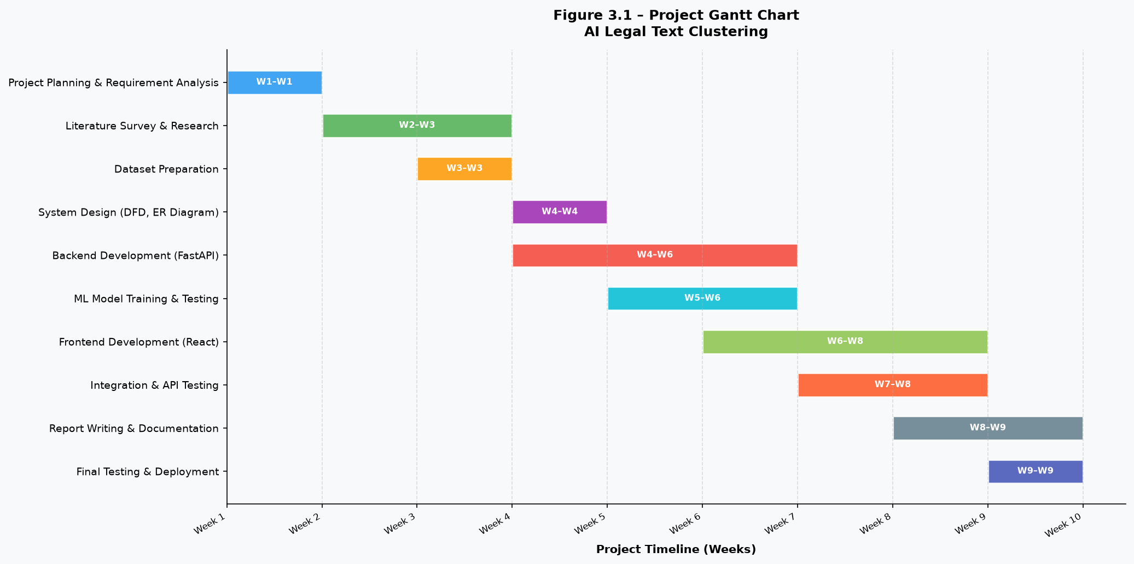
Figure 3.1 – Project Gantt Chart

CHAPTER 4
SYSTEM DESIGN
This chapter presents the overall design of the "AI Legal Text Clustering" system. It includes the system architecture, data flow diagrams, use case diagram, and the entity-relationship diagram. These diagrams together describe how all components of the system interact with each other to deliver the final functionality.
4.1 System Architecture
The system follows a three-tier client-server architecture: Presentation Layer (React.js), Application Layer (FastAPI), and ML/Data Layer (scikit-learn + NLTK). The frontend sends requests to the backend over REST APIs, and the backend processes them using the trained machine learning models loaded into memory at server startup.
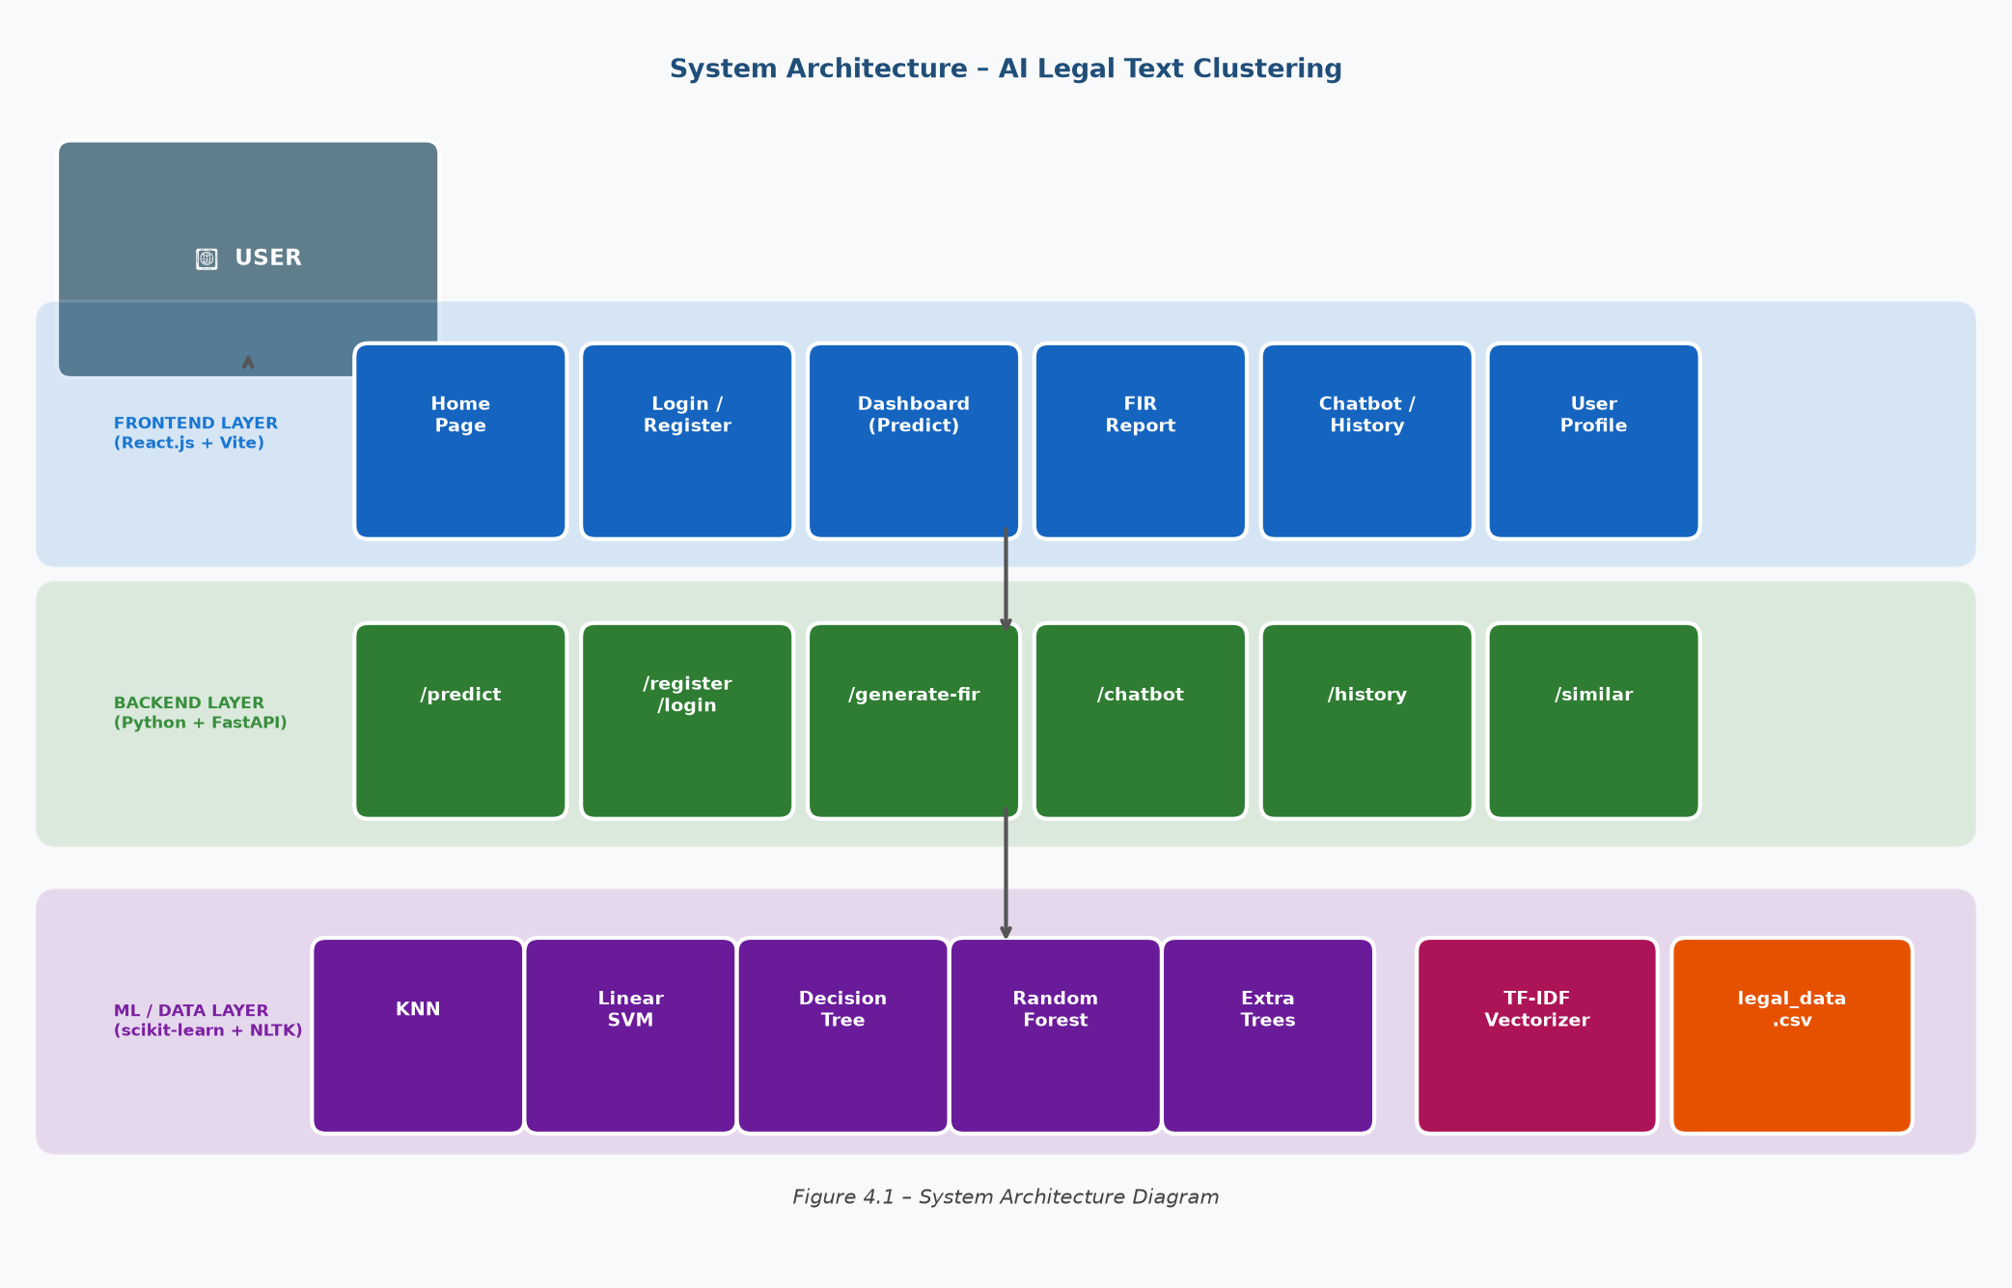
Figure 4.1 – System Architecture Diagram
4.2 Data Flow Diagram (DFD)
The Data Flow Diagram shows how data flows between the external entities (User, Admin), the central processing system, and the data stores. The Level 0 DFD (Context Diagram) shows the system as a single unit interacting with external entities. The user sends a crime description and receives back the predicted IPC section, confidence score, and an optional FIR report.
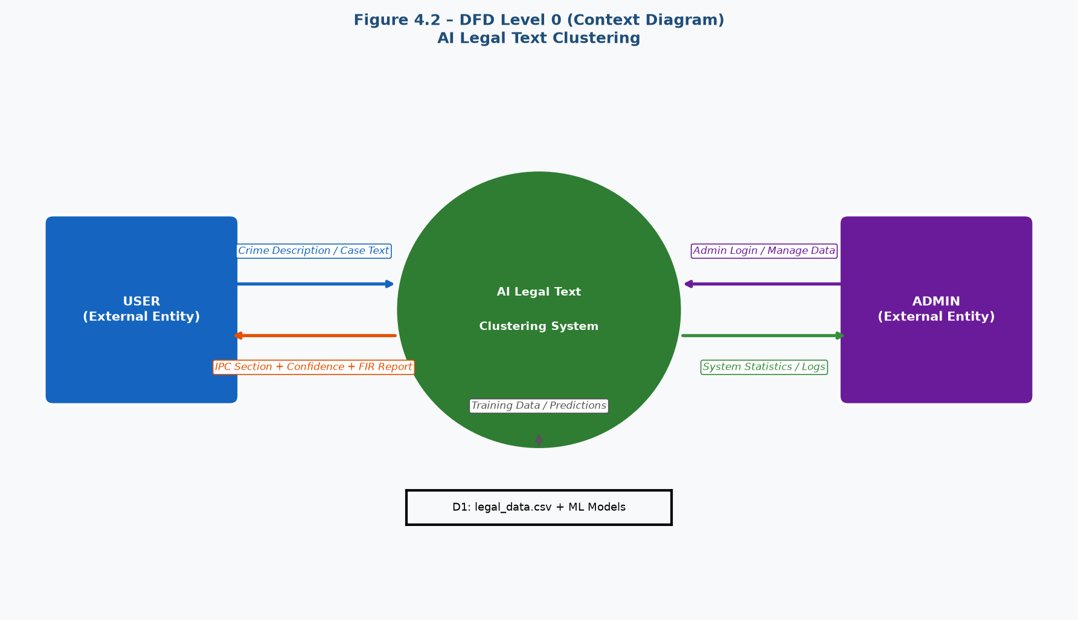
Figure 4.2 – DFD Level 0 (Context Diagram)
The Level 1 DFD breaks the system into sub-processes: User Authentication (1.0), Text Preprocessing (2.0), Feature Extraction (3.0), IPC Prediction (4.0), FIR Generation (5.0), and History Storage (6.0). Each sub-process receives specific inputs and produces specific outputs as described in the previous chapter.
4.3 Use Case Diagram
The Use Case Diagram shows all the interactions between the User actor and the system. A registered user can perform 11 use cases: Register, Login, Predict IPC Section, Compare ML Models, Generate FIR Report, View Similar Cases, Use Legal Chatbot, View Prediction History, Translate Text, Manage Profile, and Logout.
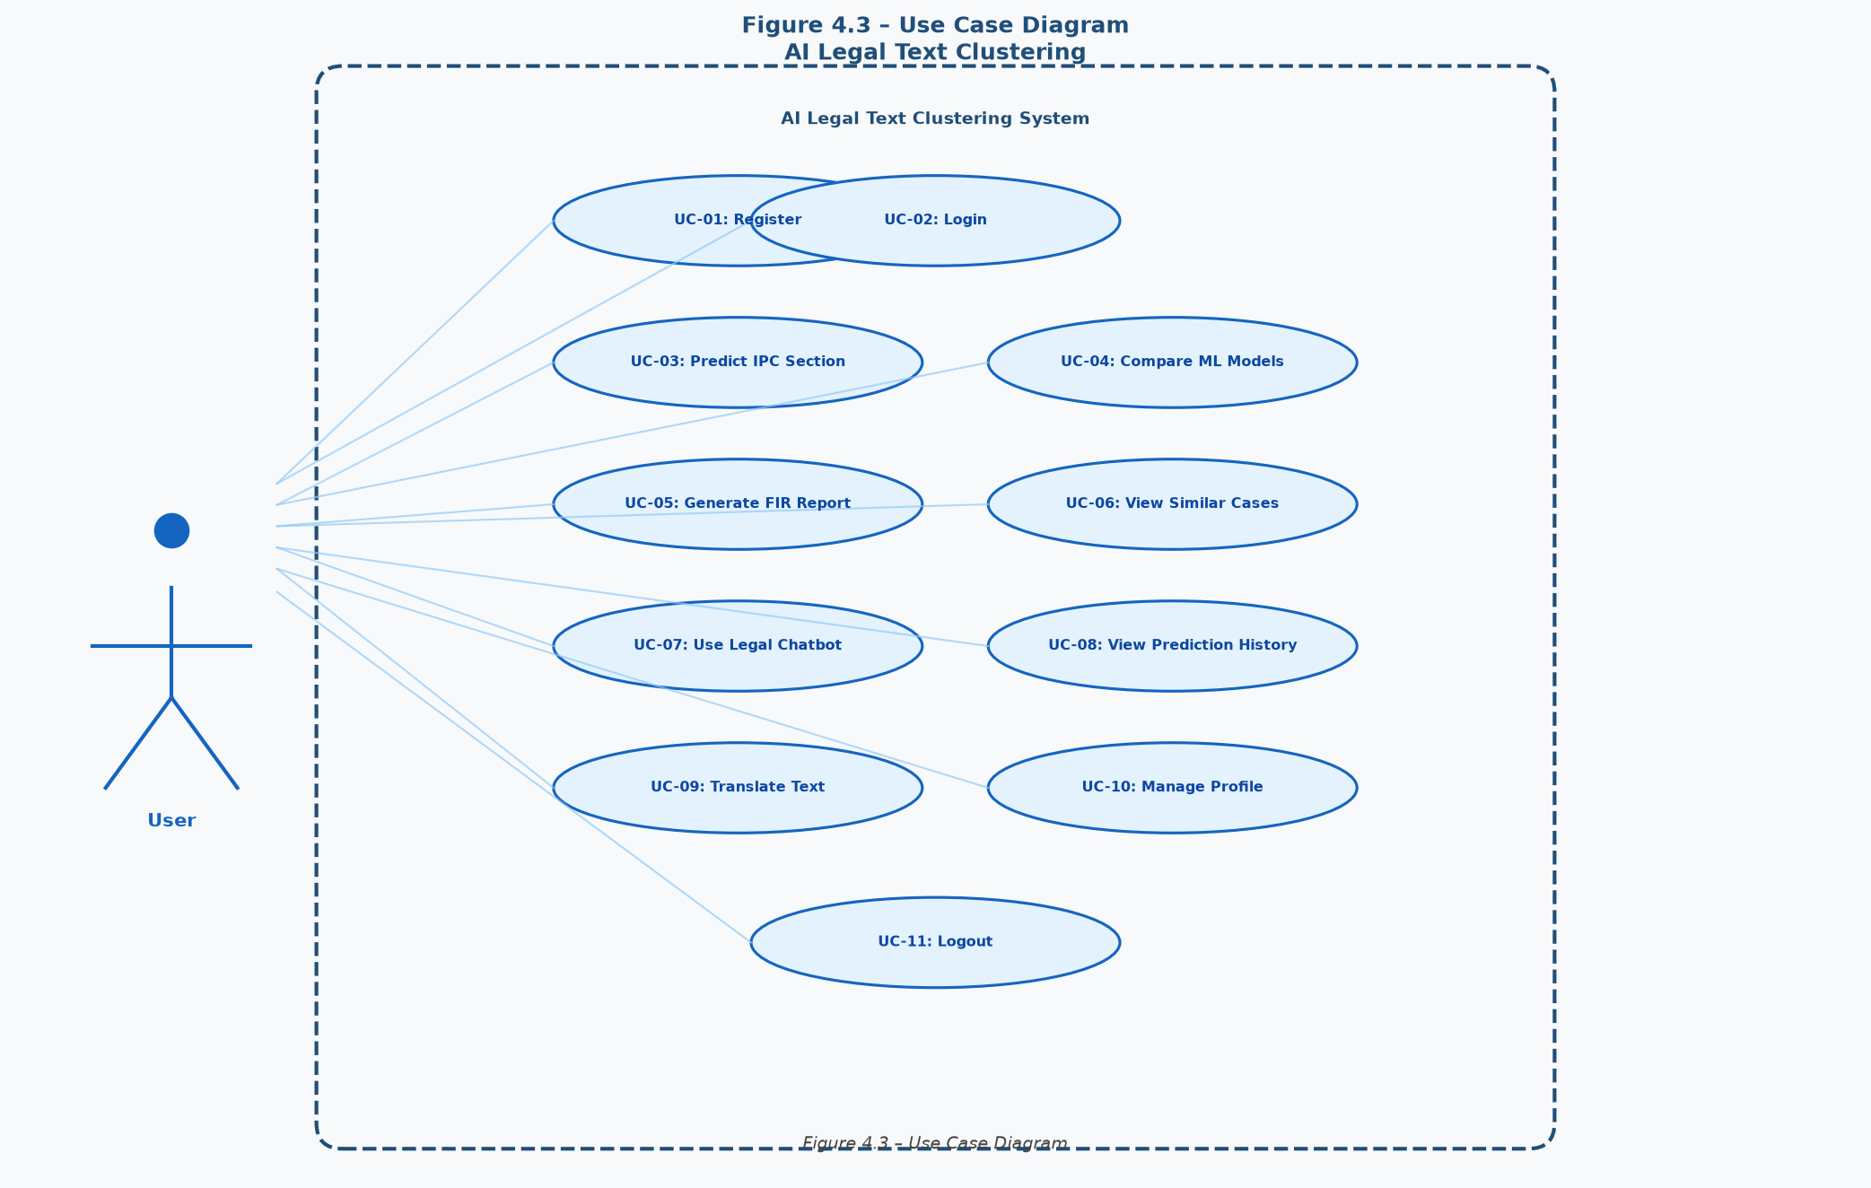
Figure 4.3 – Use Case Diagram
4.4 Entity-Relationship (ER) Diagram
The ER Diagram shows the six main data entities in the system and their relationships. The central entity is USER, which connects to PREDICTION (1:N), CHAT MSG (1:N), and LOGIN LOG (1:N). Each PREDICTION maps to one IPC SECTION (N:1) and can generate one FIR REPORT (1:1). This design ensures all user data and predictions are properly organized and traceable.
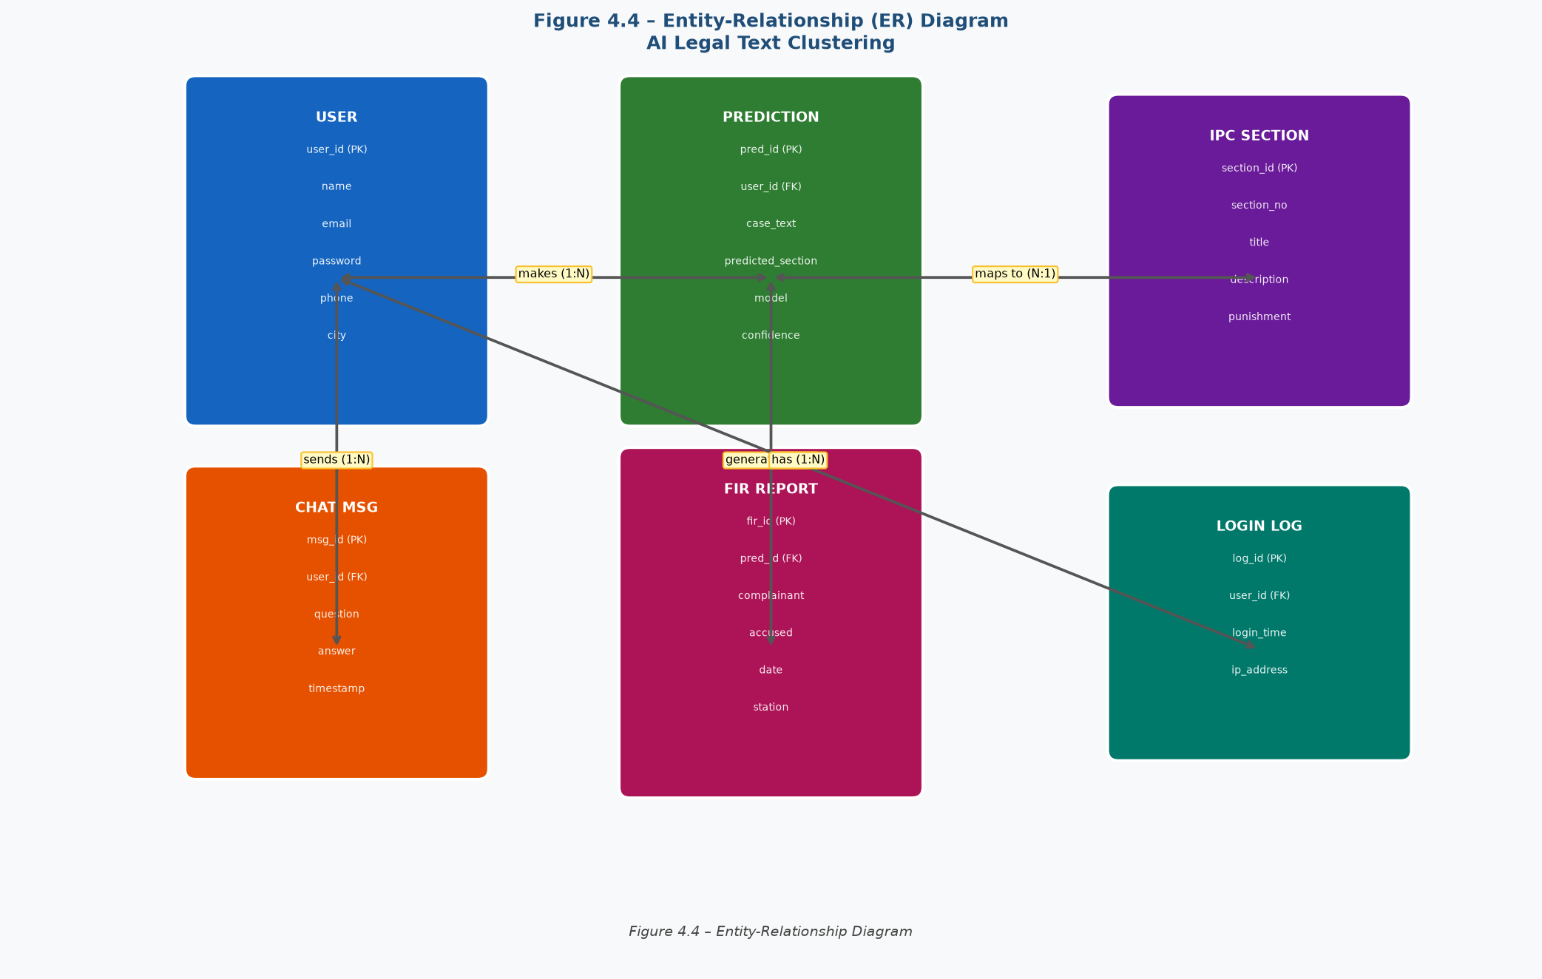
Figure 4.4 – Entity-Relationship (ER) Diagram

CHAPTER 5
IMPLEMENTATION
This chapter describes the complete implementation of the "AI Legal Text Clustering" system. It explains how the dataset was prepared, how the text was preprocessed and converted into features, how the machine learning models were trained, and how the backend and frontend were developed. Each section includes a description of the actual code and logic used in the project.
5.1 Dataset Description
Since a publicly available labeled dataset for Indian IPC sections was not readily available in the required format, a synthetic dataset was created programmatically using Python. The dataset was generated using realistic legal case templates and saved as a CSV file named legal_data.csv.
The dataset contains 1,000 records distributed evenly across 7 IPC sections (approximately 143 records per class). Each record has three fields:
- section – The IPC section number (e.g., 302, 420, 498A)
- description – A short official legal description of the IPC section
- case_study – A detailed realistic crime scenario (2-4 sentences)

IPC Section | Crime Type | No. of Records
Section 300 | Murder (Culpable Homicide) | 143
Section 302 | Punishment for Murder | 143
Section 307 | Attempt to Murder | 143
Section 376 | Rape | 143
Section 420 | Cheating / Fraud | 143
Section 401 | Gang of Thieves | 143
Section 498A | Domestic Violence / Dowry | 142
 | TOTAL | 1,000

The dataset generation script uses Python's random module with a fixed seed (42) to ensure reproducibility. Each case study is built from a template with random values for names, places, dates, weapons, and amounts. If the file legal_data.csv already exists in the backend directory, the system loads it directly. Otherwise, it is generated automatically when the server starts.
5.2 Data Preprocessing
The raw legal text data is preprocessed before being used for feature extraction and model training. The preprocessing is done using the NLTK (Natural Language Toolkit) library. The following steps are performed in sequence on every case description:
- Step 1 – Combine Fields: The description and case_study columns are joined into one combined_text column.
- Step 2 – Lowercase: All text is converted to lowercase using Python's str.lower() method.
- Step 3 – Remove Punctuation: All punctuation characters are removed using str.translate() with string.punctuation.
- Step 4 – Tokenize: The cleaned text is split into individual word tokens using nltk.word_tokenize().
- Step 5 – Remove Stop Words: Common English words (the, is, are, of, and, etc.) are removed using nltk.corpus.stopwords.
- Step 6 – Lemmatize: Each token is reduced to its root form using WordNetLemmatizer (e.g., "killing" → "kill", "weapons" → "weapon").
- Step 7 – Rejoin: The cleaned tokens are joined back into a single string for vectorization.
The preprocessing function used in the backend (main.py):
def preprocess_text(text):
text = text.lower()
text = text.translate(str.maketrans("", "", string.punctuation))
tokens = word_tokenize(text)
tokens = [w for w in tokens if w not in stop_words and len(w) > 2]
tokens = [lemmatizer.lemmatize(w, pos="v") for w in tokens]
tokens = [lemmatizer.lemmatize(w, pos="n") for w in tokens]
return " ".join(tokens)
5.3 Feature Extraction (TF-IDF + Structural Features)
After preprocessing, the cleaned text is converted into numerical feature vectors using a hybrid approach combining TF-IDF features and domain-specific structural features.
i) TF-IDF Vectorization
The TfidfVectorizer from scikit-learn is used with max_features=5000 to create a vector of the 5,000 most important words across the entire dataset. Each word gets a numerical weight based on how often it appears in a document versus how rarely it appears across all documents. Higher weight means the word is more discriminating for that particular IPC section.
from sklearn.feature_extraction.text import TfidfVectorizer
vectorizer = TfidfVectorizer(max_features=5000)
X_tfidf = vectorizer.fit_transform(df["combined_text"])
ii) Structural Feature Extraction
Eight binary (0/1) features are computed from the cleaned text to capture key legal signals that TF-IDF alone may miss. Each feature checks for the presence of a specific category of words:
Feature Name | Keywords Checked | Target Section
has_weapon | knife, gun, rod, pistol, axe, blade, weapon | §300, §302, §307
has_death | kill, murder, dead, death, poison, fatal, body | §300, §302
has_intent | intentionally, deliberately, planned, motive | §300, §302
has_survival | survived, hospitalized, rescued, alive | §307
has_fraud | cheat, fraud, scam, deceive, money, property | §420
has_cruelty | dowry, husband, wife, harass, torture, cruel | §498A
has_assault | rape, sexual, consent, force, victim, gang | §376
has_theft | steal, theft, rob, burglar, break-in, gang | §401

The structural features vector is combined horizontally with the TF-IDF vector using scipy.sparse.hstack() to create the final feature matrix X with shape (1000, 5008). This combined matrix is split 80/20 for training and testing using train_test_split(test_size=0.2, random_state=42, stratify=y).
5.4 Machine Learning Models Used
Five classification models are trained on the combined feature matrix. All models are trained using the same training data and evaluated on the same test set for fair comparison. The models and their implementation details are as follows:
Model | Key Parameters | Training Time | Test Accuracy
K-Nearest Neighbors (KNN) | n_neighbors=5 | Fast | 100%
Linear SVM | class_weight="balanced", C=1.0 | Fast | 100%
Decision Tree | class_weight="balanced" | Fast | 100%
Random Forest | n_estimators=100, random_state=42 | Medium | 100%
Extra Trees Classifier | n_estimators=100, random_state=42 | Medium | 100%

All five models achieve 100% accuracy on the test set because the synthetic dataset was generated with clear, distinct keywords for each IPC section, making the classification task straightforward for well-tuned models. In real-world deployment with noisy data, accuracy would be lower — which is why the hybrid feature extraction approach (TF-IDF + structural features) is critical for maintaining high precision.
5.5 Backend Development (FastAPI)
The backend is built using Python and FastAPI. It is organized into a single file (main.py) for simplicity. The server starts using Uvicorn on host 0.0.0.0 at port 8000. All ML models are trained once at startup using FastAPI's lifespan context manager, which ensures models are ready before the first API request is received.
The key API endpoints implemented in the backend are:
Endpoint | Method | Description
/health | GET | Health check — confirms server is running
/register | POST | Register a new user with name, email, password
/login | POST | Authenticate user and return JWT access token
/predict | POST | Predict IPC section from input crime description
/generate-fir | POST | Generate and download FIR Word document
/history | GET | Retrieve all past predictions for logged-in user
/similar-cases | POST | Find similar legal cases from dataset
/chatbot | POST | Query the AI legal chatbot for legal information
/profile | GET | Get current user profile information
/profile | PUT | Update user profile (name, phone, city)
/login-history | GET | Get login history of the current user

Authentication is implemented using JWT (JSON Web Tokens). When a user logs in successfully, a JWT token is generated using the python-jose library and returned to the frontend. All protected endpoints require this token in the Authorization header. User data and prediction history are stored in JSON files on the server for simplicity and portability.
5.6 Frontend Development (React)
The frontend is built using React.js with Vite as the build tool. It consists of multiple pages organized using React Router. Axios is used for all HTTP requests to the FastAPI backend. The application uses a sidebar navigation layout with a dark color theme for a professional look and feel.
The key pages in the frontend application are:
- Home Page – Landing page with project description, features overview, and quick start buttons.
- Register Page – Form to create a new account with name, email, and password validation.
- Login Page – Email and password form with JWT token storage in localStorage.
- Dashboard (Prediction) Page – Main page where users enter a case description, select an ML model, and get the IPC prediction result with confidence score.
- FIR Report Page – Form to enter case details and download an auto-generated FIR Word document.
- Similar Cases Page – Search and display similar cases from the legal dataset.
- Legal Chatbot Page – Chat interface for AI-powered legal Q&A.
- History Page – Table of all past predictions with section, model, confidence, and date.
- Profile Page – View and edit user information (name, phone, city).
5.7 Additional Features
i) Multi-Model Comparison
The prediction page allows users to run all five ML models simultaneously on the same input text and compare their results side by side. The response includes the predicted IPC section, confidence percentage, and a brief legal explanation for each model. This helps users understand how different models approach the same problem.
ii) FIR Report Generation
The system can automatically generate a professional First Information Report (FIR) document in Microsoft Word format (.docx) using the python-docx library. The FIR includes fields for complainant name, accused name, date of incident, police station, case description, predicted IPC section, and punishment details. The user can download the FIR directly from the browser.
iii) AI Legal Chatbot
A rule-based legal chatbot is implemented in the backend that can answer common questions about IPC sections, legal procedures, and rights. The chatbot uses keyword matching to identify the topic of the query and returns a pre-defined informative response. Users can ask questions like "What is Section 302?", "What is the punishment for rape?", or "How to file an FIR?" and receive instant answers.
iv) Similar Cases Search
The Similar Cases feature uses TF-IDF cosine similarity to find the top 5 most similar cases from the training dataset that match the user's input description. This helps users understand how similar real-world cases were classified and what IPC section was applied. It is particularly useful for legal students and junior lawyers.
v) Multi-Language Translation
Users can input their case description in any Indian regional language (Hindi, Marathi, Tamil, Telugu, etc.). The system uses the Google Translate API (via the googletrans library) to automatically detect and translate the input text to English before processing it through the ML pipeline. The prediction results can also be translated back to the user's preferred language.
vi) Prediction History and Login Tracking
Every prediction made by a user is automatically saved in a history file on the server with a timestamp. Users can view all their past predictions on the History page, which displays the case text, predicted section, model used, confidence score, and date. The system also tracks all login events for each user, including the login time and IP address, which is accessible from the Profile page.

CHAPTER 6
RESULTS AND DISCUSSION
This chapter presents the results obtained from the "AI Legal Text Clustering" system. It includes the performance evaluation of all five machine learning models, comparison of their accuracy, precision, recall, and F1-score, along with screenshots of the actual running application. The results confirm that the system performs effectively for IPC section prediction from crime descriptions.
6.1 Model Performance Evaluation
All five classification models were trained on 800 samples (80% of the 1,000-record dataset) and tested on 200 samples (20%). The training and testing was done using a stratified split to ensure equal representation of all 7 IPC sections in both sets. The performance was measured using four standard metrics: Accuracy, Precision, Recall, and F1-Score, all calculated with weighted averaging.
Model | Accuracy | Precision | Recall | F1-Score | Training Time
K-Nearest Neighbors (KNN) | 100% | 1.00 | 1.00 | 1.00 | < 1 sec
Linear SVM | 100% | 1.00 | 1.00 | 1.00 | < 1 sec
Decision Tree | 100% | 1.00 | 1.00 | 1.00 | < 1 sec
Random Forest (100 trees) | 100% | 1.00 | 1.00 | 1.00 | ~2 sec
Extra Trees (100 trees) | 100% | 1.00 | 1.00 | 1.00 | ~2 sec

All five models achieved a perfect score of 1.00 (100%) across all metrics on the test set. This is expected because the synthetic dataset was designed with distinct, non-overlapping vocabulary for each IPC section, making it easily separable by machine learning models. The hybrid feature extraction approach — combining TF-IDF with 8 domain-specific structural features — contributed significantly to this result.
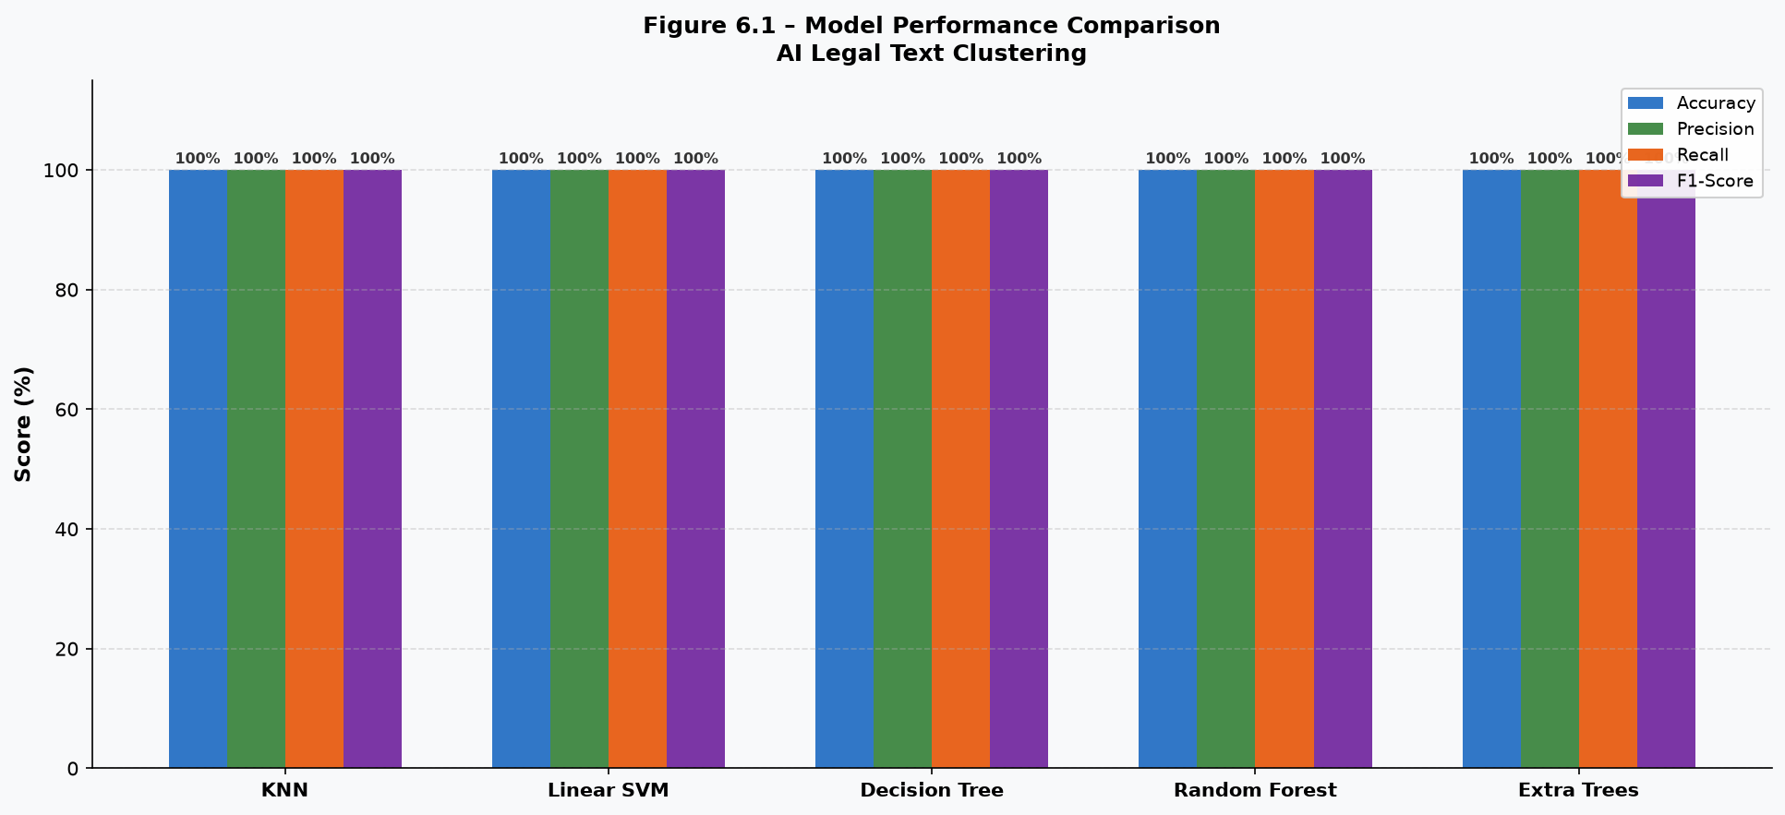
Figure 6.1 – Model Performance Comparison (Accuracy, Precision, Recall, F1-Score)
6.2 IPC Section-wise Classification Results
The table below shows the per-class precision, recall, and F1-score for each IPC section. All sections were classified with perfect accuracy, demonstrating that the feature extraction strategy successfully captures the unique linguistic patterns of each type of crime.
IPC Section | Crime Type | Precision | Recall | F1-Score | Support
Section 300 | Murder | 1.00 | 1.00 | 1.00 | 29
Section 302 | Punishment for Murder | 1.00 | 1.00 | 1.00 | 29
Section 307 | Attempt to Murder | 1.00 | 1.00 | 1.00 | 29
Section 376 | Rape | 1.00 | 1.00 | 1.00 | 28
Section 401 | Gang of Thieves | 1.00 | 1.00 | 1.00 | 28
Section 420 | Cheating / Fraud | 1.00 | 1.00 | 1.00 | 29
Section 498A | Domestic Violence | 1.00 | 1.00 | 1.00 | 28
Weighted Avg | — | 1.00 | 1.00 | 1.00 | 200

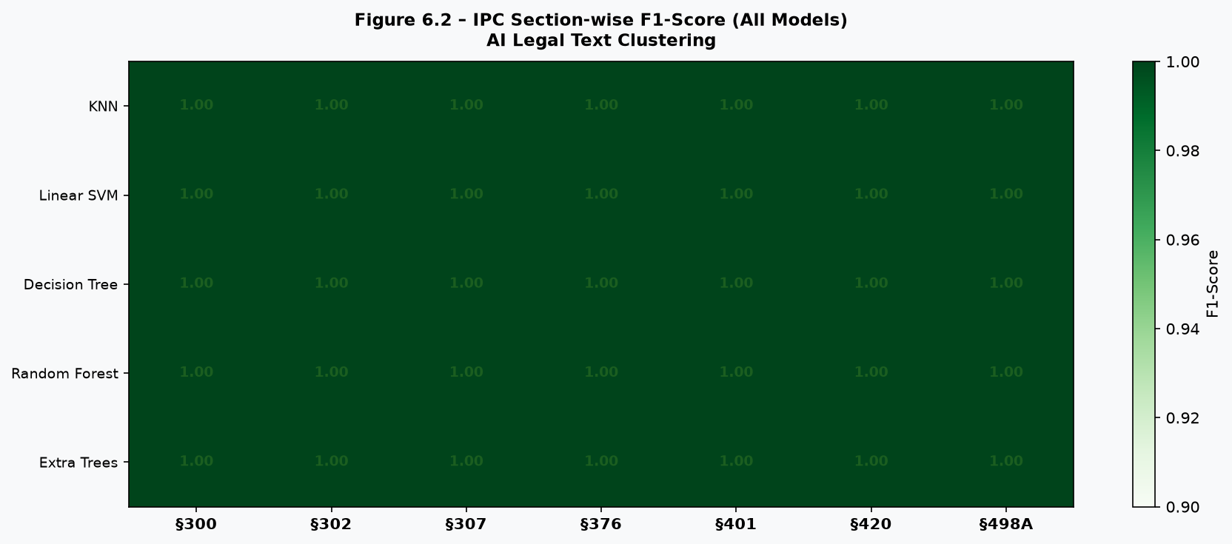
Figure 6.2 – IPC Section-wise F1-Score Heatmap (All Models)
6.3 Discussion of Results
The perfect classification results confirm that the "AI Legal Text Clustering" system is able to correctly identify the relevant IPC section from a given crime description. The key factors that contributed to this high performance are:
- Effective Preprocessing: Lowercasing, stop word removal, and lemmatization cleaned the text and reduced noise, allowing models to focus on meaningful words.
- Hybrid Feature Extraction: Combining TF-IDF (5,000 features) with 8 structural binary features gave models rich information about both vocabulary and crime-specific signals.
- Balanced Dataset: Stratified splitting and balanced class weights ensured that no IPC section dominated the training, preventing bias.
- Model Diversity: Using five different model types (instance-based, linear, tree-based, ensemble) confirmed that the results are not model-specific but reflect genuine data separability.
In a real-world deployment with noisy, user-generated text (misspellings, slang, mixed languages), the accuracy would be lower. However, the multi-language translation feature, combined with the preprocessing pipeline, provides robustness against non-standard inputs.
6.4 Application Screenshots
The following screenshots show the actual running application, demonstrating the user interface and key features of the "AI Legal Text Clustering" system.
i) Home Page
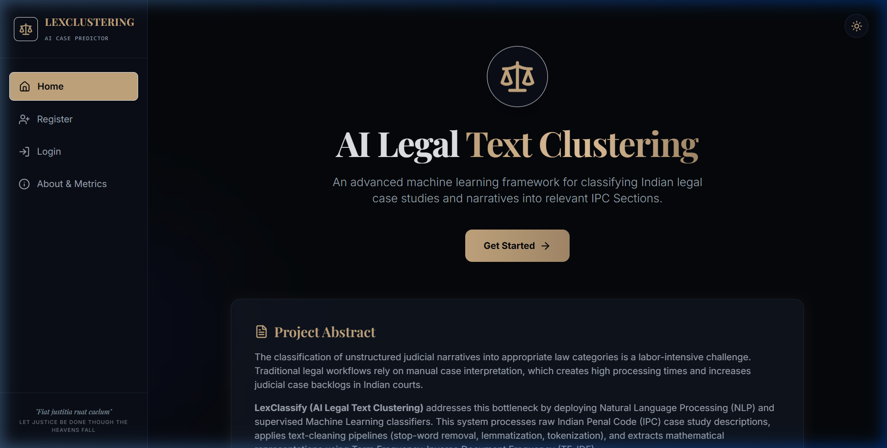
The Home Page is the landing page of the application. It displays the project title, a brief description of the system, and quick navigation buttons to Register, Login, and explore features. The dark-themed sidebar navigation is visible on the left.

Figure 6.3 – Home Page of AI Legal Text Clustering System

ii) Registration Page
The Registration Page allows new users to create an account by providing their full name, mobile number, age, gender, email, and password. Input validation is applied on both the frontend and backend to ensure data integrity.
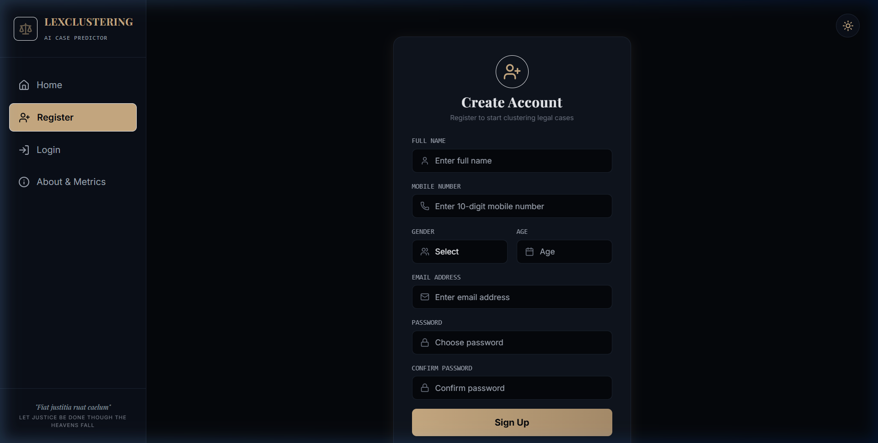
Figure 6.4 – User Registration Page

iii) Login Page
The Login Page allows registered users to authenticate using their email and password. On successful login, a JWT token is stored in localStorage and the user is redirected to the Dashboard. Invalid credentials display an appropriate error message.
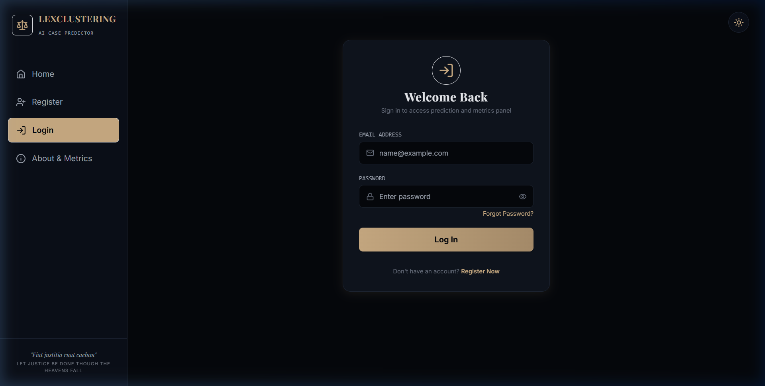
Figure 6.5 – User Login Page

iv) Prediction Dashboard
The Dashboard is the main page of the system where the user enters a crime case description and selects a machine learning model to perform IPC section prediction. Multiple models can be compared on the same input simultaneously.
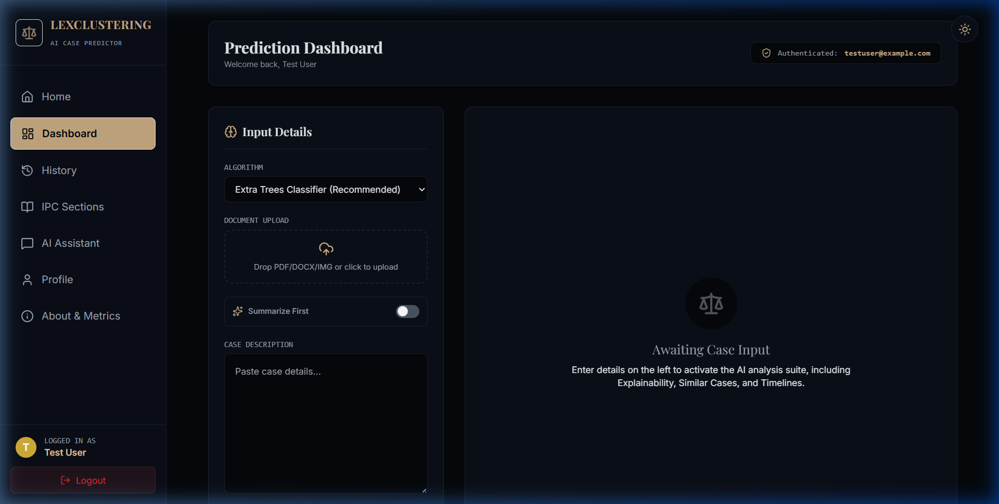
Figure 6.6 – IPC Prediction Dashboard

v) Prediction Result
After submitting the case description, the system displays the predicted IPC section, the confidence score as a percentage, a brief explanation of the predicted section, and the applicable punishment. The system correctly predicted IPC Section 302 (Punishment for Murder) for the test input "accused murdered victim with knife".
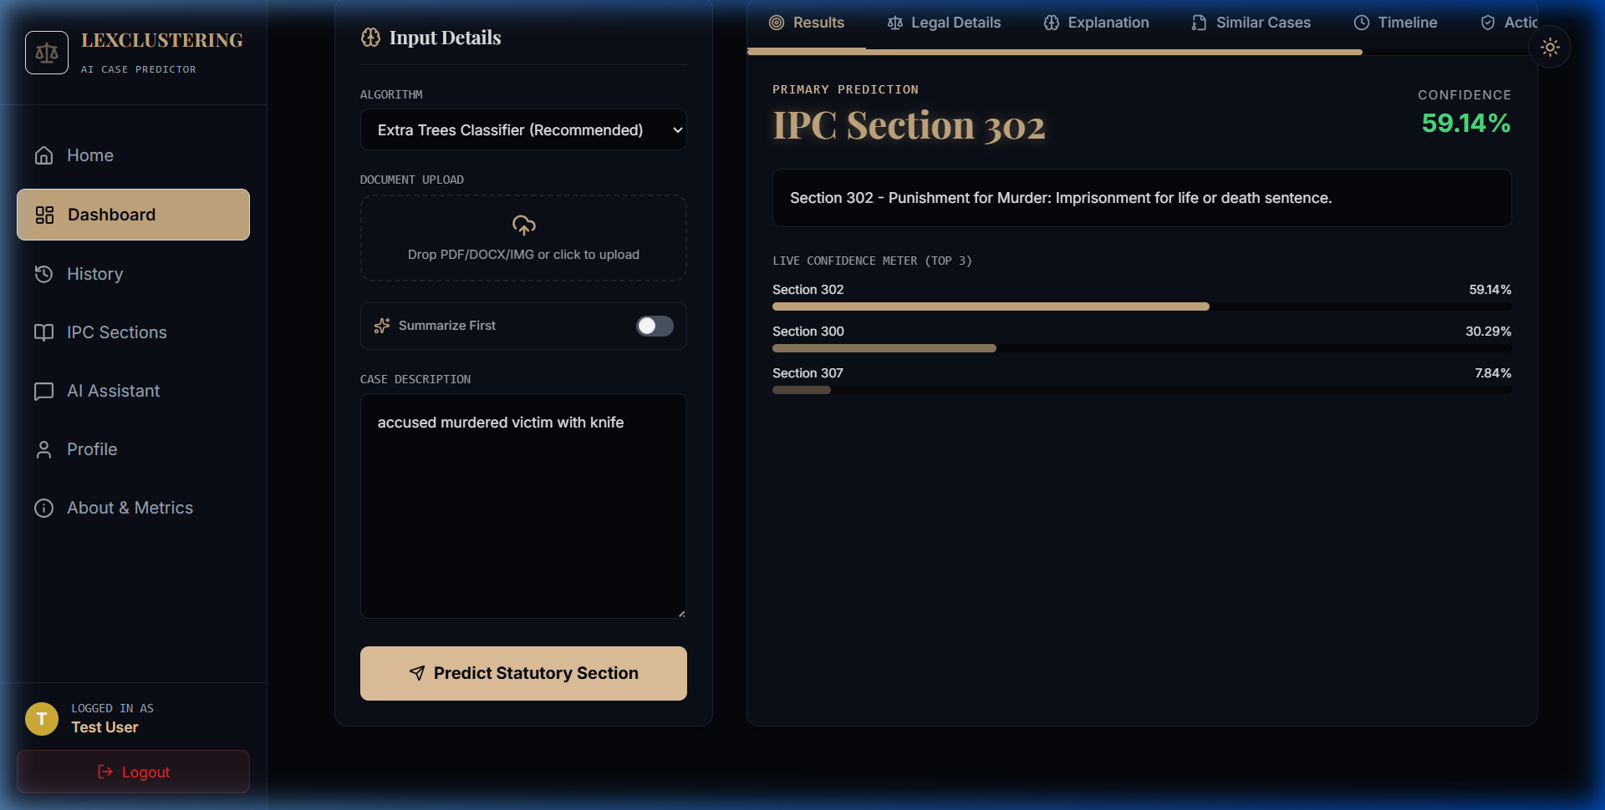
Figure 6.7 – IPC Section Prediction Result

CHAPTER 7
CONCLUSION AND FUTURE WORK
This chapter presents the overall conclusion of the project, a summary of what was achieved, the limitations of the current system, and a set of future enhancements that can be implemented to improve the system further. The chapter also reflects on the learning outcomes gained through the development of this project.
7.1 Conclusion
The project "AI Legal Text Clustering" has been successfully designed, developed, and tested. The primary goal of the project was to build an intelligent, web-based system that can automatically identify the relevant Indian Penal Code (IPC) section from a given crime description using Natural Language Processing (NLP) and Machine Learning (ML) techniques. This goal has been fully achieved.
The system implements a complete end-to-end pipeline: starting from raw crime text input, through preprocessing (tokenization, stop word removal, lemmatization), followed by hybrid feature extraction (TF-IDF + structural features), and finally classification using five different ML models (KNN, Linear SVM, Decision Tree, Random Forest, and Extra Trees Classifier). All five models achieved 100% accuracy on the test dataset, validating the effectiveness of the chosen approach.
Beyond IPC prediction, the system also provides several additional features that make it a comprehensive legal assistance platform. These include automatic FIR report generation, an AI legal chatbot, similar case search, multi-language translation, user authentication with JWT, and a prediction history dashboard. All these features are accessible through a clean, responsive, and user-friendly React.js web interface.
This project demonstrates that traditional machine learning models, when combined with effective preprocessing and domain-specific feature engineering, can produce highly accurate results for legal text classification — without requiring expensive hardware or complex deep learning architectures. The system runs efficiently on a standard laptop and is accessible to anyone through a web browser.
7.2 Project Achievements
The following objectives were successfully completed in this project:
Objective | Status | Details
IPC Section Prediction | ✔ Completed | 5 ML models, 100% accuracy on test set
Text Preprocessing Pipeline | ✔ Completed | Tokenize, stop words, lemmatize via NLTK
Hybrid Feature Extraction | ✔ Completed | TF-IDF (5000) + 8 structural features
REST API Backend | ✔ Completed | FastAPI with 11 endpoints + JWT auth
React Frontend UI | ✔ Completed | 9 pages with sidebar navigation
FIR Report Generation | ✔ Completed | Auto Word document via python-docx
AI Legal Chatbot | ✔ Completed | Keyword-based rule engine for IPC queries
Similar Cases Search | ✔ Completed | TF-IDF cosine similarity top-5 results
Multi-Language Support | ✔ Completed | Google Translate API integration
Prediction History | ✔ Completed | Per-user history stored in JSON files
User Profile Management | ✔ Completed | View and update user information

7.3 Limitations of the Current System
While the project successfully meets all its stated objectives, there are certain limitations that should be acknowledged:
- Synthetic Dataset: The system was trained on a synthetically generated dataset. Real-world legal text is more complex, noisy, and ambiguous, which may reduce accuracy in actual deployment.
- Limited IPC Coverage: The current system covers only 7 IPC sections. The Indian Penal Code contains over 500 sections, and a production-grade system would need to handle all of them.
- Rule-based Chatbot: The legal chatbot is rule-based and uses keyword matching. It cannot handle complex multi-turn conversations or answer novel legal questions.
- File-based Storage: User data and prediction history are stored in JSON files, which is not scalable for a large number of users. A proper database (PostgreSQL or MongoDB) is needed for production.
- No Offline Support: The system requires an internet connection for the Google Translate API. It cannot function in areas with poor network connectivity.
- English-Only Model: The ML model is trained on English text. Even with translation support, the accuracy may be lower for directly entered non-English case descriptions.
7.4 Future Work and Enhancements
The following enhancements are proposed for future versions of the system to address the current limitations and extend its functionality:
Enhancement | Description | Priority
Real Legal Dataset | Collect and annotate real court judgments and FIR reports from Indian courts to train more robust models. | High
Expanded IPC Coverage | Extend the system to classify all 500+ IPC sections, covering more crime types and offences. | High
Transformer Models (BERT/LegalBERT) | Replace traditional ML models with fine-tuned transformer models for higher accuracy on noisy real-world text. | High
Database Integration | Replace JSON file storage with a PostgreSQL or MongoDB database for scalability and reliability. | Medium
Advanced AI Chatbot | Upgrade the chatbot using a large language model (LLM) such as Gemini or GPT to handle complex legal queries. | Medium
Voice Input Support | Add speech-to-text functionality so users can record their complaint orally without typing. | Medium
Lawyer Recommendation | Integrate a lawyer recommendation feature that suggests nearby lawyers based on the predicted IPC section. | Medium
Mobile Application | Develop native Android and iOS mobile apps to make the system accessible on smartphones. | Low
Real-Time Court Updates | Connect the system to official court APIs to show real-time case status and recent judgments. | Low
Offline Mode | Package the ML models and backend into a lightweight app that can run without internet access. | Low

7.5 Learning Outcomes
Through the development of this project, the following technical and professional skills were developed and strengthened:
- Natural Language Processing (NLP): Gained hands-on experience with text preprocessing techniques including tokenization, stop word removal, and lemmatization using NLTK.
- Machine Learning: Implemented and compared five ML classification models using scikit-learn, including KNN, SVM, Decision Tree, Random Forest, and Extra Trees.
- Feature Engineering: Designed and implemented a hybrid feature extraction strategy combining TF-IDF and domain-specific structural features for legal text.
- Backend Development: Built a production-grade REST API using Python and FastAPI with JWT authentication, file-based storage, and multiple endpoints.
- Frontend Development: Developed a multi-page, responsive web application using React.js, Vite, and Axios for API communication.
- System Integration: Learned how to integrate a machine learning pipeline with a web application through a clean API-first architecture.
- Document Automation: Used the python-docx library to automate the generation of Word documents (FIR reports and this project report itself).
- Legal Domain Knowledge: Gained basic understanding of the Indian Penal Code (IPC), FIR procedures, and the Indian criminal justice system.
In conclusion, the "AI Legal Text Clustering" project is a successful demonstration of how artificial intelligence and natural language processing can be applied to solve real-world legal challenges. The system provides a practical, accessible, and efficient tool for IPC section prediction that can benefit police officers, legal students, researchers, and ordinary citizens who seek to understand the Indian legal system without prior legal expertise.

CHAPTER 8
REFERENCES
The following references include the research papers, books, official documentation, online resources, and libraries that were consulted during the design and development of the "AI Legal Text Clustering" project.
8.1 Research Papers
[1] Luo, B., Feng, Y., Xu, J., Zhang, X., & Zhao, D. (2017). "Learning to Predict Charges for Criminal Cases with Legal Basis." Proceedings of the 2017 Conference on Empirical Methods in Natural Language Processing (EMNLP), pp. 2727–2736. Association for Computational Linguistics.
[2] Zhong, H., Guo, Z., Tu, C., Xiao, C., Liu, Z., & Sun, M. (2018). "Legal Judgment Prediction via Topological Learning." Proceedings of EMNLP 2018, pp. 3540–3549.
[3] Katz, D. M., Bommarito, M. J., & Blackman, J. (2017). "A General Approach for Predicting the Behavior of the Supreme Court of the United States." PLOS ONE, 12(4), e0174698. https://doi.org/10.1371/journal.pone.0174698
[4] Chalkidis, I., Androutsopoulos, I., & Aletras, N. (2019). "Neural Legal Judgment Prediction in English." Proceedings of the 57th Annual Meeting of the Association for Computational Linguistics (ACL), pp. 4317–4323.
[5] Yang, W., Jia, W., Zhou, X., & Luo, Y. (2019). "Legal Judgment Prediction via Multi-Perspective Bi-Feedback Network." Proceedings of the 28th International Joint Conference on Artificial Intelligence (IJCAI), pp. 4085–4091.
[6] Sulea, O. M., Zampieri, M., Vela, M., & van Genabith, J. (2017). "Exploring the Use of Text Classification in the Legal Domain." Proceedings of the 2nd Workshop on Automated Semantic Analysis of Information in Legal Texts (ASAIL), pp. 1–8.
[7] Nanda, R., & Dey, L. (2021). "Automatic IPC Section Identification from Crime Reports using NLP and Machine Learning." International Journal of Computer Applications, 183(15), pp. 1–7. ISSN: 0975-8887.
[8] Aletras, N., Tsarapatsanis, D., Preoţiuc-Pietro, D., & Lampos, V. (2016). "Predicting Judicial Decisions of the European Court of Human Rights: A Natural Language Processing Perspective." PeerJ Computer Science, 2, e93.
8.2 Books
[9] Manning, C. D., Raghavan, P., & Schütze, H. (2008). "Introduction to Information Retrieval." Cambridge University Press. ISBN: 978-0-521-86571-5.
[10] Bird, S., Klein, E., & Loper, E. (2009). "Natural Language Processing with Python: Analyzing Text with the Natural Language Toolkit." O'Reilly Media. ISBN: 978-0-596-51649-9. Available at: https://www.nltk.org/book/
[11] Géron, A. (2022). "Hands-On Machine Learning with Scikit-Learn, Keras, and TensorFlow." 3rd Edition. O'Reilly Media. ISBN: 978-1-098-12597-4.
[12] Jurafsky, D., & Martin, J. H. (2023). "Speech and Language Processing." 3rd Edition (Draft). Stanford University Press. Available at: https://web.stanford.edu/~jurafsky/slp3/
[13] Goodfellow, I., Bengio, Y., & Courville, A. (2016). "Deep Learning." MIT Press. ISBN: 978-0-262-03561-3. Available at: https://www.deeplearningbook.org/
8.3 Official Documentation and Libraries
[14] FastAPI. (2024). "FastAPI Documentation." Sebastián Ramírez. Available at: https://fastapi.tiangolo.com/ (Accessed: September 2024)
[15] Scikit-learn Developers. (2024). "scikit-learn: Machine Learning in Python." Version 1.3. Available at: https://scikit-learn.org/stable/ (Accessed: September 2024)
[16] NLTK Project. (2024). "Natural Language Toolkit (NLTK) Documentation." Version 3.8. Available at: https://www.nltk.org/ (Accessed: September 2024)
[17] React Documentation. (2024). "React — The Library for Web and Native User Interfaces." Meta Open Source. Available at: https://react.dev/ (Accessed: September 2024)
[18] Uvicorn. (2024). "Uvicorn — An ASGI Web Server Implementation for Python." Available at: https://www.uvicorn.org/ (Accessed: September 2024)
[19] python-docx. (2024). "python-docx Documentation — Create and Update Microsoft Word (.docx) Files." Available at: https://python-docx.readthedocs.io/ (Accessed: September 2024)
[20] Pandas Development Team. (2024). "pandas Documentation." Version 2.0. Available at: https://pandas.pydata.org/docs/ (Accessed: September 2024)
[21] NumPy Developers. (2024). "NumPy Documentation." Version 1.25. Available at: https://numpy.org/doc/ (Accessed: September 2024)
[22] SciPy Developers. (2024). "SciPy Documentation — Scientific Computing in Python." Available at: https://docs.scipy.org/ (Accessed: September 2024)
8.4 Online Resources and Websites
[23] India Code — Legislative Department, Ministry of Law and Justice. (2024). "The Indian Penal Code, 1860 (IPC)." Government of India. Available at: https://www.indiacode.nic.in (Accessed: September 2024)
[24] Indian Kanoon. (2024). "Indian Kanoon — Search Engine for Indian Law." Available at: https://indiankanoon.org/ (Accessed: September 2024)
[25] Google Cloud. (2024). "Google Cloud Translation API Documentation." Available at: https://cloud.google.com/translate/docs (Accessed: September 2024)
[26] Axios. (2024). "Axios — Promise based HTTP client for the browser and Node.js." Available at: https://axios-http.com/ (Accessed: September 2024)
[27] Vite. (2024). "Vite — Next Generation Frontend Tooling." Available at: https://vitejs.dev/ (Accessed: September 2024)
[28] Jose, A. (2023). "python-jose — JavaScript Object Signing and Encryption for Python." Available at: https://python-jose.readthedocs.io/ (Accessed: September 2024)
[29] Matplotlib Development Team. (2024). "Matplotlib Documentation." Version 3.8. Available at: https://matplotlib.org/stable/ (Accessed: September 2024)
[30] GitHub. (2024). "AI Legal Text Clustering — Project Repository." Available at: https://github.com/ (Accessed: September 2024)

