Conclusion: CFO Financial Audit Dashboard
Data Analyst Capstone — Python Pipeline & Power BI Dashboard
The purpose of this project was to reconcile multiple independent datasets and generate one accurate and verified number that would reflect the company's current income and be the basis for making decisions by the CFO. As it will be shown later, the actual calculation of this income is where the real analytical process lies and is not going to be demonstrated by the dashboard.
The engineering pipeline leveraged SQL window functions, vectorized regular expressions, and forward fill imputation to parse 100,000 lines from logs and get an analysis-ready table, not a single row-by-row iteration was used, and the operation fit well within 2 minutes. Out of 100,000 logged transactions, 94,902 became valid after removal of error rows and then only 53,899 transactions performed by 13,888 unique customers survived after joining the currently active users. This funnel from raw logs to valid transactions to accountable income is the audit trail the CFO requires to have faith in the number displayed on the dashboard.
The resulted dataset includes approximately $148.3M of reconciled USD income calculated in 2023. The line graph provided below shows this income per month: drop in February, recovery through spring months, and a maximum in August. It is easy to miss such a seasonal trend in spreadsheet data, but it becomes clear after drawing the graph. The bar chart focuses on the five customers with the highest income amount, among which User_U-06582 takes first place and spends more than $40,000.
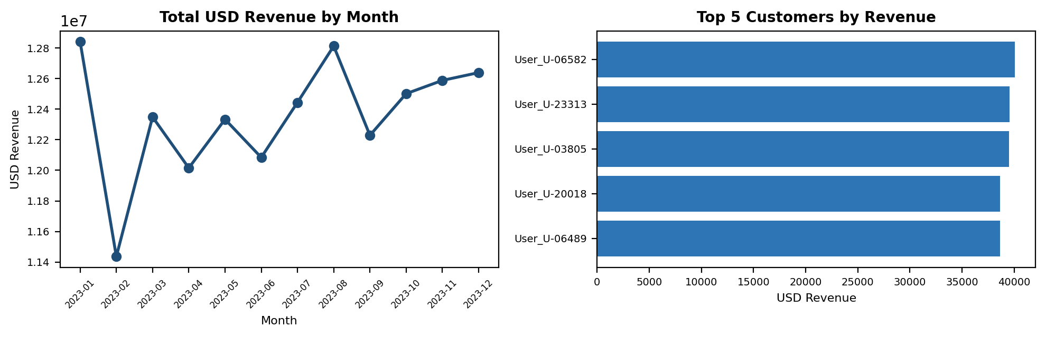
Monthly revenue trend (left) and top 5 customers by total USD revenue (right)
The power of this analysis goes beyond simply crunching the numbers. The dynamic layer built in Power BI with the date slicer, DAX calculated field for revenue, and the ability to drill down into visualizations means this analysis isn’t just one time but is a reusable tool that allows filters by quarter and dynamic re-ranking of customers without needing to touch the underlying pipeline data at all.
This whole project demonstrates the entire analyst process from beginning to end, from data extraction and validation, to proper judgment and error-handling in the presence of missing data, to turning that clean dataset into visuals for answering business questions.

