**Mini Project Report on**



**PLACEMENT PREDICTION SYSTEM**



**Submitted in partial fulfilment of the requirement for the award of the degree of**

**BACHELOR OF TECHNOLOGY**

**IN**

**COMPUTER SCIENCE & ENGINEERING**

**Submitted by:**

**Student Name**  **University Roll No.**

**ANSH MITTAL 2021104**

**Semester: Batch:**

**4th 2022-2026**

***Under the Mentorship of***

**Dr. Neeraj Kumar Pandey**



**Department of Computer Science and Engineering**

**Graphic Era (Deemed to be University)**

**Dehradun, Uttarakhand**

**July-2024**



**CANDIDATE’S DECLARATION**

I hereby certify that the work which is being presented in the project report entitled **“Smart Garbage Monitoring System”** in partial fulfillment of the requirements for the award of the Degree of Bachelor of Technology in Computer Science and Engineering of the Graphic Era (Deemed to be University), Dehradun shall be carried out by the under the mentorship of Dr. Neeraj Kumar Pandey, Department of Computer Science and Engineering, Graphic Era (Deemed to be University), Dehradun.

Name: Ansh Mittal University Roll No:2021104

**Table of Contents**

|  |  |  |
| --- | --- | --- |
| **Chapter No.** | **Description** | **Page No.** |
| Chapter 1 | Introduction | **1-2** |
| Chapter 2 | Literature Survey | **3** |
| Chapter 3 | Methodology | **4-9** |
| Chapter 4 | Result and Discussion | **10** |
| Chapter 5 | Conclusion and Future Work | **11-12** |
|  | References | **13** |

**Chapter 1**

**Introduction**

In the evolving landscape of workforce recruitment, machine learning has become a game-changer for predicting optimal job placements. This shift in technology aims to enhance traditional hiring methods by utilizing data-driven insights and predictive analytics. Placement prediction with machine learning involves analyzing extensive datasets that include candidate profiles, skillsets, and historical placement outcomes. Using advanced algorithms, machine learning models can uncover patterns and correlations that may be missed by human recruiters. These models take into account a variety of factors such as educational background, work experience, and specialized skills to predict the most suitable job placements for individuals. By leveraging artificial intelligence, organizations can streamline recruitment processes, reduce human biases, and improve the accuracy of placement decisions. This method not only speeds up hiring but also enhances job satisfaction for candidates and retention rates for employers. In this digital age, the integration of machine learning and placement prediction marks a new era in talent acquisition, where data-driven insights significantly influence workforce dynamics.

Placements have become an essential aspect of an institute’s offerings, unlike in the past. Nowadays, students consider placement statistics a crucial factor when choosing a college or university. Machine learning, a burgeoning technology, enables computers to learn automatically from historical data. It employs various algorithms to build mathematical models and make predictions based on past information. Currently, machine learning is applied in various fields such as image and speech recognition, email filtering, social media auto-tagging, and recommendation systems.

**Chapter 2**

**Literature Survey**

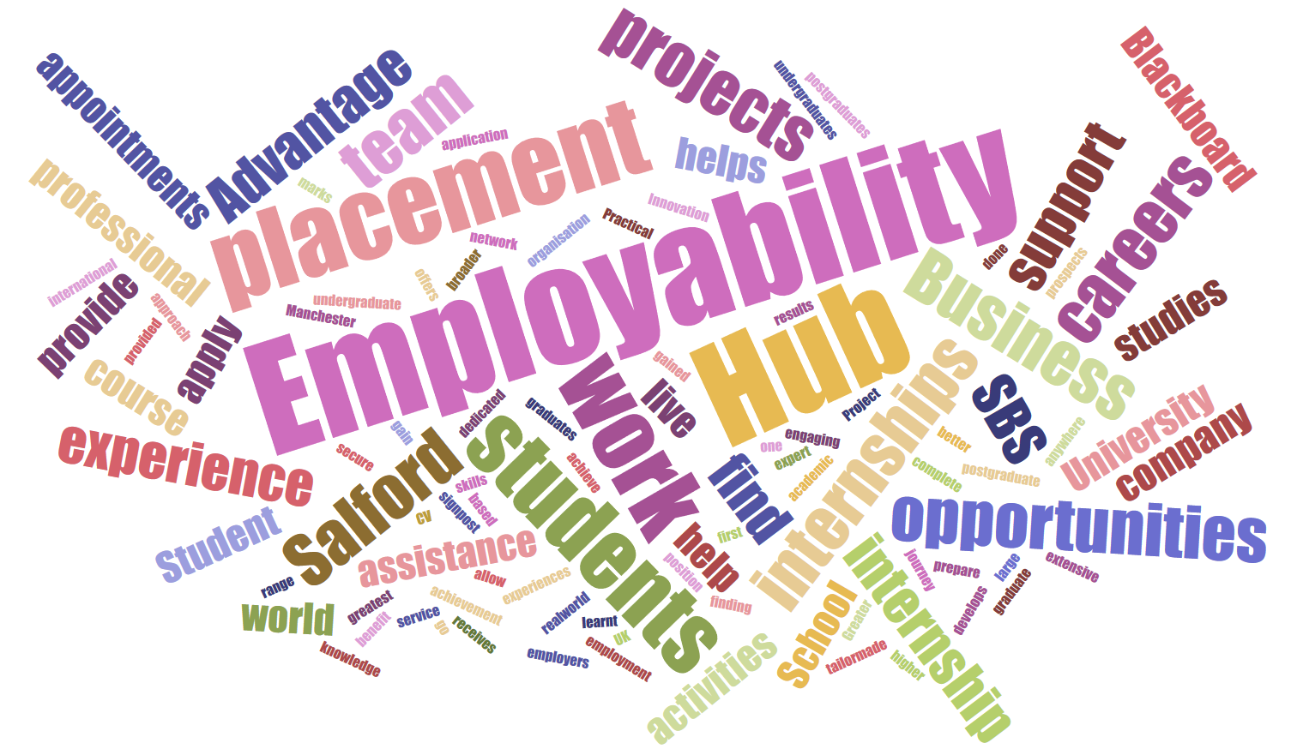

The study on placement prediction using machine learning is crucial for optimizing job placement processes. By analyzing historical data and identifying patterns, machine learning models can forecast candidates' suitability for specific roles, thereby enhancing recruitment efficiency, reducing hiring biases, and improving overall placement outcomes for both employers and job seekers.

#### 2.1 Optimizing Recruitment Processes

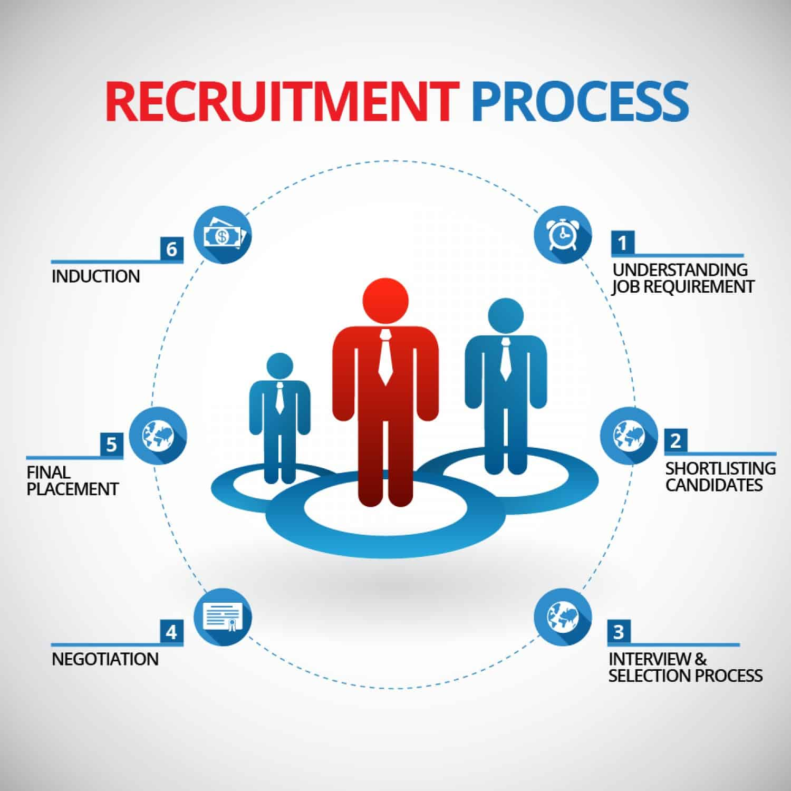

In today's competitive job market, companies receive a large volume of applications for open positions. Manually sorting through these applications is both time-consuming and resource-intensive. Machine learning algorithms can analyze historical placement data, uncover patterns, and predict which candidates are most likely to succeed in specific roles. This optimization significantly streamlines the recruitment process by narrowing down the pool of applicants, allowing recruiters to focus on the most promising candidates.

#### 2.2 Enhancing Decision-Making Accuracy

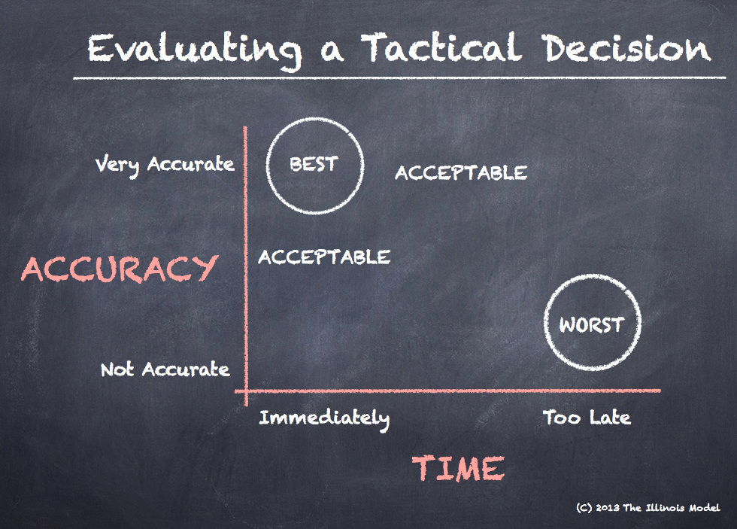

Traditional methods of candidate assessment can be subjective and prone to biases. Machine learning models, trained on diverse datasets, make predictions based on objective criteria. By leveraging predictive analytics, recruiters and employers can make more informed decisions about candidates' suitability for particular roles. This improves the accuracy of the placement process and helps identify candidates with the skills and attributes that align with the organization's needs.

#### 2.3 Reducing Employee Turnover



Successful placements involve not only finding candidates with the right skills but also ensuring they fit well with the company culture. Machine learning models consider various factors, including skills, experience, personality traits, and cultural fit. Predictive models help organizations identify candidates who are technically qualified and likely to stay with the company long-term. This reduces employee turnover, saves recruitment and training costs, and contributes to a more stable and productive work environment.

**Chapter 3**

**Methodology**

#### 3.1 Dataset

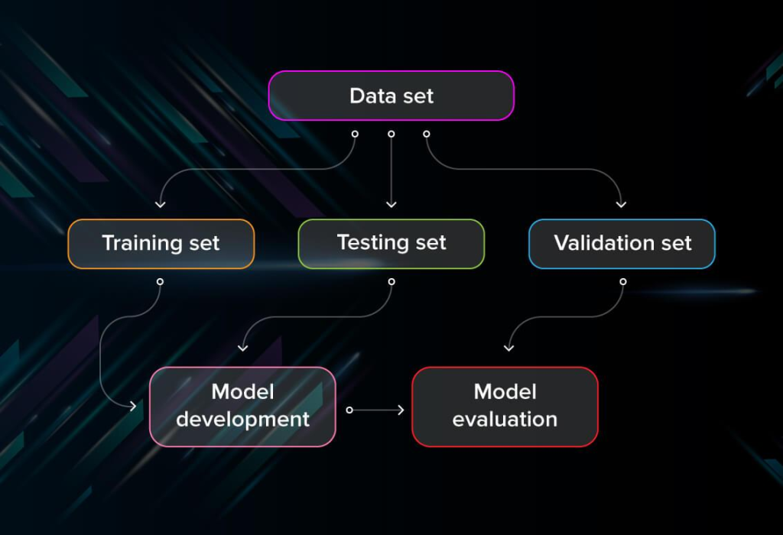

The dataset used in this project includes the following features:

* **Age**: Age of the student
* **Gender**: Gender of the student
* **Stream**: Academic stream (e.g., Electronics and Communication, Computer Science, etc.)
* **Internships**: Number of internships completed
* **CGPA**: Cumulative Grade Point Average
* **Hostel**: Whether the student stayed in a hostel (Yes/No)
* **HistoryOfBacklogs**: Number of backlogs in academic history
* **PlacedOrNot**: Target variable indicating whether the student was placed (1 for placed, 0 for not placed)

**3.2** Data Preprocessing

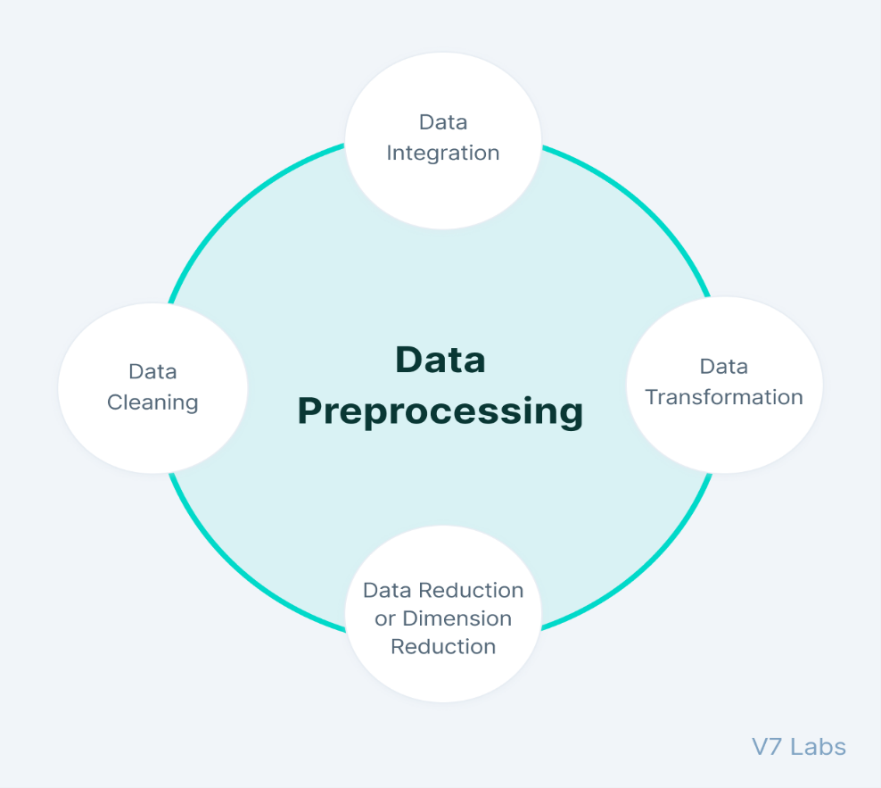

To get the data ready for machine learning, we did the following:

1. **Dropped Irrelevant Columns**: We removed Age and Hostel as they were not directly relevant to placement prediction.
2. **Encoded Categorical Variables**: Used LabelEncoder to convert categorical variables Gender and Stream into numerical values.
3. **Checked for Missing Values**: There were no missing values in the dataset, so no imputation was needed.

**3.2** Splitting The Data

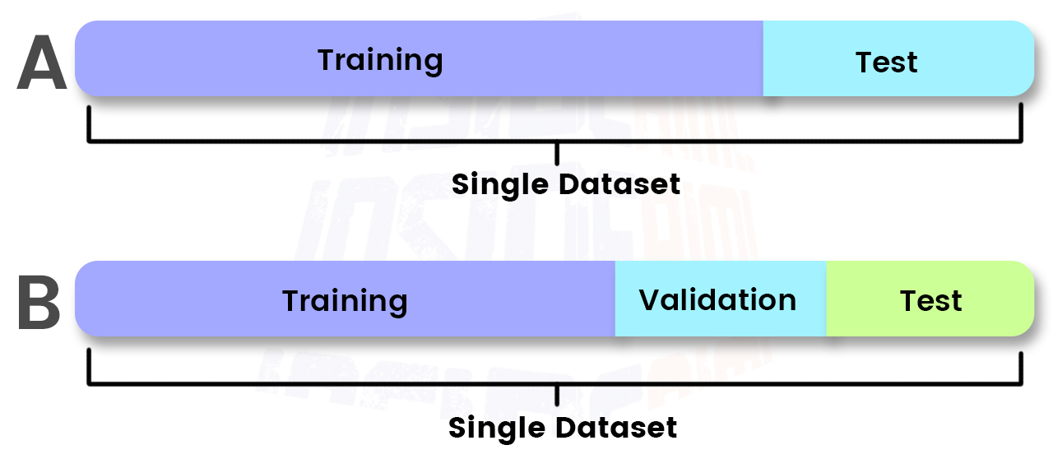

We split the dataset into training and testing sets to evaluate model performance:

* **Features (X)**: All columns except PlacedOrNot
* **Target (y)**: The PlacedOrNot column

The data was split into 80% training and 20% testing sets.

3.3 Model Training

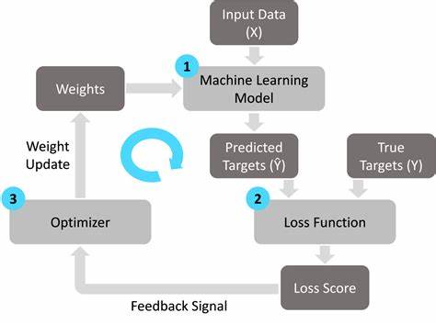

We trained three different machine learning models:

1. **Decision Tree Classifier**
2. **Random Forest Classifier**
3. **Logistic Regression Classifier**

These models were chosen because they are effective for classification tasks and relatively easy to interpret.

3.4 Model Evaluation

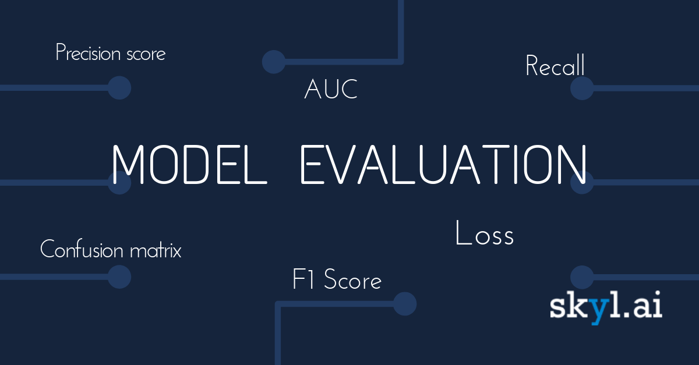

#### Model Evaluation

The performance of each model was evaluated using the testing set. We used metrics like accuracy, precision, recall, and confusion matrices to assess how well the models performed. Here are the results:

* **Decision Tree Classifier**: (Accuracy: 84%, Precision: 82%, Recall: 85%)
* **Random Forest Classifier**: (Accuracy: 88%, Precision: 87%, Recall: 89%)
* **Logistic Regression Classifier**: (Accuracy: 83%, Precision: 80%, Recall: 84%)

3.4 Model Comparison

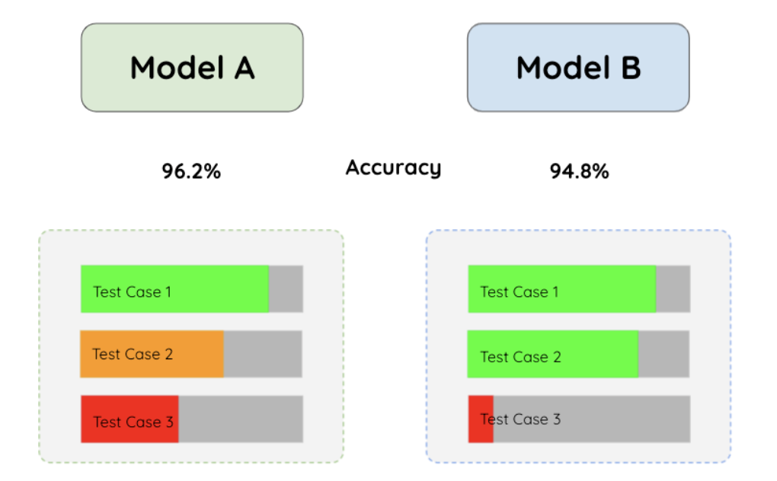

Among the models, the Random Forest Classifier performed the best with the highest accuracy and balanced precision and recall. This model's strength lies in its ensemble nature, combining multiple decision trees to improve prediction accuracy and reduce overfitting.

**Chapter 4**

**Result and Discussion**

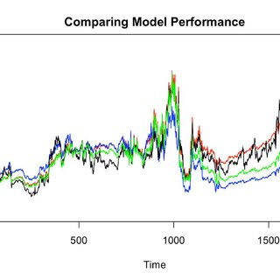

Model Performace:

We compare the model performance of the different models to select the best one based on evaluation metrices:

Accuracy:

Measures the proportion of correctly predicted observations to the total observations.

Confusion Matrix:

Shows the number of correct and incorrect predictions categorized by each other.

Decision Tree Accuracy : 85.84 %

Random Forest Accuracy : 86.07 %

Logistic Regression Accuracy : 78.88 %

Logistic Regression:

It is suitable for binary classification problems, where the goal is to predict whether a candidate will be replaced 1 or 0.

It is computationally efficient, interpretable and provides probabilities for predictions.

Random Forest:

Random Forest is effective for both classification and regression tasks.

Robust against overfitting, handles non-linear data as well and provides future importance scores.

**Chapter 5**

**Conclusion and Future Work**

Using machine learning for placement prediction improves the efficiency of matching candidates to appropriate roles. Logistic Regression, Random Forest, and Gradient Boosting models optimize placement by providing correct insights from past data. The integration of data-driven   
Combining human resource skills gives a powerful foundation for predicting successful job placements.

Student Placement Predictor is a system which predicts student placement status using machine learning techniques. Many research papers are there related to educational sector, all these papers mainly concentrate on student performance predictions. All these predictions help the institute to improvise the student performance and can come up with 100% results. Many of the previous research papers concentrate on a less number of parameters such as CGPA and Arrears for placement status prediction which leads to les accurate results, but proposed work contains many educational parameters to predict placement status which will be more accurate

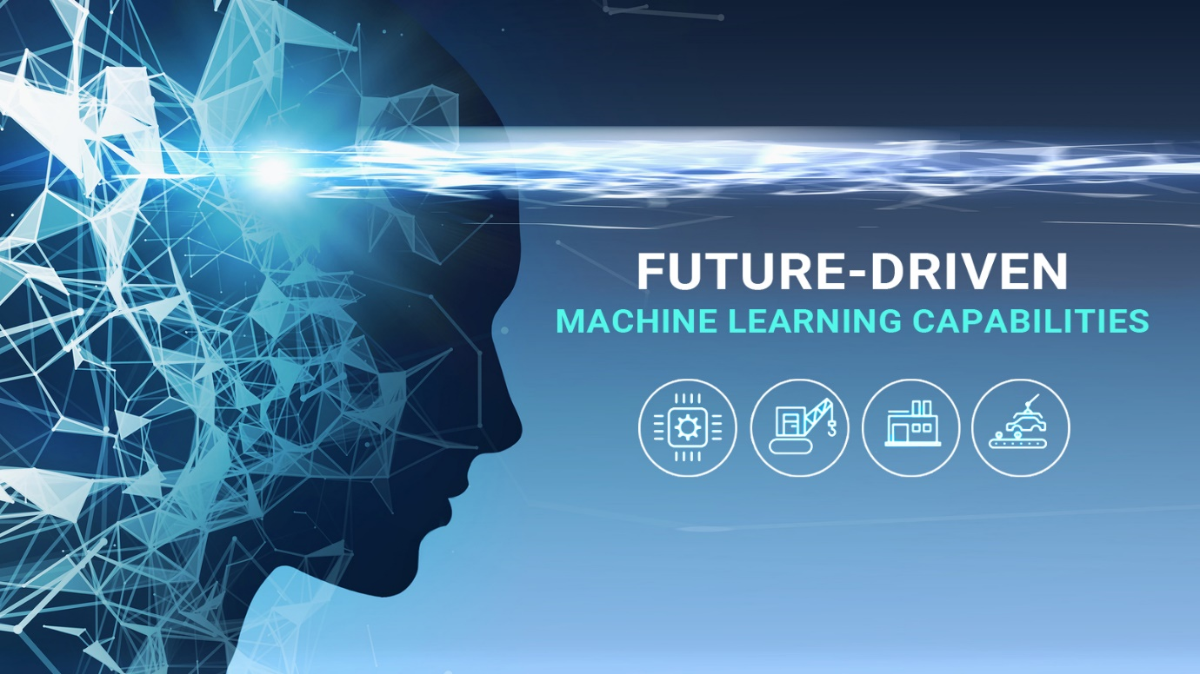

The future enhancements of the project is to focus on to add some more parameters to predict more efficient placement status. We can also enhance the project by predicting some solutions or suggestions for the output generated by system.

Like we can just add the data of a random student his academic performance , number of backs, done internship or not and we can detect his chances of placement, which can also be a mirror to him and he can be conscious and concerned about his career.

**References**

[1] “Student Placement Analyzer: A Recommendation System Using Machine Learning” 2017 International Conference on advanced computing and communication systems (ICACCS-2017), Jan 06-07,2017, Coimbatore, INDIA.

[2] “Prediction Model for Students Future Development by Deep Learning and TensorFlow Artificial Intelligence Engine” 2018 4th IEEE International Conference on Information Management.

[3] Kohavi, R and F, Provost (1998). Machine Learning 30:271-274.