**Chapter 1: Introduction**

**Background of the Project**

In this digital-first age, cybersecurity has emerged as a critical domain that protects sensitive information, systems, and networks from hostile attacks. Be it financial institutions and healthcare services, educational websites and government portals, the ever-growing dependence on the internet has opened up digital systems to unprecedented vulnerabilities and cyber threats. Vulnerability scanners like OWASP ZAP, Burp Suite, and Nessus have been utilized for years by security experts to find and examine prospective vulnerabilities in web applications. Unfortunately, these instruments tend to arrive with a cost: complicated setup, system-demanding requirements, platform dependence (such as Kali Linux), and a daunting learning curve for new users.

Seeing the necessity for an easier and user-friendly approach, this project was initiated to create a cloud-based vulnerability scanner that bridges the technical complexities of conventional scanners and the ease of use of contemporary web applications. Utilizing cloud technologies, artificial intelligence, and simple frontend frameworks, the solution seeks to enable users with diverse levels of knowledge to perform effective vulnerability scans with minimum technical knowledge and expensive hardware.

**Problem Statement**

Despite the availability of robust vulnerability scanning tools, several limitations hinder widespread adoption and usability:

* **High Resource Requirements:** Traditional scanners like Nessus or ZAP often need resource-heavy environments (e.g., Kali Linux, virtual machines).
* **Complex User Interfaces:** Tools generally favor professionals and may overwhelm students or novice users.
* **Manual Remediation:** Most tools identify vulnerabilities but do not assist with remediation unless paid versions are used.
* **Fragmented Functionalities:** Domain analysis (e.g., WHOIS lookups), DNS mapping, and security scanning are frequently accomplished with independent tools.
* **Absence of AI Integration:** There is a lack of utilizing AI to analyze vulnerability findings and create actionable mitigation steps in real time.

This project aims to address these issues by creating an intelligent, integrated, cloud-based vulnerability scanner.

**Project Overview**

The suggested system, "AI-Powered Cloud-Based Vulnerability Scanner", is an easy-to-use web application incorporating OWASP ZAP API for vulnerability scanning and WHOIS API for domain insights. Developed on Python, Flask, and React.js, the system offers an effortless user experience with a responsive UI and simple scanning process. Most importantly, the solution makes use of Google Gemini AI to provide customized remediation recommendations from scan results, replicating the advice of a seasoned cybersecurity analyst.

The project was undertaken in three formal phases:

* **Phase 1 (CLI-based Scanner):** Command-line Python application leveraging OWASP ZAP API for scanning sites and identifying security vulnerabilities.
* **Phase 2 (GUI-based Application):** Built with HTML, CSS, JavaScript, and Flask for delivering a visual frontend, combined with WHOIS lookup functionality.
* **Phase 3 (AI Integration & React.js Upgrade):** Switch to React.js frontend, usage of Tailwind CSS for new responsive design, and integration with AI through Gemini API to provide smart remediation suggestions.

The program is mobile-responsive, cross-platform compatible through browsers, and takes away the reliance on operating system-based tools.

**Project Motivation**

The inspiration for this project arose from two concurrent observations:

* **Educational and Practical Need:** As a student and cybersecurity enthusiast, there was an evident gap between studying cybersecurity concepts and implementing them with conventional tools. Most of the available scanners are strong but not learner-friendly or accessible to those who lack access to strong machines or Linux environments.

**Project Scope**

This project provides the following salient features and functionalities:

* A lightweight, web-based vulnerability scanner constructed with Python (Flask) and React.js.
* Incorporation of OWASP ZAP API for the identification of known web application vulnerabilities.
* Domain WHOIS lookup for retrieving domain ownership and registrar data.
* AI-generated remediation instructions for every vulnerability from the Google Gemini API.
* Mobile-first, responsive UI developed with Tailwind CSS.
* Cloud-deployable architecture eliminates the need for dependence upon local operating systems.
* Future plans for extension into AI-powered threat parsing, phishing detection, and mobile application development (through PWA).

The present implementation is suitable for small security teams, students, and startups who want a dependable scanning tool without the sophistication of enterprise-level setups.

**Significance of the Project**

The significance of the project is its ease of access, automation, and smarts. The tool provides, by integrating standard scanning mechanisms with contemporary web development frameworks and AI, the following:

* **Educational Utility:** Students and cybersecurity students are able to utilize the scanner without advanced setups or powerful equipment.
* **Real-Time AI Support:** Users are provided with remediation recommendations real-time, lowering dependency on manual investigations or expert advice.
* **Relevance:** Designing the system based on on-the-job experience in using ArcSight SIEM and cybersecurity processes makes it relevant to real-world situations.
* **Flexibility:** With potential modules in the future such as AI-driven phishing detection and smart data parsing, the project provides space for professional and academic research.

In conclusion, this project not only provides a functional solution but also illustrates the implementation of theoretical knowledge, industry training, and advanced technologies in developing a scalable and effective cybersecurity tool.

**Chapter 2: Objectives**

**Primary Objective**

The core objective of this project is to conceptualize, design, and implement a cloud-based, AI-integrated vulnerability scanning platform that streamlines the identification, assessment, and remediation of security flaws in web applications. This solution aspires to simplify the traditionally complex process of vulnerability management by combining automated scanning, domain intelligence, and contextual AI-powered recommendations into a unified, user-friendly platform. Emphasis is placed on cross-platform accessibility, allowing both cybersecurity professionals and novices to conduct assessments efficiently via command-line tools, browser-based interfaces, and intelligent automation layers.

**Specific Objectives**

To systematically accomplish the overarching vision, the project is divided into key developmental phases and features, each with precise technical goals:

1. **Development of a Command-Line Interface (CLI) Vulnerability Scanner (Phase 1)**
   * Develop a base Python CLI that interfaces with the OWASP ZAP API to launch active and passive scans against target web applications.
   * Add command-line arguments to provide flexibility for power users in accepting URLs, scan modes, and export options.
   * Parse and extract important vulnerability information like alert risk levels, confidence scores, and descriptions.
   * Print results in terminal-friendly formats for fast decision-making during penetration testing operations.
   * Enable local debugging, rapid iteration, and lightweight operation without needing graphical elements.
2. **Design and Deployment of a Graphical Web Interface (Phase 2)**
   * Develop an accessible and responsive web interface based on HTML5, CSS3, and Vanilla JavaScript for seamless user interaction.
   * Build a secure Flask-based backend to handle RESTful API requests, process input validation, and start scan sessions.
   * Integrate WHOIS Lookup API to fetch domain metadata such as registration, expiration, and ownership information—providing context to the security stance of a particular domain.
   * Make zero-dependency installation possible by providing browser-based access without the necessity for local installs, making it accessible to less technical users.
3. **Migration to React.js for Component-Based Architecture (Phase 3)**
   * Rebuild the frontend interface using React.js, bringing modular component-based development for scalability and maintainability.
   * Use Tailwind CSS to optimize UI/UX with a responsive, mobile-first design system for fast prototyping and consistency across screen sizes.
   * Use dynamic state management with React Hooks to manage user input, scan results, and asynchronous API interactions.
   * Create a responsive layout with CSS Grid and Flexbox to improve responsiveness, accessibility, and visual hierarchy.
4. **Integration of AI-Powered Remediation Guidance (Phase 3)**
   * Use the Google Gemini API or a similar generative AI platform to produce contextual, readable explanations and remediation steps specific to each vulnerability found.
   * Create an AI processing layer that translates scan output (e.g., vulnerability name and CWE ID) to in-depth mitigation strategies.
   * Make generated recommendations actionable, specific, and in line with industry best practices such as OWASP and NIST frameworks.
   * Enhance learning outcomes through the application of AI to describe security threats in plain terms, for the junior analysts and students.
5. **Real-Time Terminal Output Simulation and Tabular Result Display (Phase 3)**
   * Create a web-based terminal output simulation that simulates a live scan experience, increasing user interaction and realism.
   * Implement dynamic loading indicators, command echoes, and color-coded severity levels to simulate real-world tools such as Nmap or Nikto.
   * Develop a different results view as an organized HTML table with sorting and filtering functionality to support more in-depth analysis.
   * Enable downloading reports as CSV, JSON, or PDF for archiving or compliance reporting purposes.
6. **Scalability and Accessibility via Cloud Deployment**
   * Deploy the frontend application on Vercel using its CDN-backed infrastructure for worldwide reach and delivery optimization.
   * Deploy the Flask backend and OWASP ZAP runtime environment to cloud providers like DigitalOcean or Oracle Cloud, supporting headless scanning operations through Docker containers or system daemons.
   * Discover automated CI/CD pipelines through GitHub Actions to automate development-to-deployment workflows.
   * Associate a custom domain (for example, vulnhub.anshmodi.tech) to boost brand identity and ease users' entry.

**Long-Term Objectives and Vision for Future Development**

Outside of the immediate scope, the project is intended to be a starting point for ongoing improvement and innovation in cybersecurity automation. Future development objectives are:

1. **AI-Augmented Parsing and Report Simplification**
   * Create a machine learning–based parser that can condense lengthy scan logs into brief, categorized, and severity-ranked reports.
   * Train NLP models to detect redundant entries, normalize descriptions, and emphasize exploitable trends.
2. **Autonomous AI-Powered Vulnerability Scanner**
   * Develop a native vulnerability scanner with AI-powered detection mechanisms minimizing third-party API dependency.
   * Implement heuristic, behavior-based, and anomaly detection algorithms to detect new vulnerabilities in real-time.
3. **Phishing and Malicious Domain Detection Module**
   * Employ threat intelligence feeds (e.g., VirusTotal, PhishTank) to detect and block known phishing URLs.
   * Employ machine learning classifiers to detect malicious patterns in URLs, domain age, WHOIS anomalies, and SSL certificates.
4. **PWA Development**
   * Develop a PWA version for mobile devices for rapid assessments on smartphones or tablets.
   * Provide offline functionality and push notifications for scan results or warning alerts.
5. **Cloud-Based Logging, History Tracking, and Reporting**
   * Allow permanent storage of scan history by using cloud-based databases such as Firebase or Supabase.
   * Develop user-specific dashboards with time-series charts, comparative analysis, and downloadable audit logs.
   * Implement user authentication and RBAC (Role-Based Access Control) for enterprise readiness.

**Chapter 3: Literature Survey**

A survey of literature is required to determine the current state of technology, ascertain research gaps, and establish the need for an up-to-date, AI-powered, cloud-deployed vulnerability scanning solution. This chapter investigates scholarly articles, industry reports, and case studies on web application security, automated vulnerability scanning, artificial intelligence for cybersecurity, and cloud-based deployment models.

**Survey of Vulnerability Scanning Technologies**

Vulnerability scanners are tools that automate the detection of security vulnerabilities in applications and systems. Classic scanners such as Nessus, OpenVAS, and Qualys do their best to scan against predefined known vulnerability databases (e.g., CVE, CWE, and NVD). Nonetheless, most tools continue to need expert knowledge for interpretation and remediation, thus bridging the usability gap for junior developers or analysts.

A report by Scarfone & Mell (2007), which was published by the National Institute of Standards and Technology (NIST), provided key guidelines for automated vulnerability management tools. It highlighted the requirement for consistent detection, reporting, and remediation—a gap which is still being seen in many contemporary tools which provide detection but lack proper remediation support.

**OWASP ZAP and Open-Source Scanning**

The OWASP ZAP (Zed Attack Proxy), a popular open-source web application scanner, provides a mature API and active/passive scanning features. It is cited in the OWASP Top 10 2021 Report as one of the recommended tools for security testing to be integrated into CI/CD pipelines by developers. Yet, the report mentions the difficulty of understanding scan results and incorporating those into secure development practices.

Although ZAP has a great baseline, its user interfaces and outputs are not made for less skilled users or non-cybersecurity users. This stresses the importance of improved user experience design and AI-assisted guidance, which are also objectives of this project.

**Artificial Intelligence in Cybersecurity**

Recent scholarly work has examined the use of machine learning and natural language processing (NLP) in cyber defense. A 2021 article by Ucci, Aniello, and Baldoni, "Survey of Machine Learning Techniques for Malware Analysis," examines how AI models are able to amplify detection through learning patterns beyond signature-based matching.

Yet another piece of research by Chio and Freeman (2020) in "Machine Learning and Security" explains how NLP may be used to provide automated, context-specific security suggestions. Such principles are integral to this project's AI remediation module that looks to streamline security advice with the help of generative AI (e.g., Gemini or GPT models).

**Case Study: Equifax Data Breach (2017)**

The Equifax incident, involving more than 147 million users, was caused by a patch-less Apache Struts vulnerability (CVE-2017-5638). The attack highlights the significance of prompt vulnerability detection and straightforward remediation routes.

Equifax utilized scanning tools, but misconfiguration and operator error prevented them from identifying the vulnerability, as per the U.S. Government Accountability Office (GAO) report. This real-life example provides the following recommendations:

* Automation in vulnerability discovery.
* AI-augmented remediation to minimize dependence on human interpretation.
* Cloud accessibility to facilitate centralized visibility and response.

**Case Study: Shopify Bug Bounty and DevSecOps Culture**

Shopify has implemented a DevSecOps approach, with security testing in each stage of development. With its HackerOne bug bounty program, the company identified thousands of vulnerabilities using tools such as Burp Suite and bespoke scanners.

A 2022 case study released by Shopify's engineering blog pointed out that their internal teams started to incorporate scanning tools directly into deployment pipelines, accompanied by internal documentation automatically generated by NLP.

This is consistent with the objectives of the project at hand, which aims to automate scanning and offer human-readable advice, thus making security an integral process and not an afterthought patch.

**Cloud-Hosted Security Tools: Challenges and Opportunities**

As cloud migration gains momentum in every industry, cloud hosting security tools is no longer a choice—it's a must. According to a Gartner report (2023), "by 2025, 70% of all security tools will be cloud-delivered," emphasizing the need for scalable, accessible, and platform-independent security.

However, cloud-hosting scanners increases data privacy, latency, and API reliability concerns. This project addresses those concerns through headless OWASP ZAP deployment, secure APIs, and the utilization of industry-standard cloud services such as Vercal and Oracle Cloud.

**Identified Gaps in Solutions that available in Industry**

|  |  |  |
| --- | --- | --- |
| **Feature** | **Existing Tools (e.g., Nessus, Burp Suite)** | **This Project** |
| Open Source | Limited (Burp Suite Free lacks many features) | Yes |
| AI-Powered Remediation | Rare or non-existent | Yes |
| Beginner-Friendly UI | Mostly complex or technical | Yes |
| Cloud-Hosted | Often requires local installation | Yes |
| WHOIS and Domain Intelligence | Not commonly integrated | Yes |
| Mobile-Responsive Interface | Minimal | Yes |

Table 3.1: Identify Gaps

**Chapter 4: System Analysis**

System analysis entails recognizing the functional and non-functional specifications of the system, analyzing the existing technological scenario, determining flaws in current tools, and outlining a solution effective enough to serve the user's purpose. The chapter offers a detailed analysis of the suggested AI-Powered Cloud-Based Vulnerability Scanner, giving rise to the system's structure and development process.

**Existing System Overview**

There are many tools available in the market to scan web application vulnerabilities. These are:

* **Nessus:** A commonly used vulnerability scanning tool that provides extensive coverage but is paid and resource-intensive.
* **Burp Suite:** Used by penetration testers, providing manual and automated web security testing. However, its free version is limited, and its Pro version is costly.
* **OpenVAS:** A capable open-source scanner, but its learning curve is steep and system resources are large.
* **OWASP ZAP:** An open-source tool with good active/passive scanning strength, but its user interface and raw outputs tend to need expert knowledge to interpret.

Even with strengths, these tools generally suffer from the following limitations:

* No AI-based remediation recommendations.
* Difficult accessibility by non-technical users.
* Low cloud support or high setup cost.
* No mobile-friendly interfaces or on-the-move scanning.
* Insufficient integration with domain intelligence tools such as WHOIS.

**Problem Definition**

The chief issues with existing vulnerability scanning products are:

* **Newbie Complexity:** Most of the products need cyber security or network knowledge to set up, execute, and understand outputs.
* **Disperse Tools and Functionality:** A user tends to need different products for scanning, domain data, and remediation, which poses friction.
* **Lack of AI Guidance:** There is raw output from tools but no context-based suggestions, which are vital in enabling rapid, effective remediation.
* **Limited Flexibility of Deployment:** Most tools are desktop-bound and cannot be remotely accessed or incorporated into contemporary workflows.
* **No Real-Time UX:** The lack of a dynamic interface (e.g., terminal simulation or responsive design) makes these tools less interactive or intuitive.

**Proposed System Overview**

In order to overcome the above-mentioned challenges, this project suggests an AI-driven cloud-based vulnerability scanner that incorporates:

* A Python-based CLI scanner utilizing the OWASP ZAP API for terminal usage.
* A GUI web application for enhanced access, developed with Flask and JavaScript.
* A Tailwind CSS-powered React.js frontend for a contemporary, responsive feel.
* Google Gemini API (or equivalent) integration to offer AI-created remediation advice.
* WHOIS Lookup API integration for intelligence about domain registration.
* Terminal-like UX simulation and tabular data output to maximize engagement.
* Vercel (frontend) and DigitalOcean/Oracle Cloud (backend) deployment for remote usage.
* Practical lessons gleaned from real-world cybersecurity expertise, enhancing the system's real-world usability.

**Feasibility Study**

|  |  |
| --- | --- |
| **Type** | **Description** |
| **Technical Feasibility** | The technologies used (Python, Flask, React.js, OWASP ZAP, Gemini AI, WHOIS API) are open-source, well-supported, and integrable via REST APIs. Cloud platforms like Vercel and Oracle Cloud simplify deployment. |
| **Operational Feasibility** | The project can be used by developers, cybersecurity trainees, and analysts without needing deep security expertise. AI-generated remediation and clean UI reduce learning curves. |
| **Economic Feasibility** | Uses mostly free or community-tier APIs and services. Budget remains minimal as deployment on services like Vercel and Oracle Cloud offers generous free tiers. |
| **Legal/Compliance Feasibility** | The tool does not store or manipulate sensitive data. WHOIS and vulnerability scan results are publicly accessible. AI integrations comply with usage terms. |

Table 4.1: Feasibility Study

**SWOT Analysis**

* **Strength:**
  + Cost-effective
  + Cross-platform accessibility
  + Beginner-friendly UI
  + Modular and scalable architecture
* **Weakness:**
  + Limited by OWASP ZAP’s scanning capabilities
  + AI remediation depends on external API limits
  + Complex integrations may require ongoing maintenance
* **Opportunities:**
  + Growing demand for DevSecOps tools
  + Expansion into mobile and enterprise sectors
  + AI integration differentiates from traditional scanners
* **Threats:**
  + API rate limits or deprecation
  + Competitors with proprietary solutions
  + Security risks if cloud hosting is not hardened

**System Requirements**

* **Functional Requirements**
  + Users can start scans through CLI or web UI.
  + System should retrieve and present vulnerabilities from OWASP ZAP.
  + WHOIS Lookup should fetch domain metadata.
  + AI systems should provide human-readable mitigation steps.
  + Results should be presented in terminal-style output as well as in structured tables.
* **Non-Functional Requirements**
  + Applications should be mobile-friendly and responsive.
  + Backend needs to be hosted with a minimum of 99% uptime.
  + Data needs to be processed securely (HTTPS, restricted logging).
  + AI outputs need to be contextually appropriate and fast (sub-5s latency).

**Chapter 5: Methodology**

This chapter describes the systematic approach followed in the design and development of the AI-Powered Cloud-Based Vulnerability Scanner. The methodology followed ensures that the system is developed with clarity, modularity, scalability, and usability in real-world scenarios in mind. The development was done in three iterative phases, each incrementally building on the other, followed by integration with AI services and cloud deployment. This chapter also discusses the software development life cycle (SDLC), tools, frameworks, and third-party services utilized.

**Development Methodology: Agile Iterative Model**

The Agile Iterative Model was used in this project to enable ongoing development, integration of feedback, and feature-driven advancement. Each sprint aimed at producing a working subset of the system (CLI, GUI, AI, etc.) with room for refactoring and user testing.

**Key Characteristics:**

* Every phase served as a functional sprint.
* Feedback was integrated from testing to maximize features.
* AI and cloud elements were added in subsequent versions to minimize dependency risk early in the cycle.

**Phase-Wise Implementation Strategy**

1. **Phase 1: CLI-Based Vulnerability Scanner**
   * Created a simple terminal application in Python that communicates with the OWASP ZAP API.
   * Allowed for input of target URLs and returned a formatted list of vulnerabilities.
   * Prioritized ease of testing, debugging, and raw functionality without UI overhead.
   * **Tools & Libraries Used:**
     + requests, json, os, subprocess (for CLI actions and API communication)
     + OWASP ZAP in headless mode for API-driven scanning
2. **Phase 2: GUI Web Application**
   * Developed with Flask (Python backend) and HTML/CSS/JavaScript frontend.
   * Enabled form-based input for submission of URLs.
   * Integrated WHOIS Lookup API to add domain registration information to vulnerability reports.
   * Displayed results in a table-based UI through HTML templating.
   * **Tools Used:**
     + Flask, Jinja2, Bootstrap (initially), WHOIS API, JavaScript for dynamic interaction
3. **Phase 3: React-Based Web Application with AI Integration**
   * Moved frontend to React.js for a componentized architecture.
   * Employed Tailwind CSS for a clean, responsive UI.
   * Added terminal-like simulation using dynamic loading and animation effects.
   * Linked up with Google Gemini API (or OpenAI/GPT alternative) for AI-based remediation.
   * **Stack:**
     + React.js + Tailwind CSS (frontend)
     + Axios (API calls), Framer Motion (animation)
     + Flask (server), ZAP (scanner), Gemini API (AI)

**AI Integration Methodology**

The main objective was to convert static vulnerability information into readable, contextual remediation recommendations via AI. The below methodology was applied:

1. **Vulnerability Extraction:** Extracted vulnerability descriptions, impacted components, and severity from ZAP.
2. **Context Packaging:** Packed this information into well-formed prompts using JSON and forwarded it to the AI engine (Gemini).
3. **AI Prompt Engineering:** Custom prompt design guaranteed actionable and concrete remediation steps (e.g., "Based on the following vulnerability. recommend fixes developers can apply in simple terms.").
4. **Response Handling:** Presented the AI output in the UI with technical information for double-layered insight.

**Cloud Deployment Workflow**

To make the tool remotely accessible:

* **Frontend Hosting:** Hosted to Vercel for CI/CD-based React app deployment.
* **Backend Hosting:** The Flask server and OWASP ZAP container were hosted on Cloud-based Linux Server (Digital Ocean, Heroku, Oracle Cloud Infrastructure, OCI, depending on resource quotas and availability).
* **Domain Integration:** The app was optionally published to a custom domain for public and branding use.

**Tools, Libraries, and APIs**

|  |  |
| --- | --- |
| **Category** | **Technology/Tool** |
| Backend | Python, Flask, OWASP ZAP |
| Frontend | React.js, Tailwind CSS, Axios |
| AI Integration | Google Gemini API (or OpenAI GPT) |
| Domain Lookup | WHOIS python |
| Hosting | Vercel (frontend), Cloud-based Linux Server (backend) |
| Security | HTTPS, Input Sanitization, Error Logging |

Table 5.1: Tools, Libraries & APIs

**SDLC Mapping**

|  |  |
| --- | --- |
| **SDLC Phase** | **Action Performed** |
| Requirements | Gap analysis of existing tools, defining core goals |
| Implementation | Modular development in CLI → GUI → AI-based UI |
| Testing | Manual testing per phase |
| Deployment | Cloud deployment via Vercel and OCI |
| Maintenance | Version control via GitHub, code modularity for future updates |

Table 5.2: SDLC Mapping

**Chapter 6: System Design**

System Design is a key stage in the development life cycle, converting requirements and methodology into a sound technical plan. In this project, the system design incorporates modular architecture, user-oriented interfaces, and cloud-native deployments. This chapter describes the system's architecture, data flow diagrams, component interactions, UI wireframes, and principal design considerations that informed development.

**System Architecture Overview**

The design of the Cloud-Based Vulnerability Detection System with AI Integration is modular, client-server-based with five key components:

1. **CLI-Based Scanner Module (Phase 1)**
   * A local Python script that communicates with the OWASP ZAP API via a REST interface.
   * Serves as the basis for the backend functionality.
2. **Flask Backend API**
   * Responsible for communication between frontend and OWASP ZAP.
   * Handles input validation, initiating scans, formatting results, and communication with external APIs (WHOIS, Gemini).
3. **React Frontend (Phase 3)**
   * Provides an interactive UI for submitting scan requests and seeing results.
   * Displays terminal simulation, formatted tables, and AI-provided remediation output.
4. **WHOIS & AI Modules**
   * WHOIS API retrieves domain ownership and registration information.
   * Gemini AI API translates vulnerabilities and generates remediation advice.
5. **Cloud Deployment Layer**
   * Vercel serves the React frontend.
   * DigitalOcean or Oracle Cloud serves the Flask backend and headless OWASP ZAP.

**Component Design**

* **Frontend Components (React.js + Tailwind CSS)**
  + **URLInputForm:** Scan submission input component
  + **ScanTerminal:** Terminal-like output simulation during scan
  + **VulnerabilityTable:** Presents formatted vulnerability data
  + **RemediationSection:** Presents AI-generated advice
  + **DomainInfoCard:** Presents WHOIS information
* **Backend Components (Flask + Python)**
  + **/scan:** Endpoint to start scanning
  + **/whois:** Returns WHOIS information
  + **remediate:** Sends vulnerability information to Gemini API

**Database Design**

Although not used in the current version, a database schema can be implemented in future versions to store user data, scan logs, or remediation history.

**Proposed Table: scan_results**

|  |  |  |
| --- | --- | --- |
| **Field** | **Type** | **Description** |
| id | INT (PK) | Unique identifier |
| url_scanned | TEXT | URL submitted for scanning |
| vulnerability_data | JSON | ZAP scan output |
| ai_remediation | TEXT | AI-generated remediation suggestion |
| whois_data | JSON | Domain registration details |
| scan_date | DATETIME | Timestamp |

Table 6.1: Database Design

**UI Design Considerations**

* **Accessibility:** Large fonts, color contrast, mobile responsiveness using Tailwind
* **Clarity:** Icons, sectioned layouts, and minimal labels assist non-technical users
* **Simulation:** Terminal-like scan presentation improves experience for developers
* **Responsiveness:** Flex/grid layout for fluent usage on mobile, tablet, desktop
* **Sample UI Features:**
  + Scan progress bar in input bar
  + Real-time console-style output
  + Technical Details, Remediation, Domain Info tabs
  + AI Suggestions in expandable cards

**Security Design**

Security considerations in the design are:

* HTTPS communication through Vercel and backend SSL
* Sanitization of input to avoid injection or malformed URL input
* AI prompt filtering to prevent leakage of sensitive information
* Rate limiting (optional for future cloud-based versions)

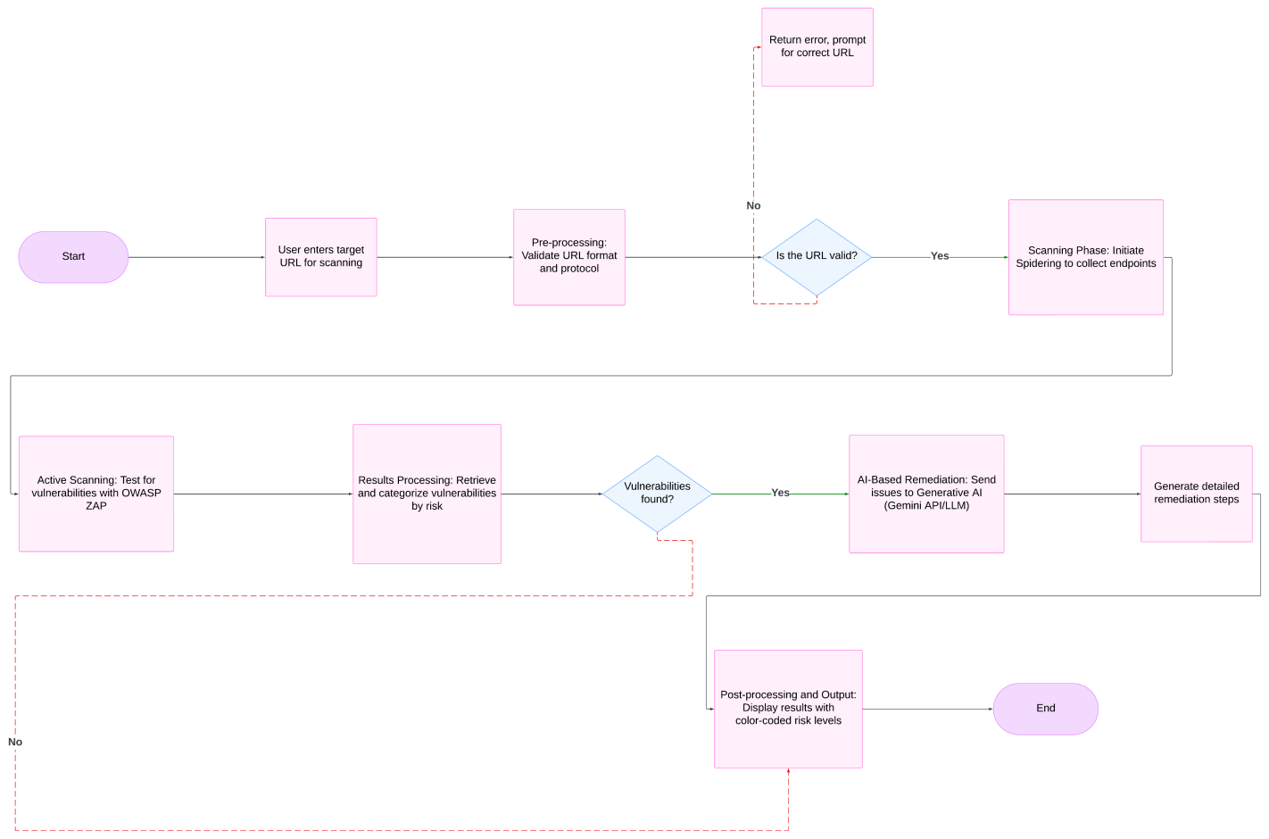

Fig 1: Flow Chart

**Chapter 7: Implementation**

Implementation phase converts the design plan into a working system. It entails programming the system, API integration, AI services, cloud hosting, and extensive testing for stability and usability. In this chapter, the tools, technologies, development process, and the problems faced during multi-stage build of the AI-driven cloud-based vulnerability scanner are discussed.

**Phase-Wise Development Approach**

The system was deployed in three primary development stages, followed by AI integration and cloud deployment:

1. **Phase 1: CLI-Based Scanner using Python**
   * Used the OWASP ZAP API to perform vulnerability scans through command-line.
   * Applied RESTful requests to drive ZAP from a Python script.
   * Parsed and printed scan results in the terminal.
   * **Developed utility scripts for:**
     + URL validation
     + Scan initiation
     + Alert extraction
     + Output formatting
2. **Phase 2: GUI Web App with Flask + HTML/CSS/JS**
   * Built a Flask backend to connect the frontend and ZAP.
   * Created a web interface with HTML, CSS, and vanilla JavaScript.
   * Included a WHOIS lookup feature with whoisxmlapi or similar APIs.
   * Added functionality to upload URLs, initiate scans, and display results.
3. **Phase 3: Migration to React.js Frontend**
   * Converted frontend to React.js for enhanced interactivity.
   * Applied Tailwind CSS for responsive and contemporary UI design.
   * **Implemented principal components:**
     + **ScanForm.jsx:**  manages scan input
     + **TerminalView.jsx:** mimics real-time output
     + **VulnTable.jsx:** table-based vulnerability view
     + **AIResponseCard.jsx:** AI-provided suggestions
   * **Improved user experience with:**
     + State management using React Hooks
     + Page transitions
     + Flexbox/Grid-based layout

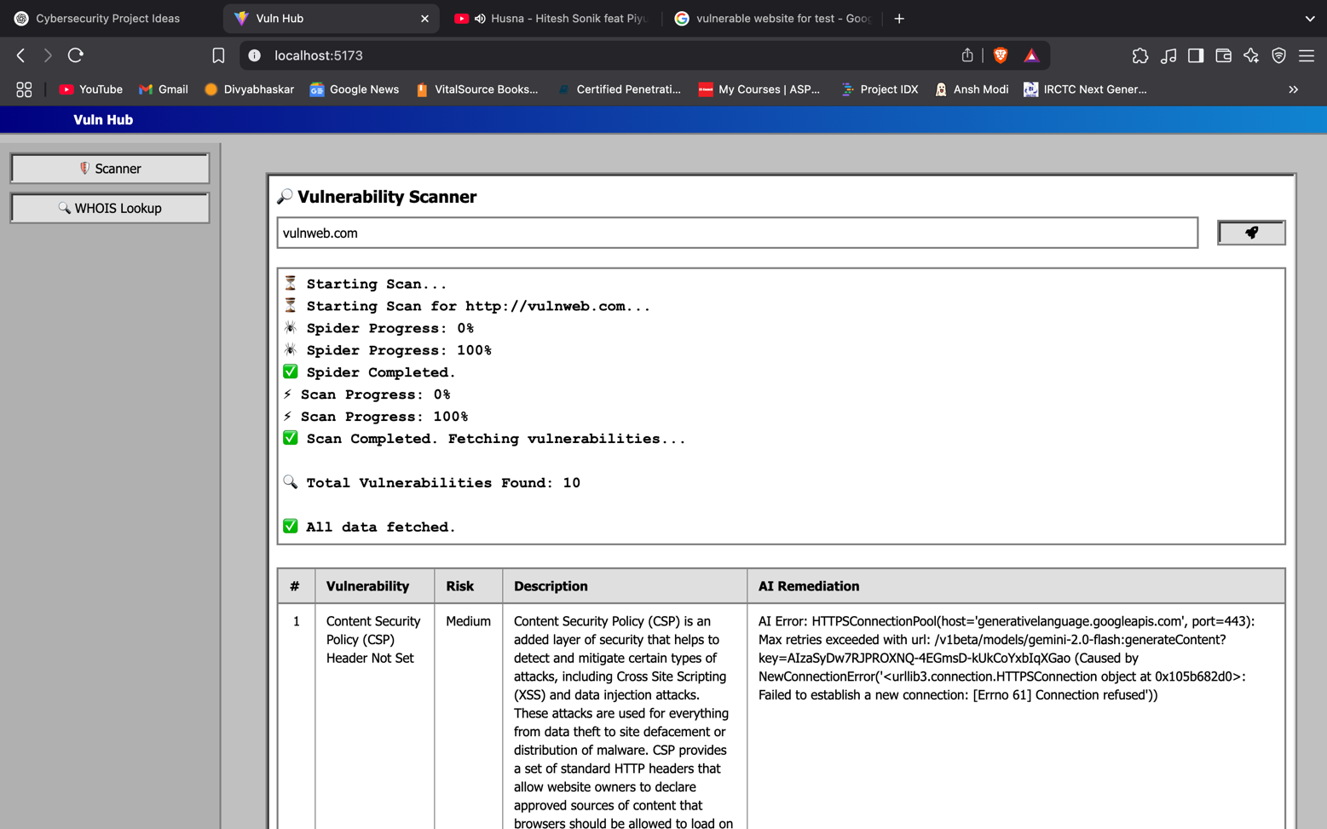

Fig 2: Output of ZAP Scanning

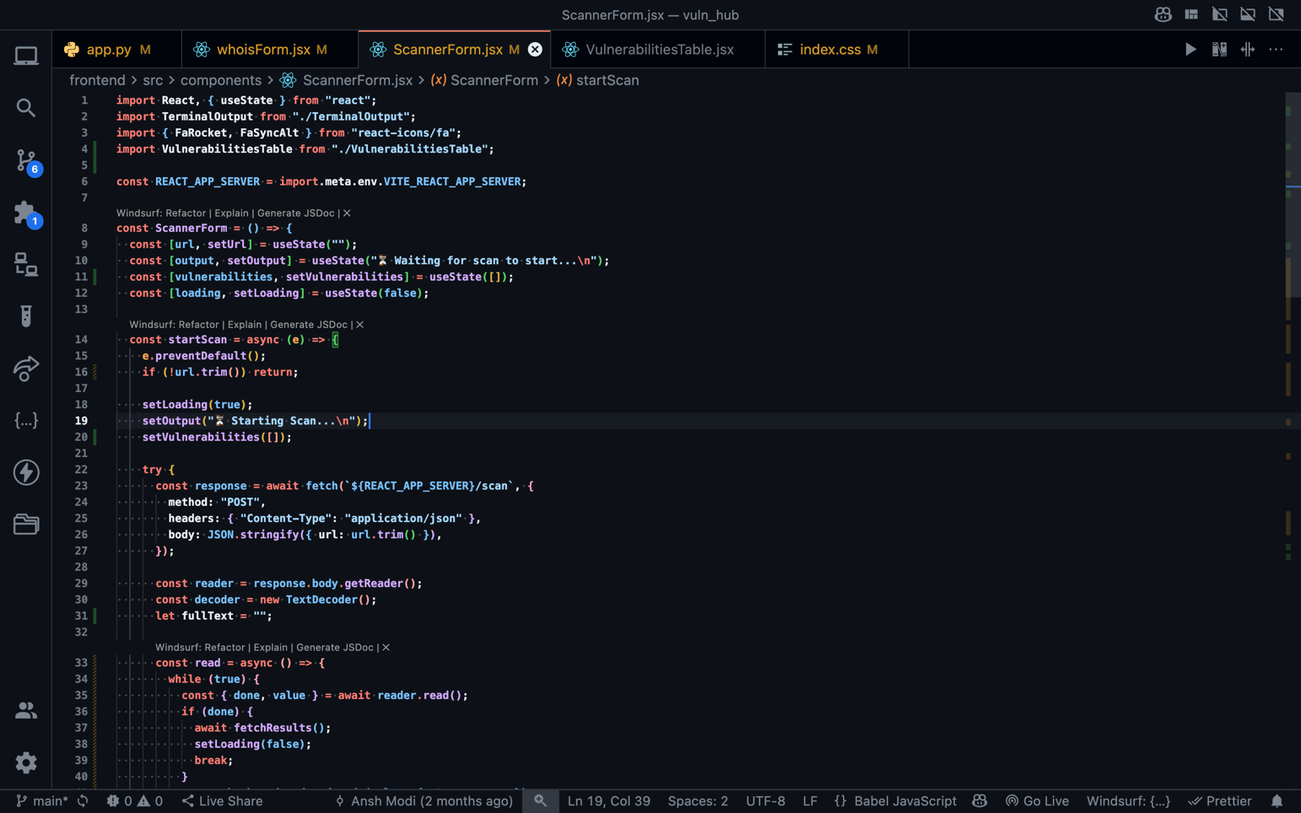

Fig 3: Scanning Code (ScannerForm.js)

**AI-Powered Remediation Integration**

Integrated Google Gemini API to process vulnerability data.

**Built prompts such as:**

* "Given this OWASP ZAP output: [vuln_data], provide specific and concise remediation steps for a web developer."
* Parsed the response and rendered it in the frontend under "AI Suggestions."

**Benefits:**

* Time-saving for developers
* Human-readable, actionable solutions
* Insight for non-security professionals

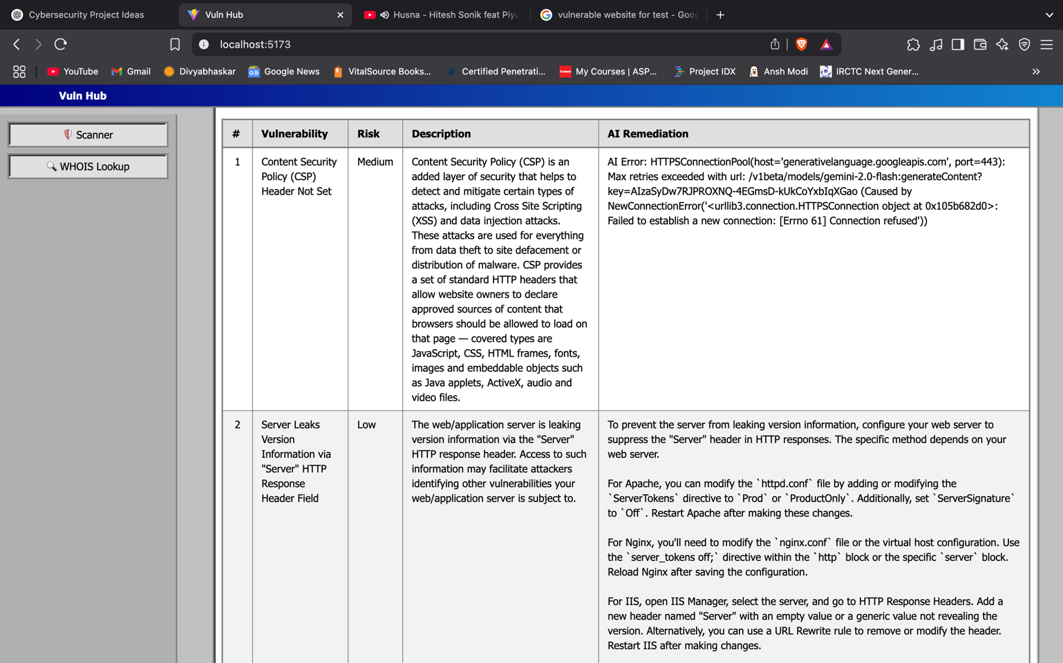

Fig 4: AI Remediation Step (Gemini AI)

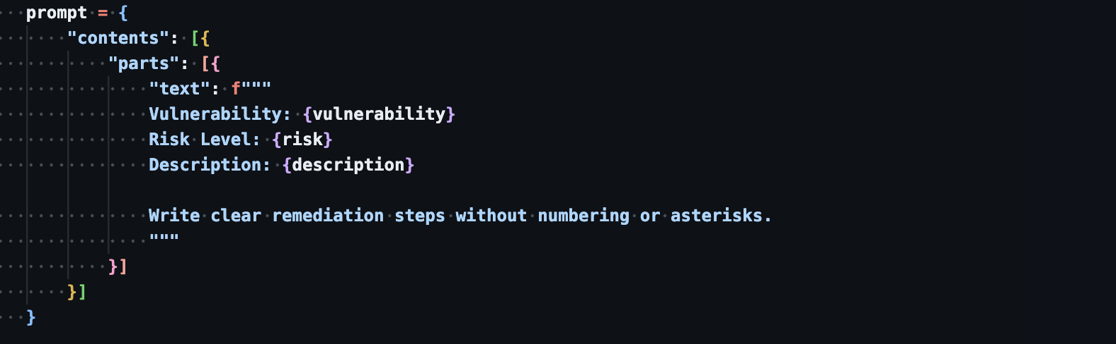

Fig 5: AI Prompt (Gemini AI) (app.py)

**WHOIS Lookup Implementation**

Utilized a third-party WHOIS API to retrieve domain data:

* Domain name
* Registrar
* Owner/Organization
* Country
* Expiration/Registration dates
* Integrated response into a React component (DomainInfoCard).

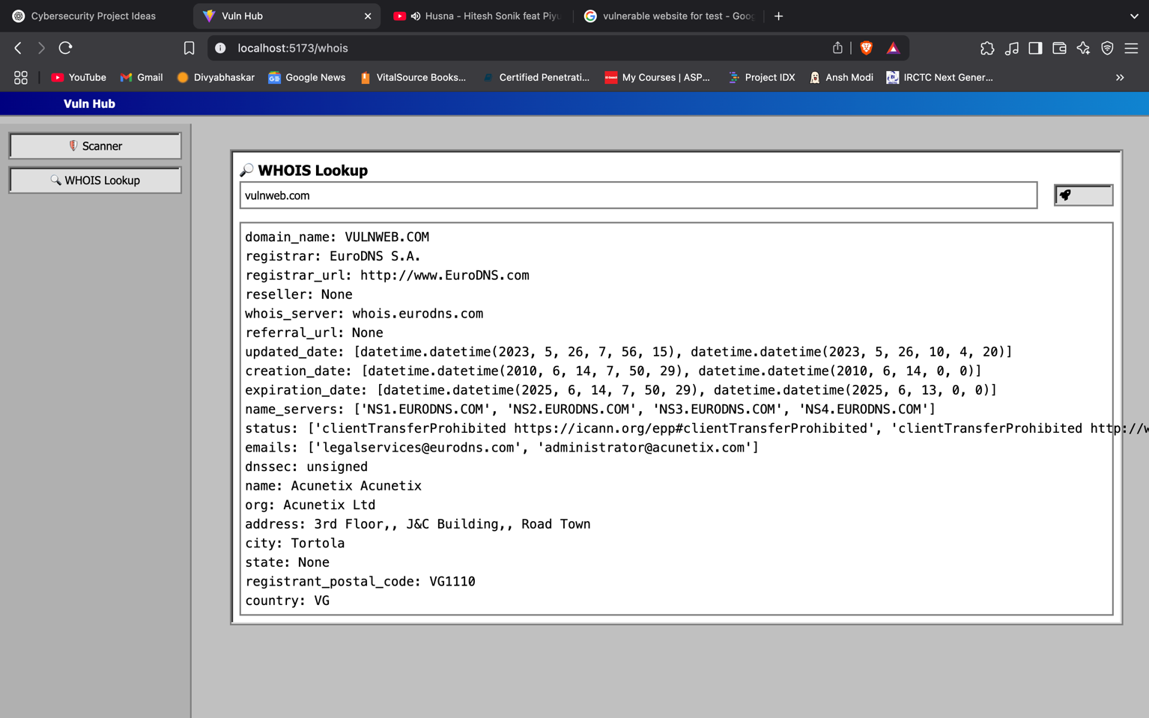

Fig 6: WHOIS Scan Result

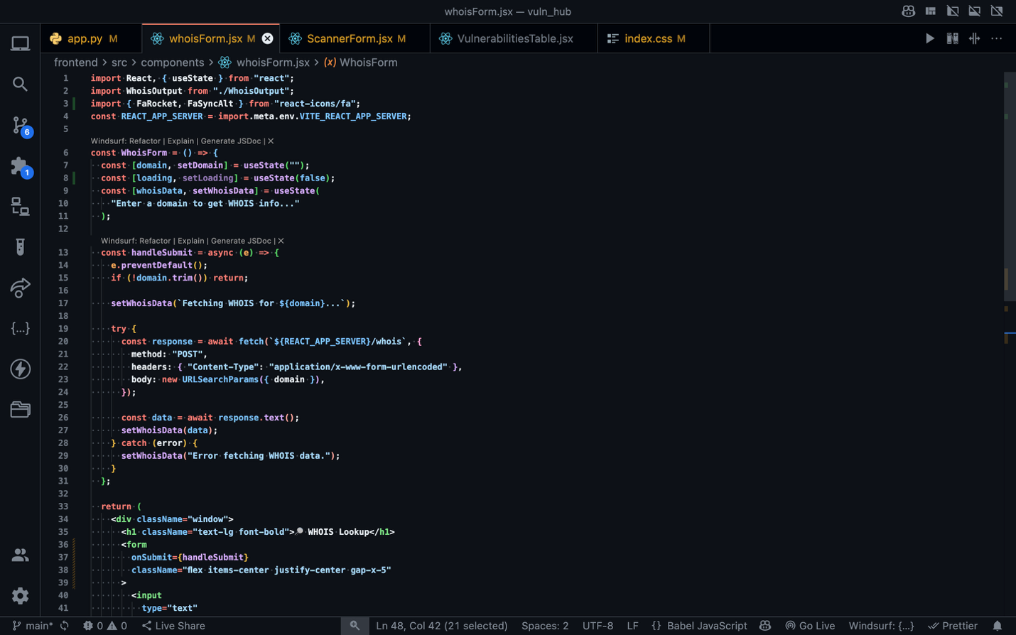

Fig 7: WHOIS Code (whoisForm.jsx)

**Cloud Deployment**

* **Frontend Deployment (Vercel):**
  + Linked to GitHub repository for CI/CD.
  + Auto-deployment on push to main branch.
  + Custom domain configured:
  + e.g., https://vulnhub.anshmodi.tech
* **Backend Deployment (Oracle Cloud or DigitalOcean):**
  + Utilized a Linux VM to execute:
  + Flask backend
  + OWASP ZAP headless daemon
  + Secured with Nginx and SSL (Let's Encrypt)
  + Exposed endpoints for scan, AI, and WHOIS

**Key Challenges and Solutions**

|  |  |
| --- | --- |
| **Challenge** | **Solution** |
| OWASP ZAP slow for large sites | Implemented timeout and async calls |
| Gemini prompt needed fine-tuning | Used prompt engineering with clear instructions |
| ZAP output was raw and verbose | Parsed and restructured using custom Python formatter |
| CORS issues between frontend and backend | Configured Flask-CORS and correct headers |
| Cloud VM resource limitations | Used lightweight Linux instance, minimized dependencies |

Table 7.1: Key Challenges & Solution

**Tools and Technologies Used**

|  |  |
| --- | --- |
| **Area** | **Technology** |
| Vulnerability Scan | OWASP ZAP (API mode) |
| CLI | Python |
| Backend | Flask, Python |
| Frontend | React.js, Tailwind CSS |
| AI Integration | Google Gemini API |
| WHOIS Lookup | WhoisXMLAPI or similar |
| Deployment | Vercel |
| Other | Git, GitHub, Postman |

Table 7.2: Tools & Technologies use

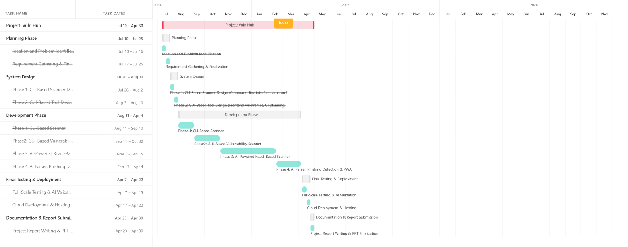

Fig 8: Gantt Chart

**Chapter 8: Results and Discussion**

This chapter outlines the results encountered in the actual deployment and application of the AI-based cloud-based vulnerability scanner. It assesses the project effectiveness in terms of performance metrics, feature delivery, user experience, and value created by AI integration and cloud hosting. Additionally, it offers key analysis of the system strengths, weaknesses, and practical impact.

**Functional Results**

The system was thoroughly tested on all features and phases with positive results. All modules worked as intended, including integration with OWISP ZAP, WHOIS API, Google Gemini AI, and the production cloud infrastructure.

|  |  |  |
| --- | --- | --- |
| **Feature** | **Outcome** | **Remarks** |
| CLI-based scanning | Successful for all tested URLs | Fast for small targets; verbose output |
| Flask web interface | Stable and responsive | Easy access via browser |
| React.js frontend | Fully responsive on all screen sizes | Improved usability and appearance |
| WHOIS integration | Returned accurate domain data | Useful for domain reconnaissance |
| AI remediation output | Contextual, readable, and specific | Significantly helped in understanding fixes |
| Cloud deployment (Vercel + VM) | High availability, fast load times | Smooth access without setup hassles |

Table 8.1: Functional Result

**Performance Metrics**

Tests run under different scenarios provided the following average performance metrics:

|  |  |
| --- | --- |
| **Metric** | **Observed Result** |
| Vulnerability Scan (avg) | 12 - 60 seconds |
| AI Response Time (Gemini API) | 1 - 7 seconds |
| WHOIS Lookup Response Time | 1 - 5 seconds |
| Page Load Time (React Frontend) | < 1 second (Vercel deployed) |
| Backend API Latency | 1ms – 60 second |

Table 8.2: Performance Metrics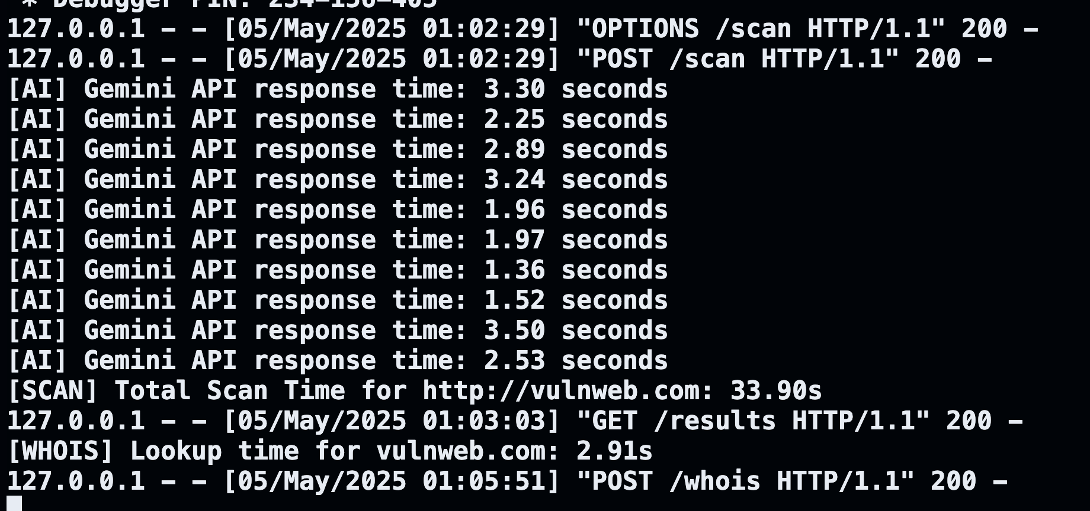

Fig 9: Performance Metrics for Vulnerability Scan, AI Scan & WHOIS ScanFig 10: Backend Latency

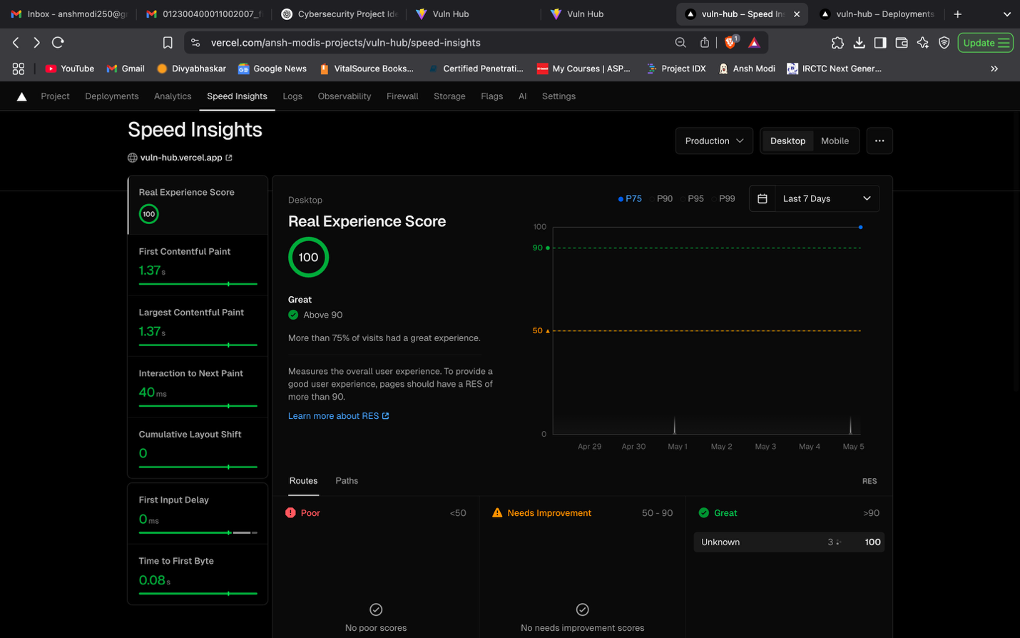

Fig 11: Page Load Metrics

**Value of AI Integration**

The Google Gemini API significantly enhanced the value of the scanner by converting technical scan results into actionable recommendations. Otherwise, users—particularly those with minimal cybersecurity experience—would have struggled to understand the raw OWASP ZAP output.

* **Pre-AI:**
  + ZAP alerts presented as raw JSON.
  + Users required in-depth knowledge to understand.
* **After AI Integration:**
  + Natural-language description of each vulnerability.
  + Specific remediation guidance (e.g., headers to set, input validation recommendations).
  + Enhanced accessibility for newcomers.

**User Experience and Accessibility**

* Trial user feedback (e.g., classmates) indicated:
* Great appreciation for live terminal simulation.
* Visualized vulnerability tables made prioritization easier.
* Mobile-responsive design improved accessibility.
* "No installation" cloud-based model was greatly appreciated.
* Accessibility Improvements:
  + Contrast-friendly color scheme
  + Button tooltips for newcomers
  + Structured output for ease of navigation

**Comparative Analysis**

Comparison with other free scanners:

|  |  |  |  |  |
| --- | --- | --- | --- | --- |
| **Tool** | **Cloud-Based** | **AI Remediation** | **Custom Branding** | **Open Source** |
| OWASP ZAP (Desktop) | ❌ | ❌ | ❌ | ✅ |
| Detectify (Free Trial) | ✅ | ❌ | ✅ | ❌ |
| This Project | ✅ | ✅ | ✅ | ✅ |

Table 8.3: Comparative Analysis

**Limitations Identified**

* Even though overall success was noted, some limitations were seen:
* OWASP ZAP scan time is greatly increased on complex, JavaScript-intensive websites.
* Gemini API has character limits and charges for prolonged usage.
* The system does not have login/authentication for safe multi-user use.
* Does not save scan histories or reports currently.

**Discussion and Reflection**

The project was successful in making vulnerability scanning for web applications democratic with cloud accessibility and AI-powered interpretation. It bridged the gap between professional and novice usability by providing:

* Easy-to-use UI
* Smart interpretation with AI
* Simple-to-deploy cloud architecture
* Modular and extensible design

**Chapter 9: Future Scope**

**Overview**

Although the present release of the Cloud-Based Vulnerability Detection System with AI Integration provides a complete solution for web application security scanning, its cloud-first approach and modular design allow it to be very extensible. Future revisions will go a long way in increasing its intelligence, precision, scalability, and usability to keep pace with emerging security threats and user requirements.

This chapter describes the potential improvements and sophisticated features proposed for upcoming revisions to the system.

**Planned Enhancements**

1. **AI-Based Parser Module**
   * **Objective:** Design a specialized AI engine that can parse raw scan outputs (OWASP ZAP JSON/XML or similar) and summarize them intelligently.
   * **Functionality:**
     + Convert complex vulnerability reports to human-friendly summaries.
     + Utilize machine learning methods (such as NLP transformers or fine-tuned LLMs) to categorize risks and provide remediation suggestions.
     + Offer risk ratings and priority logic for vulnerabilities.
2. **Native AI-Powered Scanning Engine**
   * **Objective:** Decrease dependence on external tools like OWASP ZAP through the creation of an in-built vulnerability scanner based on AI heuristics and pattern recognition.
   * **Approach:**
     + Train AI models against known patterns of vulnerabilities (XSS, SQLi, CSRF, etc.).
     + Use regular expressions, machine learning, and anomaly detection.
     + Improve constantly through user feedback and threat intelligence feeds.
3. **Phishing Detection Module**
   * **Objective:** Detect and mark phishing-at-risk URLs and domains in real-time.
   * **Key Features:**
     + URL reputation scores with third-party threat intelligence APIs.
     + Heuristic page structure analysis, form submission, and metadata analysis.
     + Simulation in the browser for behavioral analysis.
4. **PWA-Based Mobile App**
   * **Goal:** Extend platform reach by creating a Progressive Web App (PWA) for mobile.
   * **Advantages:**
     + Users can scan URLs, see results, and get AI recommendations on-the-go.
     + Offline viewing of previous scans.
     + Push-based security alerts or completion of scans.
5. **Scan History Logging & Report Dashboard**
   * **Goal:** Allow users to store and review past scan outcomes with filtering and graphical analytics.
   * **Planned Features:**
     + Secure access with authentication system.
     + Cloud database integration (Firebase, MongoDB, or Supabase).
     + Graphical dashboard of vulnerability trends and scan history.
6. **Collaboration & Team-Based Scanning**
   * **Goal:** Facilitate team-based security testing.
   * **Features:**
     + Multi-user role system (admin, analyst, viewer).
     + Commenting and tagging of vulnerabilities.
     + Sharing of reports via secure links or email.

**Academic and Research Potential**

This project opens avenues for research in:

* AI’s role in cybersecurity automation.
* Ethical hacking tools enhanced by LLMs.
* Comparative analysis of traditional vs AI-driven scanning.
* Real-time cloud security reporting architectures.

**Industry Integration Opportunities**

With further polishing, this project could evolve into a commercial SaaS product targeting:

* Small and medium enterprises (SMEs) for low-cost vulnerability scanning.
* Managed Security Service Providers (MSSPs).
* Educational institutions offering practical cybersecurity labs.
* SOC teams for quick, smart scanning support.

**Long-Term Vision**

"To revolutionize legacy vulnerability scanning as a context-driven, AI-led experience that makes cybersecurity easy for all."

This project hopes to be a full-fledged, AI-powered security automation platform with the following features:

* Always-on cloud infrastructure
* Smart risk assessment
* Plug-in based architecture
* Secure, collaborative environment

**Chapter 10: Conclusion**

**Project Summary**

The creation of the Cloud-Based Vulnerability Detection System with AI Integration represents a milestone in the mission to make cybersecurity software more accessible, smart, and easy to use. The project was able to merge a CLI-based scanning engine, a GUI-based web application, AI-fueled remediation logic, and cloud-based deployment into a single platform. It also showed real-world applicability by adding hands-on experience acquired from real-world professional cybersecurity work.

Covering three phases of development—Command-Line Interface (Phase 1), GUI-based Web Application (Phase 2), and a Responsive React + AI Interface (Phase 3)—this software caters to various segments of users, from technical security analysts to end-users, by offering depth of analysis in balance with ease of use.

**Achievements**

The major deliverables of the project are:

* A CLI tool that is functional and interacts with OWASP ZAP to scan for vulnerabilities automatically.
* A cloud-based GUI utilizing Flask and HTML/CSS that enhances usability.
* A sleek React.js frontend utilizing Tailwind CSS, with responsive, component-oriented design.
* Incorporation of the Google Gemini API for readable, AI-produced remediation of vulnerabilities.
* Support for WHOIS APIs to add extra domain intelligence and reconnaissance.
* Terminal output simulation and formatted report organization in real time.
* Complete cloud hosting with Vercel and backend test hosting experiments on DigitalOcean and Oracle Cloud.

**Key Learnings**

During the project lifecycle span, the below technical and professional skills were honed:

* **Python Development:** Extensive expertise with scripting, REST API integration, and automation.
* **Web Technologies:** Comprehensive hands-on experience with Flask, React.js, and Tailwind CSS.
* **Cybersecurity Principles:** Hands-on experience with OWASP vulnerabilities, scan engines, and remediation.
* **Cloud Deployment:** Hands-on experience in deploying scalable applications using Vercel, DigitalOcean, and DNS setup.
* **AI Integration:** Familiarity with prompt engineering and contextual response generation with LLMs.
* **Team Collaboration and Reporting:** Enhanced planning, documentation, and technical writing skills.

**Challenges Faced**

Some of the significant challenges that were faced included:

* Integrating asynchronous API responses without blocking the UI.
* Formatting complex ZAP alerts for AI prompt compatibility.
* Latency issues during cloud deployment, resolved through caching and server optimization.
* Overcoming Gemini’s token limits for long vulnerability data inputs.
* Each challenge was approached iteratively, leading to better design decisions and technical resilience.

**Final Verdict**

The cloud vulnerability scanner powered by AI not only achieved but surpassed its initial goals. It is not just a tool—it is a platform that combines automation, intelligence, and convenience into one cohesive experience. Its modular architecture and scalable design provide opportunities for expansion in the future, including phishing detection, AI-powered scanning engines, and mobile capability.

This project shows how with proper integration of AI, cloud, and cybersecurity fundamentals, security tools can be made robust yet accessible to everyone.

**Chapter 11: References**

This chapter contains all scholarly publications, official documents, APIs, tools, and platforms mentioned or used during the course of developing the Cloud-Based Vulnerability Detection System with AI Integration project.

1. OWASP Foundation – OWASP Top 10 Web Application Security Risks – 2021  
   URL: <https://owasp.org/Top10/>
2. Sadeghi, A., et al. (2018) – A Survey of AI Approaches for Cybersecurity Applications  
   Journal: ACM Computing Surveys, Volume 51, Issue 6.
3. Kim, J., & Park, Y. (2020) – Machine Learning-Based Detection of Web Application Vulnerabilities  
   Proceedings of the International Conference on Information Security.
4. Rahman, M.M., et al. (2019) – Vulnerability Scanner Tools: A Comparative Analysis  
   Journal of Computer Networks and Communications. DOI: 10.1155/2019/8062016
5. OWASP ZAP (Zed Attack Proxy)   
   URL: <https://www.zaproxy.org/>
6. Flask (Python Web Framework)  
   URL: <https://flask.palletsprojects.com/>
7. React.js (Frontend Library)  
   URL: <https://reactjs.org/>
8. Tailwind CSS (Utility-first CSS Framework)  
   URL: <https://tailwindcss.com/>
9. Vercel (Frontend Cloud Deployment)  
   URL: <https://vercel.com/>
10. DigitalOcean (Cloud Hosting for Flask Backend)  
    URL: <https://www.digitalocean.com/>
11. Google Gemini API (Generative AI Integration)  
    URL: <https://ai.google.dev/gemini-api>
12. WHOIS Lookup API (Domain Intelligence)  
    Example: <https://whoisxmlapi.com/>
13. Python Requests Library  
    URL: <https://docs.python-requests.org/en/master/>
14. OpenAI Prompt Engineering Guide  
    URL: <https://platform.openai.com/docs/guides/prompt-engineering>
15. ReactJS Official Docs  
    URL: <https://reactjs.org/docs/getting-started.html>
16. Flask REST API Development  
    URL: <https://flask-restful.readthedocs.io/>
17. TailwindCSS Components  
    URL: <https://tailwindui.com/>